Tim Black (tim.black@arcadis.com)

Consolidated Narrative

*Utilizing Esri’s ModelBuilder for a Risk-Based Approach for Stormwater Asset Management and Maintenance*

**Topic at a Glance**

As our nation’s infrastructure continues to deteriorate, the push for asset management has greatly increased. It has become evident to stakeholders that the costs required to maintain assets at the highest level far outpace the available resources. Therefore, it is imperative for the asset managers to determine the most cost-effective way to provide the greatest impact in their jurisdiction with the available resources.

Considering this, the starting point centered on extending an existing project to utilize Esri’s ModelBuilder to create a risk model for recommending and prioritizing stormwater maintenance activities for the Georgia Department of Transportation (GDOT). The risk model incorporates various criteria (such as observed condition, structure material, location of the asset, etc.) to score the assets on both the likelihood and consequence of failure. I explore the specific criteria in detail later in the paper. What is important to understand now is that application of the various criteria and the scoring calculations occur through an automated process by utilizing ModelBuilder. This model is just one piece of a much more involved asset management program, however the nature of implementing GIS and risk modeling represents a significant shift from the existing stormwater maintenance workflow utilized.

**Project Plan: Background**

The United States Environmental Protection Agency (EPA) established the Clean Water Act (CWA) in 1972 to regulate discharges and potential pollution to surface water. Under this legislation, it became unlawful to discharge a pollutant into a navigable water without a permit. The National Pollutant Discharge Elimination System (NPDES) permit became the program to regulate these discharges. As the legislation evolved, Municipal Separate Storm Sewer Systems (MS4s) were required to also obtain the permit. Thus, any municipality or jurisdiction that managed MS4 infrastructure was required to take certain steps to ensure they were in compliance (US EPA).

To properly manage compliance, municipalities must first know the location and condition of their infrastructure. Then they must use this knowledge to identify potential outfalls, or point source locations that could deliver pollutants. The necessity to collect and manage this information is perfectly complimented with the abilities of GIS.

By utilizing GPS and GIS, stormwater infrastructure can be inventoried and inspected in a sophisticated manner. This is the exact line of work in which our department specializes. Our company procured a contract with GDOT to locate and inspect all their MS4 related infrastructure along State Routes and Interstates. While the primary focus of the project was to help GDOT maintain compliance with their MS4 permit, there are other opportunities to provide value. One such area is with stormwater infrastructure maintenance.

During the MS4 inventory and inspection, each structure and pipe had various condition-related attributes collected. Some examples of these condition related attributes are damage to the structure, level of blockage, erosion, etc. This information can be leveraged to help increase the efficiency in which the assets are managed.

The current asset management approach primarily revolves around immediate needs and/or political pressure. GDOT has been working to move away from this reactionary approach to something that is more proactive. One tool that they can use is a risk-based prioritization model. A model such as this can be customized to help decision makers to meet the needs and budget of the department.

**Research Approach**

Prior to the development of the model, I began by looking for GIS-related asset management literature. At the highest level, it was obvious that many agencies have identified GIS as an important component in their asset management programs. However, it was also readily evident that each agency approaches the level of GIS integration with asset management concepts differently.

I began to narrow my search to focus on risk assessment and modeling. Initially, this research track led to resources that utilized a similar risk assessment framework. Although the asset classes were varying – typically sanitary sewer or water distribution assets – there was a common practice of building a risk matrix with relevant criteria. The common practice used was to build a risk score that was determined by multiplying the likelihood of failure score with the consequence of failure score. Obviously, the criteria used to determine these scores were dependent on the agency and the asset class, amongst other factors.

The next step was to see if anyone has been using ModelBuilder to help automate the risk assessment process. Initially, it appeared that there had been limited use of ModelBuilder to aid this process. There had been plenty of discussion of risk models, but the computations appeared to be centered in either a robust asset management software package or a more simplified spreadsheet approach. These two methodologies are likely the most common approaches used by most agencies. However, as research continued, I discovered a handful of presentations at the 2015 Esri International User Conference that specifically implemented ModelBuilder in a risk assessment\asset management context.

Finally, I reached out to a couple of colleagues at work that have been working on risk-based assessments and modeling. They shared some of their knowledge with me on the approaches and tools they have used in the past. While they have primarily focused on water distribution networks, many of the concepts were relevant for the stormwater context. One of the more valuable thoughts that they left me with was to consider the evolution of the modeling process based on client involvement and available data. In general, as there is greater client/stakeholder buy-in and more information becomes available, the criteria used in the modeling process can not only be refined, but can evolve into more complex algorithms that help reveal patterns and assist the decision makers to become more efficient as they prioritize work and capital investment.

**Notable Discoveries**

General asset management principles are well documented. It appears that integration of these principles with GIS technology has only begun to take hold in the last five to ten years. For the more progressive asset managers, some level of GIS integration and risk assessment has already taken place. The more progressive asset managers are still looking to refine their processes to continue to make the best decisions possible.

Sadly, from experience, there are many jurisdictions that are still not utilizing asset management principles. They generally follow a reactive process that is driven by citizen complaints and/or politics. The desire is to demonstrate a way to embrace asset management principles that will help guide their decision making by prioritizing work in such a manner that maximizes the available resources.

There were a handful of presentations at the 2015 Esri User Conference that highlighted the application of ModelBuilder to the risk management decision structure. This is a positive sign that managers are looking for a more sophisticated way to process their information. One advantage of ModelBuilder is that it is an out-of-the-box solution that is already included with ArcGIS. My company has a very large enterprise licensing agreement with Esri for access to (essentially) their entire suite of products. Most jurisdictions that our company works with, including the Georgia Department of Transportation, have a license agreement status with Esri that would include ModelBuilder. Because these jurisdictions already have access to ModelBuilder through a large-scale license agreement, it means that they already have access to all the tools that are used in this model. In this situation, a move to a more proactive asset management approach does not require the purchase of complicated asset management software packages that tend to be overpriced and underperform client expectations.

The examples provided in the research reveal a few key points. First, the output of the model is only going to be as effective as the input. The quality of the data, the selected criteria, and any necessary assumptions will drive the results. Due to this fact, a continual refinement of the various components can be necessary to find an appropriate balance in the output. The next key point is that the model output should be viewed as a component of the decision process and not the final decision itself. The model is truly intended to reveal patterns and priorities, but ultimately it is up to the manager and his staff to appropriately allocate the funding for the work required. To say it another way, the model output is but one tool in the manager’s tool belt to be used in the asset management process.

In the proper context, utilizing ModelBuilder to provide risk management and prioritization is viable for many different avenues. My focus is on stormwater infrastructure as it relates to roadways maintained by the State of Georgia. However, the principles and techniques used can also be extended to other asset classes and jurisdictions. In my research, I found ModelBuilder used in the context of sanitary sewer condition assessment (Biedenbender & Hamm, 2015), Capital Improvement Plan (CIP) budget allocation for sanitary sewer upgrades (Smith & Baldwin, 2015), and Environmental Impact Assessment (Powell, 2015). These presenters used a similar risk-based approach, aided by ModelBuilder, to provide a more comprehensive analysis of the available data. I used similar concepts as the foundation of this model, as it is applied to stormwater infrastructure in the state of Georgia. Even though the concepts and tools utilized are not necessarily new to the industry, the specific application of a flexible and customized solution for the maintenance of a stormwater asset class and statewide jurisdiction does represent a different level of scope from what was discovered during the literature review.

**Project Plan: Risk Matrix Terminology**

The model uses a risk matrix approach. The risk factors are grouped into two different categories – Likelihood of Failure (LOF) and Consequence of Failure (COF) – that represent the two axes of the matrix. The two categories are intuitive. Items that fall into the LOF category are more directly related to the condition of the infrastructure. This is a general indication of the level of deterioration or lack of intended functionality at the time of last inspection. The items that fall under the COF category are more directly related to the impact of a scenario where a system fails. The impact could be environmental, social, or economic (or a combination of all three). LOF deals more with observations, whereas COF deals more with “what-ifs.”

The construction of the matrix uses LOF and COF as the two axes. The values are scored and multiplied together, and an overall risk score is assigned. Assets that score high in both their LOF and COF scores are assigned the highest level of priority. Assets that score low in LOF and COF are assigned the lowest priority. A risk matrix is very simple to construct and understand, however it is more challenging to find the right balance of criteria and scoring to unlock the true value that the matrix can provide. Ultimately, the matrix helps differentiate the assets enough to provide a clear path for the maintenance plan moving forward.

**Project Plan: Criteria**

In this section, I outline the criteria that are involved in the risk model as well as their data sources. It should be noted that the following criteria were the starting point for this exercise and were adjusted as results from the model were analyzed. Changes to this list are discussed in the analysis portion of this document.

*Likelihood of Failure Criteria*

* *Remaining Useful Life* – this represents a calculation that attempts to approximate the remaining expected life of an asset. It begins with an approximate useful age life of an asset based on its material then subtracts the current age of the pipe derived from the current date and the installation date. The useful age life is pulled from industry standards and the installation dates are pulled from the data collection inventory.
* *Observed Condition* – current structural/physical condition of the asset based on field observations. This data came directly from the data collection inventory.
* *Surface Damage/Erosion* – notation of any surface damage or erosion that could either directly or indirectly be linked to an underlying issue with the infrastructure. This criterion was observed in the field during the data collection inventory.
* *Flow Limitations (Blockage/Water Level)* – record of the percentage of the infrastructure that is obstructed by an object or standing water, representing a limitation of the intended flow through the stormwater system. Represents the primary measurement of the operational status of the infrastructure. This criterion was observed during the data collection inventory.

*Consequence of Failure Criteria*

* *Impact to Impaired Stream (with a Pollutant of Concern)* – this environmental criterion determines if a stormwater system flows to an impaired stream that also contains a pollutant of concern (as identified by the Georgia Department of Transportation). This data was provided by GDOT and is derived from a subset of the EPA’s 303(d) list of impaired streams that highlights specific pollutants that the Georgia DOT wants to focus on.
* *Distance to National Wetlands Inventory (NWI)* - this environmental criterion determines if the stormwater system could be a potential source of impairment to an NWI area. This data came directly from the US Fish and Wildlife Service.
* *Distance to Outfall/Discharge Point* – this environmental criterion examines the location of the stormwater system in relation to outfall and discharge points – as defined by GDOT’s MS4 Permit. These points were located and designated during the inventory data collection process.
* *Route Priority* – this criterion is a measure of potential route disruption based upon the location of the infrastructure and the criticality of the route itself. The route prioritization for the dataset used considers many criteria, such as route classification, freight corridors, traffic volume, evacuation routes, etc. The dataset was the result of a separate study performed by the Georgia DOT in 2014 to classify and prioritize all the state routes and interstates under their jurisdiction.
* *Population* – this criterion is a measure of the population density in the vicinity of the infrastructure. It is one way to capture the potential number of people that would be impacted by infrastructure failure. The dataset used for this criterion came from the 2010 US Census Block Groups.
* *Critical Facility Impact* – this criterion is a measure of the number of critical facilities located in the vicinity of the infrastructure. Critical Facilities are loosely defined as locations that can least afford disruption of access – such as hospitals, fire stations, police stations, schools, etc. The dataset used for this came from combining various point files that contain these types of facilities across the state of Georgia.
* *Pipe Under Road* – this criterion simply gauges whether the infrastructure is located underneath the travel lanes, or outside the edge of pavement. This is an economic criterion that potentially impacts the costs involved in the repair/replacement of the infrastructure. This dataset was created on the fly in the model by comparing the infrastructure location to the road centerline.
* *Cost Estimate for Replacement* – this economic criterion was intended to be an estimation of the cost of replacing the infrastructure. Barring extenuating circumstances, this value would generally measured the worst-case cost scenario if the infrastructure were to fail. The values used for the calculations were estimates of the labor and materials involved. Ideally, exact costs could be plugged into these calculations, however, nailing down specific scopes of work for each individual asset are impossible with the level of data collected. A more precise cost evaluation requires follow up field visits by GDOT staff. Thus, the assumptions and estimates here are documented in the absence of specific maintenance costs.

**Project Plan: Scoring**

The final risk score assigned to an asset was calculated using the following formula:

Risk Score = Likelihood of Failure (LOF) Score x Consequence of Failure (COF) score

Now to reach that final score, let’s step back and look at how the LOF and COF scores are constructed. In the previous section, I outlined the various criteria that is used in the risk model. Each of those criteria are scored individually and independently of each other. The individual criteria scores use a five-point scale, where the higher numbers represent items that require higher priority. The breakdown of the individual scoring thresholds for each criterion use the following breakpoints: Very Low 1-2, Low 3-4, Moderate 5-9, High 10-15, Severe >15. These are the breakpoints utilized for this model, however, the thresholds can certainly be revised in future iterations of the model.

The building of the LOF and COF scores used in the final calculation used the following thought process. For the LOF score, a “Maximum Grade” approach to the scoring is utilized. This means that the individual criterion related to LOF are scored, and then the highest score amongst those criteria is assigned to the LOF score. The reasoning behind using this scoring approach hinges upon the fact that all the LOF criteria are condition based. The thought here is that if any one component of the infrastructure is failing, then the entire infrastructure will require some level of maintenance. Since the intention of the risk model is to help prioritize maintenance activities, it is important to ensure that the infrastructure that is currently exhibiting conditions requiring some level of maintenance get pushed toward the top of the results structure. Thus, by using a maximum grade approach, the “worst” infrastructure will stand out a bit more.

The scoring system used for the COF scoring used a more traditional weighted approach. The criteria selected for the COF score are assigned a weighting multiplier that was then applied to each individual criterion score. These weighted scores are then summed to determine the final COF score for the asset. This approach was used because the various criteria have varying levels of importance. For example, the “Route Priority” criterion might be assigned 20% of the COF scoring, while “Population” may only be assigned 5%. Then the individual criterion scores will be multiplied by the percentage. All the weighted criterion scores are summed to produce a total COF score for the asset. This computational process ensures that the most important criteria are carrying the “weight” of the overall score.

To ensure a balanced weighting approach, the criteria are grouped into environmental, social (or socio-economic), and economic groups. This balanced approach helps protect the model from becoming skewed too heavily in one direction, while also ensuring that multiple factors are truly being considered in the final calculations. While the final balance of the groups was determined through an iterative process, the groups begin by using a 40%-30%-30% breakdown. For example, all the environmental criteria make up 30% of the COF score, the social criteria 40%, and the economic criteria 30%. The sum of the criterion would thus equal the percentage assigned to their group.

As the model results were analyzed, the weighting and scoring values evolved. One of the great advantages to utilizing ModelBuilder is the flexibility to quickly change the percentages and scoring used in the model. The initial iterations of the model can be reviewed and updated based upon previous stakeholder input. Future iterations can be actively reviewed by various stakeholders and suggestions made on how to update the criteria, weighting, and scoring.

**Building and Running the Model**

The process for building the risk model inside of ModelBuilder is relatively straightforward. That is not to say that it is a breeze and without the occasional hiccup. However, the ModelBuilder software allows for relatively easy configuration of the model by allowing the user to link together pre-packaged tools. Once the specific scoring for each model criterion is determined, configuration of the model is as intuitive as selecting the tools and plugging in the values.

Despite allowing for the intuitive construction of the model, ModelBuilder still requires the user to be aware of what they are trying to accomplish. Having previous experience using ModelBuilder, I knew that I would encounter situations that don’t immediately produce the desired results. Sometimes this had nothing to do with the input values, but rather some minor nuances inside ModelBuilder that must first be resolved. One small example of this is the use of feature layers that must be created along the way. These feature layers are accessed by utilizing the “Make Feature Layer” tool. The feature layer that is created is a temporary version of the input data that is then used for many of the spatial joins and table calculations. The feature layer must eventually be kicked out into a feature class or shapefile if the user wants to visualize the data in Esri’s ArcMap (or an equivalent data viewer).

The model that I constructed also required several small scripts to aid the calculations. These generally take place in the form of an If…Then statement using either VBScript or Python. The assignment of specific risk scores inside the model required such statements to help streamline the automation process. The scripts help keep the size of the model manageable, increase performance, and provide a quick access point for any future scoring changes that need to be implemented.

The risk model is built in a modular fashion. What this means is that each model component was built independently at first. The initial modular build technique helped debug the model along the way, and helped to quickly determine where any issues were popping up. Once each component was functioning properly, then the components could be migrated to a single model. For this exercise, the intention was to only have a single model after the iterative process concluded.

While the build process was aided by the modular approach, the end user needed to have a single, simple model. The model needed to be able to be run by various individuals, some of whom do not have GIS experience. Thus, a single model was easier for them to use than a series of small modules that would have to all be run in sequence.

**Expectations**

I had a short list of expectations that I hoped to be able to demonstrate at the conclusion of the project. The first was that the model output results would demonstrate a logical and defensible prioritization method. The results are specific to prioritizing maintenance activities for stormwater assets in the state of Georgia. However, the combination of the criteria and scoring used would hopefully demonstrate to others in the industry that this is a viable methodology that can be applied to their own infrastructure.

Next, I hoped to demonstrate that others can utilize ModelBuilder as an out-of-the-box solution. In my opinion, jurisdictions are running too quickly to the promises of large-scale asset management software programs. Incredible sums of money are being spent on software that promises the moon, but no one knows how to use. The hope here was that others would recognize that they already have access to tools that can be used to implement a system that is customized to their own jurisdiction, and doesn’t require cutting another enormous check.

Third, it was my intention to demonstrate the flexibility and power of utilizing ModelBuilder. My hope is that others clearly see a repeatable methodology that can be applied to their own assets. Other users do not need to copy what I am accomplishing here. However, they can take the principles and techniques used and apply them in their own context. This flexibility is incredibly valuable, because it will help unlock more powerful analysis tools to other users.

Finally, I hoped to demonstrate that the end product is user friendly. There were bumps in the road in the configuration process, however, the final model is very straightforward to run. One of the primary benefits of the model is that it does the computational heavy lifting, and the end user simply must hit “Start.”

**Model Run Analysis**

As a brief reminder, the first iteration of the model utilized a maximum grade approach for the LOF criteria and the COF weighting that can be seen in Table 1 below. These weights were determined through conversations with maintenance stakeholders at GDOT. The criteria were discussed and weighted based on perceived importance. Conceptually, the risk model and weighted criteria approach was new to the stakeholders. The weights and distribution appeared agreeable on paper, but it was obvious that they would likely request refinements depending on the results. Working through an iterative process was going to help inform them to not only the results, but the interaction of the criteria and weighting performed in the calculations as well.

**Table 1:** COF table of criteria and weighting used for Model Run #1

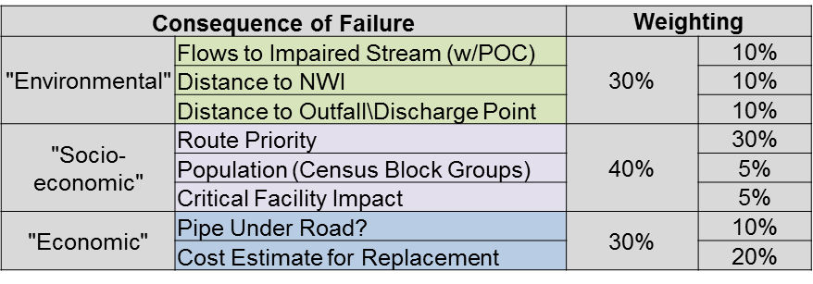

For this narrative, I only focus on the stormwater structures. A similar model was also run on the conveyance system feature class. The study area used in the metro-Atlanta area included 29,945 structures. The model runtime was approximately 25 minutes. The following table shows the distribution of the results across the various risk model categories.

**Table 2:** Distribution of results from Model Run #1



Table 2 clearly shows that there was a large grouping of data in both the Moderate and Very Low categories. Two primary factors contributed to this distribution. The first was the scoring used in the risk matrix. The Moderate category catches many assets that fall in the mid-range of the scoring spectrum. This is by design. However, based on the calculations performed, the factors utilized push a larger volume of assets into this category than initially expected. The second factor that contributed to this distribution was the involvement of the Route Priority criterion. This criterion is the largest component of the COF scoring. The study area data is located on MS4 related State Routes. By the nature of the MS4 designation and high(er) volume State Routes, the priority level of the routes was generally going to be Moderate or higher. Despite this obvious flaw, route priority remains one of the top criteria that the stakeholders wanted to consider in prioritizing maintenance activities.

The second iteration of the model utilized the COF weighting values that can be seen in Table 3 below.

**Table 3:** COF weighting utilized in Model Runs #2-3



In this iteration of the model, the environmental factors were slightly reduced and the emphasis shifted to the pipe under road criterion. The change in weighting came from stakeholders in the Maintenance Group feeling that the original emphasis on environmental/compliance factors did not play as prominent a role in their decision-making process. Meanwhile, the location of infrastructure in and under a road plays a much more important role in how quickly they perform maintenance. The travel lanes of the roadway are their primary asset, so anything that could directly impact the roadway and travel take precedence over infrastructure along the side of the roadway. The distribution of results from this model iteration are in Table 4 below.

**Table 4:** Distribution of results from Model Run #2



The results from this iteration of the model are very similar to the first. In general, some of the assets slid downward in the matrix, however, the overall distribution is almost identical. The same two overriding factors that were discussed in relation to the first run explain the similar distribution here.

The third model run utilizes the same weighting criteria that was used in the second run (Table 3). The significant change to this iteration was the way costs are considered. The first two iterations utilized an estimate for replacement, regardless of the level of work needed. This represented a worst-case-scenario, which logically follows a thought process that is considering the consequence of failure. The problem with this methodology was that nailing down true costs was impossible. Maintenance costs are situationally driven. This means that while there does exist a general template for what every maintenance activity costs, the realized costs depend on the extent of work present in each situation. To remedy this situation, the scoring was changed from assigning a dollar value for replacement to scoring the asset based on the level of work that was required. As a part of the condition assessment process performed in the field, each asset contains an attribute that classified maintenance into one of four general groups: Clean, Repair, Replace, or No Action Required. The risk model was updated to pull from this attribute as a general indicator of the level of work, and indirectly cost, that would be involved. While specific costs were impossible to nail down, classifying assets by a general maintenance activity was a calculated compromise to still have a hierarchy in place to aid in the prioritization of work.

There was also a minor change to the influence of discharge points in that environmental criterion. The buffer used dropped from fifty to twenty-five feet. In the MS4 program, the importance of discharge points continues to decline, as they are not a reportable compliance component. They simply designate where water flows out of GDOT’s right of way. The following table depicts the distribution of results after the third model run.

**Table 5:** Distribution of results from Model Run #3



While the overall distribution is still generally like the previous two iterations, we can begin to see a shift away from the significant gathering of assets in the Moderate category. Now, roughly ten percent of the total assets are in the High and Severe categories, which will be receiving immediate attention for maintenance activities.

**Case Study: Model Run Comparison**

In Map 1, visible below, I provide a small case study of the model results between the three runs. The map depicts structures that fell within either the High or Severe rating categories. These two categories were grouped in this map to focus on structures that GDOT would maintain first. The individual model runs are uniquely symbolized.

Utilizing this visualization, the analysis narrative comes to life a little bit more. The similarities between model runs one and two are confirmed. There is very little variation between these two model run results, despite the changes to the criteria calculations. The shift in results between the first two model runs and the third are clearly visible in this case study. There are many new structures that are included because of the changes to the criteria in the third model run. As previously discussed, the primary change in the third model run was the way that costing information was handled. Using the refined criteria, more structures that required short term maintenance were pushed up the priority list, particularly items that required cleaning.

In this case study, the impact of the model changes is visible in multiple structures along two distinct routes that are now to be considered for maintenance. In Map 1, turn your attention to the yellow squares that represent the results from the third model run that do not intersect the results from the previous two runs. These records are direct benefactors of the refined model. This is an important development, because it helps legitimize the line of thinking that the model would be improved by reworking the cost calculations. Many of the records that are now included in these results were significantly obstructed (>75%). They were not receiving the same level of priority in the first two model iterations because they were smaller, less expensive structures to replace. The reality, though, was that they were completely blocked and causing a risk for potential flooding of the roadway. The shift in criteria ensures that these types of situations will receive more attention moving forward.

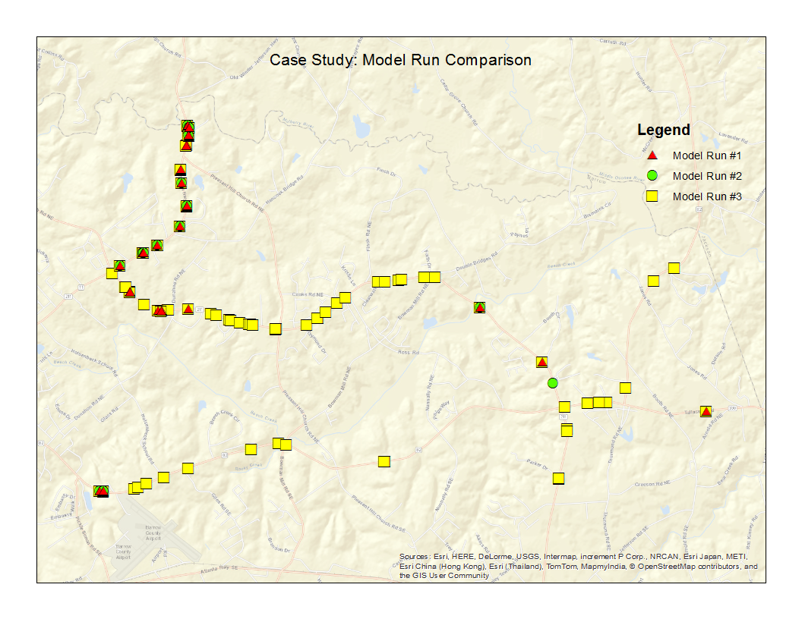

**Map 1:** Comparison of all three model run results

**Current Status and Next Steps**

The process of refining the model is ongoing. Department priorities and directives change over time, so the model will need to continue to evolve to meet their needs. Further discussions will need to be conducted to refine the criteria and weighting. Specifically, the route priority criterion continues to play a major role in the distribution of the results, so it is at the top of the list for discussion. As the spatial distribution of the model results are analyzed, there may also be a move toward grouping assets over a specific corridor to help focus both maintenance activities and funding. The flexibility of the model to quickly evolve and be re-run allows for any of these changes to take place.

The risk-based approach and model presented here are still awaiting full adoption. Two pilot projects have been conducted using the model results. In both cases, the value of the data has been evident and appreciated by GDOT. The challenges that will inhibit adoption of this program appear to be less about the quality of this product and more about other factors.

The primary challenge to adoption is a mentality that is change averse. Part of this mentality was formed from a long history of cycling through a series of “new” workflows that ultimately failed. Another part is overcoming the perceived threat of a consultant marginalizing their job. Finally, there is comfort level with the “way things have always been done.” Even if they recognize that the way that things were done in the past could be improved, it does not necessarily translate to an eagerness to change. While there will be other challenges, achieving buy-in from the end users and overcoming the change averse mentality will be vital to the adoption and success of this program.

**References**

Biedenbender, Jerry and Jordan Hamm. *Determining Consequence of Failure Using ModelBuilder.* Presentation. 2015 Esri International User Conference. Online. Retrieved from http://proceedings.esri.com/library/userconf/proc15/index.html on October 11, 2015.

Bryant, Scott D., Kenneth A. Carper, John Nicholson. *GIS Tools for Proactive Urban Watershed Management.* ASCE. Online. Retrieved from http://ascelibrary.org/doi/abs/10.1061/40583%28275%2961 on September 19, 2015.

Kurz, J. Scott. *Web Based Asset Management The* [sp] *For Stormwater Protection Program*. Online. Retrieved from https://smartech.gatech.edu/handle/1853/48544 on September 15, 2015.

Malczewski, Jacek and Claus Rinner. “Multicriteria Decision Analysis in Geographic Information Science.” *Advances in Geographic Information Science.* Eds. Shivanand Balram and Suzana Dragicevic. New York: Springer, 2015.

Martin, Terry. *Modeling System Leverages GIS to Assess Critical Assets.* “WaterWorld.” Online. Retrieved from http://www.waterworld.com/articles/print/volume21/issue4/editorialfocus/modelingsystemleveragesgistoassesscriticalassets.html on September 19, 2015.

Park, Seung, Ramiro Vega, Zororai Choto, and Matthew Grewe. *Risk-Based Asset Prioritization of Water Transmission/Distribution Pipes for the City of Tampa.* “Florida Water Resources Journal.” December 2010.

Pauls, Brendan. *Planning for the Future: Infrastructure Risk Assessment in GIS.* Presentation. 2015 Esri International User Conference. Online. Retrieved from http://proceedings.esri.com/library/userconf/proc15/index.html on October 11, 2015.

Powell, Luke. *GIS Modelling as a Unifying Tool in Environmental Impact Assessments.* Presentation. 2015 Esri International User Conference. Online. Retrieved from http://proceedings.esri.com/library/userconf/proc15/index.html on October 11, 2015.

Schultz, Alexander John. *Thesis - The Role of GIS in Asset Management: Integration at the Otay Water District.* 2012. Online. Retrieved from http://digitallibrary.usc.edu/cdm/ref/collection/p15799coll3/id/96520 on September 15, 2015.

Smith, Erin and Andy Baldwin. *Using ModelBuilder to Evaluate Risk and Prioritize Sewer Upgrades.* Presentation. 2015 Esri International User Conference. Online. Retrieved from http://proceedings.esri.com/library/userconf/proc15/index.html on October 11, 2015.

Transportation Research Board. *NCHRP Report 800: Successful Practices in GIS-Based Asset Management.* Washington. 2015.

US EPA. *Case Study: City of Grand Rapids Stormwater Asset Management Program*. Online. Retrieved from http://www3.epa.gov/region09/water/npdes/asset-mgmnt/pdf/npdes-asset-mgmnt-case-study-grand-rapids.pdf on September 15, 2015.

US EPA. *Summary of the Clean Water Act*. Online. Retrieved from http://www.epa.gov/laws-regulations/summary-clean-water-act on December 7, 2015.