Pennsylvania State University
Counting Calories Spatially: Optimizing Cross-US Running Routes
Master in GIS Capstone Project
GEOG 596B
Author: Andrew Furne Advisor: Dr. Todd Bacastow
12/2/2011

Running across the United States is no small feat. It is an objective that requires, on average, two months of physical and mental effort. What is required to determine an optimal route? Is the shortest route optimal? This project studies the effects of gradient, wind and temperature on calorie expenditure to determine an optimal running route across the United States. The determined optimal route from San Diego, CA to Virginia Beach, VA will be compared to the shortest route determined by Google Maps. The effects of gradient, wind and temperature were tested against geospatial data over Riverside County, California for the month of March. The results of the test analysis revealed multiple routes with the direction of travel from West to East as optimal. The time required to process the geospatial data between San Diego, CA and Virginia Beach, VA was unreasonable, with some processes requiring more than 72 hours to complete. Due to the overwhelming processing time, determination of the optimal running route will be presented in a future study using update criteria. Although an optimal route across the U.S. was not determined in this study, the project objectives were reasonably answered.

Acknowledgements

The author would like to thank Pennsylvania State University for the opportunity to complete the Masters of GIS program. There are more qualified applicants for the program than can be accepted. I would also like to thank the efforts of Dr. Bacastow as my advisor. His wisdom and guidance helped me shape this project. Finally, I would like to thank LT Geoff Weber. If it wasn’t for his idea and requirement, I wouldn’t have come up with this complex and challenging project.

Table of Contents

Acknowledgements ii
List of Figures iv
List of Tables vi
I. Introduction and Background. 1
II. Project Objectives. 3
III. Literature and Web Review. 4
IV. LT Geoff Weber Running Metrics. 16
V. Data. 18
VI. Analysis. 26
VII. Results. 40
VIII. Future Study. 41
VIIII. References. 43

List of Figures

Figure 1. Lewis and Clark's Expedition (NOAA, n.d.) 1
Figure 2. Frank Giannino, Left (Franks' Custom Shoe Fitting, 2009) and Forrest Gump played by Tom Hanks, Right (Paramount Pictures, 1994) 2
Figure 3. LT Geoff Weber (ABC News, 2010) 2
Figure 4. Start / Finish Locations 4
Figure 5. Shortest Walking Route from San Francisco, CA to New York, NY (Google Maps, 2011) 5
Figure 6. Shortest Walking Route from San Francisco, CA to New York, NY (Mapquest, 2011) 6
Figure 7. Shortest Driving Route from San Francisco, CA to New York, NY (Yahoo! Maps, 2011) 6
Figure 8. Human Energy and Power (Hyperphysics, 2005) 7
Figure 9. Treadmill Calculator. (42.195km.met, 2010) 8
Figure 10. Minimum Energy Cost of Walking (A) and Running (B) on a Treadmill at varying Slopes (Minetti, 2001) 10
Figure 11. Metabolic Parameters of Running at the Highest Tested Speed at varying Slopes. (Minetti, 2001) 11
Figure 12. Aspect of a Slope 12
Figure 13. Annual Prevailing Direction of Wind (NOAA, 2005) 12
Figure 14. Annual Mean Daily Average Temperature (NOAA, 2011) 14
Figure 15. Heat Index Chart (MarathonGuide.com, 2011) 14
Figure 16. UTM Zones for the Contiguous United States 16
Figure 17. Google Maps Walking Route from San Diego to Virginia Beach (Google Maps, 2011) 19
Figure 18. Shortest Driving Route from San Diego to Virginia Beach (Google Maps, 2011) 20
Figure 19. NREL Wind Data Coverage by Resolution (High = Green, Low = Red) 22
Figure 20. Wind Power Class Values (NREL, 2010) 23
Figure 21. NREL Wind Data in PDF 23
Figure 22. Wind Direction Values 24
Figure 23. Wind Direction Station Locations 24
Figure 24. Euclidean Allocation based on Station Locations for Wind Direction in January and March 25
Figure 25. Pace in Meters per Minute based on Temperatures for August 26
Figure 26. Treadmill Calculations for 160 pounds at 7.5 mph 28
Figure 27. Treadmill Calorie Expenditure Only 28
Figure 28. Backlink Values 29
Figure 29. Backlink (Left) and Aspect (Right) Comparison 29
Figure 30. Making Sense of Backlink and Aspect 30
Figure 31. Route based on Gradient with Incline and Decline Adjustments – West to East 32
Figure 32. Route based on Gradient with Incline and Decline Adjustments - East to West 32
Figure 33. Backlink (Left) compared to Wind Direction (Right) 33
Figure 34. Backlink and Wind Direction Recalculated 34
Figure 35. Wind Effect on Calorie Expenditure Equation 35
Figure 36. Wind Modified Route, West to East, based on month of March 35
Figure 37. Wind Modified Route, East to West, based on month of March 36
Figure 38. Proposed Temperature Modification to Treadmill Calorie Equation 36
Figure 39. Temperature Modification to Treadmill Calorie Equation 37
Figure 40. Preserving Inclined/Declined Slopes and Temperature Values 38
Figure 41. Declined Slope of 10 percent at varying Temperatures 38
Figure 42. Route West to East based on Temperatures for the month of March 39

List of Tables

Table 1. Treadmill Calorie Calculations. (LiveStrong, 2011c) 9
Table 2. Interpolated Energy Modifications based on Slope 11
Table 3. Effects of Wind on Running (Multiple Sources) 13
Table 4. Reduced Meters per Minute based on Temperature 15
Table 5. Declined Slope Calorie Expenditure Modifier 31
Table 6. Temperature Modification Codes 37
Table 7. Calorie Expenditure and Length in Meters of Analyzed Routes 39

Introduction and Background.

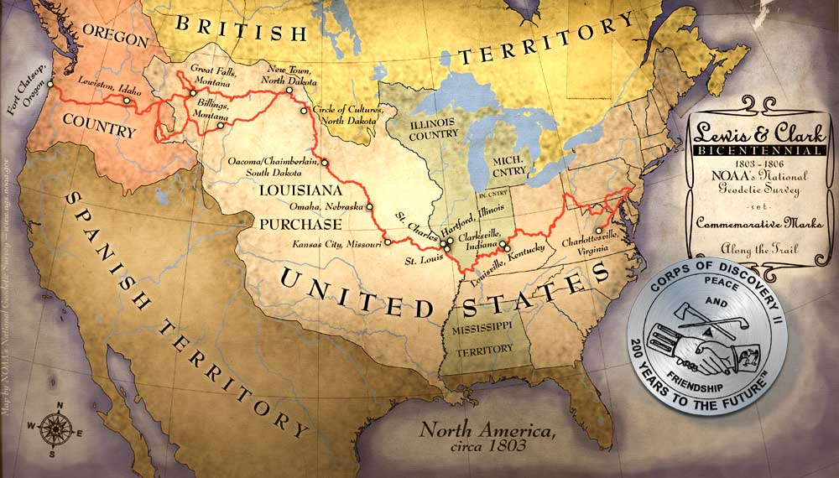
Since the 1800s, explorers have been traversing the United States (Lewis and Clark, 2009). Lewis and Clark began their exploration in 1803 as displayed in Figure 1. Of course, it wasn’t always the United States and explorers normally didn’t travel completely by foot. They definitely didn’t run, unless being chased by wild animals or hostile natives. In 1909, Edward Payson Weston completed the first documented walk across the United States at 3,895 miles in 105 days from New York City, New York to San Francisco, California (Google Books, n.d.). To date, there have been more than 266 documented runners to make the trek (USA Crossers, n.d.). In 2011 alone, there were 24 runners crossing the United States. Many of these runs were for charitable causes with the start and ending cities varying based on personal choice. Direction of travel also varied with some traveling east to west and others west to east.
Figure 1. Lewis and Clark's Expedition (NOAA, n.d.)

The fastest time recorded for the trip was made by Frank Giannino in 1980 at 46 days, 8 hours and 36 minutes from San Francisco, California to New York City, New York (Frank’s Custom Shoe Fitting, 2009). Frank actually made the run twice, once in each direction and is 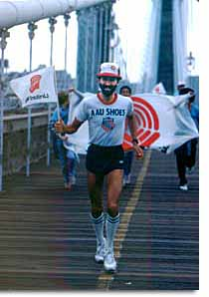alleged to be the inspiration for the running scene in the movie Forest Gump (Figure 2). Although several articles reference this crossing as a Guinness Book World Record (GBWR), no record could be found using the GBWR search tool with multiple keywords for: foot, fastest, crossing and United States (Guinness Book of World Records, 2011).
Figure 2. Frank Giannino, Left (Franks' Custom Shoe Fitting, 2009) and Forrest Gump played by Tom Hanks, Right (Paramount Pictures, 1994)
In October 2010, I was discussing GIS with Geoff Weber, a Navy Lieutenant (Figure 3). He had attempted to run unassisted across the United States in 2010 to set a new world record (You Tube, n.d.). This meant that Geoff did not have a support crew for the journey. He planned to run from Los Angeles to New York. Unfortunately, he was unable to complete the run due to legal issues with being on the Interstate, especially without any support. Although he had obtained multiple state authorizations, he was still forced to stop. Prior to his trip, Geoff had planned the route using Google Maps and other web services. Since we had been discussing GIS, he mentioned that it could probably be used to determine an optimal route. I agreed, but there would be a multitude of criteria and variables to consider. Not to mention the quantity of data required for the project.
Figure 3. LT Geoff Weber (ABC News, 2010)
Most web services determine routes based on the shortest distance between two points. When crossing the United States by foot, is the shortest route really optimal? In my experience, the shortest route by motor vehicle is not always the fastest or the most efficient. Factors such as one-way streets, traffic, traffic lights, and speed limits can make a short distance take a long time. In large cities, commuters can easily spend an hour moving only miles. However, a runner is not impeded by many of the obstacles that a motor vehicle is. Although there are private property and traffic restrictions to a person on foot, the greatest challenge is the physical effort.
What criteria could be used to determine an optimal route? There are several factors that may be optimal, such as time to destination or the least amount of effort. The amount of effort used by a runner ultimately affects the time. Therefore this project will look at determining the route that requires the least amount of effort, which may not be the shortest distance.
The website for Running across America provides a factsheet for planning a transcontinental run and lists gradient, temperature, and wind as primary considerations when determining a route (Baldock, n.d.). There may also be an optimal direction of travel, east to west or vice versa, based on the wind. Although I have never attempted a transcontinental run, I am very familiar with the effects of gradient, temperature and wind while running. I ran track and cross country in high school, trained in changing terrain and weather while serving in the Marines, and I continue to run regularly, at least three times a week.

Project Objectives.

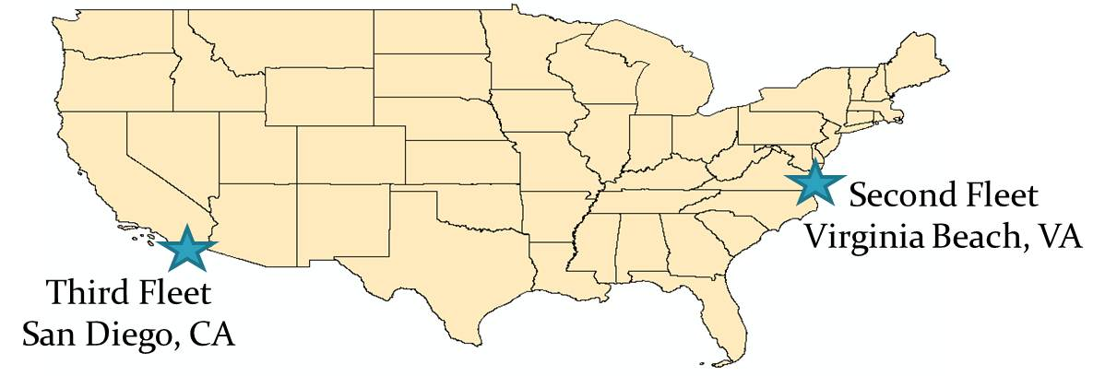
Geoff Weber still plans to beat the world record but wants to run from San Diego, California to Virginia Beach, Virginia. The reasons for these two locations are personal and symbolic. Since Geoff is a Lieutenant in the Navy, he wants to connect the two continental naval fleets: Second Fleet on the Atlantic Ocean out of Norfolk, Virginia (next to Virginia Beach) and Third Fleet on the Pacific Ocean out of Coronado, California (next to San Diego) as displayed in Figure 4.
Figure 4. Start / Finish Locations
This project will study the effects of gradient, wind and temperature based on an individual’s energy consumption to answer the following questions:
- What is the optimal route, based on energy (kilocalories) consumption, from San Diego, California to Virginia Beach, Virginia?
- Is the shortest walking route determined by Google Maps from San Diego, CA to Virginia Beach, VA more energy efficient, than the optimal route?
- Does the direction of travel across the United States (East to West or West to East) make a difference?
- Is the World Record running route across the United States more efficient than the determined route?

Literature and Web Review.

Research prior to this project revealed that there is no published study or web service that has attempted to use GIS to optimize a running route across the United States. Although there are no plans to publish a web service from this study, this may change after the project’s completion. Most people would not pick running as a long distance choice of transportation, however web-based services, such as Google Maps can provide directions and determine the shortest route from one place to another by walking (Google Maps, 2011). Using Frank Giannino’s World Record start and ending points of San Francisco, California and New York City, New York, the web services of Google Maps, Mapquest, and Yahoo! Maps were compared.
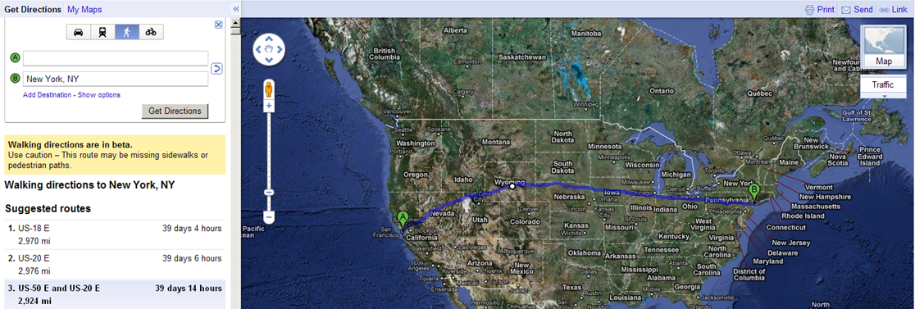
The first returned walking route by Google Maps from San Francisco, California to New York City, New York was not the shortest at 2970 miles in 39 days and 4 hours. However, a warning reveals that these directions are in beta and to use caution as highlighted by the red ellipse in Figure 5. The intent of this service is most likely for short distance inner city movement, not cross country travel by foot. I researched how Google Maps determined this distance but could not find anything online. This must assume that the individual will be required to walk 24 hours a day, since the time required beats the World Record by about 7 days. Unfortunately, the route uses ferries and crosses into Canada so it would ineligible as a legitimate running route across the United States. Although Google Maps driving directions have an option to avoid tolls and ferries, the walking directions do not. The shortest walking route was the third returned choice by Google Maps at 2924 miles in 29 days and 14 hours and highlighted by the blue ellipse in Figure 5. This route appeared to stay within the United States and did not use ferries.
Figure 5. Shortest Walking Route from San Francisco, CA to New York, NY (Google Maps, 2011)
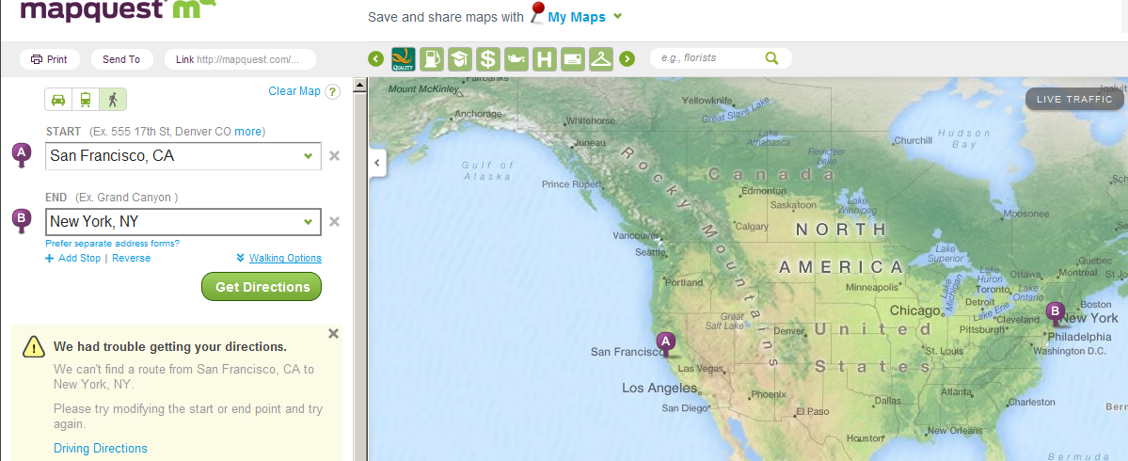
Map quest also had a walking function. However it could not determine a walking route from San Francisco, California to New York City, New York and returned an error as highlighted by the red ellipse in Figure 6.
Figure 6. Shortest Walking Route from San Francisco, CA to New York, NY (Mapquest, 2011)
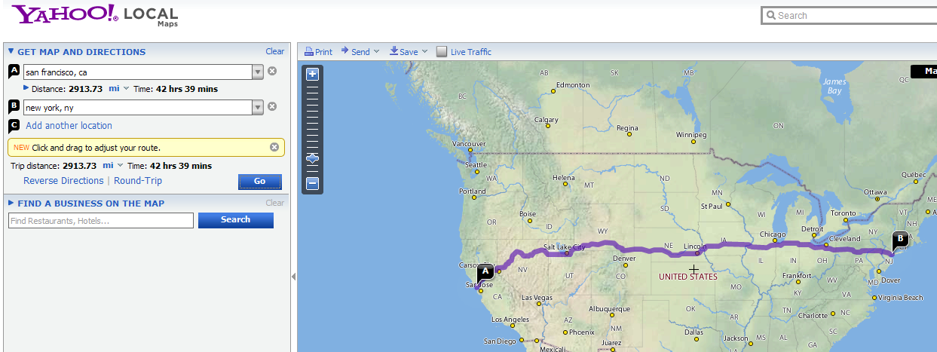
There was not a walking directions option for Yahoo! Maps. According to Yahoo! Maps, the shortest driving route from San Francisco, California to New York, New York is displayed in Figure 7. The route is 2913.73 miles long and will take 42 hours and 39 minutes by automobile.
Figure 7. Shortest Driving Route from San Francisco, CA to New York, NY (Yahoo! Maps, 2011)
As discussed earlier, this project will determine an optimal running route based on an individual’s energy consumption. This optimal route will be the most energy efficient and require the least amount of effort.
In a motorized vehicle, efficiency is normally based on fuel expenditures. Vehicles are rated for the number of miles that can be attained on a gallon of fuel. Of course the miles per gallon (mpg) can be affected by various factors inside and outside the vehicle, such as wind. Although the human body expends energy sitting still, the driver expends no additional energy other than what is required to operate the vehicle, which is very little. When the vehicle is out of fuel, the driver simply pulls into a gas station and refills.
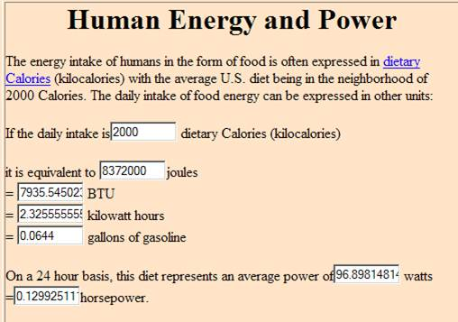
Unfortunately, the human body does not work like that. The human body requires food energy for fuel. This energy is measured in calories. Normally, nutritionists use kilocalories (kcal) or 1000 calories as the unit of measure for food energy (NutritionData, 2011). According to a 2005 study at Georgia State University, 2000 kilocalories is equivalent to .0644 gallons of gasoline as indicated by the red ellipse in Figure 8. When the body runs out of calories, the muscles begin to spasm and the body shuts down. Of course similar to a motor vehicle, there are other factors that can affect calorie expenditure.
Figure 8. Human Energy and Power (Hyperphysics, 2005)
Besides, those factors researched in this study, LT Geoff Weber will also provide statistics based on his observations while running under different gradients, wind and temperatures. These observations will be discussed in Chapter IV.
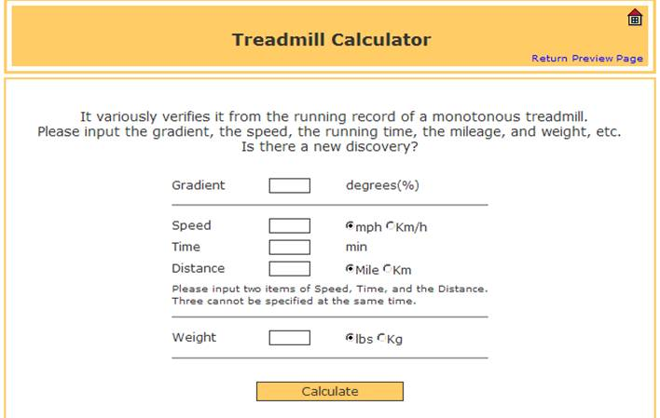
Gradient. Anyone that has ever gone running understands that there is a difference in effort between running on a flat surface and running up or down a hill. This difference in effort affects the calories burned over the same distance. Since the run across the United States will not be on a flat surface, the gradient of the surface must be accounted for in the distance. Most treadmills allow the user to change the gradient or incline during use and adjust the calories burned based on the gradient change. Figure 9 displays a treadmill calculator with the gradient factor highlighted with a red ellipse.
For this study, the calorie calculator from the LiveStrong.com website was used to determine the calories (LiveStrong, 2011c). According to the website, there are six steps in determining treadmill calories. These steps have been broken down into Table 1. Since this study will used 30 meter elevation data to determine the gradient, the time will be determined by the speed over 30 meters. For example, in Step 2 of Table 1 the speed is input as 8 MPH or 214.4 Meters/Minute (3.573 Meters/Second). At this speed, the time to move 30 meters will take 8.4 seconds or .1399 minutes.
Figure 9. Treadmill Calculator. (42.195km.met, 2010)
STEPS | CALCULATIONS
Step 1. Know Inputs | Speed, Grade, Weight and Time
Step 2. Convert Units | Speed MPH x 26.8 = Meters/Minute  8 MPH = 214.4 Meters/Minute  Grade % /100 = Grade Decimal  2 % = .02  Weight LBS / 2.2 = Weight kg  160 LBS = 72.7273 kg  Time Exercised in Minutes for 30 Meters  214.4 / 60 = 3.573 Meters/Second  30 meters / 3.573 = 8.4 Seconds  8.4 x .016666666  .1399 Minutes
Step 3. Complete Equation | (0.2 x Speed) + (0.9 x Speed x Grade) + 3.5  (0.2 x 214.4) + (0.9 x 214.4 x .02) + 3.5
Step 4. Calculate Results | (4.288) + (3.8592) + 3.5  11.6472 mL/kg/min (Oxygen Used)
Step 5. Calculate Calories/Minute | Oxygen Used x Weight x 3.5  (11.6472 x 72.7273 x 3.5) / 200  14.8237 Calories/Minute
Step 6. Calculate Calories Used | Calories/Minute x Time in Minutes  14.8237 x .1399  2.074 Calories for 30 Meters
Table 1. Treadmill Calorie Calculations. (LiveStrong, 2011c)
Unfortunately these treadmill calorie calculations do not work for declines. The same values for speed, weight and time in Table 1 calculated with a 2% decline results in a calorie expenditure of .5955 Calories for the same 30 meters. It doesn’t take long, less than a 5% decline, to come out with a negative Oxygen Used value. Running downhill may be easier but not effortless. A 1994 study on the minimum energy cost of gradient running in humans determined that between a 10% and 20% decline is the optimum economical gradient (Minetti, 1994). Another study from 2001 in the Journal of Applied Physiology, confirmed the 1994 findings (Minetti, 2001). Both studies determined that although running downhill is easier than running uphill, there is a gradient threshold for efficiency during acceleration and braking. The study set the gradient threshold for pure positive and negative work in uphill and downhill locomotion to be + or – 15% (Minetti, 2001). Figure 10 displays the minimum costs for running and walking at different gradients on a treadmill. The graph labeled as A in Figure 10, charts the walking values while chart B charts the running values.
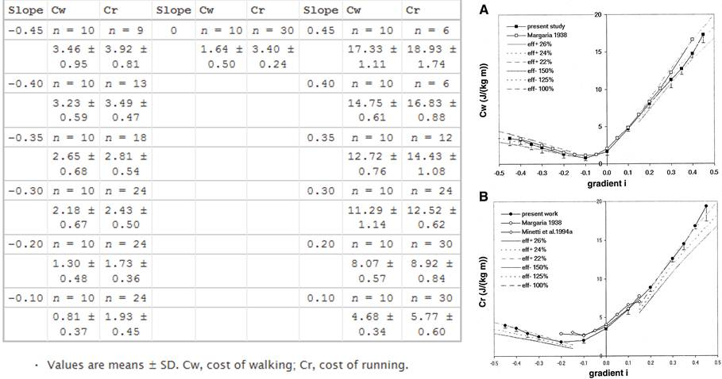
Using the minimum running costs determined in Figure 10, the values in Table 2 were interpolated. These calculations were simply determined based on the difference between running at zero percent slope (flat ground) and running at varying inclined or declined slopes. For example, the minimum cost for running on zero percent slope was 3.40 and the cost on a 10% decline was 1.93. This equates to approximately a .57 reduction in calories.
Figure 10. Minimum Energy Cost of Walking (A) and Running (B) on a Treadmill at varying Slopes (Minetti, 2001)
Decline  (-) | Slope | Incline  (+)
.57 | 10% | 1.70
.51 | 20% | 2.62
.71 | 30% | 3.68
.83 | 35% | 4.24
1 | 40% | 4.95
1.2 | 45% | 5.57
Table 2. Interpolated Energy Modifications based on Slope
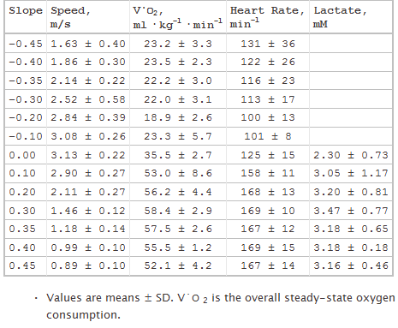
To use these modification values in the study, slopes will need to be identified as inclined or declined. For declined slopes, the calorie expenditure value for zero percent slope will be multiplied by the appropriate value within Table 2. For example, if the slope is determined to be 20% declined, then the base calorie expenditure for zero percent slope will be multiplied times a modification value of .51. Although Table 2 also lists modifications for inclines, these modifications will not be used for this study. The inclined values determined using the treadmill calculations in Table 1 will be used.
Figure 11. Metabolic Parameters of Running at the Highest Tested Speed at varying Slopes. (Minetti, 2001)
As the slope increases or decreases, a runner’s speed normally will also increase or decrease to a point. Figure 11 displays the highest tested speeds on varying slopes as determined by a 2001 study from the Journal of Applied Physiology (Minetti, 2001). The treadmill calculator formula used for this study only accepts one speed input, which will be the runner’s average or control pace. Therefore, this variable will not be considered at this time.
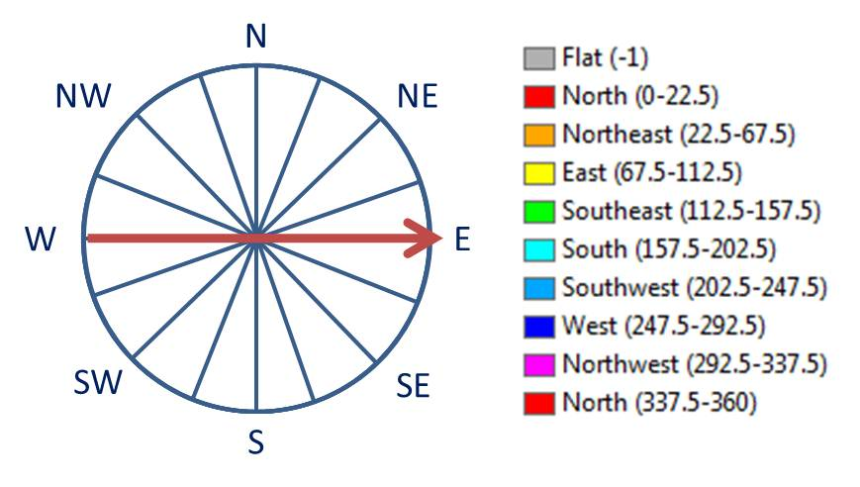
Aspect. The aspect of the slope is the direction the slope is facing as displayed in Figure 12. To determine whether the slope is inclined or declined to the runner, the direction of travel will need to be compared with the aspect of the slope. For example, when traveling from the west to the east as indicated by the red arrow in Figure 12, slopes that are west-facing will be uphill or inclined, while slopes that are east-facing will be downhill or declined.
Figure 12. Aspect of a Slope
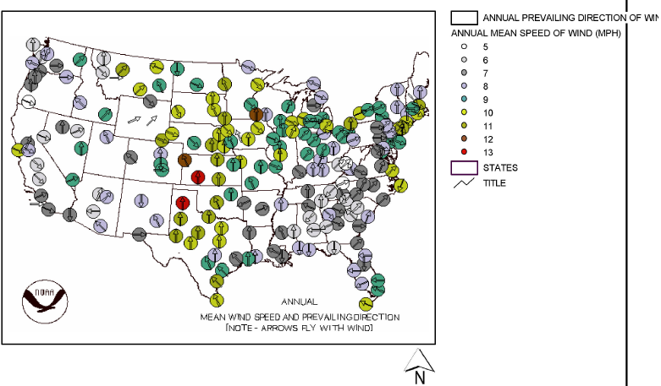
Wind. Although not a constant effect, there are areas of the United States that regularly receive winds in a particular direction and speed as displayed in Figure 13. Running into a headwind requires more effort for the same distance as running with no wind. Additionally, running with a tailwind requires less effort. This difference in effort equates to a reduction or increase in speed thus requiring a shorter or longer time for the same distance respectively. The reduced or additional time equates to less or more calories burned.
Figure 13. Annual Prevailing Direction of Wind (NOAA, 2005)
There are multiple sources that attempt to quantify the effect of wind on running. One source studied the effects of wind on the 400 meter sprint at various International Association of Athletics Federations (IAAF) tracks (Alday, 2010). The study found evidence that there may be disadvantages to running in certain lanes of a track during different wind directions.
Some websites recommend adding a percent of incline to a treadmill to account for wind resistance (LiveStrong, 2001d). According to the coolrunnings site, a 10 mph tailwind will allow a runner to travel 5% further with the same effort (Coolrunning.com, 2011a). The site also suggests that a 10 mph headwind will require a runner to use 8% more effort to cover the same distance. Another study determined that for every 100 meters, a 0.1 meter/second wind will reduce a runner’s time by 0.01 second (Hoffman, n.d.). The results of these two sites have been captured in Table 3.
WIND | EFFECT
TAILWIND | 10 mph wind = + 5% distance/same effort  For 100 meters: 0.1 meter/sec wind = - 0.01 sec time/same effort
HEADWIND | 10 mph wind = - 8% distance/same effort  For 100 meters: 0.1 meter/sec wind = + 0.01 sec time/same effort
Table 3. Effects of Wind on Running (Multiple Sources)
Based on this information, wind will be incorporated into the study as effectively as possible. For the purposes of this study, winds of 10 mph or greater will be considered at an effect of positive 5% for a tailwind and negative 8% for a headwind. Winds of less than 10 mph will be considered to have no effect on a runner.
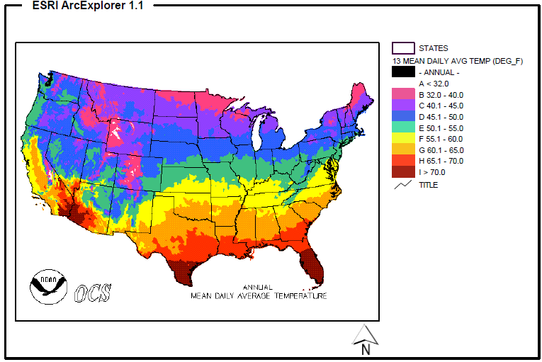
Temperature. The temperature across the United States changes with time of year, elevation and latitude as displayed in Figure 14. Similar to wind, this effect is also not a constant. Since the fastest documented run across the United States took more than a month and a half of running, there may be optimum times of the year to make the journey, especially if the goal is to beat the world record.
Figure 14. Annual Mean Daily Average Temperature (NOAA, 2011)
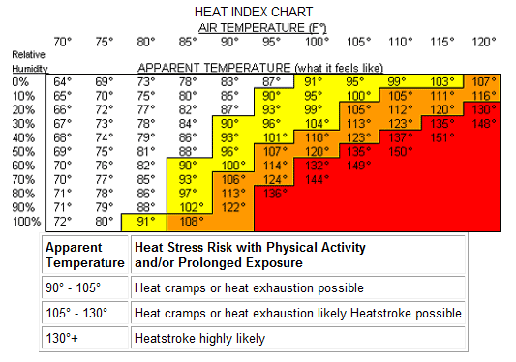
External temperatures affect a body’s inner temperature as displayed in Figure 15. Besides the increased risk of heat stroke or heat exhaustion in hot weather and hypothermia in cold weather, outside temperature affects a body’s performance. As the body exerts energy the internal temperature increases. Increased or decreased temperatures may lead to increased energy (kilocalories) consumption.
Figure 15. Heat Index Chart (MarathonGuide.com, 2011)
According to studies, warm weather increases the heart rate, which equates to more calories burned (LiveStrong, 2011e). Although one would assume that more calories would be burned in cold weather, this has been shown to not be the case. However, shivering does burn calories at a rate of about 400 calories per hour (LiveStrong,2011e).
Several studies offered statistics on the effects of temperature while running. The most useful measurement from these studies was decreasing a runner’s pace by 30 seconds per mile for each 5 degrees of temperature over 60 (Knol, 2009). So one mile at 80 degrees Fahrenheit requires an additional 2 minutes to complete. An 8 MPH pace would be reduced to 7.73 MPH. Since this study is calculating the pace at meters per minute, this would equate to a reduction of .894 meters per minute per 5 degrees of temperature over 60 degrees. Therefore a 214.4 meter per minute pace (8 MPH) would be reduced to 207.16 meters per minute. Table 4 displays the calculated meters per minute for one MPH at temperatures of 60 degrees Fahrenheit or greater.
Temperature (F) | Meters per Minute | Temperature (F) | Meters per Minute
60 | 26.8 | 95 | 20.56
65 | 25.93 | 100 | 19.67
70 | 25.03 | 105 | 18.78
75 | 24.14 | 110 | 17.88
80 | 23.25 | 115 | 16.99
85 | 22.35 | 120 | 16.09
90 | 21.46 | 125 | 15.20
Table 4. Reduced Meters per Minute based on Temperature
Other Factors. Although increased elevations affect the amount of oxygen available, this factor will not be considered in this project at this time. Precipitation and humidity are also external factors that may affect a runner’s performance, however these will not be considered at this time.
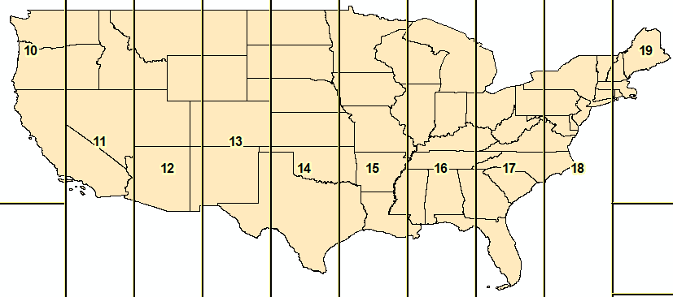
Spatial Reference System. Since this project spans the contiguous United States, a spatial reference system that spanned the entire U.S. was also required. A majority of the geospatial data acquired had a geographic coordinate system. Although the geographic coordinate system spans the entire United States, the spatial analysis performed in this project required a projected coordinate system. The Universal Transverse Mercator (UTM) system is a projected coordinate system. However, there are ten UTM zones that span the contiguous United States as displayed in Figure 16. Only one can be used at a time, therefore UTM was not an acceptable choice. For similar reasons, the State Plane system would also not be acceptable. There are several projected coordinate systems that would have been acceptable. After some research, the Lambert Conformal Conic projection for the contiguous US with the North American Datum of 1983 was decided upon because it is best for regions predominantly east – west in extent and located in the middle latitudes (ESRI, 2010). Since the study area is oriented east to west or vice versa, this projection was the most logical choice.
Figure 16. UTM Zones for the Contiguous United States

LT Geoff Weber Running Metrics.

Although available for the beginning, LT Geoff Weber was deployed during a majority of this project and was only able to provide limited information. Based on his experience, Geoff listed the variables that affect running and ranked them in importance: Gradient (Slope), Urbanization, Wind, Temperature, Humidity, Precipitation, and Surface. For the purposes of this study, not all of LT Weber’s recommended variables will be incorporated. However, as discussed in Chapter II, the major factors of gradient, wind and temperature will be considered.
Gradient. Geoff agrees that the slope of the running surface is the primary factor affecting a runner. He plans on providing personal statistics for running at grades between plus or minus 15%. LT Weber’s control zone is 7.5 miles per hour at 0% slope.
Urbanization. Geoff envisions this variable as the effect of running through urban areas. The effect of stop lights, not to mention the increased safety issues. For example, running along a road beside a strip mall and having a car pull out across your path. Urbanization would be a difficult factor to account for without detailed data. Maximizing the avoidance of urban areas may be the best option.
Wind. Geoff agrees that wind definitely affects a runner’s speed. He suggested using polygons by month showing average wind speed and direction.
Temperature. Geoff plans to gather information on this effect, but suggests increments of 10 degrees.
Humidity and Precipitation. Geoff did not have any input describing these effects but plans to gather more information.
Surface. The condition of the surface that a runner is on is a factor. Although Geoff plans to run on the edge of roads or on shoulders, some surfaces are better maintained than others. Also, some roads do not have shoulders which reduce safety.
Geoff agrees with the methodology used to determine the optimal route. As more information and metrics are gathered by LT Weber and the author, the analysis within this project will be updated. Geoff still plans to run from San Diego, California to Virginia Beach, Virginia to beat the world record and this study still intends to help him select an optimal route.

Data.

With this project spanning the entire southern contiguous United States, the data required for this project was quite extensive. Besides tedious data acquisition, this project had several challenges correcting and analyzing the data.
Start/Stop Points. Since an objective of the study was to compare the energy consumption between the shortest walking route from Google Maps and the best determined study route, it was necessary to have start and ending points that were the same for both routes. A requirement for a new World Record is that the run must start and end at the ocean. Normally, the runner would dip his or her toe into the water on one coast and finish with the same gesture at the other side.
Although the planned run will connect the two continental naval fleets, it was determined that a start and finish on military bases would create unnecessary restrictions. Therefore the points will be at easily accessible areas. Analyzing Google Maps over San Diego, California, the Ocean Beach Pier was determined to be an acceptable west coast point. To keep with the pier theme, the Virginia Beach Fishing Pier at 15th Street was used as the east coast location.
Road/Trail Network. Although a human runner can run off road, this study will only use improved surfaces, such as roads. The United States Census Bureau provides TIGER/Line shapefiles over the entire United States (U.S.Census Bureau, n.d.). This study will use the 2010 TIGER/Line shapefiles for Primary and Secondary roads over the United States. Although this study did not consider the road surface or legal issues with any roads, this may be a requirement in future analysis.
Acquiring this data turned out to be a very tedious task since the fidelity of information required was only available for download by county. This amounted to over a thousand counties of road data for this project.
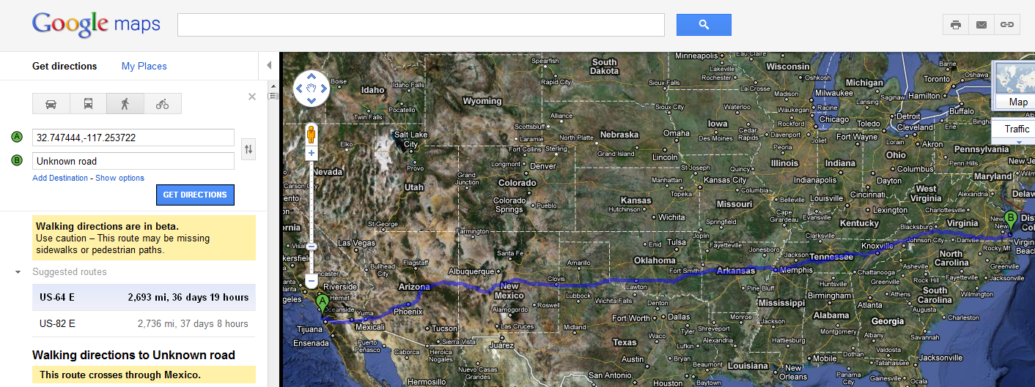
Google Maps Route. Once the two locations were determined, it was necessary to determine the Google Maps walking route between these positions. The shortest walking route was 2736 miles and primarily followed Interstate 64 as displayed in Figure 17. Unfortunately, similar to the Google Maps walking route between San Francisco and New York, the determined route did not stay within the boundaries of the United States as indicated by the red ellipse in Figure 17. All of the returned routes crossed into Mexico. There was no option to keep the walking route in the United States. This immediately created a problem with the second research objective since the goal was to compare the Google Maps walking route with the determined optimal route within the United States.
Figure 17. Google Maps Walking Route from San Diego to Virginia Beach (Google Maps, 2011)
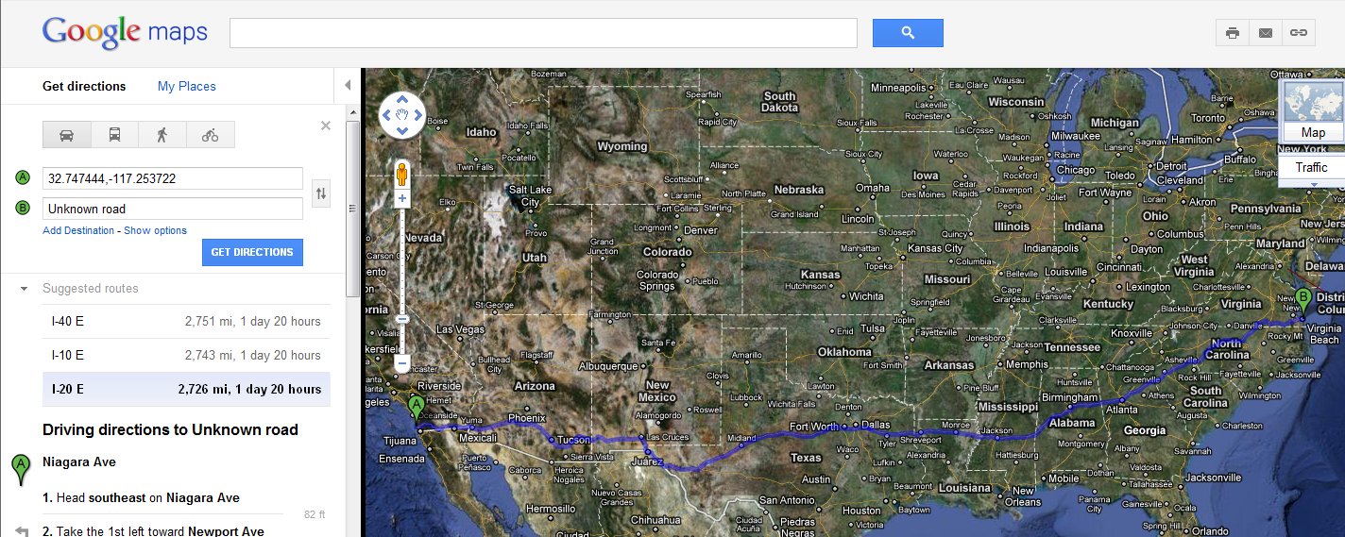
To determine a Google Maps route within the United States, the directions method was changed from walking to driving. According to Google Maps, the shortest driving route is 2726 miles as highlighted by the red ellipse in Figure 18, 10 miles less than the walking route. The route primarily follows Interstate 20 as displayed in Figure 18. Since no legitimate walking route within the United States could be determined using Google Maps, objective two will include the shortest driving route for comparison.
Figure 18. Shortest Driving Route from San Diego to Virginia Beach (Google Maps, 2011)
Unfortunately, there is no way to capture the Google Maps routes as a shapefile for later comparison or further analysis. The route is merely highlighted in a bluish-magenta over the map background and disappears with the browser. In order to analyze the energy cost for the route, the results needed to be captured as a line shapefile.
To capture both the Google Maps walking and driving routes, screen captures were collected along each route at varying levels of detail. These images were then georeferenced using the U.S. Census Bureau’s TIGER Road files. This proved to be very tedious with over twenty images required for each route to capture the required detail. However, that work was nothing compared to the effort required to digitize the route as a shapefile.
The original plan was to select roads from the U.S. Census Bureau’s TIGER Road files that corresponded with the Google Maps routes and export them as required. This method quickly became unfeasible due to the method the TIGER Road files were created and the amount of editing that would later be required. Instead, it was determined that the routes would need to be created as new shapefiles that snapped to the TIGER Road files.
For some reason, ArcGIS 10 would close out with an error after about one to two edit saves or 15 minutes of digitizing. This made digitizing the road very frustrating and time consuming. The only advantage to this method was that it allowed for a close examination of the TIGER Road files while capturing the Google Maps routes. This close examination revealed many digitizing errors with the TIGER Road files.
After the difficulty and time required capturing the driving route from Google Maps Figure 18, objective four was eliminated. Objective two will also only compare the Google Maps driving directions route at this time. Besides the tedious work that would be required to digitize the World Record route, the objective would also double the data requirements for the project. Although, Frank Giannino was able to provide some information on the route used, it was not enough to capture a shapefile accurately. If an existing shapefile becomes available, future study may incorporate the route into the analysis.
Elevation Data. National Elevation Data (NED) is available over the majority of the United States through the U.S. Department of Agriculture (USDA) Geospatial Data Gateway. NED is available in cell sizes of 30 meters with some areas available in 10 meters and 3 meters. Over 300 cells of 30 meter NED were acquired for this project.
The USDA NED data was projected in NAD83 by UTM zone across the United States. Since slope analysis is more accurate with a projected coordinate system, the data was merged together by zone. However, as discussed earlier, the study required the data to have a single projected coordinate system. The NED data was projected to Lambert Conformal Conic and merged together to create a single NED file.
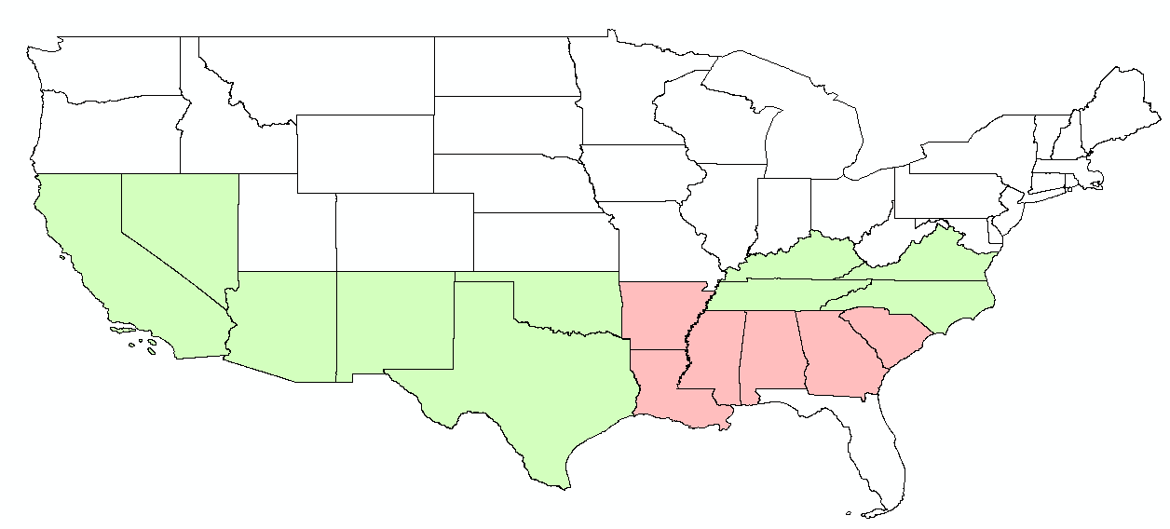
Wind. The wind data used in this study was acquired from the National Renewable Energy Laboratory (NREL). The primary use of the wind data is for the analysis of renewable energy, such as wind turbine locations. Therefore, the data was primarily concerned with wind above a certain height. The resolution of the wind data varied across the project area. Ten of the states had wind data available at high resolution (10 km) as displayed in Green in Figure 19, while the remainder of the states was only available at a lower resolution (25 km) highlighted in Red.
Figure 19. NREL Wind Data Coverage by Resolution (High = Green, Low = Red)
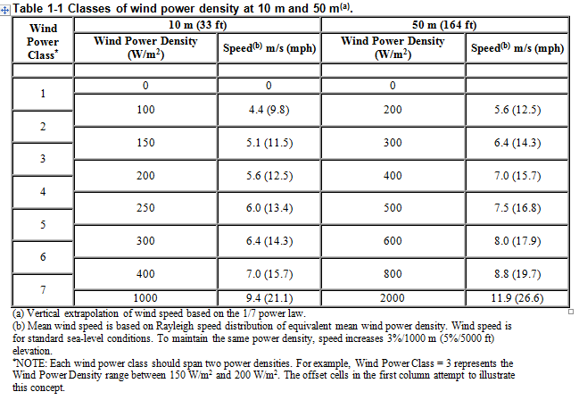
The low resolution wind data was available for the entire lower 48 contiguous states. The project could have only used the low resolution wind data, however to increase the accuracy of the study the low resolution data was clipped to the area covered by Red in Figure 19. Then both the high and low resolution data were merged together. The wind data contained three different fields with values between 1and 7 to represent wind power: GRIDCODE, POWERCLASS, and WPC. These values correspond to the Wind Power Class values in Figure 20 as indicated by the Red Ellipse.
Figure 20. Wind Power Class Values (NREL, 2010)
A new field called WIND_POWER was created and the appropriate values from each of the three fields were calculated to the new field. Using the information in Figure 20 for wind speeds, additional fields for Maximum, Minimum and Average were added and calculated: WIND_MAX_MPH, WIND_MIN_MPH, and WIND_AVG_MPH.
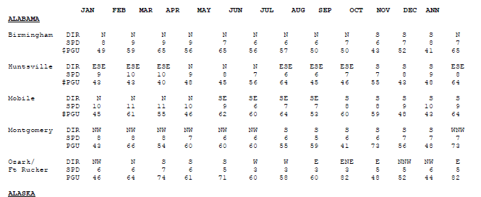
The wind direction was more difficult to acquire. The wind direction data was collected by month at designated locations within each state. Unfortunately, the data was only available as an image, displayed earlier in Figure 13, or as a table in PDF format as displayed in Figure 21. This made capturing the values as a useable dataset difficult. The PDF table was run through an online PDF to Excel converter (PDFtoExcelConverter.net, 2010). The web service did not correctly convert the information and areas were left out due to formatting problems.
Figure 21. NREL Wind Data in PDF
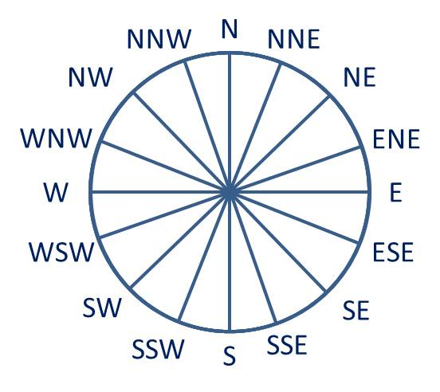
The converted information had to be manually corrected with the missing information entered. Upon completion, there were 125 locations across 16 states that had wind direction values. The wind values were based on the 16 directions of a compass as displayed in Figure 22.
Figure 22. Wind Direction Values
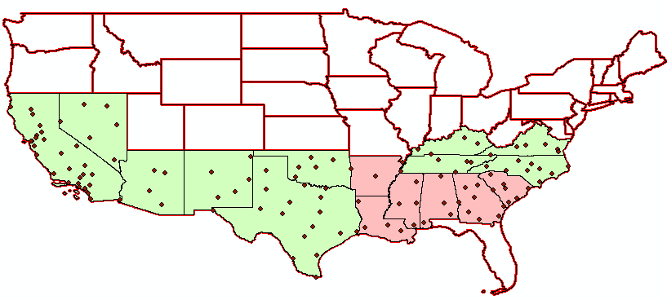
As displayed in Figure 21, the station locations contained no geographic coordinates. The station names with state were run through an online service to determine approximate geographic coordinates for each site (GPS Visualizer, 2010). The station locations were then imported into ArcGIS to create a point file as displayed in Figure 23. The green and red colors for the states in Figure 23 are carried over from Figure 19.
Figure 23. Wind Direction Station Locations
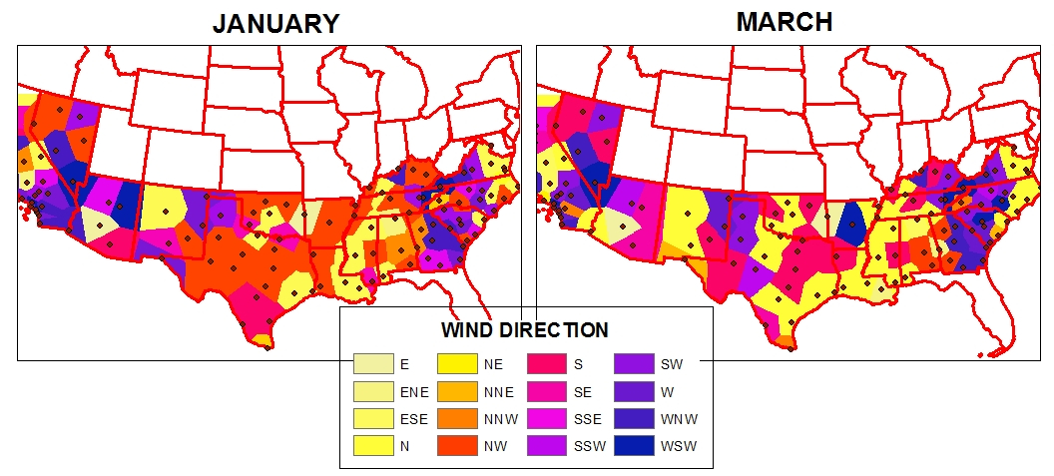
To determine the wind direction across the project area, a Euclidean Allocation was performed for each month of the year. The results for January and March are displayed in Figure 24 to emphasize the difference in wind direction values between months. The allocation was originally performed with an output cell size of 30 meters, however after 9 hours of processing, the task was canceled. The allocation was performed using the default value.
Figure 24. Euclidean Allocation based on Station Locations for Wind Direction in January and March
Temperature. The original intent for this study was to use temperature data from the U.S. Department of Agriculture. Unfortunately, the USDA temperature data only provided an annual average. Since the study required temperature data for each month of the year, another source was required. The University of Oregon (OSU) had temperature data available, however the format was difficult to use. The data was zipped using a gzip program and offered a gzip conversion tool. Although several attempts were made to get the gzip conversion tool to work none were successful.
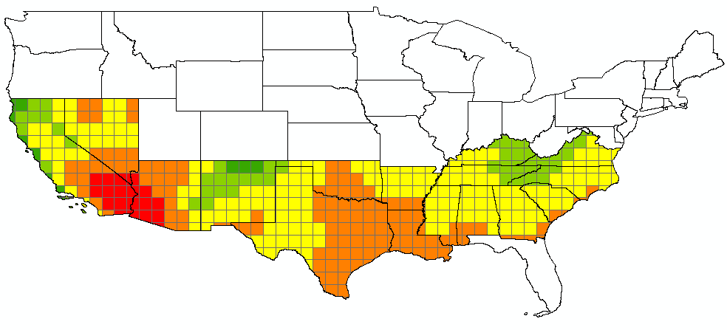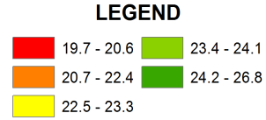Less accurate temperature data was available from the U.S. National Aeronautics and Space Administration (NASA). This data was available over the entire world at one degree cells and had values for every month of the year. The temperatures were in Celsius and were required to be converted to Fahrenheit.
Figure 25. Pace in Meters per Minute based on Temperatures for August

As discussed in Chapter III, temperatures of 60 degrees Fahrenheit or greater affect the pace or speed of the runner. Figure 25 displays the temperatures across the study area by meters per minute for the month of August. These values are multiplied by the runner’s normal pace in miles per hour to determine the adjusted speed.

Analysis.

The analysis required to complete this study was more complicated than originally anticipated. The primary focus was on creating a single raster file that contained the calorie expenditure values for each 30 meter cell, based on the runner’s statistics and external factors of gradient, temperature and wind. The final output would be a cost path that provided the route with the least calorie expenditure and the distance in meters. Although a simple concept, getting the effects of gradient, wind and temperature based on a runner’s statistics into one file proved to be very difficult and often frustrating.
Most of the problems encountered in the project were based on the limitations of ArcGIS in both Vector and Raster analysis. For example, a common raster output was 32-bit floating or 64-bit, which allow for decimal values. The problem was that some of the required analysis tools would not work on these raster outputs. Attribute tables, where further analysis could be calculated, was also not available for these files. The 32-bit floating and 64-bit files had to be converted to 16-bit or 32-bit unsigned or signed files, which did not allow values with decimal places. To avoid the loss of decimal values, the files were first multiplied times a hundred prior to conversion to 16-bit or 32-bit. After conversion, an attribute table was created and a new field was added. The raster values were then divided by 100 and put in the new field to get the decimal places back into the values. Once the calculations for a file were complete, the raster files were reclassified based on the calculated field to create a raster with that value.
Besides the software limitations, the processing time required for the analysis was intense. A majority of the analysis was performed using raster files to improve speeds. The raster analysis that required the longest processing was the creation of the cost distance and backlink files prior to the cost path. Performing analysis using vector files was abandoned due to the time required to convert the files and the time intensive processing. Using spatial joins to bring the attributes of one file into another for further analysis was attempted but abandoned due to the processing time. Of course, glitches or bugs while using ArcGIS 10 didn’t help any either.
Due to the immense quantity of data required for this project, analysis was tested over the county of Riverside in California prior to the final analysis. This county was chosen because it was oriented horizontally and had varying terrain.
Gradient (Slope). As discussed in Chapter III, the gradient of the terrain significantly affects the calorie expenditure of a runner. Using the 30 meter NED, slope was calculated for percent rise. The treadmill calorie formula from Table 1 was used to determine the calorie expenditure for a 30 meter cell of NED based on LT Geoff Weber’s control zone statistics of 160 pounds at 7.5 miles per hour. The equation used to calculate the treadmill calories based on LT Weber’s statistics and the slope are displayed in Figure 26.
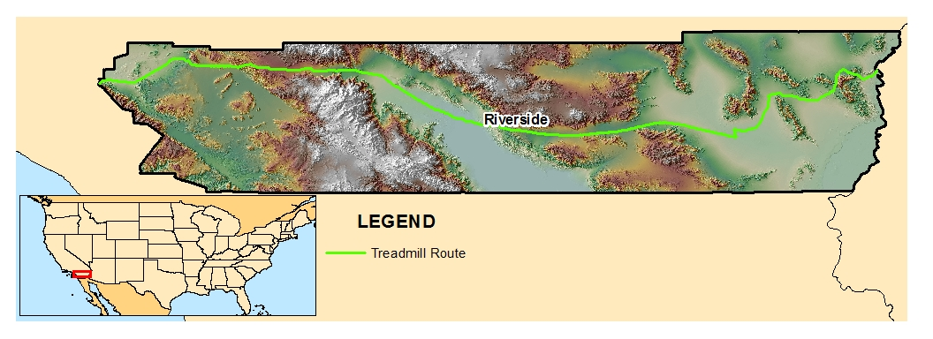
A cost path was created based on the calorie expenditure values from West to East and East to West. The analysis for both directions resulted in the same route with the same calories and length. The analysis is displayed as a green route in Figure 27. The route was estimated to require 3,350,998.3 calories and was 346,038.21 meters in length. However, this analysis did not take into account the effects of uphill or downhill gradients, temperature or wind.
Figure 26. Treadmill Calculations for 160 pounds at 7.5 mph
Figure 27. Treadmill Calorie Expenditure Only
Gradient (Uphill or Downhill). One of the directional challenges encountered in this project was determining which slopes were uphill and which were downhill. Solving this dilemma was very important, since this significantly affects the calorie expenditure of a runner. This challenge was attacked by comparing the aspect of a slope against the direction of travel. Aspect was obtained from the elevation data and the direction of travel was obtained from the cost distance analysis called backlink. The aspect of a slope was discussed earlier in Chapter III and displayed in Figure 12.
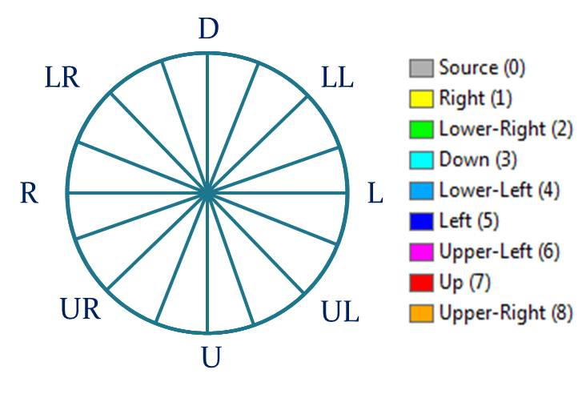
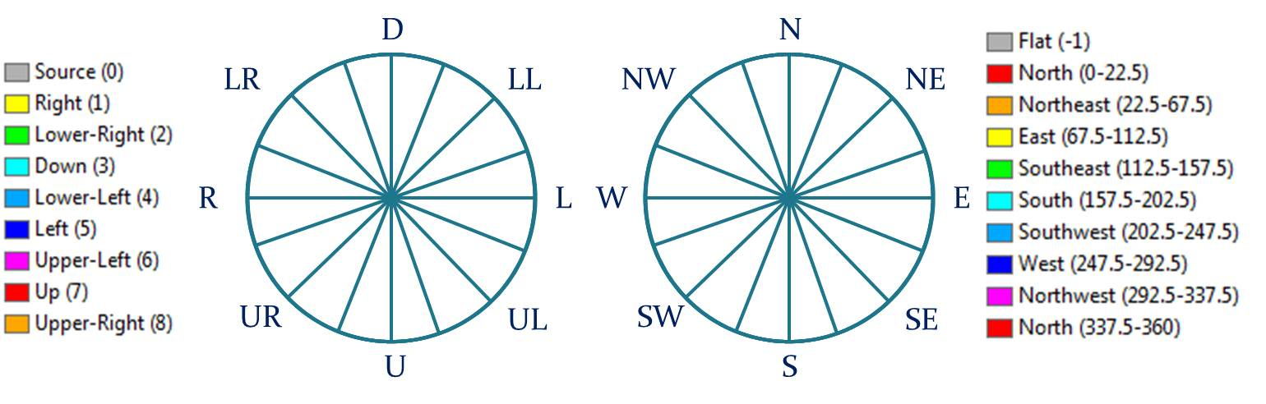
The cost backlink to a destination is very similar to aspect. Figure 28 displays the results of the analysis. A raster file is created that has cell values from 0 to 8. The cell values reflect the direction to the destination or source. As displayed in Figure 29, the differences between the Aspect and Backlink are a matter of language. However the values of each cell are quite different. The backlink values are 0 through 8, while the aspect values are -1 and 0 through 360. Determining uphill slopes vice downhill was pretty confusing to determine at first. Based on Figure 29, if the direction of travel was west then a backlink value of 1 or Right would encounter an uphill west facing slope and a downhill east facing slope.
Figure 28. Backlink Values
Figure 29. Backlink (Left) and Aspect (Right) Comparison
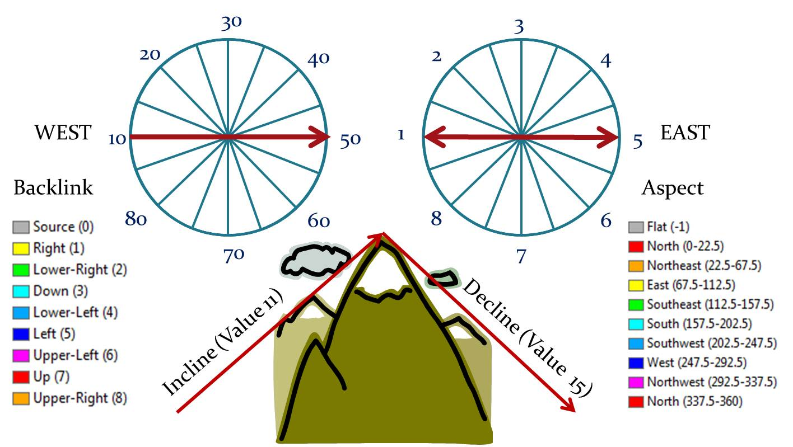
The difficulty lay in combining these two raster files to create a file that could identify uphill and downhill slopes. To make sense of it all, the backlink values were reclassified as 0 through 80 at intervals of 10 while the aspect values were grouped into values of 0 through 8 as displayed in Figure 30. The zero in the backlink file represented the source position and in the aspect it was flat ground or zero percent slope. When both raster files were added together the resulting raster file had values of 0 through 88. These values were then classified as 1 for uphill or -1 for downhill. As displayed in Figure 30, a value of 11 when traveling East would be uphill and a value of 15 would be downhill.
Figure 30. Making Sense of Backlink and Aspect
The final raster file contains only values of 1 for uphill and -1 for downhill. This raster file was then multiplied times the slope raster. The result was a slope raster that contained both positive slope (uphill) and negative slope (downhill) values. After the calories were calculated based on the gradient, the decline calorie values were adjusted based on the interpolated energy modification values in Table 2. Table 5 displays a breakdown of the declined slopes and its corresponding modifier. All declined slope values were calculated to the calorie expenditure for zero percent slope and then modified based on Table 5. The incline values were not modified.
Slope Range Declined | Modifier | Slope Declined
0 - 9% | 1 | 0%
10 – 19% | .57 | -10%
20 – 29% | .51 | - 20%
30 – 34% | .71 | - 30%
35 – 39% | .83 | - 35%
40 – 44% | 1 | - 40%
45 – 49% | 1.2 | - 45%
50 – 54% | 1.4 | - 50%
> 55% | 1.6 | > - 55%

Table 5. Declined Slope Calorie Expenditure Modifier

Unfortunately, these values had to be corrected manually. Note that values for greater than 45 percent declined slope have been added to the table. These values were added to the analysis to better account for slopes greater than 45 percent.

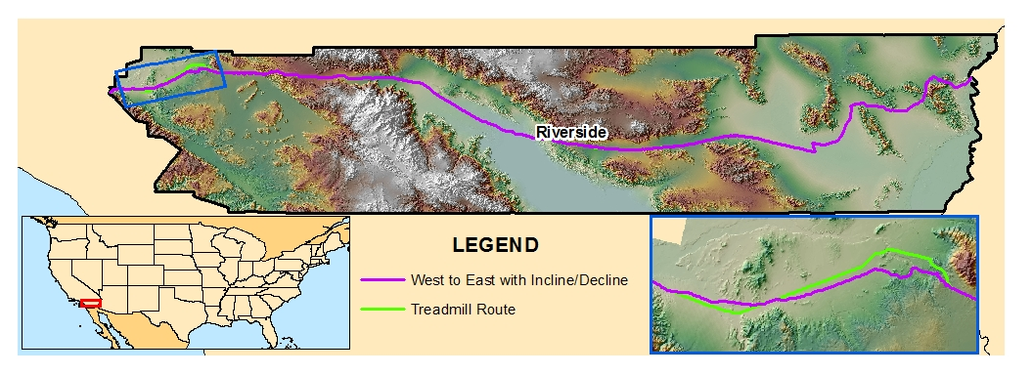
A cost path was created based on calorie expenditure from the adjusted gradient values from West to East. The results of the analysis are displayed as a magenta route in Figure 31. The route was estimated to require 3,156,370.3 calories and was 345,715.24 meters in length. That is a difference of 194,628 less calories than the treadmill only analysis over a difference in length of less than 323 meters.
Figure 31. Route based on Gradient with Incline and Decline Adjustments – West to East
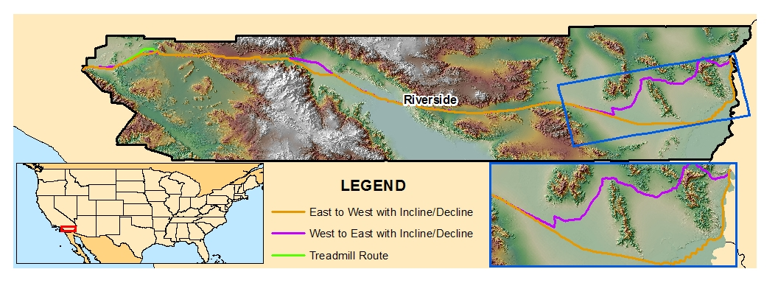
Another cost path was created based on calorie expenditure from the adjusted gradient values from East to West. The study was expecting to see the same route as West to East, however the returned route was very different as displayed by orange in Figure 32. The route was estimated to require 3,189,252 calories and was 349,865.44 meters in length. This is a more significant difference in length of 4150.2 meters and 32,881.7 calorie between the two adjusted routes. Based on the analysis for both routes between these two points, travel from West to East would be the more optimal route. Still, neither of these routes accounted for wind or temperature yet.
Figure 32. Route based on Gradient with Incline and Decline Adjustments - East to West
Wind (Headwind or Tailwind). The other directional challenge encountered in this project was determining whether winds were tailwinds or headwinds. Unlike gradient, wind is not a consistent value associated with a spatial position. Still, as discussed earlier in Chapter III, wind can affect a runner’s calorie expenditure and there are areas of the country that have significant wind in varying directions during the year.
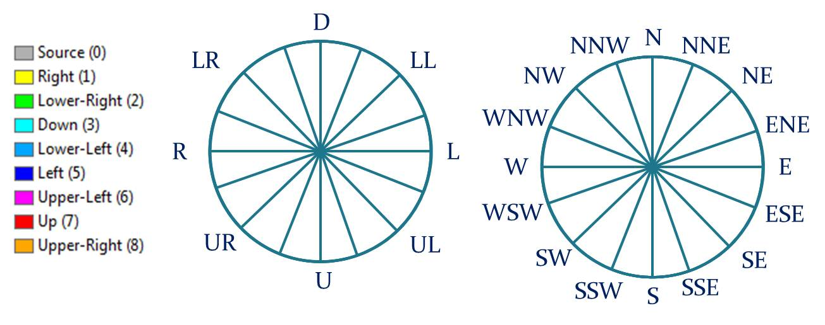
Similar to the gradient directional problem, this dilemma was solved by comparing the wind direction against the direction of travel. As discussed earlier, wind direction was obtained from station locations across the country and allocated based on Euclidean distance (Figure 24). These directions were compared to the cost analysis backlink file created based on the destination. As displayed in Figure 33, the values for both files are again described differently.
Figure 33. Backlink (Left) compared to Wind Direction (Right)
Using the same technique from the gradient direction, the wind direction was reclassified into values of 1 to 8. The same backlink file used for the gradient analysis, with values of 0 to 80, was used with the wind. The two reclassified raster files were added together to create a new file again with values of 1 to 88. Based on Figure 34, if the destination was from east to west, then a value of 55 would be a headwind, while a value of 51 would be a tailwind.
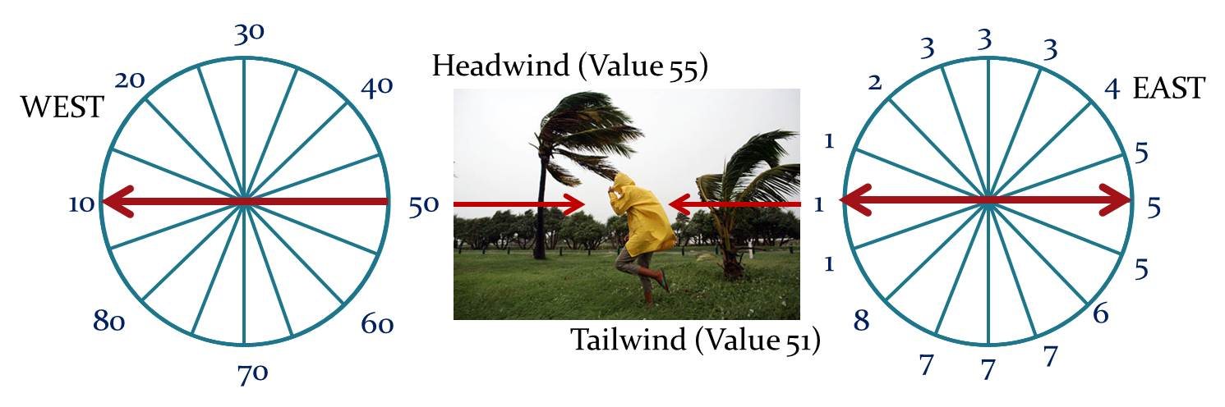
Classifying the winds as either headwinds or tailwinds was only a portion of the problem. The winds then further needed to be classified based on power. Winds that were less than 10 mph were estimated to have little to no effect. Unfortunately, the wind power values were in a separate file. Similar to the gradient, winds that were less than 10 mph were given values of 0 while winds greater than 10 mph were given values of 1. The wind power file was multiplied times the wind direction file. The final values were then joined with a lookup table for wind values of 0 to 88.
Figure 34. Backlink and Wind Direction Recalculated
Now that winds could be identified by direction and power, winds of greater than 10 mph were given values of either .95 (tailwind) or 1.08 (headwind). Winds of less than 10 mph were given the value of 1 which is equal to no effect. Therefore, the resulting raster file had values of .95, 1, or 1.08 depending on the direction of travel. The wind raster file was multiplied times the modified calorie expenditure values based on the incline/decline analysis as displayed in Figure 35. The results either had no effect on the value, reduced the value by 5% or increased the value by 8% per cell based on the wind modifier.
Figure 35. Wind Effect on Calorie Expenditure Equation
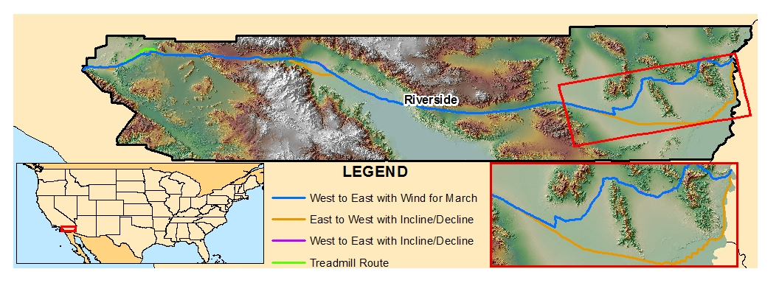
A cost path from West to East was created based on the wind adjusted calorie expenditure values for the month of March. The results of the analysis are displayed as a blue route in Figure 36. The route was estimated to require 3,080,250.3 calories at a length of 345,206.7 meters. The route is very similar to the one in Figure 31. However the calorie expenditure is less. This would indicate that the route has predominantly prevailing tailwinds.
Figure 36. Wind Modified Route, West to East, based on month of March
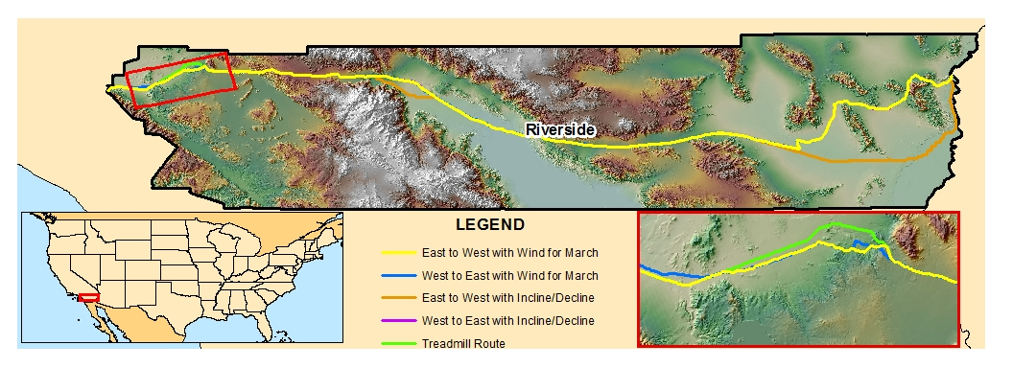
A cost path from East to West was created based on the same wind effects for the month of March. The results of the analysis are displayed as a yellow route in Figure 37. The route was estimated to require 3,134,995 calories and was 344,611.1 meters in length. A majority of the route was similar to the previous wind route except for the area highlighted by the red box. The increased calorie expenditure would indicate the presence of headwinds. Therefore, based on the analysis for both routes, the West to East route would be optimal at this time. This analysis did not incorporate the temperature for the month of March.
Figure 37. Wind Modified Route, East to West, based on month of March
Temperature. The final factor to be analyzed in this project was temperature. As discussed earlier in Chapter III, temperature affects a runner’s pace or speed. The original method of accounting for temperature was to insert the temperature values based on a designated month into the treadmill equation as displayed in Figure 38. Using LT Weber’s control pace of 7.5 MPH, Figure 38 displays three areas of the treadmill calorie equation where temperature can affect the results.
Figure 38. Proposed Temperature Modification to Treadmill Calorie Equation
The slope values within the equation are the adjusted slopes based on inclined and decline slopes from the direction of travel. The problem with this method was that it was impossible to adjust the calorie expenditure values based on declined slopes (Table 5) accurately while accounting for temperature.
To correct this problem, the adjusted slope raster needed to be added to the temperature file in a way to preserve the values of each file. This was only possible by converting the slope raster to a 32-bit signed file. This allowed for the range of values to differentiate between slope and temperature. The temperature raster was coded to values by every two million as displayed in Table 6.
Temperature (F) | Meters per  Minute | Code | Temperature (F) | Meters per Minute | Code
60 | 26.8 | 2 million | 95 | 20.56 | 16 million
65 | 25.93 | 4 million | 100 | 19.67 | 18 million
70 | 25.03 | 6 million | 105 | 18.78 | 20 million
75 | 24.14 | 8 million | 110 | 17.88 | 22 million
80 | 23.25 | 10 million | 115 | 16.99 | 24 million
85 | 22.35 | 12 million | 120 | 16.09 | 26 million
90 | 21.46 | 14 million | 125 | 15.20 | 28 million
Table 6. Temperature Modification Codes
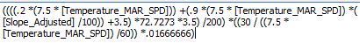
With a range of two million for the temperature, values of greater than two million but less than three million would have a positive incline value. Values less than two million but greater than 1 million would have a negative value. The values of the inclined and declined gradients with temperature are preserved in Figure 39.
Figure 39. Temperature Modification to Treadmill Calorie Equation
After the slope and temperature rasters were added together, fields for Slope (Slope_Adjusted) and Temperature (Temperature_MAR_SPD) were added to the attribute table. The values for each field were extracted from the combined values of both files. Figure 40 highlights in a red rectangle, the values for slopes of zero percent at three different temperature 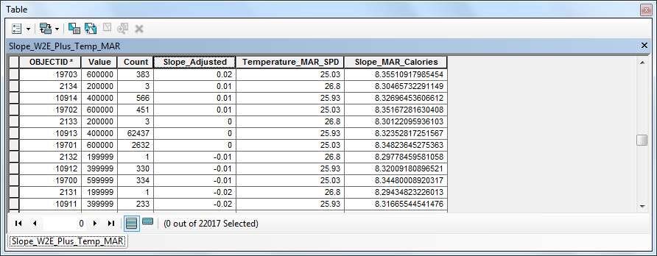values. A field to calculate the adjusted calories expenditure (Slope_MAR_Calories) was also added. The Slope_MAR_Calories field was then calculated using the treadmill formula (Figure 39) with the adjusted slope values and temperature values. Figure 41 displays the modified decline 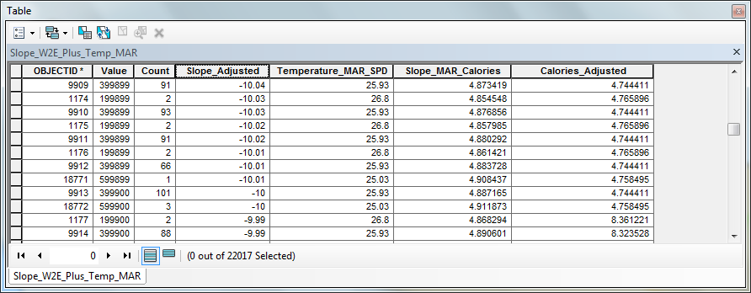calorie expenditure values for a 10 percent decline at two different temperature values.

Figure 40. Preserving Inclined/Declined Slopes and Temperature Values
Figure 41. Declined Slope of 10 percent at varying Temperatures

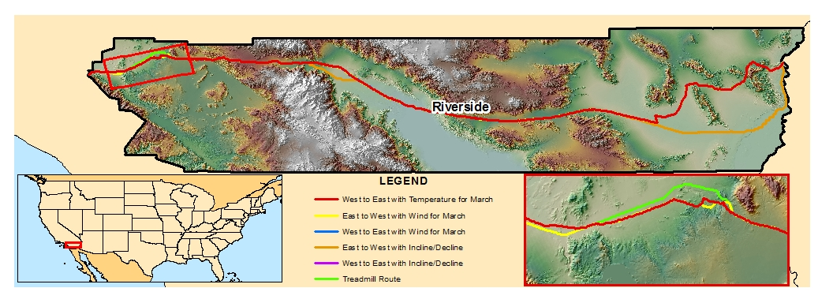
The results of the analysis are displayed as a red route in Figure 42 with 3,165,146.8 calories and a length of 345,741 meters. The calorie expenditure and length in meters for each of the analyzed routes is displayed in Table 7. At this point in the study, the results of the analysis indicate the direction of travel from West to East as optimum. Based on the temperature and wind factors for the month of March, the calorie expenditure values for all routes West to East in Table 7 were less.
Figure 42. Route West to East based on Temperatures for the month of March
Route Analysis | Calorie Expenditure | Length in Meters
Treadmill Only  West to East / East to West | 3,350,998.3 | 346,038.21
Incline and Decline Modified West to East | 3,156,370.3 | 345,715.24
Incline and Decline Modified East to West | 3,189,252.0 | 349,865.44
Wind Modified  West to East | 3,080,250.3 | 345,206.70
Wind Modified  East to West | 3,134,995.0 | 344,611.10
Temperature Modified  West to East | 3,165,146.8 | 345,741.00
Table 7. Calorie Expenditure and Length in Meters of Analyzed Routes

Results.

Unfortunately, the time required to complete the final analysis for this project was unreasonable. This project anticipated long processing times, however the time required to create the distance and backlink raster files were overwhelming. The backlink raster process was started and ran for over 72 hours before the computer unexpectedly shutdown. At this time, the cause for the shutdown is unknown.
For this study, a backlink raster file was not achieved. As discussed in Chapter IV, a backlink file for both West to East and East to West were required for the initial gradient and wind directional analysis. After the creation of the final calorie expenditure raster file, cost distance and new backlink raster files were required for the final cost path analysis.
Although the analysis for the entire study area could not be completed, the results of the analysis over the test area of Riverside County, California revealed the following about the research objectives:
- What is the optimal route, based on energy (kilocalories) consumption, from San Diego, California to Virginia Beach, Virginia? The optimal route could not be determined due to unreasonable processing time.
- Is the shortest walking route determined by Google Maps from San Diego, CA to Virginia Beach, VA more energy efficient, than the optimal route? For the test area, the determined route with the shortest distance did not have the least calorie expenditure. Therefore, the shortest distance is not necessarily the most energy efficient.
- Does the direction of travel across the United States (East to West or West to East) make a difference? For the test area, the directional factors of gradient and wind for the month of March identified West to East as the optimal direction of travel.
- Is the World Record running route across the United States more efficient than the determined route? As discussed in Chapter V, this objective was eliminated due to the difficulty and time required to capture the route accurately and acquire the data.

Future Study.
With any project there are always areas for improvement. Besides the obvious need to complete the analysis for the optimal route, there are several areas in this project that may provide more accurate results and improved use.
Data. The results of the project may be improved with more accurate data. Although the analysis at 30-meter pixels required a lot of memory and was extremely time consuming, performing the analysis at a smaller pixel size such as 10-meters or 3-meters may improve the results of some analysis. For example, the slope and aspect analysis may be improved by using 10-meter or even 3-meter elevation data. More accurate wind data could be obtained over time, along with a better spatial resolution temperature file. An improved road network that includes trails and vehicle-restricted routes may also increase route analysis.
Criteria. Besides improving the resolution and fidelity of the data used in the project, the parameters used to determine calorie expenditure could be improved. This project primarily used parameters that were obtained from existing studies with some input by LT Geoff Weber. Further projects may perform analysis on a small dataset over the local area and compare the results with gathered statistics from LT Weber running the analyzed route. The analysis would be performed under varying temperature and wind conditions. Unfortunately, since LT Weber was not available during a majority of the study, this was not possible.
Crowd sourcing may also be used to collect runner statistics and criteria based on firsthand experience. According to USA Crossers, during this project, there were approximately 24 people running across the US (USA Crossers, n.d.). David Karnazes was even televised and tracked by Regis and Kelly (Disney, 2011). This study attempted to obtain information from runners and received some positive feedback from 4 runners. Attempts to crowd source runners during this project were stopped due to the enormity of the project and difficulty with the analysis.
The gradient for a bridge cannot be determined based on elevation data. Bridges normally have a gradient of zero, connecting roads across uneven surfaces that normally exhibit large gradient effects. Since the NED data for this study was in 30-meter cells, there may have been areas connected by long bridges that were portrayed inaccurately.
Additional logistical criteria may also be included, such as lodging points. Legal restrictions for interstates and bridges may also be important. Other factors such as weight reduction of the runner would affect the calorie expenditure over time. Frank Giannino lost 20 pounds while setting the world record.
Model. Although a model was created for different portions of the project, a complete working model with parameters was not completed. This was due to a limited education with using the model tool and software glitches. The analysis was captured as accurately as possible in a model for visualization of the workflow. At this time, however the model is not completely functional.
Web Service. Once a complete, functional model is complete with field tested analysis, the process could be exported as a web service. An interface would be available for the user to designate the area and date to be analyzed along with the ability to enter personal statistics. The results would provide the route and estimated calorie expenditure.

VIIII. References.

42.195km.net (2010) Treadmill Calculator. Retrieved February 5, 2011, from http://42.195km.net/e/treadsim/
ABC News (2010). Local runner attempts to break world record. Retrieved February 5, 2011, from http://abclocal.go.com/kabc/story?section=news/local/los_angeles&id=7403766
Active (2011). Tips for Energy-Efficient Running. Retrieved March 12, 2011, from http://www.active.com/running/Articles/Tips_for_Energy-Efficient_Running.htm
Alday, V. and Frantz, M. (2010). The Effects of Wind and Altitude in the 400m Sprint with Various IAAF Track Geometries. Retrieved February 7, 2011, from http://mathaware.org/mam/2010/essays/AldayFrantzWind.pdf

Apostolos Greek Tours (2011). History of Athens Marathon. Retrieved February 11, 2011, from http://www.athensmarathon.com/marathon/history.html

Baldock, N. (n.d.). Running across America. Retrieved February 7, 2011, from http://www.runningacrossamerica.com/Preparing.htm

Body Transform (2008). Running uphill: why I was slow in Melbourne. Retrieved February 19, 2011, from http://www.bodytransform.co.nz/Blog/Running+uphill+why+I+was+slow+in+Melbourne.html

CCSE (2010). How Does One Define Efficiency? Retrieved February 19, 2011, from https://energycenter.org/index.php/technical-assistance/energy-efficiency/energy-efficiency-definition
Coolrunning.com (2011a). The Wind at Your Back (And in Your Face). Retrieved February 7, 2011, from http://www.coolrunning.com/engine/2/2_1/123.shtml
Coolrunning.com (2011b). Calorie Calculator. Retrieved March 24, 2011, from http://www.tamartrotters.co.uk/running_advice/calorie_calculator.htm
Discovery Health (2011). Your Body’s Efficiency. Retrieved March 12, 2011, from http://health.howstuffworks.com/wellness/diet-fitness/weight-loss/diet1.htm
Disney (2011). Regis & Kelly’s Run across America with David Karnazes. Retrieved March 14, 2011, from http://www.dadt.com/live/special/runacrossamerica/map/index.html
Elite Feet (2011). How Fast Can Humans Run? Retrieved February 27, 2011, from http://www.elitefeet.com/how-fast-can-humans-run
ESRI (2010). Lambert Conformal Conic. Retrieved July 11, 2011, from http://help.arcgis.com/en/arcgisdesktop/10.0/help/index.html#//003r00000034000000.htm
Ethical Energy (2011).What Is Green Transportation And Why Is It Important? Retrieved February 10, 2011, from http://www.ethicalenergy.net/green-transportation/what-is-green-transportation-and-why-is-it-important/
Field Effect (n.d.) The Third Gait: Efficiency Running. Retrieved March 12, 2011, from http://www.dalepower.net/articles/non-psychic/articles_ThirdGait.html
Frank’s Custom Shoe Fitting (2009). Franks Giannino’s Run Across America. Retrieved February 10, 2011, from http://www.shoe-fitter.com/runusa.htm
Google Books (n.d.) The World 1910 Almanac and Encylopedia. Retrieved February 10, 2011, from http://books.google.com/books?id=cGA3AAAAMAAJ&pg=PA408&lpg=PA408&dq=1909+weston+run&source=bl&ots=F7AneJ6H6u&sig=joOlY9NlCTuWnyvUhQPlcFFeEpQ&hl=en&ei=m39UTe3wKo6-sQPM_uytBg&sa=X&oi=book_result&ct=result&resnum=1&sqi=2&ved=0CBYQ6AEwAA#v=onepage&q=1909%20weston%20run&f=false
Google Maps. (2011). Get Directions for Walking. Retrieved February 7, 2011, from http://maps.google.com/maps?f=d&dirflg=w&utm_campaign=en&utm_medium=ha&utm_source=en-ha-na-us-bk-dd&utm_term=Walking
Gourley, Steve (1996). Transcontinental Runs. Retrieved January 25, 2011, from http://www.lehigh.edu/~dmd1/steve.html
GPS Visualizer (2010). Address Locator. Retrieved July 11, 2011, from http://www.gpsvisualizer.com/geocoder/
Guinness Book of World Records (2011). Find A Record. Retrieved February 10, 2011, from http://www.guinnessworldrecords.com/default.aspx
Health Status (2010). Health Calculator. Retrieved February 19, 2011, from http://www.healthstatus.com/calculate/cbc
Hoffman, P (n.d.). Effect of Wind and Altitude on running. Retrieved February 7, 2011, from http://www.cs.uml.edu/~phoffman/wind.html
Hyperphysics (2005). Human Energy. Retrieved March 12, 2011, from http://hyperphysics.phy-astr.gsu.edu/hbase/humeng.html
James A. Hunter (2008). Human Energy System & Burning Fuel/Calories. Retrieved February 27, 2011, from http://www.personaltrainerlpc.com/Human_Energy_System.html
Knol (2009). RUNNING 101 - Running in Heat & Humidity. Retrieved March 24, 2011, from http://knol.google.com/k/running-101-running-in-heat-humidity#
Lemire-Elmore, Justin (2004). The Energy Cost of Electric
and Human-Powered Bicycles. Retrieved March 1, 2011, from http://www.ebikes.ca/sustainability/Ebike_Energy.pdf
LiveStrong (2011a). How Do Treadmills Calculate Calories Burned? Retrieved March 24, 2011, from http://www.livestrong.com/article/25623-treadmills-calculate-calories-burned/
LiveStrong (2011b). How to Calculate Calories Burned on a Treadmill. Retrieved March 24, 2011, from http://www.livestrong.com/article/80974-calculate-calories-burned-treadmill/
LiveStrong (2011c). How to Calculate Treadmill Calories. Retrieved March 24, 2011, from http://www.livestrong.com/article/34973-calculate-treadmill-calories/
LiveStrong (2011d). Running on the Treadmill Vs. Running Outside. Retrieved March 24, 2011, from http://www.livestrong.com/article/404665-running-on-the-treadmill-vs-running-outside/
LiveStrong (2011e). How Does the Temperature Affect Cardio Workouts? Retrieved March 24, 2011, from http://www.livestrong.com/article/367353-how-does-the-temperature-affect-cardio-workouts/
LiveStrong (2011f). Is it Harder to Lose Weight Running in the Cold? Retrieved March 24, 2011, from http://www.livestrong.com/article/390976-is-it-harder-to-lose-weight-running-in-the-cold/
LiveStrong (2011g). Does Exercising in Hot Temperatures Burn More Fat? Retrieved March 24, 2011, from http://www.livestrong.com/article/373028-does-exercising-in-hot-temperatures-burn-more-fat/
MapCruzin (1996). U.S. Wind Energy Shapefiles. Retrieved March 16, 2011, from http://www.mapcruzin.com/renewable-energy-us-wind-shapefiles.htm
Mapquest (2011). Get Directions. Retrieved February 24, 2011, from http://www.mapquest.com/
MarathonGuide.com (2011) Running in the Heat; Respect Your Body, Respect the Heat. Retrieved October 27, 2011 from http://www.marathonguide.com/training/coachmindy/heat.cfm
Medicine News Today (2011).Study Of The Efficiency Of Human Running Improves Understanding Of Human Body Form. Retrieved March 12, 2011, from http://www.medicalnewstoday.com/articles/143106.php
Minetti, A. E. Ardigo, L. P. and Saibene, F. (1994). MECHANICAL DETERMINANTS OF THE MINIMUM ENERGYCOST OF GRADIENT RUNNING IN HUMANS. Retrieved March 1, 2011, from http://jeb.biologists.org/cgi/reprint/195/1/211.pdf

Minetti, A. E., Christian, M., Giulio, S. R., Susta, D., and Ferretti, G. (2001). Energy Cost of Walking and Running at Extreme Uphill and Downhill Slopes. Retrieved March 12, 2011, from http://jap.physiology.org/content/93/3/1039.full.pdf

National Geographic (2009). Green Guide for Everyday Living. Retrieved February 10, 2011, from http://www.thegreenguide.com/
Navy.Mil (2010). Naval Officer running from Sea to Shining Sea. Retrieved February 5, 2011, from http://www.navy.mil/search/display.asp?story_id=52808
NOAA. (2011). National Weather Service GIS Data Portal. Retrieved February 8, 2011, from http://www.nws.noaa.gov/gis/
NOAA (2008). National Weather Service GIS - AWIPS Shapefile Database. Retrieved February 28, 2011, from http://www.weather.gov/geodata/
NOAA (2008). National Weather Data in Shapefile Format. Retrieved February 28, 2011, from http://www.weather.gov/gis/shapepage.htm
NOAA (1998). Climatic Wind Data for the United States. Retrieved March 13, 2011, from http://www.ncdc.noaa.gov/oa/mpp/wind1996.pdf
NOAA (2005). Climate Maps of the United States. Retrieved February 28, 2011, from http://cdo.ncdc.noaa.gov/cgi-bin/climaps/climaps.pl
NOAA (n.d.) Lewis & Clark Bicentennial. Retrieved March 22, 2011, from http://www.ngs.noaa.gov/LewisAndClark/
NREL (2010). Wind Integration Datasets. Retreived March 13, 2011, from http://www.nrel.gov/wind/integrationdatasets/eastern/disclaimer.html?flandbased
NREL (2010). Wind Maps. Retrieved March 16, 2011, from http://www.nrel.gov/gis/wind.html
NutritionData (2011). Nutrition Glossary. Retrieved March 1, 2011, from http://nutritiondata.self.com/help/glossary#C
OpenEI (n.d.). Climate: monthly and annual average Earth skin temperature GIS data at one-degree resolution of the World from NASA/SSE. Retrieved July 22, 2011 from http://en.openei.org/datasets/node/636
OSU (2010). PRISM Climate Group. Retrieved July 14, 2011, from http://prism.oregonstate.edu/
PDFtoExcelConverter.net (2010). PDF Excel Converter. Retrieved July 5, 2011, from http://www.pdftoexcelconverter.net/
Road Race Stats (2005). Temperature Effects on Half-Marathon Times. Retrieved February 24, 2011, from http://racestats.blogspot.com/2005/05/temperature-effects-on-half-marathon.html
Runners World (2009). Turning up the Heat. Retrieved February 27, 2011, from http://www.runnersworld.com/article/0,7120,s6-238-267-269-13245-0,00.html
Run The Planet (2010). Running Calorie Calculator – Calories Burned. Retrieved February 19, 2011, from http://www.runtheplanet.com/resources/tools/calculators/caloriecounter.asp
Runner’s World (2010). How Many Calories Are You Really Burning? Retrieved February 19, 2011, from http://www.runnersworld.com/article/0,7120,s6-242-304-311-8402-0,00.html
Runner’s World (2007). Runner’s World Calorie Calculator. Retrieved February 19, 2011, from http://www.runnersworld.co.uk/weight-loss/runners-world-calorie-calculator/3166.html
SeeJohnRun (2011). Crossing the United States of America One Step at a Time. Retrieved January 25, 2011, from http://www.seejohnrun.com/Trans_USA_Ultra.htm
TerraDaily (2009). Optimum Running Speed Is Stride Toward Understanding Human Body Form. Retrieved March 12, 2011, from http://www.terradaily.com/reports/Optimum_Running_Speed_Is_Stride_Toward_Understanding_Human_Body_Form_999.html
The Lewis and Clark Fort Mandan Foundation (2009). Discovering Lewis & Clark. Retrieved February 19, 2011, from http://www.lewis-clark.org/
ThisManRuns (2008). Calories Burned Running Hills (Controversary). Retrieved February 5, 2011, from http://thismanruns.blogspot.com/2008/01/calories-burned-running-hills.html
Trans-Continental Run (2011). Venice Beach, CA to Virginia Beach, VA. Retrieved January 25, 2011, from http://www.runvb2vb.com/
USA Crossers (n.d.). Trans-USA Crossers: The List. Retrieved January 25, 2011, from http://www.usacrossers.com/

U.S. Census Bureau (n.d.). 2009 TIGER/Line Shapefiles. Retrieved January 28, 2011, from http://www2.census.gov/cgi-bin/shapefiles2009/national-files Countys
U.S. Census Bureau (n.d.). 2010 TIGER/Line Shapefiles. Retrieved January 28, 2011, from http://www.census.gov/cgi-bin/geo/shapefiles2010/main Roads
USDA (2010). Geospatial Data Gateway. Retrieved January 29, 2011, from http://datagateway.nrcs.usda.gov/
U.S. Dept of Energy (2011). Wind. Retrieved February 8, 2011, from http://www.windpoweringamerica.gov/where_is_wind.asp
U.S. Dept of Energy (2011). Fuel Economy. Retrieved March 22, 2011, from http://www.fueleconomy.gov/
Walkapedia (2010). Walking: The World on Foot & Online. Retrieved March 22, 2011, from http://walkapedia.org/walking/reading/research/136-weston-a-pedestrian-era-walking-contest-rules.html
WeatherBug (2011). Wind Speed Map. Retrieved February 8, 2011, from http://weather.weatherbug.com/wind-speed-map.html
WindSpeedbyZip. (2011). Wind Speed Map of the United States. Retrieved February 8, 2011, from http://www.windspeedbyzip.com/
Yahoo! Maps (2011). Get Directions. Retrieved February 24, 2011, from http://maps.yahoo.com/
Young, K. (n.d.).On the Effects of Wind on Road Performances. Retrieved February 7, 2011, from http://www.arrs.net/article_wind.php
YouTube (n.d.) RUNXUS – Run Across the United States by Geoff Weber. Retrieved February 5, 2011, from http://il.youtube.com/watch?v=oEk5PBcANz8
You Tube (2011). Forrest Gump Run Video. Retrieved March 12, 2011, from http://www.youtube.com/watch?v=wA1_aw2wAYI

