Patricia Green
Gaps in Coast Guard resoponse

Introduction
Geospatial Information Systems, GIS, are not currently used for analysis of Coast Guard assets and data. For my capstone project I will use GIS to study areas within the Coast Guard’s Pacific Area of Responsibility (AOR) where there are gaps in asset response. My supervisors and I believe this type of analysis would be very useful to increase awareness of our vulnerabilities and provide evidence to support changes in the asset deployment processes.
The Coast Guard is a multi-mission maritime military organization with forty-two thousand active duty men and women. The Coast Guard is divided into two geographic areas of responsibility, Atlantic Area and Pacific Area. This project will focus on the Pacific Area, PACAREA (Attachment1). In 2014 PACAREA was responsible for over 108,000 pounds of marijuana seized, nearly 200,000 pounds of cocaine seized, and the detainment of over 300 drug traffickers. This analysis will help to determine how we, as an organization can improve one of the eleven missions of the Coast Guard; focusing on Drug Interdiction, Search and Rescue, Living Marine Resource, and Migrant Interdiction. This type of analysis will highlight inefficiencies and provide information to change asset deployment processes.
To better understand the project I will briefly describe the different types of Coast Guard Assets that will be used in this analysis.
CUTTERS
A Cutter is a vessel operating on the water that is greater than sixty-five feet in length. There are five different types of cutters that will be used: National Security Cutters (NSC), High Endurance Cutters (WHEC), Medium Endurance Cutters (WMEC), and two types of Patrol Boats (WPB 87 and WPB 110). The Coast Guard also has Polar Ice Breakers and Buoy Tender Cutters that are not included in this study, because these types of cutters do not respond to Drug Interdiction, Search and Rescue, Living Marine Resource, and Migrant Interdiction, which are the focus of this study.
SMALL BOATS
A Small Boat is defined as a Coast Guard vessel that is less than eighty-seven feet in length. Small Boats are stationed at Coast Guard Small Boat Stations and are on call all day and night. When an emergency happens they get underway from the station to respond.
AIR ASSETS
Lastly, there will be three different layers for aircraft: HH/MH 65 Dolphin, MH-60T Jayhawk, and C-130. The HH/MH 65 Dolphin and the MH-60T Jayhawk are the two different types of helicopters. Sometimes Coast Guard Cutters deploy with helicopters to increase The Coast Guard’s success at interdicting vessels. The C-130 is the only fixed-wing aircraft the Coast Guard uses as an emergency response asset. Like Small Boat Stations, the aircrafts and their qualified operating personnel wait at the air station to be called to assist.
Past Studies
I was unable to find any evidence of similar projects. The Coast Guard has not done any similar analysis and I am unaware if other branches of the military have done similar analysis. Since these are military procedures, the information is sensitive or classified and cannot be found on the internet as it is only discussed on a need-to-know basis.
I searched to see if any commercial companies have conducted similar asset response analyses, but I was unable to find any information. I imagine that commercial companies that have completed similar territorial work have not performed GIS analysis to determine gaps in asset response or that the findings of such studies are made public because it shows where we are most vulnerable.
Although I could not find GIS projects that dealt with military/commercial gaps in response times within the maritime domain, I found several GIS studies that looked at emergency (police, fire and EMS) response times. I will use four of these studies to draw parallels and determine if their work can help strengthen my study.
The first analysis I looked at was conducted in Lake County, Florida (Lake County, FL, n.d.). The County formed a GIS department in 1998 and created a parcel map of the area. Once the parcel map project was complete, they wanted to reevaluate and enhance the Fire Rescue Response times by using Esri’s Desktop ArcGIS. The county found that the Fire Rescue dispatcher failed to efficiently allocate their resource. Using the Network Analyst Extension Tool they created response zones, which allowed the dispatcher to dispatch the closest response unit and make response times faster. This is similar to my capstone project, because both studies aim to more effectively allocate resources. However, my project will not have a parcel layer or a network layer like this project did. Since the ocean and air do not have roads like land does, the analysis will be performed differently. I will most likely use a buffer polygon to create the response zones.
The next study dealt with emergency response times for accidents. Estochen et al. used Iowa’s Accident Location Analysis System to assess the feasibility of pre-deploying emergency vehicles in areas of high accident density (Estochen, 1998). By using a road network layer and emergency medical service facilities point data they determined response times to accidents and were able to recommend where vehicles should be staged to make response times faster. If Coast Guard data was more readily available and not classified I would have liked to do a project very similar to this analysis system. I wanted to take the known location of drug busts over the past several years and study them to determine the best place to deploy/stage our assets. However, this would have gone beyond the scope of the capstone project and would have contained too much highly classified information. The end goal in this study and my capstone project are the same, to determine if assets are currently staged in the right location or if they should be moved somewhere else to shorten response times. However, the analysis performed in both studies will be different.
The third study was done in 2008 in the Netherlands, where Martin Landre and his colleagues studied the spatial distribution of fire stations in the Dutch city of Zutphen (Landre, 2008). They aimed to determine if the area was effectively covered by fire stations and assess where fire stations should be located to provide better coverage, if gaps existed. Using MapInfo Professional they took into consideration information including topography and fire risk to calculate drive time and response time (from time call was received until unit was on scene). Drive time took into consideration traffic density, speed limit, stop signs, and traffic lights. Next, they compared the actual response time with the mean response time to determine unreasonable response times or gaps in coverage. Once gaps were identified they recommended locations for new fire stations. This study has a lot in common with the study I will conduct for my capstone project. Just like my capstone project, the goal of this study was to determine if there were any gaps in emergency response times by studying the time it takes to respond to a case that may occur anywhere in their jurisdiction. This study took into consideration topography and fire risk, which I will not look at in my study. Weather or sea state is always a factor in response times for Coast Guard assets, but due to time restraints it is not realistic to incorporate this into my project. Incorporating high risk case areas into my project would strengthen the study. However, as stated earlier this information is too highly classified to gain access to and use in this forum. This study introduced me to the idea of using the mean response time as a gauge to consider what responses are reasonable and which should be considered “gaps” or areas where response times need to be improved.
The fourth study, done by Emilia Venalainen in 2014, is the most similar to the study I will be conducting. In her study she evaluated the voluntary emergency response in the Gulf of Finland. Her project was extremely well formatted and had many similarities to the study I will conduct, however her focus was on a much smaller scale area than I will be studying. She focused on the Search and Rescue (SAR) responses only in the Gulf of Finland, but I will be looking at all water ways from Hawaii to Alaska spanning out hundreds of nautical miles from the coastline. The three research questions she studied were: 1. What is the SAR demand?; 2. What is the current response capacity?; 3. Is the current response adequate? I will be unable to research the SAR/case (including drug and migrant interdiction cases) demand because the information is classified. However, like Venalainen’s study, I will study response capacity and if the current response is adequate. A major part of Venalaninen’s study incorporated wave height and wind speed to determine response times. This is achievable for her paper because her study deals with a confined space of water where the average wave heights are known. It also makes sense for her study the average wave heights, because the responding units (boats) are all tiny (in comparison to most of the assets I will be using in my study) and weather has a greater impact. I have chosen not to use weather information for two reasons. First, most of the assets I will be studying are larger and less affected by weather. Secondly, offshore weather is unpredictable and average wave heights far offshore are only known at weather buoys. (I confirmed this information with National Oceanic Atmospheric Association). Similar to this study, I have chosen to use theoretical maximum speeds of Coast Guard Assets for my project. I will also use the station location (latitude and longitude) of where the asset is leaving from like Venalaninen did.
The methodology section of Venalaninen’s study was well done and leant several good ideas for my project. First, if possible, I would like to incorporate cost analysis into my study. I would like to find out the cost per asset including man hours in addition to fuel costs. I think this will strengthen my study because aircraft responses only need 3 people while some of the larger cutters have 100+ people onboard making the costs significantly vary for the different units. If I am able to get cost data for the assets, I will use the cost analysis spatial analyst tool similar to Venalaninen. Her methodology to calculate response times was also well-done. However, since I am not using locations of cases I will be calculating response times differently. Although she used ArcMap’s Distance tool, I will use a buffer polygon to calculate response zones. Lastly, I liked the calculation of the point and kernel densities of the cases. If I was able to use case data in my study I would calculate kernel densities to highlight where more assets are need or identify areas where assets currently exist that are not necessary. Overall, this study provided great insight into overall structure of my project and provided a good framework on how to structure my methodology section.
The four studies discussed above have similarities to the study I will conduct. Each one of these offered insight into ways I can perform the analysis and other factors to consider in my study.
Methodology
The five objectives of this study are:
- Determine exact location of Coast Guard assets
- Create layer of Coast Guard asset locations
- Determine range/endurance of assets
- Determine areas that lack reasonable response times
- Analyze results and make recommendations on changes to Coast Guard force laydown.
DATA COLLECTION
All cutter specifics, including maximum range and maximum speed, have been taken from the Coast Guard published Register of Cutters. All aircraft specifics, including maximum range, maximum speed, burn rate and fuel capacity, were taken from U.S. Coast Guard Addendum to the US National Search and Rescue Supplement (COMDINST M16130.2F).
In order to calculate the distance the cutter can travel, latitude and longitude, maximum range, and maximum speed are required. For the purpose of this project, six hours has been determined as the reasonable response time, because a person in water 50-60 degrees Fahrenheit is expected to survive an average of 6 hours. However, certain factors can increase or decrease the 6 hour survival time. Some of those factors include: weather conditions, difference in sea water and air temperatures, and survival gear, such as wet suits, rafts, etc. The distance the cutter will travel in 6 hours is the product of the speed in knots and time in hours. All response times will be calculated from homeport, even though the cutter may be underway when they get the call to respond to a case. In order to keep this data as accurate as possible, each cutter sent me their GPS position while moored at their homeport. Then a simple Speed multiplied by Time equals Distance formula was used. Attachment 1 and attachment 2 shows the major cutter and patrol boat data.
Most of the data collected for the small boats was the same as the cutters. However, small boats are limited in the distance they can travel from the shoreline, which is why most small boats are restricted to inshore operations. Small boat locations will be plotted but no analysis will be performed on these locations. Small Boat Data can be found in Attachment 3.
Unlike cutters and small boats, the limiting factor for aircraft is fuel. For the aircraft we will use their SPLASH, or amount of time the aircraft has until it runs out of fuel. Attachment 4 shows the different air stations and their duty assets. All calculations on aircraft flight times have them flying into and out of the same air station. The calculations to get the range of the aircrafts are more in-depth then the calculations used to determine the surface asset ranges.
To calculate the distance each aircraft can travel before needing to turn around and head back to the landing pad, you first need to calculate the total time the aircraft can be in the air. To calculate the time the aircraft can be in the air you first need to take the fuel capacity of the aircraft measured in pounds and divide that by the burn rate of the aircraft measured in pounds per hour. This gives you the total amount of time the aircraft can be in the air until SPLASH. Next, subtract 30 minutes or 0.5 hours from this time. This subtraction is made to account for time on scene of the case to allow the aircraft to complete the mission. Now you have total time, divide by 2 to get the distance the aircraft would be able to travel one way. Once you have the time calculated you multiple it by the max range air speed of the aircraft to get the range the aircraft is able to fly. Table 1 shows these calculations for each of the different types of aircraft.
Aircraft Type | Fuel Capacity (lbs) | Burn Rate  (lbs/hr) | Time (hrs) | Total Distance (nm) | Range (nm)
H-65 | 1500 | 690 | 2.17 | 200.86 | 100.43
H-60 | 21884 | 1160 | 5.17 | 607.42 | 303.71
C-130 | 62900 | 5180 | 12.14 | 3618.58 | 1809.29
Table 1. Coast Guard aircraft time and range calculations. Fuel capacity and burn rate taken from the United States Coast Guard Flight Manual Series.
Analysis
The analysis was performed in several steps. The first step was to obtain all the locations for the different assets. This data was organized and stored in Excel and then brought into ArcGIS and layers were created for each different asset type. Next, buffers were made to determine how far assets could respond.
Then, I wanted to identify optimal US locations to homeport assets. It was important to look at where we lack coverage and if there are areas that would be better geographically to station our cutters, small boat stations and aircraft. In addition, I wanted to look at coverage when cutters have a helicopter on deck. How does that increase our coverage area? How many cutters are needed in high threat areas to maintain acceptable coverage?
In order to do this, the Counting Overlapping Polygon Tool was used to determine how many assets could reach each case. This was important to see if there were areas that were oversaturated or under saturated with asset coverage.
Next, the Thiessen Polygon Tool was used to determine what asset is closest to ever part of the Pacific Ocean. Only the major cutters were used in this analysis. Since many cutters are homeported in the same areas, this tool can be used to look at which home ports are most effective and cover the areas the Coast Guard wants to focus on.
The fifth step of the analysis was to look at a theoretical force laydown of the major cutters (NSC, HEC, MEC) and compare the different coverage areas of each asset to one another. Unfortunately, I cannot use actual deployment locations because the information is classified. However, there are certain “high threat areas” where the Coast Guard knows they want good coverage. A layer of potential patrolling areas was created and a buffer analysis was performed.
The final part of the analysis was to perform a cost analysis of the different assets. Table 2 shows the cost it takes to operate each asset. I used this information along with response times to look at the best asset to respond to theoretical cases.

Type | Speed (kts) | Operating cost per day ($) | Cost per hour to operate Asset ($)
WPB 87 | 25 | 17,282 | 720
WPB 110 | 29.5 | 24,525 | 1,022
WMEC | 18 | 50,707 | 2,113
WHEC | 29 | 96,807 | 4,033
NSC | 28 | 181,418 | 7,559
H-60 | 125 | 19,938 | 831
H-65 | 125 | 15,197 | 633
C-130 | 298 | 34,501 | 1,438
Table 2. Operating costs of Coast Guard assets.

Results
There are certain things that I expected to see during the analysis. A significant gap in responses out past 100 nautical miles and shoreline areas well covered by Coast Guard assets were expected.
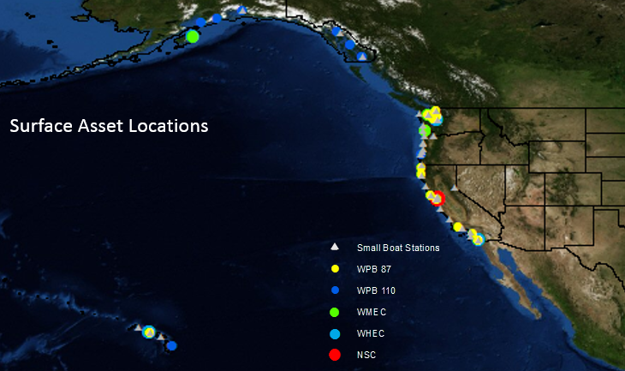
Figure 1. Location of all CG PACAREA assets.

Figure 1 shows the current location of all operational units in the PACAREA of the Coast Guard. This visual depiction of Coast Guard assets shows assets are well distributed throughout the Pacific Area. The least covered US coastlines exist in Alaska.
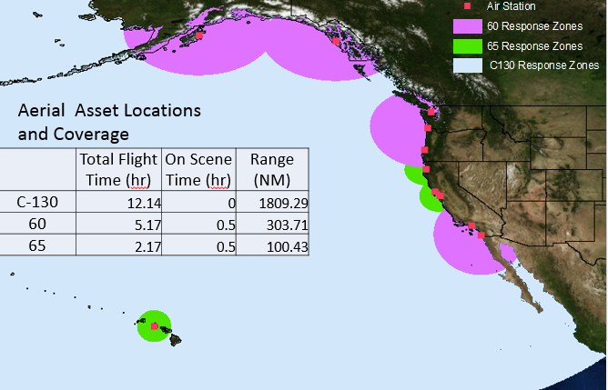
Figure 2. Coast Guard H-60, H-65, and C-130 Coverage of PACARA.
Once the locations of all assets were known, the coverage of the current force laydown was analyzed. Figure 2 shows the CG air asset laydown. There is a gap in helicopter coverage around the Kailua-Kona Island of Hawaii. There also appears to be a gap in coverage between San Francisco and Los Angeles. However, this analysis assumes that aircrafts takeoff and leave from the same airport. In order to cover a case that falls in the gaped region, an aircraft would need to take off in San Francisco and land in Los Angeles or vice versa, in order to ensure the helicopter lands safely before running out of fuel. C-130 response covers the whole pacific region stopping around the Mexico Guatemala boarder.
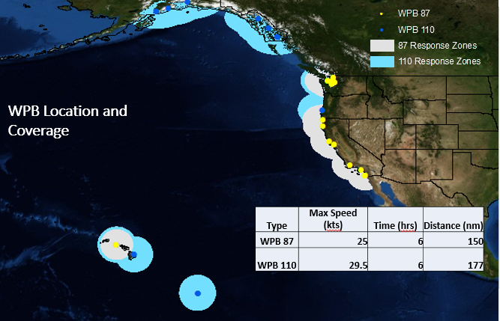
Figure 3. WPB 87 and WPB 110 coverage of PACAREA.

As anticipated, the Coast Guard overall has great shoreline coverage. Figure 3 shows the patrol boat coverage. Patrol Boat coverage is great along the coastline with the exception of Alaska, where the Allusion Islands are not well covered nor the west shoreline of Alaska. Since there is a gap in helicopter and patrol boat coverage along the western coast of Alaska, this shows the need to have a major cutter stationed up north for SAR response. Next, an analysis of the major cutters (National Security Cutters, High Endurance Cutters and Medium Endurance Cutters) was performed. Since major cutters only respond to cases if already underway, their response times from the pier are insignificant.
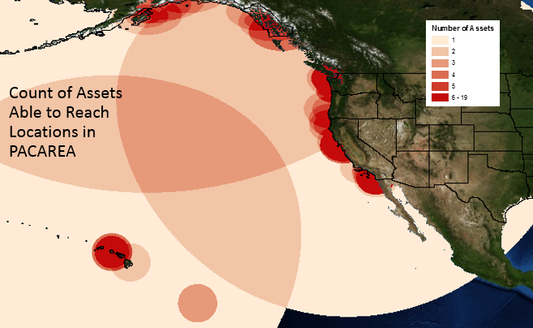
Figure 4. Count of Coast Guard assets able to reach locations in PACAREA.

The aircraft and patrol boat analysis show we are extremely well covered along almost all the Pacific US Coast boarders. Figure 4 shows how many assets can reach a given area within 6 hours or before SPLASH. There are many areas close to US shorelines that have more than 6 assets that are able to respond. In some cases this is needed because all of the assets are not always fully mission capable. Assets can be down for scheduled maintenance, dry-docks and docksides or they can have a casualty that prevents them from being able to respond to a case. However, I believe this analysis does present evidence of areas of oversaturated asset coverage, mostly caused by patrol boats. In order to definitively determine if we have too many assets in those areas, patrol schedules and maintenance periods would need to be looked at to see how many assets are operational at one time.
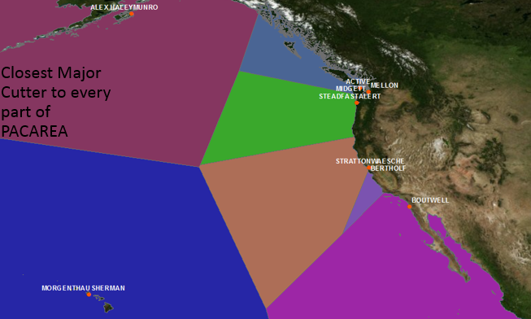
Figure 5. Thessian Polygon analysis performed on Coast Guard Cutters in PACAREA.

In order to evaluate optimal homeports I used the Thessian Polygon Tool. Figure 5 divides up PACAREA showing which major cutter, mostly the homeport, are closest to every other spot in the PACIFIC AREA. It is evident that San Diego, Honolulu, and Kodiak are excellent spots to homeport major cutters because they each cover a large area and they are areas we are very interested in patrolling through Joint Inter-Agency Task Force, North Pacific Guard, and Arctic deployments.
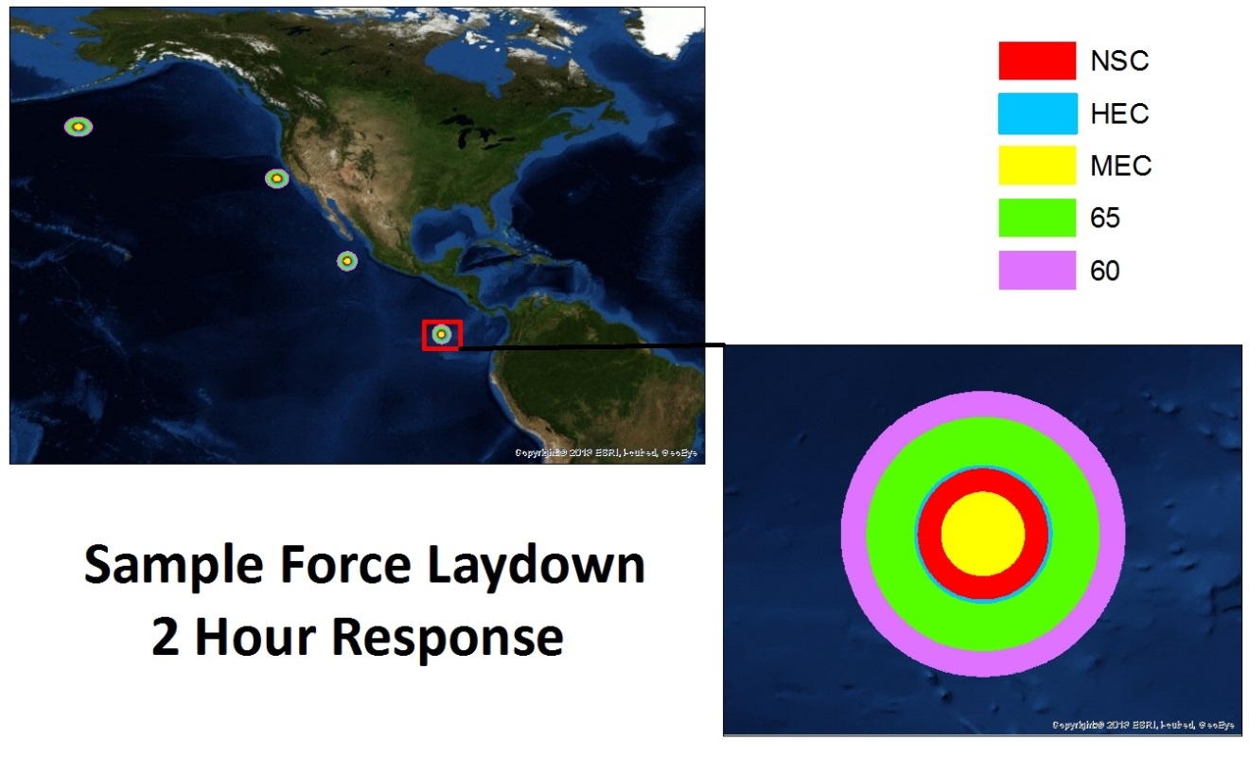
Figure 6. Sample Force Laydown with 2 hour response buffer for each asset type.

Figure 6 shows a theoretical force laydown of the Major Cutters. This theoretical force laydown shows a cutter stationed up north near the Allusion Islands in D17, a cutter stationed off the coast of California patrolling D11, and 2 cutters stationed further south. As seen earlier, the patrol boats and helicopters have excellent coverage off the coast line in D13 and D11 from Washington to Southern California. This illustrates that there is not a need to station a major cutter in that region. There is a need to have a major cutter up north patrolling around the Allusion Islands to cover the area patrol boats and aircraft cannot reach in a reasonable response time. This figure also shows that even with two cutters operating down south there is still a need for more cutters in that location. This figure shows a great 2 hour response comparison of all assets with capabilities to deploy to these areas. NSC and HECs have significantly better response times then MECs, making MECs a non-desirable asset to deploy down south. In addition, the deployment of helicopters on NSCs and HECs significantly increases response times. Currently these two assets are only allowed to deploy with H-65s. However, the Coast Guard is currently working on approval to deploy 60s on NSCs. Since H-60s have a significantly greater response time than any other asset, the approval of H-60s on NSCs would greatly increase the Coast Guards abilities, especially in the southern most area of operation.
Lastly a cost analysis was performed. Figure 7-12 show how much it cost to run each asset at full speed. While it is interesting to look at these figures they do not tell you much information. However, using a few tools in GIS we can do a lot more with this data.
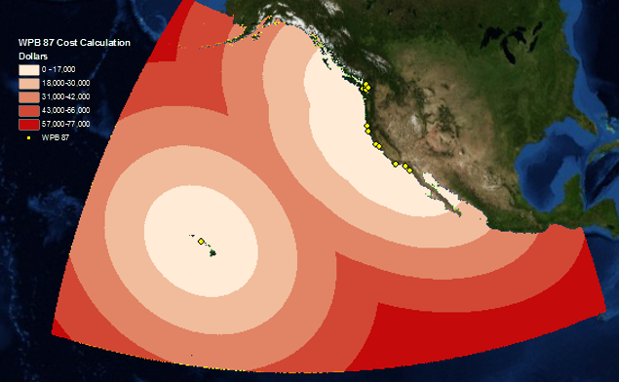
Figure 7. Operating cost calculation in dollars of WPB 87.

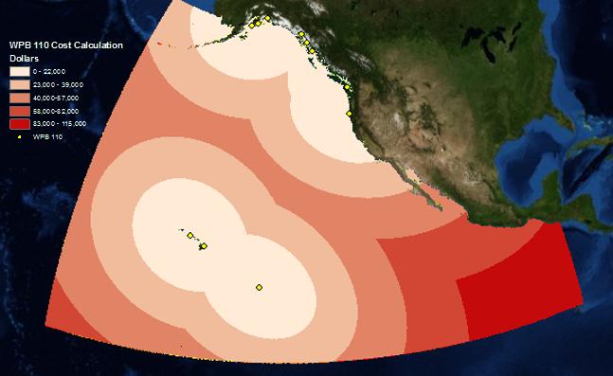
Figure 8. Operating cost calculation in dollars of WPB 110.

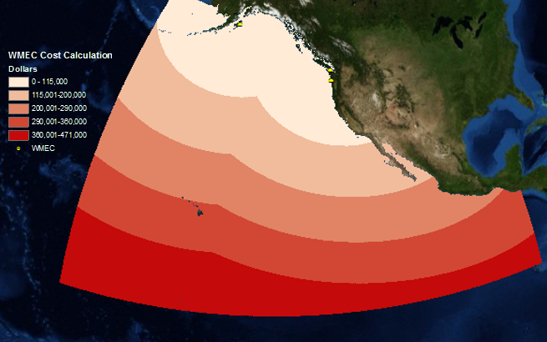
Figure 9. Operating cost calculation in dollars of WMEC.

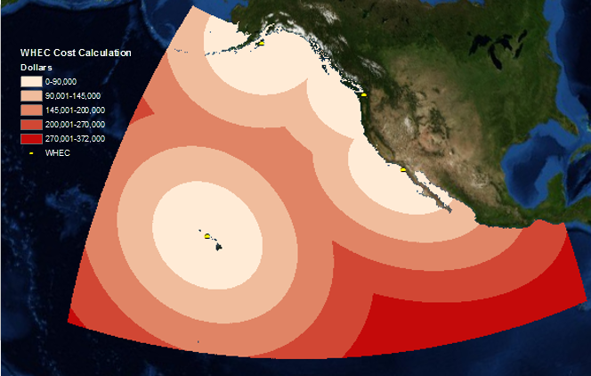
Figure 10. Operating cost calculation in dollars of WHEC.

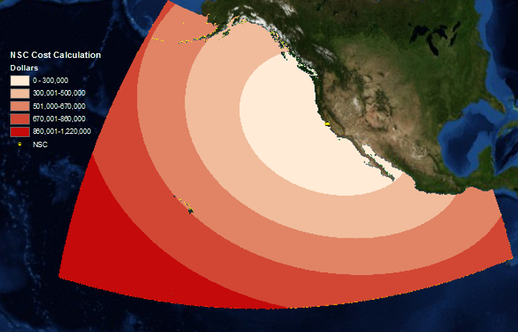
Figure 11. Operating cost calculation in dollars of NSC.

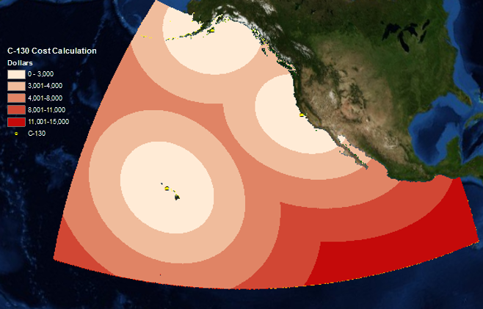
Figure 12. Operating cost calculation in dollars of C-130.

Sometimes a specific type of asset is needed to deploy to a case because of the its’ capabilities. However, that is not always the case. We can use the cost analysis performed in figures 7-12 to help determine what asset makes the most sense to deploy to cases, by taking into consideration the cost and time. Figure 13 shows 5 theoretical case locations.
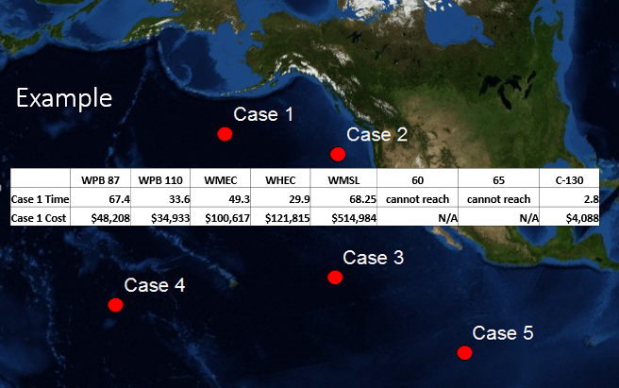
Figure 13. 5 theoretical locations of cases the Coast Guard will need to respond to. When you click on the case, in this example Case 1, GIS auto populates the cost and time of each asset.

While working in GIS when one of these cases in clicked on the user can see the cost and time it would take each different asset type to respond to that case. This would be extremely helpful in Coast Guard Command Centers in determining what asset should be deployed. In addition, the Command Center can use real time locations of Coast Guard Assets and real time information on cases.
Based on the analysis performed there were several notable takeaways. First, it is evident that shorelines are well covered by patrol boats and helicopters with the exception of the western side of Alaska. Secondly, there are too many major cutters stationed in the Pacific Northwest. To better allocate resources, it makes more sense to have the major cutters stationed in Alaska, Hawaii and Southern California. If major cutters stay stationed in the Pacific Northwest, MECs should not deploy down to Central America because it takes too long for them to get there and they are not as capable as other assets are in that mission area. The last major result of this project was that the deployment of helicopters on cutters significantly increases the Coast Guards ability to respond quickly. More specifically, the H-60 helicopter deploying on the NSC provides the most capable and fastest response asset that the Coast Guard has.

Conclusion/Future Studies
This study provides for a great foundation for GIS to be used more in the Coast Guard. Many of these layers created can be used in Command Centers (where cases are managed by the Coast Guard and decisions are made on where to deploy cutters) for actual operations. If the CG developed a post graduate school opportunity for GIS or provide GIS training to watch standers, the Coast Guard could benefit from the GIS capabilities discussed in this project. The incorporate real time weather and wave height into this analysis would help give more accurate response times for the different asset. In addition, the incorporation of classified information into this analysis, including real time information, would greatly benefit the Coast Guard and allow the Coast Guard to actively use GIS when working on real time case response.

References

Estochen, M. B., Strauss, T., and Souleyrette, R.R. 1998. An Assessment of Emergency Response Vehicle Pre-Deployment Using GIS Identification of High-Accident Density Locations. Transportation Conference Proceedings. Ames, Iowa: Center for Transportation Research and Education, Iowa State University. Retrieved November 18, 2014 from http://www.ctre.iastate.edu/pubs/crossroads/221assess.pdf

Landre, Martin (2008). GIS in Response Time Analysis. GIM International 22(2). Retrieved 16, 2014 fromhttp://www.gim-international.com/issues/articles/id1052-GIS_in_Response_Time_Analysis.html

Venalainen, Emilia 2014. Geographic Information Systems Supporting Maritime Search and Rescue Planning- Evaluating Voluntary Emergency Response in the Gulf of Finland. Retried November 21, 2014 from
http://www.libraries.psu.edu/content/dam/psul/up/lls/documents/APA_Quick_Citation_Guide.pdf

