Exploring Techniques for Spatio-Temporal Analysis in Genealogy
A Case Study of the Hawley Record

Bennett Shepherd Hawley Jr.
Masters in Geographic Information Systems
Penn State University
GEOG: 596B

Table of Contents
1 Abstract 4
2 Introduction 4
3 Examination of Base Data 5
3.1 The Hawley Society 5
3.2 Personal Family Documentation 10
3.3 Ancestry.com 13
3.4 Sources and Project Goals 16
4 Spatio-Temporal Visualization 17
4.1 Graphic Representations 17
4.2 Additional Representations 24
4.2.1 Life-Path Line Graphic 24
4.2.2 Time Space Paths 27
4.3 The Usefulness of Graphics 28
5 Development of a GIS for Genealogy 29
5.1 Base Data Structure 29
5.2 Importing into a GIS 34
5.2.1 Google Fusion Tables 34
5.2.2 CartoDB 36
5.2.3 QGIS 39
5.2.4 ArcGIS 40
6 Functionality of a GIS 42
6.1 Display of Spatial Data 42
6.2 Creation of Map Displays 44
6.3 Spatial Queries 46
6.4 Distance Measurement 50
6.5 Buffer/Proximity Queries 50
7 Answering Genealogy Spatial Questions with GIS 52
7.1 How can the movement of the Hawley family be described? 55
7.2 How does the total life-path distance of Hawley events change over time? 64
8 Reflections and Conclusions 72
9 Acknowledgements 73
10 Table of Figures 74
11 References 78

Abstract
This project examines a possible use of geographic information systems (GIS) for the field of genealogy. Tools and techniques that could be employed to incorporate GIS within the genealogy field are highlighted. Spatio-temporal analysis is defined, explained, and demonstrated by using a genealogic data sample derived from The Hawley Society and personal genealogic sources. Paternal lines of ancestry dating from the 1600s to today are analyzed to answer specific spatio-temporal questions, demonstrate GIS methodology, and provide a framework to aid other organizations and independent genealogists with incorporating GIS into their own research.

Introduction
Geographic Information Systems (GIS) are leveraged by many organizations, businesses, and individuals to analyze data that contain both a spatial (location) and temporal (time) element. GIS can be defined as “An integrated collection of computer software and data used to view and manage information about geographic places, analyze spatial relationships, and model spatial processes” (Santini, 2014). GIS aids in helping to “put the pieces together” with respect to both space and time, to possibly reveal patterns that would not be apparent with examining these two elements in isolation using more traditional data analysis methods as with paper maps or non-spatial databases. Genealogy is one field that contains data that has both location-based and time-based attributes that are often examined together to try to tell the story of a particular set of events or people. Genealogy research is a body of work that is ripe for the use of GIS techniques to harvest more information from sources of data.
This project aims to highlight how the field of genealogy could use GIS to answer specific questions related to both space and time elements within data that would be considered typical for the field. Genealogy, for the purposes of this project, is defined as “An account of the descent of a person, family, or group from an ancestor or from older forms” (Merriam-Webster, Incorporated, 2014). Alternatively, genealogy can be viewed as the study of a group of people’s history and relationships, which is the working definition that will be used for this project.
Spatio-Temporal analysis can be defined as considering the historically contingent nature of specific locations, or the spatially contingent nature of some specific temporal event. This method of analysis, which incorporates both location and time information together to reveal further patterns to the analyst than examining these elements separately, is used to answer several example questions about a sample genealogy dataset.
The subject of this analysis is the broad family tree of my personal surname, the Hawley family. This genealogy dataset was chosen for this project for several reasons, including the availability of considerable data sources on the surname and my own personal interest to learn more about the history of and relationships within my family history. Answering specific questions about the Hawley family aims to accomplish two goals:
- Demonstrate some of the methods and questions that can be answered by combining GIS with genealogy
- Learn more about the characteristics of the Hawley family and observe patterns that might not have been readily apparent

Examination of Base Data
Genealogy research aims to find sources of information to help learn more about the people and events of a specific group. The core of this research comes from forms of authoritative documentation or information from known and trusted sources. Several types of these sources can include historic map documents detailing locations and times of movement, family documentation speaking to the relationships and events of a family, official government census documentation listing the members and relationships of a household (albeit limiting birthplace data to an American state or foreign country), and first-hand interviews with a member of the family that is the subject of the research. There are many more examples of authoritative data sources that can be used, including grave markers that list birth and death date and sometimes place of origin, or county records of births and deaths, but these examples in particular are some of the sources used in this study. Specifically the primary sources used include:
- The Hawley Society Online Genealogy Database
- Personal Family Documentation
- Ancestry.com

The Hawley Society
According to The Society of the Hawley Family website, the Hawley Society “…exist to preserve the memory, records and history of the Hawley Family, and to promote friendly acquaintance and sociability among our members” (Society of the Hawley Family, Inc., 2014). The Hawley Society is an organization that meets on an annual basis for a family reunion in a location that is significant to the history of the Hawley surname. The organization also posts on its website that the annual meetings “…alternate between Connecticut, where our history is so rich, and other places of interest”; meetings have been in sites like Stratford CT, Hartford CT, Brookfield CT, Arlington VT, and Asheville NC among others (Society of the Hawley Family, Inc., 2014). The members of this society pay an annual membership fee to help fund the society’s functions, one of which is genealogic research activities by the current Society genealogist Trudy Hawley.
The online family history database is a robust source that provides a large portion of authoritative information on the Hawley surname. This database contains over 38,000 entries that include Hawley and non-Hawley surnames that are connected by some relationship (Hawley, The Hawley Record, 2014). The data include entries from modern family members (in the twenty-first century) all the way back to Joseph Hawley (1603 – 1690) who is believed to have originally sailed from England to Stratford, CT (Hawley, The Hawley Record, 2014). Each entry within the database can contain attribute information about a family member which include (but are not limited to):
- Name/Surname
- Sex
- Date of Birth/Location of Birth
- Date of Death/Location of Death
- Date of Residence/Location of Residence
- Mother/Father/Siblings
- Children
- Sources of Information
An example entry for Bennett Alexander Hawley, my great-grandfather, is shown in Figure 3.1. This entry contains both location and time data, and is a good example of data that can be used in spatio-temporal analysis. The date of birth (6 June, 1898) and death (30 September, 1974) of Bennett Alexander Hawley provide temporal information, that highlight when these events took place. The location of death (High Point, Guilford, North Carolina) provides spatial information that highlight where this event took place. Detailed information on where he was born is missing from this record (born in North Carolina), but if it were present it would help signal migration over some part of his lifespan; however, if he was born in the same place that he died, it does not help shed light on significant life-course settlement phases. Even so, these detailed pieces of information combine to create a snapshot of when and where an event happened that relate to this specific family member.
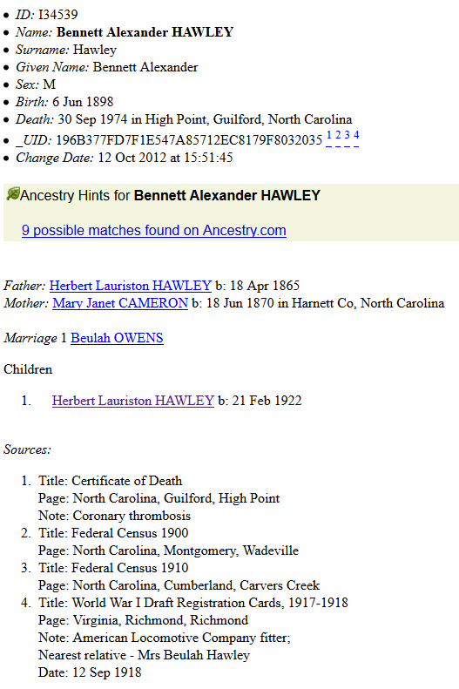
Figure 3.1: An example entry from the online Hawley Society database. Temporal data is outlined in red, while spatial data is outlined in blue (Hawley, The Hawley Record - Bennett Alexander Hawley, 2014)
The relationships that are known are viewable in a “pedigree mode”. In this view, a layout is seen that is similar to the “family tree” concept that is very familiar to most genealogists. The entries form a sideways coat-hanger type branching. Each family member is shown with lines connecting to other related family members, and the connections are dependent on the relationship to the individual. Children are seen as branching lines moving to the right, while parents are shown as lines that come together on the left. This style creates an easy-to-understand graphic for any user to quickly see how an individual is related to other family members. Each individual contains a snapshot of the spatio-temporal data contained in the full record (shown previously in Figure 3.1). The full record can be viewed by clicking the name of the individual family member (each of whom has a unique ID in the database).
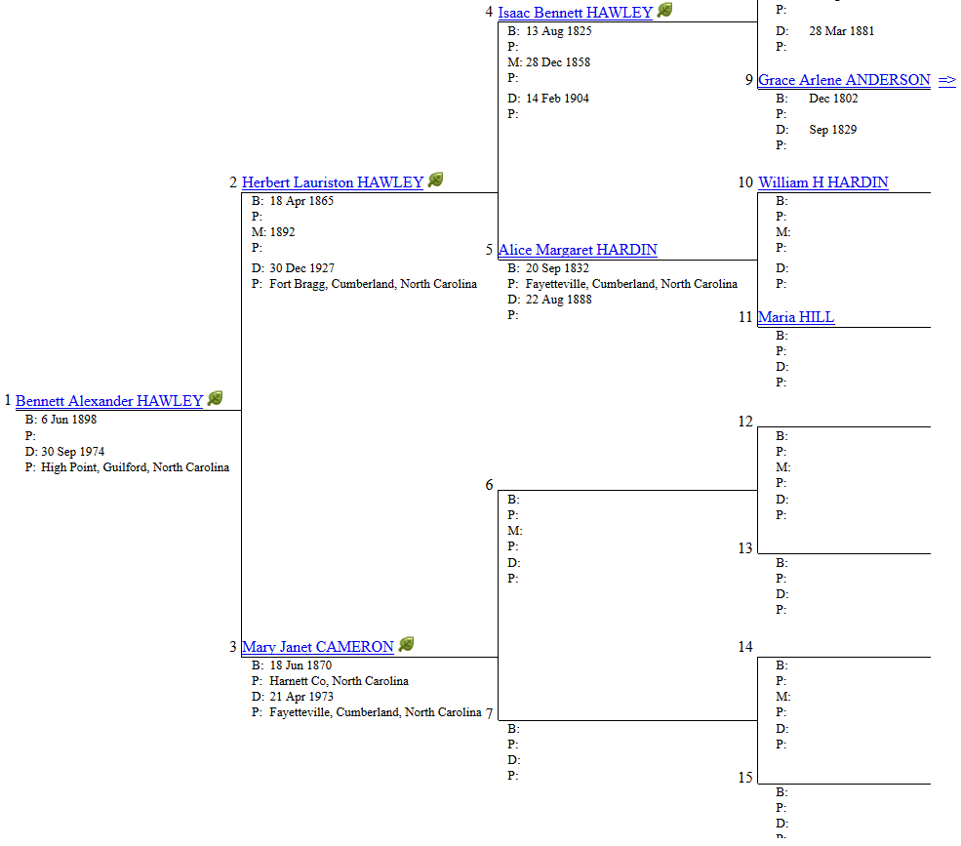
Figure 3.2: The pedigree view for Bennett Alexander Hawley, showing two children Herbert and Mary, and two grandchildren Isaac and Alice (Hawley, The Hawley Record - Bennett Alexander Hawley, 2014)

Personal Family Documentation
Choosing my own family surname gives the unique opportunity to leverage personal family documentation created by first-hand sources (direct family members) with knowledge of the events within the family. One such example document is a family tree researched by my late grandfather Charles Darwin Hawley. This document displays research performed by my grandfather into the lineage and timelines of the family surname based on graveside visitations to locations where family members are known to be buried. This information, along with his personal knowledge of the history in the family, led him to create the document shown in Figure 3.3 soon after I was born. The document was later passed it down to my father, and it was eventually passed down to me.
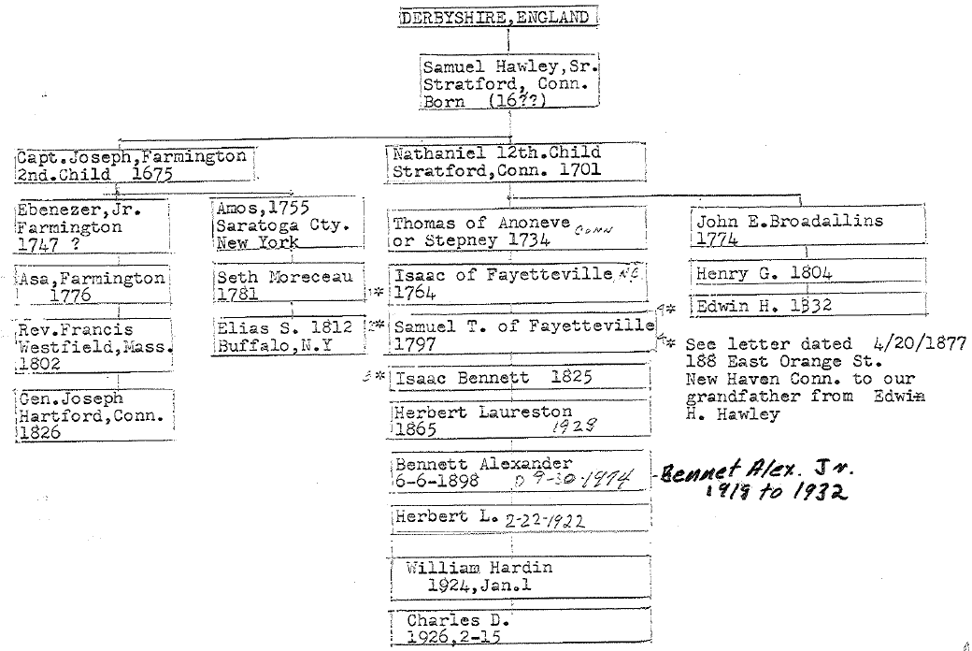
Figure 3.3: Personal family document passed down to my father from my grandfather Charles D. Hawley, depicting the lineage of the Hawley family.
The document is a more traditional “coat hanger” style visualization of the family tree. The lines shown connect each family member all the way back to the earliest known family member, in this case Samuel Hawley Sr. of Stratford, Connecticut. The timelines of birth and death, along with the relationships shown, are the “key” document linking my lineage to the lineage that can be found in The Hawley Society database. The timelines, family member names, and relationships are all consistent to the point of confidence that these are in fact the same Hawleys.
As in The Hawley Society database, this document contains both temporal and spatial data. The date of birth and deaths are displayed beneath each member name (temporal), and the location of either birth or residence is shown (spatial). This information can be used to help paint the geographic picture of the family, and adds to the body of knowledge to help “fill in the gaps” of missing information from the other sources. These elements are highlighted in Figure 3.4 below.
Figure 3.4: A section of the coat-hanger style family document researched by Charles D. Hawley. Temporal data is outlined in red, while spatial data is outlined in blue.
Other personal family documentation that contains valuable spatial and temporal information are obituaries. Obituaries have the added benefit of being published and available for other genealogists to access, while containing often very detailed information about the life of the individual. Specifics can include:
- Date and location of birth
- Date and location of death
- Date and location of burial
- Family relationships such as parents, siblings, and children
- Occupations in life
- Details about education
- Other relevant specifics about the person’s life
As in the case of my grandfather Charles D. Hawley, his obituary reveals a fair amount of the above information. There are many points of spatial and temporal information that help to give a much more detailed look into the geographic footprint of his life. The goal within this project is to harness this level of information for each individual along a paternal line to answer specific questions about the family as a whole. The spatial and temporal elements are highlighted below in Figure 3.5.
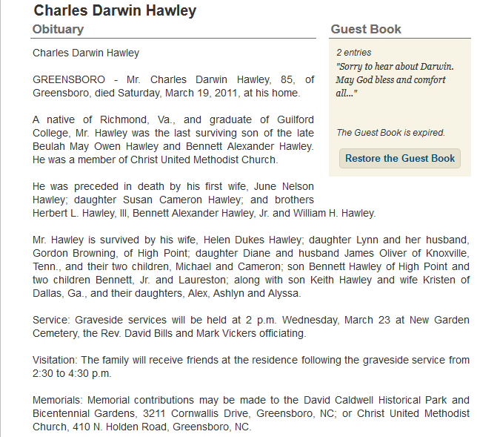
Figure 3.5: The published obituary of my grandfather Charles D. Hawley highlighting various details about his life, as well as the relationships of other family members. Temporal data is outlined in red, while spatial data is outlined in blue (Salisbury Post, 2014

Ancestry.com
The website Ancestry.com is more than a single source, but rather an interface to access many types of historical documentation and photographs. According to their website, Ancestry.com is
An extensive and unique collection of billions of historical records that we have digitized, indexed and put online since 1996. We have developed efficient and proprietary systems for digitizing handwritten historical documents, and have established relationships with national, state and local government archives, historical societies, religious institutions and private collectors of historical content around the world. (Ancestry.com LLC, 2014)
Members of Ancestry.com pay a subscription fee to gain access to the aforementioned digitized sources. These documents include (but are not limited to):
- Census documents
- Birth and death certificates or records
- Marriage certificates or records
- U.S. Military Records
These are searchable, and data can be accumulated in user “shoeboxes”. Many users post their family tree information and share their information online. Ancestry will send updates to subscribers when other people find potential links to their family trees.
Access to these types of sources to help map the linage of a family is invaluable. All of these documents add authoritative credibility to any genealogy research by having the weight of a federal or state government as the originator. The information listed on these types of documents are typically detailed in nature. They provide a fair amount of data about a particular event during a specific timeframe. Census records found on Ancestery.com, for example, contain not only information about one individual, but the members of an entire family. Not only are the relationships of the family listed, but other information such as age, occupation, and place of birth. An example census document is shown in Figure 3.6 below. This document highlights some of the information previously discussed, as well as others that are key to helping tell the story of what events took place at a specific point in time. There is also plenty of spatial and temporal information coupled together that is useful for the development of a GIS.
Additionally, Ancestry.com contains a proprietary online interface that a researcher can use to construct their own family tree. The tree is viewable similar in style to the personal family tree documentation outlined in Figure 3.3 or a pedigree mode similar to Figure 3.2. The researcher can start by entering in a few immediate family members, and how they are related (brothers, sisters, parents, etc.) and the Ancestry interface attempts to find related family members. It does this by accessing digital copies of the previously mentioned historical sources. This allows the researcher to build up the tree, and find copies of historical documents that provide clues into the family history. In this project, I began constructing my own version of the family tree using both the Hawley Society database and personal documentation, which allows for a more complete picture of each family member along the line. A sample of the Ancestry interface and my constructed family tree is shown in Figure 3.7.
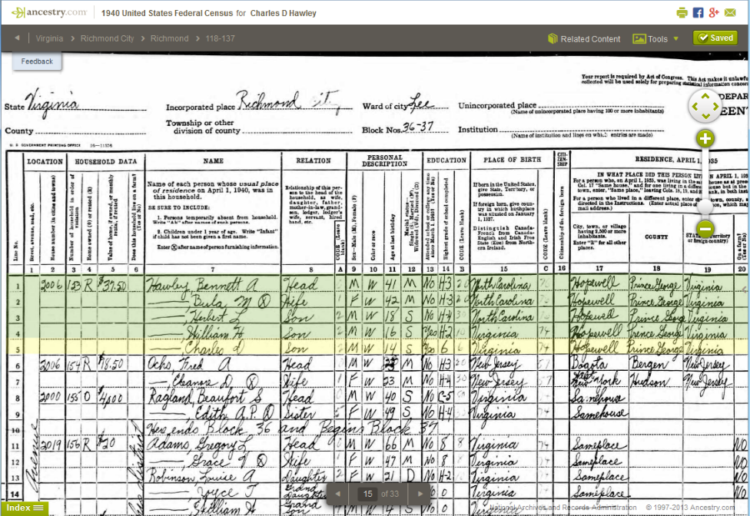
Figure 3.6: Census documentation from 1940 of the Richmond City VA area accessible through Ancestry.com (Ancestry.com Operations, Inc., 2012). This document highlights the family members of my great-grandfather Bennett Alexander Hawley, and lists all the family members at this point in time which include my grandfather Charles Darwin Hawley. Spatial information is highlighted in blue, while temporal information is highlighted in red.
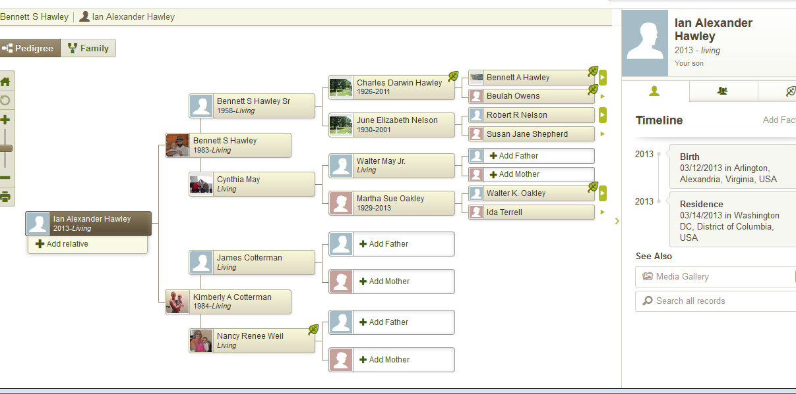
Figure 3.7: A sample of my Hawley family tree constructed using the Ancestry tools and interface shown in “Pedigree Mode”. The tree starts with my son Ian Alexander Hawley, and continues up the family line four generations. Further generations are viewable. Spatial information is highlighted in blue, while temporal information is highlighted in red.

Sources and Project Goals
Each of the previously highlighted base-data sources share a common trait for the purposes of this project. There are many instances where temporal and spatial data is present as highlighted in most of the figures shown. None of the sources discussed fully exploit this fact by giving the researcher tools to answer spatio-temporal questions. Granted, it is not the primary goal of these sources or interfaces (such as Ancestry.com) to provide this capability. The focus of these sources is more to document and record particular events in time, and how people are related to these events. One of the goals of this project is to fully exploit the information found within these sources, and provide a means to answer specific spatio-temporal questions.
Additionally, the task here is whether the spatiality of these sources can be somehow visualized effectively. The temporal data listed as day/month/year can also be visualized, to contrast longevity across generations, though such a visualization makes the data potentially messier. So with both the spatial and temporal visualizations, one guiding aspect of the research reported here is whether the extra graphics are useful. In some ways, there is a necessary partitioning of intent that needs to be recognized: a focus on a spatio-temporal user interface for the purposes of demographic or migration research would need to be cognizant of a certain type of literature, and for the purpose of genealogical research, perhaps an alternate body of work that addresses a different set of conundrums that past and current researchers have faced.

Spatio-Temporal Visualization
The role of a Geographic Information System (GIS) specifically for this project is to gain the ability to analyze both the spatial as well as the temporal features of these data sources simultaneously. In order to understand the benefits of analyzing these elements together, a paternal straight-line lineage is examined in the following sections. Specifically, the direct-line paternal lineage is visualized, starting with the earliest documented family member Joseph Hawley and moving to my son, Ian Alexander Hawley.

Graphic Representations
Figure 4.1 maps the paternal linage from Joseph Hawley to Ian Alexander Hawley by using a display similar to the “pedigree view” from other sources such as Figure 3.7. The pedigree view used in Figure 4.1 is a basic representation of a paternal family lineage. This graphic communicates only the relationship of each family member to each other, with respect to parentage and children. When focusing on an individual in this tree, any children would be represented by a line connecting the individual and spouse to each child moving toward the right. The earliest known relative, Joseph, is shown on the far left, and the viewer is able to follow the lineage of this direct line through time all the way to the most recent known individual, Ian, on the far right.
The clear benefit to this type of graphic is that it is simple and effective at displaying the information intended. The viewer is able to quickly grasp how each person is related in a chain of people, and can see a “flow” of implied birth events. The down side is that only one element, family relationships of individuals, are communicated. There is an implied temporal element by having the family members listed from earliest known on the left, and most recent on the right, but no perspective as to lengths of time. There is also no spatial information communicated at all, so this graphic would need to be combined with several others to tell the complete story of this line.
Figure 4.2 attempts to further communicate the temporal element by adding life date ranges under each family member’s name. This is a simple addition that adds more depth to the graphic by helping display more information quickly to the viewer. This graphic holds the same benefits as the initial graphic, while gaining more resolution into the communication of the time element without much additional clutter.
Figure 4.1: Single line pedigree graphic showing each family member and how they are related to other family members.
Figure 4.2: Single line pedigree graphic showing the relationships of each family member and life date ranges to aid in communicating a temporal element.

The downside of the initial graphic is somewhat accounted for by the addition of time ranges, but there is still a lacking since of scale in the timeframes that is communicated quickly. The viewer would need to observe the date ranges of each individual and mentally note who has lived certain lengths and how long, which is not a quick process. Additionally, no spatial information is communicated in this graphic.
Figure 4.3 attempts to address the lack of spatial information communicated to the viewer by applying a color scheme. Each member of the family is given a color that corresponds to a confirmed location of residence based on base-data research. If there are several locations of confirmed residence, multiple colors are applied with a gradient transition. Additionally the location that occurs earlier in the person’s life is applied to the left side of the box, and the later location color is applied to the right side of the box. This is consistent with the flow of time in the graphic. This method is useful when helping describe the overall movement of a family line.
There is a limit to the amount of spatial information that can be effectively communicated using this method. A single location for a family member is very clear, and two locations are also clear, but once three or higher locations are attempted this method quickly starts to break down and become “noisy”. The limits to this method become very obvious quickly. There are too many color transitions for the user to quickly absorb what movements are taking place from person to person. Perhaps this method would be adequate for family members during earlier dates, because less frequent movement is expected.
Figure 4.4 takes the communication of the temporal element one step further than Figure 4.2, by applying a time scale to each family member. The length of each family member’s “box” is dependent on the length of time they are (or were) alive. Family members with a longer time of life, such as my great-great grandmother Mary Janet Cameron (1870 – 1973), are shown on the graphic with a much longer box graphic than a family member with a shorter time of life. The scale of the graphic is represented by black north-south bars that mark every five years, decades, and centuries shown by a much thicker black bar.
One of the key benefits to this graphic is giving the reader further sense of time with each person. The overlap from person to person quickly communicates which family members were alive at the same time. The color scheme methodology of Figure 4.3 could be applied to this graphic to address the spatial communication aspect, but again could cause the graphic to become noisy, cluttered, or distracting.

Figure 4.3: Single line pedigree graphic showing the relationships of each family member and spatial coloration added to help communicate spatial element
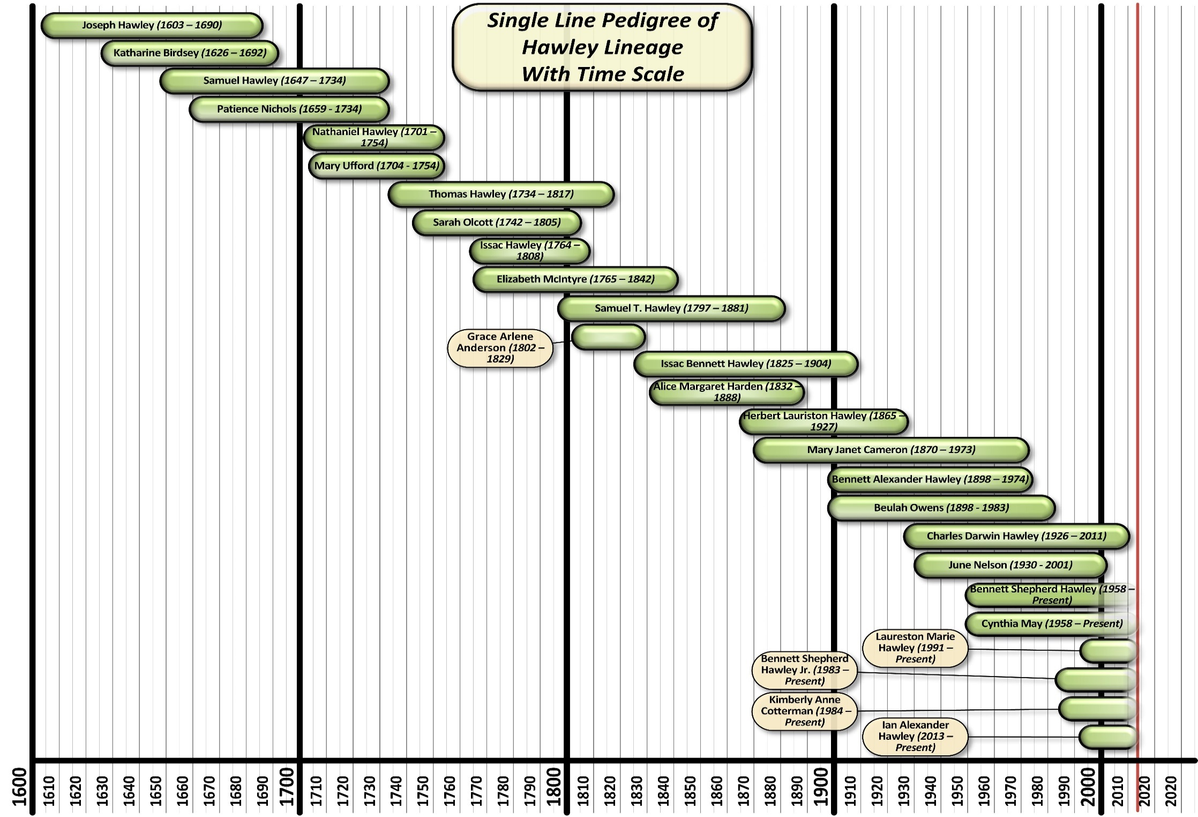
Figure 4.4: Single line pedigree with each family member displayed on a time scale. The length of each family member graphic is dependent on the length of life.

Additional Representations
There are two additional graphic representations that serve to communicate both the spatial and temporal element that are worth outlining in this documentation. The first methodology is described as a “Life-path line graphic”. The second, is described as a “Space-time path” or “Space-time prism”. These two methods are used in other research articles to describe the movement of populations through periods of time. The use of these graphics aids the reader in understanding the spatio-temporal elements of the data being described, while providing a means to quickly communicate an event or series of events related to a specific population.

Life-Path Line Graphic
A “Life-path line graphic” is a simplistic graphic consisting of a line drawn along a defined scale of time that is typically shown along the x-axis. This technique is similar to the time-scale technique displayed in Figure 4.4. The line can be straight or bend, curve, and turn sharp angles along the y axis to show a change in spatial location. An example of this methodology, used by the historical geographer Anne Knowles (1995) to visualize migration steps by nineteenth-century Welsh individuals, is shown below in Figure 4.5.
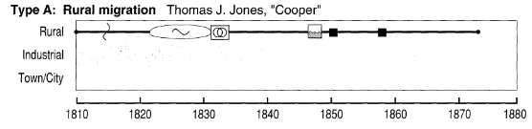
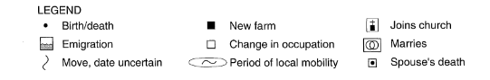
Figure 4.5: An example life-path graphic describing a spatial element (Rural, Industrial, or Town/City location) over a defined period of time. A legend is included to aid in communication of significant life events along the line (Knowles, 1995).
Symbology is used along the lines to communicate the occurrence of life events either at a specific point in time, or a range of time. In the above example, Thomas J. Jones is described as remaining in a “rural” location for the entire period of time represented in the time-scale along the x-axis. He experienced several life events that include:
- A move around 1815
- A period of local mobility from 1820 to 1831
- Marriage around 1832
- Emigration around 1848
- Two “new farms”, one around 1850 and the other around 1858
The resolution of the spatial element is not great in this example, due to the vague descriptions of “Rural”, “Industrial”, and “Town/City”. These could easily be further defined in a genealogic body of work or changed to better fit the spatial element that needs to be described. The next example in Figure 4.6 shows a much more complex line, with plenty of movement by the individual “Rev. John T. Griffiths”.
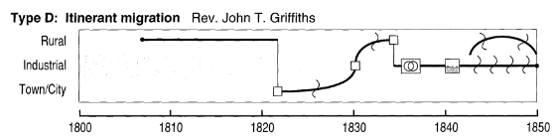
Figure 4.6: A more complex life-path graphic showing an individual with more life events and more spatial element changes during a defined period of time (Knowles, 1995)..
This method of describing spatial relationship over time has been applied to more humorous uses as well. Randall Munroe, author of the web-comic xkcd, employed a similar methodology to describe the locations of characters in several popular movie series over time. An example of this application is shown in Figure 4.8. This application helps show the effectiveness of this method for communication of life stories, albeit for a non-academic or researched-based endeavor.

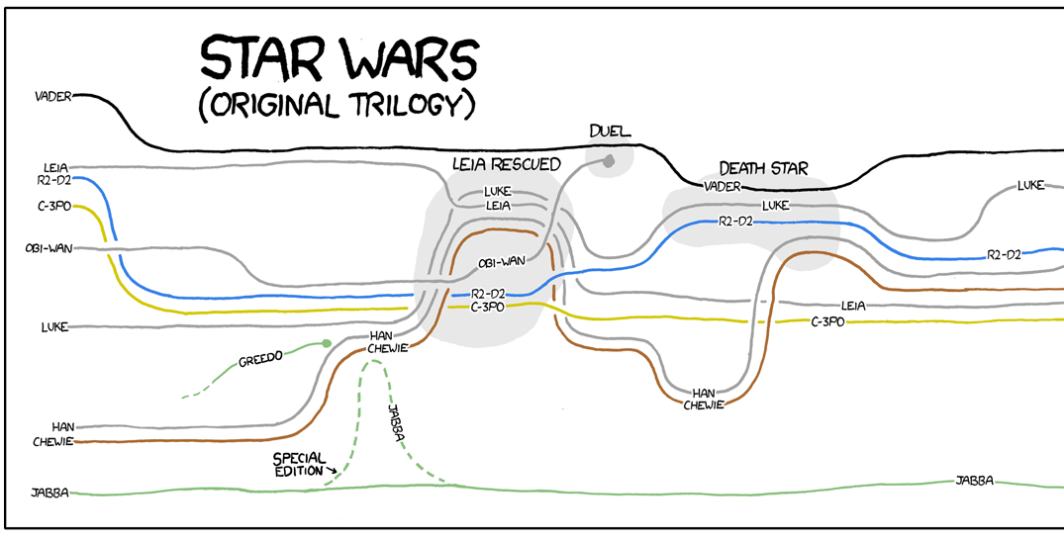
Figure 4.8: xkcd web comic # 657 depicting a life-path line style graphic of the original Star Wars Trilogy. In this segment the locations of each character in "Episode 4: A New Hope" are depicated as lines through time running togeather when the characters in the story are located spatially in the same location (Munroe, 2014).

Time Space Paths
The “Time-space path” is an additional method that can be employed to communicate or examine spatio-temporal relationships. This method is similar to the “Life-path line” graphic in that it employs the use of a line-based path to show the spatial location of a population over a given period of time. The difference being that both the spatial and time elements are shown in a three-dimensional space, rather than just a two-dimensional x and y style graphic. In most examples, such as the basic one below in Figure 4.9, the spatial location of the population being described are bound by an x and y plane, with time operating in a z plane.
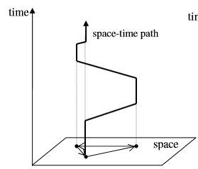
Figure 4.9: A basic "Space-time path" graphic. The spatio element is shown on a flat plane, with the time element moving from lower to higher off the plane. Older periods of time are shown lower (such as the 1600s) and more current periods of time are shown higher (such as the 1900s). A line connects each spatial observation, which shows where the population occurred during what timeframe (Yu & Shaw, 2005).
The locations of a population are typically real locations of a city or country, for example. The confirmed spatial location during a specific unit of time is placed on a representation of space such as a map of the United States with cities shown. Each observation of special location is connected by a continuous line, which turns and bends to show movement from place to place. In Figure 4.10, the immigration patterns of Chinese immigrants from 1874 to 1905 are shown in a time-space path, with lines connecting confirmed locations of each population studied. Columns or cylinders like the ones connecting San Francisco, Portland, and Philadelphia in a below graphic can provide the reader with a means to connect spatial locations together through the graphic’s use of time in a visual manner.
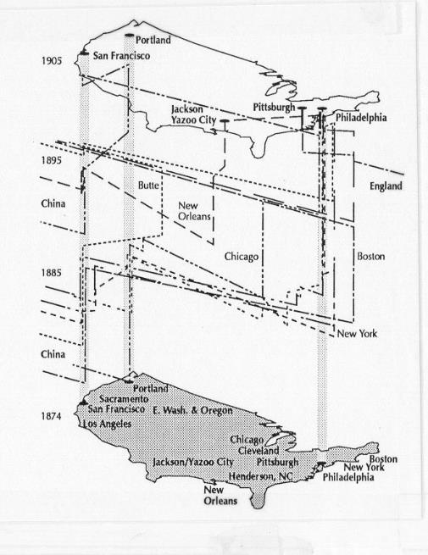
Figure 4.10: Time-space lines on a map of the United States showing the locations and movements of Chinese immigrants from 1874 to 1905 (McGlinn, 1995).

The Usefulness of Graphics
All of the previous graphics described are useful in the communication of spatio-temporal data within the context of genealogy. Each graphic aims to provide information about a population in a package that serves to reveal interesting elements about the population in question. Several of these graphics can be combined to help tell some of the story about where a family moved at what time.
These graphics have a limitation, however, in that they are static observations of genealogic information. This means that while they serve to effectively communicate observations about a family, they may serve a limited role in data analysis. This project aims to focus on providing a means for more advanced data analysis through the implementation of a GIS.

Development of a GIS for Genealogy
One of the primary reasons for the development of a GIS is to gain the ability to learn more about the data that is available to the user. It is a method that is employed to “help people transform geographic data into geographic information” (DiBiase, 2014). This definition touches on the important distinction between having data, or individual observations, to having information. One of the first steps to building an effective GIS for genealogy research is understanding how data can be structured.

Base Data Structure
Data that is input into a GIS is easily understood when structured in a table or spreadsheet format. Each row acts as a record in the data that describes an observation of some kind. A GIS based on genealogy data can use each row to define a piece of historic information. This project uses each record to describe a historic “event”, which include occurrences such as birth, confirmed residence, marriage, death, and burial. Each event record has a real-world location associated with it. This is the location the event occurred according to one or several of the previously defined base data sources (Hawley Society database, personal family documents, or Ancestry.com).
Figure 5.1: Basic structure of a single record to be used in a genealogy GIS. This record contains information related to the birth of Charles Darwin Hawley in Richmond, VA.
This example record has three important pieces of primary information. The event is defined in an “Event” column, and contains text of the event category. The location of the event is defined in a “Location” column, and contains text of the documented city, county, state, and/or country the event took place. The name of the family member is defined in a “Full_Name” column, and contains text of the first, middle, and last name, as well as any suffix. These three pieces of primary information are the backbone of each record because they combine to describe “What” took place “Where” to “Whom”. The “Where” is recognized as the spatial element that was discussed in earlier sections. These pieces of information by themselves could be used to construct a basic GIS, but one that might not be as useful to genealogy research. The “When” element, or temporal information, needs to also be added to realize more usefulness from this data. This is accomplished by adding a “Date” column to contain any date information about the event in question.
Figure 5.2: Temporal information is introduced to the table record by the addition of a "Date" column.
This record now contains all of the primary pieces of information to explain when and where a specific historical event occurred to a family member. More records are added using the same structure to describe each recorded event of a family member during his or her lifetime.
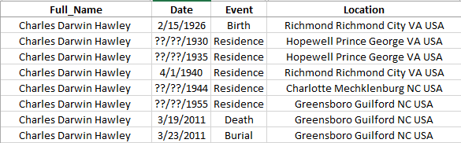
Figure 5.3: Additional records are added for Charles Darwin Hawley, one for each documented event.
This series of records serve to describe the “life-path” of Charles Darwin Hawley. In fact, a life-path line graphic or time-space path graphic could be constructed from the information found within these records.
Columns are added to the table to hold more information about each family member or event. Each record is enhanced with the addition of columns for “Sex”, “Age_at_Event”, “Generation”, “Occupation”, and “Notes_Comments”. These additions act as secondary information that aim to further enhance each record. Secondary information is not limited by these categories, but could include any information a genealogist would find valuable in research. All possible secondary information does not need to be accounted for initially either, but could be built into the table structure after it is being used within the GIS.
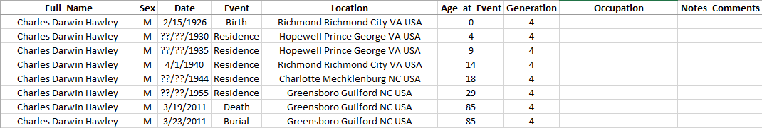
Figure 5.4: Additional columns are added to hold more information about each record.
A few final modifications are made to create a more useful database structure for searching or querying down the road. The “Full_Name” column and the “Location” column are split into several columns. The Full_Name column is split into “First_Name”, “Middle_Name”, “Last_Name”, and “Suffix”.
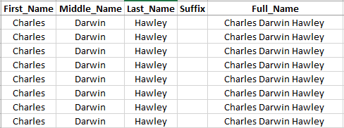
Figure 5.5: Additional columns are added to hold each "part" of the Full_Name column.
The Location column is split into “City_Settlement”, “County”, “State”, and “Country” columns. Each column is then filled with the appropriate information to create separate columns that are now searchable for each “part” of a name or location. This creates the ability to filter or search the data by all records of the city “Richmond” for example, rather than having to search for each variation of locations that contain Richmond. This is the same for the name information, in that all records of “Charles” can be searched for, instead of searching for each name that would include Charles as a first name.
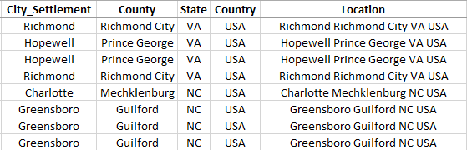
Figure 5.6: Additional columns added to hold each "part" of the Location column.
Some GIS software packages require that location information be introduced as X and Y values. This can include longitude (x value) and latitude (y value) coordinate pairs, or any other coordinate pair system that is available in that particular software platform. This project uses Long/Lat by looking up the location of each record using a web based service such as ACME Mapper (http://mapper.acme.com/) or latlong.net (http://www.latlong.net/). Both of these web services allow the user to enter a location name, such as the information in the “Location” column, and returns a Long/Lat coordinate pair. This information is then entered into the database for each record.
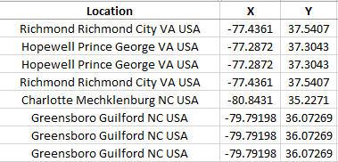
Figure 5.7: X and Y columns are added and each location Long/Lat coordinate pairs are entered.
Each family member is then entered into the spreadsheet until the entire paternal family line is represented. All records are filled with any information that is found, even if a record does not have an associated place name. The data is still useful from an analysis standpoint, but these records will just not be shown in the GIS spatially. An example of the full table is shown on the following page. The data are now ready to import into a GIS.

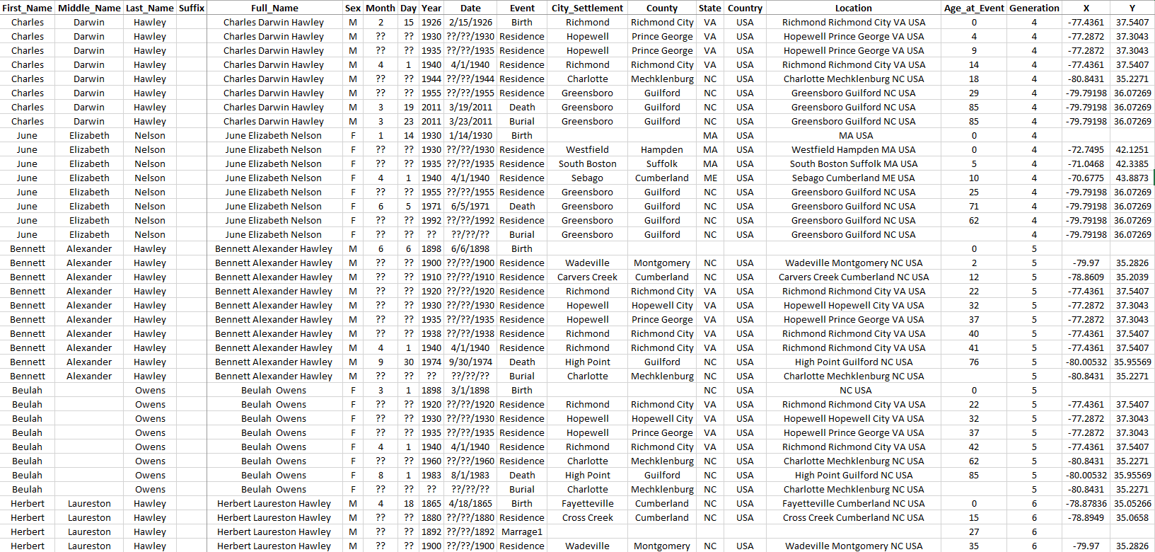
Figure 5.8: A section of the fully formatted records for several family members. These records describe information about name, sex, date of event, event, location, age, and generation in the family line.

Importing into a GIS
There are many choices of platforms to use for importing spatially enabled data to create a GIS. Each software or online platform has advantages and disadvantages in the way data is imported, processed, and displayed. Some characteristics are specifically related to how they handle data that would be useful in genealogy research, such as the Hawley family dataset created for this project. It is necessary to give a quick overview of some of the platforms currently available (as of the writing of this document). The descriptions below are not meant as an exhaustive list of every possible GIS platform, rather as a short overview of several platforms that were evaluated for use in this project.

Google Fusion Tables
Google currently offers a platform through their “Google Drive” service called “Fusion Tables”. Fusion tables are “an experimental data visualization web application to gather, visualize, and share larger data tables” (Google Inc., 2014). This online service is currently free for any user with a google account. A user can upload a table of data, much like the one created for this project, and store all of the information online.
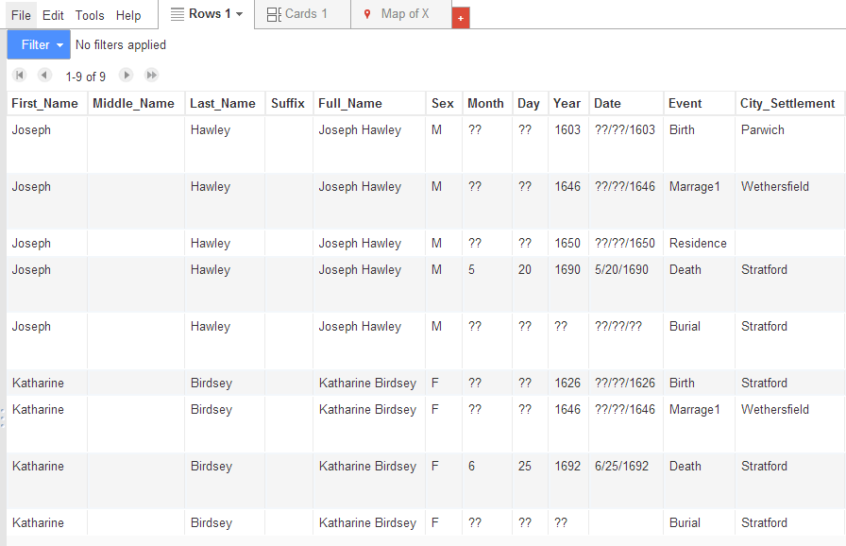
Figure 5.9: Image of fusion table records
Once imported, the tabular data can be analyzed using filters or attribute queries. The data can also be visualized by overlaying on a google map, where each record becomes a symbol on the map. Coordinate pairs, or a location name are accepted spatial information that is used to interpret where the record is spatially on the map.
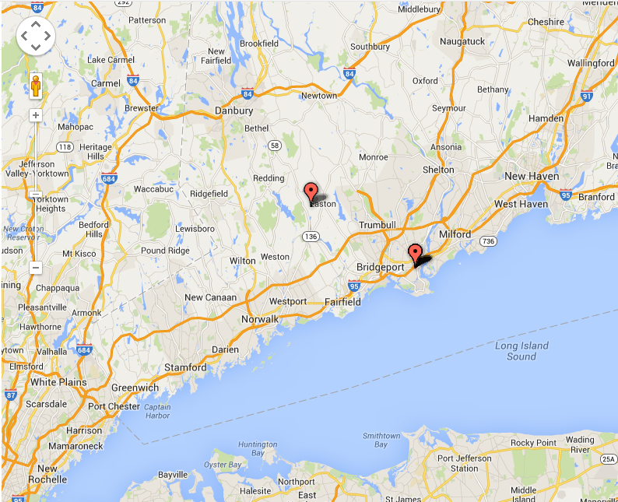
Figure 5.10: Image of google map with data produced from Fusion table data.
The advantages of this platform are cost, ease of use, and flexibility of access. Google offers this service at the moment free of charge. All that is needed to access this method is an active google account, which is free to sign up for if the user does not already have one. The learning curve is relatively low. The user is walked through a wizard, or series of instructions with options, that allows the user to either create a blank fusion table, or import a pre-made table (much like the one for this project). Once those steps are complete, the user only needs a few more steps to assign which column (or columns) will be used for location information. At that point a “map mode” can be activated and the spatial information is displayed. Since this platform is online and cloud-based, the user can access the information anywhere they have access to the internet on most computer platforms.
The disadvantage of this platform is its limitations of analysis, the need to load data onto Google servers, and the unpredictability of the terms provided by Google. This platform contains many functions for the analysis of the entered tabular data, but not necessarily the spatial elements. An example of its limitation is the fact that only one symbol is currently shown at each unique location, regardless of how many data rows are at that particular location. This is a huge problem for analysis such as the one for this project because many of the locations referenced contain multiple people or events in the exact same spot that would not be represented. Additionally to do any further spatial analysis such as spatial queries, the user would need to tap into the Google Fusion Tables API (Google. Inc., 2013) and/or the Google Maps JavaScript API (Google. Inc., 2014). Both of these are essentially programming platforms specific to Google products, and would most likely be well beyond the skillset of an average genealogist.

CartoDB
Vizzuality, a Spanish company with headquarters in NY, currently offers another platform called “CartoDB”. The website for CartoDB describes itself as “a cloud based mapping, analysis and visualization engine that lets users build spatial applications for both mobile and the web” (CartoDB, 2014). This platform is similar to Google Fusion Tables, in that it is free for any user to access by signing up for an account. The user can upload a table of records much like in the Fusion Tables platform, and select which columns represent spatial information.
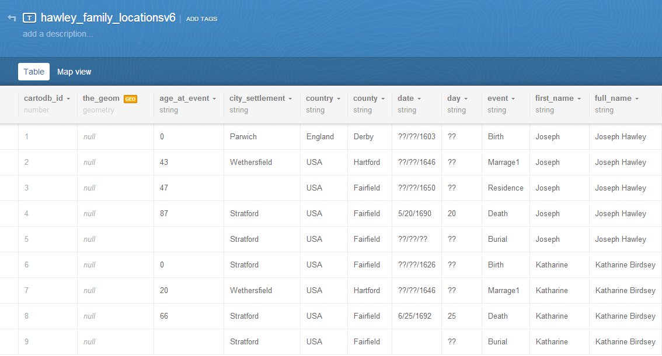
Figure 5.11: An imported table in CartoDB
Once the table is uploaded and spatial columns are selected, a “visualization” or map can be created that displays the spatial information. CartoDB differs however in the options a user has for display. This platform is specifically designed with spatial information in mind, so there are more accessible map overlays, map styles, and ways to display the data points that are useful when performing data analysis.
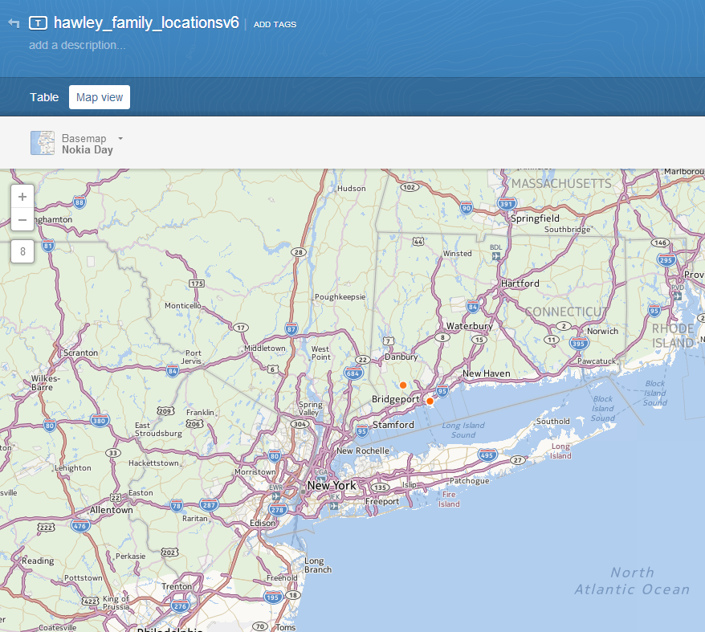
Figure 5.12: Image of CartoDB map with symbols
The advantages to this platform mirror many of the advantages of Fusion Tables in its cost, ease of use, and flexibility of access. An account is free initially to sign up for and includes the ability to store 5 MB worth of tabular data, and up to 5 different tables. If needed a user can sign up for additional space and tables, but at a monthly cost ranging from $29 to $299 per month for a single user plan (CartoDB, 2014). The interface and ability to import information is relatively easy and straight-forward. Customization of the mapping visual is also simple with easy to choose options and map styles. The created products can also be accessed from just about anywhere with an internet connection, and shared with others.
The disadvantages also mirror many of the Google Fusion Table platform. Advanced analysis or displays require the user to tap into the CartoDB.js or JavaScript programming environment. The basic tools for analysis are more useful, but still limited in what can be queried spatially. The user may also find themselves hitting a “pay wall” once the dataset being imported becomes too large.

QGIS
There are several “open source” platforms available to use when importing data into a GIS. Open source software products are freely available for anyone to download and use. The QGIS website describes this product as “a cross-platform Open Source Geographic Information system with an international support community of enthusiastic users, developers and supporters” (QGIS Open Source Project, 2014). The product requires an install onto a computer, rather than the previous two platforms that are accessed through an internet browser. Once installed, the user can import a table of information, select which columns represent the X and Y coordinates, and have all of the points display on a blank map view.
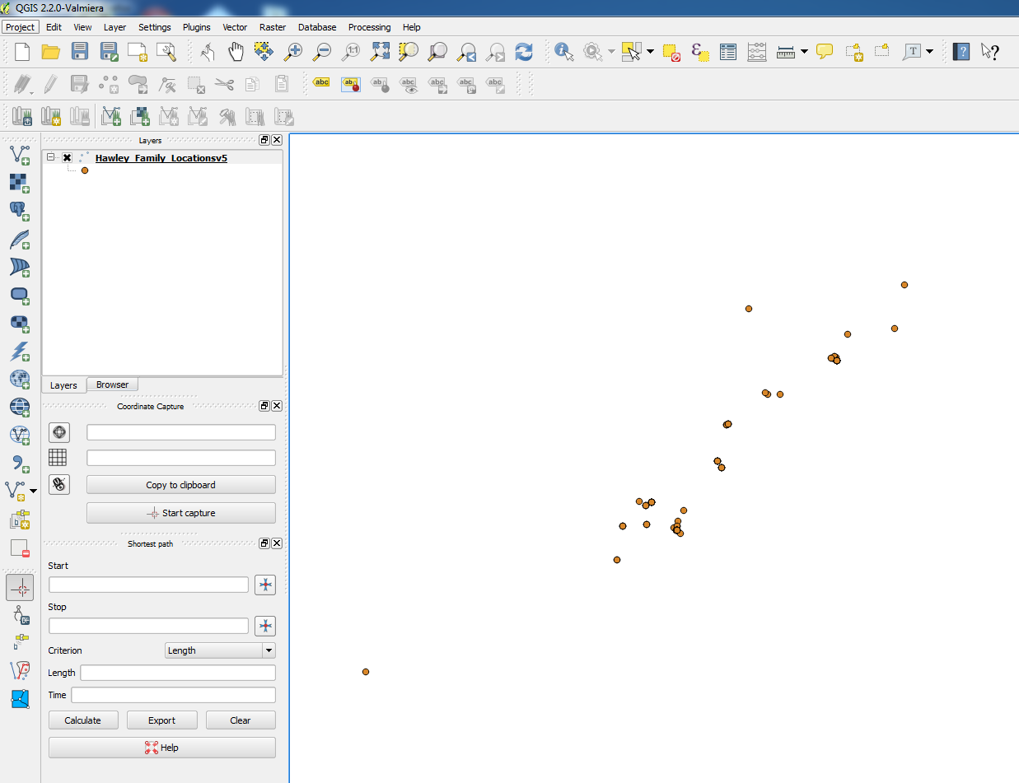
Figure 5.13: QGIS map view after importing a table of records.
Once these records are imported there are many options available to the user. QGIS contains a wide variety of analysis tools that can used to perform many tabular and spatial functions to learn more about the data. Background images such as maps can be imported as well to give a frame of reference and add resolution to the information being analyzed. The complexity of analysis is ultimately up to the user, but QGIS seems to be able to support a wide verity of processing, and could be used to answer many questions about the data at hand.
The advantage of this software platform is its cost and what analysis the user is able to perform. The open source free nature of QGIS and other platforms like it puts a very powerful tool into the hands of the user that otherwise would be very expensive to purchase commercially. There are often a dedicated volunteer user base that help to enhance and develop further improvements to the platform, and provide help through forums for questions about the platform or analysis techniques. This is a viable and strong option for users wishing to have more flexibility and analysis options within the GIS that is created.
The disadvantage of this platform is the steep learning curve. The user would need to have a fairly firm grasp of GIS concepts and analysis tools for this platform to be truly effective. Use of this platform is not as straight-forward as the first two options previously discussed, as the user base that has developed the platform assume some level of GIS competency. Supporting data and information to import into the GIS such as base maps of the United States would need to be located in a “georeferenced” format, meaning the map would need to be spatially aware of where it falls on the earth. This is a basic concept of understanding in the GIS profession, but not necessarily common knowledge. Genealogists looking to use this option would need to spend time first familiarizing themselves with basic GIS concepts.

ArcGIS
The Environmental Systems Research Institute, or Esri as it is commonly known, is a private commercial organization that sells the ArcGIS software platform. According to the Esri website, ArcGIS is “the geography platform for your organization, enabling you to create, organize, and share geographic information and tools with anyone by using intelligent online maps and useful apps” (Esri, 2014). ArcGIS is a common and popular software platform with businesses producing and analyzing GIS data, and educational facilities teaching and performing research on GIS topics. Much like QGIS, the software requires installation on a computer. After install, a user can import a table of information, choose which columns represent X (longitude) and Y (Latitude) spatial information, and display onto an empty map view. Web-based map data can also be added to enhance resolution and understanding.
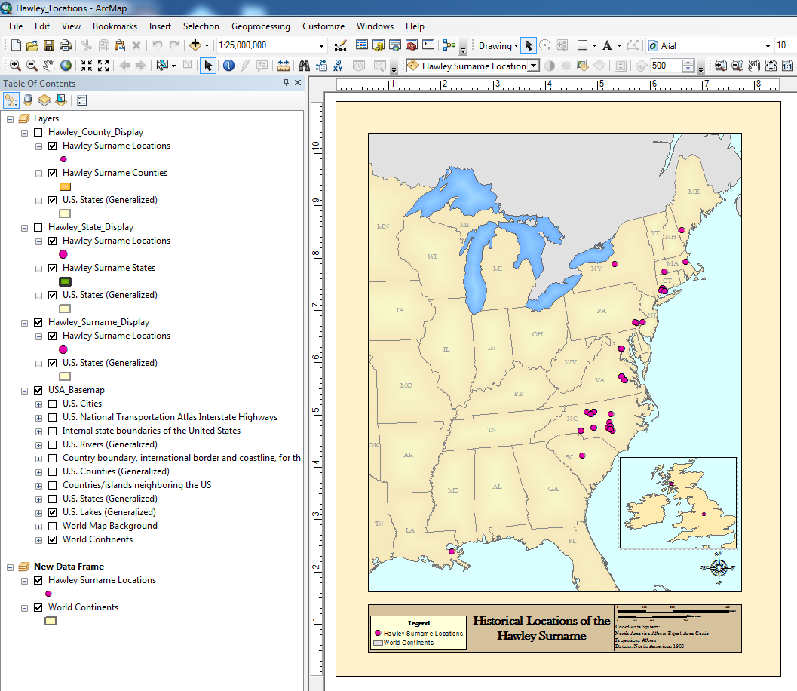
Figure 5.14: Imported data points into an ArcGIS map session, with background US map data shown.
As shown in Figure 5.14 above, there are many options available to the user, much like with the QGIS platform. Simple to complex GIS analysis techniques are supported, as well as methods to import background base data that is ready to use, and the production of quality map displays. There is a wide support for both table-based data like the one created for this project, and other data layers created in alternate platforms.
The advantage to this platform is the wide popularity and robust knowledge available. ArcGIS as of the writing of this document is one of the most popular and well known GIS software packages in the United States, with an estimated 40.7% of the GIS production market share in 2010 (Esri, 2011). There is vast support for learning the platform through company provided tutorials and publications, or through university classes. It is the platform commonly turned to for any GIS analysis.
The disadvantage of this platform is the steep learning curve. This platform has GIS professionals and researchers in mind as its user base, and is tailored to this use. There is also a cost associated with this platform. Through the Esri home use program a user can obtain a one year license for $100 dollars for non-commercial use only (Esri, 2014). Esri sponsored publications or training tutorials are an additional cost for users not previously familiar with the platform or GIS concepts.
The remaining sections of this documentation will use the ArcGIS platform for any analysis. This is due to the familiarity of this platform by the author, and the availability of this software package through Penn State University under a student license. It is recommended by this author that genealogists looking to incorporate GIS into their research examine the previously outlined platforms, as well as others available and weigh both the advantages and disadvantages of each. The spatial questions being researched should also be examined to see if the platform selected by the user has the functionality needed to help answer the desired questions.

Functionality of a GIS
The straight-line paternal Hawley lineage introduced earlier in this documentation is the example dataset imported into a GIS. ArcGIS is the software platform used to import, manage, and interact with the geospatial data that is created. The straight-line Hawley lineage records contain both spatial and temporal information that can be utilized within the created GIS. This section outlines how a researcher can interact with this example dataset within a GIS, and what functions are available to aid in genealogy research.

Display of Spatial Data
Each row of data within the Hawley dataset contains spatial information in the form of X (Longitude) and Y (Latitude) coordinate pairs. These coordinate pairs represent the latitude and longitude information that describes where a record’s event occurred. The longitude and latitude information makes it possible to display all of the records in the Hawley table as a symbol in the GIS. Figure 6.1 is an example of several records displayed in ArcMap.
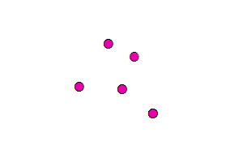
Figure 6.1: Several records in the Hawley dataset displayed in ArcMap based on the X and Y coordinate information

Other spatial data layers can be added in the map view to provide further resolution and context. Figure 6.2 shows the addition of a U.S. States boundary layer. The data points all fall within the Connecticut state boundary.
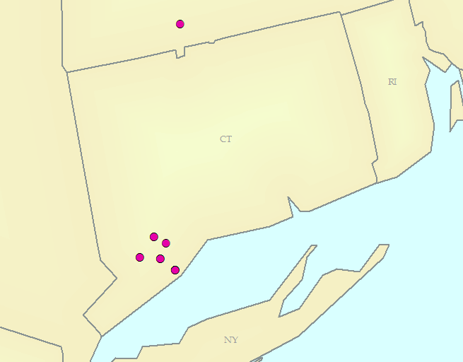
Figure 6.2: The sample Hawley dataset records displayed with US State boundaries
All of the remaining Hawley dataset records that contain X and Y information are displayable as well. Each spatial record is drawn on the map according to the exact location it falls on the earth.
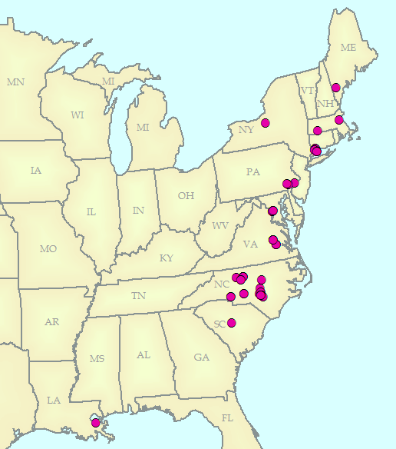
Figure 6.3: The Hawley dataset displayed on more of the US boundary layer

Creation of Map Displays
The combination of Hawley data records and US State boundaries can be used to produce cartographic products such as maps. Features such as scale bars, north arrows, legends, and more can be added to the display to provide the viewer more information from a mapping perspective. An example output of this process can be seen in Figure 6.4.

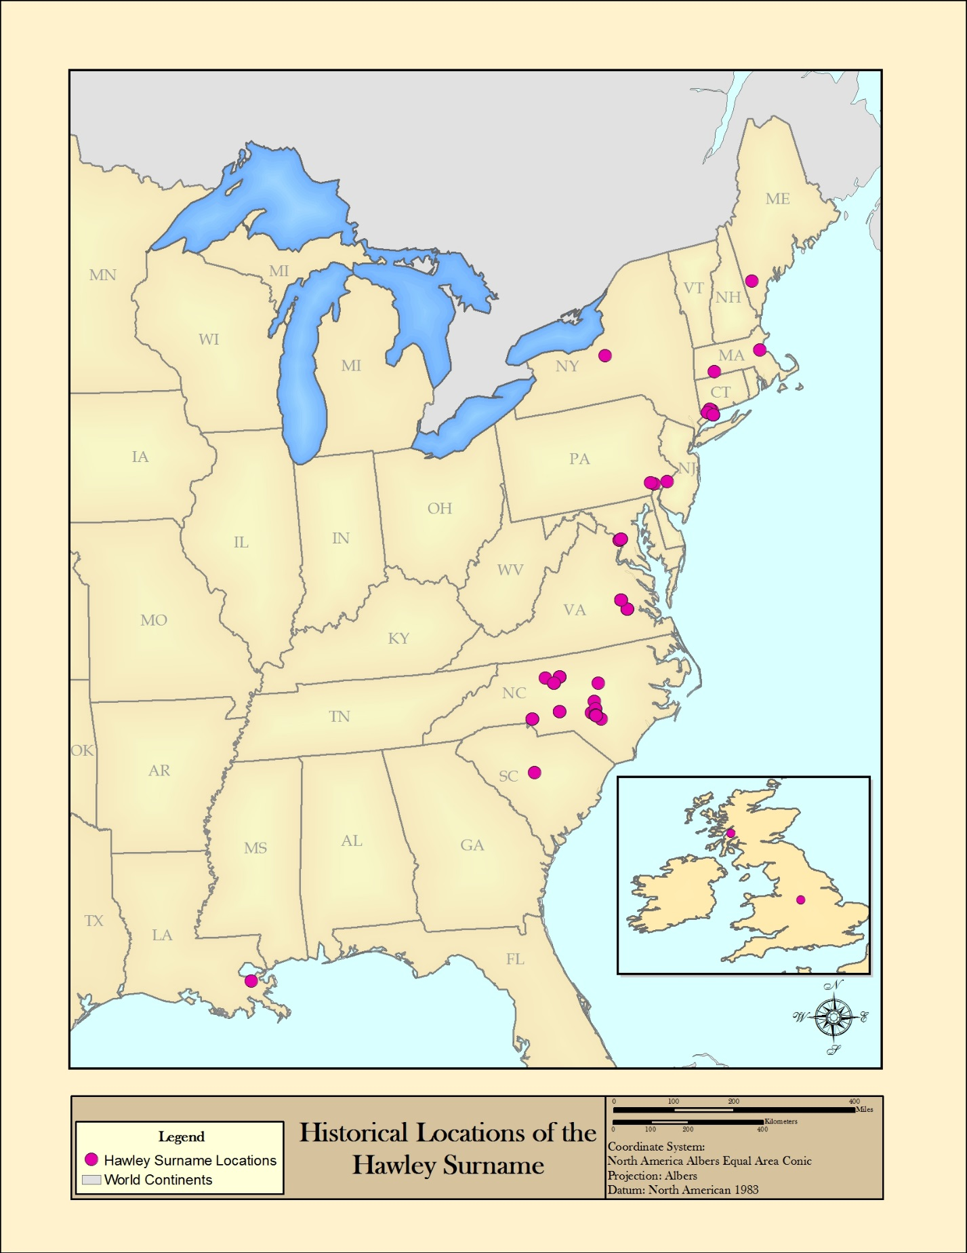
Figure 6.4: An example map product created using ArcMap and the Hawley spatial data.

Spatial Queries
One of the most useful functions of a GIS is the ability to apply “spatial queries” to the data. Simply put, this is asking a spatial related question, and using the data within the GIS to answer it. A simple example of this method is applying a query to the data to help answer “Which states in the United States contain Hawley events?” The Hawley data points can be used to select the states they are located in. This selection is now the answer to the spatial query. The resulting state records and a map of the result can be seen in Figure 6.5 and Figure 6.6 below.
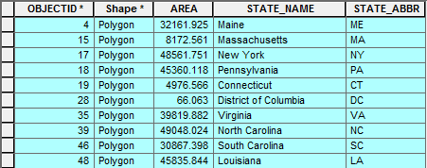
Figure 6.5: The spatial selection result for the 10 states that contain Hawley data points

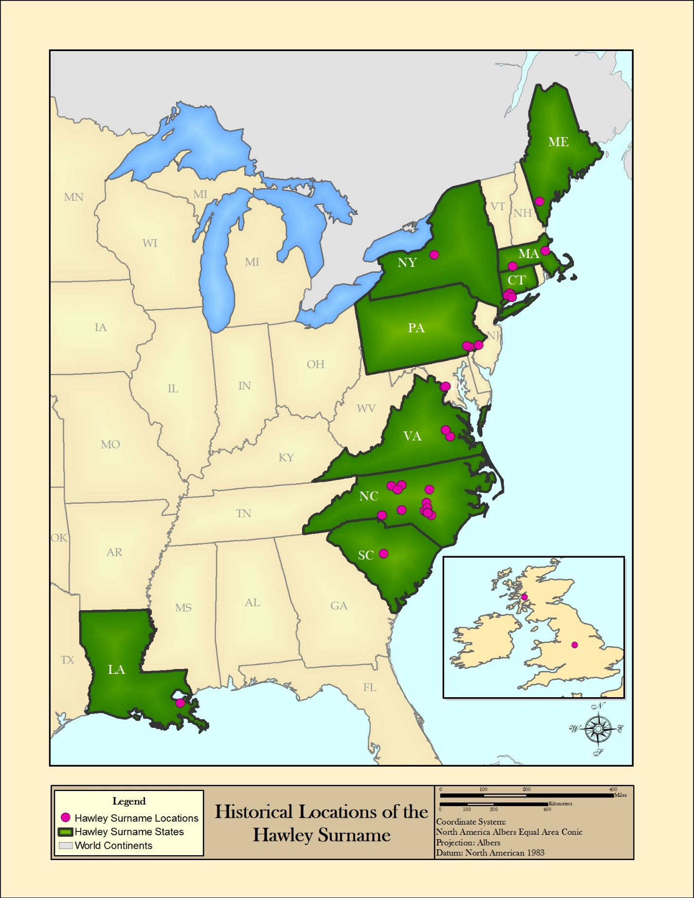
Figure 6.6: A map showing the selected state features in green from the spatial query.

When a higher level of resolution is desired, a county data layer can be added and queried in the exact same way. The results of this spatial selection process is shown in Figure 6.7 and Figure 6.8.
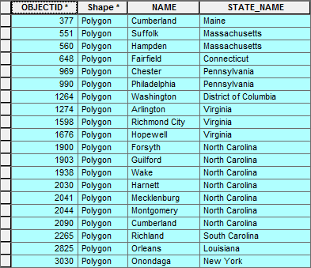
Figure 6.7: Result of a county level selection, where all of the counties in the US that contain Hawley events are selected.

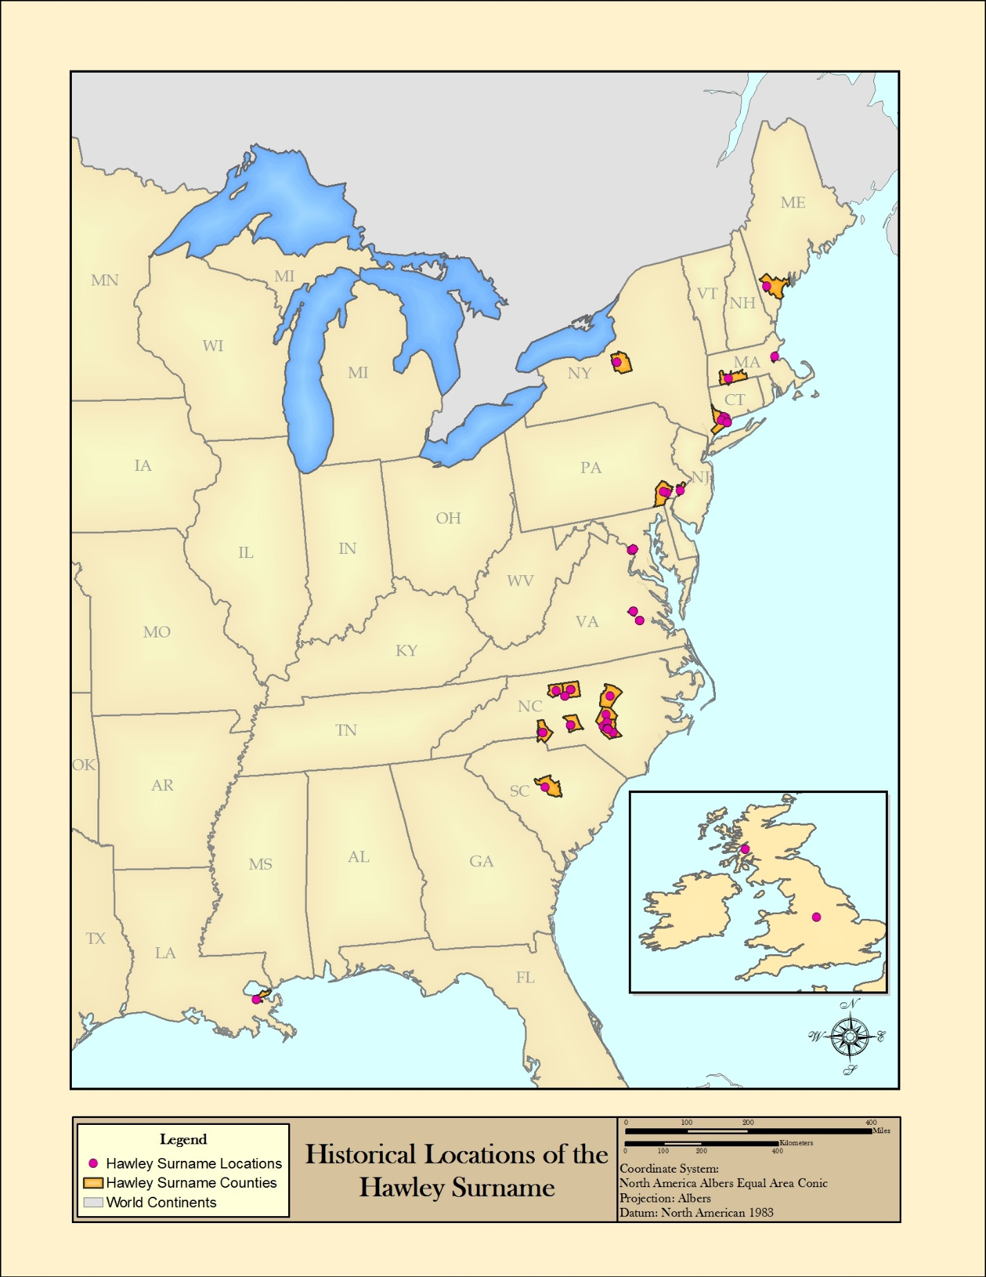
Figure 6.8: A map showing the selected county features in orange from the spatial query.

Distance Measurement
All of the data layers within the GIS are spatially enabled, and are referenced on a coordinate system. This allows for the direct measurement of real world distances from one piece of information to another. For example, the distance from one Hawley data point to another nearby Hawley data point can be measured using measurement tools that are built into ArcMap.
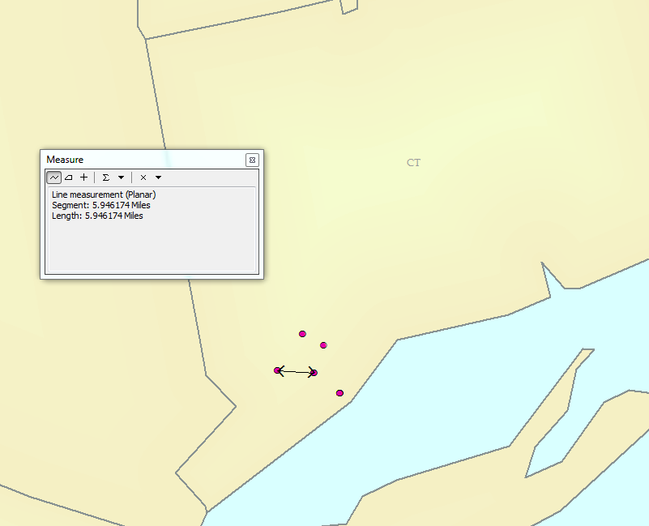
Figure 6.9: A distance measurement between two Hawley data points in Connecticut measuring approximately 5.9 miles.

Buffer/Proximity Queries
A buffer or proximity query is a type of spatial query similar to the one applied to the Hawley records in the previous sub-section. Instead of using one data layer to select information from another data layer, we can use one (or several) specific features to select other nearby features. An example of this query is “Which Hawley records are within 50 miles of Harnett County, NC”. To answer this question, first a 50-mile buffer is created around Harnett County, NC.
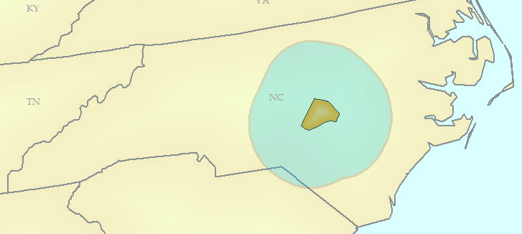
Figure 6.10: A 50 mile buffer shown in light blue around Harnett County.
Then, this buffer is used to select all of the Hawley spatial records that fall inside the 50 mile range.
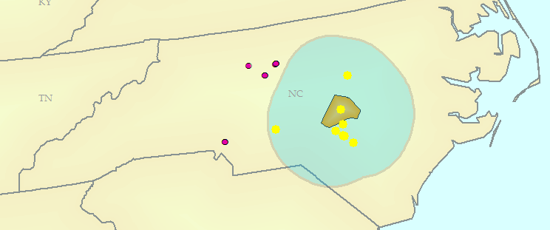
Figure 6.11: All Hawley records that are within 50 miles of Harnett County are highlighted in yellow.
The information for all of the selected records is now accessible.
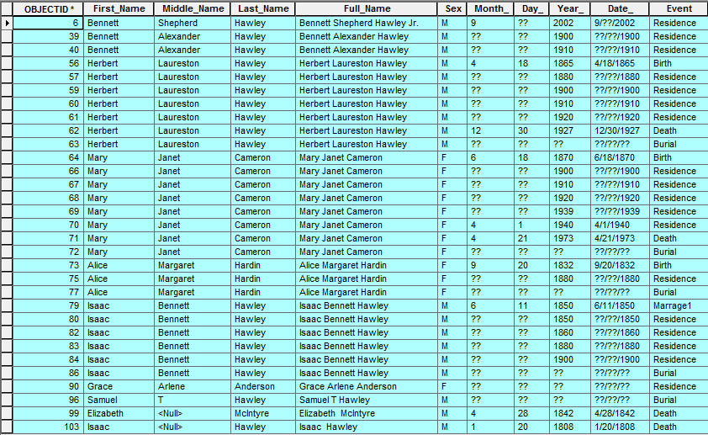
Figure 6.12: The table information for all of the selected records, showing the name, sex, date, and event information for each record.

Answering Genealogy Spatial Questions with GIS
The non-exhaustive list of functions described in the previous section can be used to answer many spatial, temporal, and data related questions about a genealogical dataset. The construction of a robust genealogic database and importing into a GIS platform gives a researcher the ability to glean far more about the spatial characteristics of a family. This section aims to overview the ways in which a populated family database can be used to describe the Hawley family lineage, and answer specific questions about the family. An additional paternal line has been added to the Hawley family database to add more diversity of generational information, in this case one that a researcher would rely solely on the Society database rather than the vast array of other materials available to my specific family line. This paternal line is constructed using the same base data sources overviewed at the beginning of this documentation.

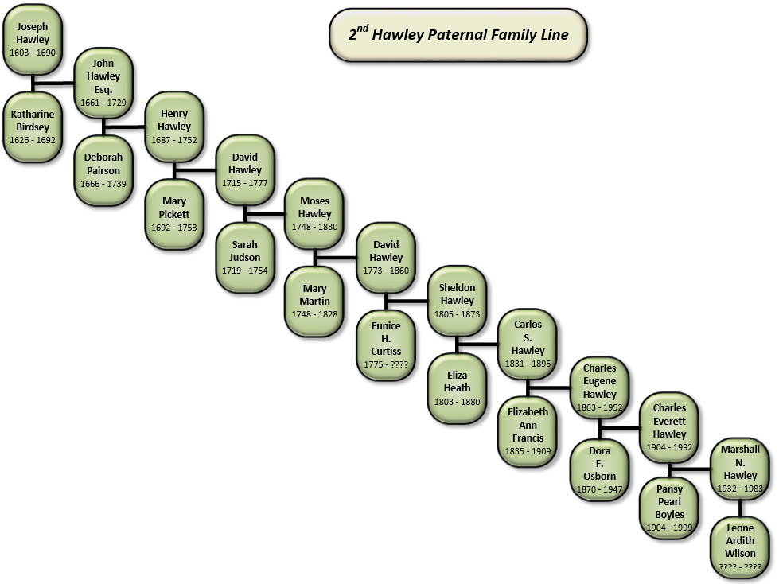
Figure 7.1: 2nd paternal family line entered into the Hawley genealogy GIS database from Joseph Hawley (1603 – 1690) to Marshall N. Hawley (1932 – 1983)

How can the movement of the Hawley family be described?
Since the Hawley database contains both spatial and temporal information, this question is answered by using a combination of several functions within GIS. Initially, the “events of origin” are displayed as a layer of point symbols on top of a United States Boundaries layer. The events of origin in this case is all of the event records related to Joseph and Katherine, the oldest original two members of the Hawley family at the starting point of the Hawley lines of lineage.
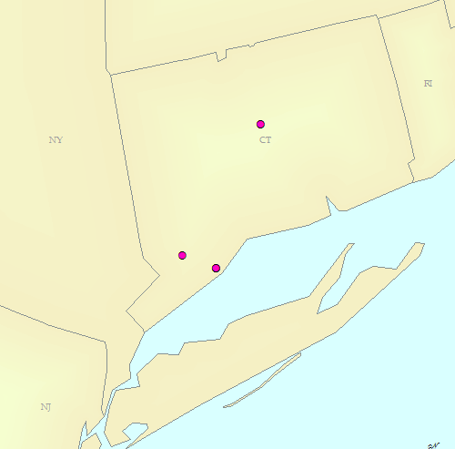
Figure 7.2: Events related to Joseph and Katherine Hawley symbolized on a United States Boundaries layer
Next, two additional layers are symbolized on top of the United States Boundaries layer. The first layer is all event records related to the initial Hawley line starting with Samuel Hawley to Ian Hawley.
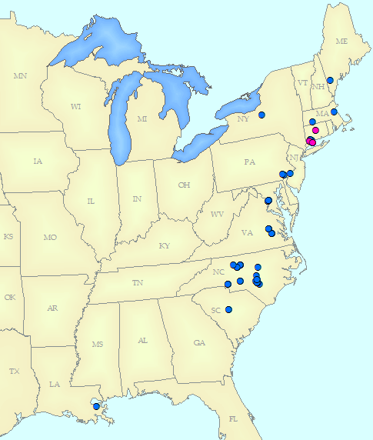
Figure 7.3: The initial Hawley line added to the United States Boundaries layer.
The second layer is all of the event records related to the additional Hawley line from John Hawley to Marshal N. Hawley. Each layer is symbolized with a different color scheme for visual clarity of all three layers. A map layout is also applied for additional information and perspective. The arrows mark a general moment trend (with a few event exceptions) of the two Hawley Lines.

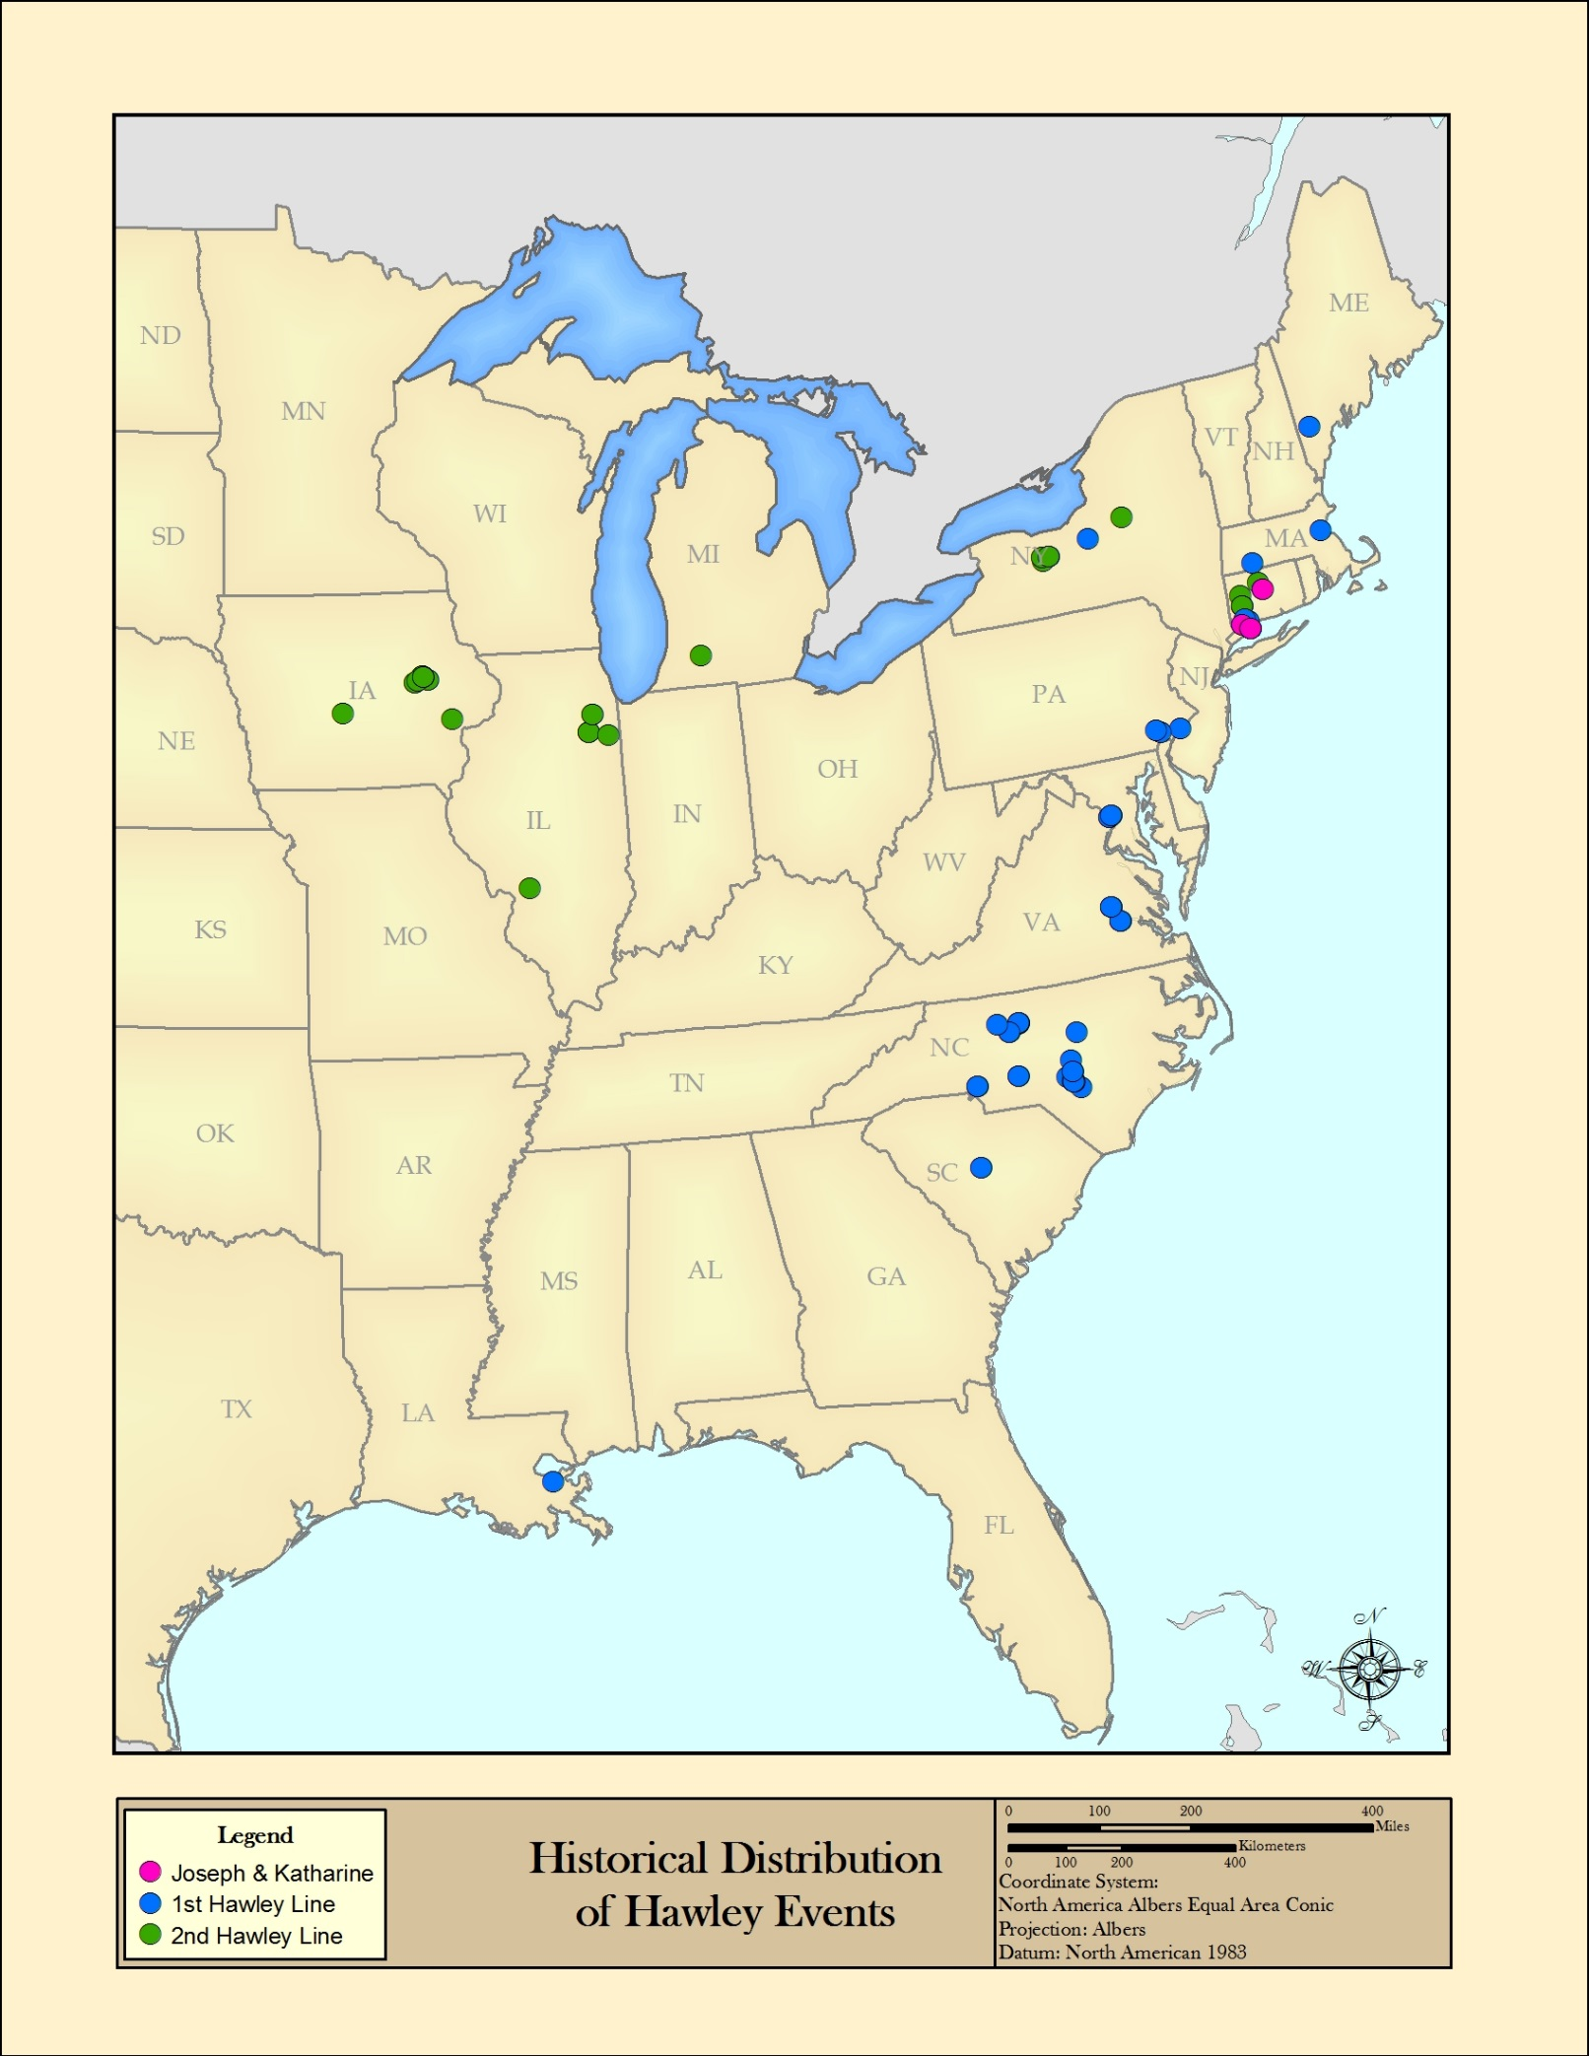
Figure 7.4: Map depicting the historical Hawley event locations in the United States, with arrows labeling the general movement of two paternal lines.
This trend is examined by accessing the temporal information within each record. The spatial records are limited from display based on the information within the date field. This functionality creates the possibility of examining the Hawley events at regular temporal intervals. The following series of maps display the movement of both Hawley paternal lines for each century, starting with the 1600s. The events are shown cumulatively from the time periods of 1600 to 1700, 1600 to 1800, 1600 to 1900, and finally 1600 to 2000. During each timeframe, spatial queries are applied to select the states and counties that Hawley events occur. The expectation is that more states and counties become selected as members of the Hawley lines move throughout the United States.

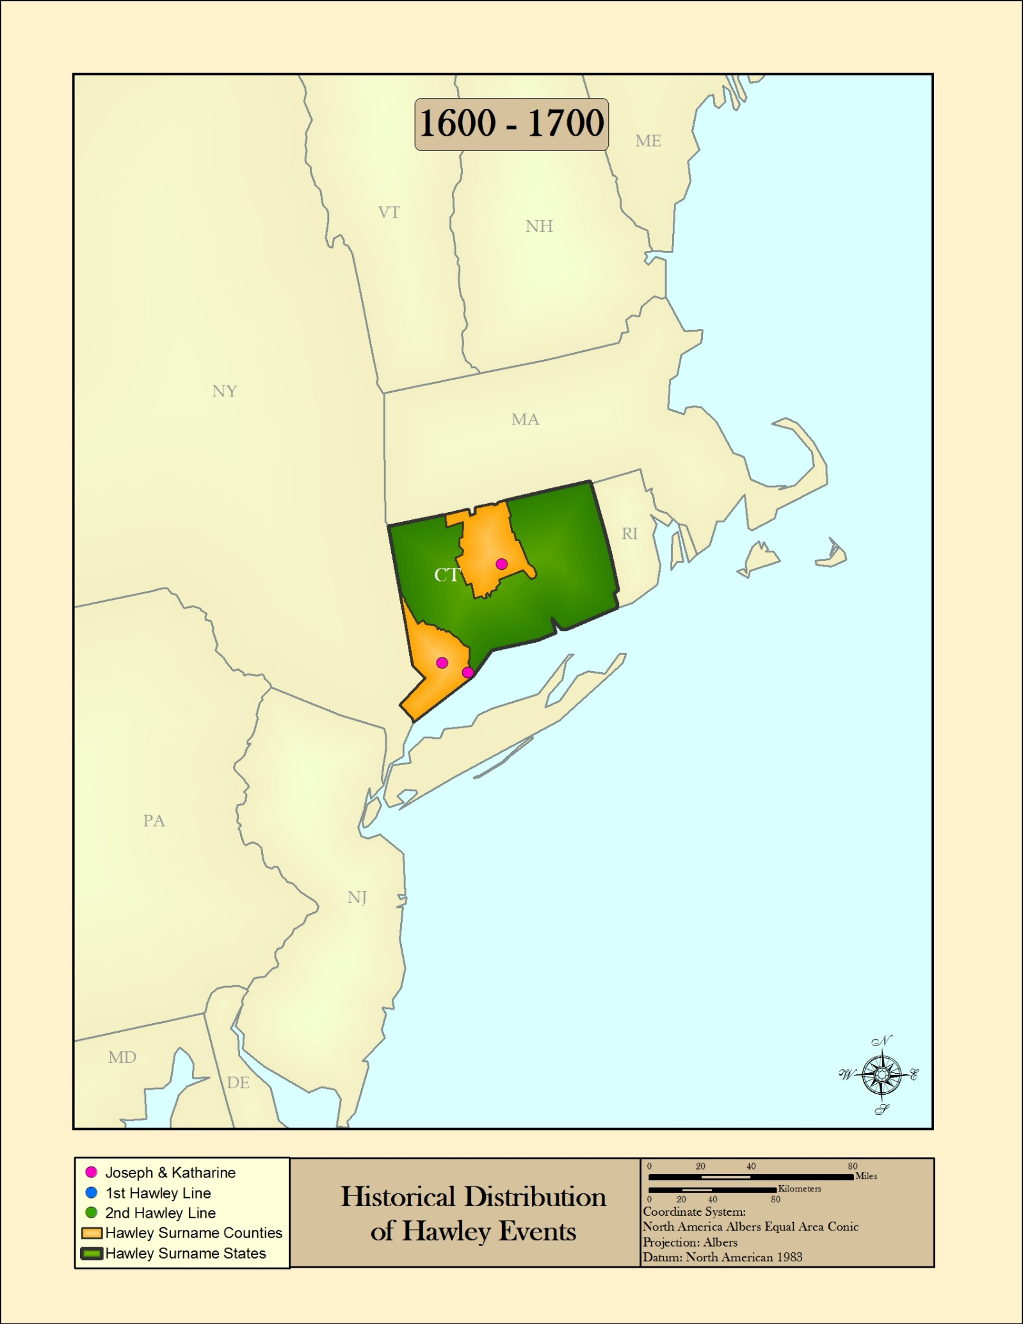
Figure 7.5: Historical Hawley event locations from the years 1600 to 1700
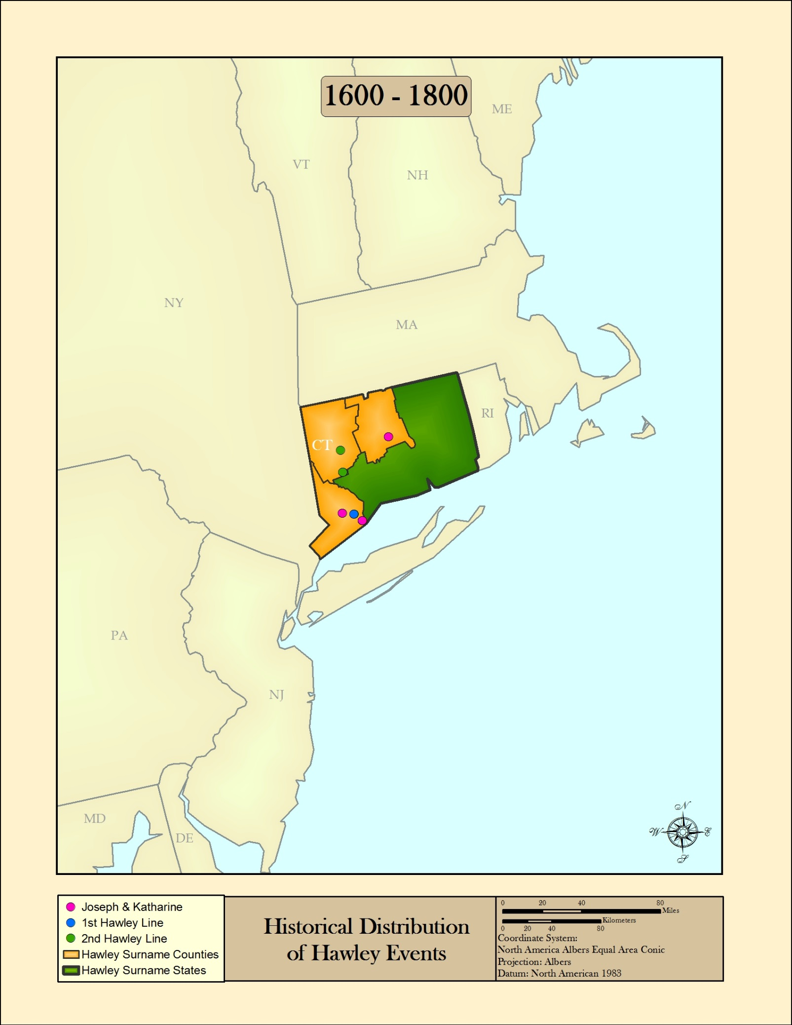
Figure 7.6: Historical Hawley event locations from the years 1600 to 1800
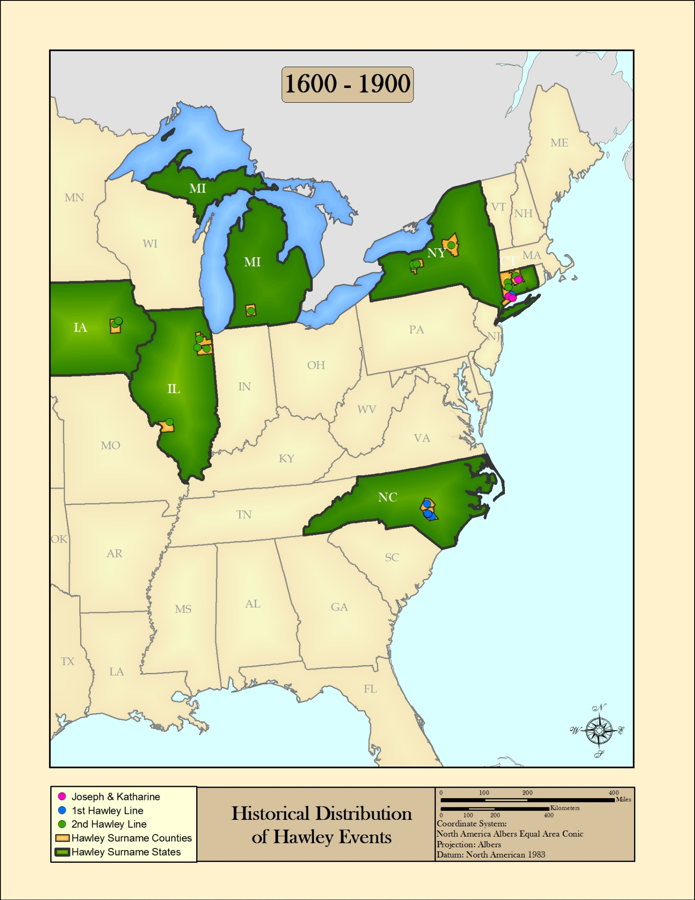
Figure 7.7: Historical Hawley event locations from the years 1600 to 1900
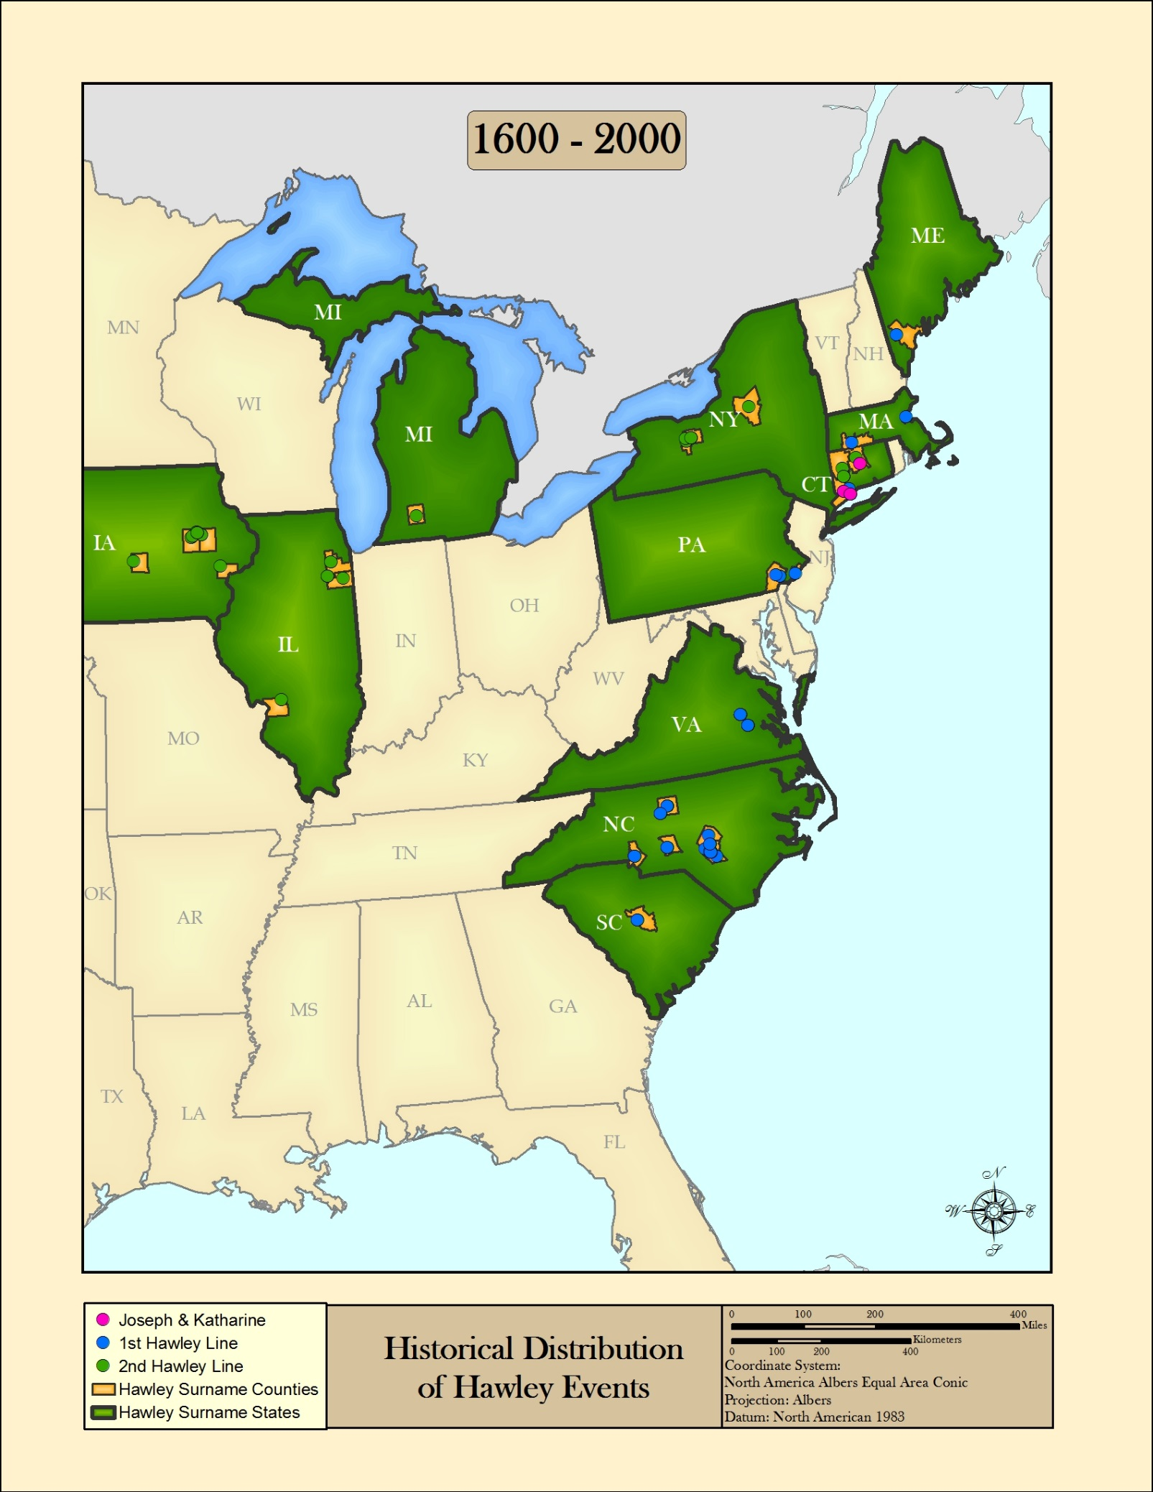
Figure 7.8: Historical Hawley event locations from the years 1600 to 2000

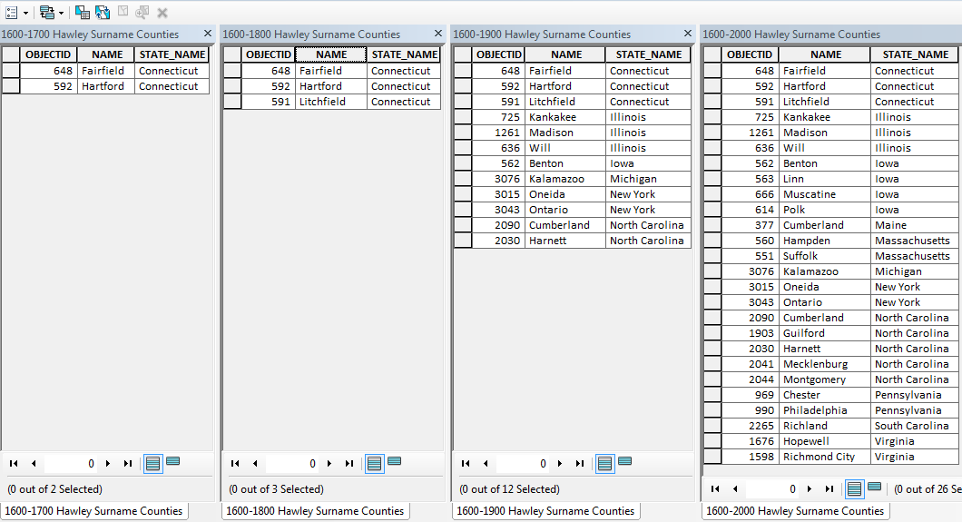
Figure 7.9: A tabular view of all four time groups. Each time group table contains the county and state name records of where Hawley events occur.

Additionally, clicking this hyperlink will play a short 1 minute video of the Hawley events in the United States from 1603 – 2013. The events appear in their spatial locations as the years advance, and the map shows the dispersion of Hawley events throughout this timeframe.

How does the total life-path distance of Hawley events change over time?
The Hawley database contains time information and spatial locations for each event that has a location listed from the base data sources used. GIS can be used to measure the total distance of these events, to help describe movement distances over time. This aims to act as a piece of information that helps to describe how a family’s movement distances have changed throughout history. It is expected that the total life-path distances would increase as dates become more recent, due to advancements in travel technology such as trains and cars, and the increasing travel infrastructure such as rail and roads.
This question is answered by using GIS to connect the same Hawley family member’s event locations with a line. This line is stored in its own layer so that the information is able to be analyzed separately. The resulting line is measured to find the total distance traveled from event to event along an individual’s life-path. The line record is assigned the name of the Hawley family member it represents, and the start and end dates (from Birth to Death or Burial).
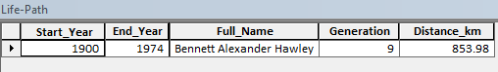
Figure 7.10: Example format of the resulting Life-Path line for Bennett Alexander Hawley
This process is repeated for each Hawley member found in the database. Each person’s event records are connected by a single line, and measured for total distance. The end result is a single line layer with all of the Hawley family members represented with one life-path line per individual. All of this information combined into a single layer should help the analyst or genealogist see how the life-path distances have changed over time.

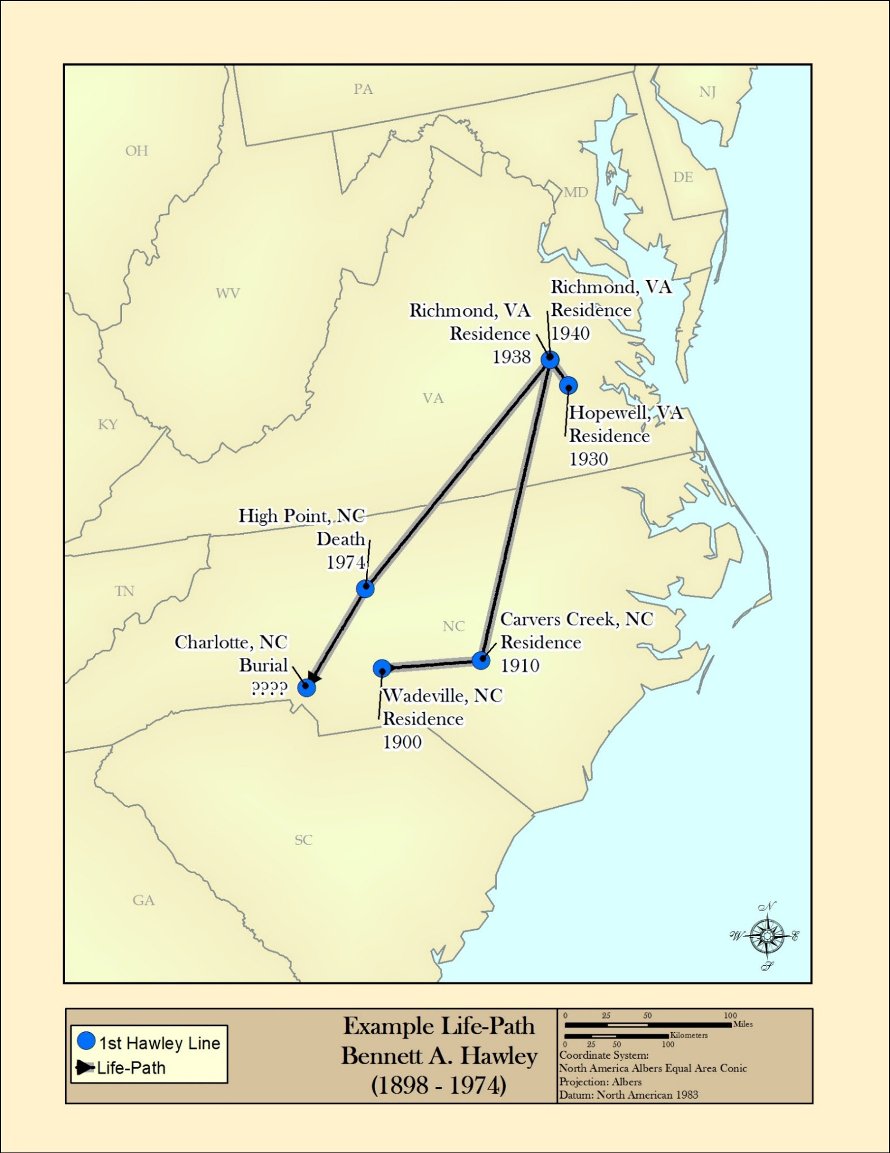
Figure 7.11: An example Life-Path for Bennett Alexander Hawley. The total line distance is measured from start to finish to obtain the Life-Path distance.
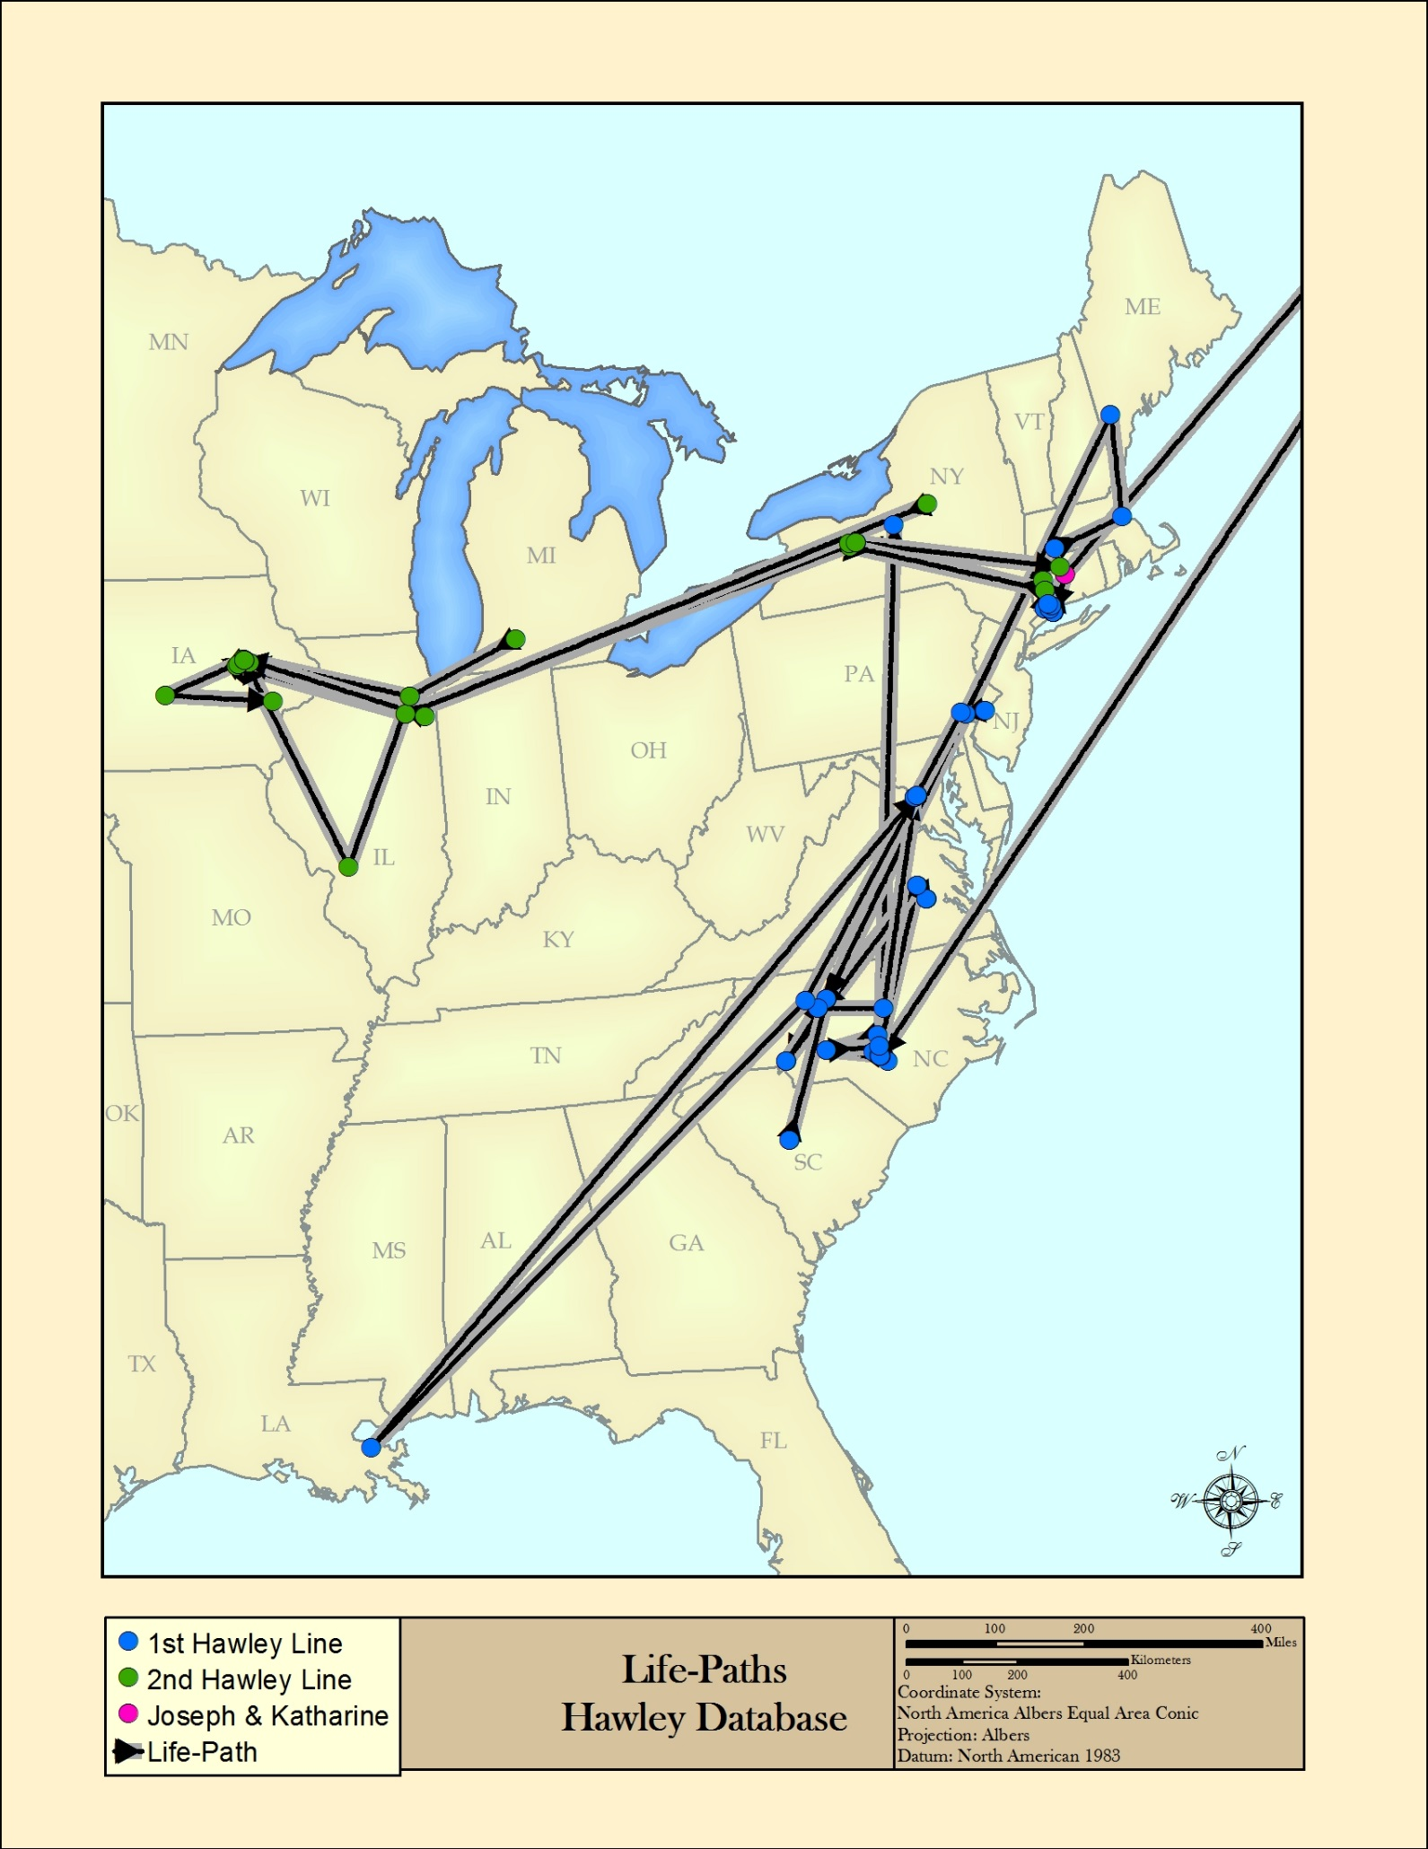
Figure 7.12: Life-Path lines for all members of the Hawley family, connecting the start and end event points for each individual.

As can be seen in the previous graphic, inspecting all of the life-path features at once is visually confusing and may not reveal much useful information. The real value comes from either inspecting each individual or a group of individuals, or working with the tabular data produced by the creation of the life-path lines. Each line contains temporal elements (generations and start/end years) and a spatial element (total distance in km). One way to examine the trend of distance over time, is to total all of the distances for each generation and compare.
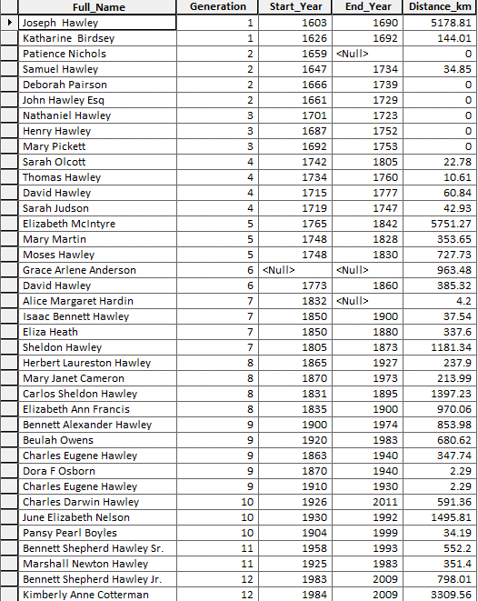
Figure 7.13: Tabular information of all life-path line features.

Figure 7.14: A bar chart showing the total life-path distances by all Hawley family members in each generation.

Figure 7.15: The same bar chart of information with any trans-Atlantic distances excluded in an effort to show the distance trend in the United States only.

Figure 7.16: A scatterplot graph with each Hawley member having an observation point on the graph. The Hawley records are ordered in chronologic order from oldest to youngest by start date. The blue trend line shows an increasing upward trend.

Reflections and Conclusions
The pilot methodologies explained previously are only a few of many ways to produce a GIS that is both usable and useful within the field of genealogic study. The intention is to outline several options for creating a GIS, and show how it is useful by giving an overview of GIS functionality. Finally, by answering a few key questions about the collected data, the reader should be able to grasp how GIS enhances the understanding of the data at hand beyond merely being able to display data points on a map.
There are several paths to the continuation of this pilot. Entering more data records into the Hawley sample database would further enrich the understanding of the Hawley family as a whole. There are many more records found within the Hawley Society’s online database that are available for entering. This would give a greater amount of resolution to the answers of the two questions asked in the previous section. The results particularly of the 2nd question “How does the total life-path distance of Hawley events change over time?” would hold much more strength due to the creation of many more family life-paths. The produced trend-line of change in life-path distances over time would be much more reflective of the actual change.
More data points would create the possibility of asking a third desired question that was taken out of consideration. This question is “How does the distance from birth to death or burial events change over time?” This was due to the lack of Hawley family members with both a recorded birth and death or burial events containing a place name within the sample of this pilot. Answering this question would provide another perspective on how the Hawley family’s movements have changed over time.
It is not expected that the methods outlined for this pilot are usable by genealogists of any technical skill level. Most of the methods presented require some introductory to intermediate understanding of the software platforms and functions used. An investment of time taking an introductory online course of study, or a self-guided introduction to GIS through either ESRI or another vendor is highly recommended before attempting to construct a usable GIS of any format. That being said, once an introductory understanding is obtained, a genealogist would have a very usable tool in learning more about the spatial elements of his or her data. All of the presented importing platforms provide a unique way of sharing the genealogic information being researched to other researchers, further offering the chance to collaborate with one another. GIS is a pathway to further understanding the realm of spatial information, and has the means to greatly improve the field of genealogy research in unique and interesting ways.

Acknowledgements
I would like to thank my advisor Dr. Deryck Holdsworth for his constant guidance and advice during the process of forming the capstone proposal and final pilot. His expertise proved critical for all aspects of this endeavor, and completion would not have been possible without his assistance.
I would like to thank Dr. Douglas Miller, Beth King, and the faculty supporting the Penn State MGIS program for providing an excellent framework for an advanced educational experience through the Dutton e-Education Institute.
I would like to thank Trudy Hawley, Pam Marlin, and the current president of the Hawley Society Michael Ray for providing me a great partnership and being receptive to the production of this pilot. My hope is for a continuing partnership to continue to support the genealogic and educational work produced by the Hawley Society.
I would like to thank my wife Kimberly Hawley for being a constant source of motivation, support, and inspiration for not only the production of this pilot, but my entire experience with the Penn State MGIS program.
Finally a special thank you to my son Ian Alexander Hawley, whose birth was the inspiration for researching my family history and forming the basis for this body of work.

Table of Figures
Figure 3.1: An example entry from the online Hawley Society database. Temporal data is outlined in red, while spatial data is outlined in blue (Hawley, The Hawley Record - Bennett Alexander Hawley, 2014) 8
Figure 3.2: The pedigree view for Bennett Alexander Hawley, showing two children Herbert and Mary, and two grandchildren Isaac and Alice (Hawley, The Hawley Record - Bennett Alexander Hawley, 2014) 10
Figure 3.3: Personal family document passed down to my father from my grandfather Charles D. Hawley, depicting the lineage of the Hawley family. 11
Figure 3.4: A section of the coat-hanger style family document researched by Charles D. Hawley. Temporal data is outlined in red, while spatial data is outlined in blue. 12
Figure 3.5: The published obituary of my grandfather Charles D. Hawley highlighting various details about his life, as well as the relationships of other family members. Temporal data is outlined in red, while spatial data is outlined in blue (Salisbury Post, 2014 13
Figure 3.6: Census documentation from 1940 of the Richmond City VA area accessible through Ancestry.com (Ancestry.com Operations, Inc., 2012). This document highlights the family members of my great-grandfather Bennett Alexander Hawley, and lists all the family members at this point in time which include my grandfather Charles Darwin Hawley. Spatial information is highlighted in blue, while temporal information is highlighted in red. 15
Figure 3.7: A sample of my Hawley family tree constructed using the Ancestry tools and interface shown in “Pedigree Mode”. The tree starts with my son Ian Alexander Hawley, and continues up the family line four generations. Further generations are viewable. Spatial information is highlighted in blue, while temporal information is highlighted in red. 16
Figure 4.1: Single line pedigree graphic showing each family member and how they are related to other family members. 19
Figure 4.2: Single line pedigree graphic showing the relationships of each family member and life date ranges to aid in communicating a temporal element. 20
Figure 4.3: Single line pedigree graphic showing the relationships of each family member and spatial coloration added to help communicate spatial element 22
Figure 4.4: Single line pedigree with each family member displayed on a time scale. The length of each family member graphic is dependent on the length of life. 23
Figure 4.5: An example life-path graphic describing a spatial element (Rural, Industrial, or Town/City location) over a defined period of time. A legend is included to aid in communication of significant life events along the line (Knowles, 1995). 24
Figure 4.6: A more complex life-path graphic showing an individual with more life events and more spatial element changes during a defined period of time (Knowles, 1995).. 25
Figure 4.8: xkcd web comic # 657 depicting a life-path line style graphic of the original Star Wars Trilogy. In this segment the locations of each character in "Episode 4: A New Hope" are depicated as lines through time running togeather when the characters in the story are located spatially in the same location (Munroe, 2014). 26
Figure 4.9: A basic "Space-time path" graphic. The spatio element is shown on a flat plane, with the time element moving from lower to higher off the plane. Older periods of time are shown lower (such as the 1600s) and more current periods of time are shown higher (such as the 1900s). A line connects each spatial observation, which shows where the population occurred during what timeframe (Yu & Shaw, 2005). 27
Figure 4.10: Time-space lines on a map of the United States showing the locations and movements of Chinese immigrants from 1874 to 1905 (McGlinn, 1995). 28
Figure 5.1: Basic structure of a single record to be used in a genealogy GIS. This record contains information related to the birth of Charles Darwin Hawley in Richmond, VA. 29
Figure 5.2: Temporal information is introduced to the table record by the addition of a "Date" column. 30
Figure 5.3: Additional records are added for Charles Darwin Hawley, one for each documented event. 30
Figure 5.4: Additional columns are added to hold more information about each record. 31
Figure 5.5: Additional columns are added to hold each "part" of the Full_Name column. 31
Figure 5.6: Additional columns added to hold each "part" of the Location column. 31
Figure 5.7: X and Y columns are added and each location Long/Lat coordinate pairs are entered. 32
Figure 5.8: A section of the fully formatted records for several family members. These records describe information about name, sex, date of event, event, location, age, and generation in the family line. 33
Figure 5.9: Image of fusion table records 34
Figure 5.10: Image of google map with data produced from Fusion table data. 35
Figure 5.11: An imported table in CartoDB 37
Figure 5.12: Image of CartoDB map with symbols 38
Figure 5.13: QGIS map view after importing a table of records. 39
Figure 5.14: Imported data points into an ArcGIS map session, with background US map data shown. 41
Figure 6.1: Several records in the Hawley dataset displayed in ArcMap based on the X and Y coordinate information 43
Figure 6.2: The sample Hawley dataset records displayed with US State boundaries 43
Figure 6.3: The Hawley dataset displayed on more of the US boundary layer 44
Figure 6.4: An example map product created using ArcMap and the Hawley spatial data. 45
Figure 6.5: The spatial selection result for the 10 states that contain Hawley data points 46
Figure 6.6: A map showing the selected state features in green from the spatial query. 47
Figure 6.7: Result of a county level selection, where all of the counties in the US that contain Hawley events are selected. 48
Figure 6.8: A map showing the selected county features in orange from the spatial query. 49
Figure 6.9: A distance measurement between two Hawley data points in Connecticut measuring approximately 5.9 miles. 50
Figure 6.10: A 50 mile buffer shown in light blue around Harnett County. 51
Figure 6.11: All Hawley records that are within 50 miles of Harnett County are highlighted in yellow. 51
Figure 6.12: The table information for all of the selected records, showing the name, sex, date, and event information for each record. 52
Figure 7.1: 2nd paternal family line entered into the Hawley genealogy GIS database from Joseph Hawley (1603 – 1690) to Marshall N. Hawley (1932 – 1983) 53
Figure 7.2: Events related to Joseph and Katherine Hawley symbolized on a United States Boundaries layer 54
Figure 7.3: The initial Hawley line added to the United States Boundaries layer. 55
Figure 7.4: Map depicting the historical Hawley event locations in the United States, with arrows labeling the general movement of two paternal lines. 56
Figure 7.5: Historical Hawley event locations from the years 1600 to 1700 58
Figure 7.6: Historical Hawley event locations from the years 1600 to 1800 59
Figure 7.7: Historical Hawley event locations from the years 1600 to 1900 60
Figure 7.8: Historical Hawley event locations from the years 1600 to 2000 61
Figure 7.9: A tabular view of all four time groups. Each time group table contains the county and state name records of where Hawley events occur. 62
Figure 7.10: Example format of the resulting Life-Path line for Bennett Alexander Hawley 63
Figure 7.11: An example Life-Path for Bennett Alexander Hawley. The total line distance is measured from start to finish to obtain the Life-Path distance. 64
Figure 7.12: Life-Path lines for all members of the Hawley family, connecting the start and end event points for each individual. 65
Figure 7.13: Tabular information of all life-path line features. 66
Figure 7.14: A bar chart showing the total life-path distances by all Hawley family members in each generation. 67
Figure 7.15: The same bar chart of information with any trans-Atlantic distances excluded in an effort to show the distance trend in the United States only. 68
Figure 7.16: A scatterplot graph with each Hawley member having an observation point on the graph. The Hawley records are ordered in chronologic order from oldest to youngest by start date. The blue trend line shows an increasing upward trend. 69

References
ACME Laboratories. (2014). ACME Mapper Main Navigation Page. Retrieved Feburary 24, 2014, from ACME Mapper 2.1: http://mapper.acme.com/
Ancestry.com LLC. (2014, Januaray 26). About Us. Retrieved from Ancestry.com: http://corporate.ancestry.com/about-ancestry/
Ancestry.com Operations, Inc. (2012). 1940 United States Federal Census [database on-line]. Sixteenth Census of the United States, 1940. Provo, UT, United States. Retrieved January 31, 2014
CartoDB. (2014). Media - What is CartoDB? Retrieved March 12, 2014, from CartoDB: http://cartodb.com/media
CartoDB. (2014). Pricing. Retrieved March 12, 2014, from CartoDB: http://cartodb.com/pricing/#/standard
DiBiase, D. (2014). Databases, Mapping, and GIS. Retrieved Feburary 16, 2014, from Penn State University, Nature of Geographic Information: https://www.e-education.psu.edu/natureofgeoinfo/c1_p6.html
Esri. (2011, November 17). News - Releases - ARC Advisory Group Report: Esri a Leading GIS Provider in Utilities Sector. Retrieved March 16, 2014, from Esri: http://www.esri.com/news/releases/11-4qtr/arc-advisory-group-report-esri-a-leading-gis-provider-in-utilities-sector.html
Esri. (2014). ArcGIS - Platform. Retrieved March 16, 2014, from Esri: http://www.esri.com/software/arcgis/platform
Esri. (2014). ArcGIS for Home Use Program - Overview. Retrieved March 16, 2014, from Esri: http://www.esri.com/software/arcgis/arcgis-for-home
Google Inc. (2014). About Fusion Tables. Retrieved March 2, 2014, from Fusion Tables Help Webpage: https://support.google.com/fusiontables/answer/2571232?hl=en
Google. Inc. (2013, October 8). Google Fusion Tables - Getting Started. Retrieved March 12, 2014, from Google Developers: https://developers.google.com/fusiontables/docs/v1/getting_started
Google. Inc. (2014, March 11). Google Maps JavaScript API v3 - Getting Started. Retrieved March 12, 2014, from Google Developers: https://developers.google.com/maps/documentation/javascript/tutorial
Hawley, T. (2014, January 12). The Hawley Record. Retrieved from Rootsweb, Ancestry.com: http://wc.rootsweb.ancestry.com/cgi-bin/igm.cgi?db=eliassillhawley&I11.x=28&I11.y=3
Hawley, T. (2014, January 12). The Hawley Record - Bennett Alexander Hawley. Retrieved from Rootsweb: http://wc.rootsweb.ancestry.com/cgi-bin/igm.cgi?op=GET&db=eliassillhawley&id=I34539
Knowles, A. (1995). Immigrant trajectories through the rural-industrial transition in Wales and the United States, 1795 - 1850. Annals, Association of American Geographers, 85, 2:246-266.
McGlinn, L. (1995). Power networks and early Chinese immigrants in Pennsylvania. Journal of Historical Geography, 21, 4:430-445.
Merriam-Webster, Incorporated. (2014, Januaray 5). Genealogy. Retrieved from Merriam-Webster: http://www.merriam-webster.com/dictionary/genealogy
Munroe, R. (2014, Feburary 15). Movie Narrative Charts. Retrieved from xkcd.com: http://xkcd.com/657/
QGIS Open Source Project. (2014, March 12). For Users - Get Started Using QGIS. Retrieved March 16, 2014, from QGIS: http://www.qgis.org/en/site/forusers/index.html
Salisbury Post. (2014, January 25). Charles Darwin Hawley Obituary. Retrieved from Salisburypost.com: http://www.legacy.com/obituaries/salisburypost/obituary.aspx?page=lifestory&pid=149551466
Santini, R. (2014, January 5). Definition and Characteristics of GIS. Retrieved from GEOG 469: Energy Industry Applications of GIS: https://www.e-education.psu.edu/geog469/node/200
Society of the Hawley Family, Inc. (2014, January 12). Home Page. Retrieved from The Society of the Hawley Family: http://www.hawleysociety.org/
Society of the Hawley Family, Inc. (2014, February 3). Reunions. Retrieved from The Society of the Hawley Family: http://www.hawleysociety.org/reunions/
www.latlong.net. (2014). Latitude Longitude Finder. Retrieved Feburary 24, 2014, from latlong.net: http://www.latlong.net/
Yu, H., & Shaw, S.-L. (2005). Publications. Retrieved 02 15, 2014, from NSF-Project-Website Oklahoma State University: http://www2.geog.okstate.edu/users/HongboYu/NSF-Project-Website/publications/Yu_Shaw_2005.pdf

