Analyzing Tobler’s Hiking Function and Naismith’s Rule
Using Crowd-Sourced GPS Data
Erik Irtenkauf
The Pennsylvania State University
May 2014

Introduction
Within the fields of geography and GIS there are a variety of methods for modeling human walking speed. Two of the most common methods are Tobler’s Hiking Function and Naismith’s Rule. Both are used for many uses, including supporting archaeological research (Gorenflo and Gale, 1990; McCoy et al., 2011; Kantner, 2004; Ullah, 2011), wilderness search and rescue (Magyari-Saska and Dombay, 2010) and emergency evacuation modeling (Wood & Schmidtlein, 2013), optimally positioning health facilities in developing areas (Matthews, 2013; Noor et al., 2006), and for outdoor recreation (Green, 2006). This wide variety of applications, some of which have life and death implications, suggests the importance of understanding how each method functions in a variety of environments and conditions.
Objectives
This project used crowd-sourced GPS data and geographic information system (GIS) modeling to validate each of these methods. This was done by acquiring 120 user submitted GPS hiking tracks and comparing the actual walking times to those predicted by Tobler’s function and Naismith’s Rule, given the distance and elevation changes for each track. Conclusions were also reached about cost-distance raster analysis techniques and the general usefulness of crowd-sourced GPS data for academic research.

Tobler’s Function & Naismith’s Rule
Tobler’s hiking function (1993) is an exponential equation that describes how human walking speed varies with slope. It can be expressed as:
W = 6 * exp {-3.5 * abs (S + 0.05)} | (1)
where W is walking velocity and S equals the slope of the terrain. The walking velocity is in kilometers per hour. Tobler developed his equation from Imhof (1950), who gathered empirical data on Swiss military marching rates.
Naismith’s rule was developed in 1892 by Scottish mountaineer William Naismith as a method of predicting hiking times. His rule states that a person takes one hour to walk 5 kilometers on flat ground, but requires an hour for every 600 meters of ascent. Langmuir amended the rule for downhill travel by subtracting 10 minutes for every 300 meters of moderate descent (between negative 5 and 12 degrees) and adding 10 minutes for every 300 meters of descent over steep slopes (greater than 12 degrees) (Fritz, Carver & See, 2000).
The rule can also be expressed as an equation (GRASS, 2013)
T = [(a) * (Delta S)] + [(b) * (Delta H Uphill)] + [(c) * (Delta H Moderate Downhill)] + [(d) * (Delta H Steep Downhill)] | (2)
T is travel time in seconds, Delta S is the horizontal distance traveled and Delta H is the vertical distance traveled. Moderate Downhill is between negative 5 and 12 degrees and Steep Downhill is less than negative 12 degrees slope.
The other parameters adjust travel speed based on these slope classes. Langmuir’s proposed values are:
Figure 1: Speed predictions from Tobler's Hiking Function and Naismith-Langmuir's Rule
a: 0.72
b: 6.0
c: 1.9998
d: -1.9998
The speeds predicted by both rules are generally very similar. They each estimate a speed of approximately 5 km / hour on level ground. Both rules also suggest that maximum walking speeds occur on gentle downslopes. Tobler’s maximum predicted speed of 6 km per hour occurs at -2.86°. However the Naismith-Langmuir maximum speed is much faster, around 12 km / hour occurring at -12° slope. Speed predictions for steep downhill and steep uphill slopes are also faster under Naismith-Langmuir.
Crowd-Sourced Sample Data
Crowd-sourced GPS data was obtained from www.wikiloc.com (Wikiloc), one of the largest sites on the Internet for uploading and sharing GPS tracks. We obtained permission from Wikiloc to access and download these tracks with the assurance that all private information would not be shared in our research findings. Each track was downloaded in GPS Exchange (GPX) Format with points recording latitude and longitude, altitude, and a date-time stamp. Each track also had a qualitative difficulty rating (easy, moderate, difficult, very difficult) assigned by the submitter.
The following criteria were used to gather sample data:
- Tracks must be categorized as “hiking”  - May not take place in majority urban areas  - Must be between 2 and 15 miles in length  - Must be recorded with a GPS device (not a phone or user digitized track) | - Only one track per submitter  - User notes for each track were also reviewed, if there were indications of GPS problems or abnormal circumstances (e.g. “we did this hike with small children and had to stop frequently…”) the track was discarded

In eight cases it was necessary to stray from these criteria in order to obtain a large enough sample size. Three tracks were recorded from a smart phone instead of a dedicated GPS device. Five tracks were subset from a GPS track longer than 15 miles.
Figure 2: Breakdown of sampled GPS tracks by year.
Thirty samples were chosen from each of four unique environmental regions as defined by Bailey’s (2008) ecoregion division scheme, for a total of 120 tracks. A map of the sampled ecoregions is available in Appendix A.
The downloaded sample of tracks spanned the time period from 2006-2013. An upward trend in the number of tracks per year is evident, likely illustrating the growing popularity of Wikiloc and/or the growing prevalence of personal GPS devices.
Figure 3: Breakdown of sampled GPS tracks by season.
Sample tracks encompassed all four seasons. The largest number of hiking events occurred in the summer (June to August) and fall months (September to November).
The tracks considered in this study occupied a variety of land cover types. Land cover percentages were determined using the 2006 National Land Cover Database (Fry, 2011), a 30 meter resolution dataset covering the continental United States. The predominant land cover types were Deciduous and Evergreen forests. Scrub/Shrub, Grassland, and Barren land cover were also included. A limited number of tracks also traversed areas categorized as Developed.
Figure 4: Breakdown of sampled GPS tracks by Land Cover type.
Data Preparation
Each track was preprocessed prior to GIS analysis. Garmin’s Basecamp software was used to review the speed and time values for each track. Those with numerous abnormal speeds or incorrect date-time values were discarded. In some limited cases tracks had to be edited to remove segments of anomalous high speeds. In at least one case it was clear this was due to the GPS device being left on in a moving vehicle at the end of the hike.
GPS time stamps make it possible to determine the total time required for each hike. However this might include time spent not actively moving. In order to properly compare actual and predicted hiking times it was necessary to calculate a “moving time” for each track. This was done using the Garmin Basecamp software which automatically calculates “moving time” as any time where walking speed is faster than 0.5 miles per hour. Although using this type of cutoff is relatively crude, this was deemed the optimal method within the timespan and constraints of this project. Spot-checking throughout the project ensured that this method was returning reasonable results and not excluding otherwise valid data points.
In addition to total and moving times, a variety of other attributes were manually recorded for each track in a spreadsheet. These included the number of GPS points, State, month, year, user described difficulty rating, length, and any miscellaneous notes shared by the individual who uploaded the track.
GPX tracks were then imported into an ArcGIS Geodatabase using the GPX to Features tool as a point feature class and then converted to a polyline feature. Because cost-distance modeling calculates movement outward from a starting location, and cannot move backward, tracks that “doubled back” over themselves had to be divided into discrete sub-tracks (Figure 5). Starting points were then created at the beginning of each sub-track.

Figure 5: Overlapping tracks were divided into sub-tracks.
Each sub-track was used as a mask to extract elevation values from a USGS National Elevation DEM with 1/3 arc-second (approximately 10 meter) resolution (USGS, 2006). This dataset is the highest resolution DEM source available at a national scale and was chosen to provide a consistent source of elevation values for this project. Elevation values along each track were extracted to limit the cost distance analysis to movement along the hiking track and not across the surrounding terrain.
Select tracks were also further processed in an attempt to analyze the relationship between speed and slope for individual GPS data points. First the speed of each GPS point was calculated using a script available from the ArcGIS Resource Center (Hibma, 2011). This script assigns speeds to polyline segments so it was necessary to use a series of geoprocessing steps to associate the calculated speed, and the distance from the previous point, with each GPS point. Elevation values for each point were then extracted from the USGS DEM. Finally, a DBF table was exported from ArcGIS for each track with speed, distance, and elevation values for each point. This file was then used in Excel to enable further analysis of specific GPS points.
The above activities were automated in ArcGIS by developing Model Builder models. This significantly reduced the processing time. Nonetheless, validating, cleaning, and processing the GPS data was the most time consuming phase of this project.
GIS Modeling Methods
Both rules were modeled using GIS cost-distance analysis. Multiple authors (Herzog, 2012; Kondo et al, 2008) have noted that results can vary based on which software package is used and how it implements cost distance algorithms The GIS modeling methods used in this project were chosen because they are commonly referenced in literature and are likely to be used by future scholars.
Tobler’s hiking function was modeled in ESRI’s ArcGIS software using the Path Distance Tool (ESRI, 2012) and a methodology developed by Tripcevich (2009). This method calculates movement cost (in time) over an elevation surface based on a starting point. Through the use of a Vertical Relative Moving Angle table, costs can be calculated based on Tobler’s function. This approach has been used by multiple other authors (Taliaferro, Schriever & Shackley, 2010; McCoy et al., 2011; Wood & Schmidtlein, 2012).
The Naismith-Langmuir rule was modeled in the GRASS GIS software package (GRASS, 2013). The GRASS r.walk module natively implements Naismith-Langmuir and several studies have used this method (Orengo & Aleix, 2009; Kondo et al., 2008; Ullah, 2011). GRASS calculates walking time using Equation 2; all the default values were kept.
In addition to an elevation file GRASS also requires a friction cost raster input. This is useful for calculating isotropic costs (such as the effect of vegetation) on top of the anisotropic costs of moving up and down hill. For this project it was not necessary to model isotropic costs, however, since GRASS requires an input the elevation file was used twice. By changing another variable called the Lambda coefficient from 1 to 0 the effect of the friction raster was cancelled out. Although this is relatively minor issue it is noted here for the benefit of others who may wish to repeat this process.
Data Analysis
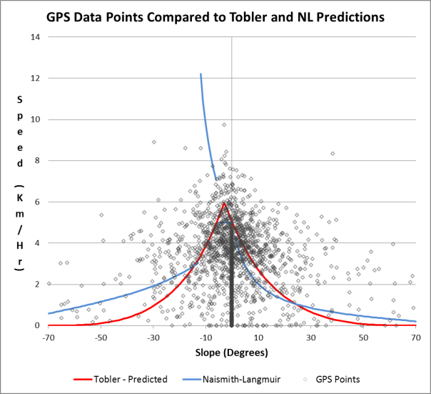
After each track was analyzed the Tobler and Naismith-Langmuir times were recorded in the tracking spreadsheet where they could be compared to the actual moving times. The GPS tracks chosen for further analysis were also imported into Excel. Tobler and Naismith-Langmuir predictions were calculated for each point and further analysis was done to compare predicted and actual speeds.
Figure 6: Sample graph showing GPS data points overlaid against Tobler and Naismith-Langmuir speed predictions.

Findings
Overall both methods produced very similar results. The correlation coefficient between predicted times was 0.99, indicating that both rules function similarly over the same terrain. This correlation was constant across all four ecoregions.
For Tobler estimates, 57 tracks were slower than predicted and 63 tracks were faster. For Naismith-Langmuir, 55 tracks were slower and 65 were faster. Comparing the estimated times, the Tobler estimate was faster than the Naismith-Langmuir estimate for 74 tracks (61.6%).
Both methods were also fairly accurate. Tobler predicted times were off by 21.05% from actual hiking times. Naismith-Langmuir predictions were off by 19.72%.
 | Full Dataset | Marine Regime | Temp. Steppe |  | Hot Continental | Warm Continental
Tobler | 21.05 | 28.34 |  | 22.02 | 17.69 | 16.14
Naismith-Langmuir | 19.72 | 23.52 |  | 21.34 | 17.18 | 16.84
Table 1: Average difference (%) between actual and predicted hiking times
The accuracy of each rule varied across the ecoregion divisions (Table 1). Tracks in the Warm Continental Regime Mountains in the American northeast had the most accurate predictions where both methods were off by only around 16%. Tracks in the Marine Regime Mountains of the Pacific Northwest had the least accurate predictions. Here Tobler estimates were off by 28.34% and Naismith-Langmuir was off by 23.52%

Figure 7: Breakdown of predictions by accuracy range.
For both rules, 35% of tracks had predicted times within +/- 10% of the actual moving time. 70% were within +/- 25% of the actual time and 93% were within +/- 50%. These percentages give an idea of the margin of error that can be expected when calculating walking times with each method.
The biggest difference between Tobler and Naismith-Langmuir predictions occurs in moderate downhill slopes, where Naismith-Langmuir predicts speeds exceeding 12 km / hour while Tobler predicts speeds between 3.5 – 5.5 km / hour. Although there were some instances where hikers achieved speeds similar to the higher Naismith-Langmuir predictions, the majority of data points reviewed were closer to the Tobler estimates.
Challenges and Lessons Learned
During the course of this project several challenges were encountered which future researchers should be aware of.
In the data analysis phase it was determined that the modeling of Tobler’s function was producing misleading results for several tracks due to small areas, usually only several pixels wide, with a large elevation change. In some cases this was caused by apparent anomalies in the digital elevation data and in others it stemmed from tracks that occurred along steep cliffs. The result was that these areas were adding excessive, apparently unrealistic, times to the Tobler predictions.
In one example a track descended a steep wall, possibly using a route that was not apparent due to the DEM’s 10 meter spatial resolution. In the span of one pixel the elevation changed from approximately 697 meters to 679 meters, or a slope of approximately -60 degrees. Tobler predicts a speed of approximately 0.01 km per hour at this slope and so this 10 meter span added 35 minutes to the overall predicted time. Once this was corrected, the track’s predicted time went from 274 minutes to 236 minutes. The actual walking time was 239 minutes, so correcting for this error resulted in an almost exact prediction.
It should be noted that the same problem did not occur in the Naismith-Langmuir predictions. That method estimates a much faster, although still slow, speed of ~.9 km per hour at -60 degrees slope. This only adds around one minute of additional travel time over the same distance. While this is still a long time to cover only 10 meters, this comparatively faster speed does not heavily impact the overall time for small areas. In this sense, Naismith-Langmuir is more “forgiving” of anomalies in the input GPS or elevation data.
Another difficulty occurred when trying to further analyze individual GPS data points in in Excel. The slope and predicted speed for each GPS data point was determined in Excel using the speed, distance from the previous point, and elevation height previously calculated in ArcGIS. It was hoped this would enable further in-depth analysis of predicted vs. actual speeds. Difficulties arose however due to differences in the way that speeds and times are calculated in raster analysis vs. in Excel, which uses straight-line distances and slopes between data points.
In Figure 8 the straight-line distance between points is 72.96 meters while the distance as calculated by the cost-distance algorithm is 104 meters. The cost-distance method also calculates slope on a cell-by-cell basis while the straight-line method can only calculate slope based on the elevation values of the starting and ending points. Although the differences are not always large in absolute terms, over the course of a multi-kilometer hike they can produce considerable differences in predicted speeds and times. This validates the findings of other researchers (Herzog, 2012; Kondo et al, 2008) who found that different software packages and methods can produce different predicted times and speeds.

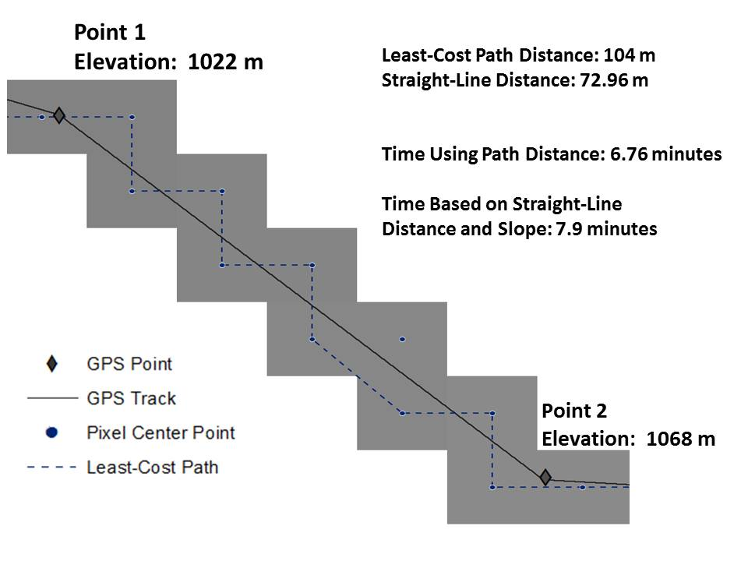
Figure 8: Comparison of distance and time differences between raster analysis and straight-line distance.
The aforementioned data anomalies encountered when modeling Tobler’s function in GIS were also apparent when deriving times in Excel. Small data anomalies resulted in extremely slow, unrealistic speeds, which drastically inflated the predicted times.
Due to these challenges it was difficult to do further in-depth analysis at the level of individual GPS points within the time constraints of this project.
Another challenge was finding an adequate number of GPS samples for each ecoregion. A defined project criterion was to locate at least 30 tracks per ecoregion division to ensure an adequate sample size. Although Wikiloc has over 1.5 million GPS tracks this number is quickly reduced when filtering non-hiking tracks and focusing on a relatively small study area. Further, it was noted that some “power users” upload a large number of GPS tracks in a particular area. Selecting only one track per user further reduces the available number of tracks.
As previously discussed, because of this issue in a limited number of instances tracks were included that did not meet all of the defined project criteria. A lack of samples also precluded analyzing some ecoregion divisions after an initial evaluation. Future researchers attempting to use crowd-sourced GPS data may wish to choose tracks from multiple websites to ensure a larger population of potential samples.
Discussion
Crowd-sourced GPS data is a rich resource that can be used to quickly develop large sample sets. Previous attempts that have validated Tobler and Naismith have relied on small sample sizes (Aldenderfer; Kondo et al; Kondo and Seino) or limited geographic areas (Kennedy, 2007; Scarf, 1998, Kondo and Seino). This project supports their conclusions but was able to validate Tobler and Naismith-Langmuir using a more diverse sample of subjects and environmental conditions. The large number of samples also makes it possible to determine accuracy ranges and assign potential margins of error to the time estimates. This is useful information that provides context for interpreting the times predicted by each method.
The results of this study also support previous research by Magyari-Saska & Dombay (2012) and Kondo et al (2008) that found a strong correlation between the times predicted by each method. Those previous studies also found that Tobler estimates are generally faster than Naismith-Langmuir, which is supported by this study.
The variation in accuracy between the ecoregion divisions is currently unexplained and requires further examination. With the presently available data there is not a clear explanation for the ability of Tobler and Naismith-Langmuir to produce better time estimates in the Warm Continental Regime Mountains compared to the Marine Regime Mountains. One hypothesis considered was that the mountains in the Northwest may have a greater percentage of high slope areas, and therefore be more difficult to hike leading to less accurate predictions.
This was tested by binning the GPS data points for all the tracks in both ecoregions by slope category (Figure 9). Both regions have similar slope distributions, particularly in moderate and high slope areas. This appears to rule out slope as the sole explanation for differences in accuracy.
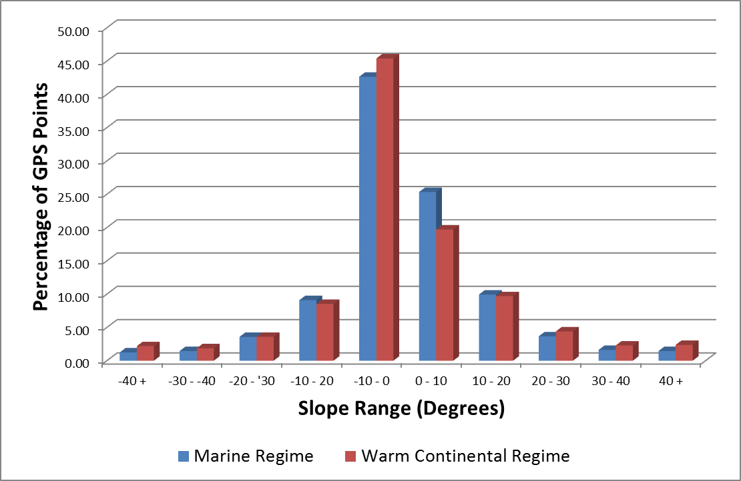
Figure 9: GPS data points binned by ecoregion divisions.
Land cover was also considered as a potential explanation for these differences. The sampled tracks from the Marine Regime Mountains are composed of a majority of Evergreen Forest (66%). However tracks in the Warm Continental Regime and Temperate Steppe Regime Mountains were also composed of large percentages (40% and 57%, respectively) of the same land cover type. This seems to rule out a simple explanation based on land cover type.
The differences in accuracy may be due to a combination of factors not captured in the available data, including weather, altitude, and trail conditions. Further research, perhaps augmenting crowd-sourced data with more rigorous experiments may help explain these discrepancies.
The lack of supporting documentation (field notes, respondent surveys) that might explain these differences highlights one drawback of working with crowd-sourced GPS data. Although uploaders to the Wikiloc website have the option of entering free text notes when they share a track, this feature is inconsistently used.
A future improvement that GPS sharing websites can make would be the addition of several drop downs or check boxes for users to fill out when uploading a track. These could describe trail conditions (e.g. dry, wet, rocky), weather conditions (clear, hot, cold, rain), as well as gather basic demographic data about physical condition and experience level of the hiker. Inputting this data would not greatly add to the burden of uploading a track while making the data much more useful for researchers (and other hikers hoping to recreate a hike).
The crowd-sourced GPS data evaluated in this project appears to validate both Tobler’s Function and the Naismith-Langmuir Rule. However it is important to consider the population sampled in this project when interpreting these results. All the tracks were recorded by hikers in natural (non-urban) environments and shared on the Internet. It is possible that people who routinely hike are more physically fit than the average person. Also, hikers who are comfortable with GPS technology and with uploading their personal data onto the Internet may also be younger than the general population. Further, due to different environmental conditions walking times in an urban environment may vary considerably from rural hiking trails. These caveats should be considered when trying to apply these results to a larger population or for use in urban settings.
Conclusions
Both Tobler’s Hiking Function and the Naismith-Langmuir rule perform well at predicting hiking times when compared to crowd-sourced GPS data. The accuracy of these predictions varies somewhat based on ecoregion division, for reasons not entirely clear. The results of this project support the usefulness of both methods. Future researchers could improve on the data preparation and analysis methods used in this project and expand the amount of crowd-sourced data analyzed. This would provide a better understanding of how the accuracy of these methods varies over space and time.

Appendix A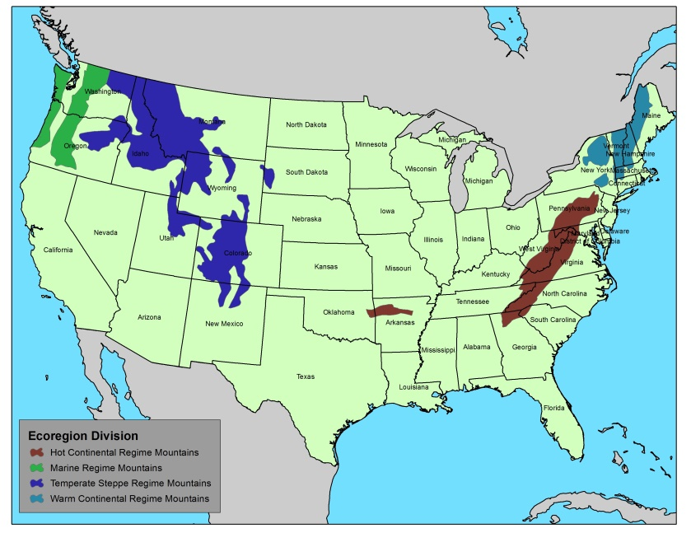
Figure 10: Ecoregion divisions sampled in this study.
Works Cited

Aldenderfer, M. S. (1998). Montane foragers: Asana and the south-central Andean archaic. Iowa City: University of Iowa Press.

Baily, R. (2008). Description of the Ecoregions of the United States. Retrieved from http://www.fs.fed.us/land/ecosysmgmt/

ESRI. (2012). How the Path Distance Tools Work. Retrieved from http://resources.arcgis.com/en/help/main/10.1/index.html#//009z00000027000000

Fritz, S., Carver, S. & See, L. (2000). New GIS Approaches to Wild Land Mapping in Europe. USDA Forest Service Proceedings RMRS-P-15-VOL-2, pp. 120-127.

Fry, J., Xian, G., Jin, S., Dewitz, J., Homer, C., Yang, L., Barnes, C., Herold, N., and Wickham, J., 2011. Completion of the 2006 National Land Cover Database for the Conterminous United States. PE&RS, 77(9), pp.858-864. Retrieved from http://www.mrlc.gov/nlcd2006.php

Gorenflo, L. J., & Gale, N. (1990). Mapping regional settlement in information space. Journal of Anthropological Archaeology, 9(3), 240-274.

GRASS Development Team. (2013). GRASS GIS manual: r.walk. Retrieved from http://grass.osgeo.org/grass64/manuals/r.walk.html

Green, C. (2006). How long is the hike? Retrieved from http://www.scoutmastercg.com/naismiths_rule_/

Herzog, I. (2012). The potential and limits of optimal path analysis. In A. Bevan and M. Lake (Eds.), Computational Approaches to Archaeological Spaces. Walnut Creek: Lef Coast Press. Retrieved from http://www.academia.edu/1565382/The_Potential_and_Limits_of_Optimal_Path_Analysis

Hibma, K. (2011). Analyzing your GPS tracking data with Python – Esri UC 2011. Retrieved from http://resources.arcgis.com/gallery/file/geoprocessing/details?entryID=2F121F58-1422-2418-8897-6CAEAA46CEE2

Imhof, E. (1950). Gelande und karte. Zurich: Eugen Rentsch Verlag.

Kantner, J. (2004). Geographical approaches for reconstructing past human behavior from prehistoric roadways. In M. Goodchild and D. Janelle (Eds.), Spatially Integrated Social Science (Spatial Information Systems) pp. 323-344. Oxford: Oxford University Press.

Kennedy, P. (2007). Naismith Rules? Actual versus predicted route times in the Scottish Highlands and English Lake District. Originally located at http://www.gillean.demon.co.uk/Naismith/Naismith.htm. Retrieved from http://web.archive.org/web/20070611004248/http://www.gillean.demon.co.uk/Naismith/Naismith.htm

Kondo, Y., Ako, T., Heshiki, I., Matsumoto, G., Seino, Y., Takeda, Y., & Yamaguchi, H. (2008). FIELDWALK@ KOZU: A Preliminary Report of the GPS/GIS-aided Walking Experiments for Re-modeling Prehistoric Pathways at Kozushima Island (East Japan). In J. Erzsebt, F. Redo, & V. Szeverenyi (Eds), On the Road to Reconstructing the Past. Computer Applications and Quantitative Methods in Archaeology. Proceedings of the 36th International Conference. Budapest, April 2-6, 2008. Archaeolingua. Retrieved from http://www.academia.edu/670946/FIELDWALK_at_KOZU_A_Preliminary_Report_of_the_GPS_GIS-aided_Walking_Experiments_for_Remodeling_Prehistoric_Pathways_at_Kozushima_Island_East_

Kondo, Y., & Seino, Y. (2009). GPS-aided Walking Experiments and Data-driven Travel Cost Modeling on the Historical Road of Nakasendō-Kisoji (Central Highland Japan). In B. Frischer, J.W. Crawford, & David Koller (Eds.), Making History Interactive. Computer Applications and Quantitative Methods in Archaeology (CAA). Proceedings of the 37th International Conference, Williamsburg, Virginia, United States of America, March 22-26, 2009, (BAR International Series 2079) pp. 158-165. Oxford: Archaeopress. Retrieved from http://www.academia.edu/670947/GPS-aided_walking_experiments_and_data-driven_travel_cost_modeling_on_the_historical_road_of_Nakasendo-Kisoji_Central_Highland_Japan_

Magyari-Saska, Z., & Dombay, S. (2012). Determining Minimum Hiking Time Using DEM. Geographia Napocensis, VI(2), 124-129.

Matthews, Z. (2013). Too far to walk – calibrating distances to maternity health facilities for women in Ghana using GIS tools [PowerPoint presentation]. Retrieved from http://www.slideshare.net/ICS_Integrare/distances-to-health-facilities-in-ghana-for-women

McCoy, M. D., Mills, P. R., Lundblad, S., Rieth, T., Kahn, J. G., & Gard, R. (2011). A cost surface model of volcanic glass quarrying and exchange in Hawai ‘i. Journal of Archaeological Science, 38(10), pp. 2547-2560.

Noor, A. M., Amin, A. A., Gething, P. W., Atkinson, P. M., Hay, S. I., & Snow, R. W. (2006). Modelling distances travelled to government health services in Kenya. Tropical Medicine & International Health, 11(2), pp. 188-196.

Taliaferro, M. S., Schriever, B. A., & Shackley, M. S. (2010). Obsidian procurement, least cost path analysis, and social interaction in the Mimbres area of southwestern New Mexico. Journal of Archaeological Science, 37(3), 536-548.

Tobler, W. R. (1993). Three Presentations on Geographical Analysis and Modeling: Non-isotropic Geographic Modeling, Speculations on the Geometry of Geography And, Global Spatial Analysis. National Center for Geographic Information and Analysis. Retrieved from http://www.ncgia.ucsb.edu/Publications/Tech_Reports/93/93-1.PDF

Tripcevich, N. (2009). Workshop 2009, No. 1 – Viewshed and Cost Distance. Retrieved from http://mapaspects.org/courses/gis-and-anthropology/workshop-2009-viewshed-and-cost-distance

Ullah, I. T. (2011). A GIS method for assessing the zone of human-environmental impact around archaeological sites: a test case from the Late Neolithic of Wadi Ziqlâb, Jordan. Journal of Archaeological Science, 38(3), 623-632.

USGS. (2006). National Elevation Dataset. Retrieved from http://ned.usgs.gov/

Wood, N. J., & Schmidtlein, M. C. (2012). Anisotropic path modeling to assess pedestrian-evacuation potential from Cascadia-related tsunamis in the US Pacific Northwest. Natural hazards, 62(2), 275-300.

Orengo, H., & Alaix, C. M. (2009). Following Roman waterways from a computer screen. GIS-based approaches to the analysis of Barcino’s aqueducts. In Go Your Own Least Cost Path. Spatial Technology and Archaeological Interpretation. Proceedings of the GIS Session at EAA 2009, Riva del Garda. Retrieved from http://www.academia.edu/1144221/Following_Roman_Waterways_from_a_Computer_Screen._GIS-based_Approaches_to_the_Analysis_of_Barcinos_Aqueducts

Scarf, P. (1998). Route Choice and an Empirical Basis for the Equivalence Between Climb and Distance. Scientific Journal of Orienteering, 14(1/2), pp. 23-30.

Ullah, I. T. (2011). A GIS method for assessing the zone of human-environmental impact around archaeological sites: a test case from the Late Neolithic of Wadi Ziqlâb, Jordan. Journal of Archaeological Science, 38(3), 623-632.

Wood, N. J., & Schmidtlein, M. C. (2013). Community variations in population exposure to near-field tsunami hazards as a function of pedestrian travel time to safety. Natural Hazards, 65(3), 1603-1628.

eji107@psu.edu or irtenkauf@gmail.com

