St. Louis: A Social and Economic

Trend Analysis, 1980-2010
  - MGIS Candidate: Samuel Jehle
  - Capstone Advisor: Stephen Matthews

BACKGROUND
The location of St. Louis was founded by Pierre Laclede Liguest, a trader from New Orleans, as a fur trading post in 1763. Upon his arrive, Pierre stated,” I have found a situation where I am going to form a settlement which might become, hereafter, one of the finest cities in America” (1). The settlement was located along the banks of the Mississippi River. Forty years later in 1803, the French and the United States came to terms on the Louisiana Purchase within the village of St. Louis (2). On December 9th, 1822 St. Louis was incorporated as a city (1), and at the time of its incorporation, St. Louis became an economical hub for fur trading (3) and was home to almost 5,000 residents (4).
The population of St. Louis City continued to grow and by 1900 the total population reached 575,238, ranking it as the fourth largest city in the United States (9). At the turn of the century and 100 years after the 1803 Louisiana Purchase, St. Louis was selected to host the World’s Fair. After being pushed back one year to allow more countries to participate in the event, the fair was held and would later be known as the greatest event in the City’s history. It was estimated that nearly 20 million visitors passed through the city during the life span of the 1904 World’s Fair (1). Over the next three decades, several notable events occurred in the St. Louis City. The effects of World War 1 took a toll on several residents, as their German population was ridiculed for their home country. The city saw its deadliest race riot in 1917 where more than 300 houses were burned down and had a death toll of nearly 100 people. To make matters worse, the passing of Prohibition in 1919 stifled the local economy due to Anheuser Busch, one of the largest employers within St. Louis, was no longer allowed to produce alcohol and accounted for thousands of jobs (10). Despite these aforementioned events, the city still prospered as more buildings and residential areas were constructed and it held on to its status as the fourth largest city (1).

ST. LOUIS CITY AND COUNTY SPLIT
During the late 1800s, local municipalities began to establish themselves around the boundaries of St. Louis City. As a result, home rule was adopted by the state of Missouri in 1875, which offered local municipalities a degree of local autonomy. While there are arguments for and against home rule, this ruling allowed municipalities to incorporate their own governance, no longer requiring the state legislature to step in for local issues (6, p2). This was a main contributor that led to the fragmentation of the St. Louis metropolitan area and ultimately the secession of St. Louis City from St. Louis County in 1876. From that point on, St. Louis City was recognized as both a city and a county, and solidified its current day boundaries (7, Gordon, p. 40). There are currently 90 municipalities within St. Louis County (8).

POPULATION AND RACIAL COMPOSITION: 1930-2010
Year | St. Louis City | % Change | % White | % African-American | % Other | St. Louis County | % Change | % White | % African-American | % Other
1930 | 821,960 |  | 88.53% | 11.47% |  | 211,593 |  | 95.40% | 4.60%
1940 | 816,048 | -0.72% | 86.61% | 13.33% |  | 274,230 | 29.60% | 95.48% | 4.49%
1950 | 856,796 | 4.99% | 81.97% | 18.03% |  | 406,349 | 48.18% | 95.81% | 4.19%
1960 | 750,026 | -12.46% | 71.20% | 28.80% |  | 703,532 | 73.13% | 97.17% | 2.83%
1970 | 622,236 | -17.04% | 58.66% | 40.85% | 0.49% | 951,671 | 35.27% | 94.81% | 4.78% | 0.41%
1980 | 452,804 | -27.23% | 53.75% | 45.61% | 0.68% | 974,177 | 2.36% | 87.80% | 11.23% | 0.97%
1990 | 396,685 | -12.39% | 50.94% | 47.50% | 0.77% | 993,529 | 1.99% | 84.17% | 14.02% | 1.81%
2000 | 348,189 | -12.23% | 43.85% | 51.20% | 4.96% | 1,016,315 | 2.29% | 76.83% | 19.02% | 4.15%
2010 | 319,294 | -8.30% | 43.93% | 49.22% | 6.85% | 998,954 | -1.71% | 70.27% | 23.33% | 6.40%
Table 1: Total population and racial composition of St. Louis City and St. Louis County. The percent change is calculated by taking the difference from the previous census and dividing difference by the total population of the previous census. The total populations were taken from the Missouri Census Data Center (http://mcdc.missouri.edu/trends/historical.shtml) and the 2010 populations were obtained through the United States Census Bureau website, http://quickfacts.census.gov/qfd/index.html. The racial percentage was calculated by dividing total race and then divided by the total population. The race data was downloaded from the National Historical Geographic Information System, https://nhgis.org/.

The following section consists of maps derived from census tracts of decennial censuses. Census tracts are subdivisions of counties and may not necessarily align for each census, however they have remained fairly consistence within the St. Louis City and the tracts bordering the city. The intent of a census tract is to represent between 1,200 and 8,000 people, but larger populations will be observed on the maps (11). Each decade may include more census tracts as the National Historical Geographic Information System (NHGIS) began to obtain boundary files with more tract outlines. As a result, the final maps in the section will be representing portions of the St. Louis Metropolitan Statistical Area (MSA). Each map maintains the same choropleth break values throughout each census so fluctuation can be visually identified.
The demographic data used in this section will portray information of the two highest populated races within the St. Louis region: White and African-American. Housing segregation of Whites and African-Americans from the mid-nineteenth century to 1930 played a major role in the current demographic landscape of St. Louis City and has labeled St. Louis as one of the most segregated regions in the United States (12, Farley, p.193).

1930
By 1930, the population of St. Louis City reached 821,960 (Table 1), which was a 42.8% increase from 1900. St. Louis County had a population of 211,593. The heavily populated areas can be seen in the center of the city (seen in Figure 1A). Figure 1B shows the percentage of African American populations. The tracts highly populated with African Americans were a result of zoning ordinance passed in 1917 that did not allow African Americans to purchase a home on a block with a White population of 75 percent White or greater. The law also prohibited Whites from purchasing a house on a block that has an African American population of 75% or greater. The most notable neighborhood within the highly populated African American tracts was known as The Ville (7, Gordon, p 70-72). When comparing Figure 1B to 1C, the segregated areas are distinctly noticeable.
Graph 1: Each graph was generated from the data displayed in Table 1.
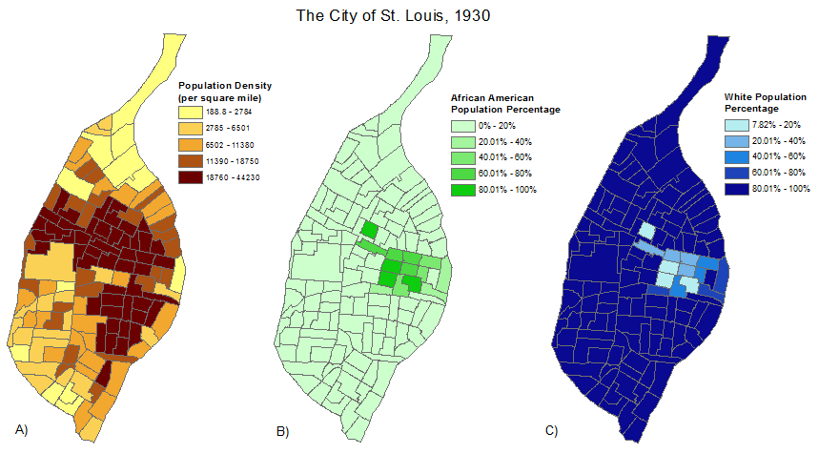
Figure 1: Tract level breakdowns of population density (A), African American population percentage (B), and White population percentage (c) in 1930.ª

1940
The population slightly decreased, less than 1 percent, over the next decade to 816,048. Tracts outside of the city can now been observed in Figure 2, which represent portions of St. Louis County in Missouri and Madison and St. Clair counties in Illinois. As a result, the St. Louis City boundary is represented with a black outline. The population distribution throughout the city remained relatively the same as the previous decade. Moderately sized population densities can also be observed just outside of the city’s boundary as well.
The same areas of high African American population percentages can be seen in Figure 2B within the city limits. There was an increase in the percentage of African-American population as well. A majority of the population outside of the city is White (Figure 2C), with the exception of six tracts to the east in Illinois and seven tracts within St. Louis County.

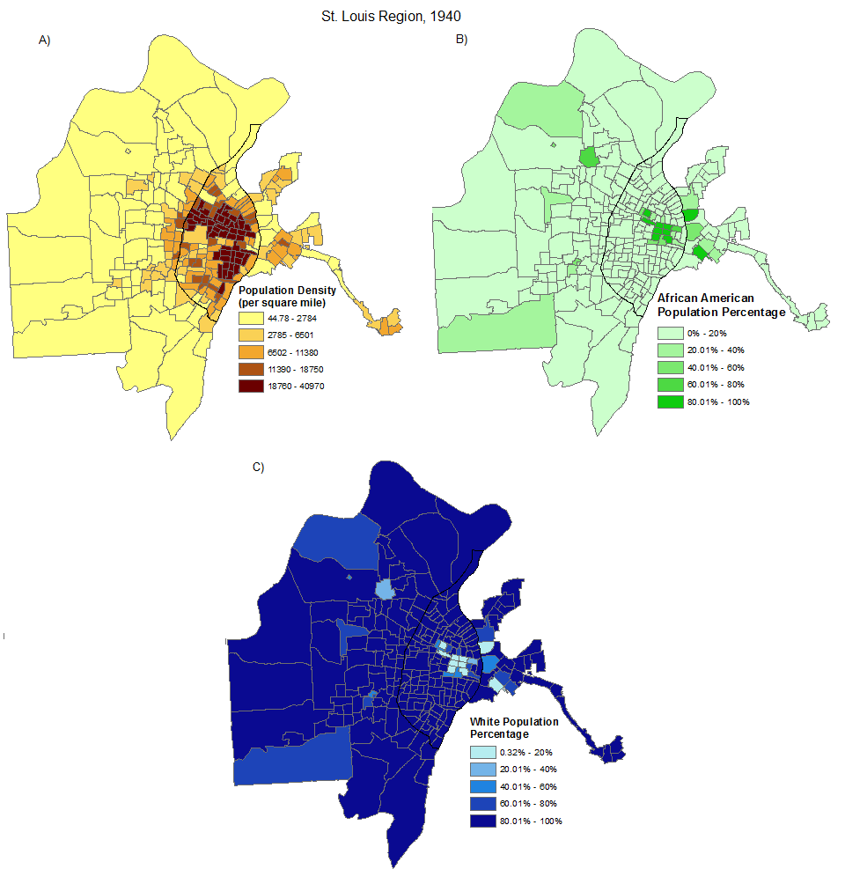
Figure 2: Tract level breakdowns of population density (A), African American population percentage (B), and White population percentage (c) in 1940.ª

1950
During the 1940s, urban renewal began to identify areas of blight and build additional housing with the intent of rejuvenating areas within the city of St. Louis. The areas of blight, slums and poor populations, were ultimately determined to be highly populated African-American areas causing the upheaval of many families as new construction began in the mid to late 1940s and decades later. While the intent was to reinvigorate areas of the city by attracting more people, building and construction companies were more interested in expanding to areas clear lands that did not require the demolition and reconstruction of buildings (7, Gordon, p204-205).
The 1950 census recorded the highest population seen within the city of St. Louis. St. Louis City, with a population of 856,756, and the surrounding counties ranked ninth in the country with a population of 1,681,281 (13, Laslo, p3). The city saw 4.99% increase in population from the previous census while St. Louis County saw a remarkable increase in population to 406,349, which was a 48.18 percent increase from the previous census. This was the only ten year period within the observed timeframe that had a positive population increase, most likely due to the post war boom. Some increase in population density can be seen in the southwestern tracts within St. Louis City. The tracts bordering the city boundary in St. Louis County, and others throughout the county, increased in population density as well. High African-American percentage tracts within the city remained somewhat the same, with some tracts in the northwestern part of the city gaining a greater percentage. Across the Mississippi River into Illinois, more tracts along the river saw an increase in the African-American population percentage as well.
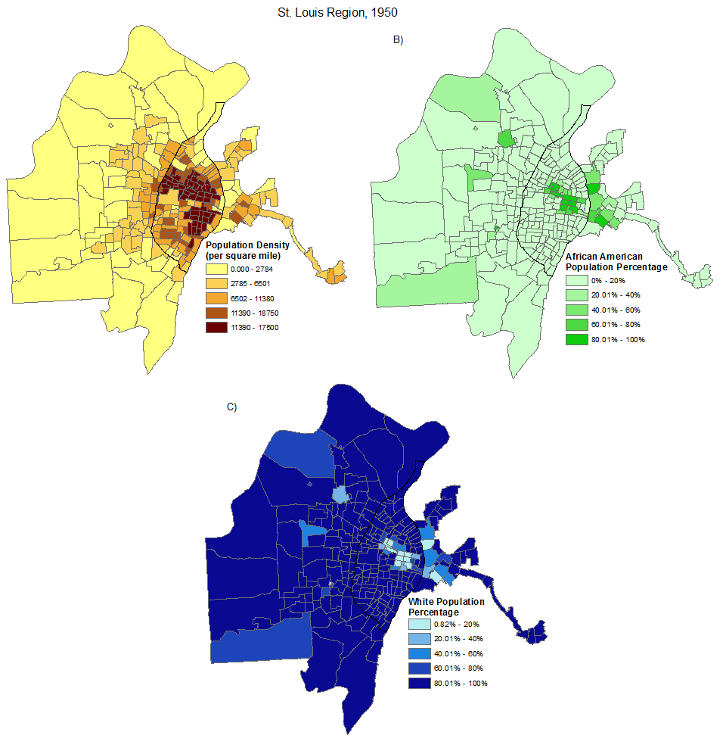
Figure 3: Tract level breakdowns of population density (A), African American population percentage (B), and White population percentage (c) in 1950.ª

1960
By 1960, the population drop significantly to 750,026. This was a 12.56% decrease from the previous census, and was the beginning of suburbanization in the St. Louis region. During the 1950s, several city residents started to move to St. Louis County, growing the county’s population to 703,532, a 73.13 percent increase. A stark demographic change can be seen in the northwestern tracts within the city’s boundary. These tracts are now around 80 percent African-American or higher and a high white population percentage can be observed in the tracts outside of city limits. A decrease in population density in St. Louis City can be seen near the center of the city. The beginning of white flight can now be observed within the city of St. Louis as a response to the construction of public housing from the urban renewal era. Due to racial zoning and restrictions, African-Americans are not giving the same opportunities to move westward during the white flight era and began to be the primary occupants of public housing (7, Gordon, p87-88; 99).
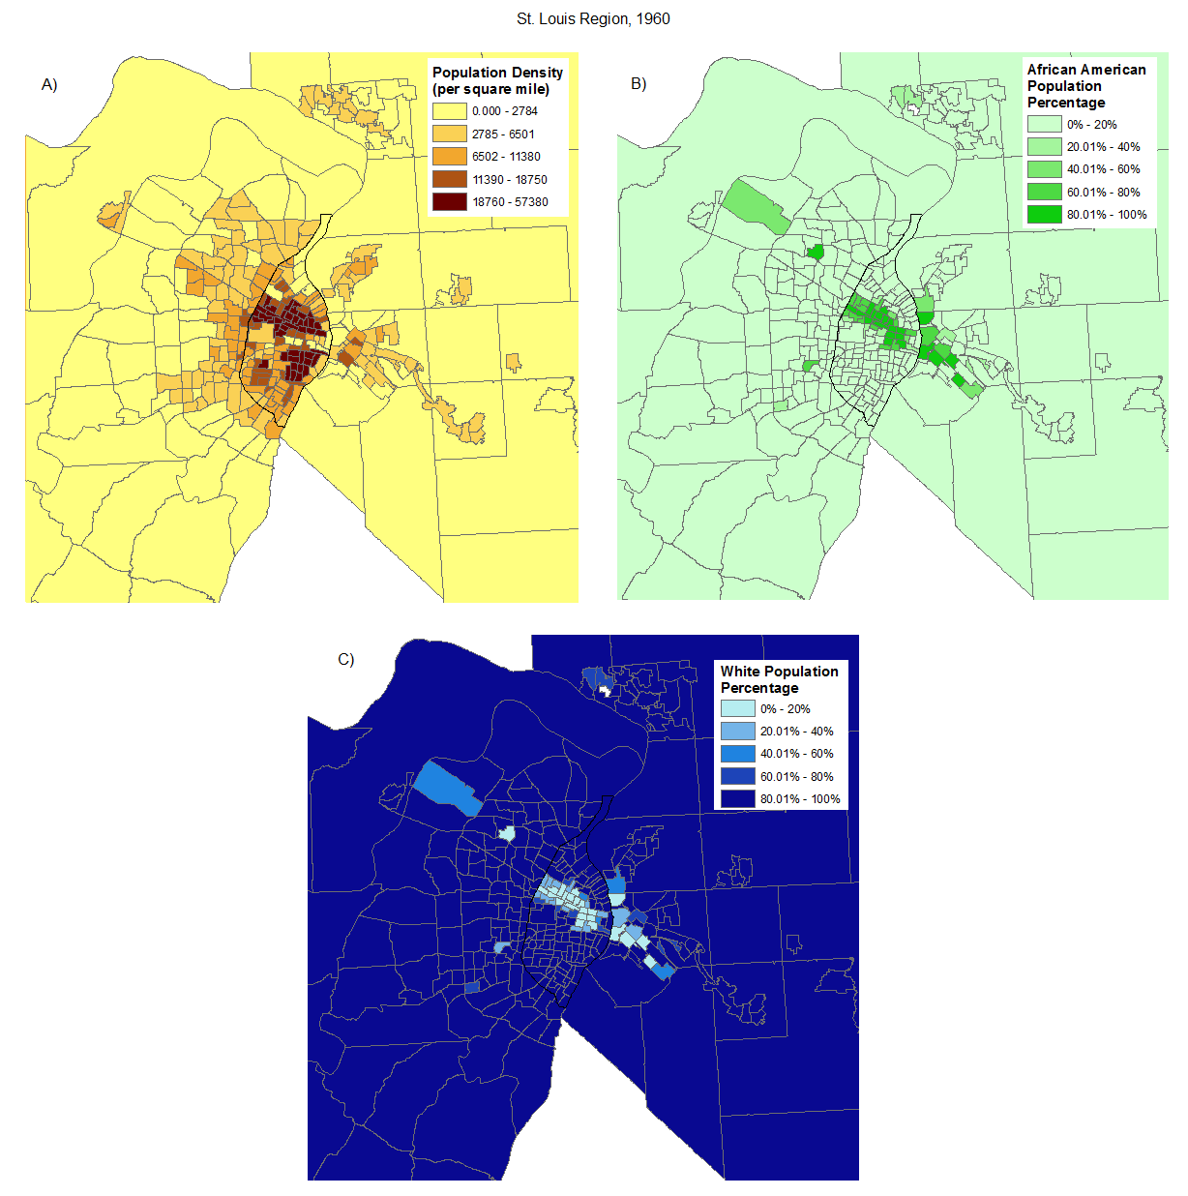
Figure 4: Tract level breakdowns of population density (A), African American population percentage (B), and White population percentage (c) in 1960.ª

1970
The population continued to fall between 1960 and 1970. The city’s population decreased to 622,236, a 17.04 percent drop from the previous census, while the population of St. Louis County continued to rise, increasing to 951,671, a 35.27 percent gain. A decrease in population density can be observed in multiple tracts throughout the city in Figure 5A. The African-American population percentage continued to grow in the northern part of St. Louis City and along the northwestern city boundary in St. Louis Count as the White population continued to move out of the city into St. Louis County. In Illinois, southwest of St. Louis City in St. Claire, the similar phenomenon was occurring, however additional tracts were incorporated in this area between the 1960 and 1970 census. A majority of the tracts outside of the city remained predominantly white.
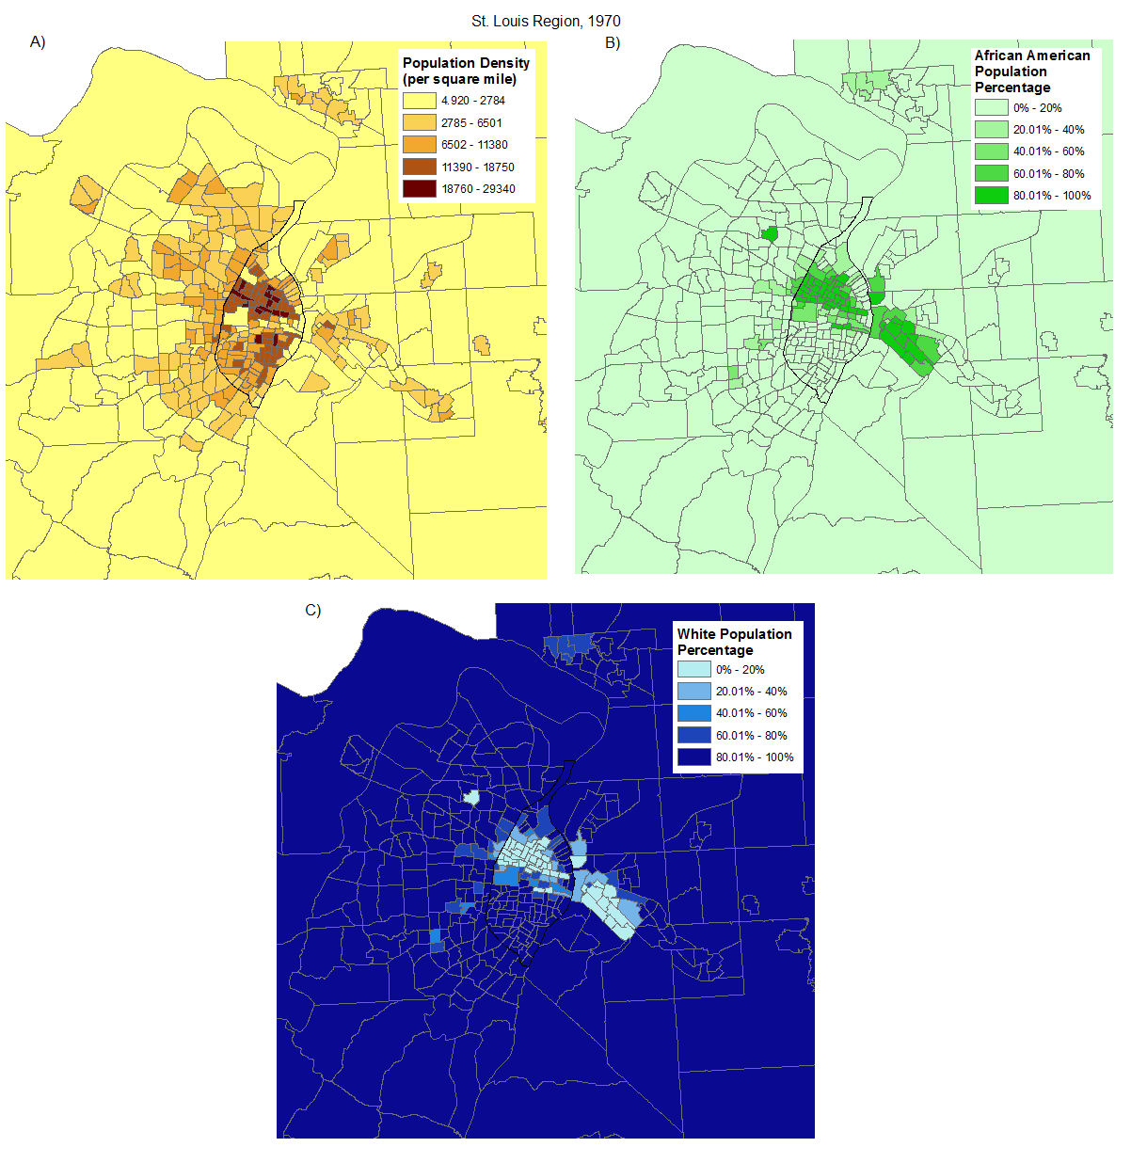
Figure 5: Tract level breakdowns of population density (A), African American population percentage (B), and White population percentage (c) in 1970.ª

1980
The largest population percentage decrease of 27.23 percent occurred between 1970 and 1980. The city’s population fell to 452,804 while St. Louis County’s population slightly enlarged to 974,177 (a 2.36 percent increase). Higher African American population percentages continued to migrate to the north and northwest of the city as well as southwest of the city in St. Clair County, Illinois. The southern portion of the city still maintained a higher white population percentage, creating a stark demographic split across the center of the city that can be seen in both Figure 6A and 6B.
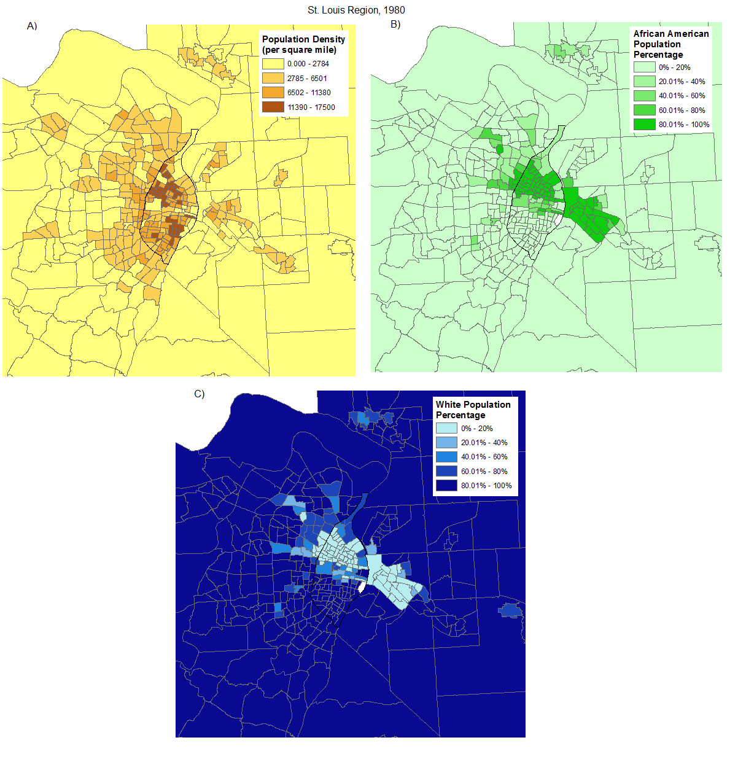
Figure 6: Tract level breakdowns of population density (A), African American population percentage (B), and White population percentage (c) in 1980.ª

1990
Between 1970 and 1990, more than 80,000 manufacturing jobs were lost in the city of St. Louis while St. Louis County gained around 44,000 manufacturing jobs (14, Cummings, p101). As a result, the city’s population continued to drop to 396,685, a 12.39 percent decrease. From 1990 to 2010, the population of St. Louis County plateaued and hovered around a total population of 1 million residents. It is worth noting, within a matter of a 40-50 year span the population of city of St. Louis lost around 400,000 residents.
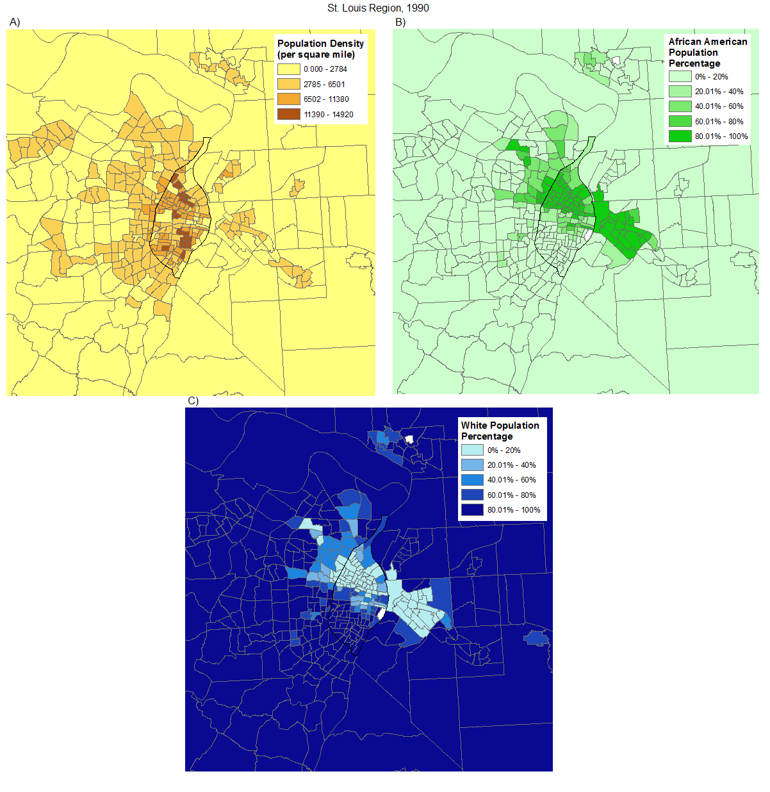
Figure 7: Tract level breakdowns of population density (A), African American population percentage (B), and White population percentage (c) in 1990.ª

2000
St. Louis City’s population decreased by 12.23 percent to 348,189 residents.
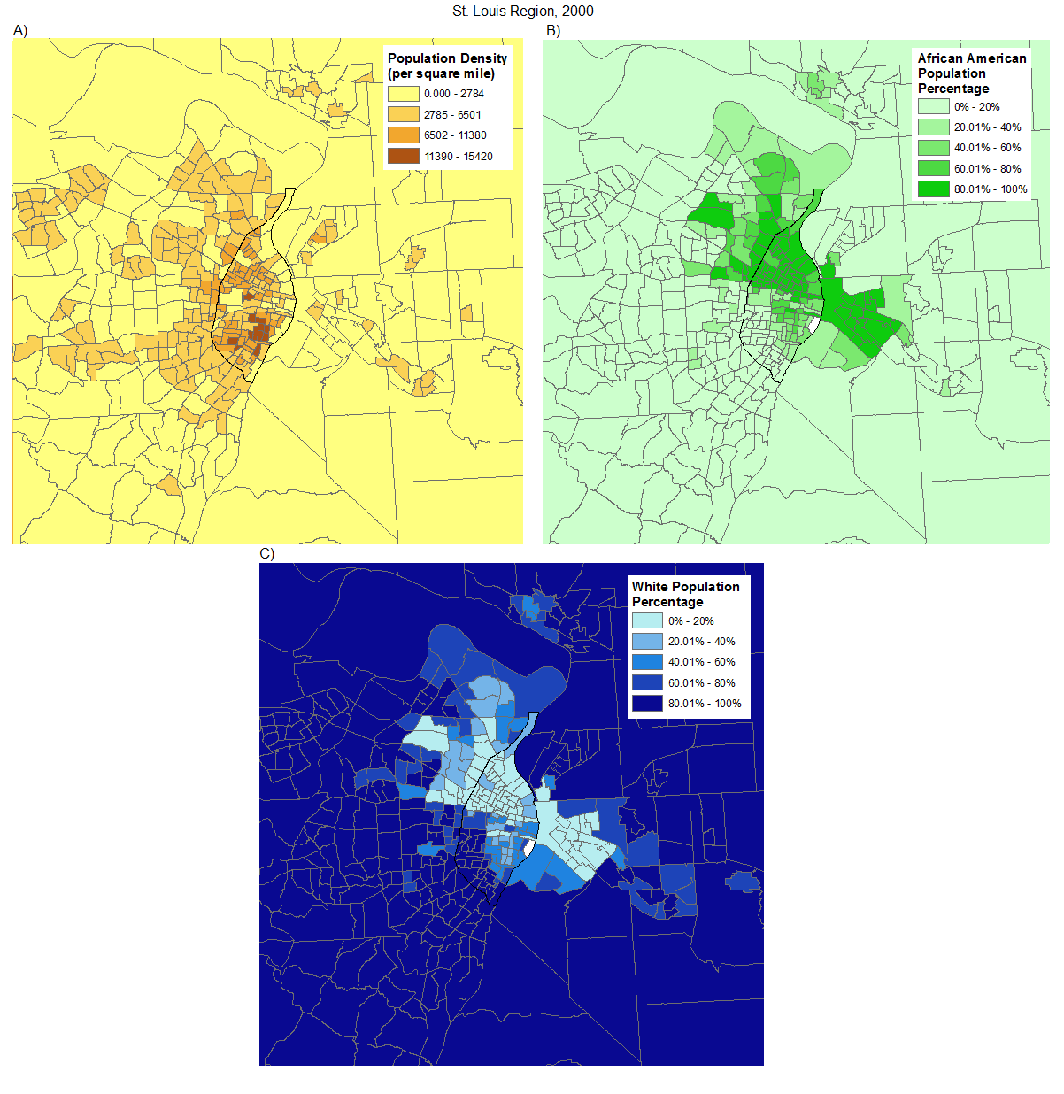
Figure 8: Tract level breakdowns of population density (A), African American population percentage (B), and White population percentage (c) in 2000.ª

2010
St. Louis City’s population decreased by 8.30 percent to 319,294 residents.

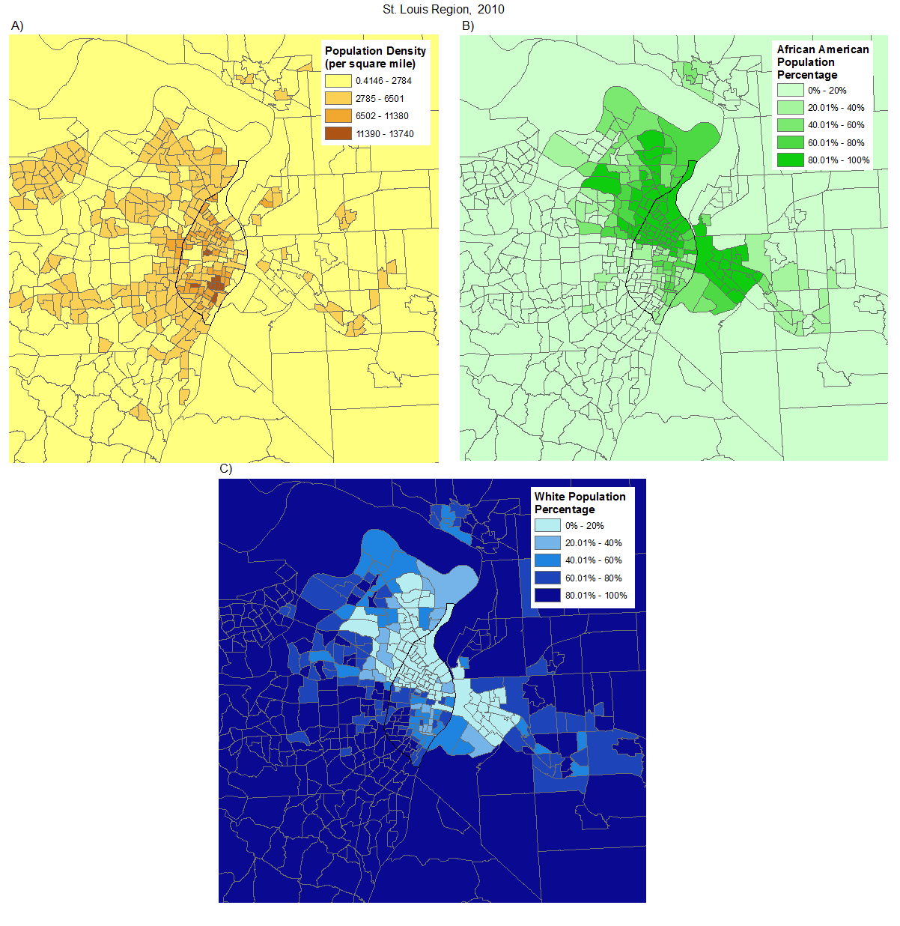
Figure 9: Tract level breakdowns of population density (A), African American population percentage (B), and White population percentage (c) in 2010.ª

GOALS AND OBJECTIVES
The social and economic landscape of St. Louis has evolved over the past several decades. The goal of this project is to analyze St. Louis from 1980 to 2010 using GIS and several different sociological and economical indices. These indices will be used to identify trends over time. St. Louis will be compared to other Midwestern cities in each decade using a success index developed by John Norman. The talk will then dive in deeper to identify areas of poverty, demographic unevenness, and home values and vacant housing at the census tract level for each decade. The focus for the tract analysis will be on the bottom and top tertiles (33%).

MIDWESTERN CITY COMPARISON
The idea behind this comparison it to put St. Louis city in context of other cities within the Midwest. The Midwestern city analysis can be used to give a greater meaning to the St. Louis tract analysis. An upward trend of a census tract in a city that ranks high in the Midwest may have a different implication than in a city that ranks low.
The criteria for the cities is as follows:
- The city must be located within a Midwestern state:
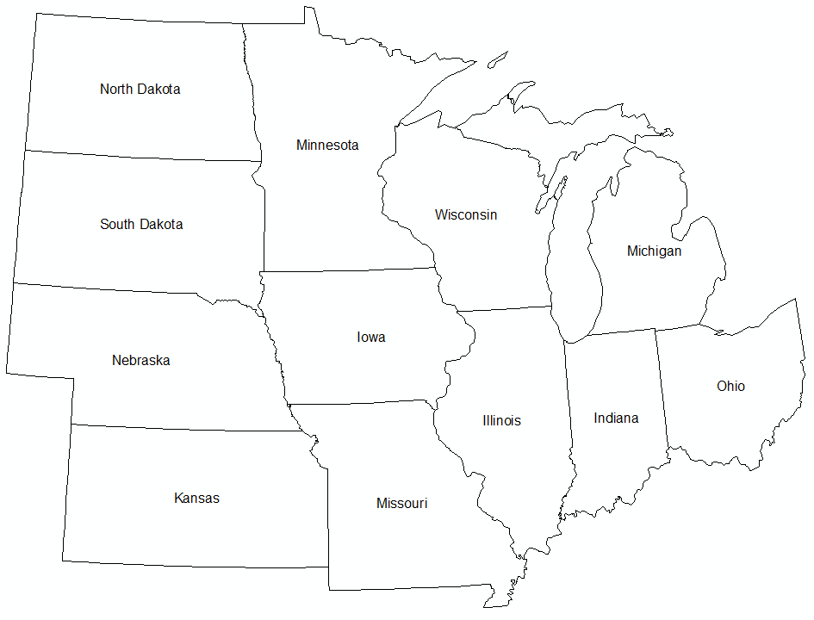
Figure 10: Midwestern States
- A city population around 300,000 to 1,000,000 in the 2010 census
- A metropolitan statistical area population between 1 million and 3 million in the 2010 census
The 2010 census was used to create a list of cities that meet the Midwestern City criteria (Table 2). The total land area was obtained from the 2014 cartographic boundary shapefile from the United State Census Bureau’s website (https://www.census.gov/geo/maps-data/data/cbf/cbf_msa.html). The cities were then compared using three different criteria used by Jon Norman in his book Small Cities USA: Growth, Diversity, and Inequality to create a success ranking.

City | State | 2010 Census | 2010 MSA | 2014 land area (city)
Indianapolis | Indiana | 820,445 | 1,887,877 | 361.4 sq mi
Columbus | Ohio | 787,033 | 1,901,974 | 217.2 sq mi
Detroit | Michigan | 713,777 | 4,296,250 | 138.8 sq mi
St. Paul - Minneapolis | Minnesota | 667,646 | 3,348,859 | 193.8 sq mi
Milwaukee | Wisconsin | 594,833 | 1,555,908 | 96.1 sq mi
Kansas City | Missouri | 459,787 | 2,009,342 | 315.0 sq mi
Cleveland | Ohio | 396,815 | 2,077,240 | 77.7 sq mi
St. Louis | Missouri | 319,294 | 2,787,701 | 61.9 sq mi
Cincinnati | Ohio | 296,943 | 2,114,580 | 77.9 sq mi
Table 2: Midwestern Cities

MEDIAN HOUSEHOLD INCOME
Median household income is a common measure for indicating changes in the economy and quality of life in an area. Norman states that high income regions do not face as many hardships as low income regions since there is typical a better quality of life. Based off of this logic, having a higher median household income would theoretically mean a region would have a better quality of life. Identifying the change in median household income can also be used to measure the fluctuation of an area’s economy as well, however on its own it can be considers insufficient. Norman points out that places with the lowest levels of income usually experience the greatest percentages of change while having higher levels of income, when compared to other cities, have no growth in income, indicating an economy in stasis. The latter scenario may indicate growing economic inequality as well.

POPULATION CHANGE
Norman outlines that population growth is crucial when measuring to the success of an area. While generally viewed as good, a dramatic or slight increase in population can be hindering for an area and are not as successful as areas with moderate growth. Likewise, a decrease in population is not attractive for people moving into the area as it may be an indicator of underlying problems. In his comparison, Norman uses the mean population growth of the entire United States as the basis for a best case population growth scenario, and argues that a moderate population growth is possibly the best indicator of a successful area.

ECONOMIC INEQUALITY
The measure used by Norman to assess economic inequality is known as the 90:10 index of inequality. This index is a way to measure income distribution in a population. This index is calculated by acquiring the 90th percentile income and dividing it by the income level of the 10th percentile. For example, if an area’s population top 10% (90th percentile) earned $200,000 and the bottom 10% (10th percentile) earned $40,000, then the 90:10 index would be 5. If a second sample population’s top 10% earned $300,000 and the bottom 10% of the population earned $30,000, then the 90:10 index of inequality would be 10. In these examples, it could be said that first population’s income is distributed more evenly throughout the community, whereas the second population has a larger difference of low income and high income individuals. It could then be said that the first area’s income is distributed more equally than the second area. While median household incomes can be used to measure economy, the distribution of that income is important in assessing the quality of life within a particular community.

SUCCESS INDEX
Each of the three measurements are combine into a formula to create an index used to measure the success of a city.
$$Success Index=\left[(IncChange*IncAbs\right)+PopChange+(IneqChange*0.50)]$$
The first section of the equation uses the percentage change in median household income (IncChange) multiplied by the absolute value of median household income (IncAbs). The absolute value of the difference between the calculated percentage change in population from the national mean population change over each decade (PopChange) is then added. Lastly, the percentage change in the 90:10 index of inequality over the decade (IneqChange) multiplied by 0.50 is added. The 0.50 weight was incorporated because Norman felt population change and income change were more related than economic inequality (18).
It is important to note that 1980 will be the starting point for the analysis, which in turn means that the change measurement will be observed for 1990, 2000 and 2010. Additionally, Norman used his success index to assess small cities with a population between 100,000 and 200,000, so the cities being analyzed will have larger populations. Since the focus of the research is on the city of St. Louis, it will be the focal point for this section.

RESULTS
The rankings for the success index for each decade can be observed in Table 3. During the 1980 to 1990 time frame, St. Louis ranked as number seven among the nine cities. While the median house hold income slightly declined, compared to the other cities in the study, St. Louis was ranked one of the highest in median household income change. Regarding the population change, St. Louis was the second worst ahead of Detroit and the second worst in inequality change ahead of Cincinnati. From 1990 to 2000, St. Louis ranked last in the success index. The median household income slightly increased during the timeframe, however when comparison to the other cities in the study, it ranked towards the bottom. St. Louis experienced the largest decline out of any city in this study in percent change of population in this time period. The change in income inequality ranked in the middle of the pack.
St. Louis experienced its biggest jump in the success index rankings from 2000 to 2010 from 9th to 4th. During this observation period, every city in the study had a decrease in median household income. Out of all of the cities, St. Louis experienced the smallest decrease in median household income. This ranking in median household income would prove to be the sole reason for its jump in rank, as the city ranked in the middle for income inequality change and still experienced a decrease in population from the previous census.
 | SUCCESS INDEX RANKINGS
1990 | 2000 | 2010
1) Columbus | 1) Minneapolis/St. Paul | 1) Minneapolis/St. Paul
2) Indianapolis | 2) Columbus | 2) Columbus
3) Minneapolis/St. Paul | 3) Detroit | 3) Kansas City
4) Kansas City | 4) Indianapolis | 4) St. Louis
5) Milwaukee | 5) Kansas City | 5) Milwaukee
6) Cincinnati | 6) Cincinnati | 6) Indianapolis
7) St. Louis | 7) Cleveland | 7) Cincinnati
8) Cleveland | 8) Milwaukee | 8) Cleveland
9) Detroit | 9) St. Louis | 9) Detroit
Table 3: Success Index

TRACT ANALYSIS
In order to perform a temporal analysis to measure variable changes, it is crucial to have consistent boundaries across time. The tract boundaries within the city of St. Louis remained the same from 1980 to 2000 at a count of 113 total tracts, however in 2010 several tracts were split and merged reducing the total count of tracts to 106. These splits and mergers usually occur due to population changes (22). This would mean that only 91 tracts remained the same for the observed time frame. This required the creation of a new tract boundary file using tracts from both 1980-2000 and tracts from 2010. Table 4 depicts the tracts that either split or merged. The merged tracts created in 2010 used the sum or weighted average of the data from the original tracts for 1980-2000 and the boundary of the new tract. A total of 19 tracts were merged creating 9 new tract areas. Tracts that were split in 2010 would use the original tract boundary from the 1980-2000 tracts. There 3 tracts were split as of 2010 resulting in 6 new tracts. The final tract count for the study’s tract boundaries was 103 and while the boundaries have been modified, all areas of the city were included in the study.

TRACT VARIATIONS
1980-2000 | 2010
103900, 104100 | 126800
107100, 107700 | 126900
108400, 108500 | 127000
120100, 120300 | 127100
113100, 113400 | 127200
117300, 118500 | 127300
122100, 122200, 122400 | 127400
121300, 121400 | 127500
123400, 123500 | 127600
119100 | 119101, 119102
114100 | 114101, 114102
116300 | 116301, 116302
Table 4: Tracts that split or merged; the italicized tract is the
tract boundary used for the time consistence tract boundaries
Each of the tract sections use a similar approach for identifying trends. Once the tract data was compiled, the values were ranked to create tertiles labeled as top, middle and bottom. Contingency tables were then used to classify which tracts were in stasis, fell from their original rank, or increase from their original rank. Each contingency table uses the data from 1980 as a reference point. The sections will also include additional information on two tracts that observed the largest rank change: one from the top tertile in 1980 and one from the bottom tertile from 1980.

CONCENTRATED DISADVANTAGE
Certain social measures, such as unemployment and poverty, are known to show spatial similarities. In the book Great American City: Chicago and the Enduring Neighborhoods, Robert Sampson argues that areas of disadvantage are not simply measure based on a single characteristic. Sampson and his colleagues analyzed six interrelated census tract characteristics across the United States (20):
- Percent of individuals below the poverty line
- Percent of households on public assistance*
- Percent of female-headed households
- Percent of unemployed individuals
- Percent of individuals less than age of 18
- Racial composition (percentage African-American)

This analysis was giving the name concentrated disadvantage and was used by Sampson to analyze a link between a neighbor’s willingness to intervene for a greater good and lower crime rates (15) and to examine a relationship between verbal ability and poverty stricken neighborhoods (21). Due to its use in each of these studies, the concentrated disadvantage will be used to analyze St. Louis at the tract level.
When recreating their concentrated disadvantage measure, Sampson, Sharkey and Ruadenbush found that there was a 0.99 positive correlation between the measure with and without the racial component (21). Their findings, along with racial composition being analyzed with a separate tract measure, provided enough evidence to omit the racial composition variable. Z-scores were calculated for the remaining percentages and averaged to obtain a measurable index for each tract within the study area. The scores were ranked based upon the resulting average. The top tertile (top 33%) tracts were defined as areas with the low levels of concentrate disadvantage, whereas the bottom tertile (bottom 33%) tracts were defined as areas with high levels of concentrated disadvantage.
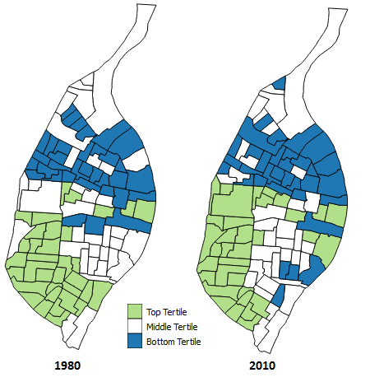
Figure 11: Concentrated Disadvantage tertiles for 1980 and 2010; the 1980 tract in black had a population of zero

Figure 11 portrays the concentrated disadvantage z-scores for the years 1980 and 2010. In 1980, the majority of the bottom tertile tracts were in the northern and central parts of the city. The top tertile tracts were predominately in the central and southwestern port of the city. Much of the same pattern can be observed in 2010 as well. A majority of the northern half of St. Louis contained tracts within the bottom tertile, however some bottom tertile tracts can be seen in the southeastern section of the city as well. The top tertile tracts can be observed in the southwestern and central parts of the city.
 |  | 1980
2010 |  | Bottom | Middle | Top
 | Bottom | 25 | 8 | 1
 | Middle | 9 | 19 | 7
 | Top | 0 | 8 | 26
Table 5: Concentrated disadvantage contingency table
 | 1990 | 2000 | 2010
Stasis | 82.52% | 70.87% | 67.96%
Fell | 8.74% | 14.56% | 15.53%
Rose | 8.74% | 14.56% | 16.50%
Table 5 shows the sum of the tracts that fall within each tertile for 1980 and 2010. The cells highlighted in grey are the amount of cells that remained in the same tertile and are identified as tract in a stasis state. The tracts to the bottom left of the grey cells are tracts that fell from their original tertile and tracts to the upper right are tracts that rose from their original tertiles. As each decade occurred, more and more tracts were falling out of a stasis state, but as of 2010 the majority of tracts remained in stasis. As tracts moved to a different tertile, the percentage of tracts that fell and rose increase. For the first two decades, the amount of tracts that that fell and rose were equal and by 2010 the amount of tracts that rose were slightly higher than the tracts that fell. Tract 115500, located in the southeastern portion of Dutchtown, fell from the top tertile to the bottom tertile over the observed time frame, going from rank 34th to 73rd. This tract saw an increase in percentage for every measure, with its biggest increases occurring for the percentage of people below the poverty line and the percentage of female headed households (Table 7). There was a decrease of population for this area over the 30 year period as well, going from 6,331 to 5,625. Tract 127500, located within the Midtown and Downtown West neighborhoods, went from the bottom tertile to the middle tertile, going from rank 103rd to 58th. A decrease in percentage can be seen for four of the five measures with the greatest decrease seen for the percentage of people on public assistance and the percentage of people below the poverty line (Table 8). This area was merged from two separate tracts in 2010, and up to 2000, each of the original tracts saw a decrease in population. The
Table 6: Concentrated disadvantage contingency table ranking changes; the percentages are base off of the 1980 concentrated disadvantage rankings

Tract 115500
 | 1980 | 2010
Below Poverty Line | 9.05% | 38.95%
On Public Assistance | 3.86% | 4.42%
Female Headed Households | 6.73% | 13.66%
Persons Below 18 | 20.30% | 28.00%
Unemployed | 3.46% | 11.80%
population nearly doubled from 2000 to 2010.
Tract 127500
 | 1980 | 2010
Below Poverty Line | 48.82% | 36.79%
On Public Assistance | 29.56% | 3.54%
Female Headed Households | 21.72% | 12.70%
Persons Below 18 | 41.89% | 23.51%
Unemployed | 7.12% | 9.39%
Table 8: Concentrated disadvantage measures for tract 127500

Table 7: Concentrated disadvantage measures for tract 115100

DISSIMILARITY INDEX
Segregation has been measured and broken down into many different aspects. Massey and Denton concluded that there are five dimensions that can be used to measure residential segregation: evenness, exposure, concentration, centralization and clustering (16). Each of these dimensions have several different methods that can be used as a measure, such as the delta approach used for measuring concentration or the spatial proximity method for identify clustering (19). This analysis will examine evenness by using the dissimilarity index to measure segregation.
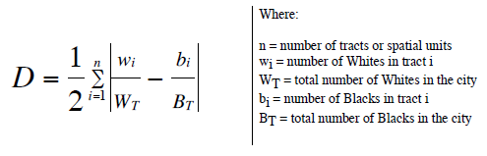
Figure 12: Dissimilarity Index formula (23)
The dissimilarity index ranges from 0 (complete integration) to 1 (complete segregation) and “measures the percentage of a group’s population that would have to change residence for each neighborhood to have the same percent of that group as the metropolitan area overall” (19). The dissimilarity index will be calculated for the following racial and ethnic groups: African American, Asian (a combination of Asian, Pacific Islander and Native Hawaiian) and Hispanic. This calculation will be derived from the majority population, which is white within St. Louis during the 1980s. The index is calculated for each tract by taking the absolute value of the tract majority population to city majority population ratio and subtracting the total tract minority population to the total city minority population ratio. The dissimilarity index for each decade can be seen in Table 9. Since the index uses the summation of all the tracts to create the measure, the following sections will use portray the tertile rankings of the difference between the white population count divide by the total white population in the city and the total number of the minority population divided by the total number of minority population in the city.
DISSIMILARITY INDEX
 | African American | Asian | Hispanic
1980 | 0.8350 | 0.4188 | 0.3230
1990 | 0.7803 | 0.3710 | 0.2579
2000 | 0.6869 | 0.3652 | 0.2941
2010 | 0.6511 | 0.3619 | 0.3434
Table 9: Dissimilarity Index comparison between 1980 and 2010

AFRICAN AMERICAN
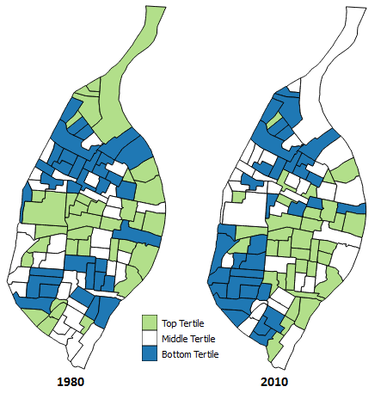
Figure 13: African American dissimilarity index tertiles for 1980 and 2010
In 1980, the African American dissimilarity index was the highest of any other race at 0.835, grossly close to complete segregation. The bottom tertile tracts can be observed in both the northern and south parts of the city. During this time, the bottom tertile tracts in the southern tracts were more predominately white bottom tertile tracts in the north were predominately African American. The central, extreme northern region and tracts in the extreme southern region of the city ranked in the top tertile. The dissimilarity index consistently dropped over each decade and was 0.6511 by 2010, suggesting whites and African Americans were less segregated. However, the tract map in 2010 still shows some similarities to the 1980 map. Tracts in the northern part of the city were almost all middle or bottom tertile as the white population moved out of the northern most tracts. In the southern portion of the city, the bottom tertile tracts are now found in the southwest and more top tertile tracts can be seen in the southeastern portion of the city. While the decrease in dissimilarity index promotes a more even distribution as more African Americans moved to the south-southeastern portion of the city, the decrease can also be attributed to the amount of whites that left the city over the 30 year timeframe.

Table 10: African American contingency table

Table 11: African American contingency table ranking percentage change; percentages based off of the 1980 dissimilarity values

 | 1990 | 2000 | 2010
Stasis | 79.61% | 53.40% | 45.63%
Fell | 10.68% | 24.27% | 27.18%
Rose | 9.71% | 22.33% | 27.18%

 |  | 1980
2010 |  | Bottom | Middle | Top
 | Bottom | 16 | 13 | 5
 | Middle | 13 | 12 | 10
 | Top | 5 | 10 | 19

The contingency table for the African American dissimilarity index indicates that 45.63% of tracts remain within the same tertile. This means that a majority of the tracts over the 30 year period changed, of which 27.18% both rose and fell. Out of all the tracts within the top tertile in 1980, tract 108100 went from the top to the bottom tertile over the 30 year period. The tract fell within the North Pointe, Belfontaine and Baden neighborhoods in north St. Louis and went from a rank of 7th to 79th. The white population decrease from 1985 to 142. The African American population on the other hand increased, going from 2122 to 3197. Tract 124100, part of the eastern Gravois Park and northeastern Dutchtown neighborhoods, went from 87th from the bottom tertile to 25th in the top tertile. The white population dropped dramatically from 6,107 to 1,060 and the African American population went from 7 to 3,213, showing that even though the tract ended up in the top tertile in 2010, there is still an overall unevenness for the tract.

ASIAN
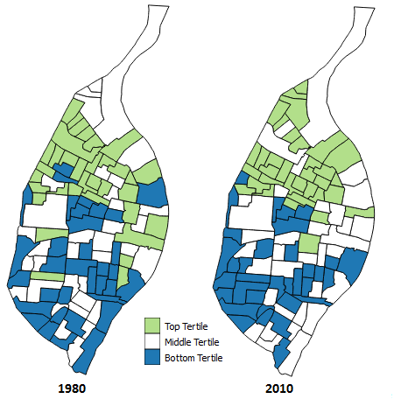
Figure 14: Asian dissimilarity index tertiles for 1980 and 2010
The Asian dissimilarity index went from 0.4188 to 0.3619 over the 30 year period. As of 1980, the bottom tertile tracts can be mostly seen in the central and southern part of St. Louis whereas the top tertile tracts are meanly in the eastern central and north part of the city. When compared to 2010, a majority of the bottom and top tertile appear to remain in the same regions. According to the Asian dissimilarity index contingency table, 51.46% of the tracts were in stasis over the time frame while the percentage of tracts that fell and rose were both 24.27%. This shows that the majority of the tracts were in stasis, but the tracts in stasis only outnumbered the changing tracts by a few tracts. It should be noted that the Asian population increased from 2,214 to 13,467. Unlike the African American contingency table percentages, the tract rankings for the Asian dissimilarity index values in stasis dropped from 1990 to 2000 but increased from 2000 to 2010 and the large change occurred from 1980 to 1990.
Tract 105400 from the top tertile in 1980, located in the northwestern portion of the West End neighborhood, went from rank 11th to 91st. The original rank for this tract was due to its extremely low white population, a total of 62 individuals, and the complete absence of an Asian population. The white population increased to 223 and the Asian population increase to 232 by 2010. The population for each race may indicate an evenness of diversity for the particular tract; however since the dissimilarity index weights each tracts population by the total number of the race, the diversity index increases since there is a small difference between each population. The tract that had the greatest increase in rank from the bottom tertile was tract 121100. Part of the Midtown and Covenant Blu-Grand Center neighborhoods, this tract went from rank 96th to 9th. This change in rank can be attributed to the decrease in the white population, going from 939 to 267 and the decrease in Asian population, going from 68 to 27. A majority of the tracts began with no Asian population in 1980 and had a decrease in the white population. Table 14 portrays tracts within the top tertile for both 1980 and 2010. These tracts remained in the top tertile due to their small white populations and having Asian populations at or near zero.
Tract 112100, which consists of Forest Park, DeBaliviere Place and part of the Central West End neighborhoods, went from a rank of 3 in 1980 to a rank of 79 in 2010. This tract saw in increase in both the white, 2,123 to 2,809, and Hispanic, 47 to 131, population. Tract 106300, located in the Wells Goodfellow neighborhood, went from 108th to 92nd. The white population went from 91 to 16 while the Hispanic population went from 88 to 9.

 |  | 1980
2010 |  | Bottom | Middle | Top
 | Bottom | 19 | 11 | 4
 | Middle | 11 | 14 | 10
 | Top | 4 | 10 | 20
 | 1990 | 2000 | 2010
Stasis | 58.25% | 50.49% | 51.46%
Fell | 22.33% | 27.18% | 24.27%
Rose | 19.42% | 22.33% | 24.27%

Table 13: Asian contingency table ranking percentage change; percentages based off of the 1980 dissimilarity values

Table 12: Asian dissimilarity index contingency table

Tract | White Population 1980 | Asian Population 1980 | Asian Dissimilarity 1980 | White Population 2010 | Asian Population 2010 | Asian Dissimilarity 2010
105300 | 90 | 0 | 0.00018523 | 133 | 14 | 0.00004569
106100 | 31 | 0 | 0.0000638 | 26 | 4 | 0.00005583
106200 | 36 | 0 | 0.00007409 | 18 | 8 | 0.00023286
106300 | 91 | 0 | 0.00018729 | 16 | 4 | 0.00009148
106400 | 32 | 0 | 0.00006586 | 22 | 6 | 0.00014434
106700 | 42 | 0 | 0.00008644 | 50 | 6 | 0.00004454
107200 | 259 | 0 | 0.00053305 | 20 | 0 | 0.00007129
107300 | 694 | 6 | 0.00007331 | 54 | 8 | 0.00010453
107500 | 194 | 0 | 0.00039927 | 37 | 4 | 0.00001662
107600 | 77 | 0 | 0.00015847 | 7 | 0 | 0.00002495
109600 | 326 | 9 | 0.00136158 | 16 | 5 | 0.0001286
110200 | 38 | 7 | 0.00150264 | 44 | 12 | 0.00028869
110500 | 215 | 0 | 0.00044249 | 30 | 2 | 0.00003268
111100 | 23 | 0 | 0.00004734 | 46 | 10 | 0.0002073
111200 | 17 | 0 | 0.00003499 | 77 | 2 | 0.00020022
111300 | 0 | 0 | 0 | 13 | 0 | 0.00004634
111400 | 79 | 0 | 0.00016259 | 16 | 6 | 0.00016573
112200 | 452 | 0 | 0.00093026 | 54 | 3 | 0.00008111
120200 | 334 | 0 | 0.0006874 | 121 | 8 | 0.0001343
127100 | 424 | 0 | 0.00087263 | 60 | 0 | 0.00021388
Table 14: Tracts that remain in the top tertile from 1980 to 2010 for the Asian dissimilarity

HISPANIC
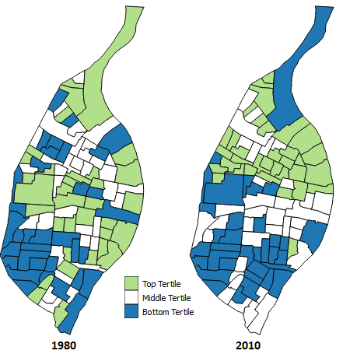
Figure 15: Hispanic dissimilarity index tertiles for 1980 and 2010

The Hispanic dissimilarity index was the only measure that increase over the observed time frame. The index in 1980 was 0.3230 and both the bottom and top tertiles appear to be scattered across the city with a cluster of bottom tertile tracts in the southwestern part of St. Louis. In 2010 the index was 0.3434 and almost all of the top tertile tracts can be found in the northern tracts, while the bottom tertile tracts are in the southern tracts with the exception of northern most tract. Over the course of 30 years, 41.11% of the tracts were in stasis, 25.56% fell from their original tertile and 33.33% rose from their previous tertile. Table 16 shows the ranking percentage changes for the Hispanic dissimilarity index and indicates that a majority of tracts changed from 1980. The greatest change in the tract rankings occurred from 1980 to 1990 and the percentages remained almost the same for the next two decades. Hispanic tracts that remained in the top tertile mostly saw a fluctuation in white populations with little change in the Hispanic populations (Table 18).
Table 17: Hispanic contingency table ranking percentage change; percentages based off of the 1980 dissimilarity values

 |  | 1980
2010 |  | Bottom | Middle | Top
 | Bottom | 16 | 8 | 5
 | Middle | 8 | 11 | 10
 | Top | 9 | 13 | 10
 | 1990 | 2000 | 2010
Stasis | 42.22% | 38.89% | 41.11%
Fell | 26.67% | 27.78% | 25.56%
Rose | 31.11% | 33.33% | 33.33%
Table 16: Hispanic dissimilarity index contingency table

Tract | White Population 1980 | Hispanic Population 1980 | Hispanic Dissimilarity 1980 | White Population 2010 | Hispanic Population 2010 | Hispanic Dissimilarity 2010
105200 | 317 | 10 | 0.00025191 | 995 | 75 | 0.00017753
106100 | 31 | 17 | 0.00147355 | 26 | 14 | 0.00053625
108100 | 1985 | 48 | 0.00025543 | 142 | 17 | 0.00025752
108200 | 1498 | 19 | 0.00136481 | 99 | 10 | 0.00009634
111100 | 23 | 9 | 0.00076655 | 46 | 17 | 0.00059973
111500 | 16 | 17 | 0.00150442 | 23 | 4 | 0.00009771
112200 | 452 | 8 | 0.0002068 | 54 | 15 | 0.00048136
124300 | 5012 | 125 | 0.00098886 | 2034 | 146 | 0.00069161
126600 | 2707 | 66 | 0.00039726 | 663 | 69 | 0.00073638
126700 | 2530 | 72 | 0.00130414 | 284 | 13 | 0.00042835
Table 18: Tracts that remain in the top tertile from 1980 to 2010 for the Hispanic dissimilarity

HOME MEASURES
The median home value and the amount vacant housing units are used to measure residential stability and land use. Home values are attributed with playing a role in neighborhood stability as well as contributing to the revival of neighborhoods. The fluctuation in home value may also result in attracting people from different socioeconomic statuses. For example, as home values decrease, low-income families are able to afford a home within a neighborhood (17). To see if these variables could be used in the same measure using z-scores, the correlation was calculated for the 1980 and 2010 decade.
Graph 1 portrays the resulting median home values and percentage of vacant homes in for each tract in 1980. The Pearson’s correlation coefficient during this decade was -0.14953. This indicates the correlation between the two variables for this decade is negligible. Graph 2 shows the same variables for the tracts in 2010. During this time frame, the resulting Pearson’s correlation coefficient was -0.41676, indicating a moderate negative correlation. Even though there is a stronger negative correlation between median home value and percentage of vacant homes in 2010, since neither decade showed a strong negative correlation (ranging from -0.70 to -0.90), the two variable rankings will be assessed separately*.
Graph 2: Scatter plot of median home value by percentage of vacant homes for St. Louis in 2010
Graph 1: Scatter plot of median home value by percentage of vacant homes for St. Louis in 1980; the median home value was adjusted for inflation (http://www.bls.gov/data/inflation_calculator.htm)

MEDIAN HOME VALUE
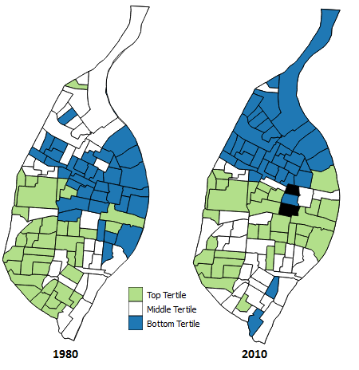
Figure 16: Median home value tertile rankings for St. Louis tracts in 1980 and 2010;
tracts with no available data are in black and were removed from the tract count
The rankings for the median home value were derived from the 1980 and 2010 census dollar values. For tracts that were merged from the 1980-2000 and 2010 census boundaries, the median values were weighted by the amount of households that were in each tract and averaged. The resulting value was the estimated median home value for the merged tracts. The median values were then ranked and broken up into tertiles where the top tertile represents high median home values and the bottom tertile represents lower median home values. The tertiles can be observed in Figure 16. A majority of the bottom tertile tracts in 1980 are located in the eastern and northeastern portion of St. Louis. The bottom quartile appears to “shift” to the northern tracts in the city in 2010. The top tertiles in 1980 are predominately located in the southwestern section of the city. In 2010, top tertile tracts can still be observed in the southwestern portion of St. Louis. Additionally, the central portion of the city has several tracts within the top tertile when compared to 1980.
Data was not available for two tracts in 2010, therefore the tracts have been omitted from the contingency table and are shown in black in Figure 16. For the remaining 101 tracts, 53.47% were in stasis while 29.70% fell from their original tertile and 16.83% rose to a different tertile. The majority of tracts remained in stasis over the 30 year period, however the majority of tracts that changed had a decrease in their median home value or no change relative to the rest of the tracts. Out of the tracts in the upper tertile in 1980, tract 108200, which is part of the neighborhoods Baden and North Point, saw the largest rank change from 25th in 1980 to 67th in 2010. The median home values shown in Table 21 only shows a $12,000 increase in the tracts median home value over the 30 year period. This would indicate that is rank change was due to several tracts have a greater increase in their median home values. Tract 125500 showed one of the the greatest rank change from tracts within the bottom quartile in 1980, going from 87th to 14th. This tract falls within the Downtown West neighborhood.

 | 1990 | 2000 | 2010
Stasis | 76.70% | 66.99% | 53.47%
Fell | 14.56% | 19.42% | 29.70%
Rose | 8.74% | 13.59% | 16.83%

Table 20: Median home value contingency table ranking changes; the percentages are base off of the 1980 median home value rankings
Table19: Median home value contingency table

Median Home Values
Tract | 1980 | 2010
108200 | $82,409.70 | $94,700
125500 | $33,125 | $213,900

 |  | 1980
2010 |  | Bottom | Middle | Top
 | Bottom | 18 | 16 | 0
 | Middle | 5 | 16 | 14
 | Top | 9 | 3 | 20

VACANT HOMES
Table 21: Median home values; the 1980 values have been adjusted for inflation
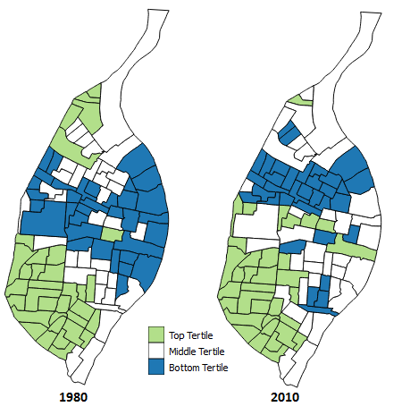
Figure 17: Vacant home percentage tertile rankings for St. Louis tracts in 1980 and 2010
The percentage of vacant homes was calculated by taking the amount of vacant homes divided by the total homes within the tract. These percentages were ranked and broken up into tertiles according to the lowest percentage of vacant homes (top tertile) and the highest percentage of vacant homes (bottom tertile). In 1980, the bottom tertile tracts are located in the northern and central regions of the city, while the top tertile tracts can be found in the southwestern part of the city. A cluster of top tertile tracts can also be found in the extreme northwestern section of the city as well. By 2010, the majority of bottom tertile tracts are found in the north-central St. Louis. The contingency table (Table 22) shows that 50.49% of tracts were in a stasis state and 26.21% fell from their original tertile and 23.30% rose from their original tertile.
Originally in the upper tertile in 1980, tract 118400 fell within the bottom tertile by 2010, going from 26th to 91st. The majority of this tract is located within the eastern half of the DeBaliviere Place neighborhood. From 1980 to 2010, the total home count decreased by half and the amount of vacant homes tripled. Tract 105200 ranked 103rd in the bottom tertile in 1980 and by 2010 it was ranked 29th and fell within the top tertile. The total amount of homes slightly decreased, the amount of vacant homes in 2010 was 4 times less than it was in 1980.

 | 1990 | 2000 | 2010
Stasis | 81.55% | 68.93% | 50.49%
Fell | 9.71% | 16.50% | 26.21%
Rose | 8.74% | 14.56% | 23.30%
 | 1980
2010 |  | Bottom | Middle | Top
 | Bottom | 15 | 18 | 1
 | Middle | 15 | 12 | 8
 | Top | 4 | 5 | 25
 | 1980 |  |  | 2010
Tract | Vacant Homes | Total Homes | Percentage | Vacant Homes | Total Homes | Percentage
118400 | 53 | 1177 | 4.50% | 184 | 564 | 32.62%
105200 | 889 | 1834 | 48.47% | 213 | 1647 | 12.93%

SUMMARY
Table 24: Home counts for tracts with greatest ranking change from each tertile
Table 23: Vacant home percentage contingency table ranking changes; the percentages are base off of the 1980 vacant home percentages
Table 22: Vacant home percentage contingency table
Based upon the measures used, the city of St. Louis experienced observable change for each of the measures. For most measures, an increasing number of tracts changed tertiles as time progressed, with the exception of the Asian and Hispanic dissimilarity index which experienced the most tertiles changes from 1980 to 1990. While several tracts changed tertiles over each decade, it is unclear if the same tracts changed across time. Parallel coordinate plots can be used to identify the tracts that changed tertiles over time. To create these, shapefiles can be exported from the Postgres tables and imported into GeoDa. Additionally, GeoDa can also be used to calculate other measures, such as Moran’s I to detect spatial clustering, to preform further analysis. Furthermore, this project mentioned tracts that the greats changes in rank for each of the measures in the tract analysis. More research can be done to identify what might have caused these large changes in rank.
St. Louis ranked towards the bottom of the Midwestern city comparison for 1990 and 2000 and jumped to the middle of the rankings in 2010. To build off of the Midwestern city comparison, a similar tract analysis can be done to cities that ranked similarly to St. Louis across each decade. The analysis can then be used identify if other cities within the Midwest went through similar patterns as St. Louis.

NOTES

Midwestern City Comparison
- When calculating the change in median household income, two percentages were created using inflation from 2010 (newest data) (http://www.bls.gov/data/inflation_calculator.htm) and no inflation:
  - 1980: $1 in 2010 = $2.65
  - 1990: $1 in 2010 = $1.67
  - 2000: $1 in 2010 = $1.27
  - 2010: normal
- National Population Change by decade:
  - % change taken from Population Distribution and Change: 2000 to 2010
  - 1980-1990: 9.8%
  - 1990-2000: 13.2%
  - 2000-2010: 9.7%
- Median household income was weighted for Kansas City and Minneapolis/St. Paul.
  - The weight was based on the total households in the cities
- 90/10 income inequality uses the larger value of the groups in order to avoid larger skews
  - E.g. if the range is $30,000 to $34,999 then $35,000 will be used

Tract Analysis
*Tract 105100 in 1980 became tract 105198 as of 1990 which is located west of Forest Park. There were some modifications in the boundary, but no information about the boundary modification could be found. For the purposes of this study, tract 105198 inherited the data from tract 105100 in 1980.

Concentrated Disadvantage
* The data source for the amount of individuals on public assistance could not be found. The amount of households on public assistance was used in its place

Home Measure
* The correlation groupings were obtained from A Guide to Appropriate Use of Correlation Coefficient in Medical Research (https://www.ncbi.nlm.nih.gov/pmc/articles/PMC3576830/table/T1/).

SOURCES
- https://www.stlouis-mo.gov/archive/history-physical-growth-stlouis/
- http://www.stl250.org/crash-course-colonial-and-early.aspx
- http://www.stl250.org/crash-course-fur-traders.aspx
- http://www.census.gov/population/www/documentation/twps0027/tab06.txt
- http://www.census.gov/population/www/documentation/twps0027/tab13.txt
- http://scholarship.law.wm.edu/cgi/viewcontent.cgi?article=2835&context=wmlr
- Colin Gordon. Mapping Decline: St. Louis and the Fate of the American City. 2008.
- https://www.washingtonpost.com/news/the-watch/wp/2014/09/03/how-st-louis-county-missouri-profits-from-poverty/
- http://www.stl250.org/crash-course-fourth-city.aspx
- http://www.stl250.org/crash-course-dry-weary-years.aspx
- https://www.census.gov/geo/reference/gtc/gtc_ct.html
- Farley, John E. Past Trends and Future Directions. The St. Louis Region, 1950-2000: How We Have Changed.
- Laslo, David. Past Trends and Future Directions. The Past, Present, and Future of the St. Louis Labor Force.
- Cummings, Scott. Past Trends and Future Directions. Racial Inequality and Developmental Disparities in the St. Louis Region.
- Sampson, Robert; Raudenbush, Stephen; Earls, Felton. Neighborhoods and Violent Crime: A Multilevel Study of Collective Efficacy. 1997.
- http://www.unc.edu/~pmeyer/carstat/tools.html. Massey, Douglas S.; Denton, Nancy A. The Dimensions of Residential Segregation. 1988.
- Wesenberg, Richard. City Neighborhoods: Housing Stability, Quality, and Affordability.
- Norman, Jon. Small Cities USA: Growth, Diversity, and Inequality.
- Iceland, John and Weinberg, Daniel H. with Steinmetz, Erika. Racial and Ethnic Residential Segregation in the United States: 1980-2000. 2002.
- Sampson, Robert J. Great American City: Chicago and the Enduring Neighborhood Effect. 2012. The University of Chicago.
- Sampson, Robert J.; Sharkley, Patrick; Raudenbush, Stephen W. Durable Effects of Concentrated Disadvantage on Verbal Ability Among African-American Children. 2007. PNAS. January 22, 2008.
- https://www2.census.gov/geo/pdfs/education/CensusTracts.pdf
- Forest, Benjamin. Measures of Segregation and Isolation. 2005. http://www.dartmouth.edu/~segregation/IndicesofSegregation.pdf

DATA
- Minnesota Population Center. National Historical Geographic Information System: Version 2.0. Minneapolis, MN: University of Minnesota 2011.

