Jonas Miller
GEOG 596B

User-Defined Geospatial Risk Index and Weighting for Initial Emergency Response Mapping

The complex, multi-level, catastrophic disasters responses since September 11, 2001 including Hurricane Katrina, the BP Deepwater Horizon Gulf Oil Spill, and Superstorm Sandy have been managed under the National Response Framework. This federal mandate outlines how federal, state, and local agencies interact during significant emergencies (FEMA 2013). While the National Response Framework provides organization for planning, tactics, and execution of objectives for response and recovery, it lacks guidance for local emergency managers for assessing risks to resources (natural, infrastructure, population) into account during the initial response. This type of risk assessment and risk assessment concepts in general are supported by higher level (Regional/Federal) stakeholders and often are overlooked by local level emergency managers and responders in an effort to focus on immediate response action. These responders need an easy to use GIS (geographic information system) tool to assess and plot this risk quickly.
Additionally, disaster risk and susceptibility assessments are mostly academic and scientific in nature and often lack practical end-user input or validation. Alexander (2010) argued in a study of a United Kingdom knowledge exchange exploratory tool that the most effective emergency response tools are participatory in nature, in that knowledge from the public and professional realm is fully integrated with scientific knowledge. Based on this participatory model of tool design, this study provides a risk index and weighting method designed with the end user in mind to be plotted in a GIS. While this tool will lack the specific focus of previous single disaster studies, it provides a framework for an initial emergency responder or manager to construct a simple, baseline analysis of risk based on publically available data and viewed on a GIS. This generalized identification of risks during the initial phase of emergency response could alter objectives, tactics, plans, and even recovery outcomes.
Imagine an emergency manager in Oso, Washington becomes concerned with heavy downpours over a two-week period. What if that emergency manager could use his or her subject matter knowledge and GIS to quickly assess the risks to his local resources? This emergency manager could choose publically available layers like soil type, topography, and population to determine this initial risk the tool presented in this study. Unfortunately, the above scenario actually occurred in 2014, resulting in a mudslide that caused millions of dollars of damage and killed 43 people. How could the outcome of the mudslide have been different had the emergency manager had access to this simple risk analysis method?

Case Studies of Hazards, Vulnerability, and Geospatial Risk in Emergency Management

The broadly accepted definition of risk is the consequences of expected losses (loss of life, loss of property, loss of natural resource) due to a specific hazard. Risk = Hazard x Vulnerability (Jafari 2010; Poompavai 2012; Cova 1999). Over the past two decades, there has been abundant use of GIS in the field of Emergency Management for specific disasters including landslides, cyclones, floods and wildfires (Jafari 2010; Poompavai 2012; Abuzied 2016; Aubrecht 2012). While these studies are specific to single hazards (cyclones, floods, wildfires), each followed a similar model for developing a risk index. Factors such as topography, hydrology, demographic and population data, and environmental sensitivity data were used as indicators of risk. When individual layers are combined to create a final susceptibility factor, risks were either weighted based on importance or equally weighted.
Jafari (2010) studied an Iranian pipeline and identified associated environmental and ecological risks. The effect on population was not considered due to the network’s isolation from populated areas. Despite this isolation, the pipeline still posed a major risk to the environment based on a constructed Fragile Ecosystem Score (FES), a Sensitivity Risk Score (SES), and a Land Use Risk Score (LURS). The FES was defined as a function of the inverse square root of the distance from a specific habitat to the pipeline and a constant to give the score a range between 0.01-15. The SES was a user-defined graduated scale ranging from 1-10 based on the sheltering and productivity. Low productivity/sheltered habitats had lower sensitivity scores than higher productivity, exposed habitats. The LURS followed the same 1 – 10 classification scheme with higher scores for forested or land used for farming versus lower scores for industrial or commercial use. The product of FES, SES, and LURS (FES x SES x LURS) equaled the Final Risk Score (FRS). This FRS was overlayed in a 200m x 200m raster grid of the study area and classified by range of values to create a risk map (Jafari 2010).
Abuzied (2016) further examined environmental risk indices related to Egyptian desert flash floods. This study included individual risk factors for specific flood hazards including land drainage risk, catchment risk, runoff risk, and soil characteristic risks. Drainage risk was a combined risk score for soil type and rainfall depth rankings between 0 and 1. The resulting flash flood risk map identified areas that were prone to flash floods and included model predictions for lag time for flooding after intense rains (Abuzied 2016).
Poompavai (2012) explored calculating risk for other natural disasters like cyclones. This methodology also involved a combination of risk factors including several proximity measures, land use/land cover measures, storm characteristics, and a social vulnerability component. The social vulnerability was constructed from population density and a ‘coping’ factor. Calculating the coping factor was more involved and included variables for income, housing type, communications, and access to resources. Raw population density data was grouped in five classes with natural breaks and then assigned a number from 1-5 with 5 being the densest and 1 being the least dense. This study was unique from the other previously mentioned studies in that it explored the weighting of risk factors. Factor weighting by category resulted in a more flexible risk determination structure compared to an equally weighted model. The weighting within each category summed to 1 and the overall risk index were the combined sums of each factor (Poompavai 2012).
Ahmed (2015) conducted a study of user-determined weighting of risks in relation to landslides in Bangladesh. While he used a similar pattern of selected factors ranging from vegetation to soil moisture to geology, he employed a series of trial and error weighting schemes to produce different risk maps for the same factors. Ahmed highlighted that very little convention exists in weight determination and that scientific researchers use theoretical weight values in modeling. However, he recommended that these theoretical weights be validated through dialogue with local officials and stakeholders (Ahmed 2015).
Each of the above studies employed either a scaled classification or the weighting of individual risk factors. The methodology for this study will explore both using user-selected geospatial properties (via selection of publically available data layers) and user-defined weighting to determine geospatial risk and produce a geospatial risk map, rooted deeply in the findings of Alexander (2013) and Ahmed (2015).

Target User
The target user for this study is the local emergency manager with disaster response expertise and baseline knowledge of GIS. This emergency manager will be expected to use the risk-mapping tool within the first 12 hours of an incident, the expected time frame before state or local assistance would arrive based on the National Response Framework. Based on this described target user, the scope of this model is limited to the county or municipality level emergency manager (FEMA, 2013).

Publically Available Emergency Management Data
Data accessibility is paramount to mapping both the response and geospatial risk. This proposed model will utilize two of many robust and compatible open source databases with data specific to the United States: Homeland Infrastructure Foundation-Level Data (HIFLD) Open Data and ArcGIS Open Data. HIFLD is a Department of Homeland Security (DHS) database with nationwide datasets designed at supporting local, state, and interagency preparedness. The datasets are available in formats including .csv, kml, and shapefiles (HIFLD 2016). ArcGIS Open Data is ESRI’s publically available repository aimed at sharing both spatial and non-spatial data to facilitate learning among students, businesses, communities, and researchers. These datasets are even more widely compatible and can be published directly as web services. Access requires a subscription through to ArcGIS Online, which is cost-free for individuals and non-profits (ESRI 2016).

Methodology
During initial emergency response to a disaster or crisis, there may not be resources or personnel to dedicate to a complete and thorough generation of a risk map. However, this study aims to create an analysis tool for initial responders and local emergency managers that they can leverage a baseline understanding of GIS, local knowledge, and emergency response fundamentals to create such a map that shows the combined resources at risk. The basic framework is based on the concept of raster overlay and discussed below.

Using ArcGIS Desktop, a user selects up to three layers from open source data (HIFLD, ArcGIS Online) based on the type of emergency. Depending on the data selected, the user has to convert each layer to a raster using the appropriate tool from the Conversion Toolbox. If user desires to measure risk based on the proximity to a feature (roads, railroads, hydrology), the user can create a raster using the Euclidean Distance tool. Once all data is converted to raster format, it can be reclassified based on user’s experience and expertise. Based on the ArcGIS 10.4 Desktop Help and consultation with ESRI’s Public Safety team, a graduated scale of 1-10 is recommended. On this scale, 1 is the lowest risk, 10 is the highest. In some cases, such as land use, there might not be ten individual categories; classification should be stretched between 1 and 10, omitting intermediate values as desired. Environmentally sensitive areas could be 10, residential areas could be 5, and vacant commercially zoned land could be l. Once reclassified, the user has the opportunity to assign weights to each of the layers using the Weighted Overlay tool from Spatial Analyst. This weighting will also be user-determined based on experience and the type of emergency. An example output of ArcGIS Modelbuilder is shown below in Figure 1. Practical application is illustrated through the discussion of two disaster examples (ESRI 2016).
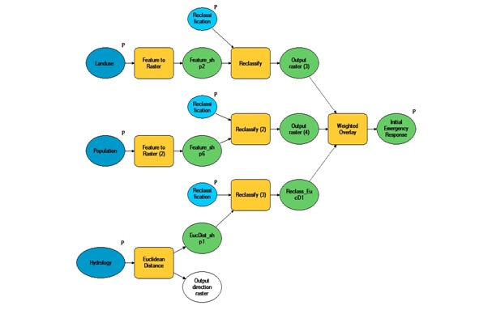

Figure 1: Example Modelbuilder Workflow

Two Sample Workflows: Colorado Wildfire and Illinois Tank Car Derailment

For a wildfire in Douglas County Colorado, an emergency manager (either local or forest service) might recognize the importance of protecting population dense areas, previously burned lands, and critical habitat areas. The manager could download the USA Urban Areas Dataset (ArcGIS Open Data), Historical Fire Perimeters 2000 to 2011 layer (HIFLD), and the Habitat Conservation Area layer (ArcGIS Open Data). Once each layer is converted to a raster, that emergency manager could reclassifly each of the datasets based on their professional knowledge and experience. For example, the USA Urban Areas Dataset can be classified from 1-10 based on the population density field, where 1 has the lowest population density and 10 has the highest population density. For the Historical Fire Perimeters, the manager can create a multi-ring buffer around each perimeter, and then reclassify data based on proximity to a previous historical fire perimeter, 1 being furthest; 10 being closest. The emergency manager can classify the Habitat Conservation Area layer based on his perception of highest priority habitats as 10 (endangered wildlife, fragile ecosystems), versus lower priority as 1. Finally, the emergency manager can assign weights based on which of the three factors (Urban Area Risk Score, Historical Perimeter Risk Score, and Habitat Conservation Risk Score) he deems to be most important. Based on his expertise, the manager selects the Habitat Conservation Risk to weigh heaviest since his priority during fighting this fire might be to save at risk habitat and wildlife. Result of this example is shown below in Figure 2.
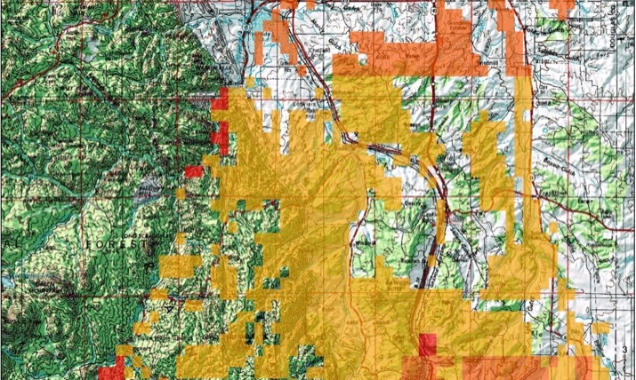

Figure 2. Wildfire Risk Map Result

In Figure 2, the highest risk areas are shown in red, the medium risk areas are shown in orange, and the lower risk areas are shown in yellow.

In another example, if a tank car carrying North Dakota Bakken Crude were to derail in Illinois, a state emergency manager could download the Railroads layer (HIFLD), National Hydrography Dataset (NHD) Lines: High Resolution (HIFLD), and a local data the local Lake County Wetland Inventory Dataset (ArcGIS Open Data). The emergency manager would have to use the Euclidian Distance tool on both the Railroads and Hydrology Line Datasets to create a distance based raster to reclassify. The railroads could be reclassified by distance to the track, closest being 10, furthest being 1. The Hydrology Line Dataset could be classified the same. For the Wetlands Inventory, areas with wetlands ecosystems could be classified with 10, areas without wetlands could be classified as 1. Based on the state emergency manager’s experience and response priorities, they may see each risk as equally important and therefore weigh each factor equally (weight = 1.0).

Discussion and Further Study

The largest limitation of this model is the subjective selection of both geospatial layers and the associated weights for individual emergency response scenarios. The more flexible framework used in this study expanded on the findings of Alexander (2013) with regard to emergency response tool development and Ahmed (2015) on user-defined weights. Unlike the rest of the literature reviewed, this model was developed with a strong dependence on user subject knowledge expertise. While this assumption may not support traditional scientific or academic structure and justification of the model, it creates an unmatched flexibility for practical application during emergency response scenarios. Another limitation of the model is that it requires emergency managers/responders to have basic knowledge of GIS and open source data. This limitation can be overcome relatively easy with training, but they should be familiar with how a GIS can provide geoprocessing and analysis through the use of tools. Finally, the model is also limited by how the layers are combined using ArcGIS tools. There are multiple ways to combine/overlay layers in ArcGIS, but the Weighted Overlay tool was selected as is provided the easiest interface for a user to input weights.
The model will be tested using a sample of local emergency managers from different geographic areas given several different disaster/emergency scenarios. The expected results would be varied based on the background and experience of each emergency manager. It could be expected that with such a large selection of data layers to choose from, there could be multiple combinations for the same hazard with completely different weighting schemes.
Lastly, the validation for the model would be to compare risk analysis for previous events/disasters with a simulated initial risk model from this study. While this provides a comparison, it would be hard to be completely unbiased in selection of initial risk factor layers knowing the outcome of the disaster. For example, it would be hard to pick without bias layers for Hurricane Katrina, however the simulation might include layers for the floodplain, population, and transportation infrastructure. Without knowing the result of the disaster, an emergency manager might weight the flood plain the highest, population second, and infrastructure third. In retrospect, the order could have been population (or household income), infrastructure, and floodplain since those provided responders the greatest challenge.
Further study on this topic would include expanding the number of layers used as risk indicators. For simplicity, only three factors were chosen for this study. Additionally, exploring the development of the model from ArcGIS Desktop to a hosted geoprocessing tool on ArcGIS Online would expand the applicability and usability of this tool. Local emergency managers from across the country, with departments, offices, and agencies both large and small would be able to access the same geoprocessing tool to analyze risk to their local area.

References

Abuzied, S., Yuan, M., Ibrahim, S., et al. Journal of Arid Environments (2016) 133: doi:10.1016/j.jaridenv.2016.06.004

Aubrecht, C., Özceylan, D., Steinnocher, K. et al. Natural Hazards (2013) 68: 147. doi:10.1007/s11069-012-0389-9.

Environmental Systems Research Institute (ESRI), (2016). ArcGIS Desktop Help 10.4 Spatial Analyst.http://resources.arcgis.com/en/help/main/10.4/index.html

Jafari, J., Khorasani, N., & Danehkar, A. (2010). Using environmental sensitivity index (ESI) to assess and manage environmental risks of pipelines in GIS environment: A case study of a near coastline and fragile ecosystem located pipeline. World Academy of Science, Engineering and Technology, 44, 1101-1111.

Poompavai, V. & Ramalingam, M. J Indian Soc iety of Remote Sensing (2013) 41: 157. doi:10.1007/s12524-011-0198-8.

U.S. Department of Homeland Security, Federal Emergency Management Agency (2013). National Response Framework, pp. 2-13.

U.S. Department of Homeland Security, Homeland Infrastructure Foundation Level Data (2016). Geospatial Management Office. Available online at https://hifld-dhs-gii.opendata.arcgis.com/.

Special Acknowledgement to the ESRI Public Safety Team for consultation and guidance of the development of the ArcGIS Workflow

