Educating Youth Organizations on Fire Risks in the New Jersey Pinelands

Kevin Mahoney
Pennsylvania State University
October 12, 2021

Abstract
In recent years, groundwater withdrawals, changes in climate, and vegetation patterns all have their part to play when it comes to forest fires occurring in the New Jersey Pinelands. This project was developed with the purpose of creating a web mapping application to educate and inform members of youth scouting organizations, with inherent interests in environmental issues and community involvement, about human impact and fire risk factors. We worked with three scoutmasters and twelve adult leaders to develop the learning objectives as well as lay out the wireframe for the web application. Utilizing several current frameworks and applications programming interface (API), we developed a web mapping application that serves as a learning guide for the scouts in these organizations to use prior to trips into the New Jersey Pinelands. The application helps scouts to identify areas at risk of forest fire in the field, recognize areas where it is safe to start campfires, and understand how they can mitigate these risks. Anticipated impacts for this project include raising awareness and understanding of environmental risks taking place in the local communities by disseminating information and the tools needed for geospatial thinking to local scouting organizations.

Keywords: Environmental Education, Experiential Learning, Web Mapping

Background
In the last few years, we have seen an uptick in the number of major forest fires events on a global scale, from the Australia bush fires to the numerous fires that have happened in the western United States. A study from the US Global Change Research Program notes a profound increase in forest fires in recent years. Additionally, the organization Global Fire Watch (GFW) has noted that areas within the Arctic Circle in northern Europe saw a significant increase in fire events during 2018.
Several major organizations, such as National Aeronautics and Space Administration (NASA), the Environmental Protection Agency (EPA), The National Park Services (NPS), and those mentioned above, have cited the causes of this increase as warmer temperatures, an increase in droughts, and drier soils. A more succinct explanation would be climate change. However, these are not the only causes that have been identified. In a study of spatial wildfire occurrence data, Short (2017) noted “85% of US wildfires were caused by Human involvement.” Short listed some of the notable human causes as unattended campfires, discarded cigarettes, and intentional acts of arson. Though, as we have seen in recent headlines, human causes are not limited to this list when it comes to starting major forest fires.
Focusing on the forest fires in the United States, there are a few interesting trends taking place. In the study Geography of Wildfires Across the West conducted by Weber (2017), between 1950 and 2017 61% of the forest fires had occurred between 2000 and 2017 (figure 1). Additionally, Weber found that fires post-2000 was occurring more frequently in coniferous tree areas. This is significant when we look to the eastern United States, especially when we look at the New Jersey Pinelands or Pine Barrens.
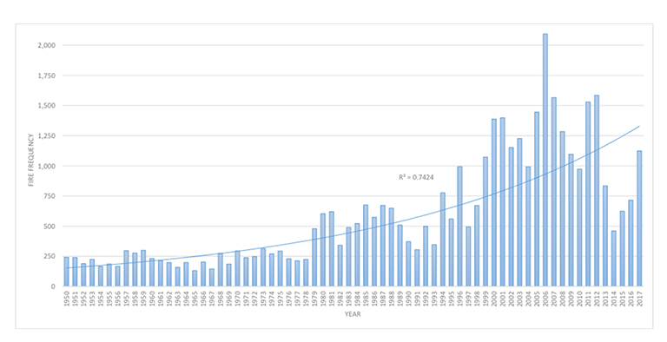
Figure 1. Wildfires Across the West (Weber, 2017)
The New Jersey Pinelands is home to the largest unbroken tracts of forest in the eastern United States (figure 2) and in May of 2021, a forest fire consumed over 1,000 of its acres. With drier conditions on the rise, most of the state has been listed as a high danger for fires. The New Jersey Pinelands are at significant risk of being devastated by another large-scale forest fire event. The New Jersey Department of Environmental Protections points toward nutrient-poor soils, acidic water, and dry soils as aids for the growth of vegetation that can thrive in fire-prone forests (New Jersey Pinelands Commission, 2021). These changes in soil and vegetation can lead to a higher probability of forest fires. While some plant species, like the pitch pine, have adapted to the fires many of the animal species, most importantly the 43 endangered and threatened species that call the Pinelands home, have not. Not to mention there is a wide variety of land uses in the Pinelands, and when major fires occur it can spell disaster for citizens living and working in or around the Pinelands.
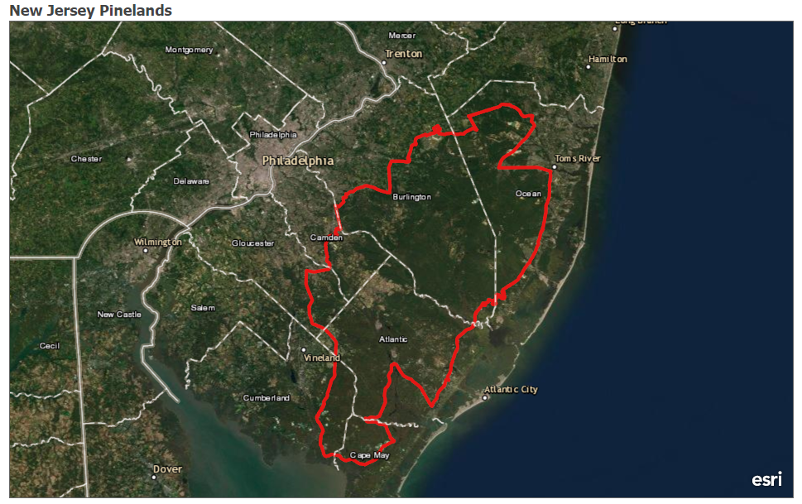
Figure 2. The full extent of the New Jersey Pinelands (Source of data outline layer)
Purpose
This capstone project aims to create a web application to be used as a pre-trip guide for youth scouting organizations, such as the Boy Scouts of America, the Girl Scouts, and the Adventure Scouts (hereafter referred to as “the Scouts”), to guide them on what causes are increasing the risk of forest fires and how they can identify them when they are camping or hiking in the Pinelands. The information we are providing focuses on several risk factors identified already by studies within the Pinelands. The first of the learning objectives will be focused on watershed withdrawals creating drier conditions. In a study conducted by Zhang and Bognar, they found that as the groundwater began to be withdrawn, different vegetation began to grow in the drier areas (Zhang and Bognar, 2011). The second learning objective focuses on changes in vegetation patterns and growth. This will pertain to vegetation patterns around streams that can predict watershed withdrawals by the appearance of certain vegetation around streams, the areas containing high ladder fuels that can increase fire spread, and indicator species that can be found along and around streams in the Pinelands (Laidig, 2010, Skowronski, 2007, Zampella, 1997). Due to limitations from data availability, we will be looking characterizing the areas with the highest potential risk relating to these two learning objectives. Additionally, we hope to provide information about current issues with invasive species, namely insects, that are killing vegetation and increasing potential fire fuels.
The choice to build a web application around these learning objectives for the Scouts was straightforward. Youth scouting organizations, like the ones mentioned above, have a foundation in forestry and environmentalism, in addition to a focus on community involvement. This makes them a prime target for encouraging community clean-up efforts or for increasing environmental awareness. Additionally, writing the information we are providing across the various layers as well as quizzes to the reading level of the Scouts will put us at the average United States reading level of 8th grade, according to a 2012 study on readability by Lauren M. Stossel. The importance of the 8th grade reading level came into play with how complex the wording of our layer names is, as well as in the language we chose to use when synthesizing the information and presenting it to the user. As for the web application component, we wanted to develop something that would make this information easily accessible to the public and make sure that information was clear and easy to understand using web maps.
This form of public education can be highly important to tackling environmental issues. A study has shown student’s education and understanding of sustainability improves from educational travel programs for sustainability versus the level of education and understanding in the classroom (Hale, 2021). Additionally, evidence shows environmental education is most successful when focused on local and actionable aspects of climate change (Anderson, 2013). Therefore, the goal of our web application is to not only educate but to foster a more personal stake in these issues from the community surrounding the Pinelands.

Methodology
Before we began the process of developing the web application, we first meet with three scout masters and their troops to workshop a wireframe model for the application, as well as information they wanted to see present in the application. With this information from our anticipated end users, we could then begin the process of developing the application. We first needed to define the tools we used in the development of the web app. We stored our data and the layers we created using ArcGIS Pro on ArcGIS online. This made it easier to access using the ArcGIS API for JavaScript, which provides several useful web development tools for accessing and displaying feature layers on a web map. Additionally, we used the Bootstrap framework for styling and designing the web page and user interface.
The analysis on the data acquired from various New Jersey government agencies focused on overlay analysis of the various risk factors within the bounds of the Pinelands. The information we attached to these various layers displayed includes factors that show a potential change in soil pH, as direct pH data was not available at this time, and where specific vegetation that acts as an identifier for watershed changes when it appears around streams and surface water. As direct soil pH and vegetation data was not available at the time, we choose to look at zones with the highest potential based on previous research. We looked for areas that contained both of our chosen factors for potential soil pH change as well as where within the zones for watershed disturbance indicator species may be found. The way we determined the factors for potential change in soil pH was to look at what was leeching into the groundwater, specifically the ambient levels of nitrate, cooper, and cadmium. Nitrates, while they are already abundant in New Jersey soils, will leech form lower pH soils better. As for cadmium and copper, lower pH soils will hold cadmium better than copper and vice versa (Yong and Phadungchewit, 1993). So, zones that have a higher ambient level of cadmium versus copper and a higher ambient level of nitrate would have the highest potential for a lower-than-normal pH for the soil. Additionally, we included information on campsite clean-up, fire safety, and responsible fuel collections for campfires in relation to the types of vegetation that act as an indicator species for watershed disturbance that can be found around streams. Table 1 includes a breakdown of layers and datasets we used for the map, as well as where they were obtained and their year of publication.
After obtaining these layers, we began several GIS operations to cut out the data that was not useful to us and identify our risk areas. First, we took the ambient groundwater monitoring data for nutrients and extracted all stations that had recent reports of high amounts of nitrate, as nitrate begins to leach more when soil pH rises. Then we did the same for the ambient ground water monitoring for metals, expect this time we compared the levels of cadmium to the levels of copper, because according to a study by Yong and Phadungchewit (1993), lower pH soils will hold cadmium better than it will hold copper. These two factors that indicate a potential change in the soil pH showed us what areas may have shifted soil pH, which in turn can shift what type of vegetation is growing in that area. We also took the data for category one waters, or surface waters, in New Jersey, clipped it to the Pinelands boundary and then extracted only the streams found in the Pinelands. Our focus on streams comes from a study by Laidig (2010) that found that when the watershed was experiencing withdrawal, certain plant species would begin to appear around streams indicating the withdrawal.

Additionally, we provided resourses on what this vegetation is, what to do when it is found, and how it can increase the potential risk of forest fires. Several plants can act as ladder fuels in the event of a forest fire, which can in turn increase the damaging effects of the fire. We will also be providing, as a further development of the web application, a tool to submit data of any sittings of these plant species to expand on our risk identification and provide more useful information about encountering these plants while camping and hiking. Pulling from this same study, we created a twenty-meter buffer layer around the streams. The extracted monitoring station data was also given a two-kilometer buffer, as that seems to be the extent the stations could effectively monitor. Each of these buffers were then overlayed to identify areas with in the 20-meter stream buffer as well as monitoring station buffer for our pH indicators. Three layers were created, one that showed the areas that had all three indicators for a potential fire risk zone, another with just the streams and nitrates, and the final with just the streams and metals, which can be seen in red in Figure 5. To make this information more useable for these scouting organizations, we tied our learning objectives and field guides to merit badges or awards, for example, awards focusing on forestry, ecology, and fire safety.

Layer | Year Published | Link to layer
Category One (C1) Waters of New Jersey | 2021 | https://njogis-newjersey.opendata.arcgis.com/datasets/njdep::category-one-c1-waters-of-new-jersey/about
Ambient-Nutrients of New Jersey | 2021 | https://gisdata-njdep.opendata.arcgis.com/datasets/njdep::ambient-nutrients-of-new-jersey/about
Ambient-Metals of New Jersey | 2021 | https://hub.arcgis.com/datasets/njdep::ambient-metals-of-new-jersey/about
Parks in New Jersey | 2021 | https://njogis-newjersey.opendata.arcgis.com/datasets/a2d2729d7e50444f9fefaadbc55e5d7b_5/about
Parks and Forests Trail System for New Jersey State Park Service | 2021 | https://njogis-newjersey.opendata.arcgis.com/datasets/f866ab117bb64288a7de0b07c206cc70_63/about
Table 1. A list of layers and datasets used and where they were obtained
Logistics
To make sure the web application is not only effective but continues to be used by the local scouting organizations, we have broken the development into three phases. The first phase of development focused on feature layers and an alpha version of the app focusing on the map and data display in the web app. This alpha version was tested by Boy Scout Troop 2002. The feedback we obtained went into fine-tuning the displays and data. These changes will mark the start of the second phase which focused on our secondary attributes of the website, which include the use of tracking forms and additional learning resources. This phase was followed by another round of testing with troop 2002. With this new round of feedback and adjustments, the third phase focused on the dissemination of the web application. Namely, meeting with some of the New Jersey Councils for Girl Scouts and Boy Scouts, of which there are three for the Girls Scouts and five for the Boy Scouts. Since the councils meet monthly, we also included an interim presentation with several local troops and groups. These presentations showcased the use cases and information available in the web application. At this stage of the project, the major application elements have been completed and visual polish has been applied as we move into disseminating the project to the local Boy Scout Councils.
Outcomes
As a result of our development and testing cycle, the web application we created has taken on some variations not previously outlined. Based on the feedback during the first round of testing with Boy Scout troop 2002, a number of the scouts offered critiques of the maps complexity and how the information was displayed for various data. For example, much of the soil acidity indicators information had been only found in popups when a site on the map was clicked. So, to simplify the information we provided and make it easier on the user to find we used a suggestion from the Scouts. This was to move the information from the pop ups into different parts of our application. First, we created a togglable section titled “More Information”, which would contain all of the general information about the layer currently being displayed, so attributes like the aquifer the streams are in was unnecessary to the be included in each pop up, so we removed it. After this, to simplify our remaining information new legends were created to remove the need for pop up, see Figures 3 and 4 for new legend and information layout. The beta phase of development came with some additional issues, as there had been a development roadblock for the quiz portion of the application. While the quiz loading errors were addressed, we made use of another suggestion from our testing troop. This was to crowdsource the quiz questions and answers, which allowed us to better achieve our goal of readability and understanding for the information we want to impart to the Scouts. With the web application now finalized, see Figure 5 for the finalized version of the app, the project will now move into a continuous stage as we begin the process of disseminating the application to local scout troops and councils.

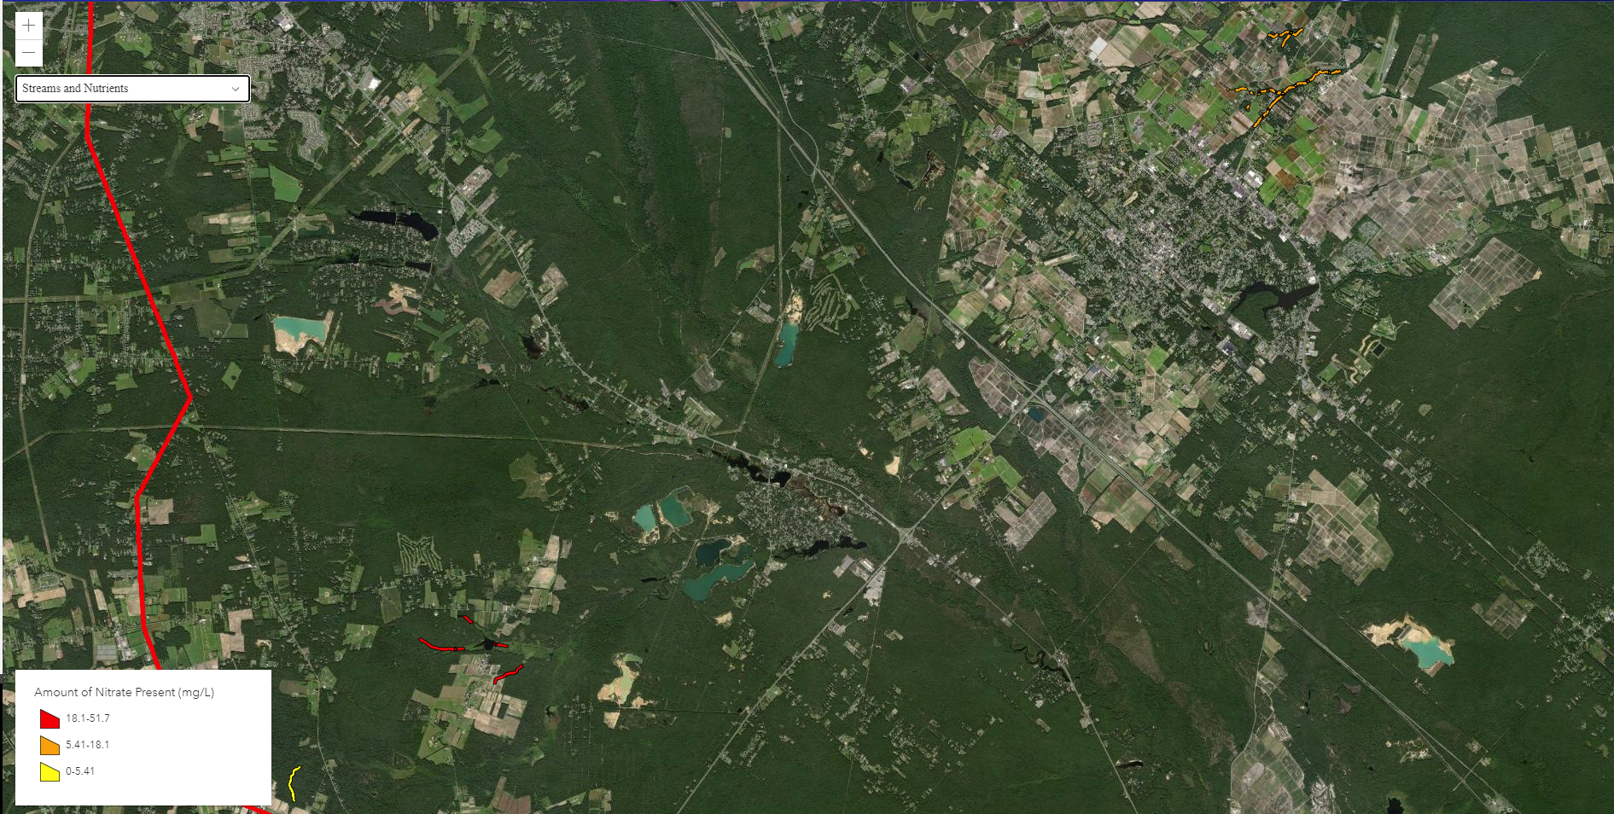
Figure 3. New Legend information design for High Nitrates in the Ground water Zones around Streams around
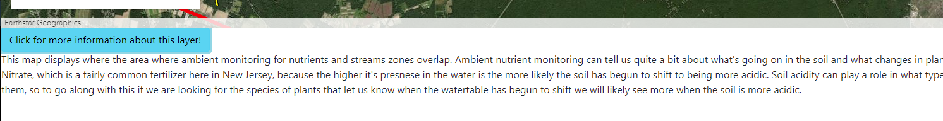
Figure 4. New more information section for High Nitrates in the Ground water Zones around Streams
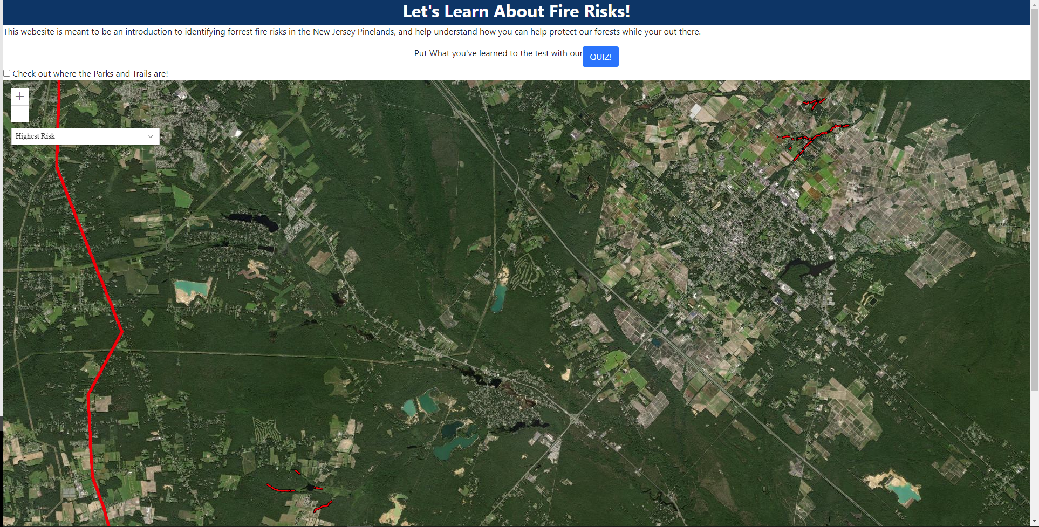
Figure 5. High Risk zones in the New Jersey Pinelands displayed in the web application
Additional Developments
In addition to these outcomes, we have several developments planned for further down the line. Some of the developments we hope to make include automating data updates with new research, expanding the identification of risk factors, creating an additional tool for people to record and report information post camping or hiking trips into the Pinelands then creating a new data layer on the map, and connecting with popular campgrounds and park officials. These developments hope to improve the web applications’ functionality and increase the success of our goal to disseminate new information to the local communities.
Summary
With development of the web application completed, it is safe to say we have accomplished a number of our goals as we move into the ongoing goal of dissemination of the application to the various Scout groups around New Jersey. The layers that were developed clearly indicate high risk zones or areas were some of soil pH may be changing or our indicator species might appear. We have provided sufficient information for what that vegetation may be and used merit badges like fire safety and forestry to assist in reinforcing the importance of this information. Our quiz has been set up with crowd sourced questions based on what the Scouts we worked with took away from our alpha and beta tests. We have maintained our goal of keeping the information at an 8th grade reading level, which should allow any and all to easily understand our easy to access web application. With our final polishing completed and plans for future developments laid out we are now achieving our final goal of disseminating the web application to various Scout groups around the state.

References
Anderson, A. (2013). Climate Change Education for Mitigation and Adaptation. Journal of Education for Sustainable Development, 6(2), 191–206. https://doi.org/https://doi.org/10.1177/0973408212475199
Environmental Protection Agency. (2021, April). Climate Change Indicators: Wildfires. Retrieved September 23, 2021, from https://www.epa.gov/climate-indicators/climate-change-indicators-wildfires
Hale BW. Educating for the Environment: The Role of the Host Destination in Education Travel Programs. Sustainability. 2021; 13(15):8351. https://doi.org/10.3390/su13158351
Kinver, M. (2021, August 1). Then and now: The burning issue of wildfires. BBC News. Retrieved September 20, 2021, from https://www.bbc.com/news/science-environment-57946155
Kummer, F. (2021, May 18). 1,000 acres of New Jersey Pine Barrens burned this week amid 'exceptionally dry' conditions. https://www.inquirer.com. Retrieved September 20, 2021, from https://www.inquirer.com/science/climate/new-jersey-pinelands-pine-barrens-20210518.html
Laidig, K. J., Zampella, R. A., Brown, A. M., & Procopio, N. A. (2010). Development of vegetation models to predict the potential effect of groundwater withdrawals on forested wetlands. Wetlands, 30(3), 489–500. https://doi.org/10.1007/s13157-010-0063-5
NASA. (n.d.). Fire. NASA. Retrieved September 21, 2021, from https://earthobservatory.nasa.gov/global-maps/MOD14A1_M_FIRE
New Jersey Pinelands Commission. (2021, August 24). Pinelands Facts. Retrieved September 21, 2021, from https://www.nj.gov/pinelands/infor/fact/Pinelands%20Facts.pdf
Short, Karen C. 2017. Spatial wildfire occurrence data for the United States, 1992-2015 [FPA_FOD_20170508]. 4th Edition. Fort Collins, CO: Forest Service Research Data Archive. https://doi.org/10.2737/RDS-2013-0009.4
Skowronski, N., Clark, K., Nelson, R., Hom, J., & Patterson, M. (2007). Remotely sensed measurements of forest structure and fuel loads in The Pinelands of New Jersey. Remote Sensing of Environment, 108(2), 123–129. https://doi.org/10.1016/j.rse.2006.09.032
Stossel, L. M., Segar, N., Gliatto, P., Fallar, R., &amp; Karani, R. (2012). Readability of patient education materials available at the point of care. Journal of General Internal Medicine, 27(9), 1165–1170. https://doi.org/10.1007/s11606-012-2046-0
U.S. Department of the Interior. (n.d.). Wildfire causes and evaluations (U.S. National Park Service). National Parks Service. Retrieved September 20, 2021, from https://www.nps.gov/articles/wildfire-causes-and-evaluation.htm
Weber, K. T., Yadev, R., Davis, J., Blair, K., Schnase, J., Carroll, M., &amp; Gill, R. (n.d.). Geography of Wildfires Across the West. The NASA RECOVER DSS. Retrieved September 22, 2021, from https://giscenter.isu.edu/research/Techpg/nasa_RECOVER/pdf/GeographyWildfires.pdf
Yong, R. N., & Phadungchewit, Y. (1993). Ph influence on selectivity and retention of heavy metals in some clay soils. Canadian Geotechnical Journal, 30(5), 821–833. https://doi.org/10.1139/t93-073
Zhang, Y., Miao, Z., Bognar, J. et al. Landscape Scale Modeling of the Potential Effect of Groundwater-level Declines on Forested Wetlands in the New Jersey Pinelands. Wetlands 31, 1131–1142 (2011). https://doi.org/10.1007/s13157-011-0223-2
Zampella, R. A., & Laidig, K. J. (1997). Effect of watershed disturbance on Pinelands Stream vegetation. Journal of the Torrey Botanical Society, 124(1), 52–66. https://doi.org/10.2307/2996598

