Pennsyvania State University
Capstone Project
Interactive Web Map of Marcellus and Utica Shale Showing Thickness and Depth within the State of PA
By Derege Kobre
Advisor : Dr. Jay Parrish
Presented at the NE GSA Conference on 3/24/2014 held in Lancaster, PA
3/24/2014

The objective of this capstone project is to develop an interactive web map that will display the Marcellus Shale and Utica Shale thickness and depth model within the State of Pennsylvania. Both Marcellus Shale and Utica Shale have now become economically attractive resources in the State of PA. They are predicted to boost the economy of the commonwealth for the coming ten years. In this project I will be emphasizing on the methodology that is applied to complete the project. The methodology has two important phases: geo-statistical analysis and GIS web development.

Table of Contents
Abstract 3
Introduction 5
Methodology 6
Algorithm 6
Anticipated Results 12
Conclusion 20
Works Cited 21
Appendices 22
Appendix I) Form XML data using PHP server side scripting language 22
Appendix II) Create the point and polygon maps using Google Engine, HTML and JavaScript client side programming language 28
Appendix III) Marcellus Shale Thickness Standard Error Map 45
Appendix IV) Marcellus Shale Depth Standard Error Map 46

Abstract
The objective of this capstone project is to develop an interactive web map that will display the Marcellus Shale and Utica Shale thickness and depth model within the State of Pennsylvania. Both Marcellus Shale and Utica Shale have now become economically attractive resources in the State of PA. They are predicted to boost the economy of the commonwealth for the coming ten years. In this project I will be emphasizing on the methodology that is applied to complete the project. The methodology has two important phases: geo-statistical analysis and GIS web development.
1,795 Marcellus Shale well-heads and 71 Utica Shale well-heads are used to serve as control stations or data points around which the geo-statistical interpolation will be used. In order to create the models I have picked kriging analysis method for the Marcellus Shale and Natural Neighbor for the Utica Shale to be the suitable approach. Kriging method involves semi-variogram and other options that will enable more accurate representation by taking the standard error into account.
Server side programming language is applied to add the interpolated layers (polygons) and the data point layers (points) in the Google API web map. MySQL database that is administered by phpMyAdmin and that allows ODBC connection to Access database is applied in the process. XML file transferring technology is used in the web-publishing. Client based scripting languages like Java script and HTML are also partially used in the web development. Clickable sidebars will be placed below the maps to refer and identify each representation of the map features and attributes in a popping up information window.

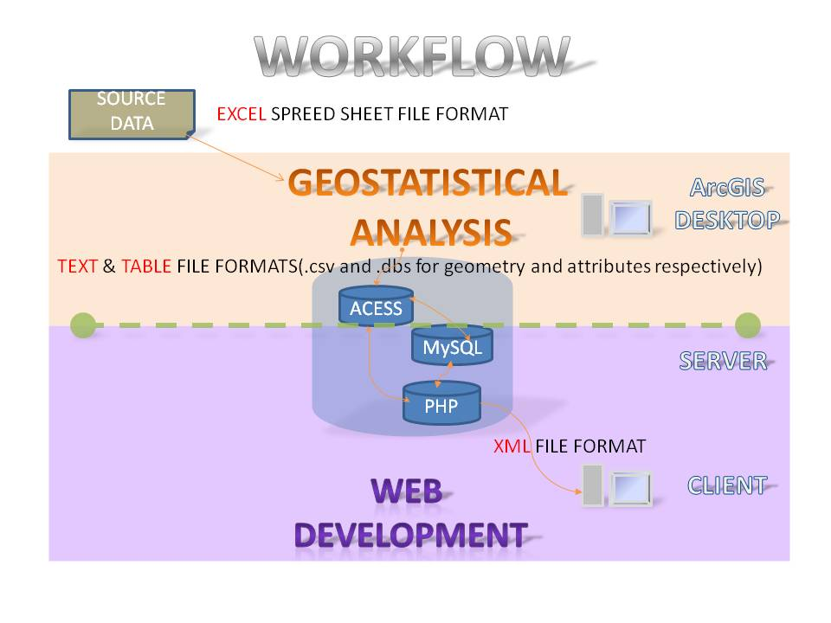
Figure 1: In this project I will be emphasizing on the methodology that I have applied to complete the project. The methodology has two important phases: geo-statistical analysis and GIS web development. The source data is in EXCEL spread sheet file format. This source data is processed through Geostatistical analysis using ArcGIS desktop. The byproduct has two file formats Text and Table. The .csv is responsible for geometry and .dbf for attribute. These files are exported out from ArcGIS into Access database and then appended into the tables in MySQL and PHP database. The web development section uses server side programming languages like PHP and client side programming languages like JavaScript

Introduction
As a geospatial professional with a geology background I have always been curious about revealing and presenting the subsurface structure using modern GIS techniques. It is my intention that the public will benefit from the interactive web map that is developed as a pilot project and presented in this paper. Both the academia and geospatial professionals can take advantage of the methodology applied in this presentation to adapt it in other useful projects.
Marcellus shale (Middle Devonian Deposit) and Utica shale (Ordovician Deposit) that were deposited in different dispensation has left sedimentary deposits that are about 2000 feet apart in depth and extending north east from Virginia up to New York. The Utica shale has the greater extent. (King)
Unlike the oil fields of Oil City, PA that were extracted from sand reservoirs, both Marcellus Shale and Utica Shale deposits haven't been economically attractive as natural gas resources in Pennsylvania until the beginning of the 21st century.
Based on the importance of shale in relation to its structural property in accommodating subsurface gas, oil and water it can be classified as:
- Ceiling rocks (because of its low permeability)
- Reservoir rocks (as a result of its porosity)
- Vertically fractured rocks
In the case of Marcellus and Utica shale, vertical fractures or pores are very important factors. In the contrary extracting them out is difficult due to its low permeability.
A recent improvement in extraction that technically connects or intersects the vertical fractures and pores in the shale together to form a network(horizontal drilling) and the application of high pressure water to increase this fractures (hydraulic fracturing) has made Marcellus Shale and Utica Shale deposits economically important. These methods were deployed in Pennsylvania in 2005. Geologists and geoscientists have predicted that by applying the above extraction methods 50 trillion cubic feet of gas that has a wellhead value of one trillion dollars might be recoverable. This is estimated to be 2 years natural gas supply of the entire United States. (King)

Methodology
The original data consist of the following:
- Wellheader.xls : A spread sheet of wellhead data for Marcellus shale. The data consists of 1796 well header data points with Marcellus Shale top and bottom information.
- UTICA_tops.xls: A spread sheet of wellhead data for Utica shale. The data consists of 71 well header data points with Utica shale top and bottom information.
Some of the other attributes for these data are UWI, latitudes and altitudes given in NAD83 Geographic coordinate reference system, operators, surface elevation, county and etc. The source for these data is DCNR.
Since the objective is to show both the point and polygon data on the map, we first start with the point data.

Algorithm

I) Data Preparation (ACCESS database)
- The data is prepared in access database by applying the following query statements with the corresponding results for the Marcellus data

QUERY1 = SELECT Kobre_wellheader.*, Marcellus_tops.VALUE AS MTOP
FROM Kobre_wellheader INNER JOIN Marcellus_tops ON Kobre_wellheadeR.UWI = Marcellus_tops.UWI
`UWI` DOUBLE NOT NULL ,
WHERE Marcellus_tops.NAME = "MARCELLUS"
ORDER BY Kobre_wellheader.UWI;
1795 RETURNS
QUERY2 = SELECT Kobre_wellheader.UWI, Marcellus_tops.VALUE AS MBOT
FROM Kobre_wellheader INNER JOIN Marcellus_tops ON Kobre_wellheadeR.UWI = Marcellus_tops.UWI
`UWI` DOUBLE NOT NULL ,
WHERE Marcellus_tops.NAME = "MARCELLUS_B"
ORDER BY Kobre_wellheader.UWI;
1753 RETURNS
QUERY3 = SELECT Query1.* INTO WELLMTOP
FROM Query1;
QUERY4 = SELECT Query2.* INTO WELLMTOP
FROM Query2;
- Export out WELLMTOP table to dbase IV file to be added into ArcGIS

II) Geopraoccessing (ArcGIS)
- Add coordinate data to the WELLMTOP table (x y events)
- Save as a shapefile
- Join the rest of the table to it to include the fields MTOP and MBOT
- Name the combined shapefile WELLCOMB
- In an edit mode add the fields MTHICK and MDEPTH
- Use the field calculator to update the records
  - MTHICK = [MBOT]-[MTOP]
  - MDEPTH = [MTOP]-[ELEV_GR]
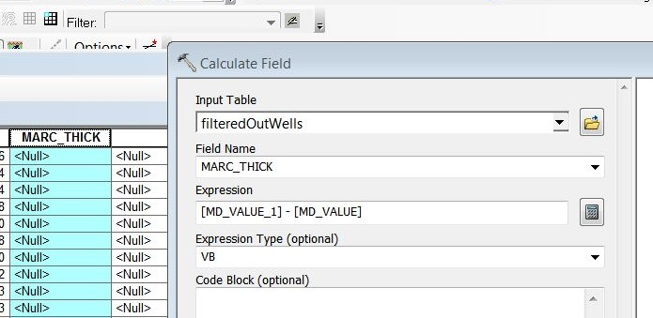

Figure 2: field calculator used to update the records

- Do Geostatistical Analysis from Geostatistical Wizard using Kriging method for each fields to create a prediction map layer of polygon shape (David O'Sullivan & Unwin, 2010)
  - right click on the kriging layer then
  - data >> export to vector
- Confirm that "GA Layer To Contour" dialogue box pops up allowing to make a polygon shape file of filled contours that showed both the prediction map and prediction standard error map for each field
- Export the shapefiles out to access database. (the shapefiles are: WELLCOMB.shp, MTHICK.shp, MDEPTH.shp, MTHICKERR.shp and MDEPTHERR.shp)
- The shapes are exported out in two forms
  - Text (use export shapefile to csv tool created by Jim Detwiler from my toolbox) Note: to append the geometry data
  - Table (dbase IV) Note: This is used to append the attributes
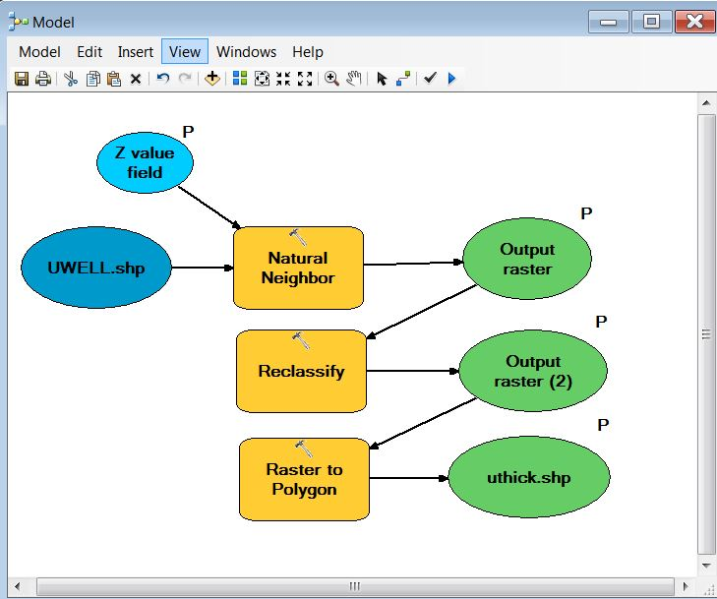
Figure 3: Natural Neighbor interpolation method is used to for the Utica data which will go through the process of reclassification. The raster output will later be converted to polygon .

III) Create Tables (MySQL database)
Create the table 'well' in MySQL database defined as follows.
CREATE TABLE `WELL` (
`FID` INT NOT NULL AUTO_INCREMENT PRIMARY KEY ,
`UWI` DOUBLE NOT NULL ,
`COUNTY` VARCHAR( 50 ) NOT NULL ,
`WELLNAME` VARCHAR( 50 ) NULL ,
`ELEV_GR` INT NOT NULL ,
`MTHICK` DOUBLE NOT NULL ,
`MDEPTH` DOUBLE NOT NULL ,
`SURFLAT` DOUBLE NOT NULL ,
`SURFLON` DOUBLE NOT NULL ,
INDEX ( `FID` , `WELLNAME` )
) ENGINE = MYISAM
Create the table 'marTK' in MySQL database defined as follows.
CREATE TABLE `marcTK` (
`ID` INT(11) NOT NULL AUTO_INCREMENT PRIMARY KEY ,
`grid_code` INT(11) NOT NULL ,
`MIN` DOUBLE NULL ,
`MAX` DOUBLE NULL ,
) ENGINE = MYISAM
Create the table 'mThickGeomERR' in MySQL database defined as follows.
CREATE TABLE `mThickGeomERR` (
`ID` INT(11) NOT NULL AUTO_INCREMENT PRIMARY KEY ,
`identity` INT(11) NULL ,
`Part` TINYINT(4) NULL ,
`ring` TINYINT(4) NOT NULL ,
`Y` DOUBLE NULL ,
`X` DOUBLE NULL ,
INDEX (`VID`)
) ENGINE = MYISAM;

IV) Form XML data using PHP server side scripting language
The forth algorithm is to form the XML data and it is done using PHP which is a server side scripting language
This is an example of one of the polygon geometry XML files which is the byproduct of the PHP code which I have omitted from this slide. “poly” stands for polygon and “V” stands for vertex.

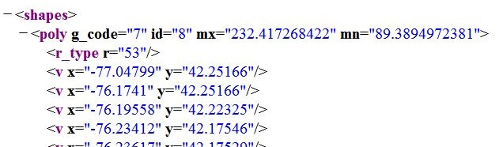

Figure 4: an example of one of the polygon geometry XML files which is the byproduct of the PHP code which I have omitted from this slide. “poly” stands for polygon and “V” stands for vertex.

And here is an example of one of the point geometry XML files a byproduct of another PHP code with little modification. The “pt” stands for point.

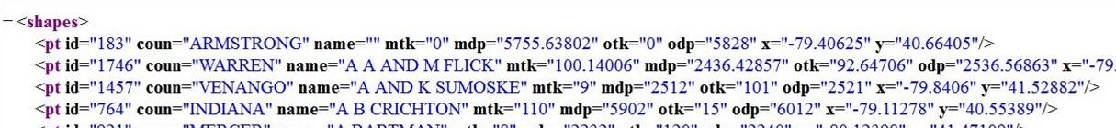
Figure 5: an example of one of the point geometry XML files a byproduct of another PHP code with little modification. The “pt” stands for point.

Note: Refer to Appendices section of this website for the code

V) Create the point and polygon maps using Google Engine, HTML and JavaScript client side programming language
The fifth algorithm is to create the point and polygon maps using Google Engine and HTML technology as well as JavaScript client side programming language. You will find the html and JavaScript codes on the appendices section of the project paper.

I will illustrate a demonstration of parts of the pilot project at the conclusion part of this presentation. The result would be similar to this one.

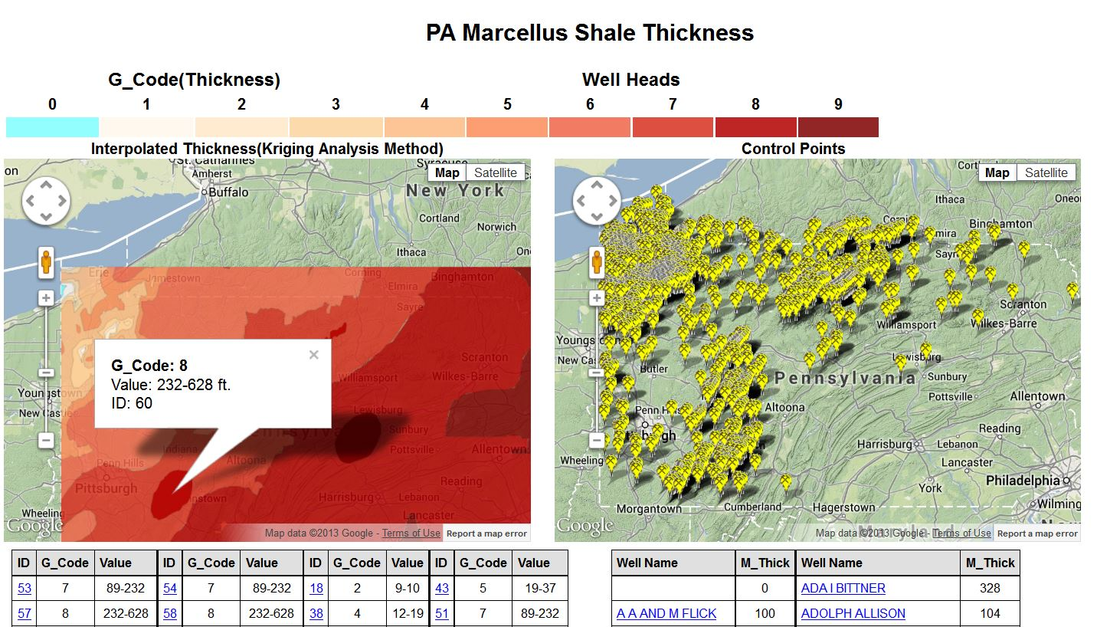
Figure 6: The output of the project looks like the one above. The shadow portion is revoked from Google API after the release of V 3.14 (Google, 2014)

VI) Repeat the above steps for each layer

Anticipated Results
The anticipated result for the Marcellus shale thickness should be very much like this one where it decreases in thickness from 250 feet down to 0 feet going towards north eastern Pennsylvania.

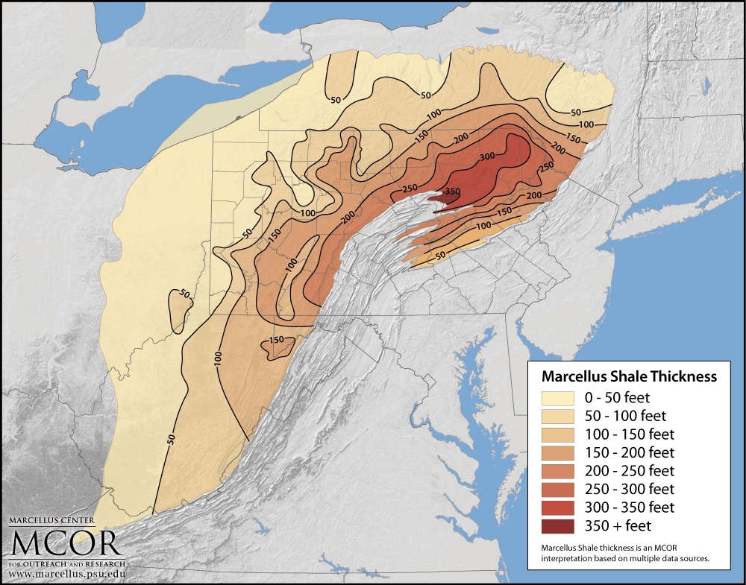
Figure 7: Map showing thickness of Marcellus shale. Map is prepared by MCOR. (MCOR)
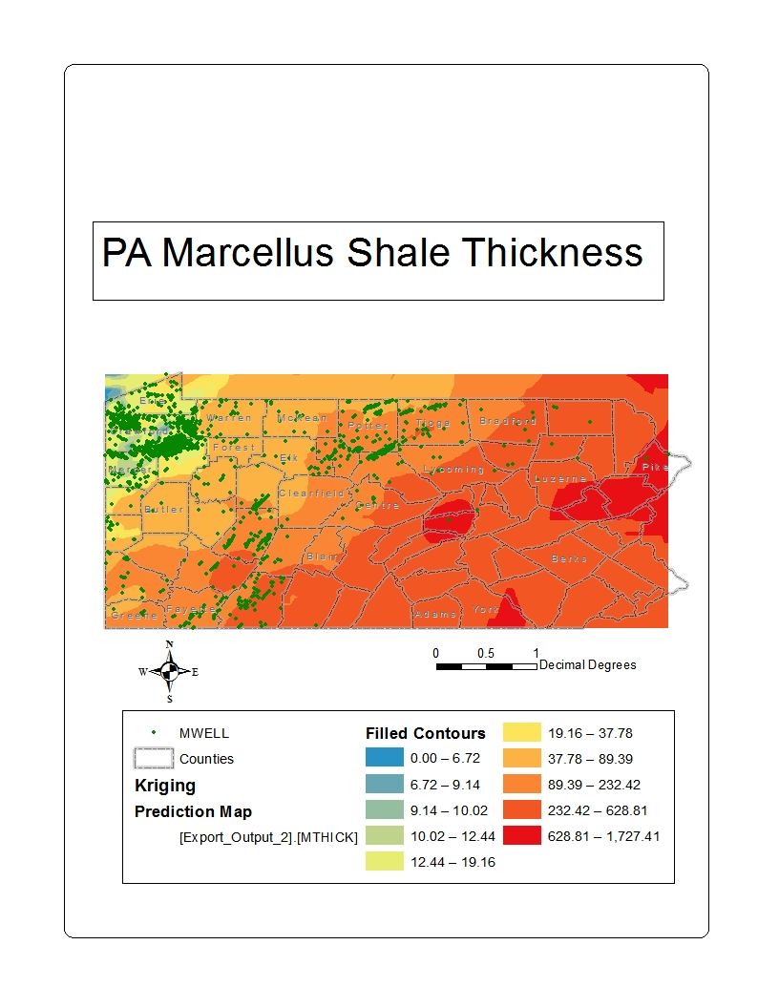
Figure 8: Marcellus shale thickness map that I have created using the geoprocessing (Kriging) result. This value could be misleading without looking at the standard error map in Appendix III.

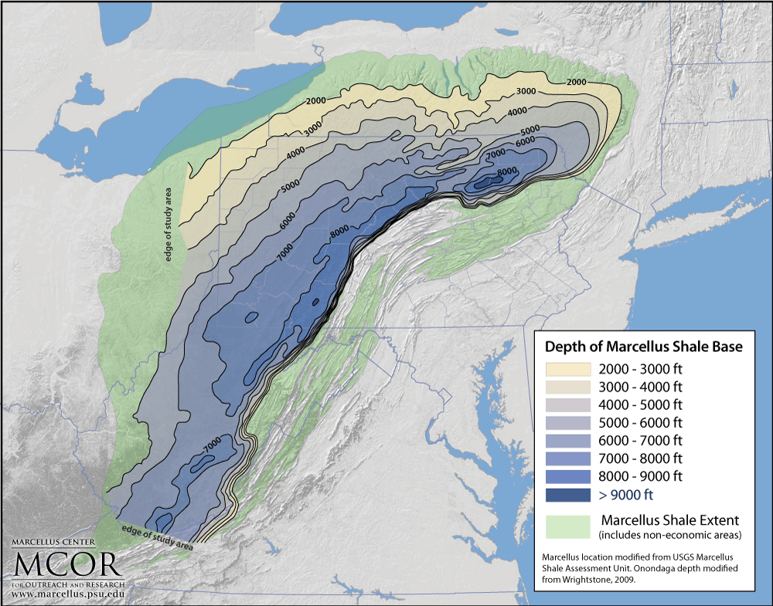
For the Marcellus shale depth it should be very much like this one where it decreases in depth from 7000 feet down to 400 feet going towards north eastern Pennsylvania.
Figure 9: Map showing depth of Marcellus shale base. Map is prepared by MCOR. (MCOR)
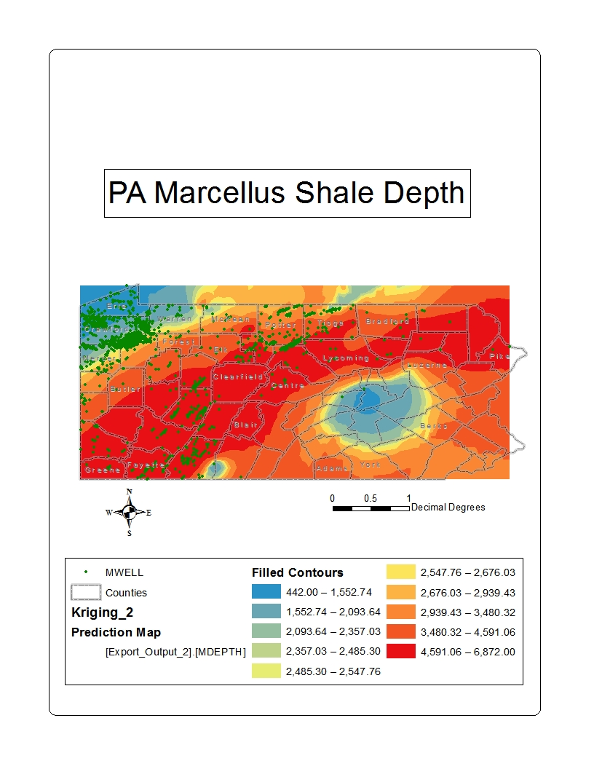
Figure 10: Marcellus shale depth map that I have created using the geoprocessing (Kriging) result. This value could be misleading without looking at the standard error map in Appendix IV.

The thickness of the Utica shale is expected to be more random ranging from 500 feet in some parts of PA to less than 100 feet in other parts of PA.
The data for Marcellus Shale is more numerous than the data for the Utica shale because the latter one involves much deeper drilling. As a result a less accurate representation is expected for Utica shale.
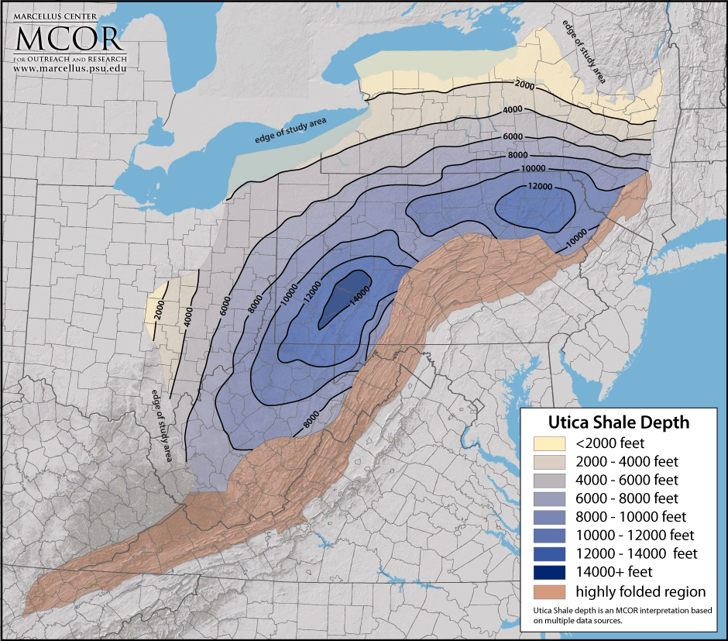
Figure 11: Map showing depth of Utica shale base. Map is prepared by MCOR. (MCOR)
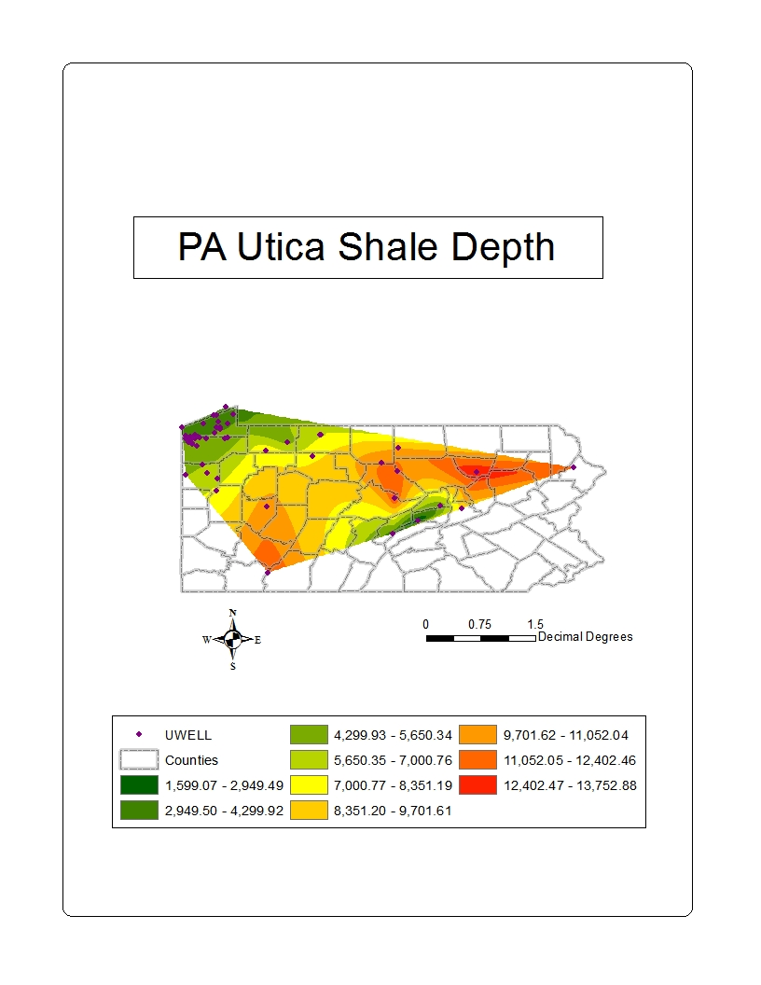
Figure 12: Utica Shale depth map that I have created using the geoprocessing (Natural Neighbor) result.

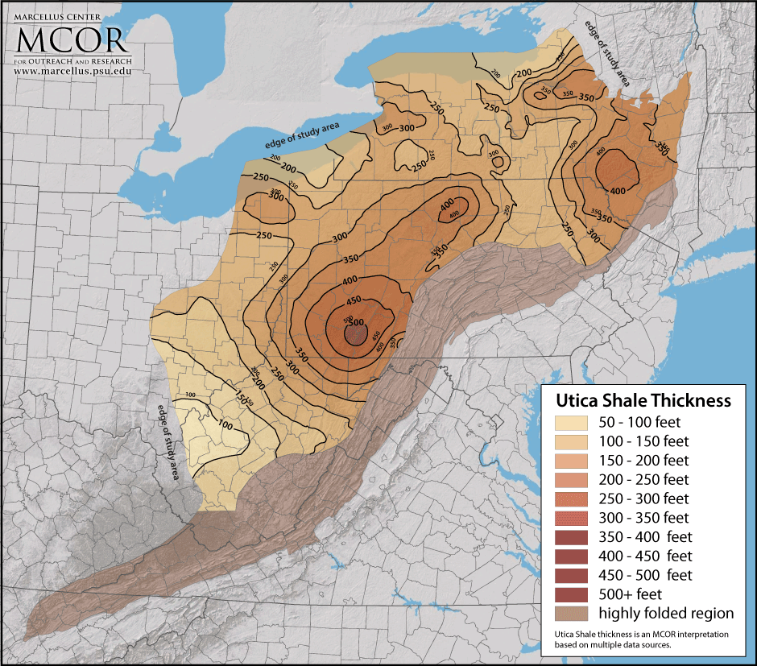
In the Appalachian Basin most rock units are thicker in the east and thinner in the west. The rock units b/n Utica and Marcella follow the same trend
Therefore the difference is about 1000 feet close to OH and reaching to 7000 feet in central PA. In other words the Utica gets more dipper along the south west to north eastern axis of PA.
Figure 13: Map showing thickness of Utica shale base. Map is prepared by MCOR. (MCOR)

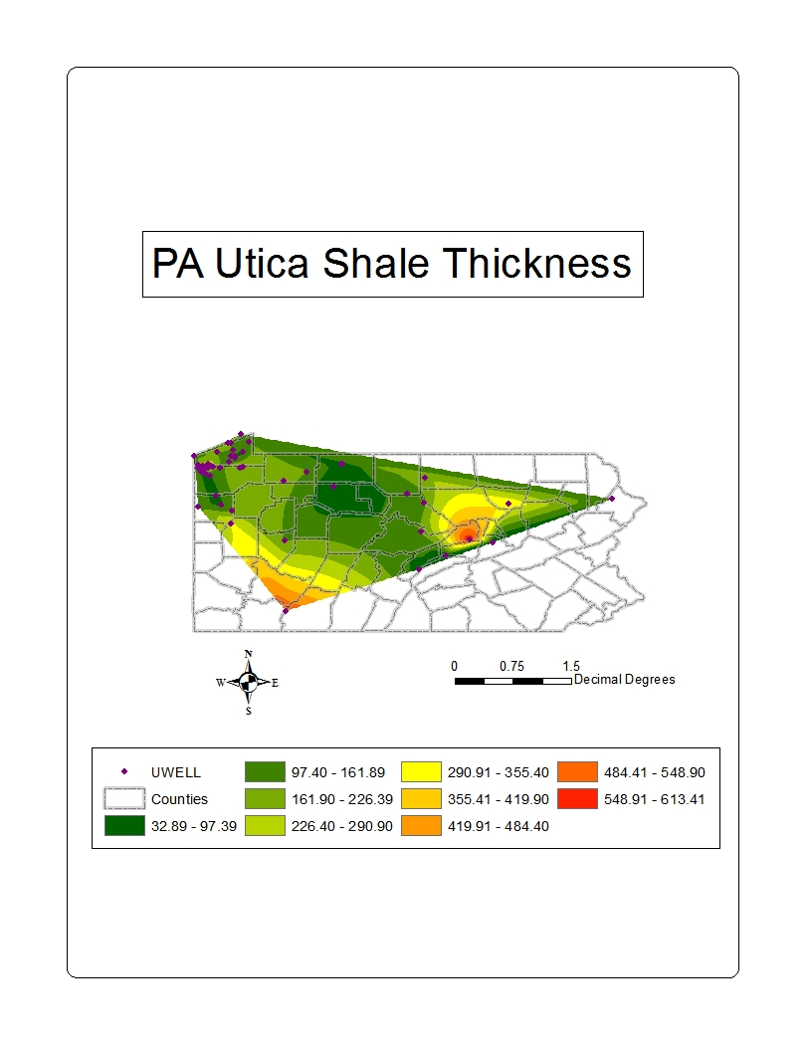
Figure 14: Utica Shale depth map that I have created using the geoprocessing (Natural Neighbor) result.

Conclusion
One of the challenges that I have faced in this project was forming XML data for multi-polygons that involved interior rings using PHP server side scripting language. With multiple of efforts I was able to come up with a code that can work for any polygon shaped data.
Mapping the interpolated results still involves much effort in transferring the polygon data to the web. However once a PHP code is written for one layer it can be re-used for the other layers with only minor modifications applied to it.
I hope that we will see some improvement in the near future by exploring better methodology, like on the fly geo-processing. In this case the geoprocessing is executed before it was transferred to the web.
A different approach of creating web map is using Esri's ArcGIS Rest Services. This approach will be easier since it will avoid the tedious process of creating XML files. A good example is a map which I have created called -Results from the presidential primaries held on "Super Tuesday," 2008(Arizona Sidebar). (ESRI, 2014)
Feel free to go through the Web Sample Demonstration . Select a layer and click the "Go!" button to go through the six layer options.

Works Cited
Data, R. (2014, 01). W3Schools References. Retrieved 01 2014, from w3schools: http://www.w3schools.com/default.asp
David O'Sullivan, P., & Unwin, D. J. (2010). Geographic Information Analysis (2nd ed.). New Jersey: John Wiley & Sons, Inc.
ESRI. (2014, 01). ArcGIS Server REST API. Retrieved 01 2014, from esri.com: http://maps.esri.com/apl4/sdk/rest/
Google. (2014, 01). Google Maps Javascript API V3 Reference. Retrieved 01 2014, from Google Developers: https://developers.google.com/maps/documentation/javascript/reference
King, H. (n.d.). Marcellus Shale - Appalachian Basin Natural Gas Play. Retrieved 12 01, 2013, from Geology.com: http://geology.com/articles/marcellus-shale.shtml
Maps and Digital Data. (n.d.). Retrieved from DCNR Pennsylvania Department of Conservation and Natural Resources: http://www.dcnr.state.pa.us/topogeo/econresource/oilandgas/marcellus/marcellus_maps/index.htm
MCOR. (n.d.). Resources : Maps & Graphics. Retrieved 2 3, 2014, from Penn State Marcellus Center for Outreach and Research : http://www.marcellus.psu.edu/resources/maps.php
NETL. (2007, 1 31). Natural Gas Program Archive. Retrieved from U.S. Department of Energy: Office of Fossil Energy: National Energy Technology Laboratory: http://www.netl.doe.gov/KMD/Forms/CdDvdRetrieval.aspx
Pictures of the Marcellus Shale formation outcrop . (n.d.). Retrieved 12 7, 2013, from WV Surface Owners’ Rights Organization (WV SORO): http://www.wvsoro.org/resources/marcellus/surface_pictures.html

Appendices

Appendix I) Form XML data using PHP server side scripting language

PHP Code for Marcellus shale well header point geometry or "qurWell1.php"
<?php
$link = mysqli_connect("instructdb3.ait.psu.edu","userID","Password","database");

$sql = "SELECT *
FROM WELL
ORDER BY WELLNAME;";

$result = mysqli_query($link, $sql);
if ($result != 0) {

header("Content-type: text/xml; charset: utf8");

echo '<shapes>';

$num_results = mysqli_num_rows($result);
for ($i=0;$i<$num_results;$i++) {
$row = mysqli_fetch_array($result);
$id = $row['FID'];
$name = $row['WELLNAME'];
$coun = $row['COUNTY'];
$elev = $row['ELEV_GR'];
$mtk = $row['MTHICK'];
$mdp = $row['MDEPTH'];
$otk = $row['OTHICK'];
$odp = $row['ODEPTH'];
$x = $row['SURFLON'];
$y = $row['SURFLAT'];

echo '<pt id="' .$id. '" coun="' .$coun. '" name="' .$name. '" mtk="' .$mtk. '" mdp="' .$mdp. '" otk="' .$otk. '" odp="' .$odp. '" x="' .$x. '" y="' .$y. '" ></pt>';

}

echo '</shapes>';
}
?>

PHP Code for Utica shale well header point geometry or "qurUWell.php"

<?php
$link = mysqli_connect("instructdb3.ait.psu.edu","userID","Password","database ");

$sql = "SELECT *
FROM UWELL
ORDER BY UWI;";

$result = mysqli_query($link, $sql);
if ($result != 0) {

header("Content-type: text/xml; charset: utf8");

echo '<shapes>';

$num_results = mysqli_num_rows($result);
for ($i=0;$i<$num_results;$i++) {
$row = mysqli_fetch_array($result);
$id = $row['FID'];
$name = $row['UWI'];
$coun = $row['COUNTY'];
$elev = $row['ELEV_GR'];
$utk = $row['UTHICK'];
$udp = $row['UDEPTH'];
$x = $row['SURFLON'];
$y = $row['SURFLAT'];

echo '<pt id="' .$id. '" coun="' .$coun. '" name="' .$name. '" utk="' .$utk. '" udp="' .$udp. '" x="' .$x. '" y="' .$y. '" ></pt>';

}

echo '</shapes>';
}
?>

PHP Code for Marcellus shale thickness polygon geometry or "qurMThic.php"

<?php
$link = mysqli_connect("instructdb3.ait.psu.edu","userID","Password","database ");

$sql = "SELECT *, count(*) AS cnt
FROM marcTk INNER JOIN mThickGeomHole ON mThickGeomHole.identity = marcTk.grid_code
GROUP BY ring, identity
ORDER BY cnt DESC";

$result = mysqli_query($link, $sql);
if ($result != 0) {

header("Content-type: text/xml");
echo '<shapes>';

$num_results = mysqli_num_rows($result);
for ($i=0;$i<$num_results;$i++) {
$row = mysqli_fetch_array($result);
$id = $row['ID'];
$g_code = $row['grid_code'];
$p = $row['Part'];
$r = $row['ring'];
$mx = $row['MAX'];
$mn = $row['MIN'];

echo '<poly g_code="' .$g_code. '" id="' .$id. '" mx="' .$mx. '" mn="' .$mn. '" >';
echo '<r_type r="' .$r. '" />';
$sql = "SELECT * FROM mThickGeomHole WHERE identity ='" .$g_code. "' AND ring ='" .$r. "' ORDER BY VID, ring, Part ASC;";

$coords = mysqli_query($link, $sql);
if ($coords != 0) {
$num_coords = mysqli_num_rows($coords);
for ($k=0;$k<$num_coords;$k++) {
$rec = mysqli_fetch_array($coords);
$x = $rec['X'];
$y = $rec['Y'];

echo '<v x="' .$x. '" y="' .$y. '" />';

}
}

echo '</poly>';
}

echo '</shapes>';
}
?>

PHP Code for Marcellus shale depth polygon geometry or "qurMDept.php"

<?php
$link = mysqli_connect("instructdb3.ait.psu.edu","userID","Password","database ");

$sql = "SELECT *, count(*) AS cnt
FROM marcDepth INNER JOIN mDepGeom ON mDepGeom.identity = marcDepth.grid_code
GROUP BY ring, identity
ORDER BY cnt DESC";

$result = mysqli_query($link, $sql);
if ($result != 0) {

header("Content-type: text/xml");
echo '<shapes>';

$num_results = mysqli_num_rows($result);
for ($i=0;$i<$num_results;$i++) {
$row = mysqli_fetch_array($result);
$id = $row['ID'];
$g_code = $row['grid_code'];
$p = $row['Part'];
$r = $row['ring'];
$mx = $row['MAX'];
$mn = $row['MIN'];

echo '<poly g_code="' .$g_code. '" id="' .$id. '" mx="' .$mx. '" mn="' .$mn. '" >';
echo '<r_type r="' .$r. '" />';
$sql = "SELECT * FROM mDepGeom WHERE identity ='" .$g_code. "' AND ring ='" .$r. "' ORDER BY VID, ring, Part ASC;";

$coords = mysqli_query($link, $sql);
if ($coords != 0) {
$num_coords = mysqli_num_rows($coords);
for ($k=0;$k<$num_coords;$k++) {
$rec = mysqli_fetch_array($coords);
$x = $rec['X'];
$y = $rec['Y'];

echo '<v x="' .$x. '" y="' .$y. '" />';

}
}

echo '</poly>';
}

echo '</shapes>';
}
?>

PHP Code for Utica shale thickness polygon geometry or "qurUThic.php"

<?php
$link = mysqli_connect("instructdb3.ait.psu.edu","userID","Password","database ");
$sql = "SELECT *, count(*) AS cnt
FROM uticThick INNER JOIN uThickGeom ON uThickGeom.identity = uticThick.ID
GROUP BY ring, identity
ORDER BY cnt DESC, ring DESC";

$result = mysqli_query($link, $sql);
if ($result != 0) {

header("Content-type: text/xml");
echo '<shapes>';

$num_results = mysqli_num_rows($result);
for ($i=0;$i<$num_results;$i++) {
$row = mysqli_fetch_array($result);
$id = $row['ID'];
$g_code = $row['grid_code'];
$p = $row['Part'];
$r = $row['ring'];
$mx = $row['MAX'];
$mn = $row['MIN'];

echo '<poly g_code="' .$g_code. '" in="' .$id. '" mx="' .$mx. '" mn="' .$mn. '" >';
echo '<r_type r="' .$r. '" />';
$sql = "SELECT * FROM uThickGeom WHERE identity ='" .$id. "' AND ring ='" .$r. "' ORDER BY VID, RING;";

$coords = mysqli_query($link, $sql);
if ($coords != 0) {
$num_coords = mysqli_num_rows($coords);
for ($k=0;$k<$num_coords;$k++) {
$rec = mysqli_fetch_array($coords);
$x = $rec['X'];
$y = $rec['Y'];

echo '<v x="' .$x. '" y="' .$y. '" />';

}
}

echo '</poly>';
}

echo '</shapes>';
}
?>

PHP Code for Utica shale thickness polygon geometry or " qurUDept.php"

<?php
$link = mysqli_connect("instructdb3.ait.psu.edu","userID","Password","database ");

$sql = "SELECT *, count(*) AS cnt
FROM uticDepth INNER JOIN uDepthGeom ON uDepthGeom.identity = uticDepth.ID
GROUP BY ring, identity
ORDER BY cnt DESC, ring DESC";

$result = mysqli_query($link, $sql);
if ($result != 0) {

header("Content-type: text/xml");
echo '<shapes>';

$num_results = mysqli_num_rows($result);
for ($i=0;$i<$num_results;$i++) {
$row = mysqli_fetch_array($result);
$id = $row['ID'];
$g_code = $row['grid_code'];
$p = $row['Part'];
$r = $row['ring'];
$mx = $row['MAX'];
$mn = $row['MIN'];

echo '<poly g_code="' .$g_code. '" in="' .$id. '" mx="' .$mx. '" mn="' .$mn. '" >';
echo '<r_type r="' .$r. '" />';
$sql = "SELECT * FROM uDepthGeom WHERE identity ='" .$id. "' AND ring ='" .$r. "' ORDER BY VID, RING;";

$coords = mysqli_query($link, $sql);
if ($coords != 0) {
$num_coords = mysqli_num_rows($coords);
for ($k=0;$k<$num_coords;$k++) {
$rec = mysqli_fetch_array($coords);
$x = $rec['X'];
$y = $rec['Y'];

echo '<v x="' .$x. '" y="' .$y. '" />';

}
}

echo '</poly>';
}

echo '</shapes>';
}
?>

Appendix II) Create the point and polygon maps using Google Engine, HTML and JavaScript client side programming language

HTML + JScript Code for PA Marcellus Shale Thickness Map

<!DOCTYPE html>
<html>
<head>
<title>PA Marcellus Shale Thickness</title>
<meta name="viewport" content="initial-scale=1.0, user-scalable=no" />
<style type="text/css">
body { font-family: arial }
h2 { text-align: center }
table.small { font-size: 80%; border-collapse: collapse; float: left }
td.o { filter:alpha(opacity=100); opacity:.85 }
</style>
<script type="text/javascript" src="https://maps.google.com/maps/api/js?sensor=false&amp;v=3.13""></script>
<script type="text/javascript" src="downloadxml.js"></script>
<script type="text/javascript">
var map;
var map2;
var polys = [];
var markers = [];
var infoWindow = new google.maps.InfoWindow();
var infoWindow2 = new google.maps.InfoWindow();
var inputFile = "qurMThic.php" //options are "qurMThic.php","qurMDept.php","qurMThicErr.php","qurMDepthErr.php","qurUThic.php","qurUDept.php".
var inputField = "mtk" //options are "", "mtk", "mdp", "utk","udp".
var param = 'M_Thick' //options are '','M_Thick','M_Depth', 'U_Thick','U_Depth'.

function handle_clicks(poly,info1,side) {
google.maps.event.addListener(poly, 'click', function() {

var infoWindowMap = map;
var infoWin = infoWindow;

infoWin.close();
infoWin.setContent(info1);

var polyCenter = getBoundsForPoly(poly).getCenter();
infoWin.setPosition(polyCenter);
infoWin.open(infoWindowMap);
});

}

function myclick(num) {
google.maps.event.trigger(polys[num], "click");

}
function myclick2(num) {
google.maps.event.trigger(markers[num], "click");
}

function createMarker(point,info, map) {
var iconURL = 'well.png'; var iconSize = new google.maps.Size(20,34);
var iconOrigin = new google.maps.Point(0,0); var iconAnchor = new google.maps.Point(10,34);

var myIcon = new google.maps.MarkerImage(iconURL, iconSize, iconOrigin, iconAnchor);

var shadowURL = 'well_shadow.png'; var shadowSize = new google.maps.Size(35, 34);
var shadowOrigin = new google.maps.Point(0, 0); var shadowAnchor = new google.maps.Point(10, 33);

var myShadow = new google.maps.MarkerImage(shadowURL, shadowSize, shadowOrigin, shadowAnchor);

var iconShape = [13,19, 11,15, 8,10, 9,6, 13,3, 15,3, 19,6, 20,10, 17,15, 15,19];
var myMarkerShape = {
coord: iconShape,
type: 'poly'
};

var myMarkerOpts = {
position: point,
map: map,
icon: myIcon,
shadow: myShadow,
shape: myMarkerShape
};

var marker = new google.maps.Marker(myMarkerOpts);
markers.push(marker);

google.maps.event.addListener(marker, 'click', function() {
infoWindow.close();
infoWindow.setContent(info);
infoWindow.open(map,marker);
});
}

function get_color(margin) {
if (margin == 1) { color = "#FFF7EC"; }
else if (margin == 2) { color = "#FEE8C8"; }
else if (margin == 3) { color = "#FDD49E"; }
else if (margin == 4) { color = "#FDBB84"; }
else if (margin == 5) { color = "#FC8D59"; }
else if (margin == 6) { color = "#EF6548"; }
else if (margin == 7) { color = "#D7301F"; }
else if (margin == 8) { color = "#B30000"; }
else if (margin == 9) { color = "#7F0000"; }
else if (margin == 0) { color = "#7FFFFF"; }

return color;
}

// function found on Maps API forum
function getBoundsForPoly(poly) {
var bounds = new google.maps.LatLngBounds;
poly.getPath().forEach(function(latLng) {
bounds.extend(latLng);
});
return bounds;
}

// number formatting function
// copyright Stephen Chapman 24th March 2006, 10th February 2007
// permission to use this function is granted provided
// that this copyright notice is retained intact
function formatNumber(num,dec,thou,pnt,curr1,curr2,n1,n2) {
var x = Math.round(num * Math.pow(10,dec));
if (x >= 0) n1=n2='';
var y = (''+Math.abs(x)).split('');
var z = y.length - dec;
if (z<0) z--;
for(var i = z; i < 0; i++) y.unshift('0');
y.splice(z, 0, pnt);
if(y[0] == pnt) y.unshift('0');
while (z > 3) {
z-=3;
y.splice(z,0,thou);
}
var r = curr1+n1+y.join('')+n2+curr2;
return r;
}

function initialize() {
var latlng = new google.maps.LatLng(41.08690771,-78.01441767);

var mapOpts = {
zoom: 7,
center: latlng,
mapTypeId: google.maps.MapTypeId.TERRAIN,
};

map = new google.maps.Map(document.getElementById("map"), mapOpts);

downloadUrl(inputFile, function(data) {
var xmlDoc = xmlParse(data);
var records = xmlDoc.getElementsByTagName("poly");
var row = xmlDoc.getElementsByTagName("r_type");

var starttable = '<table class="small" border="1" cellpadding="5"> \
<thead><tr style="background-color: #e0e0e0"><td><strong>ID</strong></td> \
<td><strong>G_Code</strong></td>\
<td><strong>Value</strong></td></tr></thead>\
<tbody>'

var side_html = starttable;

records.length = row.length ;
for (var i = 0; i < records.length; i++) {
var rec = records[i];
var rw = row[i];
var name = parseInt(rec.getAttribute("g_code"));
var number = parseInt(rw.getAttribute("r"));
var max = parseInt(rec.getAttribute("mx"));
var min = parseInt(rec.getAttribute("mn"));
var value = min +'-'+ max;

var color = get_color(name);

side_html += '<tr><td><a href="javascript: myclick(' + i + ')">' + number + '</a></td>' +
'<td style="text-align: center">' + name + '</td>' +
'<td style="text-align: center">' + value + '</td></tr>';

if ((i+1) % 18 == 0) {
var newtable = '</table><table class="small" \
border="1" cellpadding="5"><thead><tr style="background-color: #e0e0e0"> \
<td><strong>ID</strong></td>\
<td><strong>G_Code</strong></td>\
<td><strong>Value</strong></td>\
</tr>\
</thead><tbody>'
side_html += newtable;

}
var verts = rec.getElementsByTagName("v");
var pts = [];

for (var j = 0; j < verts.length; j++) {
var vert = verts[j];
var lat = parseFloat(vert.getAttribute("y"));
var lng = parseFloat(vert.getAttribute("x"));
pts[j] = new google.maps.LatLng(lat,lng);
}

var polyOpts = {
paths: pts,
map: map,
strokeColor: "#333333",
strokeOpacity: 1,
strokeWeight: .1,
fillColor: color,
fillOpacity: .85
}
var poly = new google.maps.Polygon(polyOpts);
polys[i] = poly;

var html = "<strong>G_Code: " + name + "</strong><br />" + "Value: " + value + " ft." + "<br />" + "ID: " + number;

handle_clicks(poly, html, 1);

}

var endtable = '</tbody></table>';
side_html += endtable;

document.getElementById("sidebar").innerHTML = side_html;

});

map2 = new google.maps.Map(document.getElementById("map_canvas"),
mapOpts);

downloadUrl("qurWell1.php", function(data) {
var xmlDoc = xmlParse(data);
var records = xmlDoc.getElementsByTagName("pt");

var starttable2 = '<table class="small" border="1" cellpadding="5"> \
<thead><tr style="background-color: #e0e0e0"><td><strong>Well Name</strong></td> \
<td><strong>'+ param +'</strong></td></tr></thead>\
<tbody>'

var side_html2 = starttable2;

for (var i = 0; i < records.length; i++) {
var rec = records[i];

var name = rec.getAttribute("name");
var coun = rec.getAttribute("coun");
var numb = formatNumber(rec.getAttribute(inputField),0,',','','','','','');
var lat = parseFloat(rec.getAttribute("y"));
var lng = parseFloat(rec.getAttribute("x"));

var pt = new google.maps.LatLng(lat, lng);

side_html2 += '<tr><td><a href="javascript: myclick2(' + i + ')">' + name + '</a></td>' +
'<td style="text-align: center">' + numb + '</td></tr>';

if ((i+1) % 18 == 0) {
var newtable2 = '</table><table class="small" \
border="1" cellpadding="5"><thead><tr style="background-color: #e0e0e0"> \
<td><strong>Well Name</strong></td>\
<td><strong>'+ param +'</strong></td></tr></thead>\
<tbody>'
side_html2 += newtable2;
}

var html2 = "<strong>" + param + ": " + numb + " ft." + "</strong><br />" + "Well Name: " + name + "<br />" + "County: " + coun;

createMarker(pt,html2,map2);

}
var endtable2 = '</tbody></table>';
side_html2 += endtable2;
document.getElementById("sidebar2").innerHTML = side_html2;
});
}

</script>

</head>
<body onload="initialize()">

<form name="opennew">
<select name="layer" id="layer">
<option value="" selected>Select Layer</option>
<option value="https://phpdb.aset.psu.edu/phpdwk159/project.html">PA Marcellus Shale Thickness</option>
<option value="https://phpdb.aset.psu.edu/phpdwk159/projectb.html">PA Marcellus Shale Thickness Standard Error</option>
<option value="https://phpdb.aset.psu.edu/phpdwk159/projecta.html">PA Marcellus Shale Depth</option>
<option value="https://phpdb.aset.psu.edu/phpdwk159/projectc.html">PA Marcellus Shale Depth Standard Error</option>
<option value="https://phpdb.aset.psu.edu/phpdwk159/projectd.html">PA Utica Shale Thickness</option>
<option value="https://phpdb.aset.psu.edu/phpdwk159/projecte.html">PA Utica Shale Depth</option>
</select>

<input type="button" name="Submit" value="Go!" onClick="window.open(layer.value, '_parent')">
</form>
<h2 style="width: 1225px">PA Marcellus Shale Thickness</h2>
<div id="legend" style="float: left; width: 1225px">
<table align="center" class="opaque">
<tr>
<th colspan="4" style="font-size: 120%">G_Code(Thickness)</th>
<th>&nbsp;</th>
<th colspan="4" style="font-size: 120%">Well Heads</th>
</tr>
<tr>
<th style="font-size: 100%">0</th>
<th style="font-size: 100%">1</th>
<th style="font-size: 100%">2</th>
<th style="font-size: 100%">3</th>
<th style="font-size: 100%">4</th>
<th style="font-size: 100%">5</th>
<th style="font-size: 100%">6</th>
<th style="font-size: 100%">7</th>
<th style="font-size: 100%">8</th>
<th style="font-size: 100%">9</th>
</tr>
<tr>
<td style="background-color: #7FFFFF; width: 130px" class="o">&nbsp;</td>
<td style="background-color: #FFF7EC; width: 130px" class="o">&nbsp;</td>
<td style="background-color: #FEE8C8; width: 130px" class="o">&nbsp;</td>
<td style="background-color: #FDD49E; width: 130px" class="o">&nbsp;</td>
<td style="background-color: #FDBB84; width: 130px" class="o">&nbsp;</td>
<td style="background-color: #FC8D59; width: 130px" class="o">&nbsp;</td>
<td style="background-color: #EF6548; width: 130px" class="o">&nbsp;</td>
<td style="background-color: #D7301F; width: 130px" class="o">&nbsp;</td>
<td style="background-color: #B30000; width: 130px" class="o">&nbsp;</td>
<td style="background-color: #7F0000; width: 130px" class="o">&nbsp;</td>
<td style="width: 505px">&nbsp;</td>

</tr>
</table>
</div>
<div style="float: left; width: 550px; text-align: center"><strong>Interpolated Thickness(Kriging Analysis Method)</strong></div>
<div style="float: left; width: 550px; text-align: center"><strong>Control Points</strong></div>
<div id="map" style="float: left; width: 550px; height: 400px"></div>
<div style="float: left; width: 25px">&nbsp;</div>
<div id="map_canvas" style="float: left; width: 550px; height: 400px"></div>
<div id="sidebar" style="clear: left; float: left; width: 610px; padding: 0.5em"></div>
<div id="sidebar2" style="width: 610px; height: 600px; position: relative; top: 0px; left: 0px; padding: 0.5em; overflow: auto"></div>
<p style="clear: left">Source: <a href="http://www.dcnr.state.pa.us/topogeo/econresource/oilandgas/marcellus/marcellus_maps/index.htm">
DCNR</a></p>

</body>
</html>

HTML + JScript Code for PA Utica Shale Depth Map

<!DOCTYPE html>
<html>
<head>
<title>PA Utica Shale Depth</title>
<meta name="viewport" content="initial-scale=1.0, user-scalable=no" />
<style type="text/css">
body { font-family: arial }
h2 { text-align: center }
table.small { font-size: 80%; border-collapse: collapse; float: left }
td.o { filter:alpha(opacity=100); opacity:.85 }
</style>
<script type="text/javascript" src="https://maps.google.com/maps/api/js?sensor=false&amp;v=3.13""></script>
<script type="text/javascript" src="downloadxml.js"></script>
<script type="text/javascript">
var map;
var map2;
var polys = [];
var markers = [];
var infoWindow = new google.maps.InfoWindow();
var infoWindow2 = new google.maps.InfoWindow();
var inputFile = "qurUDept.php" //options are "qurMThic.php","qurMDept.php","qurMThicErr.php","qurMDepthErr.php","qurUThic.php","qurUDept.php".
var inputField = "udp" //options are "", "mtk", "mdp", "utk","udp".
var param = 'U_Depth' //options are '','M_Thick','M_Depth', 'U_Thick','U_Depth'.

function handle_clicks(poly,info1,side) {
google.maps.event.addListener(poly, 'click', function() {

var infoWindowMap = map;
var infoWin = infoWindow;

infoWin.close();
infoWin.setContent(info1);

var polyCenter = getBoundsForPoly(poly).getCenter();
infoWin.setPosition(polyCenter);
infoWin.open(infoWindowMap);
});

}

function myclick(num) {
google.maps.event.trigger(polys[num], "click");

}
function myclick2(num) {
google.maps.event.trigger(markers[num], "click");
}

function createMarker(point,info, map) {
var iconURL = 'well.png'; var iconSize = new google.maps.Size(20,34);
var iconOrigin = new google.maps.Point(0,0); var iconAnchor = new google.maps.Point(10,34);

var myIcon = new google.maps.MarkerImage(iconURL, iconSize, iconOrigin, iconAnchor);

var shadowURL = 'well_shadow.png'; var shadowSize = new google.maps.Size(35, 34);
var shadowOrigin = new google.maps.Point(0, 0); var shadowAnchor = new google.maps.Point(10, 33);

var myShadow = new google.maps.MarkerImage(shadowURL, shadowSize, shadowOrigin, shadowAnchor);

var iconShape = [13,19, 11,15, 8,10, 9,6, 13,3, 15,3, 19,6, 20,10, 17,15, 15,19];
var myMarkerShape = {
coord: iconShape,
type: 'poly'
};

var myMarkerOpts = {
position: point,
map: map,
icon: myIcon,
shadow: myShadow,
shape: myMarkerShape
};

var marker = new google.maps.Marker(myMarkerOpts);
markers.push(marker);

google.maps.event.addListener(marker, 'click', function() {
infoWindow.close();
infoWindow.setContent(info);
infoWindow.open(map,marker);
});
}

function get_color(margin) {
if (margin == 1) { color = "#FFF7EC"; }
else if (margin == 2) { color = "#FEE8C8"; }
else if (margin == 3) { color = "#FDD49E"; }
else if (margin == 4) { color = "#FDBB84"; }
else if (margin == 5) { color = "#FC8D59"; }
else if (margin == 6) { color = "#EF6548"; }
else if (margin == 7) { color = "#D7301F"; }
else if (margin == 8) { color = "#B30000"; }
else if (margin == 9) { color = "#7F0000"; }
else if (margin == 0) { color = "#7FFFFF"; }

return color;
}

// function found on Maps API forum
function getBoundsForPoly(poly) {
var bounds = new google.maps.LatLngBounds;
poly.getPath().forEach(function(latLng) {
bounds.extend(latLng);
});
return bounds;
}

// number formatting function
// copyright Stephen Chapman 24th March 2006, 10th February 2007
// permission to use this function is granted provided
// that this copyright notice is retained intact
function formatNumber(num,dec,thou,pnt,curr1,curr2,n1,n2) {
var x = Math.round(num * Math.pow(10,dec));
if (x >= 0) n1=n2='';
var y = (''+Math.abs(x)).split('');
var z = y.length - dec;
if (z<0) z--;
for(var i = z; i < 0; i++) y.unshift('0');
y.splice(z, 0, pnt);
if(y[0] == pnt) y.unshift('0');
while (z > 3) {
z-=3;
y.splice(z,0,thou);
}
var r = curr1+n1+y.join('')+n2+curr2;
return r;
}

function initialize() {
var latlng = new google.maps.LatLng(41.08690771,-78.01441767);

var mapOpts = {
zoom: 7,
center: latlng,
mapTypeId: google.maps.MapTypeId.TERRAIN,
};

map = new google.maps.Map(document.getElementById("map"), mapOpts);

downloadUrl(inputFile, function(data) {
var xmlDoc = xmlParse(data);
var records = xmlDoc.getElementsByTagName("poly");
var row = xmlDoc.getElementsByTagName("r_type");

var starttable = '<table class="small" border="1" cellpadding="5"> \
<thead><tr style="background-color: #e0e0e0"><td><strong>ID</strong></td> \
<td><strong>G_Code</strong></td>\
<td><strong>Value</strong></td></tr></thead>\
<tbody>'

var side_html = starttable;

records.length = row.length ;
for (var i = 0; i < records.length; i++) {
var rec = records[i];
var rw = row[i];
var name = parseInt(rec.getAttribute("g_code"));
var number = parseInt(rw.getAttribute("r"));
var max = parseInt(rec.getAttribute("mx"));
var min = parseInt(rec.getAttribute("mn"));
var value = min +'-'+ max;

var color = get_color(name);

side_html += '<tr><td><a href="javascript: myclick(' + i + ')">' + number + '</a></td>' +
'<td style="text-align: center">' + name + '</td>' +
'<td style="text-align: center">' + value + '</td></tr>';

if ((i+1) % 20 == 0) {
var newtable = '</table><table class="small" \
border="1" cellpadding="5"><thead><tr style="background-color: #e0e0e0"> \
<td><strong>ID</strong></td>\
<td><strong>G_Code</strong></td>\
<td><strong>Value</strong></td>\
</tr>\
</thead><tbody>'
side_html += newtable;

}
var verts = rec.getElementsByTagName("v");
var pts = [];

for (var j = 0; j < verts.length; j++) {
var vert = verts[j];
var lat = parseFloat(vert.getAttribute("y"));
var lng = parseFloat(vert.getAttribute("x"));
pts[j] = new google.maps.LatLng(lat,lng);
}

var polyOpts = {
paths: pts,
map: map,
strokeColor: "#333333",
strokeOpacity: 1,
strokeWeight: .1,
fillColor: color,
fillOpacity: .85
}
var poly = new google.maps.Polygon(polyOpts);
polys[i] = poly;

var html = "<strong>G_Code: " + name + "</strong><br />" + "Value: " + value + " ft." + "<br />" + "ID: " + number;

handle_clicks(poly, html, 1);

}

var endtable = '</tbody></table>';
side_html += endtable;

document.getElementById("sidebar").innerHTML = side_html;

});

map2 = new google.maps.Map(document.getElementById("map_canvas"),
mapOpts);

downloadUrl("qurUWell.php", function(data) {
var xmlDoc = xmlParse(data);
var records = xmlDoc.getElementsByTagName("pt");

var starttable2 = '<table class="small" border="1" cellpadding="5"> \
<thead><tr style="background-color: #e0e0e0"><td><strong>Well Name</strong></td> \
<td><strong>'+ param +'</strong></td></tr></thead>\
<tbody>'

var side_html2 = starttable2;

for (var i = 0; i < records.length; i++) {
var rec = records[i];

var name = rec.getAttribute("name");
var coun = rec.getAttribute("coun");
var numb = formatNumber(rec.getAttribute(inputField),0,',','','','','','');
var lat = parseFloat(rec.getAttribute("y"));
var lng = parseFloat(rec.getAttribute("x"));

var pt = new google.maps.LatLng(lat, lng);

side_html2 += '<tr><td><a href="javascript: myclick2(' + i + ')">' + name + '</a></td>' +
'<td style="text-align: center">' + numb + '</td></tr>';

if ((i+1) % 19 == 0) {
var newtable2 = '</table><table class="small" \
border="1" cellpadding="5"><thead><tr style="background-color: #e0e0e0"> \
<td><strong>Well Name</strong></td>\
<td><strong>'+ param +'</strong></td></tr></thead>\
<tbody>'
side_html2 += newtable2;
}

var html2 = "<strong>" + param + ": " + numb + " ft." + "</strong><br />" + "Well Name: " + name + "<br />" + "County: " + coun;

createMarker(pt,html2,map2);

}
var endtable2 = '</tbody></table>';
side_html2 += endtable2;
document.getElementById("sidebar2").innerHTML = side_html2;
});
}

</script>

</head>
<body onload="initialize()">

<form name="opennew">
<select name="layer" id="layer">
<option value="" selected>Select Layer</option>
<option value="https://phpdb.aset.psu.edu/phpdwk159/project.html">PA Marcellus Shale Thickness</option>
<option value="https://phpdb.aset.psu.edu/phpdwk159/projectb.html">PA Marcellus Shale Thickness Standard Error</option>
<option value="https://phpdb.aset.psu.edu/phpdwk159/projecta.html">PA Marcellus Shale Depth</option>
<option value="https://phpdb.aset.psu.edu/phpdwk159/projectc.html">PA Marcellus Shale Depth Standard Error</option>
<option value="https://phpdb.aset.psu.edu/phpdwk159/projectd.html">PA Utica Shale Thickness</option>
<option value="https://phpdb.aset.psu.edu/phpdwk159/projecte.html">PA Utica Shale Depth</option>
</select>

<input type="button" name="Submit" value="Go!" onClick="window.open(layer.value, '_parent')">
</form>
<h2 style="width: 1225px">PA Utica Shale Depth</h2>
<div id="legend" style="float: left; width: 1225px">
<table align="center" class="opaque">
<tr>
<th colspan="4" style="font-size: 120%">G_Code(Depth)</th>
<th>&nbsp;</th>
<th colspan="4" style="font-size: 120%">Well Heads</th>
</tr>
<tr>
<th style="font-size: 100%">0</th>
<th style="font-size: 100%">1</th>
<th style="font-size: 100%">2</th>
<th style="font-size: 100%">3</th>
<th style="font-size: 100%">4</th>
<th style="font-size: 100%">5</th>
<th style="font-size: 100%">6</th>
<th style="font-size: 100%">7</th>
<th style="font-size: 100%">8</th>
<th style="font-size: 100%">9</th>
</tr>
<tr>
<td style="background-color: #7FFFFF; width: 130px" class="o">&nbsp;</td>
<td style="background-color: #FFF7EC; width: 130px" class="o">&nbsp;</td>
<td style="background-color: #FEE8C8; width: 130px" class="o">&nbsp;</td>
<td style="background-color: #FDD49E; width: 130px" class="o">&nbsp;</td>
<td style="background-color: #FDBB84; width: 130px" class="o">&nbsp;</td>
<td style="background-color: #FC8D59; width: 130px" class="o">&nbsp;</td>
<td style="background-color: #EF6548; width: 130px" class="o">&nbsp;</td>
<td style="background-color: #D7301F; width: 130px" class="o">&nbsp;</td>
<td style="background-color: #B30000; width: 130px" class="o">&nbsp;</td>
<td style="background-color: #7F0000; width: 130px" class="o">&nbsp;</td>
<td style="width: 505px">&nbsp;</td>

</tr>
</table>
</div>
<div style="float: left; width: 550px; text-align: center"><strong>Interpolated Thickness (Natural Neighbor Analysis Method)</strong></div>
<div style="float: left; width: 550px; text-align: center"><strong>Control Points</strong></div>
<div id="map" style="float: left; width: 550px; height: 400px"></div>
<div style="float: left; width: 25px">&nbsp;</div>
<div id="map_canvas" style="float: left; width: 550px; height: 400px"></div>
<div id="sidebar" style="clear: left; float: left; width: 610px; height: 550px; padding: 0.5em; overflow: auto"></div>
<div id="sidebar2" style="width: 610px; height: 550px; position: relative; top: 0px; left: 0px; padding: 0.5em; overflow: auto"></div>
<p style="clear: left">Source: <a href="http://www.dcnr.state.pa.us/topogeo/econresource/oilandgas/marcellus/marcellus_maps/index.htm">
DCNR</a></p>

</body>
</html>

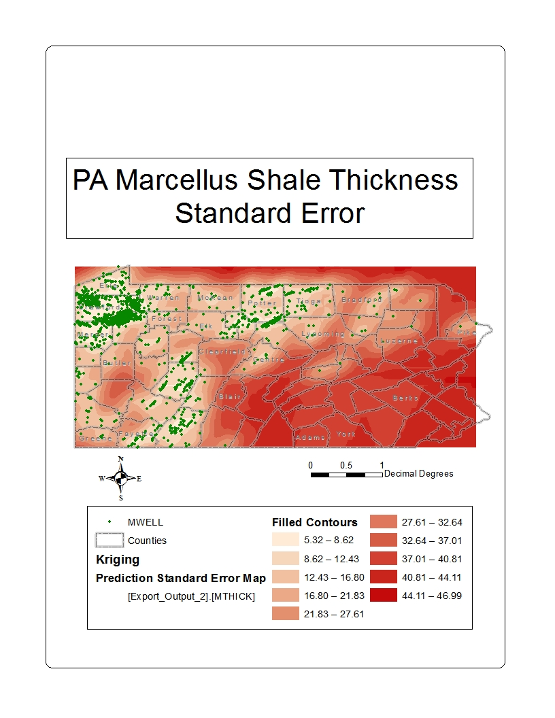
Appendix III) Marcellus Shale Thickness Standard Error Map(Areas with no control stations are shown with very high values indicating that they need to be ignored)

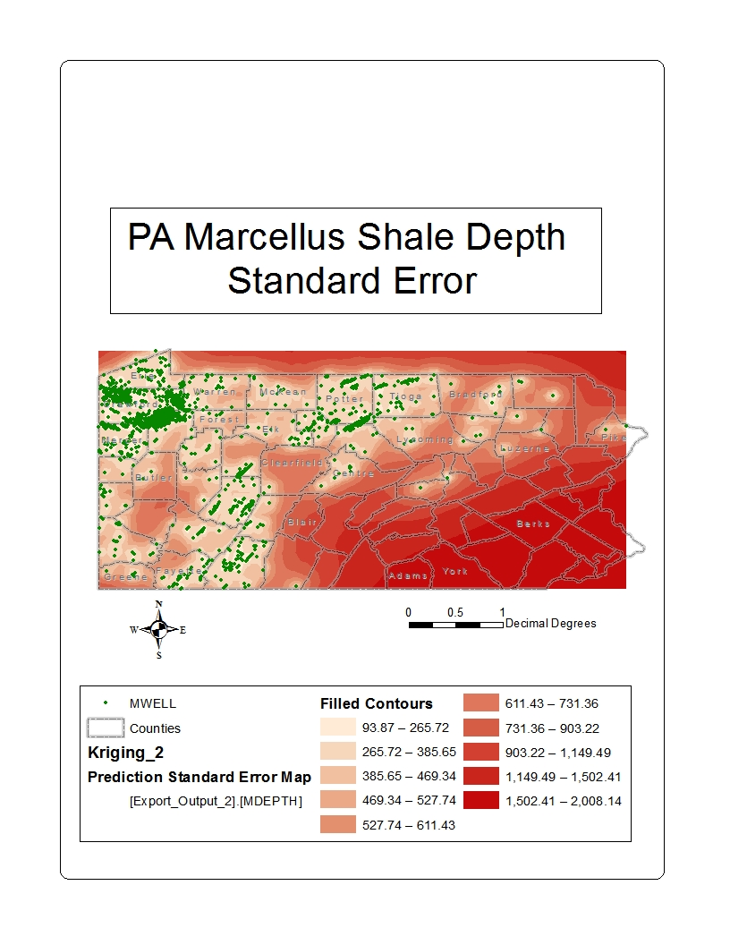
Appendix IV) Marcellus Shale Depth Standard Error Map (Areas with no control stations are shown with very high values indicating that they need to be ignored)

