Building Spatial Search Capabilities for the Omaha District Geospatial Data Catalog

The Omaha District Geospatial Data Catalog (NWO-GDC) provides an interactive, web-based GIS data catalog used to search the vast amounts of data housed by the US Army Corps of Engineers (USACE) Omaha District’s GIS Service Center (GSC). Users search the catalog through a spatial selection in the GSC’s current web mapping application, the NWO Web Mapping Interface. This type of data search currently exists within the Omaha District, but is only available for ArcGIS Desktop users. The primary goal for this capstone project was to extend this functionality to the web to allow web-based users and project managers who might not have access to or are not in need of the robust functionality of ArcGIS to view available project data that may benefit business lines or projects in their area of interest. The NWO-GDC also serves as an important communication tool between project managers, supervisors, GIS users, and the GSC.

Literature Review

In preparation for building the NWO-GDC, thorough reviews of other web-based GIS data catalogs and data clearinghouses were completed. These reviews were done to see what other organizations have created, to learn how other map-based spatial selections were handled, and to find ideas for additional functionality. The catalogs and clearinghouses evaluated represent both state and national agencies and serve a wide range of stakeholders and fields.
No matter how simple or complex, the fundamental purpose of a GIS data catalog is to provide users with access to available GIS datasets. The reviewed clearinghouses all provided this capability. Most also highlighted the spatial aspect of the cataloged data, with the map or spatial criteria the main focus of the catalog search. Simpler catalogs, such as the New York State GIS Clearinghouse or the State Data Center of Iowa provided static interactive maps, with the ability to browse datasets solely by clicking on a single county. More complex options included the ability to draw shapes on a web map or search by other spatial user inputs such as the Public Land Survey System’s (PLSS) Township, Range, and Section. The complex catalogs also provided the separation of data searches by theme, i.e. Structures, Transportation, Boundaries, or Orthoimagery (U.S. Geological Survey, 2014b). Complex data clearinghouses included The National Map from the U.S. Geological Survey (USGS), the USGS’s EarthExplorer, the U.S. Department of Agriculture’s (USDA) Geospatial Data Gateway, and Pennsylvania Spatial Data Access (PASDA).
The predominant methods of spatial search across all map-based catalogs were either a user-defined point or bounding box. The user-defined point generally identified a pre-defined shape that was then used to search against the catalog. Examples of these pre-defined shapes included a USGS 24K Quad, a custom defined tile as shown in the example from PASDA below, or an administrative area such as a county or congressional district. Bounding boxes could be defined by either coordinate input or drawing a rectangle on the map area.
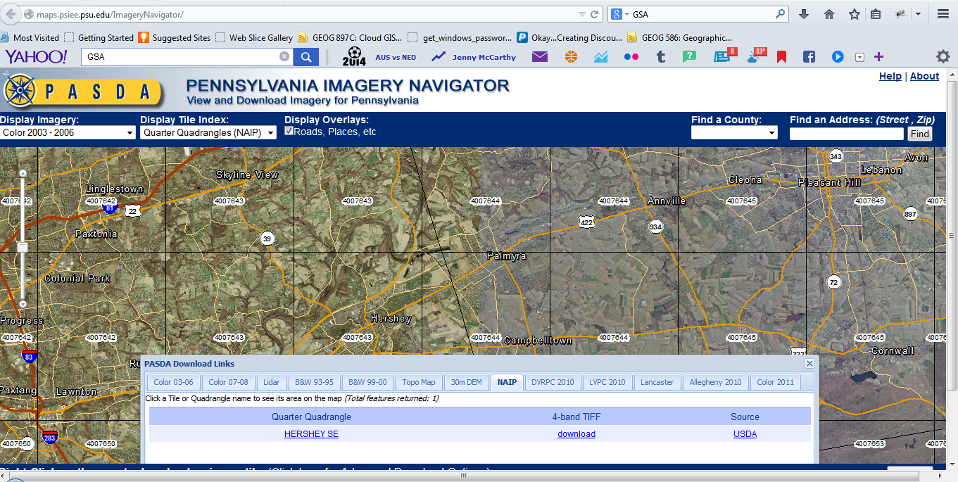
Figure 1 A single click on the map returns available imagery results by tile for that location. Created using the PASDA Imagery Navigator at http://maps.psiee.psu.edu/ImageryNavigator/.
Data in most of the clearinghouses was also easily searched by spatial user inputs. The Iowa Geographic Map Server, for example, allows users to search by Township, Range and Section, City Name, or USGS quad name. The Geospatial Data Gateway provided the ability to search place types such as zip code, hydrologic unit code, or soil survey area, as well as state or county.
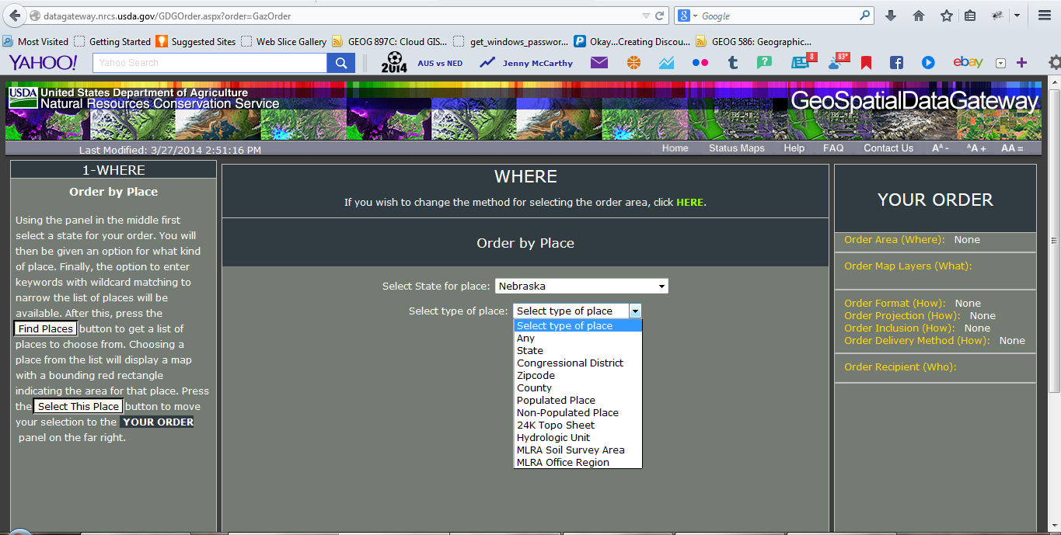
Figure 2 Available place types for data searches within the Geospatial Data Gateway. Retrieved from http://datagateway.nrcs.usda.gov/GDGOrder.aspx?order=GazOrder.
Three catalogs deviated from these norms significantly. These were the Iowa LiDAR Mapping Project, The National Map, and EarthExplorer. The Iowa LiDAR Mapping Project allows the user to draw a custom polygon to define their search area, not simply a rectangular bounding box. This custom polygon can be used to not only download the original LiDAR LAS files made available through this interface, but can also be used to create “derived LiDAR products” (GeoInformatics Training Research Education and Extension & Iowa Department of Natural Resources, 2014) such as contours, Digital Elevation Models (DEMs), and hillshades for the area of interest. This functionality was unique across all data catalogs, including others that provided the ability to search and download LiDAR data.
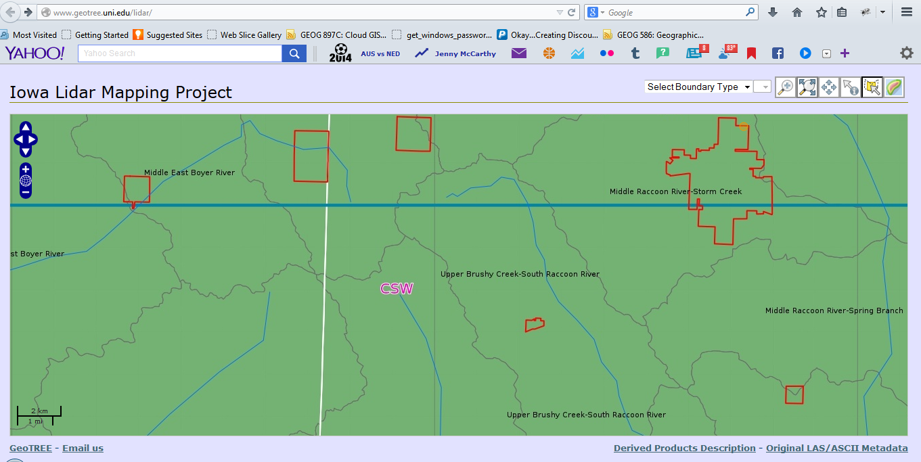
Figure 3 The Iowa LiDAR Mapping Project's unique tool to return derived data for a user defined location is shown circled above in red. Retrieved from http://www.geotree.uni.edu/lidar/.
USGS’s The National Map and EarthExplorer also provide the ability to search by a custom polygon. This functionality is fairly hidden in The National Map. The user is required to draw a map annotation and then use the graphic as the area of interest for the data search. The map annotation can be either a polygon or an ellipse. EarthExplorer, which is now only used for legacy data, appears to have offered the most robust search options while it was actively used. At one time it contained the ability to search by a circle or to search by an uploaded shapefile or KML. These options are still shown in the application and associated help, but are greyed out.
There were also a several catalogs that classified themselves as geoportals. These included the National Oceanic and Atmospheric Association's (NOAA) National Geophysical Data Center‘s (NGDC) geoportal, the U.S. government’s Data.gov, and the State of Nebraska’s NebraskaMap.gov. The main difference between these portals and the other data clearinghouses was the approach to the data search. The map occupies very little space on the main search page. Searches are primarily keyword based, with the ability to refine results using spatial parameters. A location can be defined by a place keyword, though there is the ability to draw a rectangle on the map. NOAA’s NGDC and NebraskaMap provide the user with advanced search options which include refinement by data category and creation date. There are also pre-set tags, which can be used to filter search results further. Data.gov uses these modifications to include non-spatial data in its search results.
The secondary difference between these portals and the other explored clearinghouses is the seeming standardization of the portal functionality and layout. NOAA’s NGDC and NebraskaMap are based on ESRI’s Open Source Geoportal Extension, while Data.gov runs on Comprehensive Knowledge Archive Network’s (CKAN) open source data portal. Both are extremely similar in terms of web page design and while each offers slightly different search functionality, the search workflow is the same. This streamlines the user experience between sites, making it easy and familiar for the user to search for available datasets.
Ultimately, the review turned up very little in terms of new functionality that could be added to the Omaha District’s web-based GIS catalog. The Iowa LiDAR Mapping Project’s tool that provides processed DEMs or Contours instead of raw LAS data was very intriguing. These products are delivered with every LiDAR data collection NWO requests, however, and should already be returned as a search result for an area where they are available. The abundance of spatial user input searches in all of the catalogs, however, has led to the idea of including this type of search to the Omaha District’s catalog, even though the concept might not be new. This would allow the user to search by PLSS, River Mile, or Missouri River Bend. Lastly, the fact that only EarthExplorer provided the option to search for data along a user specified line is a bit perplexing. The lack of its existence in other catalogs will not prevent it from being included in the Omaha District’s catalog, as it can be quite useful for a NWO user to search for data along a specified section of river bank. Hopefully this line search will be a feature that will help distinguish the Omaha District’s GIS data catalog while providing required functionality for catalog users.

Functionality Specifications

The Omaha District Geospatial Data Catalog is a stand-alone application, used to search approximately 30TB of data served by the GSC. The application consists of an Oracle Application Express (APEX) front end, with the GSC’s NWO Web Map Interface embedded in it. The NWO Web Map Interface is built on the ArcGIS API for JavaScript and utilizes REST services published with ArcGIS for Server 10.1. The data published by ArcGIS for Server resides in an Oracle 11g database and is accessed using ESRI’s Spatial Data Engine (SDE) technology.
The NWO-GDC spatial search leverages this existing architecture, utilizing the IdentifyTask and IdentifyParameters classes within the API for JavaScript to intersect catalog indexes served through ArcGIS for Server. All of the spatial search functionality is contained within the NWO Web Map Interface, while the search results are managed within APEX. This provides better integration with information stored outside of the results indexes’ SDE feature classes and helps align the spatial data search component with its project management and communication goals.
The spatial search tools allow users to search for available data by several different methods:
- User drawn inputs on the map interface:
  - Point
  - Line (USGS, 2014)
  - Polygon

- Uploading an existing shapefile or KML/KMZ (USGS, 2014)
- Locally defined user inputs:
  - City
  - County
  - Public Land Survey System (PLSS)
  - Missouri River Bend Name
  - River Mile
  - USGS 24k Quad Name

The locally defined user input method is customizable on the backend, allowing new user inputs to be easily added in the future as they are requested. The spatial search tools, shown circled in blue, can be seen on the initial “Search By Map” screen of the NWO-GDC in Figure 4 below.
Figure 4 depicts the spatial search tools, located on the “Search By Map” page of the NWO-GDC. Retrieved from http://imgis2.nwo.usace.army.mil:7777/pls/apex/f?p=125:3.

Each spatial search method returns a geometry that is then used as the geometry parameter for the ArcGIS API for JavaScript IdentifyTask. “Find by Point,” “Find by Line,” and “Find by Polygon” simply convert the graphic drawn on the map into the geometry object. For the “Find By Uploaded Data” method, the graphic of the uploaded data is first added to the map using existing functionality. Once that graphic has been added, it is then converted into a geometry object. Lastly, the “Find By User Input” method uses the QueryTask on the user-specified layer to find the desired feature, such as Missouri River Mile 836. The QueryTask returns the geometry associated with the specified attribute, which is then used as the geometry object for the IdentifyTask.
As stated above, the IdentifyTask is executed after a user completes the desired spatial search method. When the IdentifyTask is complete, the resulting values of each identified feature’s EGIS_ID field, which can be found in the feature classes’ attribute tables, is passed to the APEX front end using the postMessage method. Once APEX receives the values, it performs an SQL query to retrieve the matching records in the GSC’s Data Inventory Table and displays these records in the “Results” panel below the map. An example of the “Results” panel can be seen below in Figure 5.
Figure 5 illustrates a successful search, which returns the identified results’ corresponding database information, including EGIS_ID number, a link to view the data on the map, data type, project description, data collection dates, a link to available metadata, contract number, company information, and the COE project manager’s e-mail address. Retrieved from http://imgis2.nwo.usace.army.mil:7777/pls/apex/f?p=125:3.

The “Results” panel provides basic details about each identified result including data type, project description, data collection dates, metadata, contract number, company information, and project manager e-mail address. The panel also contains both sort and filter functionality allowing users to manipulate the records as desired. Users can click the link under the “Metadata” column to view that result’s metadata in a new tab. This metadata contains more information such as spatial reference, horizontal accuracy, vertical accuracy, and the details regarding the data creation process. To contact the project manager directly regarding a specific result, users can click the link under the “COE Project Manager” column. This link will open up a form that auto-populates information regarding the dataset in question, as seen in Figure 6 below. The user simply enters their name, e-mail address, and questions and clicks “Send”.
Figure 6 demonstrates sending an e-mail to the COE project manager after clicking on their email address in the “Results” pane. All pertinent result information is pre-populated so that the user only has to fill in their name, e-mail address and question. Retrieved from http://imgis2.nwo.usace.army.mil:7777/pls/apex/f?p=125:5.

For each result, the table also displays a link to view the dataset’s tiles on the map. Clicking this link will send that particular result’s EGIS_ID back to the mapping application using the postMessage method. Once the map receives the EGIS_ID, it will turn on the associated layer and select the tile(s) that have been identified. It will also begin a partial page refresh of the APEX front end, which executes a custom PL/SQL function to populate the “Available Data Tiles and Location” sidebar. The final result of clicking the “See Tile(s) on Map” link is shown below in Figure 7.

Figure 7 shows the result of the clicking the “See Tile(s) on Map” link from the “Results” panel. The dataset’s layer is turned on in the map with the tile(s) selected. The “Available Data Tiles and Location” sidebar is also populated with all information that pertains that particular data result. Retrieved from http://imgis2.nwo.usace.army.mil:7777/pls/apex/f?p=125:3.

All results will display the tile name(s) that are located at the search location as well as a button to pre-populate an e-mail to the GSC for questions. If a tile is located on one of the GSC’s servers, it will provide the link to that location, as shown in Figure 7 above. The user can click or copy and paste this link to open the data directory in a new Windows Explorer. If a tile is located “Offline,” the panel will indicate the tile(s) are offline and will provide all GSC staff member’s phone numbers.
Depending on the data type returned, additional options will be available. Shapefile data can be added directly to the map interface. This functionality uses open-source utilities JSZip and shp2geojson.js. Shapefile data, LAS files, text files, and CSV files can also be downloaded, provided that each tile is under 20MB. The JSZip utility is also used here to create a zip file of the resulting tiles and to provide it to the user. If the data type is already being served as a WMS or REST service, the “Available Data Tiles and Location” sidebar will present a button that allows the service to be added directly to the map. Once the service is added to the map, the user can push the service to a new instance of the NWO Web Map Interface, allowing them to mash up the service with other data layers that the GSC serves. Adding a service to a new instance once again relies on the postMessage method to pass the data from one application to another. Figure 8 below shows examples of the “Available Data Tiles and Location” sidebar when the above mentioned options are provided to users.
Figure 8 shows additional options for data results depending on the data type. At the left, shapefile data can be either added directly to the map or downloaded. At the right, data already being served in REST or WMS format can be added to the map as a service and then pushed to a new instance of the NWO Web Map Interface. Retrieved from http://imgis2.nwo.usace.army.mil:7777/pls/apex/f?p=125:3.
At any time, users can click the “New Search” button, shown in Figure 8 above to begin a new search. The user can also initiate a new search within the map. The “Results” panel will be refreshed with the new results when they are available.

Project Results and Future Enhancements
The NWO-GDC will make it easier than ever for supervisors, project managers, and novice GIS users to find available GIS data. They will no longer have to ask GSC staff members to browse through 30 TB of data, hoping that the results actually encompass their area of interest. Users will now be able to complete the search themselves with the easy-to-use web-based spatial search tools that guarantee they will find all available data for their search area. They will also be able to contact the project manager of a dataset directly, as well as communicate any questions they have regarding specific datasets with GSC staff members. This increase in efficiency for data searches will allow GSC staff members to spend more time on other user requests such as data creation or technical support and hopefully increase the GSC’s overall efficiency as well.
User response to the NWO-GDC has been positive thus far. For example, Jeff Cowman, a geographer in the Omaha District’s Natural Resources section had the following comments after completing beta testing, “Cool! This is going to be extremely valuable and useful. I am digging it. Good work.” (personal communication, November 6, 2015). With such a positive response to beta testing, the GSC plans to continue to enhance the NWO-GDC in the future. Current enhancements being explored are integration into other applications that also use the NWO Web Map interface, server-side download capabilities, and providing public access to search capabilities. The NWO-GDC will also be presented at the Corps’ monthly geospatial technical exchange meeting in the hopes of setting up other districts in the Corps with the power spatial search capabilities that have been added to the Omaha District’s Geospatial Data Catalog.

References

CKAN. (2014). Retrieved from http://ckan.org/.
ESRI. (2015). ArcGIS API for JavaScript API Reference Overview. Retrieved from
https://developers.arcgis.com/javascript/jsapi/.
General Services Administration. (2014). Data.gov. Retrieved from http://catalog.data.gov/dataset.
GeoInformatics Training Research Education and Extension & Iowa Department of Natural Resources.
(2014, April 8). Iowa LiDAR Mapping Project. Retrieved from
http://www.geotree.uni.edu/lidar/.
Gipong. (2015). Shp2geojson.js. [Software]. Available from https://github.com/gipong/shp2geojson.js.
Iowa State University Geographic Information Systems Support & Research Facility. (2013). The Iowa
Geographic Map Server. Retrieved from http://ortho.gis.iastate.edu.
JSZip. (2015). (Version 2.5.0) [Software]. Available from https://stuk.github.io/jszip/.
National Oceanic and Atmospheric Association National Geophysical Data Center. (n.d.) Geoportal.
Retrieved from http://www.ngdc.noaa.gov/geoportal/catalog/main/home.page.
Mozilla Developer Network. (2015, Aug 3). Window.postMessage(). Retrieved from https://developer.mozilla.org/en-US/docs/Web/API/Window/postMessage.
New York State GIS Clearinghouse. (n.d.). Retrieved from http://gis.ny.gov.
Penn State Institutes of Energy and the Environment. (2013). Pennsylvania Spatial Data Access.
Retrieved from http://www.pasda.psu.edu/.
State of Nebraska. (2013). NebraskaMap. Retrieved from
http://www.nebraskamap.gov:8080/geoportal/catalog/search/search.page.
State Library of Iowa. (2014). State Data Center of Iowa. Retrieved from
http://www.iowadatacenter.org.
U.S. Department of Agriculture Natural Resources Conservation Service. (2014, March 11). Geospatial
Data Gateway. Retrieved from http://datagateway.nrcs.usda.gov/.
U.S. Geological Survey. (2014a, May 14). EarthExplorer. Retrieved from http://earthexplorer.usgs.gov.
U.S. Geological Survey. (2014b, May 13). The National Map. Retrieved from
http://viewer.nationalmap.gov/viewer/.

