MOBILE DEVICE VISUALIZATION OF CLOUD GENERATED TERRAIN VIEWSHEDS

Chris Mangold
College of Earth and Mineral Science
Penn State University
State College, PA
csm202@psu.edu

ABSTRACT
Cloud GIS based services, large scale DEM GIS datasets, and onboard mobile device graphic and sensor resources allow creation of a functional terrain viewshed least observed path (LOP) geovisualization mobile application. The LOP application enables a mobile device user to visualize the best path to travel, from their current location to a point visible through their device’s camera, minimizing the possibility of being seen from one or more application identified observer points. The application consumes cloud generated terrain viewsheds, for the identified observer points, combines the viewsheds locally and constructs an augmented reality color scaled geolayer. The application’s dashboard viewer overlays the generated geolayer on the devices live camera feed to provide the LOP view. The LOP view updates as the mobile user’s location changes and traverses observer point viewsheds. The LOP Android application implemented several critical technical decisions. Sensor orchestration algorithms manage GPS, accelerometer, gyroscope and device orientation input to synchronize333 the LOP geolayer with the live camera feed. Key system elements supporting the application include services and data hosted by a cloud GIS. Utilizing cloud based services significantly reduces computational times to perform viewshed terrain analysis for identified observer points. The cloud also provides large scale storage of DEM datasets providing a geospatially wide operational domain. Field tests of the LOP application utilized SRTM 3 arc-second, ASTER GDEM 1 arc-second, NED 1/3 and 1/9 arc-second, and 1 meter lidar first return. Initial performance results indicate DEM data source resolution has negligible impact on computational processing times on the cloud and mobile platforms but LOP results vary based on DEM data sources in urban landscape The LOP results and user experience can be improved by considering nearest neighbor results when calculating the LOP geolayer.

Keywords: Mobile, Viewshed Geovisualization, Augmented Reality

INTRODUCTION
Location intelligence (LI) applications are a fixture on most mobile devices today. Whether engaged in work or leisure activities, people want to know where they are and better understand the world around them. With the advent of augmented reality (AR) , and the ability to “inject virtual information into real scenes” (Dalla Mura, 2012a) location intelligence applications are rapidly moving from the 2D to 3D paradigm for visualization of geospatial data allowing users to better understand and engage the world around them. With the growing popularity of consumer applications such as Yelp’s (Yelp, 2014) mobile urban guide and the introduction of mobile AR frameworks like layar (layar, 2014) and Wikitude (Wikitude, 2014) one can expect visualization of geospatial data using AR geolayer to become a mainstay of LI mobile applications. Today’s mobile AR enabled LI applications provide an engaging approach to visualizing feature point vector data stored in geospatial aware databases but with continuing advances in technology more engaging visualization of geo-spatial data are possible.
By leveraging technology advances in the cloud and mobile computing domains and distributing workflow load across platforms (Noguera, 2013) it is possible to deliver and visualize more complex geospatial information on the mobile device. A GIS platform hosted in the cloud can leverage the massive computing power offered by virtualized commodity resources and the MapReduce (Rosenberg, 2011) distributed programming model to perform computational intensive GIS cell-based raster spatial analysis tasks in near real-time. The massive storage capabilities of the cloud can also make it possible to host large (multi-terabyte sized) extents of geospatial raster data. Mobile devices (smart phones, tablets) are rapidly becoming the preferred computing platform in the consumer market and manufactures are delivering devices with significantly more computing power. Today’s mobile devices come standard with 1 – 3 GB RAM, onboard dual-core and even quad-core CPUs, 16 to 32 GB secondary storage, rich Retina displays and even graphic processing units (GPUS). This paper documents an implementation of a mobile least observed path (LOP) application that demonstrates that by using AR, cloud and consumer grade mobile technologies it is feasible to bring raster based geospatial information to the mobile environment.

LEAST OBSERVED PATH APPLICATION CONCEPT
The LOP application’s purpose is to allow a mobile user to visualize a path or compass azimuth to move in to avoid being observed from one or more observer points articulated by the user of the device. Figure 1 illustrates the basic concept of the application. Figure 1A illustrates a 2D basemap view of an office park with two observer viewshed overlays; each viewshed origin point is noted with a green marker. The blue marker indicates the physical location of a LOP application mobile user who might want to determine the best direction for them to proceed with minimal visual detection by the observer(s). Figure 1A shows that topography, landscaping and physical structures prevent unobstructed views from either observer points which creates an unobserved pathway opportunity for the LOP application user, indicated by the yellow arrow. Using the LOP application the user will be able to visualize this pathway by means of an augmented LOP geolayer, Figure 1B.

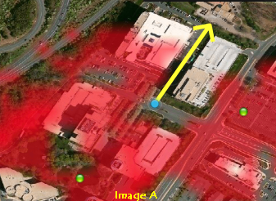  Figure 1. LOP application concept images. | 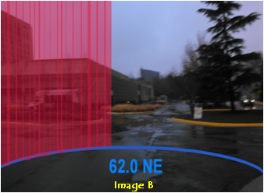

SYSTEM WORKFLOW
The LOP system work flow is illustrated in Figure 2. The application user configures the LOP evaluation radius which determines the area of interest (AOI) around the user that potential observer viewshed results should be considered (defaulted to 200 meters). The LOP user then identifies 1 or more observer viewshed origin points. When an origin point is selected a viewshed REST call is made over the cellular and IP network(s) to the cloud GIS instance. Each request includes the configurable observe/target height, observer origin point and viewshed radius. The cloud GIS processes the request and returns a viewshed image result in portable network graphics (PNG) format along with an associated bounding box extent.
CLOUD GIS PLATFORM
The cloud GIS utilized by the LOP workflow is the MapReduce Geospatial (MrGeo) (DigitalGlobe, 2014) GEOINT cloud services framework which is optimized to perform scalable geospatial analytics across large geographical regions using multi-terabyte data sets. This software can be deployed in a CPU or GPU-based configuration distributed across multiple server nodes using the Apache Hadoop/MapReduce framework (Apache, 2013). Though scalable to N number of commodity computing platforms the cloud GIS used for testing the LOP application was a development instance consisting of a 5 node cluster with a single GPU instance hosted in Amazon’s AWS Elastic Compute Cloud (EC2). The cloud GIS services performing the raster based viewshed analysis were GPU based and accessible through a REST (Fielding, 2000) services API call.
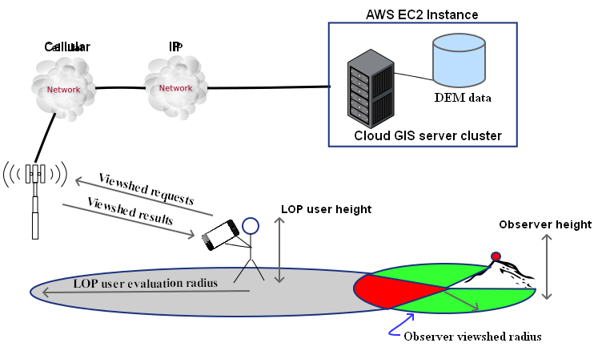
Figure 2. LOP system workflow

LOP MOBILE APPLICATION
The LOP application runs on the Android operating system (OS) and was integrated into a mapping navigation application framework based on the open source OSM Automated Navigation Directions (OsmAnd, 2014) project. There are primarily two UI views for the LOP functionality: LOP application map view (Figure 3) and LOP augmented curtain view (Figure 4). When the device is held in a horizontal orientation the map view is displayed. The major components of the map view are the basemap, GPS location indicator (if activated) and one or more observer viewshed results received via the cloud GIS. With the OsmAnd slippy map gesture interface users can navigate across the map’s extent, zoom in and out using their fingers. After activating the observer viewshed selector a user can touch the devices screen to drop a pin and initiate an observer viewshed request to the cloud GIS. When the observer viewshed result is returned it is overlaid on the basemap and centered at the latitude/longitude position indicated by the dropped pin. The OsmAnd framework natively supports rendering of

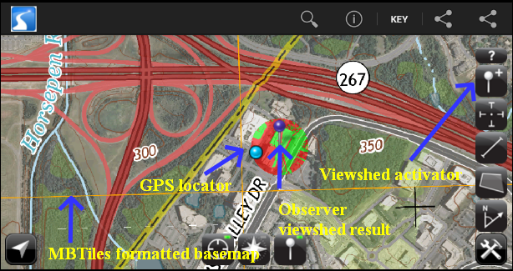
Figure 3. LOP application map view.

WGS84 Web Mercator (Auxiliary Sphere) (EPSG: 900913) projected map tiles stored in the MBTiles (MapBox, 2013b) format. To create a meaningful basemap for the application a USGS GeoPDF raster for the Herndon, Virginia quadrangle was acquired via the USGS Store Map Locator & Downloader online site (USGS, 2013). The GeoPDF was then projected from its native NAD 1983 UTM Zone 18N (EPSG: 26918) projection to EPSG: 90013 using gdalwarp (GeoTools, 2014) and then an MBTiles store was created using TileMill (MapBox, 2013a).
When holding the device in a vertical position the application displays the calculated LOP augmented curtain view. The major components of this view are the LOP curtain displaying the calculated percent of visibility for each 1 degree of azimuth. The augmented curtain view is anchored on a virtual compass dial base with vertical hash tics marking every 10 degrees of azimuth. Each degree of visibility is represented by a curtain panel in the augmented view. A yellow to red color ramp is used across the curtain giving the user a relative indication of the probability of visibility along any azimuth.

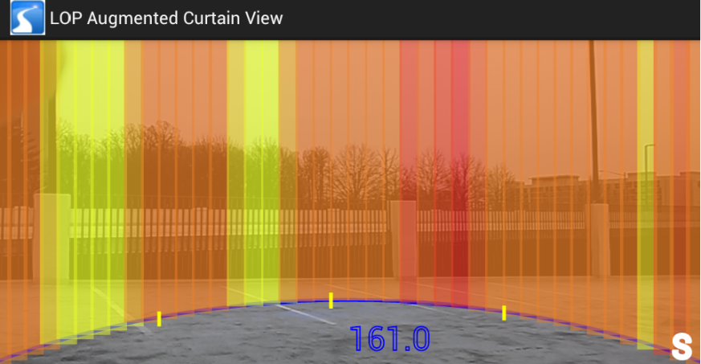
Figure 4. LOP augmented curtain view.

PROJECT DEM DATA SOURCES
The LOP application concept was evaluated within the boundaries of the Dulles Corner Office Park Herndon, Virginia.
One of the goals of this project was to evaluate the system and application runtime performance as well as the LOP augmented layer accuracy using different digital elevation models (DEM) data sources and resolutions. Table 1 lists the data DTM/DSM data sources used for the LOP evaluation effort.

Table 1. LOP evaluation DTM/DSM data sources.
Data source | Elevation model | Source
ASTER GDEM 1”(~30 meter resolution) | DSM | (NASA, 2014a)
Lidar 1 meter | DSM | (William and Mary, 2014)
NED 1” (~30 meter resolution) | DTM | (USGS, 2014)
NED 1/3” (~10 meter resolution) | DTM | (USGS, 2014)
SRTM 3” (~90 meter resolution) | DSM | (NASA, 2014b)

Global SRTM and ASTER DSM data already existed in the cloud GIS instance so no additional processing was required for this data. Prior to being loaded into the cloud GIS, data for the other DTM/DSM sources needed to be acquired for the evaluation extent and converted from its native format and projection into a WGS 84 (EPSG: 4326) projected GeoTIFF. The lidar data was downloaded in the compressed LAS format and converted to a GeoTIFF 1st return DSM using the las2dem tool [rapidlasso GmbH, 2013] the native NAD 1983 UTM Zone 18N (EPSG:26918) projection was maintained. The lidar and NED data was then re-projected to WGS84 using the image reprojection and warping utility gdalwarp (GeoTools, 2014). To increase the evaluation data options, 3 meter and 10 meter reduced resolution rasters of the original 1 meter lidar data were created. The 3 meter and 10 meter rasters where generated using ESRI’s ArcGIS Desktop aggregate generalization spatial analysis tool, using the median aggregation technique. Table 2 presents hillshade reliefs for the DTM/DSM datasets processed for evaluation of the LOP application.

Table 2. DTM/DSM data source hillshade reliefs.
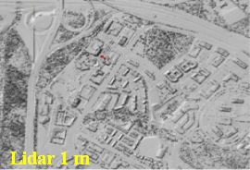 | 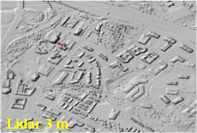 | 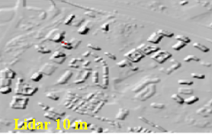
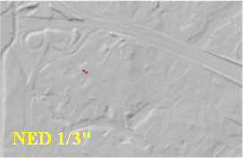 | 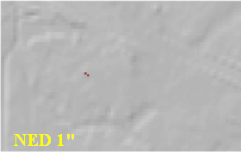

LOP AUGMENTED CURTAIN GENERATION
Holding the LOP application in a vertical position initiates the LOP curtain view activity. The LOP curtain view activity constructs and renders the LOP augmented geolayer in relation to the user’s location as reported by the Android OS location services API. The location services API uses GPS, cellular, and Wi-Fi networks as sources to derive the devices location. Once a location is determined the activity constructs an AOI evaluation bitmap sized to the configured evaluation radius where 1 pixel = 1 meter. The activity then accesses the cloud generated viewshed images stored on the devices SD card. Each cloud generated PNG image is opened as an Android bitmap and each pixel evaluated to determine its RGB value. If the pixel has a green intensity channel value > 0 indicating a visible cell the pixel value is modified to 0x00FF00 otherwise the pixel is determined to be not visible and given a value of 0x0000FF. The bounding extent of the viewshed image is used to determine the pixel to meter ratio for scaling the image. Using the Android image libraries each processed viewshed bitmap is clipped and merged with the AOI evaluation bitmap. The final merged evaluation bitmap is then processed at the pixel level where each pixels azimuth is calculated in relation to the center point of the evaluation AOI. Two counters are maintained during this process: a cumulative count of visible pixels (green intensity channel value of 0x00FF00) for each azimuth and a cumulative count of total pixels for each azimuth.

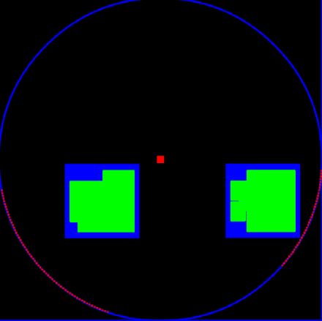
Figure 5. Captured image of merged evaluation bitmap.

Once the AOI evaluation bitmap (Figure 5) has been processed a LOP augmented curtain base is constructed using the visible and total pixel azimuth counters. The curtain base is a 360 element array where each element contains a weighted visibility value indicating the probability the LOP application user will be visible along that azimuth within the AOI defined by the evaluation radius. To create a transparent yellow to red gradient each azimuth weighted visibility value is constructed using a RGBA base value of 0x78ECXX29, the green intensity channel is computed by multiplying the percent ratio of Pixels_{visible}/Pixels_{total} by a value of 255. Once the curtain base array is generated the LOP geolayer is rendered over the devices live camera feed provided via Android’s SurfaceView API. Each LOP curtain panel is painted using the Android graphics library and filled with the weighted visibility value previously calculated.
With augmented reality applications developers are tasked with integrating virtual data with the real-world to enhance the user experience. In order to present a believable and accurate augmented view in a mobile environment the devices inertia sensors need to be utilized and managed, a subject that has been the focus of other papers (Porzi, 2012). The LOP curtain view is geo-registered to the live camera view using the devices orientation, magnetic and gravity sensors. Initially, when reading the raw orientation sensor data the level of jitter was significant enough to require the user to remain in a stationary position for a prolonged period of time in order for the augmented layer to render correctly. To smooth out the rendering the LOP layer the raw orientation sensor data was passed though open source implementation of a Kalman filter [JKalman, 2013]. By adopting this Kalman filter approach the erratic rendering behavior of the LOP geolayer was significantly reduced.

EVALUATION
Evaluation of the LOP application was performed with a Droid Incredible 4G LTE HTC (ADR6410LVW) smart phone running the Android 4.0 (Ice Cream Sandwich) OS. A standard device configuration was utilized which consisted of 1 GB of RAM, 8 GB of internal memory, an 8 MP onboard camera and 1.2 GHz dual core processor. Figure 6 illustrates the site area where stationary evaluation of the LOP application occurred. The test observer view point, indicated by the purple pin, was on the roof of a 2 story parking garage (Figure 7). The light blue dot identifies the location of the LOP application user which is positioned at the entrance of an alley between a 1 story conference structure and the parking garage (Figure 8). The yellow arrow marks the LOP pathway that was expected to be detected by using the application. The LOP application observer viewshed requests were configured to use an observer and LOP target height of 2 meters, distance radius of 100 meters with 360-degree view and LOP AOI evaluation area radius of 200 meters. Connectivity to the cloud GIS was established using Verizon’s 4G cellular network.

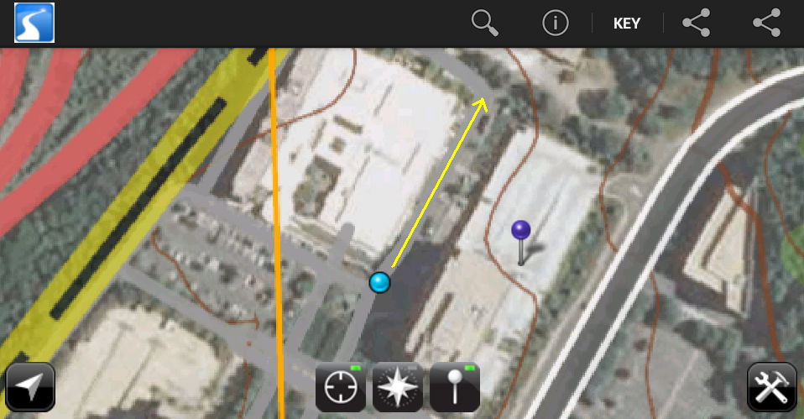  Figure 6. LOP evaluation site. |  | 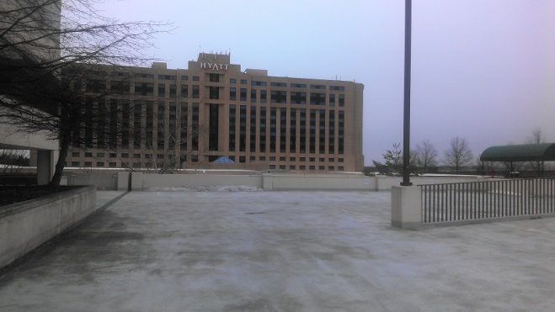  Figure 7. Viewshed origin looking west towards alley.
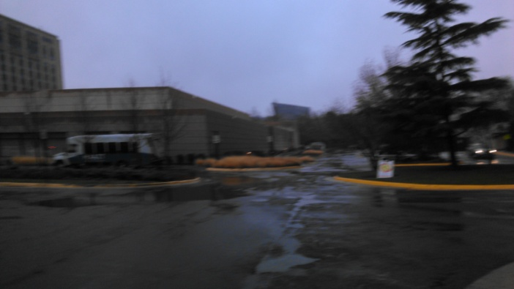  Figure 8. LOP site looking north through alley. | 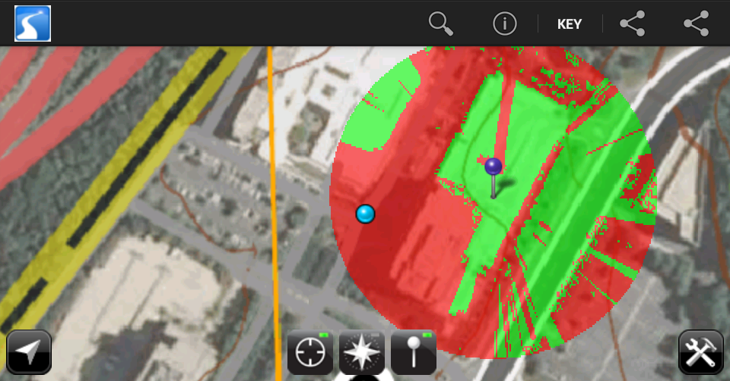  Figure 9. LOP basemap with 1 meter viewshed overlay.

With the initial 200 meter defined LOP AOI application performance was not an issue. The key application performance metrics measured where the response times between the LOP observer request being initiated and the observer image being actually displayed on the base map as well as the time required to generate and render the LOP augmented geolayer. In both cases, and for all data sources, the response times where under 0.500 milliseconds. The spread between the slowest and fastest response times, in each case, were no more than 0.040 milliseconds and not dependent on the selected data source. So at least with a 200 meter defined LOP AOI the DEM data source did not have an impact on LOP application performance.
Figure 10 displays screen captures of the observer viewshed result alongside the corresponding rendered LOP augmented geolayer for each DEM data source. While the performance time measurements did not indicate a reason to prefer one DEM data source over another the rendered LOP curtain geolayer results do identify clear distinctions. Standing on the ground at the LOP users position the width of the alley can be measured from 24.0º north-northeast to 44.0º north-northeast. Looking at the LOP curtain geolayer for the Lidar 1 m data source 3 visible sections exist in the LOP curtain between azimuths of 26º and 37º in addition a broader LOP area with a relatively lower probability of being seen observed, exists between azimuths of 25.0º and 45.0º. With the Lidar 3 m generalization data source a more contiguously defined LOP is shown between azimuths of 34.0º and 40.0º. With the Lidar 10 m generalization data source the LOP widens further and is well defined between 29.0º and 39.0º. With the lower resolution data sources the resulting LOP curtain geolayer resembled the NED 1” example below and indicated no LOP. The coarse ground resolutions of the SRTM 3” and ASTER 1” DSM data sources and ground surface elevation data from the NED DTM data sources did not allow for detection of the LOP pathway in this urban location with relatively level topography. The LOP is more clearly defined in the Lidar 3 m and 10 m generalizations then in the original Lidar 1 m data source. This disparity can be explained by the existence of isolated cells being marked as visible with the Lidar 1 m raster data source. These same cells were filtered out in the 3 m and 10 m generalizations when they were created from the Lidar 1 m DEM using the median aggregation generalization process. This would indicate that the LOP augmented layer generation algorithm should be enhanced to consider nearest neighbor values to filter out false positives or surface noise produced in the high resolution 1 m Lidar data.

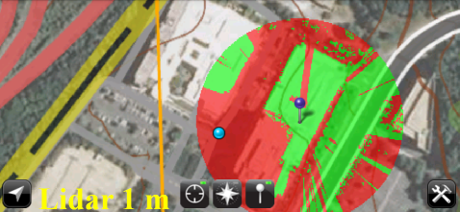 | 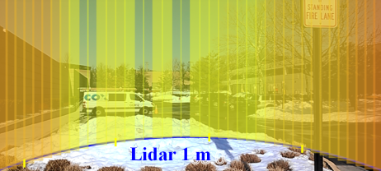
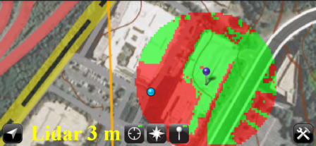 | 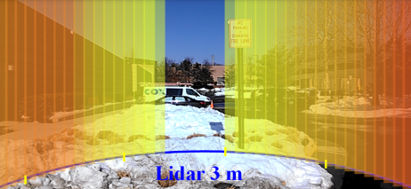
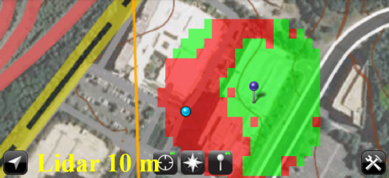 | 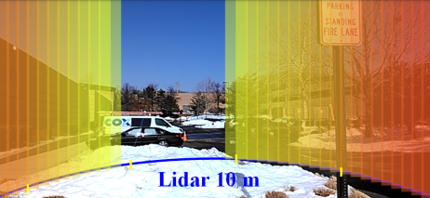
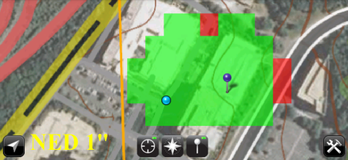 | 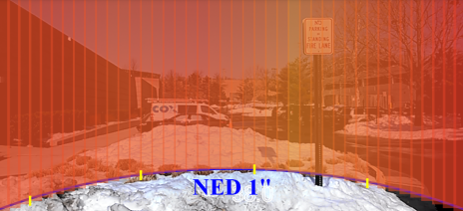
Figure 10. LOP viewshed results and corresponding rendered augmented geolayer.

Although the ASTER, SRTM and NED data sources did not provide a usable LOP pathway in this urban office and level topography evaluation area it easy to see how in other environs, with larger natural line of sight barriers, these DEM data sources could be utilized with the LOP application. It is also important to note that high resolution 1 meter elevation data does not exist for a large portions of the earth’s surface, is extremely time consuming and expensive to produce and takes a considerable amount of digital resources to store. One has to consider that a 1 kilometer x 1 kilometer extent of 1 meter Lidar data takes 4 MBs of storage while the same extent of NED 1” data takes 40 kilobytes

CONCLUSIONS
The LOP application demonstrates that by distributing the geoprocessing workflow across cloud and mobile platforms and leveraging emerging technologies, useful location information can be brought to mobile using high resolution DEM raster data sources and spatial analyses algorithms. As technology capabilities continue to advance in the cloud and mobile domains high resolution DEM data and spatial analysis processes will be increasingly used to create more complex and richer AR geolayers. To compensate for outlier visibility results generated when utilizing high resolution DEM data products a nearest neighbor filter algorithm will be incorporated into the LOP generation algorithm. Moving forward the performance limitations of the LOP work flow will be explored determining the threshold points where LOP evaluation AOI size and number of observer viewsheds degrade performance. It is assumed that the mobile LOP application image processing algorithms will need to be optimized and possibly migrated to a GPU implementation in order to scale for larger spatial requirements and to accommodate a nearest neighbor filter.
Augmented reality is going to be the mobile UI paradigm of the future for applications running on head-up display (HUD) platforms similar to Google Glass (Google, 2014). Acknowledging that UI and gesture design changes will need to be made to the LOP application in order for it to target Google Glass devices; it is envisioned that a large portion of the application functionality can be leveraged since the Google Glass platform utilizes the Android SDK .

ACKNOWLEDGEMENTS
I would like to thank Professor Peter L. Guth for his valued comments, ideas and guidance given though out the development of the LOP application and this paper.
I would also like to thank both my manager David J. Grason, for his valued advice, and employer DigitalGlobe for making the MrGeo cloud GIS available for this effort.

REFERENCES
Apache, 2013, ApacheTM Hadoop: http://hadoop.apache.org/, last accessed 19 Feb 2014.
Amazon, 2014, Amazon web services – Amazon EC2: http://aws.amazon.com/ec2/, last accessed 19 Feb 2014.
Baboud, Lionel. M. Cadik, E. Eisenmann and H.P. Seidel, 2011. Automatic photo-to-terrain alignment for the annotation of mountain pictures, IEEE Conference on Computer Vision and Pattern Recognition, pp. 41-48
Dalla Mura, M., M. Zanin, C.Andreatta and P.Chippendale, 2012a. Augmented reality: Fusing the real and synthetic worlds, IEEE International Geosciences and Remote Sensing Symposium, (8):170-173.
Dalla Mura, M., and P.Chippendale, 2012b. Real-World DEM Harmonization through Photo Re-Projection, IEEE International Symposium on Geoscience and Remote Sensing, 2012. (7): pp 428-430
DigitalGlobe, 2014, DigitalGlobe – Defense & Intelligence http://www.digitalglobe.com/Industries/defense%26intelligence#overview, last accessed 17 Feb 2014.
Fielding R.T., 2000. Architectural Styles and the Design of Network-based Software Architectures, University of California, Irvine, 2000 http://www.ics.uci.edu/~fielding/pubs/dissertation/top.htm , last accessed 17 Feb 2014.
GeoTools, 2014, GeoTools - The Open Source Java GIS Toolkit: http://www.geotools.org/, last accessed 17 Feb 2014.

Google, 2014, GLASS: http://www.google.com/glass/start/, last accessed 17 Feb 2014.
JKalman, 2013, JKalman http://sourceforge.net/projects/jkalman/, last accessed 17 Feb 2014.
layar, LAYAR SDK: https://www.layar.com/developers/, last accessed 17 Feb 2014.
Mapbox, 2013a, TileMill: https://www.mapbox.com/tilemill/, last accessed 17 Feb 2014.
Mapbox, 2013, MBTiles tileset format: https://github.com/mapbox/mbtiles-spec, last accessed 19 Feb 2014.
NASA, 2014a, ASTER: http://asterweb.jpl.nasa.gov/, last accessed 19 Feb 2014.
NASA, 2014b, SRTM: http://www2.jpl.nasa.gov/srtm, last accessed 19 Feb 2014.
OsmAnd, 2014, OsmAnd – Map & Navigation: http://osmand.net/ , last accessed 17 Feb 2014.
Noguera, J.M., C. Ogayar and R. Joan-Arinyo, 2013. A scalable architecture for 3D map navigation on mobile devices, Personal and Ubiquitous Computing, 17(7): pp. 1487-1502.
Porzi, L., E. Ricci, TA. Ciarfuglia, and M. Zanin, 2012. Visual-inertial tracking on Android for augmented reality applications, IEEE Workshop on Environmental Energy and Structural Monitoring Systems,(8):35-41.
Rosenberg, J., and A. Mateos, 2011. The Cloud at Your Service, Manning, Greenwich, pp 146-146.
Yelp, 2014, Yelp http://www.yelp.com, last accessed 17, Feb 2014.
USGS, 2013, The USGS Store – Map Locator & Downloader: https://store.usgs.gov/b2c_usgs/usgs/maplocator, last accessed 20, Dec 2013.
USGS, 2014, National Elevation Dataset: http://ned.usgs.gov/, Last accessed 17, Feb 2014.
Wikitude, Wikitude SDK: http://www.wikitude.com/products/wikitude-sdk/, last accessed 17 Feb 2014.
William and Mary, 2014, Virginia lidar: http://www.wm.edu/as/cga/VALIDAR/ , last accessed 08 Feb 2014.

