Using GIS to Construct a Database and Map Burial Sites: A Case Study of St. Mary’s Roman Catholic Cemetery, Kinney PA.  
Kera Mariotti, LS

**Abstract**

Cemeteries are the final resting place for most individuals and the marking of the end of one’s life - literally with a grave marker or in a paper sense through obituaries, death certificates or cemetery records. These cemeteries provide an important repository of information for a wide array of scholarship. Scholars have investigated variations in gravestone shapes and iconography or analyzed dates of death to calculate longevity in a community or time period or to see whether disease wreaked havoc. And recently, advances in digital data gathering and the capacity to map complex interrelationships at multiple spatial scales have led scholars to explore the possibilities of using Geographical Information Systems (GIS) to aid in such investigations. This paper is a case study of such efforts to link GIS and cemetery data, using material gathered from one historic cemetery in Kinney, PA**.** After providing an initial overview of scholarship on cemeteries and on the possibilities of GIS, the paper carefully summarizes the methods used, discusses the data tables that were compiled, and presents a series of geographical analyses to demonstrate the range of insights that are of value, not just for this cemetery, but for many cemetery associations that might find this software useful for management of their records. As such, the information given is written with two audiences in mind: one a more scholarly formal engagement with data and its limitations, and the other a broader public, including cemetery groups and genealogists.

**Introduction**

In colonial America many graveyards were simple family plots, in a corner of a farm field walled off from animals or croplands; some of these family plots can still be explored in rural areas (Lewis, 1990, p.7). Many more were attached to specific churches, and each denomination had their own morphologies and traditions. Stones in Quaker burial grounds, for example, were very plain and noted months by number, not name, not wishing to acknowledge pagan gods who gave their names to months (Swarthmore, 2012). Settlers in swampy Savannah or New Orleans buried their dead in above-ground tombs. Catholic congregations buried their dead under the guiding shadow of a large cross. Later, in the industrial era associated with massive immigration waves from many parts of Europe, the cemeteries echoed those many heritages. In the anthracite mining town of Shenandoah, PA, there are over a dozen Catholic cemeteries in Shenandoah Heights, above the town, each reflecting the preferences for the last resting places for Irish, Italian, Hungarian, Czech and Lithuanian communities. These are located next to both a Hebrew cemetery and, for Protestants, the Independent Order of Odd Fellows cemetery (where many of the earlier Welsh and German miners and their families are buried) (Simons, 2005). Cemeteries are thus not only a place for the dead to rest but they also reveal the social and ethnic geographies associated with the lives of its occupants as well. In Hornell, NY, this denominational and ethnic geography is reflected in its cemeteries and their layout, and they have recently been the subject of a GIS study through the State University of New York, College of Technology at Alfred (Senior Seminar Projects, 2010). This GIS shows how, even after death, you are still expected to take your “place” in the social hierarchy.

Over time, the limitations of space in urban churchyards led to a cemetery movement to the suburban edge of cities, and many of these became almost park-like settings for people to visit on the weekends (Sloane, 1991). This resulted in the actual grave locations becoming uncoupled from churchyards. The same could be the case when there was not sufficient numbers for a local denominational churchyard in more rural areas, which led to people being transported across dozens of miles to a final resting place next to others of the same denomination. Another important American variant are military cemeteries such as those at Gettysburg, PA, or Arlington, VA, dating from the Civil War. Veterans who lived in Soldiers and Sailors Homes often were buried in associated adjacent cemeteries; which later became National Cemeteries under the Veterans Affairs Medical Center system. According to the Veterans Affairs website, one nearby example is in Bath, New York. The Bath National Cemetery is currently located adjacent to the Bath Soldiers and Sailors Veterans Hospital (Bath National Cemetery, 2012). A link between these national cemeteries and local ones becomes evident every Memorial Day, when scout troops or volunteers mark cemeteries with flags and metal holders that tell visitors which war – spanning from the Revolutionary War, 1812, Civil War, WWI, WWII, Korea, Vietnam, and now Persian Gulf and the Global War on Terror – that a veteran served in. Veteran’s data is one of the dimensions of cemetery data that is most researched and most marked.

In well-organized cemeteries, the gravestones and grave records are clear and unambiguous. But in some instances, in more remote places or where the local population has declined or monies have not been made available for good record-keeping, there is more uncertainty about the information available, whether visible or on paper. Headstones break, grass isn’t weeded, and the institutional memory and mental map of a grave digger disappears when he or she is no longer alive. In many instances, there is even uncertainty as to where the graves are located, and new sections are opened up to avoid the trauma and embarrassment of digging up old remains, and it is to clarify such spatial ambiguity that a Geographical Information System (hereafter GIS) might be employed.

**Geographic Information System**

A GIS is defined by Esri (Environmental Systems Research Incorporated) as a system that “lets us visualize, question, analyze, interpret, and understand data in many ways that reveal relationships, patterns, and trends in the form of maps, globes, reports, and charts” (Esri 2012). Esri is the industry leader in GIS software; it started as a project at Harvard University by Jack Dangermond and several other researchers (Esri 2012). Eventually Dangermond and his wife Laura started the company that became the software giant and were able to release the first commercial GIS in 1982, based out of Redlands, California (Esri 2012). Esri continues to grow with the advancements in technology to remain at the forefront of GIS technology. But Esri’s definition of GIS is not the only one. According to John Pickles (1995), the author of *Ground Truth: The Social Implications of GIS,* a GIS is having the ability to derive information from the interpreting of data (p. 2), and it is also “frequently applied to geographically oriented computer technology, integrated systems used in substantive applications and, more recently, a new discipline” (p. 2).

Imagine having the ability to ask a map some basic question as to whom, what, and where, but also have the ability to ask the same map more detailed questions like when, to what extent, and how often! A GIS gives the user the ability to ask those exact questions (and more detailed questions that are not even thought of yet). Instead of being the long-time conventional paper map that showed elevation, hydrology and some limited information on settlement and transportation, a GIS allows for the storage of a vast array of data at a remarkable number of scales within a map, stacking data in layers, identified by coordinates, and able to be made visible at a click of a button. A GIS is a collection of any type of data, as long as it can also be tied to a geographic location. The geographic location of said data can vary in precision from a specific foot (or more) to sub-centimeter level. Some of the most popular-realm GIS systems are the websites and GPS units that give the user directions to and from any desired location. Other types of GIS show tax information, elevation, aerial photography, utilities, animal habitats, census information, recreation facilities, water levels, and many other types of data. The possibilities are endless when it comes to the collection of data that can be incorporated into a GIS.

**Aspects of GIS** One example of a collection of data that has been incorporated into a GIS are the remains of Civil War battlefields, as documented in David Lowe's essay *Telling Civil War Battlefield Stories with GIS.* In Lowe's essay, he describes how the National Park Service (NPS) has utilized GIS to support one of its missions, to strive to "keep American history alive by preserving the physical remains of the past" (Lowe, 2002, p. 1). The largest obstacle to this project was actually finding the battlefields in the topography of today's civilization. The NPS, with the aid of local surveyors armed with GPS, located present-day landmarks that could also be located on Civil War maps made by United States Army engineers. These Civil War maps were created shortly after each battle had taken place and were very detailed and accurate (fig 1). The maps not only depicted areas that were clear-cut for firewood/building materials but also conveyed the relationship of ground bunkers and trenches built for battle purposes.

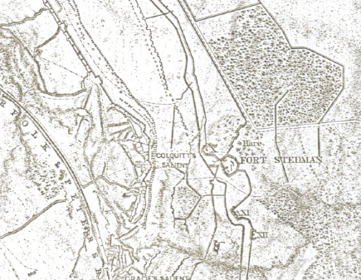  
 Figure 1: Civil War Map of Fort Stedman (Lowe 2002, p.56).

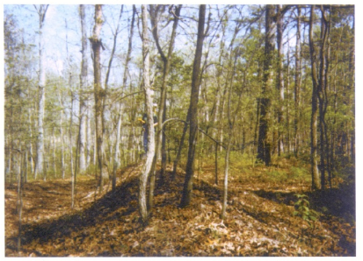  
 Figure 2: Typical Civil War Earthwork Trench (Lowe 2002, p.52).

These Civil War maps covered vast amounts of land that have drastically changed over the years. The surveyors attempting to relocate the areas required smaller search areas. Georeferencing the Civil Wars maps to a geographic coordinate system needed to first occur; the surveyors located historical monuments from the war maps that were still standing today. Once these Civil War maps were geographically referenced to the GPS coordinates collected by surveyors, the search area to find these battlefields were significantly reduced. This process led surveyors to areas inside the NPS boundaries (as expected) and also outside of the protected areas of NPS. The NPS is trying to find ways to protect the unprotected areas of these battlefields. These surveyors found enough evidence of battlefields (see fig 2) to convince the NPS that GIS is an invaluable tool in order to protect and restore Civil War Battlefields to their original topography.

Using GIS for historical purposes is only one of its many uses; sociologists also have a vested interest in GIS. Jon Goss, a geographer, wrote an essay that appeal to sociologists called *Marketing the New Marketing.* Itintroduces the concept that has evolved into the phrase Geodemographics (Goss, 1995). A Geodemographic System is defined as a "computerized systems used for pinpointing mailings by direct marketers and for determining the best sites for businesses and other facilities" (Philips & Curry, p.2). This form of GIS allows "corporate executives to turn a marketing office into a data powerhouse with maps and reports on consumers and businesses anywhere in America" (Pickles, 1995, p. 130). GIS can give businesses the ability to search for (and find) the exact demographic of their targeted consumers, allowing for a more direct approach when trying to market their products. This accounts for some of the reasons that the junk mail received by an individual seems to make them look twice (or three times) before tossing it into the garbage. The same system will aid any company with the search for an area to expand their business. All of the search parameters required to expand a business, such as location to highways, population and zoning information, etc, can be entered into the geodemographic GIS and the results listed will help to narrow the prospective site list, ultimately saving the company money. The social aspect of direct mailings and marketing and business placement has changed the way that consumers shop, either online or in stores.

GIS has also made its way into agriculture and plays a pivotal role in crop production, pattern, and yield; also irrigation, soil management, and precision farming (Agriculture GIS Products, 2012). Utilizing GIS in the farming industry has not only become financially beneficial, but also has been beneficial to the environment as well. A tractor can cross a field and the right amounts of fertilizers are applied to different parts of the slope, since the underlying soil types and soil boundaries are precisely evident.

The fine spatial resolution of storable data in a GIS environment has meant that many municipal, county and state planning officials can coordinate data management. Parcel-level data is coded for the e911 emergency systems, and property parcel data can track land use, ownership, price of property, tax assessment, dates of water and sewer projects and the like. It is this real-estate quality that is particularly useful for cemetery management, which is, in a way, just one more variant of real-estate parcels.

**Data** When dealing with GIS data, there are many issues and questions that come to mind about the data itself. How is the data going to be collected and stored? What is the accuracy of the data? What attributes will the database have? Will any set standard be adhered to? Who has rights to access and use the data?

The data collection for any GIS project is done via different avenues. Many organizations collect the data through employees on the clock; while other organizations are so stretched for funds that they take data that has been collected by volunteers. Another option is to obtain data from online clearinghouses that generally don’t disclose how the data was collected. If at all possible, ground-truthing of the data is useful to check for accuracy, but given the size of some of the datasets, the data is often used with gratitude, turning a blind eye to meta-data issues (see below, page 11).

There are no universally accepted standards for data collection procedures or accuracies for GIS projects; there are, however, mapping standards that directly relate to the data collected. Storage of GIS data is normally done on the GIS consultant’s servers. The data for a simple GIS can easily reach in excess of 10GB; large GIS projects need dedicated servers for data storage and retrieval. The mapping standards in existence for GIS projects are considered a standards for all GIS projects, although there are no standards in existence specifically for creating a cemetery GIS. Standards created by the Federal Government for mapping spatial data are to be adhered to “only when no equivalent voluntary consensus standards exist” (FGDC, 2012). So it is assumed that all collections of GIS data, especially data obtained from an online clearinghouse, would at least adhere to this standard. Just because there are no existing federal cemetery GIS standards to pull from, doesn’t mean that there aren’t any to adhere to.

Many states offer grant monies to cemeteries for the purpose of creating a cemetery GIS. If a cemetery is to participate in this state program, the database must adhere to certain standards. For example, Utah has devised a standard for GIS work in cemeteries. The database must contain only certain attributes of a certain size and the mapping work must be completed by a firm specializing in GIS consulting (Utah, 2012). All of Utah’s standards for a cemetery GIS can be found at <http://history.utah.gov/research_and_collections/cemeteries/submit_data_info.html>. Because many public authorities are struggling financially, most have not set standards for the collection of the data. Maine, for example, is looking for volunteers to collect cemetery data for inclusion into their database (Maine.gov, 2012). The standards used for cemetery GIS projects vary and until a federal standard specifically for the creation of a cemetery GIS is created, the standards will never be identical from cemetery to cemetery.

If a standard for collecting cemetery data for inclusion into a GIS project were to be created from scratch that the entire GIS community should adhere to, that standard should be as follows: all data must be collected and verified by a licensed land surveyor to sub-centimeter accuracy and the data should be collected with survey grade equipment. The mapping standards should include a 95% accuracy of all monuments mapped to their ground coordinates in the Cemetery’s State Plane Coordinate System. This standard will allow all future generations to accurately and definitively locate memorial monuments in a cemetery. The standard for attributes in a table should also follow the example set in the case study, with the option of additional attributes per the cemeteries discretion. Today’s standards for data collection will quickly become tomorrow’s outdated standards when trying to locate monuments on the ground with equipment that easily achieved today’s accuracies.

Another aspect to consider when dealing with GIS data is the metadata. Metadata is commonly referred to as “data about data”. Metadata will inform an individual that is utilizing the data with the necessary information about the data, hence “data about data”. Metadata information includes such important items as who created the data and their contact information, a summary of the data, and a description of the data, and any user constraints that may be attached to the data. The information previously listed is very beneficial to the general user of the GIS. If a more experienced GIS technician will be analyzing the data, then more metadata will need to be included; such as, the maintenance schedule of the data (how often is the data updated), the spatial reference system of the data, any geoprocessing tools that have been utilized and the attribute fields in the database. The attributes in the data should agree with the standards utilized for the creation of the GIS. The above listed metadata should be included as a bare minimum in all GIS projects, but there is always room to add more metadata to be sure the information is as complete as possible. Sometimes this very important step is often overlooked when creating a GIS project.

**GIS and Cemeteries** The data storage and data management aspects of GIS are also giving cemeteries the ability to better maintain their records. Traditional thinking of tethering GIS and cemetery information would lead to a searchable database of the individuals laid to rest. For example, Prairie Home Cemetery in Waukesha, WI, maintains an online searchable GIS; this GIS contains data that includes first name, last name, geographic location of grave, birth date, and death date of each occupant. In addition, it also includes age, sex, and funeral home information. Unfortunately, the only searchable information is by first and last name, there is no ability to search according to any other data type, such as, for example, searching by the death date of an individual. The broad outline of the cemetery, subdivided by various roadways, is seen in figure 3.

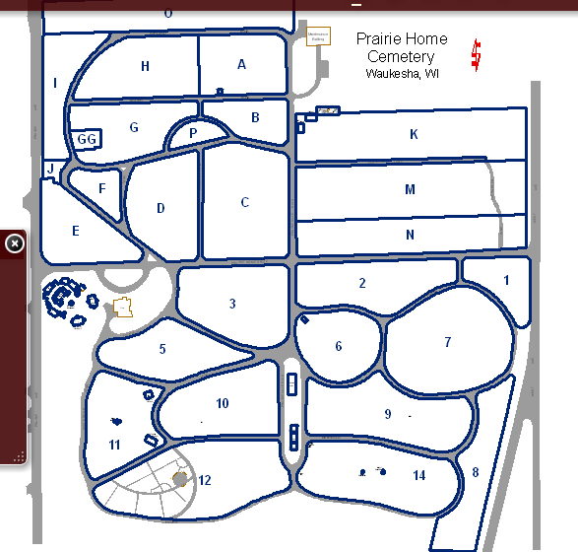

Figure 3: The entire Prairie Home Cemetery at full extent (Prairie Home GIS, 2012).

But what is especially exciting about the Prairie Home Cemetery GIS data is that it does allow the user to maintain the ability of visually finding available spaces. The cemetery has color coded each space according to the space’s availability status: available, reserved, restricted, sold, or sold with burial (fig 4).

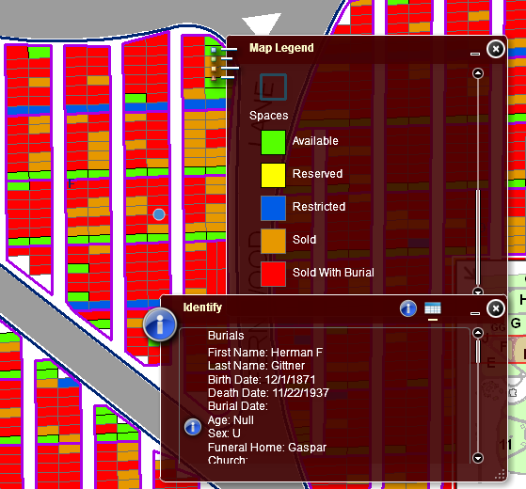

Figure 4: A space level view of Prairie Home GIS showing status of spaces and occupant information (Prairie Home GIS, 2012).

The Prairie Home GIS is a very usable database, but it does not give the user many options when it comes to any other type of cemetery analysis.

An additional online cemetery GIS example is St Michael’s Cemetery in Pensacola, FL. This GIS is maintained by the University of West Florida. Students and faculty at the University have dedicated their time to researching, creating and maintaining the database. The St. Michael’s Cemetery database (St. Michael’s GIS, 2012) contains the following information: geographic location of each grave, photographs of memorial monument, first name, last name, birth year, death year, epitaph, and occupation; additional data included in the GIS is topographic information, soil, and even botanical data. The St. Michael’s GIS does permit users to search the database according to last name, birth year, death year, epitaph, occupation, and grave id. The searching parameters of St. Michael’s expand upon the search parameters of Prairie Home Cemetery GIS. St. Michael’s permits users to search by one particular death or birth year, even though additional dates are in the database for month and year of both categories. This aspect does not lend itself to searching for an individual that died in a particular month or season. The botanical database is searchable according to the common name of the vegetation. Additional environmental data, such as topography and soil, are for informational purposes only, with no searchable attributes attached. Figures 5 and 6 provide more information about St. Michael’s GIS. The first image (Figure 5) shows the search results in a more detailed format than Prairie Home’s GIS.

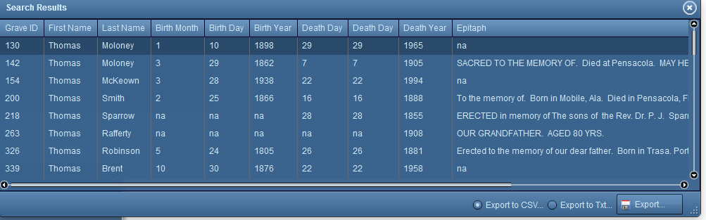  
Figure 5: Detailed Search Results of the Last Name Thomas of St. Michael’s GIS

The detailed search results also give the user the opportunity to export and print the results. This would be beneficial if the user is not exactly sure who they are looking for and would benefit from taking the information into the cemetery. An additional search option, also not available in the Prairie Home GIS, is a spatial search. The user has the option of searching for grave sites that are a particular distant from either another grave site or botanical elements (figure 6). For example, this gives the user the ability to locate all of the Thomas’ in a particular area.

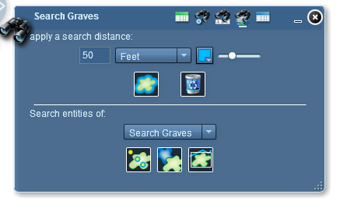  
Figure 6: Spatial Search parameters of St. Michael’s GIS.

The project has yet to achieve one of its stated goals of searching and finding for “hidden people.”[1] In order to achieve the previously stated unaccomplished goal, ground penetrating radar (GPR) needs to be utilized in order to locate any unidentified or unmarked graves. Figure 7, obtained from the University of West Florida’s St. Michael’s GIS website, shows the location of a marked grave in the center of the area and an unmarked grave in the top portion of the area.

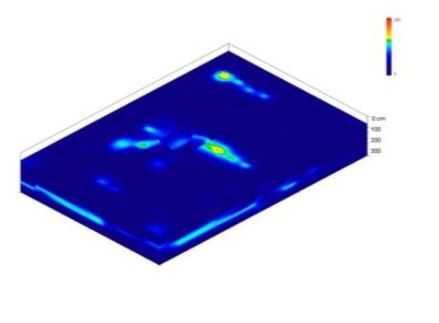  
Figure7: A GPR image from UWF showing an unmarked grave in the northern corner.

The idea of adding GPR data to locate unmarked graves will also be discussed for use in the Kinney case study which tries to incorporate many of the positives of the research found from other cemetery GIS projects and negate the negatives.

**Case Study**

The cemetery chosen as the case study herein is St. Mary’s Roman Catholic Cemetery in Kinney, PA (figure 8C) in Potter County, located in the northern part of Pennsylvania, just south of the New York state border (figure 8A and B). St. Mary’s Cemetery is approximately one acre in size, with both a more “historic” section and a relatively newer section.

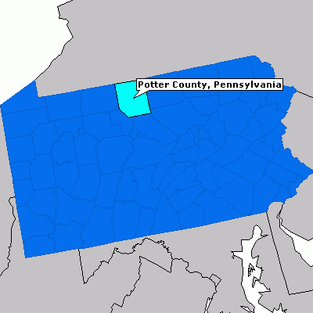  
Figure 8A: Potter County in relation to Pennsylvania (epodunk.com, 2012)

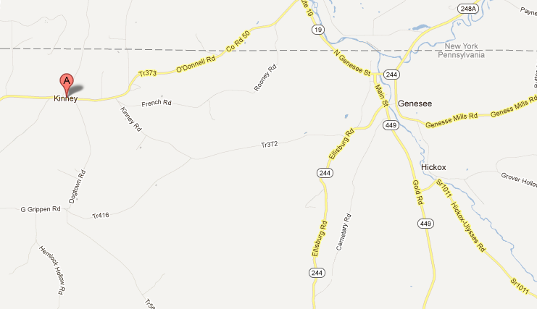

 Figure 8B: Kinney and Genesee (Google, 2012)

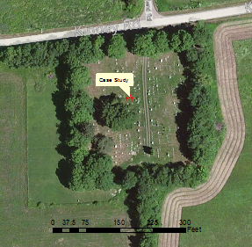

Figure 8C: Aerial View St. Mary’s Cemetery (St. Mary’s GIS, 2012).

According to the local residents of the Sacred Heart Parish associated with the cemetery, it originally started out as a Hart “family plot” and later was donated to the Catholic Church located 500 feet down the road from the cemetery, and eventually grew to include many families from the parish. The church burned to the ground and the cemetery became attached to Sacred Heart Parish in Genesee, PA, approximately five miles away. The ground the cemetery was located on was eventually deeded over to the Catholic Diocese for eternal use as a cemetery. Also, in the deed, it was stated that all family members of the Sacred Heart Parish community will not be charged a fee for a plot. As a result of this stipulation, family members from around the county were transported to Kinney, PA, to be buried at no charge. There are no official maps or documents relating to the actual occupants of the cemetery; there are, however, two websites that list the occupants. Findagrave.com lists 517 of the 574 occupants with pictures of some of the monuments. This website is maintained by volunteers donating the information (figure 9).

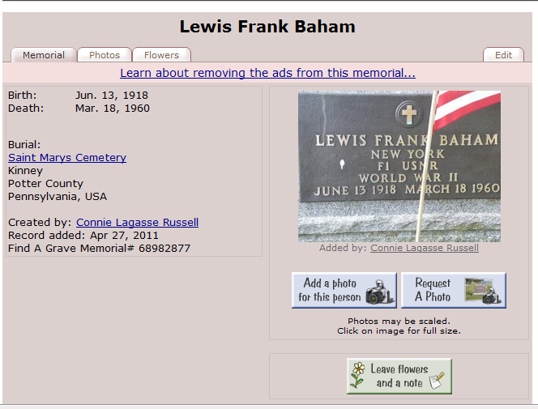  
Figure 9: Findagrave.com website example.

Another site, The Painted Hills Genealogical Society, maintains a listing of all the occupants with the information maintained by one individual *(*www.paintedhills.org). The website does not provide pictures, but many other types of genealogic information are listed. Both of these sites were consulted during the creation of the case study.  
 This case study arose because of a need for more precise information on the layout of plots in an open, mostly unoccupied field; this portion of the cemetery is known as the "Hart Plot,” named after the benefactor of the land (fig 10) for the cemetery expansion. The Hart Plot descendants are direct decedents of the original cemetery lands.

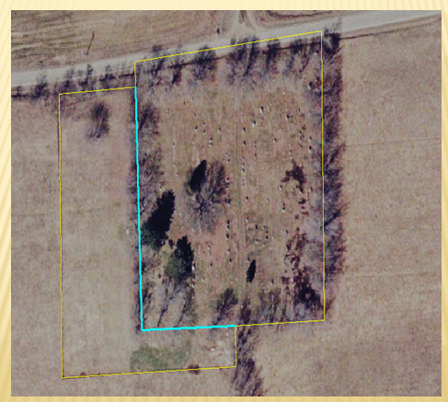  
Figure 10: Aerial Image of St. Mary's Cemetery showing the "Hart Plot' to the left of the cyan line and the "Old Section" to the right. The yellow lines are the property boundary of the cemetery. (St Mary’s Cemetery GIS, 2012).

The Hart Plot was starting to become occupied in an inconsistent manner that was going to further compound the problem of the lack of proper documentation and organization of occupants for this cemetery. The lots were initially only surveyed and laid out on the ground, but the usefulness of a GIS was soon apparent. Not only could the lots be documented in the GIS, but the survey information could also easily be transferred. After the lots for the Hart Plot were designed and monumented with half inch steel rebar pins for locating the plots at a later date, a need arose for the documentation and location of the occupants in the Old Section of the cemetery.   
 The newly created database includes photographs of each monument, age at time of death (if inscribed on the monument), veteran status, geographic location of plot, and birth and death date broken down by month, day, and year to allow searches based on any one of the pieces of information. Also included is genealogical data such as surname, spouse, mother, father, and (when possible) sibling information. This data also has the ability to be linked to any public genealogic information, such as Findagrave.com or ancestry.com (if you are a member of the site). It may also be linked to census data, also available through ancestry.com or through many libraries. All of the above information was gathered from the previously stated internet sites and the cemetery itself.

The actual geographic locations of the memorial monuments were located with a survey grade Topcon GRS-1 GPS unit and the more traditional Topcon total station. The geographic location of the monuments was obtained at the center of the west side of each monument; this helped to determine where the actual occupant was buried. Part of the mission of this GIS exercise is to determine where additional occupants can be placed in the Old Section of the cemetery. The locations of botanical data are also incorporated with the purpose of helping to decide where new plots can be located if desired. After consulting Richard G. Bish (2010), funeral director, the new lots created in the Hart Plot have been allocated a generous 10 foot by 5 foot dimension while the existing plots in the Old Section have been assigned a 9 foot by 4 foot size. The size of the older plots in the Old Section of the cemetery are created large enough to hopefully not be too close to another occupant when the time comes to fill the plot. Unfortunately, there exists the possibility of finding an unmarked grave. If this were to occur, an immediate geographic location of the occupant will need to take place in order to ensure accurate coordinates in the database. The only other option is employing ground penetrating radar (GPR) as previously described. Utilizing this recent technology, all unmarked graves will have the opportunity to be documented and marked by the St. Mary's Cemetery Grounds Committee.

The database was compiled from information gathered via internet sites, relatives, and local parishioners with the proper knowledge base. After an extensive search, none of the information gathered on the occupants were able to be linked to the Ellis Island Passenger Search. However, it was determined through local family members that the majority of the immigrants in the Kinney area came to the United States through Nova Scotia, Canada. An example of the database that was created is illustrated in figure 11, using the example of Mr. Martin Moran. The dataset that was created for Mr. Moran shows all of the information found, including a photograph of his memorial monument; the information collected is incomplete but will be updated as more information becomes available through various documents and/or living relatives.

The information for Mr. Moran shows all of the “fields” that allow a user to apply as search criteria. The ObjectID field is automatically assigned by the software and cannot be edited. The ID field is the actual plot number that is assigned to an individual(s) when a plot is reserved, owned or occupied. Searching by lot number will help the user determine where the lot is located inside the cemetery.

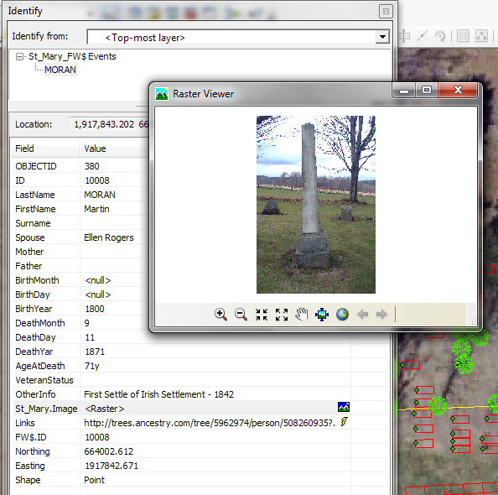

Figure 11: Martin Moran's Database information.

Neither the Hart Plot nor the Old Section has corresponding numbers. The next two fields are Last Name and First Name; both of these fields allow for a search that is based only by name. The following four fields all deal with genealogic data, allowing for a search by a woman’s surname or either of the parents. The genealogic data also helps in determining family relationships. The next six fields deal with the birth date and death date, visible in the above table, though Mr. Moran’s birth month and day are not entered. This is the type of information that will need to be completed as it becomes available. The full database is in Appendix A.

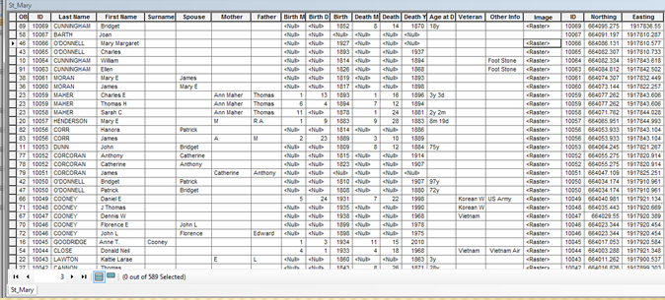

Figure 12: An excerpt of the database that holds the information seen visually in the GIS.

The database gives the ability to search all of the occupants of the case study cemetery (figure 12) by, say, birth or death month and will help to determine mortality rates in different seasons. For example, were there more deaths in the winter or the summer?

Number of Deaths

Figure 13: Number of deaths per year.

Year

As easily visible in Figure 13, the number of deaths per year peaked in the early years of the twentieth century. In 1900, thirteen deaths occurred, with no concrete reason as yet found. Of the thirteen deaths, only two were under the age of 25 years old and seven of the thirteen were men. Three members of the O’Donnell family perished that year. During the twelve deaths in 1913, two were children under the age of 3 years old and three were from the McNulty family. The 1918 Spanish flu pandemic is the presumed cause of the 13 deaths in that same year. Eight men and five women were buried, and according to the dates listed, four were less than 40 years old and seven were 40 years old or older. Again, four members of the O’Donnell family were lost that year, with one additional member becoming deceased in early 1919.

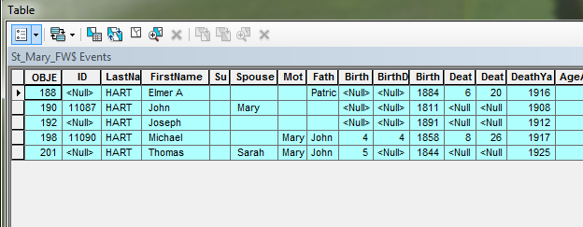  
Figure 14: Search Results from St. Mary’s GIS

The database also gives the ability to search by more than one variable (figure 14). The user may choose to search by a particular first or last name but also add a range of years to the search. For example, searching for any Hart family member that died between 1900 and 1925 gives results that five Hart men perished in that time frame: John, Joseph, Elmer, Michael, and Thomas. The relationship of the Hart men indicates that a father and two of his sons died in this timeframe.

The “age of death” field is only entered if the age was inscribed on the memorial monument or if the date was manually calculated. The “veteran status” field gives the name of the war or a simple “yes” if not in an actual conflict.

The most unique field in the data base is the “other information” field; this can contain a variety of information, including marriage dates, immigration status, military unit or awards, siblings, multiple spouses, etc. Any known pertinent information is placed in this field. The image attached in the next field is a digital picture of the monument face. The links associated with a plot can be a link to an outside source of information, mostly to findagrave.com or ancestry.com. The plot number is listed again followed by the NAD83 Pennsylvania North State Plane Coordinates of the memorial stone. The final “shape” field refers to the image on the screen of the memorial monument.

Many of the living relatives of occupants in the Old Section would prefer to be buried as near to an existing family plot if possible; this has led to the creation of new plots in the Old Section. Because of the randomness of the locations of the plots in the Old Section, as shown in Figure 14, new lots are laid out on a first come, first served basis. These lots will not be laid out and numbered, like in the Hart Plot, but the family will need to contact the St. Mary’s Cemetery Association grounds crew with a desired location and the grounds crew will make the final determination, with the help of the GIS, if a plot(s) are available.

. 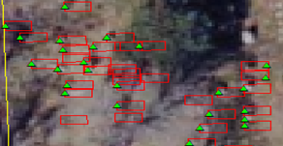

Figure 15: portions of the Old Section, the green triangles are the actual location of the memorial monuments for the Old Section of St. Mary’s Roman Catholic Cemetery.

Figure 16 shows most of the Hart Plot with the reserved lots tagged with a green triangle in the center. As of the time of this case study, the Hart Plot of the cemetery is only occupied by four people, with less than two dozen lots actually reserved. The Cemetery Association has established guidelines as to where the memorial monuments are located for the Hart Plot; this relieves the need for locating every monument that will be placed in the future. This database makes no effort to determine if the lot is occupied or not; it only shows whether the lot is available for purchase.

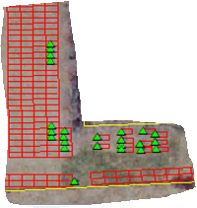

Figure 16: Locations of reserved lots in the Hart Plot.

**Further Development of the Case Study**

This case study is far from complete. The actual location of the monuments in the cemetery must continually be located as people become deceased. Also, the database is incomplete, particularly in the genealogy sections. This case study will be presented to the St. Mary's Cemetery Association with the hopes of gaining additional information for the database from the members. As of writing, there are no plans to utilized GPR to locate unmarked graves; the Cemetery Association simply does not have the financial resources available. The final vision of this case study is to publish the GIS online, so all members of the community may utilize its wealth of information. The internet will also provide a way for relatives to easily send updates to the webmaster for inclusion into the dataset.

Further analysis into the locations of Catholic churches and cemeteries during the early settlement period may also provide insights. Figure 17 shows the locations of all the Catholic churches that surround the case study cemetery. For analysis purposes, churches that are no longer in operation are still being displayed. The Catholic Churches located across Potter County, PA were located in Genesee, Kinney, Oswayo, Shinglehouse, Coudersport, Roulette, Galeton, Austin and Germainia. There were also Catholic Churches located directly across the border in New York State in the towns of Whiteville, Bolivar, Wellsville and Andover. All of the above places of worship were located within a days “wagon” ride of each other. See figure 17 below for the distribution of the churches across the study area.

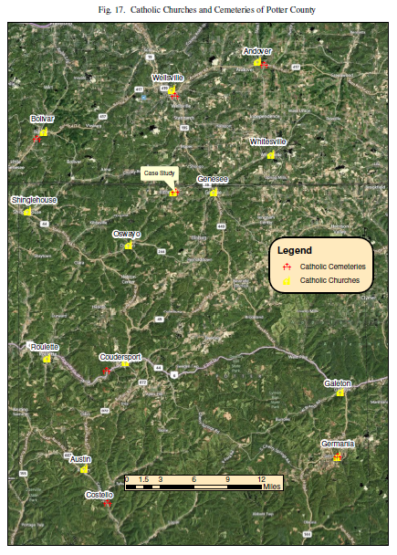  
 It is Roman Catholic custom that members of their religion be placed in consecrated ground to wait judgment day. This custom has traditionally led Catholics to be buried only in Catholic Cemeteries. There are only four Catholic Cemeteries in Potter County and three in the very southern portion of adjacent Allegany County, New York. It can be assumed that the journey to the final resting places for the majority of Catholic residents of Potter County was long and arduous in the early days of Potter County settlement. No Catholic churches could be found in the northwestern part of the county; there were, however, many Baptist churches located in that area. Many other non-Catholic cemeteries are located in towns across Potter County, but it is assumed that the majority of Catholics traveled to be buried properly.

The research of the area so far has led to more questions than what can be answered here. What journeys brought them to this part of the world? Were the men loggers, farmers, craftsmen, or workers on the canals and railroads? What did women do? And who came from what other faraway places? In order to find the above stated questions, we first must discover how Potter County was formed.

The land that is now contained inside the County borders was originally purchased from the Native Americans in 1784, but Potter County wasn’t officially created until 1804 as a tribute to General James Potter of the Revolutionary War (Potter Co., PA). The first road was opened in an East/West direction in 1808 allowing for sporadic settlement off the main corridor. The settlements remained scattered due to the difficulties in finding bare necessities in the area. Within the next 40 years, lumber became the primary industry in the County which led to an increase in populations. Rivers and streams were utilized to move the logs to the mill. Around 1850, the first railroad came to the area and not only significantly improve the lumber business, but also allowed for more movement within Potter County itself (see Fig 18 for a map of the system in 1895). A few of the communities in Potter County were settled before the railroad, Shinglehouse in 1806, Coudersport in 1807,Sweden Valley in 1808 and Galeton in 1810. There were also a considerable number of railroad communities that were created throughout Potter County; some like Harrison Valley Mills was likely tied in with logging. Other smaller settlements like Germania (also suggesting some ethnic clustering akin to Sweden Valley) was settled in 1855, and Ole Bull Settlement in 1852. This rail method of transportation throughout the County helped to develop additional communities in rural Potter County. It is as yet unknown how some of the pioneer settlers came from Antigonish or other parts of Nova Scotia and whether they wanted to either settle with relatives already in a particular town or wanted to start a community of their own.

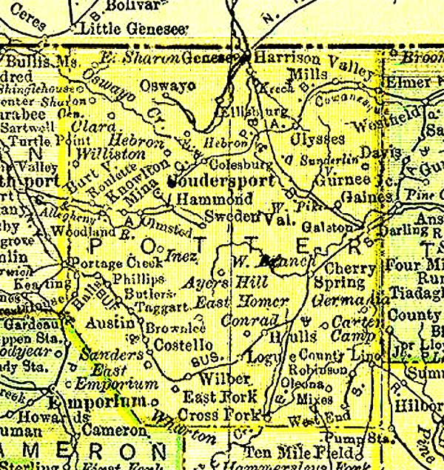  
Figure 18: Railroad map of Potter County, PA (Reitsch, 2012).

There are also two further spatial frames that can be developed. One will seek to locate the places where people lived before they died and/or how far did their last journey take them?

The decadal census is the first database to be consulted for that facet of the broader work. One person buried in the cemetery already identified is Martin Moran (fig.11). In the 1860 census he is listed in Genesee Township, Potter County, and his occupation was farmer. He is recorded as being born in Mayo, Ireland, as are several other farmers and farm laborers on that and nearby pages of the census (William Cunningham, Patrick O’Donnell, Michael McHale and James McDermott, for example). Their children were born in Canada, England, New York and Massachusetts, as well as Pennsylvania, suggesting some interesting migration paths to this place. Elmer Hart, also discussed earlier, was also found in Genesee Township of Potter County; in 1900 at age 16 he was listed as a day laborer. His parents were both Pennsylvanians, born of Irish parents, and he was a farmer. Neighbors on the census forms include McKinley and McNulty, also Irish, but like McDermott, names that possibly suggest Protestants. But listed below Elmer Hart’s family were two other Harts, then a Moran, (farmer) and one James Macken, priest, suggesting there were indeed some Catholic Irish among the group, and perhaps a mixed-religion Irish-origin settlement. Even if cemetery names can only be linked to a township area, as opposed to a specific village or farm, the aggregate patterns of a township-by-township map adds some spatial specificity to start to answer how far was that last journey.

The capacity to “zoom in and out” at so many spatial scales to search for patterns and correlations now provides a constant encouragement to seek and add new genealogical data. With the GIS database framework in place, so many things are possible.

**Conclusion**

From Colonial America's small family oriented final resting places to the monstrous cemeteries of today, where occupants are sometimes buried three deep (Bish, 2010), cemeteries have become more than just a final resting place. Today's cemeteries offer much insight into genealogy and other forms of historical information. The wealth of information that can be gathered from a cemetery is invaluable, but in the past has often been lost due to lack having the ability to store the information for others to access. The creation of Geographic Information Systems had brought, and will continue to bring, a wealth of data to an immeasurable amount of people, including the community of people that utilize cemetery information. GIS has given the ability for that information to not only be brought into the 21st century, but also be stored in a permanent place for others to utilize.

The central focus here has been local, and geared to the needs of the cemetery association. Clarifying the ambiguities of the plot parcels has been paramount. But it is also clear that the database allows for a considerable amount of data to be added, some from the grave markers and others from the association records. But there are several other sorts of data that will be pursued to make this database of wider appeal. Records from the county records office can be used to double-check death dates and to possibly list a cause of death, which will help in demography work and on the history of medicine in the area. The amount of data that is able to go into a cemetery database is endless, but having the ability to pass the GIS database from generation to generation will allow for future generations to input the data needed for their uses. In essence, creating a GIS for a cemetery should be looked at as in investment in the future needs of the generations to follow.

**References**Agriculture GIS Products (2012, January 27). *Agriculture.* Retrieved from  
 <http://www.gisdevelopment.net/application/agriculture/products/agrip0008.htm>.

Bish, Richard G. (2010). Phone Interview.

Environmental Systems Research Institute (2012, January 15). *Esri Undertanding Our  
 World.* Retrieved from <http://www.esri.com/>.

ePodunk - The Power of Place (2012, February 2). *Profile for Potter County,   
 Pennsylvania.* Retrieved from  
 <http://www.epodunk.com/cgibin/genInfo.php?locIndex=14695>

Find A Grave (2012, January 19). *Find A Grave.* Retrieved from   
 <http://www.findagrave.com/cgi-bin/fg.cgi?page=gsr&GScid=1962933>

Goss, J. (1995). Marketing the New Marketing: The Strategic Discourse of   
 Geodemograhpic Information Systems. In J. Pickles, *Ground Truth: The Social   
 Implications of Geographic Information Systems* (pp.132-141). New York, NY:   
 The Guilford Press.

Kinney, PA (2012, March 19). *Google Maps*. Retrieved from <http://maps.google.com/maps?hl=en&bav=on.2,or.r_gc.r_pw.r_qf.,cf.osb&biw=1366&bih=664&q=genesee,+pa&um=1&ie=UTF-8&hq=&hnear=0x89d1f933efed3d4d:0x304f47ef6d570f55,Genesee,+PA&gl=us&ei=tpSNT4WiJMrfggeH842dDg&sa=X&oi=geocode_result&ct=image&resnum=1&ved=0CCoQ8gEwAA>

Lewis, P.F. (1990) The Northeast and the making of American geographical habits. In   
 Michael P. Conzen (Ed.) *The Making of the American Landscape* (pp. 80-103). New York: Routledge.   
Lowe, D. W. (2002). Telling Civil War Battlefield Stories with GIS. In Anne Kelly  
 Knowles (Ed.), *Past Time, Past Place GIS for History* (pp. 51-63). Redlands,  
 CA: Esri Press.

Maine.Gov (2012, April 5). *Geographic Names Information System – Cemeteries*.  
 Retrieved from <http://www.maine.gov/megis/projects/gnis.shtml>.

O’Sullivan, D., & Unwin, D.J. (2010). *Geographic Information Analysis, second edition.* Hoboken, NJ: John Wiley & Sons.

Philips, D. J. & Curry, M.R. *Privacy and the Phenetic Urge: Geodemographics and the   
 Changing Spatiality of Local Practice.* *http://www.geog.ucla.edu/~curry/Phillips-Curry-GDP.pdf*

Pickles, J. (1995). Representations in an Electronic Ages: Geography, GIS, and   
 Democracy. In John Pickles (Ed), *Ground Truth, The Social Implications of   
 Geographic Information Systems* (pp.1-30)*.* New York, NY: Guilford Press.

Potter County Pennsylvania (2012, April 5). Retrieved from   
 <http://www.pottercountypa.net/history.php>.

Ramaker & Associates, Inc. (2012). [Interactive map of cemetery informations]. *Prairie   
 Home Cemetery.* Retrieved from <http://www.map.ramaker.com/prairiehome/>

Rietsch, P. (2003). 1895 U.S. Atlas. Retrieved from   
 <http://www.livgenmi.com/1895/PA/County/potter.htm>.

Simons, William (2005). Cemeteries (2012, February 17). *The Cemeteries of   
 Shenandoah, PA.* Retrieved from  
 <http://www.tuslogdet4.com/shenandoah/cemeteries/cemeteries.htm>

Stringfield, M. S., Hamilton, S., Leibens, J., Johnson, J. K., Haley, B. S., Fogle, A.,   
 Kennedy, K., Williams, S. *The Search for the Hidden People of St. Michaels   
 Cemetery.* Retrieved from   
 <http://www.uwf.edu/gis/research/smc/smcfinalv1.pdf>

Sloane, D. C. (1991). *The last great necessity: cemeteries in American history*.   
 Baltimore, MD: Johns Hopkins University Press.

State University of New York, College of Technology Senior Seminar Projects (2010).

Swarthmore College (2012, April 5). *Quaker Burial Grounds in Philadelphia.* Retrieved

from <http://www.swarthmore.edu/library/friends/philaburials3.htm>.

The Statue of Liberty- Ellis Island Foundation, Inc. (2012, January 26). *Passenger  
 Search.* Retrieved from <http://www.ellisisland.org/>.

The Painted Hills Genealogy Society (2011, December 01). *St. Mary’s Catholic  
 Cemetery.* Retrieved from <http://www.paintedhills.org/POTTER/KinneyCem.htm>

Federal Geographic Data Committee (2012, April 5). *Standards.* Retrieved from   
 <http://www.fgdc.gov/standards>.

University of West Florida. (2012). [Interactive map of cemetery information]. *Historic St.   
 Michael’s Cemetery.* Retrieved from <http://uwf.edu/gis/research/smc/index.cfm>

Utah State History (2012, April 5). *Submitting Burials Data.* Retrieved from[*http://history.utah.gov/research_and_collections/cemeteries/submit_data_info.html*](http://history.utah.gov/research_and_collections/cemeteries/submit_data_info.html)*.*

Veterans Affairs (2012, February 17). *Bath National Cemetery.* Retrieved from   
 <http://www.cem.va.gov/CEM/cems/nchp/bath.asp>

Wikipedia (2012, February 17). *1918 flu pandemic.* Retrieved from   
 <http://en.wikipedia.org/wiki/1918_flu_pandemic>

**Appendix A**

|  |  |  |  |  |  |  |  |  |  |  |  |  |  |  |  |
| --- | --- | --- | --- | --- | --- | --- | --- | --- | --- | --- | --- | --- | --- | --- | --- |
| **ID** | **LastName** | **FirstName** | **Surname** | **Spouse** | **Mother** | **Father** | **Birth Month** | **BirthDay** | **Birth Year** | **Death Month** | **DeathDay** | **Death Year** | **AgeAt Death** | **VeteranSta** | **Other Info** |
|  | AHEARN | Michael |  | Rebbeca |  |  | 8 | 28 | 1860 | 9 | 9 | 1935 |  |  |  |
|  | AHEARN | Rebecca M |  | Michael |  |  | 4 | 10 | 1872 | 2 | 11 | 1929 |  |  |  |
|  | BAHAM | Lewis Frank |  |  |  |  | 6 | 13 | 1918 | 3 | 18 | 1960 |  | WWII |  |
|  | BARNES | Mary E |  | Ralph |  |  |  |  |  |  |  |  |  |  |  |
|  | BARNES | Ralph A |  | Mary E | Bertah P | Charles H | 6 |  | 1885 |  |  | 1944 |  |  |  |
| 9018 | BIGELOW | Helen Z |  | Vincent W |  |  |  |  | 1917 |  |  | 2003 |  |  |  |
| 9018 | BIGELOW | Vincent W |  | Helen Z |  |  |  |  | 1914 |  |  | 1993 |  |  |  |
| 9010 | BRACY | Mary M |  |  |  |  | 5 | 17 | 1916 | 3 | 16 | 1993 |  |  | [Rest in Peace] Stone for both wives read McCale |
| 9013 | BRICKER | Elizabeth |  |  |  |  |  |  |  |  |  |  |  |  |  |
| 9014 | BRICKER | John William |  |  |  |  |  |  | 1961 |  |  | 1989 |  |  |  |
| 9015 | BRICKER | Marion |  | William |  |  |  |  | 1919 |  |  |  |  |  |  |
| 9015 | BRICKER | William |  | Marion |  |  |  |  | 1907 |  |  | 1982 |  |  |  |
| 10026 | BRIZZEE | Dora |  | A |  |  |  |  |  | 12 | 3 | 1888 | 34y |  |  |
|  | BROWN | David A |  |  |  |  |  |  | 1919 | 6 |  | 1919 |  |  |  |
| 9002 | BURKETT | Logan John |  |  |  |  | 1 | 21 | 2009 | 5 | 14 | 2009 |  |  |  |
|  | BURNS | George |  |  |  |  |  |  | 1889 |  |  | 1963 |  |  |  |
| 10006 | BURNS | James |  |  |  |  |  |  |  | 5 | 1 | 1879 | 45y |  |  |
|  | BURNS | James P |  |  |  |  | 1 | 6 | 1894 | 10 | 21 | 1918 |  |  | 170th NY Inf |
|  | BURNS | Mary |  |  |  |  |  |  |  | 4 | 1 | 1872 | 48y |  |  |
|  | BURNS | Mary |  | William |  |  |  |  |  | 11 | 18 | 1918 | 55y |  |  |
|  | BURNS | Patrick |  |  |  |  |  |  |  | 5 | 11 | 1866 | 50y |  |  |
|  | BURNS | Richard |  |  |  |  |  |  |  |  |  | 1919 |  |  |  |
|  | BURNS | Robert |  |  |  |  |  |  | 1903 |  |  | 1905 |  |  | 170th Regt NY Vols Captured at Ream's Station VA in Prison - Salisbury, NC |
|  | BURNS | Sarah |  | Thomas |  |  |  |  | 1855 |  |  | 1911 |  |  |  |
|  | BURNS | Thomas |  | Sarah |  |  |  |  | 1851 |  |  | 1939 |  |  |  |
|  | BURNS | William |  | Mary |  |  |  |  | 1852 |  |  | 1938 |  |  |  |
| 10042 | CANNON | Thomas |  |  |  |  |  |  |  | 8 | 26 | 1871 | 28y |  |  |
|  | CARNEY | John |  | Elizabeth |  |  |  |  | 1848 |  |  | 1916 |  | Civil War |  |
|  | CARROLL | Francis J |  |  | Florence Cooney | George | 10 | 25 | 1924 | 10 | 2 | 2006 |  |  |  |
|  | CARROLL | George |  |  |  | John | 5 |  | 1893 |  |  | 1942 |  |  |  |
|  | CARROLL | James |  |  |  |  |  |  | 1862 |  |  | 1938 |  |  |  |
|  | CARROLL | Joseph A |  | Margaret C |  | James | 1 |  | 1895 |  |  | 1937 |  |  |  |
|  | CARROLL | Margaret C |  | Joseph A |  |  |  |  | 1894 |  |  | 1941 |  |  |  |
|  | CARROLL | Paul E |  |  |  |  |  |  | 1934 |  |  | 1968 |  |  | [Green be the turf above thee Friends of my better days/ None knew thee but loved thee |
|  | CARROLL | Phyllis M |  |  |  |  |  |  |  |  |  | 1927 | 6w |  |  |
|  | CLANCY | Bridget |  | Patrick |  |  |  |  |  | 11 | 12 | 1892 | 68y |  | First Settle of Irish Settlement - 1842 |
|  | CLANCY | Bridget |  | Dennis |  |  |  |  | 1834 | 12 | 12 | 1900 |  |  |  |
|  | CLANCY | Cecile |  |  | Bridget | Patrick |  |  | 1842 |  |  | 1879 |  |  |  |
|  | CLANCY | Cecile Helena |  |  |  |  |  |  | 1880 |  |  | 1908 |  |  |  |
|  | CLANCY | Clair E |  |  | Sibrena | John J | 7 | 22 | 1892 | 9 | 27 | 1947 |  |  |  |
|  | CLANCY | Dennis |  | Bridget |  |  |  |  | 1833 | 10 |  | 1864 |  | Civil War |  |
|  | CLANCY | Elizabeth B |  | John D |  |  |  |  | 1863 |  |  | 1911 |  |  |  |
|  | CLANCY | Frank D |  |  |  |  |  |  | 1890 |  |  | 1907 |  |  |  |
|  | CLANCY | Irving P |  |  | Sibrena | John H | 11 | 19 | 1894 | 6 | 6 | 1972 |  |  |  |
|  | CLANCY | John D |  | Elizabeth B |  |  |  |  | 1861 |  |  | 1941 |  |  |  |
|  | CLANCY | Laura M |  |  |  |  |  |  | 1910 |  |  | 1979 |  |  |  |
|  | CLANCY | Mary Elizabeth |  |  | Sarah | Patrick |  |  | 1875 |  |  | 1905 |  |  |  |
|  | CLANCY | Patrick |  | Sarah |  |  | 3 |  | 1849 | 5 | 8 | 1890 | 41y 2m |  |  |
|  | CLANCY | Patrick |  | Bridget |  |  |  |  |  | 12 | 8 | 1892 | 79y |  |  |
|  | CLANCY | Sarah Veronica |  |  |  |  |  |  | 1877 |  |  | 1896 |  |  |  |
|  | CLARK | Ann |  | Patrick |  |  |  |  |  | 8 | 19 | 1890 | 60y |  |  |
|  | CLARK | Patrick |  |  |  |  |  |  |  |  |  |  |  |  |  |
|  | CLARK | Sarah M |  |  |  |  |  |  | 1871 |  |  | 1944 |  |  |  |
| 10044 | CLOSE | Donald Neil |  |  |  |  | 4 | 1 | 1933 | 4 | 18 | 1968 |  | Vietnam |  |
|  | COFFEY | John |  |  |  |  |  |  | 1825 |  |  | 1912 |  |  |  |
|  | COFFEY | John |  |  |  |  |  |  | 1871 | 11 |  | 1918 |  |  |  |
|  | COFFEY | Margaret | Crane |  |  |  |  |  | 1831 |  |  | 1912 |  |  |  |
|  | COFFEY | Marguerite |  |  |  |  | 1 | 21 | 1895 | 1 | 19 | 1897 |  |  |  |
|  | COFFEY | Thomas |  |  |  |  |  |  | 1862 | 11 |  | 1921 |  |  |  |
|  | COLLINS | Della |  | John F |  |  |  |  | 1854 |  |  | 1900 |  |  |  |
|  | COLLINS | Edward |  |  |  |  |  |  |  | 1 | 24 | 1862 |  |  |  |
|  | COLLINS | John |  |  | Mary | Edward |  |  |  | 5 | 31 | 1878 |  |  |  |
|  | COLLINS | John F. |  | Della |  |  | 9 | 16 | 1848 | 5 | 31 | 1899 |  |  |  |
|  | COLLINS | Sadie |  |  | Della | John F |  |  | 1879 |  |  | 1905 |  |  |  |
|  | COONEY | Catherine L |  | Stephen N |  |  |  |  | 1889 |  |  | 1966 |  |  |  |
| 10049 | COONEY | Daniel E |  |  |  |  | 5 | 24 | 1931 | 7 | 22 | 1998 |  | Korean War |  |
| 10047 | COONEY | Dennis W |  |  |  |  |  |  | 1938 |  |  | 1968 |  | Vietnam |  |
|  | COONEY | Edward |  |  |  | Edward |  |  | 1890 |  |  | 1969 |  |  |  |
|  | COONEY | Ellen |  |  |  |  |  |  | 1858 |  |  | 1912 |  |  |  |
| 10046 | COONEY | Florence E |  | John L |  |  |  |  | 1899 |  |  | 1978 |  |  |  |
| 10048 | COONEY | J Thomas |  |  |  |  |  |  | 1935 |  |  | 1990 |  | Korean War |  |
| 10046 | COONEY | John L |  | Florence |  | Edward |  |  | 1898 |  |  | 1975 |  |  |  |
|  | COONEY | Katherine | Wiles |  | Mary Wiles | James |  |  | 1866 |  |  | 1936 |  |  |  |
|  | COONEY | Katherine I |  |  |  | Edward |  |  | 1895 |  |  | 1974 |  |  |  |
|  | COONEY | Olive M |  |  |  |  |  |  | 1905 |  |  | 1988 |  |  |  |
|  | COONEY | Stephen N |  | Catherine L |  |  |  |  | 1893 |  |  | 1972 |  |  |  |
| 10052 | CORCORAN | Anthony |  | Catherine |  |  |  |  | 1815 |  |  | 1914 |  |  |  |
| 10052 | CORCORAN | Catherine |  | Anthony |  |  |  |  | 1823 |  |  | 1907 |  |  |  |
| 10051 | CORCORAN | James |  |  | Catherine | Anthony |  |  |  |  |  |  |  |  |  |
|  | CORCORAN | John |  |  |  |  |  |  |  |  |  |  |  |  | Native of Ireland |
|  | CORCORAN | Mary |  |  |  |  |  |  | 1912 |  |  | 1915 |  |  |  |
| 10056 | CORR | Hanora |  | Patrick |  |  |  |  | 1814 |  |  | 1886 |  |  |  |
| 10056 | CORR | James |  |  | A | M | 2 | 23 | 1889 | 3 | 10 | 1889 |  |  | Wed 4-17-1880 |
|  | COSTELLO | Susiella | Doyle | Frank C | Mary | Patrick | 12 | 11 | 1852 | 3 | 13 | 1882 | 29y 3m 2d |  |  |
|  | COVEY | Mary |  |  |  |  |  |  | 1915 |  |  | 1919 |  |  |  |
|  | COVEY | Orpha |  |  |  |  |  |  | 1881 |  |  | 1919 |  |  |  |
|  | CULLEN | Thomas |  |  |  |  | 2 | 26 | 1839 | 8 | 18 | 1913 |  | Civil War |  |
|  | CUNNINGHAM | Anthony |  | Catherine Moran | Margaret | Peter |  |  | 1834 | 11 | 11 | 1912 |  |  |  |
| 10069 | CUNNINGHAM | Bridget |  |  |  |  |  |  |  | 8 | 14 | 1870 | 18y |  |  |
|  | CUNNINGHAM | Catherine |  |  |  |  |  |  | 1848 |  |  | 1895 |  |  |  |
| 10063 | CUNNINGHAM | Ellen |  |  |  |  |  |  | 1826 |  |  | 1868 |  |  |  |
|  | CUNNINGHAM | James |  |  | Margaret | Peter |  |  | 1841 |  |  | 1906 |  |  |  |
|  | CUNNINGHAM | Jerome C |  |  | Kate | James | 9 | 30 | 1874 | 7 | 7 | 1875 | 9m 7d |  |  |
|  | CUNNINGHAM | John |  |  |  |  |  |  | 1853 |  |  |  |  |  |  |
|  | CUNNINGHAM | Margaret |  | Peter |  |  |  |  | 1820 |  |  |  |  |  |  |
|  | CUNNINGHAM | Mary |  |  |  |  |  |  | 1915 |  |  | 1919 |  |  |  |
|  | CUNNINGHAM | Monica C | Holloran |  |  |  |  |  | 1907 |  |  | 1908 |  |  |  |
|  | CUNNINGHAM | Orpha |  |  |  |  |  |  | 1881 |  |  | 1919 |  |  |  |
|  | CUNNINGHAM | Patrick |  |  |  |  |  |  | 1847 |  |  |  |  |  |  |
|  | CUNNINGHAM | Peter |  | Margaret |  |  |  |  |  | 4 | 24 | 1888 | 74y |  |  |
| 10064 | CUNNINGHAM | William |  |  |  |  |  |  | 1814 |  |  | 1894 |  |  |  |
|  | CURRAN | Mary E |  |  |  |  |  |  | 1876 |  |  | 1953 |  |  | In Ireland |
|  | DOLAN | Charles |  |  |  |  |  |  | 1824 | 8 | 27 | 1878 | 45y |  |  |
|  | DOLAN | Edward C |  |  |  |  |  |  | 1860 |  |  | 1936 |  |  |  |
|  | DOLAN | Rose |  |  |  |  |  |  | 1866 |  |  | 1934 |  |  |  |
|  | DOLAN | Rose A |  |  |  |  |  |  | 1830 |  |  | 1909 |  |  | [Rest in Peace] Stone for both wives read McCale |
|  | DONIHI | Eva (Sikes) |  |  |  |  |  |  | 1889 |  |  | 1969 |  |  |  |
|  | DONIHI | Frank |  | Mary |  |  | 9 |  | 1868 |  |  |  |  |  |  |
|  | DONIHI | Frank S |  |  |  |  |  |  | 1903 |  |  | 1968 |  |  | Native of Ireland Co Mayo Parish Of Turlavah |
|  | DONIHI | George |  |  | Mary Donihi | Frank | 2 |  | 1893 |  |  |  |  |  |  |
|  | DONIHI | Mary |  | Frank |  |  | 12 |  | 1867 |  |  |  |  |  |  |
|  | DORLEY | Catherine M [Kate] | McGinnis | Patrick A | Anna O'Rourke | Dennis Sr. | 8 |  | 1847 |  |  | 1939 |  |  |  |
|  | DORLEY | Patrick A |  | Kate McGinnis | Catherine Rigney | Thomas |  |  | 1837 |  |  | 1907 |  |  |  |
|  | DOYLE | Mary |  | Patrick |  |  | 6 | 4 | 1822 | 1 | 24 | 1915 |  |  |  |
|  | DOYLE | Patrick |  | Mary |  |  |  |  | 1818 | 12 | 20 | 1896 |  |  |  |
| 10053 | DUNN | John |  | Bridget |  |  |  |  |  | 8 | 12 | 1884 | 75y |  |  |
|  | DWYER | Ellen |  | Michael |  |  |  |  |  | 5 | 1 | 1833 | 31y |  |  |
|  | DWYER | Helen |  |  |  |  |  |  |  |  |  |  |  |  |  |
|  | DWYER | James |  | Mae | Margaret Dwyer | Michael |  |  | 1876 |  |  | 1933 |  |  |  |
|  | DWYER | Katie | Burns |  |  |  |  |  | 1890 |  |  | 1973 |  |  |  |
|  | DWYER | Mae |  | James |  |  |  |  | 1887 |  |  | 1917 |  |  |  |
|  | DWYER | Margaret |  | Michael |  |  |  |  |  | 4 | 25 | 1884 | 45y |  |  |
|  | DWYER | Mary C |  | Patrick W |  |  | 10 | 28 | 1843 | 3 | 28 | 1928 |  |  |  |
|  | DWYER | Michael |  | Margaret/ Ellen |  |  |  |  | 1830 |  |  |  |  |  |  |
|  | DWYER | Patrick W |  | Mary C |  |  | 9 |  | 1853 |  |  | 1919 |  |  |  |
|  | EWELL | Margaret M |  |  |  |  | 4 | 22 | 1915 | 7 | 14 | 1915 |  |  |  |
|  | FAULT | Gerald J |  | Matilda E |  |  |  |  | 1883 |  |  | 1963 |  |  |  |
|  | FAULT | Matilda E |  | Gerald J |  |  |  |  | 1883 |  |  | 1942 |  |  |  |
|  | FITZPATRICK | James Stephens |  |  |  |  |  |  | 1871 |  |  | 1881 |  |  |  |
|  | FITZPATRICK | Mary | Welsh | Michael |  |  |  |  | 1801 |  |  | 1885 |  |  |  |
|  | FITZPATRICK | Mary |  |  |  |  | 12 | 11 | 1824 | 2 | 16 | 1908 |  |  |  |
|  | FITZPATRICK | Michael |  | Mary Welsh |  |  |  |  | 1801 |  |  | 1900 |  |  |  |
|  | FITZSTEPHENS | Anna |  | John |  |  |  |  |  |  |  | 1920 |  |  |  |
|  | FITZSTEPHENS | Anne E |  |  |  |  |  |  | 1902 |  |  | 1904 |  |  |  |
|  | FITZSTEPHENS | Beatrice M |  | Martin |  |  |  |  | 1896 |  |  | 1985 |  |  |  |
|  | FITZSTEPHENS | Dennis |  |  |  |  |  |  | 1875 |  |  | 1908 |  |  |  |
|  | FITZSTEPHENS | Dennis |  |  |  |  |  |  | 1849 |  |  | 1930 |  |  |  |
|  | FITZSTEPHENS | James D |  |  |  |  | 11 | 20 | 1891 | 10 | 8 | 1967 |  | WWI |  |
|  | FITZSTEPHENS | John |  | Anna |  |  |  |  |  |  |  | 1926 |  |  |  |
|  | FITZSTEPHENS | Marguerite |  |  |  |  |  |  | 1906 |  |  | 1906 |  |  |  |
|  | FITZSTEPHENS | Martin |  | Beatrice M |  |  |  |  | 1888 |  |  | 1937 |  |  |  |
|  | FITZSTEPHENS | Martin F |  |  | Mary | Patrick | 5 | 28 | 1927 | 3 | 5 | 2002 |  | WWII |  |
|  | FITZSTEPHENS | Mary |  | Patrick |  |  |  |  | 1847 |  |  | 1923 |  |  |  |
|  | FITZSTEPHENS | Mary Caden |  |  |  |  |  |  | 1916 |  |  | 1916 |  |  |  |
|  | FITZSTEPHENS | Patrick |  | Mary |  |  |  |  | 1844 |  |  | 1928 |  |  |  |
|  | FITZSTEPHENS | Stephen |  |  |  |  |  |  | 1881 |  |  | 1941 |  |  |  |
|  | FITZSTEPHENS | Thomas |  |  |  |  |  |  | 1873 |  |  | 1942 |  |  |  |
|  | FITZSTEPHENS | Walter W |  |  |  |  |  |  | 1899 |  |  | 1959 |  |  |  |
| 10033 | FLYNN | Ann |  | Edward F |  |  |  |  |  | 3 | 12 | 1877 | 43y |  |  |
|  | FLYNN | Bridget |  | Thomas |  |  |  |  | 1820 |  |  |  |  |  |  |
| 10031 | FLYNN | Edward |  |  |  |  | 1 | 11 | 1892 | 3 | 8 | 1953 | 62y | WWI |  |
|  | FLYNN | Edward F |  | Ann |  |  |  |  | 1833 |  |  | 1895 |  |  |  |
|  | FLYNN | John |  |  |  |  |  |  |  |  |  |  |  |  |  |
|  | FLYNN | Martha |  |  |  |  |  |  | 1898 |  |  | 1955 |  |  |  |
|  | FLYNN | Paul E |  |  |  |  |  |  | 1927 |  |  | 1987 |  |  |  |
|  | FLYNN | Thomas |  | Bridget |  |  |  |  |  | 7 | 9 | 1866 | 70y |  |  |
|  | FLYNN |  |  |  |  |  |  |  | 1862 |  |  | 1904 |  |  |  |
| 9006 | FRENCH | Harold W |  | Helen E |  |  |  |  | 1901 |  |  | 1974 |  |  |  |
| 9006 | FRENCH | Helen E |  | Harold W |  |  |  |  | 1907 |  |  |  |  |  |  |
| 9008 | FRENCH | Mary H |  |  |  |  |  |  |  |  |  |  |  |  |  |
|  | FRENCH | Shaun Michael |  |  |  |  |  |  |  |  |  | 1966 |  |  |  |
| 9008 | FRENCH | William E |  |  |  |  |  |  |  |  |  |  |  |  |  |
| 10024 | GANGHAN | Catherine |  | John |  |  |  |  |  | 10 | 13 | 1887 | 82y |  | Killed in McGonigal House fire in Oswayo |
| 10040 | GILLETT | Frederick S |  | P M |  |  | 3 | 12 | 1815 | 6 |  | 1979 |  | Civil War |  |
| 10041 | GILLETT | P M |  | Frederick S |  |  | 6 | 5 | 1812 | 3 | 13 | 1878 |  |  |  |
|  | GILLON | Ellen |  |  | Mary Gillon | Mark |  |  |  | 10 | 27 | 1860 |  |  |  |
|  | GILLON | Thomas |  |  | Mary Gillon | Mark |  |  |  | 12 | 17 | 1857 |  |  |  |
| 10045 | GOODRIDGE | Anne T. | Cooney |  |  |  | 1 | 3 | 1934 | 11 | 15 | 2010 |  |  |  |
|  | GRIFFIN | Mary Judge |  |  |  |  |  |  | 1868 |  |  | 1931 |  |  |  |
|  | GRIMES | Agnes |  | Patrick |  |  |  |  | 1869 |  |  | 1938 |  |  |  |
|  | GRIMES | Bridget |  | John |  |  |  |  | 1840 | 11 | 27 | 1914 |  |  |  |
|  | GRIMES | Earl J |  |  | Agnes Grimes | Patrick |  |  | 1892 |  |  | 1920 |  |  |  |
|  | GRIMES | Irene M |  | Robert M |  |  |  |  | 1909 |  |  | 1964 |  |  |  |
|  | GRIMES | Jean |  |  |  |  | 9 | 4 | 1901 | 1 | 2 | 1916 |  |  |  |
|  | GRIMES | Joe |  |  |  |  |  |  |  |  |  |  |  |  |  |
|  | GRIMES | John |  | Bridget |  |  |  |  | 1829 |  |  | 1908 |  |  |  |
|  | GRIMES | Joseph |  |  |  |  | 10 | 25 | 1894 | 10 | 31 | 1954 |  | WW I |  |
|  | GRIMES | Michael |  |  |  |  |  |  |  |  |  |  |  |  |  |
|  | GRIMES | Patrick |  | Agnes | Bridget Grimes | John |  |  | 1861 |  |  | 1937 |  |  |  |
|  | GRIMES | Robert M |  | Irene M |  |  |  |  | 1901 |  |  | 1967 |  |  |  |
|  | HAGEN | Patrick |  |  | Helen | Patrick |  |  |  | 8 | 31 | 1867 | 3y |  |  |
|  | HAGEN | Rose Ann |  |  | Helen | Patrick |  |  |  | 9 | 4 | 1867 | 6y |  |  |
|  | HART | Catherine |  |  | Mary | John |  |  | 1848 |  |  | 1934 |  |  |  |
|  | HART | Delia |  |  | Mary | John |  |  | 1863 |  |  | 1935 |  |  |  |
|  | HART | Dominick |  |  | Mary | John |  |  | 1853 |  |  | 1864 |  |  |  |
|  | HART | Edward |  |  | Mary | John |  |  | 1860 |  |  | 1949 |  |  |  |
|  | HART | Ellen |  |  | Mary | John |  |  | 1855 |  |  | 1929 |  |  |  |
|  | HART | Elmer A |  |  |  | Patrick |  |  | 1884 | 6 | 20 | 1916 |  |  | Wed 6-4-1903 |
|  | HART | Hava |  | M |  |  |  |  | 1919 |  |  |  |  |  |  |
|  | HART | John |  | Mary |  |  |  |  | 1811 |  |  | 1908 |  |  |  |
| 9011 | HART | John A |  | Katherine A | Elizabeth | John |  |  | 1899 |  |  | 1983 |  |  |  |
|  | HART | Joseph |  |  |  |  |  |  | 1891 |  |  | 1912 |  |  | Survived by six children |
| 9011 | HART | Katherine A |  | John A |  |  |  |  | 1907 |  |  | 1988 |  |  |  |
|  | HART | M |  | Hava |  |  |  |  | 1902 |  |  | 1977 |  |  |  |
|  | HART | Mae | Moran |  |  |  |  |  | 1886 |  |  | 1979 |  |  |  |
|  | HART | Mary |  | John B |  |  |  |  | 1821 |  |  | 1897 |  |  |  |
|  | HART | Mary |  |  |  |  |  |  | 1854 |  |  | 1945 |  |  |  |
| 9012 | HART | Michael |  |  | Mary | John | 4 | 4 | 1858 | 8 | 26 | 1917 |  |  |  |
|  | HART | Patrick |  | Mary | Mary | John |  |  | 1849 |  |  | 1942 |  |  |  |
|  | HART | Sarah |  | Thomas |  |  |  |  |  | 6 | 20 | 1880 | 30y |  |  |
|  | HART | Thomas |  | Sarah | Mary | John | 5 |  | 1844 |  |  | 1925 |  |  |  |
|  | HAWKS | Mary D |  |  | B | N | 6 | 3 | 1885 | 1 | 29 | 1897 |  |  |  |
|  | HAYES | Celia E |  |  |  |  |  |  | 1870 |  |  | 1913 |  |  |  |
| 10057 | HENDERSON | Mary E |  |  | M | R A | 1 | 9 | 1883 | 9 | 28 | 1883 | 8m 19d |  |  |
|  | HOLLORAN | Anthony |  | Catherine |  |  |  |  | 1834 |  |  | 1923 |  |  |  |
|  | HOLLORAN | Catherine |  | Anthony |  |  |  |  | 1834 |  |  | 1914 |  |  |  |
|  | HOLLORAN | Monica C |  |  |  |  |  |  | 1907 |  |  | 1908 |  |  |  |
|  | HUGHES | Celia D |  | Fred |  |  |  |  | 1889 |  |  | 1958 |  |  | Died in Ireland |
|  | HUGHES | Fred |  | Celia D |  |  |  |  | 1890 |  |  | 1980 |  |  |  |
|  | HUGHES | Fred M |  |  |  |  |  |  | 1889 |  |  | 1958 |  |  |  |
|  | HUGHES | Gertrude M |  |  |  |  | 6 | 18 | 1888 | 5 | 11 | 1957 |  |  | Wed in 1878 |
|  | HUGHES | John |  | Margaret |  |  |  |  | 1859 |  |  | 1930 |  |  |  |
|  | HUGHES | Margaret | Gorman / O'Donnell | James O'Donnell/ John Hughes |  |  |  |  | 1853 | 9 | 16 | 1915 |  |  |  |
|  | HUGHES | Mary M | McHale | Thomas | Nancy Moran | Michael | 1 | 1 | 1854 | 9 | 6 | 1911 |  |  |  |
|  | HUGHES | Mary M |  |  |  |  |  |  | 1857 |  |  | 1911 |  |  |  |
|  | HUGHES | Michael |  |  |  |  |  |  | 1801 |  |  | 1900 |  |  |  |
| 9017 | HUGHES | Robert D |  |  |  |  |  |  | 1921 |  |  | 2011 |  |  |  |
|  | HUGHES | Thomas |  | Mary McHale | Margaret Hughes | James | 4 | 8 | 1857 | 2 | 12 | 1905 |  |  |  |
|  | HUGHES | Thomas |  |  |  |  |  |  | 1884 |  |  | 1913 |  |  |  |
|  | JOHNSON | Janetta L |  |  |  |  |  |  | 1939 |  |  | 1982 |  |  |  |
|  | KEIB | Ellen F |  | John J |  |  |  |  | 1879 |  |  | 1929 |  |  | 170th NY Inf |
|  | KEIB | John J |  | Ellen F |  |  |  |  | 1874 |  |  | 1943 |  |  |  |
|  | KERNAN | Mary |  | F |  |  | 7 | 1 | 1860 | 1 | 1 | 1889 | 28y 6m |  |  |
| 9005 | KIEL | Anna R |  | Frederick |  |  |  |  | 1933 |  |  |  |  |  |  |
| 9005 | KIEL | Frederick |  | Anna R |  |  |  |  | 1930 |  |  | 1980 |  |  | Medal of Honor Co I 82 NY Inf Citation: Capture of flag of 22d or 28th North Carolina died in Ireland |
|  | LAMB | Harry |  |  |  |  |  |  | 1886 |  |  | 1918 |  |  |  |
| 10043 | LAWTON | Kattie Larae |  |  | E | L |  |  |  |  |  | 1863 | 3y |  |  |
|  | LAWTON | Lottie |  |  |  |  | 4 |  | 1861 | 12 | 17 | 1863 | 2y 8m |  | Survived by nine children |
|  | LUDDIN | Francis |  | Mary Kinney |  |  |  |  | 1830 |  |  | 1902 |  |  |  |
|  | LUDDIN | Mary | Kinney | Francis B |  |  |  |  | 1832 | 2 | 3 | 1919 |  |  | Wed in 1849 in Castlebar |
| 10059 | MAHER | Charles E |  |  | Ann Maher | Thomas | 1 | 13 | 1893 | 1 | 16 | 1896 | 3y 3d |  |  |
| 10058 | MAHER | Sarah C |  |  | Ann Maher | Thomas | 11 |  | 1878 | 1 | 24 | 1881 | 2y 2m |  | Wed in 1849 in Castlebar |
| 10059 | MAHER | Thomas H |  |  | Ann Maher | Thomas | 6 | 4 | 1894 | 7 | 12 | 1894 |  |  |  |
|  | MARKEY | Ann |  | James |  |  |  |  |  | 9 | 29 | 1872 | 51y |  |  |
|  | MARKEY | Anna |  |  |  |  | 1 | 5 | 1893 | 12 | 20 | 1893 | 11m 15d |  |  |
|  | MARKEY | Catherine L |  | Frank M |  |  |  |  | 1899 |  |  | 1968 |  |  |  |
|  | MARKEY | Frank M |  | Catherine L | Mary Markey | Patrick |  |  | 1890 |  |  | 1950 |  |  |  |
|  | MARKEY | James |  | Ann |  |  |  |  |  | 1 | 2 | 1870 | 68y |  |  |
|  | MARKEY | James P |  | Loretta E |  |  |  |  | 1881 |  |  | 1925 |  |  |  |
|  | MARKEY | John R |  |  |  |  |  |  | 1926 |  |  | 1993 |  |  | 170th NY Inf |
|  | MARKEY | Loretta E |  | James P |  |  |  |  | 1892 |  |  | 1918 |  |  |  |
|  | MARKEY | Mary |  | Patrick |  |  |  |  | 1856 |  |  | 1913 |  |  |  |
|  | MARKEY | Patrick |  | Mary |  |  |  |  | 1843 |  |  | 1923 |  |  |  |
|  | MARKEY | Walter J |  |  | Mary Markey | Patrick | 11 | 2 | 1896 | 7 | 6 | 1953 |  | WWI | Wed 1849 in Belemont NY |
|  | MARKEY | William F |  |  |  |  |  |  | 1929 |  |  | 1992 |  |  | Wed James in 1872 Wed John 5-1-1881 |
|  | MAWN | Bryan |  | Catherine Dolan |  |  |  |  | 1833 |  |  | 1900 |  |  |  |
|  | MAWN | Catherine | Dolan | Patrick |  |  |  |  | 1831 | 11 | 29 | 1906 |  |  |  |
|  | MAWN | John |  |  | Catherine Dolan | Patrick |  |  | 1865 |  |  | 1936 |  |  |  |
|  | MAWN | Mary E |  |  | Catherine Dolan | Patrick |  |  | 1868 |  |  |  |  |  |  |
|  | MCDERMOTT | Bridget |  |  |  |  |  |  | 1850 |  |  | 1921 |  |  |  |
|  | MCDERMOTT | Bridget J |  |  | Kate McDermott | John | 11 |  | 1875 | 5 | 18 | 1880 | 4y 6m |  | Survived by wife and 2 sons |
|  | MCDERMOTT | Catherine |  |  |  |  |  |  | 1842 |  |  | 1929 |  |  |  |
|  | MCDERMOTT | Francis A |  |  | Kate McDermott | John | 10 | 31 | 1880 | 2 | 14 | 1881 | 3m 14d |  |  |
|  | MCDERMOTT | Gertrude V |  |  | Kate McDermott | John | 6 | 8 | 1884 | 11 | 16 | 1891 |  |  | in PA |
|  | MCDERMOTT | John |  |  |  |  | 7 |  | 1871 | 3 | 1 | 1880 | 8y 8m |  |  |
|  | MCDERMOTT | John |  |  |  |  |  |  | 1834 |  |  | 1901 |  |  | four children |
|  | MCDERMOTT | Kate E |  |  | Kate McDermott | John | 3 | 20 | 1878 | 3 | 28 | 1880 | 2y 8d |  |  |
|  | MCDERMOTT | P James |  |  |  |  | 6 |  | 1869 | 1 | 5 | 1890 | 20y 7m |  |  |
|  | MCDERMOTT | Peter |  |  |  |  |  |  | 1836 |  |  | 1935 |  |  |  |
|  | MCGINNIS | Agnes |  |  | Kate | John | 2 | 25 | 1869 | 3 | 1 | 1869 |  |  |  |
|  | MCGINNIS | Agnes |  |  |  |  |  |  | 1873 |  |  | 1894 |  |  |  |
|  | MCGINNIS | Alfred L |  | Mildred E | Kate | John |  |  | 1874 |  |  | 1933 |  |  | Wed 8-14-1859 Immigrated abt 1853 |
|  | MCGINNIS | Anna |  |  |  |  |  |  | 1877 |  |  | 1968 |  |  |  |
|  | MCGINNIS | Bryan |  | Helen [Ella] Moran |  |  |  |  | 1839 | 2 | 28 | 1912 |  | Civil War |  |
|  | MCGINNIS | Charles F |  |  | Edna | Frank |  |  |  |  |  | 1904 | Infant |  |  |
|  | MCGINNIS | Clara |  |  |  |  |  |  | 1873 |  |  | 1894 |  |  |  |
|  | MCGINNIS | Connell A |  |  |  |  | 12 |  | 1870 | 7 | 14 | 1872 | 1y 7m |  | Wed 1-1-1866 |
|  | MCGINNIS | Dennis |  | Nancy Moran | Anna O'Rourke | Dennis | 5 | 11 | 1842 | 2 | 7 | 1915 |  | Civil War |  |
|  | MCGINNIS | Dennis |  |  |  |  |  |  |  | 2 | 8 | 1861 | 65y |  |  |
|  | MCGINNIS | Dennis |  |  |  |  | 4 |  | 1868 | 3 | 7 | 1875 | 6y 11m |  |  |
|  | MCGINNIS | Dennis |  |  |  |  | 5 | 9 | 1863 | 8 | 23 | 1886 |  |  |  |
|  | MCGINNIS | Donna P |  | Thomas K |  |  |  |  | 1933 |  |  |  |  |  |  |
|  | MCGINNIS | Edna L | Neefe | Frank H |  |  |  |  | 1878 |  |  |  |  |  |  |
|  | MCGINNIS | Edward |  |  |  |  |  |  |  | 3 | 15 | 1880 | 12Y |  |  |
|  | MCGINNIS | Ellen | Morley | Francis | Nora O'Boyle | Edmund |  |  | 1840 |  |  | 1932 |  |  |  |
|  | MCGINNIS | Francis |  | Ellen Morley | Mary | John | 1 | 19 | 1839 | 5 | 29 | 1920 |  |  |  |
|  | MCGINNIS | Frank E |  | Clara P Crane |  |  |  |  | 1858 |  |  |  |  |  |  |
|  | MCGINNIS | Frank H |  | Edna L Neefe |  |  |  |  | 1869 | 5 |  | 1906 |  |  |  |
|  | MCGINNIS | George B |  |  |  |  | 1 |  | 1879 | 3 | 17 | 1880 | 1y 2m |  |  |
|  | MCGINNIS | Helen [Ella] | Moran | Bryan | Ellen Rogers | Martin |  |  | 1841 |  |  | 1932 |  |  |  |
|  | MCGINNIS | John |  | Mary Moran |  |  |  |  | 1892 |  |  | 1906 |  |  |  |
|  | MCGINNIS | John A |  |  | Mildred E | Alfred L |  |  | 1917 |  |  | 1933 |  |  |  |
|  | MCGINNIS | Laura A |  |  |  |  | 11 | 28 | 1858 | 3 | 17 | 1871 | 12y 4m |  | D 108th Inf 27th Div |
|  | MCGINNIS | Leo |  | Margaret K |  | Daniel |  |  | 1888 |  |  | 1945 |  |  |  |
|  | MCGINNIS | Margaret |  |  |  |  |  |  | 1864 |  |  | 1880 |  |  |  |
|  | MCGINNIS | Margaret K |  | Leo |  |  |  |  | 1892 |  |  | 1968 |  |  |  |
|  | MCGINNIS | Mary | Moran | John | Catherine Moran | Laurance |  |  | 1835 | 7 | 30 | 1913 |  |  |  |
|  | MCGINNIS | Mary Ellen |  |  |  |  |  |  | 1868 |  |  | 1934 |  |  |  |
|  | MCGINNIS | Nancy | Moran | Dennis | Ellen (Rogers) Moran | Martin | 1 |  | 1846 |  |  | 1917 |  |  |  |
|  | MCGINNIS | Thomas K |  | Donna P |  |  |  |  | 1928 |  |  |  |  |  |  |
|  | MCGINNIS | William |  |  | Ella | Bryan |  |  |  | 12 | 22 | 1865 |  |  |  |
|  | MCGONIGAL | Anna |  | Edward |  |  |  |  | 1841 |  |  | 1916 |  |  |  |
|  | MCGONIGAL | Edward |  | Anna |  |  |  |  | 1844 |  |  | 1941 |  |  |  |
| 10025 | MCGONIGAL | Johanna |  | E |  |  |  |  |  | 8 | 23 | 1887 | 49y |  |  |
|  | MCHALE | Andrew J |  |  | Bridge A Moran | John | 2 |  | 1894 |  |  | 1974 |  |  |  |
|  | MCHALE | Bridget A | Moran | John |  |  |  |  | 1857 |  |  | 1909 |  |  |  |
| 10030 | MCHALE | Bridget E |  |  | Mary | Miles | 7 | 27 | 1870 | 10 | 28 | 1893 |  |  |  |
|  | MCHALE | Catherine |  |  |  |  |  |  | 1892 |  |  | 1962 |  |  |  |
|  | MCHALE | Genevieve |  |  | E | JL |  |  |  |  |  |  | 5w |  |  |
|  | MCHALE | Grace V |  | James H |  |  |  |  | 1898 |  |  | 1955 |  |  |  |
|  | MCHALE | Hannah |  | Miles |  |  |  |  | 1837 |  |  | 1927 |  |  |  |
|  | MCHALE | James D |  | Nora |  |  |  |  | 1855 |  |  | 1930 |  |  |  |
|  | MCHALE | James H |  | Grace V | Nora V | James D |  |  | 1900 |  |  | 1962 |  | WW I |  |
|  | MCHALE | John |  | Bridget A Moran |  |  | 6 |  | 1845 |  |  | 1902 |  |  |  |
|  | MCHALE | John H |  |  | Bridget Moran | John | 1 |  | 1892 |  |  | 1978 |  |  |  |
|  | MCHALE | John L |  |  |  |  | 4 | 11 | 1862 | 11 | 13 | 1904 |  |  |  |
|  | MCHALE | Joseph |  |  |  |  |  |  |  |  |  |  |  | Civil War |  |
|  | MCHALE | Joseph F |  |  | Bridget Moran | John | 3 |  | 1896 |  |  | 1918 |  | WWI |  |
|  | MCHALE | Joseph Merill |  |  |  |  |  |  | 1908 |  |  | 1913 |  |  |  |
|  | MCHALE | Margaret |  | Thomas P |  |  | 6 | 11 | 1858 | 2 | 21 | 1936 |  |  |  |
|  | MCHALE | Martin |  |  | Hannah | Miles |  |  |  | 11 | 14 | 1889 | 29y |  |  |
| 10028 | MCHALE | Mary | Jennings | Michael |  |  |  |  |  | 5 | 1 | 1855 | 25y |  |  |
|  | MCHALE | Mary | Moran | Michael |  |  |  |  |  | 6 | 15 | 1887 | 60y |  | in Ireland |
|  | MCHALE | Metzgar J |  |  | Nora V | James D |  |  | 1904 |  |  | 1940 |  |  |  |
|  | MCHALE | Michael |  |  |  |  | 6 | 18 | 1869 |  |  | 45 |  |  |  |
|  | MCHALE | Michael |  | Mary Jennings/ Mary Moran |  |  | 4 | 3 | 1814 | 4 | 11 | 1904 |  |  |  |
|  | MCHALE | Michael |  |  |  |  |  |  |  |  |  |  |  | Civil War |  |
|  | MCHALE | Michael M |  | Nancy |  |  |  |  |  | 3 | 20 | 1888 |  |  |  |
|  | MCHALE | Nancy |  | Michael M |  |  |  |  |  | 6 | 12 | 1875 |  |  |  |
|  | MCHALE | Nellie |  |  |  |  |  |  | 1884 |  |  | 1940 |  |  |  |
|  | MCHALE | Nora |  |  | Mary | Michael | 7 | 27 | 1859 | 11 | 7 | 1881 | 22y 3m 11d |  |  |
|  | MCHALE | Nora M |  | James D | Hannah | Miles |  |  | 1868 |  |  | 1941 |  |  |  |
|  | MCHALE | Sarah A | Ryan |  |  |  |  |  | 1894 |  |  | 1976 |  |  |  |
| 10028 | MCHALE | Thomas |  |  | Hannah | Miles |  |  |  | 12 | 25 | 1889 | 31y |  |  |
|  | MCHALE | Thomas P |  |  |  |  | 4 | 12 | 1840 | 6 | 24 | 1912 |  |  |  |
|  | MCHALE | Unknown |  |  |  |  |  |  |  | 3 | 23 | 1873 |  |  |  |
|  | MCHALE | William J |  |  |  |  |  |  | 1897 |  |  | 1938 |  |  |  |
|  | MCHALE | William M |  |  |  |  | 4 | 25 | 1895 | 6 | 27 | 1969 | 1st | WWI |  |
|  | MCMURRAY | Ann |  |  |  |  |  |  |  |  |  |  |  |  |  |
|  | MCMURRAY | Dennis |  |  |  |  |  |  | 1871 |  |  | 1889 |  |  |  |
|  | MCMURRAY | Mary |  |  |  |  |  |  |  |  |  |  |  |  |  |
|  | MCMURRAY | Patrick |  | Sarah |  |  |  |  | 1824 |  |  | 1905 |  |  |  |
|  | MCMURRAY | Sarah |  | Patrick |  |  |  |  | 1836 |  |  | 1900 |  |  | Wed 8-14-1859 14 Children |
|  | MCNICHOLS | Honora |  | Michael |  |  |  |  | 1830 |  |  | 1900 |  |  |  |
|  | MCNICHOLS | Michael |  | Honora |  |  |  |  | 1829 |  |  | 1899 |  |  |  |
|  | MCNULTY | Emma E |  |  | Maggie | James | 2 | 17 | 1882 | 9 | 31 | 1882 | 7m 13d |  |  |
|  | MCNULTY | James |  | Margaret | Margaret Kane | Michael |  |  | 1850 |  |  | 1926 |  |  |  |
|  | MCNULTY | John |  |  |  |  |  |  | 1874 |  |  | 1898 |  |  |  |
|  | MCNULTY | Margaret | Kane | Michael |  |  |  |  | 1827 | 9 | 10 | 1913 | 87y |  |  |
|  | MCNULTY | Margaret |  | James |  |  |  |  | 1856 |  |  | 1933 |  |  |  |
|  | MCNULTY | Michael |  | Margaret Kane |  |  |  |  | 1822 | 7 | 1 | 1913 | 91y |  |  |
|  | MCNULTY | Thomas |  |  |  |  |  |  | 1846 |  |  | 1913 |  |  |  |
|  | MERTSOCK | Anna Marie |  |  |  |  |  |  |  | 11 | 1 | 1959 |  |  |  |
|  | MICHAUD | Claire I |  | Louis P |  |  |  |  | 1903 |  |  | 1994 |  |  |  |
|  | MICHAUD | Louis P |  | Claire I |  |  |  |  | 1899 |  |  | 1962 |  |  |  |
|  | MICHAUD | Paul |  |  |  |  |  |  |  | 6 | 2 | 1947 |  |  |  |
|  | MICHAUD | Renald J |  |  |  |  |  |  | 1931 |  |  |  |  |  | Wed 11-14-1887 |
|  | MORAN | Alice |  | Joseph L |  |  |  |  | 1898 |  |  | 1989 |  |  |  |
|  | MORAN | Ann |  | Jeremiah |  |  |  |  | 1829 |  |  | 1870 |  |  |  |
| 10020 | MORAN | Ann |  | Patrick |  |  |  |  | 1810 |  |  |  |  |  |  |
|  | MORAN | Bridget |  | John W |  |  | 4 | 3 | 1831 | 6 | 3 | 1872 | 41y 2m |  |  |
|  | MORAN | Bridget |  |  |  |  |  |  |  |  |  | 1948 |  |  | Wed 11-14-1887 |
|  | MORAN | Byran |  | Bridget McNulty | Catherine | Lawrence |  |  | 1848 | 8 | 13 | 1913 | 65y |  |  |
| 10011 | MORAN | Catherine |  | Lawrence |  |  |  |  |  | 11 | 21 | 1891 | 84y |  |  |
|  | MORAN | Clair M |  |  | Catherine C | Patrick M | 3 |  | 1896 |  |  | 1959 |  |  |  |
|  | MORAN | Clair T |  |  | Mary | Thomas |  |  | 1896 |  |  | 1972 |  |  |  |
|  | MORAN | Dorothy |  |  |  | Matt |  |  | 1902 | 1 | 2 | 1916 | 14y |  |  |
|  | MORAN | Edward H |  |  | Katherine C | Patrick | 3 | 29 | 1883 | 10 | 26 | 1963 |  |  |  |
|  | MORAN | Eleutherius J |  | Francis P | Katherine C | Patrick |  |  | 1894 |  |  | 1920 |  |  |  |
|  | MORAN | Francis P |  | Eleutherius J |  |  | 1 |  | 1890 |  |  | 1920 |  |  | Wed 10-30-1889 |
|  | MORAN | Francis T |  |  |  |  |  |  | 1900 |  |  | 1958 |  |  |  |
| 10060 | MORAN | James |  | Mary E |  |  |  |  | 1817 |  |  | 1898 |  |  |  |
|  | MORAN | James P |  | Lizzie | Mary Sullivan | Patrick |  |  | 1866 |  |  | 1929 |  |  |  |
|  | MORAN | Jeremiah |  | Ann |  |  |  |  | 1824 |  |  | 1900 |  |  |  |
|  | MORAN | John |  |  | Mary |  |  |  |  | 2 | 20 | 1881 | 77y |  |  |
|  | MORAN | John P |  | Lizzie | Mary | Patrick |  |  | 1854 |  |  | 1905 |  |  |  |
|  | MORAN | John P |  | Lizzie | Mary | Patrick |  |  | 1854 |  |  | 1905 |  |  |  |
| 10018 | MORAN | John W |  | Bridget | Margaret | John |  |  | 1855 |  |  | 1935 |  |  |  |
|  | MORAN | Joseph |  |  |  |  | 7 | 21 | 1895 | 7 | 23 | 1916 |  |  |  |
|  | MORAN | Joseph L |  | Alice | Mary | Thomas |  |  | 1893 |  |  | 1972 |  |  |  |
|  | MORAN | Katherine [Kate] |  | William |  |  | 7 | 23 | 1864 | 9 | 15 | 1910 |  |  |  |
|  | MORAN | Katherine C |  | Patrick M |  |  |  |  | 1858 |  |  | 1930 |  |  |  |
|  | MORAN | Laurence |  | Catherine |  |  |  |  |  | 8 | 26 | 1870 | 72y |  |  |
|  | MORAN | Lawrence L |  | Lowella | Catherine | Laurance |  |  | 1853 |  |  | 1929 |  |  |  |
|  | MORAN | Lizzie |  | James P |  |  |  |  | 1872 |  |  | 1903 |  |  |  |
|  | MORAN | Madelaine L |  |  |  |  | 3 | 28 | 1901 | 10 | 21 | 1979 |  |  | 80th Div 317th Inf |
|  | MORAN | Margaret |  |  | Ann | Jeremiah |  |  | 1858 |  |  | 1862 |  |  |  |
|  | MORAN | Marie G |  |  |  |  | 5 | 7 | 1898 | 7 | 23 | 1960 |  |  |  |
|  | MORAN | Mark A |  |  | Katherine C | Patrick | 6 | 3 | 188 | 2 | 18 | 1965 |  |  |  |
| 10008 | MORAN | Martin |  |  |  |  |  |  |  | 9 | 11 | 1871 | 71y |  |  |
|  | MORAN | Martin P |  |  | Ellen Rogers | Martin | 12 | 24 | 1856 | 1 | 13 | 1940 |  |  |  |
|  | MORAN | Mary | McNulty | Thomas L | Margaret Kane | Michael |  |  | 1857 |  |  | 1950 |  |  |  |
|  | MORAN | Mary |  |  |  |  |  |  |  | 1 | 1 | 1852 | 69y |  |  |
| 10061 | MORAN | Mary E |  | James |  |  |  |  | 1819 |  |  | 1893 |  |  |  |
|  | MORAN | Mary Ellen |  | James M |  |  |  |  | 1858 |  |  | 1922 |  |  |  |
|  | MORAN | Mathew |  |  |  |  |  |  |  | 7 | 15 | 1848 | 74y |  |  |
|  | MORAN | Matthew |  |  |  |  |  |  | 1902 |  |  | 1981 |  |  |  |
|  | MORAN | Nora |  |  |  |  |  |  | 1870 |  |  | 1950 |  |  |  |
|  | MORAN | Patrick |  |  | Ann | Jeremiah |  |  | 1866 |  |  | 1875 |  |  |  |
| 10020 | MORAN | Patrick |  | Ann |  |  | 3 | 19 | 1800 | 9 | 3 | 1885 | 87y 5m 15d |  |  |
|  | MORAN | Patrick |  |  |  |  |  |  | 1843 |  |  | 1908 |  |  |  |
|  | MORAN | Patrick M |  | Katherine C |  |  | 6 |  | 1843 |  |  | 1932 |  |  |  |
|  | MORAN | Robert J |  |  |  |  |  |  | 1930 |  |  | 1993 |  |  |  |
| 10019 | MORAN | Sarah E |  |  | Bridget | John | 10 |  | 1865 | 1 | 21 | 1868 | 2y 3m |  |  |
|  | MORAN | Susie T |  |  | Mary Ellen | James |  |  | 1876 |  |  | 1907 |  |  |  |
| 10022 | MORAN | Thomas |  |  | Ann | Patrick |  |  |  | 8 | 8 | 1867 | 25y |  | Three Children |
|  | MORAN | Thomas B |  |  |  |  |  |  | 1871 |  |  | 1936 |  |  |  |
|  | MORAN | Thomas D |  |  |  |  | 3 | 3 | 1900 | 6 | 20 | 1953 |  |  |  |
|  | MORAN | Thomas Henry |  |  |  |  |  |  | 1910 |  |  | 1926 |  |  | Grandson of John Rooney Sr. |
|  | MORAN | Thomas L |  | Mary McNulty | Catherine | Laurance |  |  | 1843 |  |  | 1925 |  |  |  |
|  | MORAN | Vina |  |  |  |  |  |  | 1875 |  |  | 1944 |  |  | in PA |
|  | MORAN | William |  |  |  |  | 10 |  | 1853 | 3 | 14 | 1922 |  |  |  |
|  | MORLEY | Edmund |  | Nora O'Boyle |  |  | 4 |  | 1803 |  |  |  |  |  | Was a barber |
|  | MORLEY | John |  | Winifred O'Donnell | Nora O'Boyle | Edmund |  |  | 1838 | 12 | 2 | 1918 |  | Civil War |  |
|  | MORLEY | John K |  |  | Nancy Hunt | Hastings |  |  |  | 10 | 2 | 1917 | 73y |  |  |
|  | MORLEY | John P | O'Boyle |  |  |  | 6 | 9 | 1873 | 3 | 19 | 1873 | 10d |  | Wed 10-30-1889 |
|  | MORLEY | ora | O'Donnel | Edmund |  |  |  |  |  | 4 | 7 | 1887 | 78y |  |  |
|  | MORLEY | Winifred |  | John |  |  |  |  |  | 4 | 8 | 1881 | 42y |  |  |
|  | MORS | John F |  |  | Teresa O |  |  |  | 1936 |  |  | 2000 |  |  | 305 BN Tank Corps |
|  | MORS | Mary L |  |  |  |  |  |  | 1939 |  |  | 1970 |  |  | E 6th Ammo Train 6th Div |
|  | MORS | Teresa O |  |  |  |  |  |  | 1901 |  |  | 1966 |  |  |  |
|  | MURPHY | Charlotte |  |  |  |  |  |  |  |  |  |  |  |  |  |
|  | MURPHY | Margaret |  | Patrick |  |  |  |  |  | 3 | 8 | 1880 | 22y |  | School Teacher |
|  | MURPHY | Mary | McDermott | T J Jr |  |  |  |  |  | 8 | 2 | 1905 | 41y |  |  |
|  | MURTAUGH | Bernard |  |  |  |  |  |  |  | 5 | 5 | 1885 | 62y |  |  |
|  | MURTAUGH | Infant |  |  | M | D | 1 | 31 | 1857 | 2 | 1 | 1857 | 1d |  |  |
|  | MURTAUGH | Infant |  |  | M | D | 3 | 24 | 1863 | 3 | 26 | 1863 | 2d |  |  |
|  | MURTAUGH | Joseph |  |  | M | D | 1 |  | 1867 | 5 | 12 | 1867 | 5m |  |  |
|  | MURTAUGH | Mary L |  |  | M | D |  |  |  | 4 | 8 | 1873 | 13y |  |  |
| 9003 | NARDONE | Dominick |  | Janet |  |  | 11 | 13 | 1930 |  |  |  |  |  |  |
| 9003 | NARDONE | Janet |  | Dominick | Cathryn Luzier McCann | Herman | 6 | 23 | 1932 | 1 | 22 | 1993 |  |  |  |
|  | O'CONNER | Mary M |  | Patrick |  |  |  |  |  | 1 | 23 | 1893 | 83y |  |  |
|  | O'DONNELL | Agnes |  |  |  |  |  |  | 1879 |  |  | 1959 |  |  |  |
|  | O'DONNELL | Anice |  |  |  |  |  |  |  |  |  |  |  |  |  |
|  | O'DONNELL | Ann |  | TCH |  |  |  |  |  | 1 | 2 | 1822 |  |  |  |
|  | O'DONNELL | Ann |  | Thomas |  |  |  |  |  | 1 | 26 | 1872 | 29y |  |  |
|  | O'DONNELL | Ann |  | Thomas M |  |  |  |  | 1851 |  |  | 1885 |  |  |  |
|  | O'DONNELL | Anna | Moran | Daniel |  |  |  |  | 1864 |  |  | 1940 |  |  |  |
|  | O'DONNELL | Bernard |  |  |  |  |  |  | 1887 |  |  | 1936 |  |  |  |
|  | O'DONNELL | Bridget |  | Michael |  |  |  |  |  | 5 | 5 | 1847 | 35y |  |  |
|  | O'DONNELL | Bridget |  |  |  |  |  |  |  | 8 | 12 | 1899 | 61y |  |  |
| 10050 | O'DONNELL | Bridget |  | Patrick |  |  |  |  | 1810 |  |  | 1907 | 97y |  |  |
|  | O'DONNELL | Bridget |  | Patrick |  |  |  |  | 1843 |  |  | 1915 |  |  |  |
|  | O'DONNELL | Bridget | McNulty | John W |  |  |  |  | 1844 |  |  | 1920 |  |  | Inf |
|  | O'DONNELL | Bridget |  | Joseph |  |  |  |  | 1850 |  |  | 1921 |  |  |  |
| 10065 | O'DONNELL | Charles |  |  |  |  |  |  | 1893 |  |  | 1937 |  |  | 306th Svc CPAAF |
|  | O'DONNELL | Cornelius |  |  |  |  |  |  | 1868 |  |  | 1924 |  |  |  |
|  | O'DONNELL | Daniel |  | Anna Moran | Bridget |  |  |  | 1859 |  |  | 1948 |  |  |  |
|  | O'DONNELL | Delia |  |  |  |  |  |  |  |  |  |  |  |  |  |
|  | O'DONNELL | Eunice |  | James L |  |  |  |  | 1900 |  |  | 1987 |  |  |  |
|  | O'DONNELL | Fannie B |  | P |  |  |  |  | 1877 |  |  | 1958 |  |  |  |
|  | O'DONNELL | Frank |  |  | Bridget | John |  |  | 1875 |  |  | 1936 |  |  |  |
|  | O'DONNELL | Frank L |  |  |  |  |  |  | 1874 |  |  | 1906 |  |  |  |
|  | O'DONNELL | George W |  |  |  |  |  |  | 1882 |  |  | 1922 |  |  |  |
|  | O'DONNELL | James |  |  |  |  |  |  |  | 3 | 24 | 1878 | 37y |  | USNR NY F1 |
|  | O'DONNELL | James |  |  |  |  |  |  | 1843 |  |  | 1919 |  |  |  |
|  | O'DONNELL | James L |  | Eunice | Anna | Thomas |  |  | 1893 |  |  | 1981 |  |  |  |
|  | O'DONNELL | John |  | Ludwina T |  |  |  |  | 1839 |  |  | 1923 |  |  | Vietnam Air Medal and 2O LC Medals HQ's 305th Bomb Wing |
|  | O'DONNELL | John R |  | Agnes Markey |  |  |  |  | 1882 |  |  | 1958 |  |  |  |
|  | O'DONNELL | John W |  | Bridget McNulty | Anna | Thomas |  |  | 1871 |  |  | 1924 |  |  |  |
|  | O'DONNELL | Joseph |  | Bridget | Bridget | Patrick |  |  | 1846 |  |  | 1918 |  |  |  |
|  | O'DONNELL | Joseph H |  |  | Bridget | Patrick |  |  | 1872 |  |  | 1947 |  |  |  |
|  | O'DONNELL | Joseph S |  |  |  |  |  |  | 1887 |  |  | 1962 |  |  |  |
|  | O'DONNELL | Julia |  |  |  |  |  |  | 1878 |  |  | 1918 |  |  |  |
|  | O'DONNELL | Julia |  |  |  |  |  |  | 1867 |  |  | 1930 |  |  |  |
|  | O'DONNELL | Karen A |  |  |  |  |  |  | 1956 |  |  | 1976 |  |  | 94th NY Inf |
|  | O'DONNELL | Katherine | Clancy | Thomas |  |  |  |  | 1861 |  |  | 1942 |  |  |  |
|  | O'DONNELL | Lauretta M |  |  | Bridget | John |  |  | 1887 |  |  | 1965 |  |  |  |
|  | O'DONNELL | Leo E |  |  | Agnes M | John R | 8 | 14 | 1910 | 3 | 13 | 1992 |  |  |  |
|  | O'DONNELL | Ludwina T |  | John |  |  |  |  | 1870 |  |  |  |  |  |  |
|  | O'DONNELL | Madeline |  |  |  |  |  |  | 1911 |  |  | 1914 |  |  |  |
|  | O'DONNELL | Margaret |  |  |  |  |  |  | 1897 |  |  | 1930 |  |  |  |
|  | O'DONNELL | Margaret |  |  |  |  |  |  | 1875 |  |  | 1966 |  |  |  |
|  | O'DONNELL | Mark A |  |  | Bridget | Thomas | 4 |  | 1880 | 7 |  | 1918 |  |  |  |
|  | O'DONNELL | Mary |  |  |  |  |  |  | 1872 |  |  | 1880 |  |  |  |
|  | O'DONNELL | Mary |  | Patrick |  |  |  |  | 1858 |  |  | 1907 |  |  |  |
|  | O'DONNELL | Mary |  |  |  |  |  |  | 1862 |  |  | 1939 |  |  |  |
| 10066 | O'DONNELL | Mary Margaret |  |  |  |  |  |  | 1927 |  |  |  |  |  |  |
|  | O'DONNELL | Michael |  |  |  |  |  |  |  | 3 | 17 | 1867 | 71y |  |  |
|  | O'DONNELL | Michael |  | Winifred K |  |  | 2 |  | 1846 |  |  | 1912 |  |  |  |
|  | O'DONNELL | Michael |  |  |  |  |  |  | 1852 |  |  | 1936 |  |  |  |
|  | O'DONNELL | Michael C |  |  |  |  |  |  |  | 12 | 9 | 1900 |  | Spanish War |  |
|  | O'DONNELL | Michael F |  |  |  |  |  |  | 1863 |  |  | 1937 |  |  |  |
|  | O'DONNELL | N |  | Agnes |  |  |  |  | 1879 |  |  | 1959 |  |  |  |
|  | O'DONNELL | Nellie |  |  |  |  |  |  | 1864 |  |  | 1940 |  |  |  |
|  | O'DONNELL | Nora |  |  |  |  |  |  | 1878 |  |  | 1962 |  |  |  |
|  | O'DONNELL | P James |  | Fannie |  |  |  |  | 1878 |  |  | 1941 |  |  |  |
|  | O'DONNELL | Patrick |  | Mary |  | Michael |  |  | 1832 |  |  | 1899 |  |  |  |
| 10050 | O'DONNELL | Patrick |  | Bridget |  |  |  |  | 1808 |  |  | 1880 | 72y |  |  |
|  | O'DONNELL | Patrick E |  |  |  |  | 7 | 19 | 1917 | 5 | 31 | 1969 |  | WWII |  |
|  | O'DONNELL | Patrick J |  |  | Bridget | Joseph |  |  | 1880 |  |  | 1938 |  |  |  |
|  | O'DONNELL | Patrick L |  |  |  |  |  |  | 1832 |  |  | 1900 |  |  |  |
|  | O'DONNELL | Paul C |  |  | Agnes M | John R |  |  | 1919 |  |  | 1920 |  |  | HQ 314 Field Artillary |
|  | O'DONNELL | Teresa |  |  |  |  |  |  | 1878 |  |  | 1900 |  |  |  |
|  | O'DONNELL | Thomas |  |  |  |  |  |  | 1800 | 4 | 29 | 1861 | 61y |  |  |
|  | O'DONNELL | Thomas |  |  |  |  |  |  | 1884 |  |  | 1913 |  |  |  |
|  | O'DONNELL | Thomas F A |  | Katherine Clancy | Bridget | Patrick |  |  | 1849 |  |  | 1935 |  |  |  |
|  | O'DONNELL | Thomas M |  | Ann |  |  |  |  | 1847 |  |  | 1918 |  |  |  |
|  | O'DONNELL | Winifred |  | Michael |  |  | 7 |  | 1866 |  |  | 1943 |  |  |  |
|  | O'FLAHERTY | Rev Thomas N |  |  |  |  |  |  | 1814 |  |  | 1894 |  |  |  |
|  | O'HARA | Charles |  |  |  |  |  |  |  | 6 | 16 | 1882 | 52y |  |  |
|  | O'HARA | Charley |  |  | Mary | C | 3 | 21 | 1873 | 4 | 11 | 1873 | 3w |  |  |
|  | O'HARA | Mary |  |  |  |  |  |  | 1835 |  |  | 1918 |  |  |  |
|  | O'HARA | Sylvester |  |  |  |  |  |  | 1861 |  |  | 1907 |  |  |  |
|  | O'HARA | Thomas |  |  |  |  |  |  | 1844 |  |  | 1925 |  |  |  |
|  | PROBASCO | George W |  |  |  |  |  |  | 1907 |  |  | 1976 |  |  |  |
|  | PROBASCO | Lucilla [Cilia] | Shall |  | Congetta Brenella | Raphael |  |  | 1915 |  |  | 1999 |  |  |  |
| 9009 | QUINN | James B |  |  |  |  |  |  | 1928 |  |  |  |  |  |  |
|  | RAFFERTY | Unknown |  | M |  |  |  |  |  | 12 | 26 | 1827 |  |  | 1988 - Eyes willed to Lions Eye Bank |
|  | REESE | Jane M |  |  |  |  |  |  | 1879 |  |  | 1964 |  |  |  |
| 9019 | RILEY | Bernard |  | Mary |  |  |  |  | 1924 |  |  | 1994 |  | WWII |  |
| 9019 | RILEY | Mary |  | Bernard |  |  |  |  |  |  |  |  |  |  |  |
|  | ROCHE | Anna |  | Patrick |  |  |  |  | 1839 |  |  | 1927 |  |  |  |
|  | ROCHE | Frank D |  |  | Anna | Patrick |  |  | 1874 |  |  | 1939 |  |  |  |
|  | ROCHE | Freddie |  |  | Anna | Patrick |  |  | 1872 |  |  | 1875 |  |  |  |
|  | ROCHE | Mathew |  |  | Anna | Patrick |  |  | 1862 |  |  | 1894 |  |  |  |
|  | ROCHE | Patrick |  | Anna |  |  |  |  | 1829 |  |  | 1886 |  |  | US Army |
|  | ROONEY | Ellen |  |  | Mary | John |  |  |  | 7 |  |  | 7y 2d |  |  |
|  | ROONEY | John |  | Mary Clancy |  |  |  |  | 1795 |  |  | 1882 |  |  |  |
|  | ROONEY | Mary (Clancy) |  | John |  |  |  |  | 1803 |  |  | 1885 |  |  |  |
|  | ROONEY | Roger |  |  |  |  |  |  |  | 5 | 18 | 1864 |  | Yes |  |
|  | RUSSELL | Anna G |  | Joseph L |  |  |  |  | 1888 |  |  | 1927 |  |  |  |
|  | RUSSELL | David B |  |  | Ellen | Michael |  |  | 1892 |  |  | 1972 |  | Yes |  |
|  | RUSSELL | Edward |  |  | Ellen | Michael | 2 | 18 | 1890 | 9 | 10 | 1966 |  | WWI |  |
|  | RUSSELL | Ellen |  | Michael |  |  |  |  | 1858 |  |  | 1931 |  |  | US Army |
|  | RUSSELL | John |  |  | Ellen | Michael |  |  | 1879 |  |  | 1914 |  |  |  |
|  | RUSSELL | Joseph L |  | Anna G | Ellen | Michael |  |  | 1886 |  |  | 1939 |  |  |  |
|  | RUSSELL | Michael |  |  |  |  |  |  | 1845 | 11 | 19 | 1900 |  |  | US Army |
|  | RUSSELL | Michal |  | Ellen Rooney |  |  |  |  | 1849 |  |  | 1932 |  |  | Wed 10-29-1936 in Latrobe PA |
|  | RYAN | Joseph James |  |  |  |  |  |  |  | 8 | 21 | 1933 |  | WWI |  |
|  | RYAN | Josephine | Fitzstephens | William Patrick |  |  |  |  | 1886 |  |  | 1940 |  |  |  |
|  | RYAN | William Patrick |  | Josephine Fitzstephens |  |  |  |  | 1877 |  |  | 1955 |  |  |  |
|  | SCHWARZ | Leo |  |  | Terese | JP |  |  | 1902 |  |  | 1903 |  |  |  |
| 10027 | SEGAR | Lawrence |  |  |  |  |  |  |  |  |  | 1876 |  |  |  |
| 10023 | SEGAR | Maria |  |  |  |  |  |  | 1845 |  |  | 1906 |  |  |  |
|  | SHALL | Congetta | Brenella | Raphael |  |  |  |  | 1883 |  |  | 1964 |  |  |  |
|  | SHALL | Helen N |  |  | Cengetta Brenella | Raphael | 9 | 6 | 1924 | 10 | 15 | 2010 | 86y |  |  |
|  | SHALL | Ralphael |  | Congetta Brenella |  |  |  |  | 1879 |  |  | 1960 |  |  |  |
|  | SHEA | Michael |  |  |  |  |  |  |  | 5 | 20 | 1903 | 34y |  |  |
|  | STEARN | Ralph C |  |  |  |  |  |  | 1937 |  |  | 1988 |  | Korean War |  |
|  | STEARNS | Justina | Shall |  | Cengetta Brenella | Raphael |  |  | 1907 |  |  | 1944 |  |  |  |
|  | STEPHENS | James |  |  | K Stephens | Addison | 12 |  | 1870 | 6 | 8 | 1882 | 11y 6m |  | Mayo Parish of Turlough Ireland (1850 Genesee Census) |
| 9016 | STONEMETZ | Harold |  |  |  |  | 8 | 28 | 1914 | 8 | 27 | 1981 |  | WWII |  |
|  | SULLIVAN | Catherine |  | Michael |  |  |  |  | 1872 |  |  | 1944 |  |  |  |
|  | SULLIVAN | Della | McGinnis | James L | Nora |  |  |  | 1878 |  |  | 1974 |  |  |  |
|  | SULLIVAN | James L |  | Della McGinnis | Mary | John |  |  | 1871 |  |  | 1951 |  |  |  |
|  | SULLIVAN | John |  | Mary |  |  |  |  | 1834 |  |  |  |  |  | Wed Frank 6-4-1903 Wed Reverdy 5-10-1913 at Buffalo NY |
|  | SULLIVAN | John Jr |  |  | Margaret | John |  |  | 1856 |  |  | 1879 |  |  |  |
| 10038 | SULLIVAN | John L |  |  | Kate | Michael | 3 | 28 | 1894 | 4 | 1 | 1895 |  |  |  |
|  | SULLIVAN | John Sr |  | Margaret |  |  |  |  | 1796 |  |  | 1878 |  |  |  |
|  | SULLIVAN | L H |  |  |  |  |  |  |  |  |  |  |  |  | Wed 11-26-1889 |
|  | SULLIVAN | Margaret |  | John Sr |  |  |  |  | 1788 |  |  | 1884 |  |  |  |
|  | SULLIVAN | Margaret Little |  |  | Margaret | John |  |  | 1876 |  |  | 1879 |  |  |  |
| 10034 | SULLIVAN | Mary |  | Daniel |  |  |  |  |  | 4 | 4 | 1877 | 46y |  |  |
|  | SULLIVAN | Mary |  | John |  |  |  |  | 1843 |  |  | 1902 |  |  |  |
|  | SULLIVAN | Mary M |  |  | Della | James |  |  | 1912 |  |  | 1929 |  |  |  |
|  | SULLIVAN | Michael |  | Catherine |  |  |  |  | 1852 |  |  | 1933 |  |  |  |
|  | SULLIVAN | Nellie |  |  |  |  | 9 | 25 | 1874 | 11 | 30 | 1918 |  |  |  |
| 10035 | SULLIVAN | Thomas |  |  |  |  | 12 |  | 1852 | 4 | 22 | 1892 | 39y 4m |  |  |
| 10036 | SULLIVAN | Thomas Daniel |  |  | Kate | Micheal | 4 | 12 | 1892 | 1 | 18 | 1893 | 9m 6d |  |  |
| 10037 | SULLIVAN | Thomas E |  |  | Mary | Thomas | 12 | 4 | 1892 | 2 | 18 | 1893 |  |  |  |
|  | TORMEY | Catherine |  | Dennis |  |  | 12 |  | 1831 | 7 | 17 | 1908 | 77y |  |  |
|  | TORMEY | Catherine M |  | James J |  |  |  |  | 1873 |  |  |  |  |  |  |
|  | TORMEY | Dennis |  | Catherine |  |  |  |  |  | 10 | 1 | 1891 | 66y |  |  |
|  | TORMEY | Edward |  |  | L | D | 11 | 30 | 1887 | 5 | 5 | 1890 |  |  |  |
|  | TORMEY | James J |  | Catherine M |  |  |  |  | 1864 |  |  | 1929 |  |  |  |
| 9001 | TOWNSLEY | Bill |  | Sandra B |  |  |  |  | 1939 |  |  |  |  |  |  |
| 9001 | TOWNSLEY | Sandra |  | Bill |  |  |  |  | 1944 |  |  | 2003 |  |  |  |
|  | WADSWORTH | Margaret | McGinnis | J |  |  |  |  | 1894 |  |  | 1979 |  |  |  |
| 10017 | WAGNER | Celia |  | George |  |  |  |  | 1849 |  |  | 1924 |  |  | Stone Broken |
| 10015 | WAGNER | George J |  |  | Celia | George |  |  | 1880 |  |  | 1897 |  |  |  |
|  | WALTER | Dorothy C |  |  |  |  |  |  | 1890 |  |  | 1947 |  |  |  |
|  | WALTER | John F |  |  |  |  |  |  | 1888 |  |  |  |  |  |  |
|  | WELSH | Gertrude |  |  |  |  |  |  | 1887 |  |  | 1932 |  |  |  |
|  | WELSH | Mary |  |  |  |  |  |  | 1801 |  |  | 1885 |  |  |  |
|  | WIDRICK | Anna |  |  |  |  |  |  |  | 12 | 2 | 1877 | 35y |  |  |
|  | WILES | Charles |  |  |  |  |  |  | 1871 | 6 | 3 | 1960 |  |  |  |
|  | WILES | Elizabeth |  |  |  |  |  |  | 1869 | 8 | 22 | 1909 |  |  |  |
| 10005 | WILES | James |  | Mary |  |  |  |  |  | 3 | 1 | 1882 | 52y |  |  |
|  | WILES | Mary |  |  | Mary | James |  |  | 1861 |  |  | 1943 |  |  |  |
| 9004 | WOLLASTON | Hilda S | Hanes | James A | Mary Schwabenbauer Hanes | William C | 1 | 23 | 1910 | 9 | 16 | 2002 | 92y |  |  |
| 9004 | WOLLASTON | James Arthur [Art] |  | Hilda Hanes | Kathryn | James E | 3 | 27 | 1908 | 1 | 31 | 2005 | 96y |  |  |
|  |  | Mark Jr |  |  |  |  |  |  | 1913 |  |  | 1913 |  |  |  |
|  |  | N Teresa |  |  |  |  |  |  | 1878 |  |  | 1900 |  |  |  |

1. The search for “hidden people” is a topic covered by Stringfield, et al.