North Country Trail Maintenance GIS
Jesse Mourer
Geog 596B
7/24/18

Abstract
Enjoying hikes along nature trails are important but can be ruined if trails are not maintained. Being aware of issues prior to a hike can allow hikers to plan accordingly and for maintenance staff to plan for repairs in a timely manner. The purpose of this project was to create a Web Mapping Application for users to report maintenance issues along the North Country Trail in Butler County and assist volunteers responsible for repairing issues along the trail. The application will make volunteers aware of issues along their section of trail and provide a way to communicate issues to hikers so that they can plan accordingly. The results from this study can also be used by other national and local hiking trails.

Keywords
ArcGIS Online, Collector for ArcGIS, North Country Trail, North Country Trail Association, Trail Maintenance, Web Mapping Application

Background
The North Country National Scenic Trail (NCT) is a 4,600 mile hiking trail that crosses seven states and extends from the Finger Lakes of New York state to just outside of Bismarck, North Dakota (North Country Trail Association, n.d.) (Figure 1). The North Country National Scenic Trail is governed by the National Parks Association. The trail is built and maintained by the North Country Trail Association (NCTA). The NCTA is a 501(c) 3 non-profit organization primarily made up of volunteer workers. (North Country Trail Association, n.d.) The mission statement of the NCTA is “to develop, maintain, protect and promote the North Country National Scenic Trail as the premier hiking path across the northern tier of the United States through a trail-wide coalition of volunteers and partners” (North Country Trail Association, 2014). The NCTA is governed by a board of directors who are responsible for all fiscal appropriations and setting policy and program direction for the NCTA. Along with the board of directors the NCTA also has nine paid staff members who are in charge of working with local volunteer groups (chapters) who primarily do trail development and maintenance. (North Country Trail Association, n.d.)

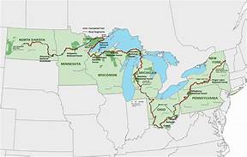
Figure 1. Map of the North Country Trail (North Country Trail Association, 2011)
Different sections of the trail are maintained by a number of volunteer organizations. (North Country Trail Association, n.d.) There are advantages and disadvantages to having volunteers work on these trails. The biggest advantage being you have a passionate, free, work force that is dedicated to the task. The biggest disadvantage is trying to organize and communicate with a diverse group of workers when a project needs to be done in a hurry. One of the most difficult problems to deal with when considering hiking trails is keeping up with the constant maintenance. Small problems such as moderate side-hill erosion can grow into major problems, such as landslides, if they are not corrected in a timely fashion. Taking corrective measures quickly can prevent small problems from turning into major disasters.
Problems along the NCTA trail can be viewed online for each state by visiting the website (North Country Trail Association, n.d.) or contacting the local group maintaining the section of trail they intend to hike. Currently reports of problems can be reported using an online form as shown in Figure 2.
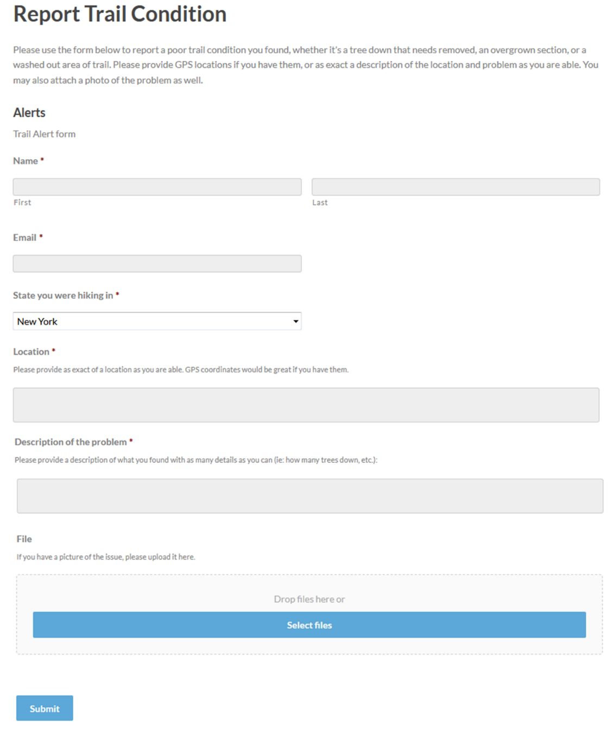
Figure 2: Reporting form used by North Country Trail (North Country Trail Association, n.d.)

The reporting system used by the NCTA is similar to those used by other national and local trail systems (Table 1). For example, the Appalachian National Scenic Trail, which is one of the oldest trails in the National Scenic trail system uses an e-mail system for hikers to report the conditions of the trail (Appalachian Trail Conservancy, 2018) as does the Ice Age National Scenic Trail (Ice Age Trail Alliance, n.d.) and the New England National Scenic Trail (New England Trail, n.d.). The Pacific Crest National Scenic Trail (Pacific Crest Trail Association, n.d.), uses something other than the typical e-mail reporting system, they have a message board on their web page where hikers can post trail conditions they encounter that need addressed, thus enabling others to view trail conditions and issues that they may encountered. A similar message board system is also used by the Arizona National Scenic Trail (Arizona Trail Association, 2018)(REF) in conjunction with an email system. Few of these trails incorporate these reports into maps to show where issues may be located (e.g. the Ice Age National Scenic Trail (Ice Age Trail Alliance, n.d.)).

Trail | Maintenance group | Reports of issues | Advantages/Disadvantages | URL
Appalachian National Scenic Trail | Appalachian Trail Conservancy  Volunteer group(s) | Hikers use e-mail system to report the conditions of the trail | Disadvantages: users are unable to view reports. | http://www.appalachiantrail.org/home/explore-the-trail/trail-updates
Pacific Crest National Scenic Trail | Pacific Crest Trail Association  Volunteer group(s) | Hikers use a message board on their web page | Advantages:  -users are able to view messages and learn about issues on the trail  Disadvantages:  -doesn’t capture when the message was posted  -doesn’t capture where along the trail the problem may be. | https://www.pcta.org/discover-the-trail/trail-conditions/
Ice Age National Scenic Trail | Ice Age Trail Alliance  Volunteer group(s) | Hikers use e-mail system to report the conditions of the trail  A map is used to display changes or improvements of trail | Advantages:  - visual map to show where along the trail a problem may be located  Disadvantages:  - users are unable to update the map. | https://www.iceagetrail.org/trail-maps-guidebooks/
Arizona National Scenic Trail | Arizona Trail Association  Volunteer group(s) | Hikers use message board that is supported by a conditions form | Advantages:  -hikers can easily complete form  Disadvantages:  -not done in real time  - not all hikers can provide GPS coordinates | https://aztrail.org/the-trail/trail-conditions-form/
New England National Scenic Trail | Appalachian Mountain Club  Connecticut Forest & Park Association  Volunteer group(s) | Hikers use an online form to report the conditions of the trail | Advantages:  - easy to complete form  - can upload a picture  Disadvantages:  - not in real time  - not all hikers can provide GPS coordinates | https://newenglandtrail.org/report-trail-problem
Mid-State Trail | Mid State Trail Association  Volunteer group(s) | Hikers use a message board to read about trail conditions and email trail coordinators with reports | Advantages:  - several ways to search for trail sections  Disadvantages:  - delays in information from email to board  - no prompts provided to tell hiker information needed  - no way to pinpoint area of concern | http://hike-mst.org/index.php/guide-and-maps/section-updates
Baker Trail | Rachel Carson Conservancy  Volunteer group(s) | Hikers use e-mail system to report the conditions of the trail | Disadvantages:  -users are unable to view reports. | https://www.rachelcarsontrails.org/trails/baker-trail
Alleghany Front Trail | Penn State Outing Club  Ridge & Valley Outings Club  Quehanna Area Trails Club  Keystone Trails Association  Volunteer group(s) | Hikers use a blog to report conditions of the trail | Disadvantages:  -Many different groups maintain this trail which creates organization problems, and lack of continuity  - use of a single blog, with no map access makes pinpointing areas of concern difficult | http://www.pahikes.com/trails/allegheny-front-trail  https://www.alltrails.com/trail/us/pennsylvania/allegheny-front-trail
Quehanna Trail | Quehanna Area Trails Club  Volunteer group(s) | Hikers use several different blogs to report conditions of the trail | Disadvantages:  -use of several different blogs for reporting maintenance issues is both time consuming and confusing | https://www.alltrails.com/trail/us/pennsylvania/quehanna-trail  http://www.pahikes.com/trails/quehanna-trail

Table 1. Summary of reporting systems used by different trail organizations for users to report an issue.

After viewing many different national scenic trail websites and several local trails in Pennsylvania (Table 1) to see how they tackle the issues of reporting trail maintenance, I have come to the conclusion that a better system can and should be designed. Many of these trail systems use only a simple e-mail system to pass along reports for trail maintenance. This is sufficient for letting the person who receives the e-mails know what the problem is, but it does not alert any of the other trail maintenance volunteers. If the e-mail contact person has changed, or is not checking and acting upon emails in a timely fashion then delays are imminent. Also, many volunteers are willing to work on sections of trail that they have not adopted; however, they need to be notified by the main contact person and under the current system this is difficult. It is apparent that, the e-mail system of notification makes it hard for all workers to view maintenance that is needed on the trail in a timely fashion. Additionally, email does not help hikers identify problems and difficulties they may encounter on the trail. And there is no easy way for the hiker to identify where they encountered their problem. For example, if a hiker sends an email stating that he encountered downed trees on his recent hike through state game lands 95 a volunteer worker could end up hiking the entire 23 mile stretch before discovering the problem. This would seriously delay any corrective measures that could be taken. Some trail websites do use maps for displaying trail conditions, but these do not allow the user to directly report the trail conditions they encounter. So once again there can be serious lag time between reported problems on the trail and the webmaster actually taking appropriate action. All in all, there currently is no adequate, digital system for reporting the areas that require trail maintenance to volunteer workers. There is also no digital system to alert potential hikers to areas that are difficult or dangerous to travel. Both of these objectives can be accomplished with a well-designed GIS map.

Goals and objectives
The focus of this project is The North Country Trail system, specifically the section that crosses through Butler County, Pennsylvania which covers a total of 57 miles (Figure 3). My family has been very involved in the development and maintenance of the trail on many different sections that pass through Butler County. Because of this, I am well aware of the problems that can occur when communication of trail problems is delayed or incorrectly reported. Thus, the aim of my project was to develop an online web mapping system for the North Country Trail for this section of the trail so that problems can be reported by anyone hiking the trail and for volunteers to see these problem areas, address the problem and provide updates. This project will provide a proof-of-concept that will be shared with the NCTA so that eventually this can be used along other sections of the full trail.
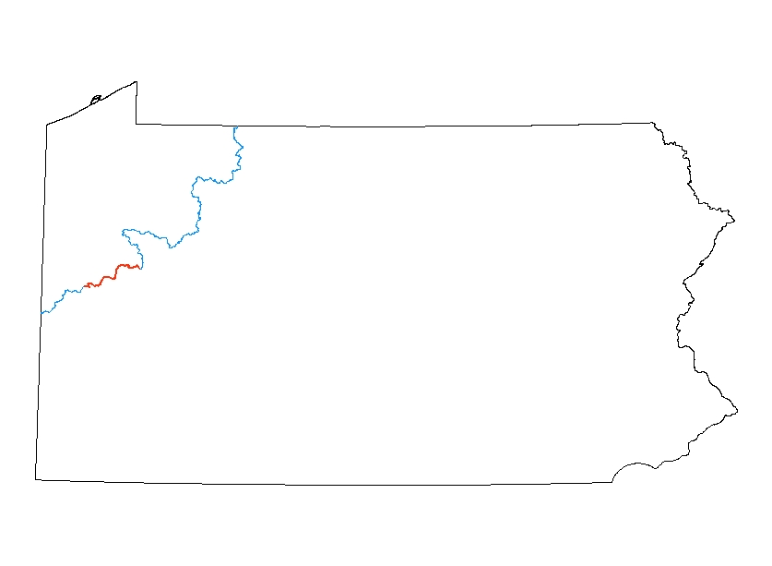
(Figure3. Map displaying the section of the North Country Trail in Butler County in red)

Methodology
Overview of the system
The system allows hikers to access a web page for the North Country Trail, and from there they would be able to view a map of the trail. Additionally, the hiker would be able to click on the area of the trail where they encountered the problem if using a cell phone with GPS to determine their position. Next the user can select from a list of common problems such as impassable, obstructed, nuisance or poor blazing. The user would then be able to give a description of the problem or upload a picture of the problem if they are able to take a picture with their phone or camera. This results in trail volunteers being able to easily view any problems on their section of the trail. Describing the problem will quickly alert the volunteer of any maintenance that is needed and the volunteer can then plan accordingly. Different problems require different tools and with proper reporting volunteers would be prepared to make the necessary improvements. The system will be accessible through a mobile device or through a web browser and need to be able work in the field in areas that may have limited or poor cellular coverage.

Who will be using the system?
To better understand the users of the system several personas were created to capture a visitor who will likely report a problem and the maintenance staff who fix the problem:
- A visitor. A person who visits the trail and encounters a maintenance need and reports the problem on the system. The user will need to sign up once to create a user account.
- Volunteer Maintenance staff. Volunteers who are willing to address the maintenance needs of the trail and resolve issues that have been reported. Volunteers will routinely check the system to see if maintenance problems have occurred in their adopted section or a section they are willing to work on. The volunteer will then set up a plan to fix the problem whether it be organizing other volunteers for large projects or completing the maintenance themselves for smaller issues. Once the issue is resolved the volunteer will then remove the flag from the map.

Requirements for the application
Since the purpose of this application is to be able to provide information about maintenance needs along a trail, the application needed to be available via a mobile device and be able to work in an environment with cellphone coverage and in remote areas where cellphone coverage may be limited or intermittent. Essentially the application needed to be able to report the location of where the maintenance is needed (preferably using a GPS in the mobile device), display a map of the trail so that hikers and maintenance staff/volunteers are aware of issues along the trail and be easy to access and use as well as be freely available.
Several applications were evaluated that included ESRI ArcGIS Collector App, Survey123 and ArcGIS online (Table 2) against the aforementioned criteria. As seen from Table 2 each of the three applications satisfies different needs. Collector App, although satisfies all of the criteria, each user would need a subscription to ArcGIS online or be part of an organization that used ArcGIS Enterprise. Since this is a volunteer based organization with limited resources this option was not viable. Survey 123, although useful doesn’t have the ability to display a map, only collect points. Lastly ArcGIS Online. This option was selected since it was freely available via the web and has the ability to add a point to a section of the trail.

 | Collector App for ArcGIS | Survey123 for ArcGIS | Webb App ArcGIS Online
Able to report location of required maintenance | X | X | X
Displays map of trail | X |  | X
Shows hikers maintenance issues they may encounter | X |  | X
Able to use phone GPS to determine location | X | X
Free to use for Hikers |  | X | X
Downloadable app for phone | X | X

Table 2. Comparison of different web applications systems to run NCTA – Butler maintenance application

Developing the application
An edit template available on ArcGIS online was selected since users need to edit the maintenance layer to report an issue they encounter. Since the web mapping application created a long URL (http://pennstategis.maps.arcgis.com/apps/Editor/index.html?appid=a9c1b2c7001942658bc49687a3abe471) a shorter URL (http://butlernctmaintenance.weebly.com/) was created using weebly and can be added to the NCTA Butler homepage for all users to use.
Several layers and tables were created (Table 3) using ArcMap. (v. 10.6) The NCT Butler County layer is a shapefile depicting the footpath of the North Country Trail in Butler County Pennsylvania. The layer was clipped from a larger file depicting the entire footpath of the North Country trail. The second layer created using ArcMap (v. 10.6) was the NCT Trail Maintenance layer. The NCT Trail maintenance layer is a point feature layer used to display and collect the problems encountered along the trail. This layer captures the type of maintenance needed (Table 2), A description of the maintenance, the location of the encounter and any attachments (photos) provided by the user.
LayerName | Type | Attributes | Comments
NCT Trail Maintenance | Point – Feature Layer | OBJECTID (ObjectID)  Type of Maintenance (String)  Description of Damage (String)  GlobalID (Globalid)  Photos and files (Attachments) | Type of Maintenance field is restricted to 4 categories.  Inconvenient – high grass or vegetation on tread way  Impassable – Bridge out, tread way washed out, etc.  Obstructed – Trees down etc, but able to get around the problem  Blazing – Trail is poorly blazed or blazing is obstructed and hard to follow
NCT Butler County | Line – Shapefile
Table 3: List of data layers used in the NCTA-Butler Trail Maintenance application.
The feature layer was assigned four domains of maintenance for the users to choose from when editing the layer. The domains are impassable (red), obstructed (yellow), inconvenient (green) and blazing (blue). Each layer was assigned a color to help determine the priority level of the maintenance issue being posted (Figure 4).
(Figure 4. Explanation of each domain of the maintenance feature layer)

Once created the feature layer was uploaded to ArcGIS online to create a Web map. A basemap, ESRI’s World Topographic Map was selected since many hikers are likely to be familiar with and can easily read topographic maps. The NCT footpath was also added to display where the trail runs through Butler County. Lastly, the NCT feature layer to collect data of where maintenance is needed along the trail was created and added to the web map.
User Testing
Once the Web Mapping Application was up and running I did several test runs on the trail. It was easy to determine my location using the topographic basemap. There are still limitations when using the app where there is no cell phone signal, but it is easy to go back and report a maintenance issue, and attach a photo, once cell phone service is available. In order to provide a quick example, I hiked to a location where a previous major issue had recently been resolved (bridge that was badly damaged). While at the site I was able to use the app to report this maintenance concern, at the correct location, and even upload an image previously stored on my phone. (Figure 7)
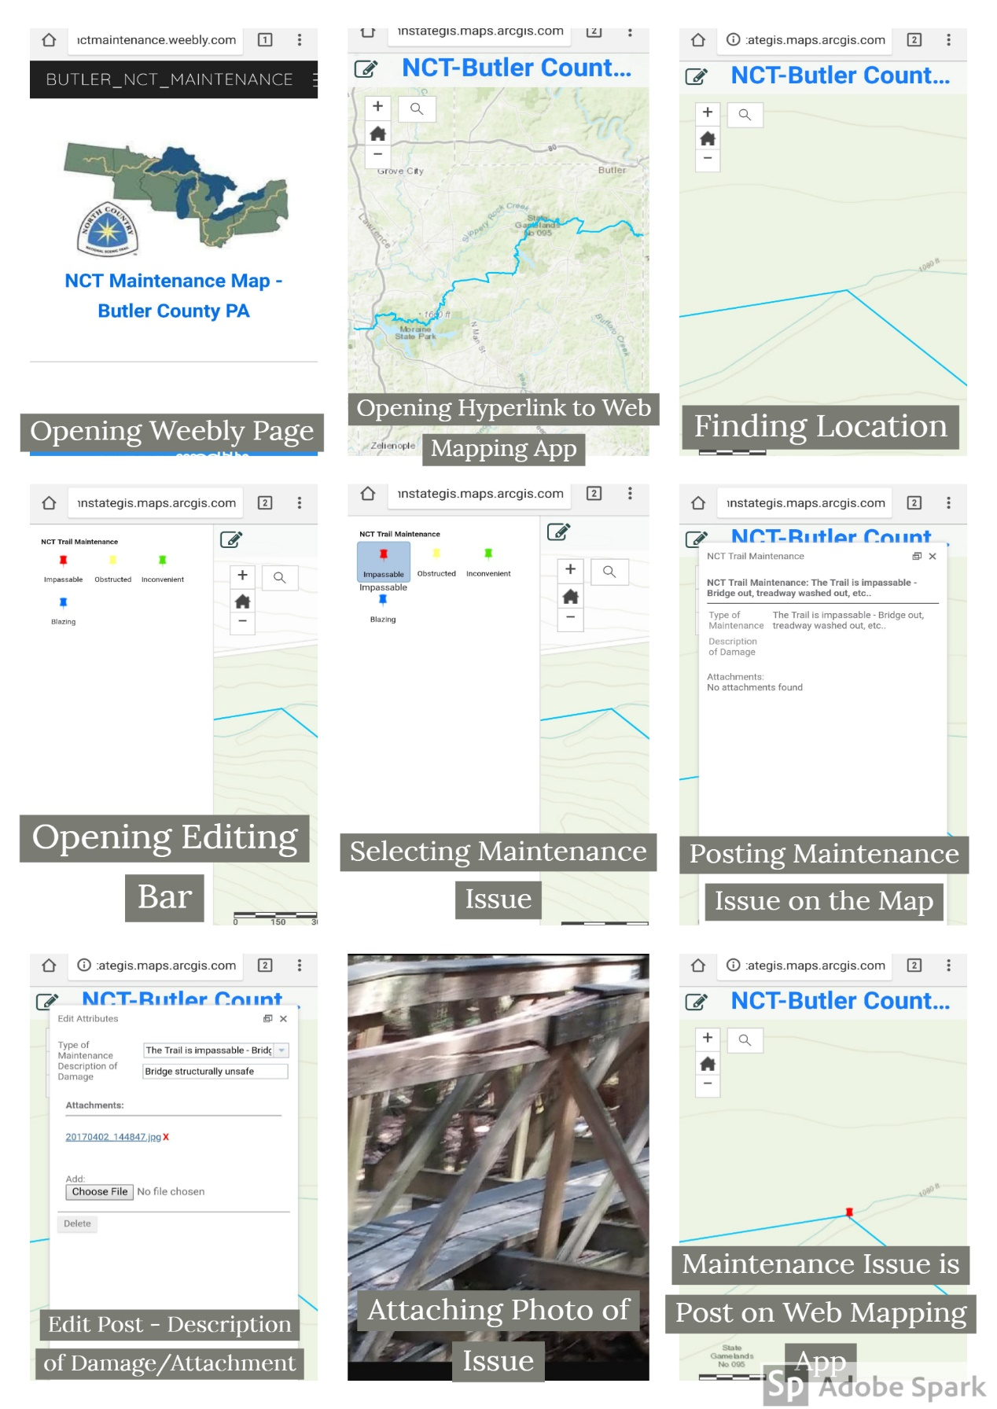

Figure 7 – Steps of posting maintenance issue using the Web Mapping Application

Conclusion and Future work
The application that was developed, although simple provides all users with the ability to report and view areas in need maintenance along the trail rather than sending an e-mail, the current reporting method. I anticipate this web mapping application will help speed up the process of trail maintenance along the North Country Trail as well as give users of the trail a more convenient way of reporting trail damage that they encounter and a convenient way to see if there is damage along the section of trail they intend to hike.
Maintenance reports can be used by the NCTA to better understand volunteer requirements and over time be used to assess problem areas along the trail. This will give the staff and volunteers the ability to see what has been corrected, the time it took to correct the maintenance issue, and better allow them to assess the methods of completing trail maintenance. The application in its current form is a viewing tool that does not store maintenance reports. Future work should consider linking maintenance reports to a spreadsheet so that these reports can be stored.
Although the aim of this application is to enhance reporting procedures, future enhancements should include automating the acquisition of GPS coordinates from the mobile device rather than the user adding a point along the trail. This will minimize errors in reporting.
To make access to the application more convenient, QR codes can be placed at kiosks along the trail and on trial maps so that hikers are able to link directly to the web mapping app and be reminded that they can report any issues they encounter.
Lastly, it is anticipated that other North Country Trail Chapters in Pennsylvania, and in other states, will be eager to utilize mapping systems of this type for their sections of trail. While most people are rarely without a cell phone, and cell phone service has increased exponentially it simply makes sense to utilize this technology by developing apps that can assist hikers and trail maintainers. Finally, (this is a hope more than an anticipation given the current political climate) I anticipate that the National Park Service, which oversees the National Scenic Trail System, will take note of its capabilities and consider offering grant money to allow growth in app development that will allow interactive mapping of its National Scenic Trails.

References
Appalachian Trail Conservancy. (2018). Trail Updates. Retrieved July 23, 2018, from Appalachian Trail Conservancy: http://www.appalachiantrail.org/home/explore-the-trail/trail-updates
Arizona Trail Association. (2018). Trail Conditions Form. Retrieved July 23, 2018, from Explore the Arizona Trail: https://aztrail.org/the-trail/trail-conditions-form/
Ice Age Trail Alliance. (n.d.). Trail Map and Guidebooks. Retrieved July 23, 2018, from Ice Age Trail Alliance: https://www.iceagetrail.org/trail-maps-guidebooks/
New England Trail. (n.d.). Report A Trail Problem. Retrieved July 23, 2018, from New England Trail: https://newenglandtrail.org/report-trail-problem
North Country Trail Association. (2011). Sample and Savor the North Country. Retrieved July 23, 2018, from National Forest Foundation: https://www.nationalforests.org/our-forests/your-national-forests-magazine/sample-and-savor-the-north-country
North Country Trail Association. (2014, August 21). NCTA’s Mission and Vision. Retrieved July 23, 2018, from North Country Trail Assocation: https://www.northcountrytrail.org/docs/NCTA-Mission-Vision-2014.pdf
North Country Trail Association. (n.d.). About Us. Retrieved July 23, 2018, from North Country Trail Association: https://northcountrytrail.org/about/
North Country Trail Association. (n.d.). Explore the Trail. Retrieved July 21, 2018, from https://northcountrytrail.org/trail/
North Country Trail Association. (n.d.). Report Trail Alerts. Retrieved July 21, 2018, from https://northcountrytrail.org/trail/trail-alerts/
North Country Trail Association. (n.d.). Report Trail Condition. Retrieved July 21, 2018, from https://northcountrytrail.org/trail/report-trail-condition/
Pacific Crest Trail Association. (n.d.). Pacific Crest Trail Association. Retrieved July 23, 2018, from Report trail conditions.

