A Land Cover Change Analysis of Khartoum Over a 30-year Time Frame

_____________

A Thesis
Presented to
The Faculty of the Department of Geography
Pennsylvania State University

_____________

In Partial Fulfillment
Of the Requirements for the Degree of
Master of Science
Geographic Information Systems

by
Naji Rizig

December 2021
Abstract
Sudan has experienced a significant population increase over the span of the past 30 years. This rapid population growth has resulted in intense urbanization and agricultural activity within the state of Khartoum. This study aims to combine moderate resolution satellite imagery acquired through Landsat 5, with high spatial resolution imagery obtained from Sentinel-2 and Planet Labs, to detect and quantify the land use land cover change in Khartoum state between the years 1990 and 2020. ArcGIS Pro and eCognition are the two software packages used for the purposes of this research to create a Supervised Object Based Classification with ArcGIS Pro, and a ruleset-based classification with eCognition. The purpose of this research is to map, quantify, and analyze the effects human activity has had on increasing Khartoum’s vulnerability to environmental risks such as flooding hazards and food insecurity as a result of agricultural activity and desertification. This will help provide high priority land-cover information to government officials for better future land use planning.

Introduction
Sudan’s population is rapidly increasing. When Sudan first gained its independence from Egypt and Britain in 1956, the country, which included the region of South Sudan (see fig. 1), had a population of 6.7 million people. Over the past 70 years however, Sudan has experienced an exponential population growth (see fig 2). As of 2021, there are roughly 45 million people that currently reside in North Sudan. Among the many states in Sudan, the most populated state is the country’s capital, Khartoum, which has approximately 5.9 million people as opposed to the 268,000 it had during its independence (see fig 3). According to the country’s population forecast as seen in table 1, it is projected that by the year 2050, Sudan will have approximately 82 million residents, nearly doubling its current population size and taking the country from the 34th most populated country in the world, to the 23rd.
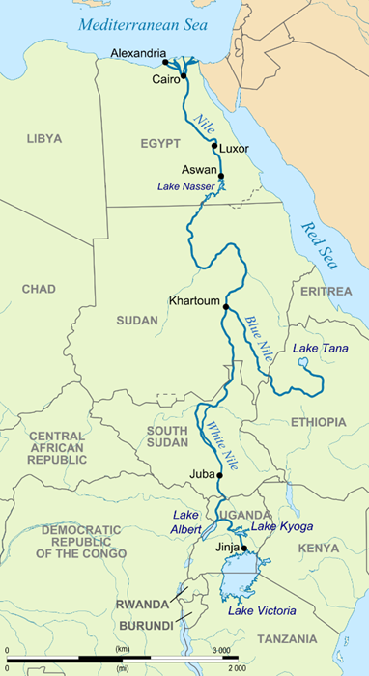
Figure 1. Map of Sudan, South Sudan, and Eastern Africa
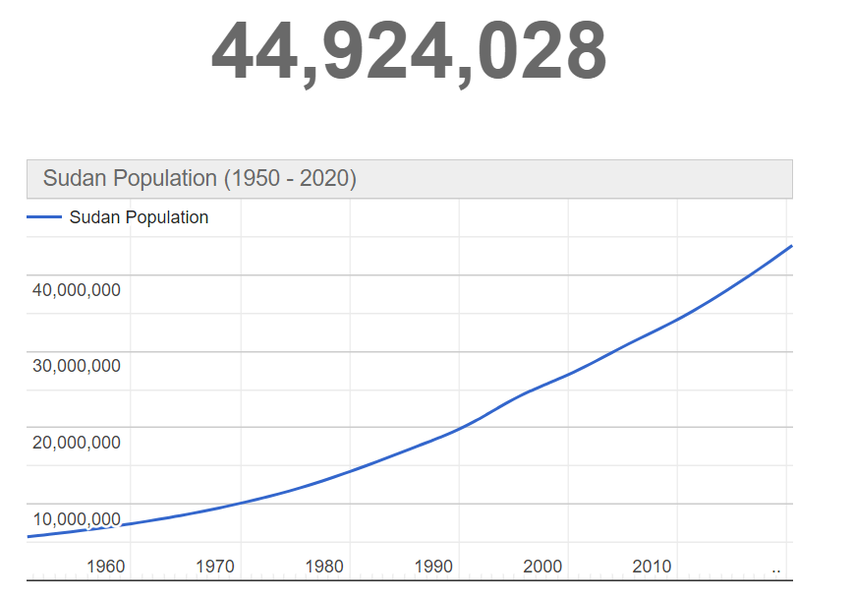
Figure 2. Sudan’s Population Growth Over 70 years
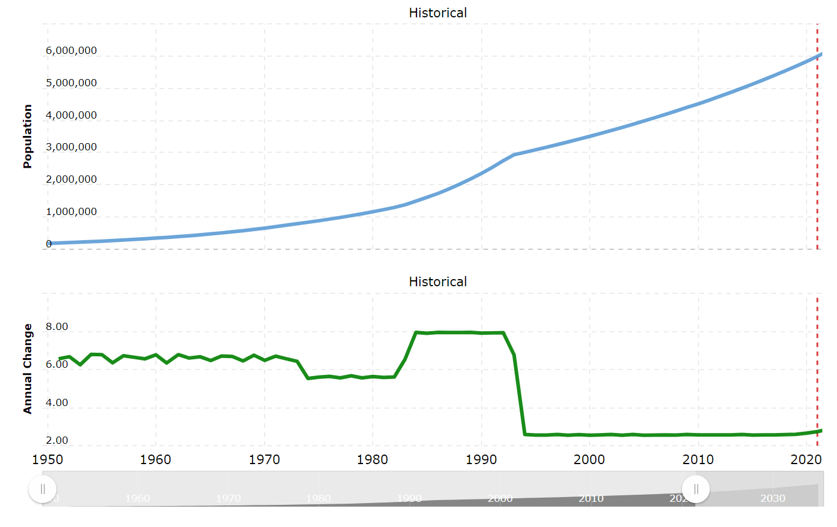

Figure 3. Annual Change and Overall Population Growth of Khartoum

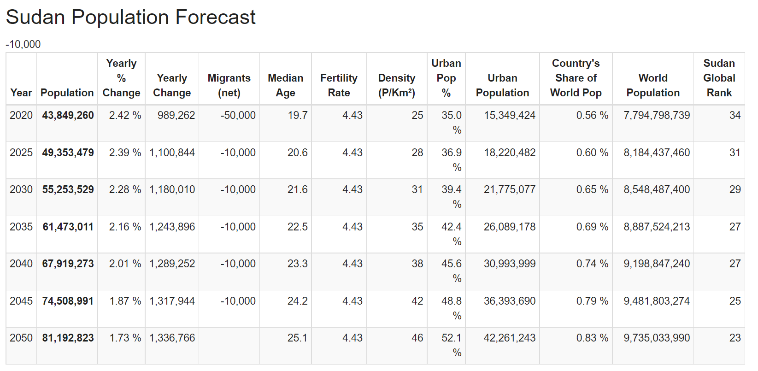

Table 1. Sudan’s Population Forecast
With this rapid increase in population growth, there has been significant activity regarding urbanization and agricultural development over the past 30 years. Particularly in the country’s capital state of Khartoum. This increase in human activity has resulted in an increased vulnerability to environmental events such as flooding and desertification. This is primarily due to activities related to deforestation, overgrazing, and cultivation, in addition to the higher risk of flooding events caused by the Blue and White Nile channels, and degradation of land quality due to agricultural growth.
Background
There have been a handful of remote sensing and land use land cover change studies that have been performed in Sudan over the years. Among them, many have concentrated on the biggest environmental risk that Sudan currently faces; the environmental phenomenon known as desertification. Desertification is defined by the United Nations Environment Programme (UNEP) as a process in which land-degradation occurs in arid, semi-arid, and dry sub-humid areas due to a multitude of different factors (Ambalam, 2014). These factors range from climate change related events to human activities such as deforestation, overgrazing, cultivation, and soil erosion. The effects of this phenomenon threaten the sustainability of natural resources such as water, agricultural production, and major human infrastructure including roads and occupancies. To study this phenomenon, the European Union developed a model known as the Mediterranean Desertification and Land Use model (MEDALUS) to identify environmentally sensitive areas, known as ESA’s, in regions in Africa and the Middle East. The MEDALUS model utilizes the Environmentally Sensitive Area Index (ESAI), which factors in four primary variables that include soil quality (SQI), vegetation quality (VGI), climate quality (CQI), and management quality (MQI), to obtain an in-depth understanding of the parameters causing desertification in different arid, and semi-arid regions (Lamqadem et al., 2018). The benefit of this approach lies in its simplicity, robustness, applicability, and acceptability to new indicators and parameters that allow for adjustments to scale. Among the many articles written using the MEDALUS method include (Lamqadem et al., 2018) and (Lahlaoi et al., 2017) which primarily focus on assessing desertification in parts of Morocco by identifying different environmentally sensitive regions within the country. Additionally, other publications such as (Lee et al., 2019) & (Boudjemline & Semar, 2018) have utilized the MEDALUS model in their research to identify and assess the effects of desertification in Mongolia and Algeria respectively, prioritizing the utilization of GIS indicators for quality indices over high spatial resolution imagery. Unfortunately, no such analysis using the MEDALUS method has yet to be performed for Sudan.
Furthermore, other methods have been studied over the years to map desertification using remote sensing imagery. Among the articles that discuss those methods include (Albalawi & Kumar, 2013) who, in their article titled “Using Remote Sensing Technology to Detect, Model and Map Desertification” identify several driving forces pertaining to desertification that are detectible using remote sensing. These forces include intensification of agricultural activity and cultivation of marginal land due to population growth, reduced rainfall and increased drought due to climactic changes, and pollution of ecosystems and poverty as a result of civil and international wars. Moreover, in the paper titled “Monitoring and Analyzing of Desertification Trend in North Sudan Using MODIS from 2000 to 2014”, (Mohamed, 2016), the author analyzes the rate of desertification in the western states of Darfur, Kordofan and Alshymalia using MODIS and Landsat-8 imagery to calculate vegetative assessment indices such as NDVI (Normalized Difference Vegetation Index), EVI (Enhanced Vegetation Index), and SAVI (Soil Adjusted Vegetation Index), to assess the activity and movement of land degradation caused by desertification. The results of his research include classification maps derived from MODIS data that were grouped into four land cover classes and used to create land cover change analyses to quantify the change that had occurred within his respective study area. His results showed significant southern movement of the Sahara Desert over the course of the 14-year time span of his study.
Other articles that focus on land cover change analyses in Sudan utilizing remote sensing include a paper titled “Land Use Land Cover Change Detection: A Case Study For Khartoum State, Sudan, 1972-2006” (Hilmi & Sedahmad, 2014) which aimed to detect the land use and land cover change for the state of Khartoum by looking at the years 1972, 1986, 2000 and 2006. The authors of the study used Multispectral Scanner (MSS) Landsat 1 and Landsat 5 imagery with a spatial resolution of 60 meters for the years 1972 and 1986. They then acquired 30-meter Landsat 7 spatial resolution imagery for the year 2000, and lastly15-meter SPOT spatial resolution imagery for the final year of their study, 2006. The results of the analysis suggested a 17% increase in settlement land while vegetation area decreased by approximately 12% over the same time frame. Similarly, the authors of (El-Hamid et al., 2021), which is a recently published article titled “Assessment and prediction of land-use/land-cover change around Blue Nile and White Nile due to flood hazards in Khartoum, Sudan, based on geospatial analysis” utilized Landsat-8’s Operational Land Imager sensor with a 30-meter spatial resolution to analyze and predict flood risks for the state of Khartoum. The predictions were done for the year 2024 based on flooding events that occurred in 2014, 2016, and 2020. The article utilizes NDVI (Normalized Difference Vegetation Index), data NDWI (Normalized Difference Water Index) to assess and extract water and vegetation data from the imagery. The results showed that the flooding events affected people and crop land surrounding the White Nile significantly more than those that resided by the Blue Nile. The significance of these articles is that they attempt to detect and quantitatively identify the land use land cover change in Khartoum state using remote sensing technology and multi temporal imagery to estimate the area of each classified category of land use. This project will build upon these previous land cover change analyses performed in the region using higher resolution imagery that has become available in recent years. This includes 10-meter spatial resolution multispectral imagery from Sentinel-2, and up to 3-meter spatial resolution multispectral imagery acquired through Planet Labs.
Objectives
The aim of this research is to provide visual and quantitative groundwork regarding the land cover change Khartoum and Jebel Awlia have undergone over a 30-year time frame between the years 1990 and 2020. The priority of this study is to emphasize the environmental risks and vulnerabilities rapid urbanization and agricultural development are causing the state of Khartoum to become more susceptible to. This includes events such as the conversion of land types from semi-desert to desert as a result of cultivation and erosion, resulting in desertification and food insecurity. As well as an increased susceptibility to flooding events due to increased agricultural activity causing the ground soil to lose its structural strength.
This information is primarily targeted towards policy makers and government officials such as those who work in the Ministry of Agriculture and Natural Resources, the Ministry of Irrigation and Water Resources, and the Ministry of Trade. By being able to both visually see the land cover change over the span of the last three decades, as well as the quantifiable amount of area that has changed in that span of time, government officials can begin making better policy decisions that balance the needs of the people with the environmental consequences those decisions result in. To achieve this objective, the specific deliverables for this project will be:
- Land cover maps for the years 1990 and 2020 using eCognition and ArcGIS Pro
- An object-based image analysis of land cover change observed in Agriculture, Urbanization and Water classes
- A paper and PowerPoint presentation
Study Area
Sudan is comprised of a total of 18 states and 189 districts (see fig 4). For the purposes of this research, my study area will be focusing on the state of Khartoum, which is comprised of 7 districts (see fig 5). I will primarily be analyzing the capital district of Khartoum and the district of Jebel Awlia (see fig 6). The reason for choosing these districts is that they are the districts in the state of Khartoum that have undergone the most extreme urbanization and agricultural development changes over the 30-year period between 1990 and 2020 and therefore merit a more in-depth analysis.
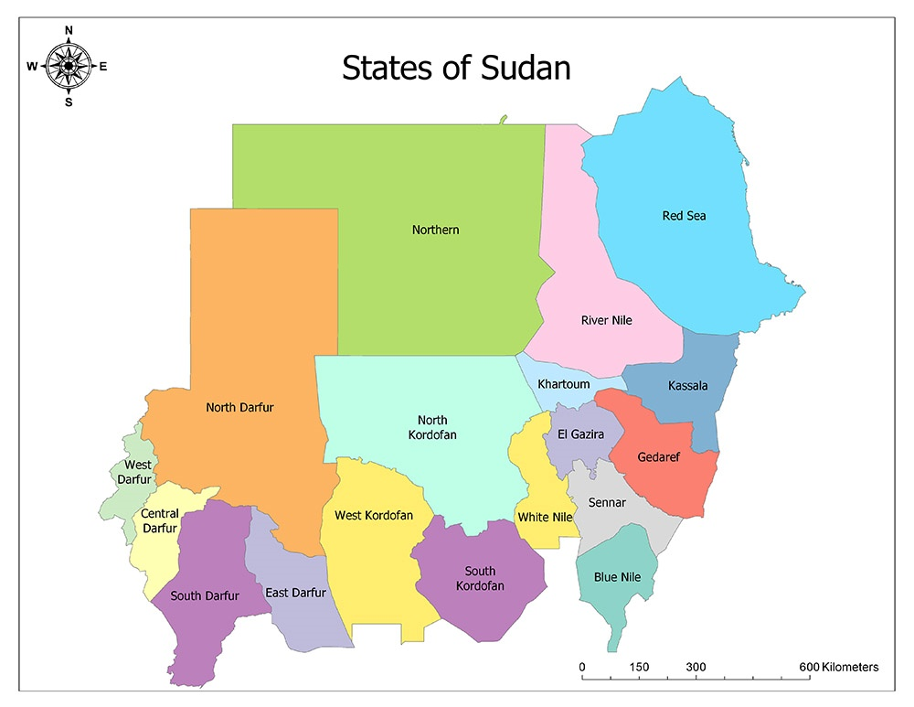
Figure 4. States of Sudan

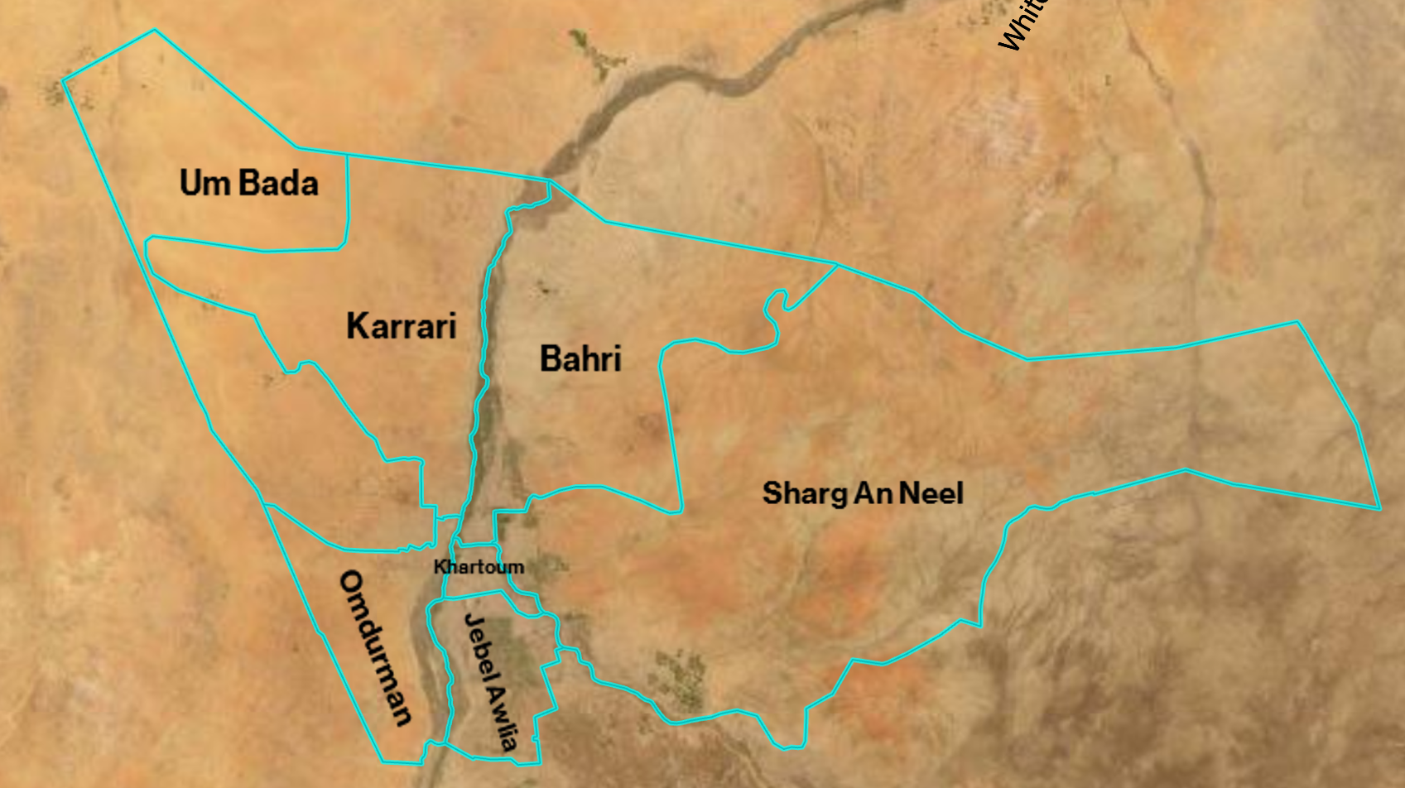
Figure 5. State of Khartoum with District Boundaries

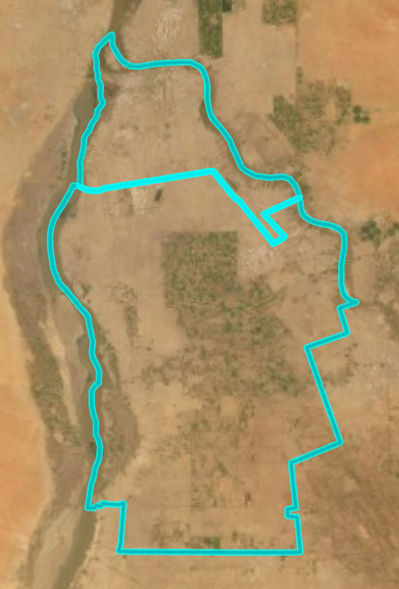
Jebel Awlia
Khartoum
Figure 6. Study Area Including the Capital District of Khartoum and Jebel Awlia
Data:
Satellite | Sensors | Path/Row | Date | Spatial Resolution | Band Combinations  (Color Infrared)
Landsat 5 | Thematic Mapper (TM) | 173/49 | 09/16/1990 | 30 meters | 4-3-2
Sentinel-2 | Multi-Spectral Instrument (MSI) | T36PVC | 09/19/2020 | 10 meters | 8-4-3
Planet Labs | PlanetScope | 080/435 | 09/28/2020 | 3 meters | 4-3-2
Table 2. Satellite Data Acquired for Study

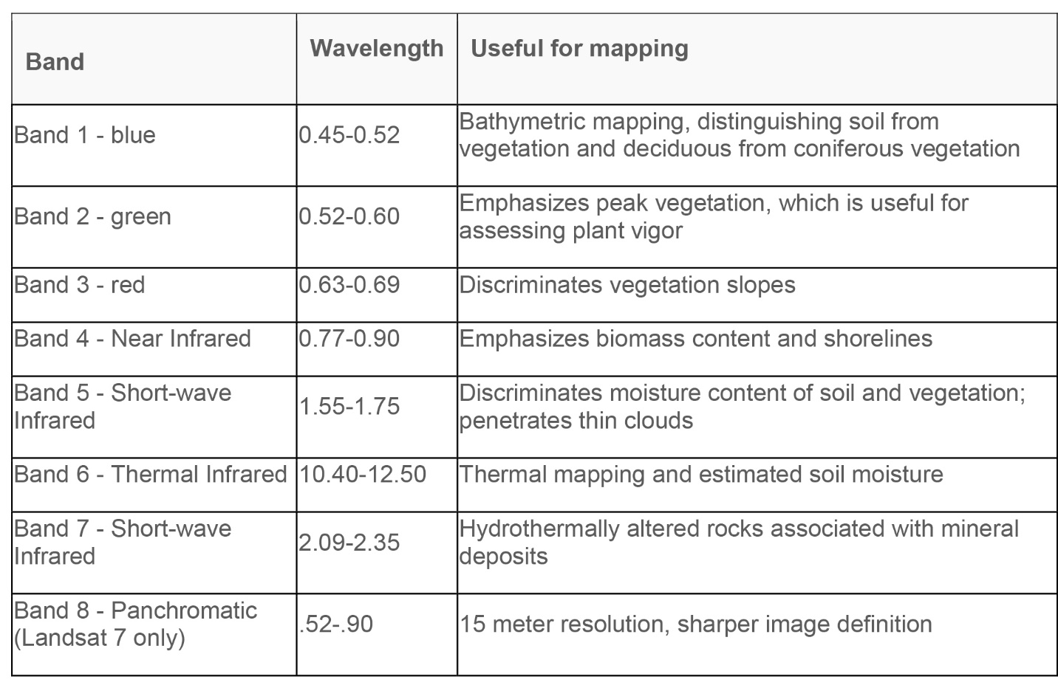
Table 3. Landsat 5 Bands

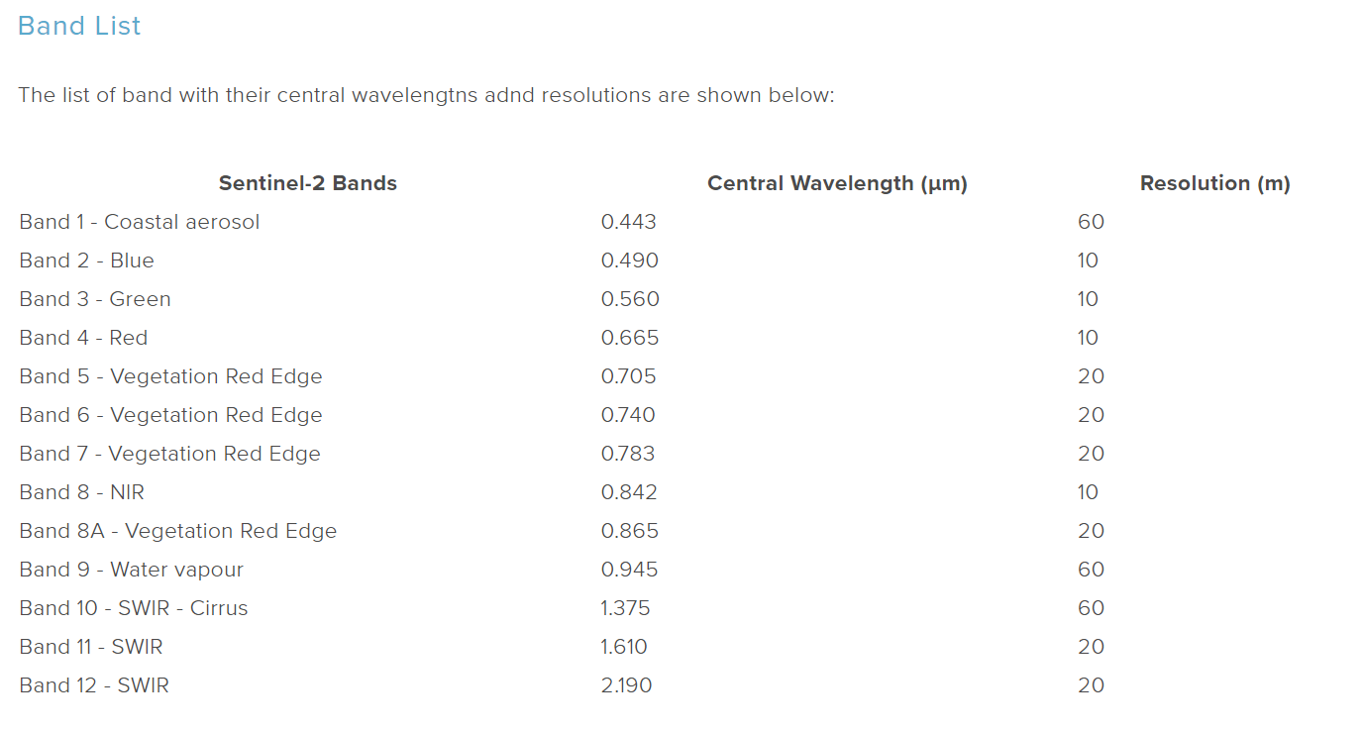
Table 4. Sentinel-2 Bands

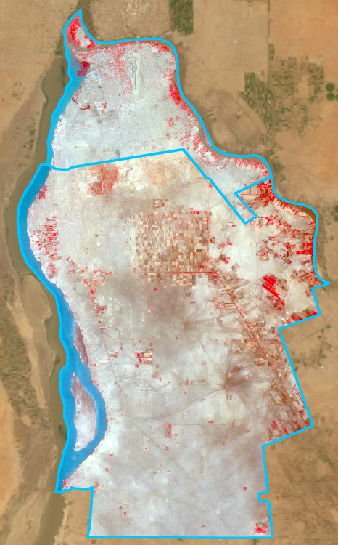
Figure 7. Color Infrared Image (Bands 4-3-2) Acquired From Landsat 5 on 09/16/1990

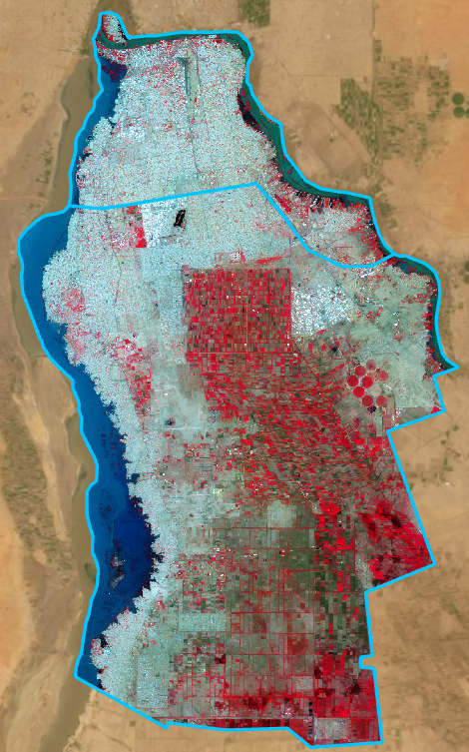
Figure 8. Color Infrared Image (Bands 8-4-3) Acquired From Sentinel-2 on 09/19/2020
Methodology
- ArcGIS Pro
The process of analyzing the imagery included an initial object based supervised classification using ArcGIS Pro. This involved selecting the multi-band Landsat 5 and Sentinel-2 imagery for the regions of Khartoum and Jebel Awlia and setting them to their respective infrared band-combinations of 4-3-2 and 8-4-3. Once set, the images underwent a raster segmentation process that groups neighboring pixels together based on their similarity. This is to create objects that are then used for image classification. The spectral detail parameter, which sets the level of importance given to spectral differences between pixels on a scale of 1 to 20 was set to 18. A higher value means that pixels need to be more similar to be grouped together, while a lower value means less similarity is required. The second parameter, which is spatial detail, sets the level of importance given to the proximity between pixels also on a scale of 1 to 20. This was set to 10 as not all similar objects are within proximity of each other. All remaining segmentation parameters were left at their default setting. Once the segmentation process is complete, the next step in the object based supervised classification is creating training samples based on the objects created to form the segmentation layer. These training samples will act as the reference point for the supervised classification algorithm to classify the objects into the classification schema. The classes created for this schema include ‘Agriculture’, ‘Barren’, ‘Blue Nile’, ‘White Nile’, ‘Fallow’, and ‘Urban With Vegetation’. Once an adequate number of training samples have been selected for each class, the final step is to classify the image by categorizing all the pixels into the six classes created through ArcGIS Pro’s automated algorithm. To do this, you must first select a classification method. In this case we chose ‘Supervised’ as our method of classification. Next is the classification type, be it pixel-based or object-based. For the purposes of this analysis, we chose object-based since we created an object-based segmentation in the earlier steps mentioned above. Additionally, we also selected the classification schema that we made earlier as well as the segmented image with the object layer attributes and the training samples to be referenced. Lastly, the classifier, which is the algorithmic method in which the pixels/objects will be classified based on, was chosen to be ‘Random Trees’. This classifier uses multiple decision trees that are trained using small variations of the same training data and accepts multiband imagery with any bit depth, as well as being less vulnerable than other classifiers to overfitting. Furthermore, the parameters for this classifier method include ‘Maximum Number of Trees’, ‘Maximum Tree Depth’, and ‘Maximum Number of Samples per Class’. The ‘Maximum Number of Trees’ parameter sets the maximum number of trees in the forecast. Meaning that the higher the number of trees, the higher the accuracy rate. The default value for this setting is 50, however for the purposes of our analysis we set the parameter to 120. The second parameter is the ‘Maximum Tree Depth’ which sets the number of rules each tree is allowed to create to come to a decision. The higher the number, the more rules each tree creates. The default value for this parameter is also set to 50. For the purposes of our analysis, we set the parameter to 80. Lastly, the final parameter of ‘Maximum Number of Samples per Class’ was kept at the default value of 1000 samples. The results for the object based supervised classification can be seen in the figures below.
- eCognition
Furthermore, to get a more accurate analysis for the land cover change in the districts of Khartoum and Jebel Awlia over the 30-year time frame between 1990 and 2020, a similar supervised object-based image analysis classification was performed using a much more intricate and in-depth software known as eCognition. The primary advantage eCognition has over ArcGIS Pro is that it allows its users to access the values for all the individual bands per each individual pixel, whereas ArcGIS Pro is limited to only a 3-band RGB composite view. With multi-band imagery such as Landsat 5 and Sentinel-2 imagery, which have 8 and 13 bands respectively, it is a significant advantage in being able to see the values for all the induvial bands when creating a segmentation and classification analysis for satellite imagery. Particularly in urban regions such as Khartoum and Jebel Awlia where there is a mixture of natural and man-made dynamics.
To create the object based supervised classification using eCognition, we must first upload all the required shapefiles and imagery into ArcGIS Pro. Once all the imagery is uploaded, the data processing can begin. This includes using the raster function clip tool to clip the Landsat 5 imagery to the Khartoum and Jebel Awlia shapefiles, in addition to mosaicking two Sentinel-2 images together to cover the entire area of Khartoum and Jebel Awlia using the ‘Mosaic to New Raster’ tool found in the Data Management Toolbox and ensuring the resulting raster layer maintains the original 10-meter spatial resolution of the original Sentinel-2 images. Once processed, mosaiced, and clipped, the layers are then exported and saved as .TIFF files to be accessible on eCognition. From there, a workspace and new project are created within eCognition’s environment and the .TIFF image layers, with all 8 bands associated with the Landsat 5 imagery as well as the 13 bands associated with the Sentinel-2 imagery, are selected, and labeled accordingly. Then the segmentation process begins. This step involves creating a rule set. The first algorithm for the segmentation process involves a ‘multiresolution segmentation’ algorithm with weights given to each individual band. The higher the weight assigned to an image layer; the more weight will be given to that layer’s pixel information during the segmentation process. The Near-Infrared band (NIR), which is a significant band in distinguishing between vegetation, water, and ground, was given a weight of 2, while the other 7 bands were all given a weight of 1. Additionally, the main settings in the multiresolution segmentation algorithm that influence the size and shape of objects in the segmentation include the scale parameter, the shape parameter, and the compactness. All three values were changed accordingly for each individual image to ensure minimal class bleeding between objects occurred. Once the multiresolution segmentation was complete, and we had created our objects, the next step was a spectral difference segmentation in which we set the maximum spectral difference value between image objects that are used during the segmentation. If the difference is below the set value, then the neighboring objects are merged. This was to clean up the multiresolution segmentation and merge similar objects together.
Once the segmentation process is complete, the next step is the classification. This step involves creating interpretation keys using 15 samples per class to record the values for all the band layers in addition to object-based features such as the Normalized Difference Vegetation Index (NDVI), and the Normalized Difference Water Index (NDWI). The averages for all 15 samples are then calculated along with the minimum and maximum values to create the conditions each object much meet in order to fall into a certain class hierarchy. The classes used include:
- Agriculture
- Barren
- Blue Nile
- Fallow
- Urban
- Urban With Vegetation
- White Nile
eCognition Interpretation Keys
To create the rulesets for the object-based image classifications for the Landsat 5 and Sentinel-2 imagery using eCognition, object information tables were created comprising 15 object-based samples per class for each satellite image. They were then interpreted to determine parameters for the classification rule set in eCognition.
- Sentinel-2: Jebel Awlia Ruleset and Object Information Tables
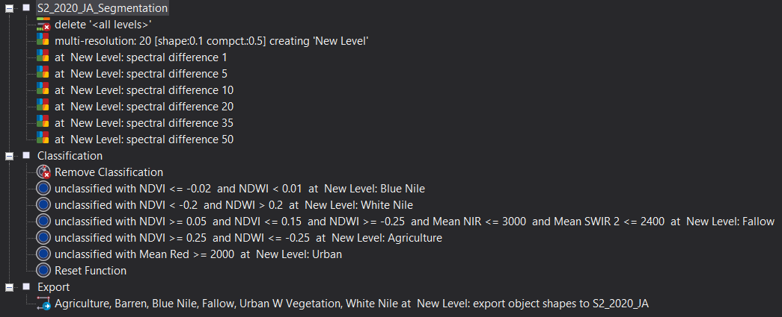
Figure 9. Sentinel-2 Jebel Awlia eCognition Ruleset

Blue Nile Summary: The average NDVI value for objects that represent the Blue Nile appears to be -0.04 and the average NDWI value is -0.008. We can set the Blue Nile classification ruleset to be where NDVI is less than or equal to -0.02, and NDWI is less than or equal to 0.01.
Object # | Blue | Green | Red | NIR | SWIR1 | SWIR2 | NDVI | Brightness | NDWI
1 | 1517.4 | 1593.2 | 1776.4 | 1662.6 | 967.1 | 669.5 | -0.03 | 1335.4 | -0.02
2 | 1515.9 | 1590.1 | 1779.3 | 1630.7 | 946.3 | 661.3 | -0.04 | 1323 | -0.01
3 | 1510.3 | 1582.1 | 1764.5 | 1629.2 | 962.1 | 677.6 | -0.04 | 1322 | -0.01
4 | 1503.8 | 1569.7 | 1744.2 | 1622.7 | 963.4 | 675.5 | -0.04 | 1315.3 | -0.02
5 | 1516.7 | 1611.1 | 1827.6 | 1609.4 | 947.6 | 665.1 | -0.06 | 1324.7 | 0
6 | 1512.1 | 1583.2 | 1777.1 | 1596.3 | 920.7 | 650.6 | -0.05 | 1306.8 | -0.004
7 | 1480.5 | 1545.3 | 1724 | 1555.4 | 859.3 | 596.5 | -0.05 | 1269 | -0.003
8 | 1487.7 | 1559.7 | 1735.2 | 1597.5 | 880.6 | 602.5 | -0.04 | 1288.7 | -0.01
9 | 1483.8 | 1552.3 | 1720.1 | 1553 | 849.2 | 586.4 | -0.05 | 1267.1 | 0
10 | 1519.5 | 1608.1 | 1801.1 | 1594.7 | 877 | 613.5 | -0.06 | 1304.5 | 0.004
11 | 1487.1 | 1555.2 | 1720.4 | 1570.9 | 885.1 | 616.9 | -0.05 | 1279.4 | -0.005
12 | 1485.5 | 1551.1 | 1710.5 | 1585.6 | 910.5 | 632.6 | -0.04 | 1285.4 | -0.01
13 | 1494.6 | 1564.4 | 1736.8 | 1604.4 | 914.6 | 641.5 | -0.04 | 1295.9 | -0.01
14 | 1501.4 | 1574.2 | 1747.2 | 1599.8 | 904.4 | 635.5 | -0.04 | 1296 | -0.008
15 | 1509.5 | 1581.8 | 1755.7 | 1606.9 | 913 | 645.5 | -0.04 | 1301.9 | -0.008
Avg | 1501.7 | 1574.8 | 1754.7 | 1601.3 | 913.4 | 638 | -0.04 | 1301 | -0.008
Min | 1480.5 | 1545.3 | 1710.5 | 1553 | 849.2 | 586.4 | -0.06 | 1267.2 | -0.02
Max | 1519.5 | 1611.1 | 1827.6 | 1662.6 | 967.1 | 677.6 | -0.03 | 1335.4 | 0.004

White Nile Summary: The average NDVI value for the White Nile segmented objects is -0.26 while the average NDWI value is positive 0.26. We can set the White Nile classification ruleset to be where NDVI is less than -0.2, and NDWI is greater than 0.2.
Object # | Blue | Green | Red | NIR | SWIR1 | SWIR2 | NDVI | Brightness | NDWI
1 | 1628.4 | 1777.7 | 1753 | 1020 | 582.1 | 424 | -0.26 | 1088.6 | 0.27
2 | 1619 | 1764 | 1722.5 | 1018.4 | 579.7 | 416.3 | -0.26 | 1082.3 | 0.27
3 | 1583.6 | 1718.1 | 1675.7 | 986.2 | 560.9 | 399.7 | -0.26 | 1053 | 0.27
4 | 1573.3 | 1705.9 | 1661 | 981.9 | 567.9 | 406.3 | -0.26 | 1048.6 | 0.27
5 | 1612.7 | 1759.2 | 1713.3 | 1016.3 | 610.9 | 444.7 | -0.26 | 1082.5 | 0.27
6 | 1639.4 | 1801.9 | 1807.5 | 985 | 563.7 | 417.8 | -0.29 | 1086.6 | 0.29
7 | 1633.1 | 1789.7 | 1782.3 | 1051.4 | 645.3 | 474.7 | -0.26 | 1116.7 | 0.26
8 | 1637.7 | 1796.4 | 1786.9 | 1091.2 | 693.2 | 516.2 | -0.24 | 1138 | 0.24
9 | 1618.9 | 1766 | 1733.7 | 1039.5 | 613.5 | 443.7 | -0.25 | 1094.1 | 0.26
10 | 1594.6 | 1737.9 | 1682.4 | 1015.6 | 609.2 | 439.8 | -0.25 | 1074.2 | 0.26
11 | 1612.7 | 1759.2 | 1713.3 | 1016.3 | 610.9 | 444.7 | -0.26 | 1082.5 | 0.27
12 | 1575.4 | 1708.6 | 1662.4 | 974.3 | 555.6 | 396.2 | -0.26 | 1044.6 | 0.27
13 | 1640.4 | 1798.3 | 1776.1 | 1040.3 | 586.3 | 421 | -0.26 | 1103.8 | 0.27
14 | 1641.9 | 1795.3 | 1798.6 | 1042.8 | 621.6 | 460.6 | -0.27 | 1112.2 | 0.27
15 | 1631.9 | 1785.1 | 1774 | 1109.2 | 729.4 | 543.8 | -0.23 | 1145.8 | 0.23
Avg | 1616.2 | 1764.2 | 1736.2 | 1025.9 | 608.68 | 443.3 | -0.26 | 1090.2 | 0.26
Min | 1573.3 | 1705.9 | 1661 | 974.3 | 555.6 | 396.2 | -0.29 | 1044.6 | 0.23
Max | 1641.9 | 1801.9 | 1807.5 | 1109.2 | 729.4 | 543.8 | -0.23 | 1145.8 | 0.29

Fallow Summary: Based on the averages, we can set the classification ruleset to be where NDVI is greater than or equal to 0.05 and less than or equal to 0.15, NDWI is greater than or equal to -0.25, NIR is less than or equal to 3000 and SWIR2 is less than or equal to 2400
Object # | Blue | Green | Red | NIR | SWIR1 | SWIR2 | NDVI | Brightness | NDWI
1 | 1468.4 | 1508.5 | 1747.2 | 2076.8 | 2361.8 | 1811.6 | 0.09 | 1656.4 | -0.2
2 | 1481.3 | 1526 | 1770.1 | 2085.2 | 2365.6 | 1814.5 | 0.08 | 1666.2 | -0.2
3 | 1523.6 | 1579.2 | 1816.4 | 2187.1 | 2536.3 | 1976.9 | 0.09 | 1742.8 | -0.2
4 | 1544 | 1613 | 1835.5 | 2361 | 2664.3 | 2000.9 | 0.1 | 1823 | -0.2
5 | 1530.3 | 1591.8 | 1804.2 | 2282.3 | 2559.3 | 1967.5 | 0.1 | 1776.3 | -0.2
6 | 1569.4 | 1643.8 | 1900 | 2427.1 | 2837 | 2113.4 | 0.1 | 1880.2 | -0.2
7 | 1603.3 | 1701 | 1972.1 | 2490 | 2883.9 | 2208 | 0.1 | 1932.3 | -0.2
8 | 1616.4 | 1718.3 | 2001.1 | 2470.9 | 2811.6 | 2151.6 | 0.1 | 1924.8 | -0.2
9 | 1545.6 | 1602.2 | 1837.1 | 2216.2 | 2559.6 | 1990.3 | 0.1 | 1763.8 | -0.2
10 | 1595 | 1657.8 | 1899.5 | 2267.7 | 2564.1 | 1983.4 | 0.1 | 1801.1 | -0.2
11 | 1584.1 | 1648.6 | 1899.5 | 2323.2 | 2700.4 | 2056.5 | 0.1 | 1832.4 | -0.2
12 | 1548.7 | 1603.3 | 1859.5 | 2132.1 | 2499.4 | 1978.8 | 0.1 | 1733.1 | -0.1
13 | 1576.3 | 1638 | 1945.3 | 2430.7 | 3038.2 | 2165.9 | 0.1 | 1905.2 | -0.2
14 | 1603.8 | 1664 | 1910.2 | 2202.7 | 2518.2 | 1966.4 | 0.1 | 1777.3 | -0.1
15 | 1598.6 | 1679.9 | 1957.6 | 2356.4 | 2705.8 | 2073.4 | 0.1 | 1859.3 | -0.2
Avg | 1559.3 | 1625 | 1877 | 2287.3 | 2640.4 | 2017.3 | 0.1 | 1804.9 | -0.2
Min | 1468.4 | 1508.5 | 1747.2 | 2076.8 | 2361.8 | 1811.6 | 0.08 | 1656.4 | -0.2
Max | 1616.4 | 1718.3 | 2001.1 | 2490 | 3038.2 | 2208 | 0.1 | 1932.3 | -0.1

Agriculture Summary: Based on the averages, we can set the classification ruleset to be where NDVI is greater than or equal to 0.25 and NDWI is less than or equal to -0.25
Object # | Blue | Green | Red | NIR | SWIR1 | SWIR2 | NDVI | Brightness | NDWI
1 | 1353.3 | 1437 | 1249.4 | 3575.6 | 2359.8 | 1292 | 0.5 | 2001.7 | -0.4
2 | 1361.9 | 1422.1 | 1265.4 | 3644.7 | 2372.9 | 1307.1 | 0.5 | 2018.5 | -0.4
3 | 1387.9 | 1513 | 1357.6 | 3264 | 2405.3 | 1382 | 0.4 | 1947.5 | -0.4
4 | 1403.7 | 1521.2 | 1418.3 | 2720.3 | 2312.2 | 1729.8 | 0.3 | 1790 | -0.3
5 | 1354.7 | 1432.4 | 1272.7 | 3262.8 | 2355.8 | 1296.8 | 0.4 | 1916.5 | -0.4
6 | 1367.5 | 1467 | 1332.7 | 3037.4 | 2355.7 | 1335.1 | 0.4 | 1868.3 | -0.3
7 | 1428.8 | 1521.2 | 1408.9 | 3404 | 2237.6 | 1278.1 | 0.4 | 2002 | -0.4
8 | 1382.3 | 1454.1 | 1313.8 | 3255.8 | 2299.7 | 1284.9 | 0.4 | 1915.6 | -0.4
9 | 1454.8 | 1487.4 | 1377.3 | 3391.9 | 2223.9 | 1254.6 | 0.4 | 1957.6 | -0.4
10 | 1442.4 | 1572.7 | 1483.6 | 3213.7 | 2516.6 | 1483.2 | 0.4 | 1986.9 | -0.3
11 | 1457.9 | 1627.2 | 1497.8 | 3226.6 | 2454.1 | 1468.6 | 0.4 | 2004.9 | -0.3
12 | 1435.9 | 1571.2 | 1442.8 | 3328 | 2434.7 | 1417.3 | 0.4 | 2005.2 | -0.4
13 | 1431.9 | 1540.2 | 1392 | 3457.8 | 2339 | 1335.1 | 0.4 | 2026.5 | -0.4
14 | 1380.4 | 1452.8 | 1318.7 | 3277.6 | 2260.7 | 1253.8 | 0.4 | 1927.7 | -0.4
15 | 1354.7 | 1401.8 | 1292.2 | 2970.1 | 2136 | 1206.9 | 0.4 | 1793.8 | -0.4
Avg | 1399.9 | 1494.8 | 1361.5 | 3268.7 | 2337.6 | 1355.0 | 0.4 | 1944.2 | -0.4
Min | 1353.3 | 1401.8 | 1249.4 | 2720.3 | 2136 | 1206.9 | 0.3 | 1790 | -0.4
Max | 1457.9 | 1627.2 | 1497.8 | 3644.7 | 2516.6 | 1729.8 | 0.5 | 2026.5 | -0.3

Urban Summary: Based on the averages, we can set the classification ruleset to be where unclassified objects with a Red band value greater than or equal to 2000 is classified as urban
Object # | Blue | Green | Red | NIR | SWIR1 | SWIR2 | NDVI | Brightness | NDWI
1 | 1831.4 | 2031.7 | 2523.9 | 2800.8 | 3215.2 | 2647.5 | 0.05 | 2242.9 | -0.2
2 | 1807.5 | 1986.4 | 2452.8 | 2704.6 | 3168 | 2592.8 | 0.05 | 2192 | -0.2
3 | 1905.8 | 2087.7 | 2481.3 | 2672.8 | 3054.2 | 2532.6 | 0.04 | 2182.6 | -0.1
4 | 1746.1 | 1856.9 | 2197 | 2458.9 | 2866.4 | 2332.9 | 0.06 | 1993.9 | -0.1
5 | 1709.7 | 1828.9 | 2193 | 2435.5 | 2892.2 | 2360.5 | 0.05 | 1985 | -0.1
6 | 1697.5 | 1805.8 | 2166.6 | 2458.3 | 2912.3 | 2322.7 | 0.1 | 1988.8 | -0.2
7 | 1831.4 | 2031.7 | 2523.9 | 2800.8 | 3215.2 | 2647.5 | 0.05 | 2242.9 | -0.2
8 | 1807.5 | 1986.4 | 2452.8 | 2704.6 | 3168 | 2592.8 | 0.05 | 2192 | -0.2
9 | 1905.8 | 2087.7 | 2481.3 | 2672.8 | 3054.2 | 2532.6 | 0.04 | 2182.6 | -0.1
10 | 1746.1 | 1856.9 | 2197 | 2458.9 | 2866.4 | 2332.9 | 0.06 | 1993.9 | -0.1
11 | 1709.7 | 1828.9 | 2193 | 2435.5 | 2892.2 | 2360.5 | 0.05 | 1985 | -0.1
12 | 1697.5 | 1805.8 | 2166.6 | 2458.3 | 2912.3 | 2322.7 | 0.1 | 1988.8 | -0.2
13 | 1709.7 | 1828.9 | 2193 | 2435.5 | 2892.2 | 2360.5 | 0.05 | 1985 | -0.1
14 | 1697.5 | 1805.8 | 2166.6 | 2458.3 | 2912.3 | 2322.7 | 0.1 | 1988.8 | -0.2
15 | 1831.4 | 2031.7 | 2523.9 | 2800.8 | 3215.2 | 2647.5 | 0.05 | 2242.9 | -0.2
Avg | 1775.64 | 1924.08 | 2327.513 | 2583.76 | 3015.753 | 2460.58 | 0.06 | 2092.473 | -0.2
Min | 1697.5 | 1805.8 | 2166.6 | 2435.5 | 2866.4 | 2322.7 | 0.04 | 1985 | -0.2
Max | 1905.8 | 2087.7 | 2523.9 | 2800.8 | 3215.2 | 2647.5 | 0.1 | 2242.9 | -0.1

- Landsat 5: Jebel Awlia Sep. 16, 1990
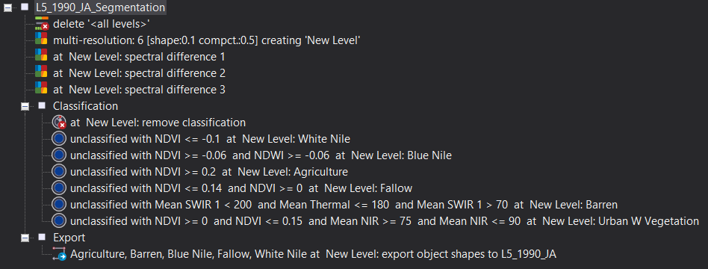
Figure 10. Landsat 5 Jebel Awlia eCognition Ruleset

White Nile Summary: Based on the averages, we can set the classification ruleset to be where NDVI is less than or equal to -0.1
Object # | Blue | Green | Red | NIR | SWIR1 | SWIR2 | NDVI | Brightness | NDWI | Thermal
1 | 134.1 | 71.1 | 76.4 | 40.8 | 34.8 | 20.6 | -0.30 | 72.9 | 0.27 | 132.4
2 | 131 | 69.4 | 75.1 | 38.6 | 30.9 | 18.6 | -0.32 | 70.9 | 0.29 | 133.1
3 | 132 | 69.9 | 75.9 | 41.2 | 36.8 | 21.8 | -0.30 | 73 | 0.26 | 133.5
4 | 132.9 | 70.4 | 76.4 | 43 | 39 | 23.1 | -0.28 | 74 | 0.24 | 133.3
5 | 133.5 | 70.8 | 76.7 | 43.4 | 39.5 | 23.4 | -0.28 | 74.4 | 0.24 | 133.7
6 | 131 | 68.6 | 74.2 | 46.7 | 41.2 | 23.8 | -0.23 | 74.3 | 0.19 | 134.7
7 | 134 | 71.2 | 77.7 | 44.9 | 38.8 | 22.7 | -0.27 | 74.6 | 0.23 | 132.9
8 | 132.4 | 70.4 | 76.2 | 43.6 | 39.5 | 23.2 | -0.27 | 74.1 | 0.24 | 133.5
9 | 134.9 | 71.7 | 77.2 | 42.5 | 38.1 | 22.5 | -0.29 | 74.3 | 0.26 | 133.5
10 | 133.8 | 71.1 | 77.2 | 43.5 | 38 | 22.5 | -0.28 | 74.1 | 0.24 | 132.7
11 | 132.7 | 69.5 | 76.9 | 48.1 | 39.7 | 23.5 | -0.23 | 74.7 | 0.18 | 132.4
12 | 128.9 | 67.9 | 74.3 | 41 | 35.2 | 21.1 | -0.29 | 71.9 | 0.25 | 134.9
13 | 128.5 | 67.3 | 73.6 | 44.9 | 40.1 | 23.2 | -0.24 | 73.5 | 0.20 | 136.8
14 | 130 | 68.6 | 74.6 | 40.5 | 33.9 | 19.9 | -0.30 | 71.6 | 0.26 | 133.7
15 | 130.1 | 69.4 | 75.1 | 38.6 | 30.9 | 18.6 | -0.32 | 70.9 | 0.29 | 133.1
Avg | 132.0 | 69.8 | 75.8 | 42.8 | 37.1 | 21.9 | -0.28 | 73.3 | 0.2 | 133.6
Min | 128.5 | 67.3 | 73.6 | 38.6 | 30.9 | 18.6 | -0.32 | 70.9 | 0.18 | 132.4
Max | 134.9 | 71.7 | 77.7 | 48.1 | 41.2 | 23.8 | -0.23 | 74.7 | 0.29 | 136.8

Blue Nile Summary: Based on the averages, we can set the classification ruleset to be where unclassified objects with an NDVI that is greater than or equal to -0.06 and NDWI is greater than or equal to -0.06 to be classified as Blue Nile
Object # | Blue | Green | Red | NIR | SWIR1 | SWIR2 | NDVI | Brightness | NDWI | Thermal
1 | 112.7 | 56.3 | 67 | 62.4 | 43.5 | 24.9 | -0.04 | 72.1 | -0.05 | 138.1
2 | 112 | 55.6 | 66 | 60.9 | 39.2 | 22.5 | -0.04 | 70.3 | -0.04 | 135.7
3 | 115.1 | 57.3 | 67.3 | 61.8 | 66 | 39 | -0.04 | 78.7 | -0.04 | 144.7
4 | 112.9 | 56.4 | 67 | 62.3 | 42.8 | 24.3 | -0.04 | 72.4 | -0.05 | 141.2
5 | 112.6 | 56 | 66.7 | 62.3 | 43.7 | 24.8 | -0.03 | 72.7 | -0.05 | 142.7
6 | 112.9 | 56.4 | 66.5 | 62.2 | 44.3 | 25.3 | -0.03 | 73 | -0.05 | 143.5
7 | 112.4 | 56.5 | 66.2 | 62.4 | 42.3 | 24.8 | -0.03 | 72.4 | -0.04 | 141.1
8 | 113.1 | 56.8 | 66.5 | 60.2 | 43.9 | 25.2 | -0.04 | 71.5 | -0.04 | 138.6
9 | 114.7 | 55.5 | 67.4 | 62.4 | 42.7 | 24.6 | -0.04 | 70.2 | -0.04 | 141.1
10 | 112.6 | 56 | 66.7 | 62.3 | 43.7 | 24.8 | -0.03 | 72.7 | -0.05 | 142.7
11 | 112.9 | 56.4 | 66.5 | 62.2 | 44.3 | 25.3 | -0.03 | 73 | -0.05 | 143.5
12 | 112.9 | 56.4 | 66.2 | 62.9 | 44.8 | 25.7 | -0.03 | 77 | -0.05 | 139.5
13 | 112.9 | 56.4 | 66.2 | 61.3 | 43.9 | 25.2 | -0.03 | 75.2 | -0.04 | 144.7
14 | 115.1 | 57.3 | 67.3 | 61.8 | 66 | 39 | -0.04 | 78.7 | -0.04 | 144.7
15 | 112.9 | 56.4 | 67 | 62.3 | 42.8 | 24.3 | -0.04 | 72.4 | -0.05 | 141.2
Avg | 113.2 | 56.4 | 66.7 | 62.0 | 46.3 | 26.6 | -0.04 | 73.5 | -0.05 | 141.5
Min | 112 | 55.5 | 66 | 60.2 | 39.2 | 22.5 | -0.04 | 70.2 | -0.05 | 135.7
Max | 115.1 | 57.3 | 67.4 | 62.9 | 66 | 39 | -0.03 | 78.7 | -0.04 | 144.7

Agriculture Summary: Based on the averages, we can set the classification ruleset to be where unclassified objects with an NDVI that is greater than or equal to 0.2 to be classified as agriculture
Object # | Blue | Green | Red | NIR | SWIR1 | SWIR2 | NDVI | Brightness | NDWI | Thermal
1 | 110.7 | 56.6 | 59.1 | 85.3 | 94.4 | 45.2 | 0.2 | 85.6 | -0.2 | 147.9
2 | 110.1 | 56.5 | 58.6 | 87.3 | 98.4 | 46.2 | 0.2 | 86.7 | -0.2 | 149.6
3 | 112.2 | 55.3 | 59.3 | 82.4 | 94.9 | 47 | 0.2 | 86.2 | -0.2 | 152.5
4 | 110.8 | 53.8 | 57 | 91.2 | 99.7 | 47.9 | 0.2 | 87.4 | -0.3 | 151.6
5 | 109.5 | 53 | 54.2 | 102.5 | 98.7 | 43.3 | 0.3 | 87.1 | -0.3 | 148.7
6 | 110 | 54 | 54.7 | 99.4 | 97.8 | 44 | 0.3 | 86.3 | -0.3 | 144.2
7 | 111.6 | 55.2 | 56.1 | 103.2 | 102.9 | 46.7 | 0.3 | 8.8 | -0.3 | 145.9
8 | 111 | 55.7 | 57.4 | 88 | 97.7 | 45.3 | 0.2 | 85.6 | -0.2 | 144.2
9 | 111 | 55.5 | 57 | 94.2 | 95.5 | 43.9 | 0.2 | 86.1 | -0.3 | 145.8
10 | 111.7 | 55.5 | 58.6 | 84.9 | 93.9 | 45.3 | 0.2 | 85.2 | -0.2 | 146.2
11 | 112.2 | 55.4 | 60 | 81.4 | 90.9 | 46.8 | 0.2 | 85.4 | -0.2 | 151.2
12 | 111.7 | 56.8 | 57.6 | 107.1 | 99.5 | 45.4 | 0.3 | 89.2 | -0.3 | 146.4
13 | 109.4 | 53.8 | 55.7 | 93.5 | 91 | 42.5 | 0.3 | 85.3 | -0.3 | 151
14 | 109.4 | 53.9 | 57.6 | 92 | 90.6 | 44.2 | 0.2 | 85.6 | -0.3 | 151.4
15 | 111.9 | 55.6 | 62.2 | 86.7 | 97.6 | 51.5 | 0.2 | 88.4 | -0.2 | 153.5
Avg | 110.9 | 55.1 | 57.7 | 91.9 | 96.2 | 45.7 | 0.2 | 81.3 | -0.3 | 148.7
Min | 109.4 | 53 | 54.2 | 81.4 | 90.6 | 42.5 | 0.2 | 8.8 | -0.3 | 144.2
Max | 112.2 | 56.8 | 62.2 | 107.1 | 102.9 | 51.5 | 0.3 | 89.2 | -0.2 | 153.5

Barren Summary: Based on the averages, we can set the classification ruleset to be where unclassified objects with a SWIR 1 value less than 200 and greater than 70, and a Thermal value less than or equal to 180 to be classified as barren land
Object # | Blue | Green | Red | NIR | SWIR1 | SWIR2 | NDVI | Brightness | NDWI | Thermal
1 | 130.4 | 67.8 | 82.4 | 73.2 | 112.9 | 73.5 | -0.06 | 101 | -0.04 | 166.7
2 | 125.3 | 63.7 | 76.2 | 67.2 | 103.1 | 68.1 | -0.06 | 96.1 | -0.03 | 169.5
3 | 131.4 | 68.4 | 82.9 | 73.3 | 114 | 75 | -0.06 | 101.2 | -0.03 | 163.4
4 | 133.5 | 69.8 | 85.6 | 76.9 | 119 | 78.1 | -0.05 | 104.5 | -0.05 | 168.7
5 | 125.6 | 64.3 | 77 | 68.9 | 107.5 | 70.9 | -0.06 | 98.1 | -0.03 | 172.5
6 | 122.8 | 62.1 | 73.7 | 65.7 | 102.4 | 66.8 | -0.06 | 94.9 | -0.03 | 171.4
7 | 132.8 | 71.4 | 89.3 | 82.5 | 131.1 | 84.8 | -0.04 | 108.6 | -0.07 | 167.9
8 | 132.5 | 72.4 | 92.1 | 86.6 | 142 | 92.6 | -0.03 | 112.2 | -0.09 | 167.5
9 | 133.4 | 69.8 | 85.6 | 76.9 | 119 | 78.1 | -0.05 | 104.5 | -0.05 | 168.7
10 | 127.7 | 65.2 | 79.5 | 73.7 | 119.7 | 75.9 | -0.04 | 101.1 | -0.06 | 166
11 | 127.8 | 65.6 | 78.7 | 70.3 | 109.4 | 72.1 | -0.06 | 99.3 | -0.03 | 171.1
12 | 132.4 | 68.6 | 82.4 | 72.6 | 111.8 | 74.3 | -0.06 | 101.3 | -0.03 | 166.8
13 | 130.5 | 67.4 | 81.2 | 72.3 | 112.8 | 75 | -0.06 | 100.8 | -0.04 | 166.2
14 | 133.9 | 69 | 82.1 | 74.1 | 120.8 | 75 | -0.05 | 102.5 | -0.04 | 162.6
15 | 127.7 | 68.2 | 85.6 | 81.8 | 136.4 | 89 | -0.02 | 108.1 | -0.09 | 167.9
Avg | 129.8 | 67.6 | 82.3 | 74.4 | 117.5 | 76.6 | -0.05 | 102.3 | -0.05 | 167.8
Min | 122.8 | 62.1 | 73.7 | 65.7 | 102.4 | 66.8 | -0.06 | 94.9 | -0.09 | 162.6
Max | 133.9 | 72.4 | 92.1 | 86.6 | 142 | 92.6 | -0.02 | 112.2 | -0.03 | 172.5

Urban With Vegetation Summary: Based on the averages, we can set the classification ruleset to be where unclassified objects with an NDVI value greater than and equal to 0 and less than and equal to 0.15, with NIR values between 75 and 90 to be classified as urban with vegetation
Object # | Blue | Green | Red | NIR | SWIR1 | SWIR2 | NDVI | Brightness | NDWI | Thermal
1 | 119.3 | 60.8 | 69.3 | 84 | 108.3 | 61.8 | 0.1 | 94.5 | -0.2 | 158.3
2 | 125.5 | 65.4 | 79.4 | 81.1 | 119.6 | 73.4 | 0.1 | 100.5 | -0.1 | 159.1
3 | 120.2 | 62.3 | 71.7 | 82.5 | 108.9 | 63.8 | 0.1 | 95.3 | -0.1 | 158
4 | 123.6 | 64.3 | 78.4 | 88.2 | 124.4 | 69.9 | 0.1 | 101.5 | -0.2 | 161.6
5 | 126.2 | 67.2 | 81.8 | 86.2 | 126.5 | 77.3 | 0.1 | 103.6 | -0.1 | 160.3
6 | 123.9 | 65.4 | 79.4 | 82.1 | 118.3 | 71.5 | 0.1 | 100.3 | -0.1 | 161.6
7 | 125.6 | 64.9 | 78.7 | 85.4 | 119.4 | 71 | 0.1 | 101.2 | -0.1 | 163.3
8 | 123.8 | 65.2 | 77.1 | 84.7 | 119.6 | 71.6 | 0.1 | 100.7 | -0.1 | 162.9
9 | 125 | 64.9 | 76.9 | 81.8 | 113.2 | 68 | 0.1 | 98.3 | -0.1 | 158.7
10 | 121.4 | 62.3 | 75 | 79.4 | 112.1 | 67.4 | 0.1 | 97.6 | -0.1 | 165.9
11 | 120 | 61 | 70.8 | 79.5 | 104.7 | 61.2 | 0.1 | 93.5 | -0.1 | 157.2
12 | 122.2 | 63.4 | 74.6 | 78.4 | 112.1 | 67.8 | 0.1 | 97 | -0.1 | 160.2
13 | 126.2 | 65.2 | 75.7 | 81 | 108.5 | 64.3 | 0.1 | 97.1 | -0.1 | 159
14 | 123 | 63.5 | 75.5 | 85.5 | 116.5 | 66 | 0.1 | 98.7 | -0.1 | 161
15 | 124.7 | 65.7 | 77.5 | 89.5 | 122.7 | 71.3 | 0.1 | 101.8 | -0.2 | 161
Avg | 123.4 | 64.1 | 76.1 | 83.3 | 115.7 | 68.4 | 0.1 | 98.8 | -0.1 | 160.5
Min | 119.3 | 60.8 | 69.3 | 78.4 | 104.7 | 61.2 | 0.1 | 93.5 | -0.2 | 157.2
Max | 126.2 | 67.2 | 81.8 | 89.5 | 126.5 | 77.3 | 0.1 | 103.6 | -0.1 | 165.9

Fallow Summary: Based on the averages, we can set the classification ruleset to be where unclassified objects with an NDVI value greater than and equal to 0 and less than and equal to 0.14 to be classified as fallow land
Object # | Blue | Green | Red | NIR | SWIR1 | SWIR2 | NDVI | Brightness | NDWI | Thermal
1 | 121.9 | 62.7 | 76.4 | 72.8 | 116 | 72.7 | 0.07 | 98.9 | -0.07 | 169.5
2 | 122.9 | 63.4 | 76.8 | 73.1 | 114.5 | 71.3 | 0.07 | 98.8 | -0.07 | 169.5
3 | 126.1 | 67.6 | 87.5 | 88.7 | 132 | 70.9 | 0.1 | 105.6 | -0.1 | 166.5
4 | 123.4 | 65.7 | 74.6 | 83.8 | 112.1 | 72.9 | 0.1 | 97.6 | -0.07 | 167.3
5 | 124.6 | 64.3 | 72.4 | 82.1 | 115.8 | 72.4 | 0.1 | 98.9 | -0.07 | 168.3
6 | 121.1 | 63.7 | 74.6 | 88.9 | 127.6 | 73.8 | 0.08 | 97.6 | -0.07 | 167.4
7 | 128.6 | 65.7 | 75.8 | 79.7 | 115.2 | 72.5 | 0.08 | 95.7 | -0.07 | 166.2
8 | 127.4 | 65.3 | 76.7 | 76.8 | 114.6 | 72.4 | 0.1 | 99.4 | -0.08 | 169.3
9 | 122.4 | 67.9 | 76.6 | 79.2 | 113.8 | 74 | 0.1 | 93.7 | -0.07 | 169.8
10 | 125.9 | 64.2 | 73.5 | 82.4 | 112.1 | 73.3 | 0.1 | 94.8 | -0.07 | 163.4
11 | 129.6 | 67.2 | 78.3 | 81.1 | 121.7 | 73.6 | 0.06 | 95.6 | -0.07 | 167.3
12 | 127.7 | 67.9 | 72.2 | 77.4 | 124.5 | 72.1 | 0.06 | 95.7 | -0.08 | 165.2
13 | 130.1 | 68.2 | 71.4 | 78.5 | 123 | 73.3 | 0.06 | 96.3 | -0.08 | 166.8
14 | 123.4 | 68.2 | 74.5 | 85.6 | 123.9 | 72.7 | 0.08 | 103.4 | -0.08 | 163.4
15 | 126.8 | 65.5 | 76.3 | 87.7 | 123.7 | 72.9 | 0.08 | 104.5 | -0.08 | 167.3
Avg | 125.5 | 65.8 | 75.8 | 81.2 | 119.4 | 72.7 | 0.08 | 98.4 | -0.08 | 167.1
Min | 121.1 | 62.7 | 71.4 | 72.8 | 112.1 | 70.9 | 0.06 | 93.7 | -0.1 | 163.4
Max | 130.1 | 68.2 | 87.5 | 88.9 | 132 | 74 | 0.1 | 105.6 | -0.07 | 169.8

- Sentinel-2: Khartoum Sep. 19, 2020
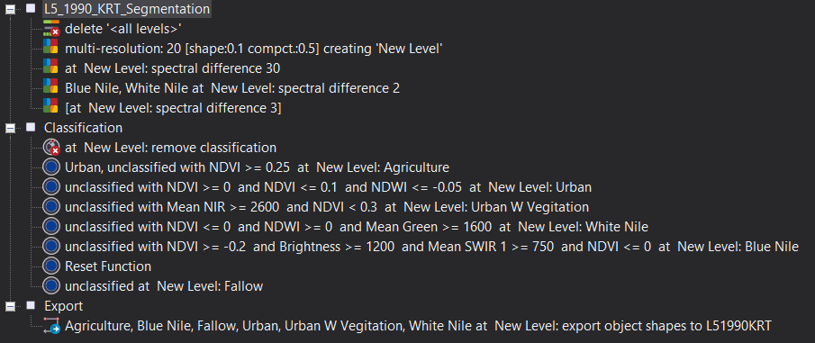
Figure 11. Sentinel-2 Khartoum eCognition Ruleset

White Nile Summary: Based on the averages, we can set the classification ruleset to be where unclassified objects with an NDVI less than or equal to 0, an NDWI greater than or equal to 0 and a Green band value greater than or equal to 1600 is classified as White Nile
Object # | Blue | Green | Red | NIR | SWIR1 | SWIR2 | NDVI | Brightness | NDWI
1 | 1648.5 | 1808.1 | 1848.7 | 1030.2 | 615.5 | 459.4 | -0.3 | 1116.3 | 0.3
2 | 1642.3 | 1799.4 | 1839.8 | 1046.7 | 644.2 | 480.5 | -0.3 | 1123.4 | 0.3
3 | 1632.4 | 1782.5 | 1815 | 1044.3 | 631.2 | 471 | -0.3 | 1115.1 | 0.3
4 | 1622.3 | 1768.7 | 1790 | 1062.9 | 662.4 | 491.7 | -0.3 | 1121.4 | 0.2
5 | 1624.3 | 1772.2 | 1797.4 | 1049.5 | 642.8 | 479.9 | -0.3 | 1114.7 | 0.3
6 | 1610.9 | 1754.5 | 1768.8 | 1126.8 | 675.6 | 483 | -0.2 | 1136.4 | 0.2
7 | 1618 | 1763.3 | 1784.8 | 1099.6 | 657.7 | 475.6 | -0.2 | 1128.9 | 0.2
8 | 1624.7 | 1771.6 | 1797.3 | 1073.9 | 643.6 | 470.2 | -0.3 | 1122 | 0.2
9 | 1625.2 | 1773 | 1801.4 | 1052.5 | 622 | 453.9 | -0.3 | 1112.5 | 0.3
10 | 1635.7 | 1789.7 | 1825.8 | 1044.1 | 613.6 | 444.8 | -0.3 | 1113.1 | 0.3
11 | 1606.7 | 1746.8 | 1746.5 | 1147 | 740.6 | 539.5 | -0.2 | 1152.6 | 0.2
12 | 1612.1 | 1754.2 | 1757.9 | 1117.4 | 707.9 | 519.1 | -0.2 | 1140.5 | 0.2
13 | 1594.9 | 1723.9 | 1712.3 | 1134.3 | 745.5 | 550.4 | -0.2 | 1143.8 | 0.2
14 | 1625.6 | 1776.1 | 1806.6 | 1070.8 | 677.6 | 499.5 | -0.3 | 1126.6 | 0.2
15 | 1612.1 | 1753.1 | 1761.7 | 1088.7 | 704.7 | 519.1 | -0.2 | 1128 | 0.2
Avg | 1622.4 | 1769.1 | 1790.3 | 1079.2 | 665.7 | 489.2 | -0.3 | 1126.4 | 0.2
Min | 1594.9 | 1723.9 | 1712.3 | 1030.2 | 613.6 | 444.8 | -0.3 | 1112.5 | 0.2
Max | 1648.5 | 1808.1 | 1848.7 | 1147 | 745.5 | 550.4 | -0.2 | 1152.6 | 0.3

Blue Nile Summary: Based on the averages, we can set the classification ruleset to be where unclassified objects with an NDVI greater than or equal to -0.2 and less than or equal to 0, Brightness greater than or equal to 1200 and a SWIR 1 band value greater than or equal to 750 is classified as Blue Nile
Object # | Blue | Green | Red | NIR | SWIR1 | SWIR2 | NDVI | Brightness | NDWI
1 | 1542.1 | 1629.5 | 1843.4 | 1564.7 | 845.2 | 620.5 | -0.08 | 1306 | 0.02
2 | 1515.7 | 1586.5 | 1771.5 | 1506.6 | 779.4 | 567.7 | -0.08 | 1259.3 | 0.02
3 | 1517.4 | 1588.8 | 1774.3 | 1522.9 | 804.2 | 587.2 | -0.08 | 1268.8 | 0.02
4 | 1522.5 | 1599.3 | 1789 | 1544.3 | 833.4 | 607 | -0.07 | 1283.4 | 0.02
5 | 1531.3 | 1611.1 | 1806.1 | 1576.1 | 875.5 | 639.1 | -0.07 | 1304 | 0.01
6 | 1527.4 | 1600.3 | 1785.6 | 1590 | 909.4 | 661.3 | -0.06 | 1309.5 | 0.003
7 | 1549.7 | 1628 | 1828.7 | 1650.6 | 975.2 | 711 | -0.05 | 1349.8 | -0.007
8 | 1536.1 | 1606.2 | 1798.7 | 1632 | 961.7 | 698.9 | -0.05 | 1333.2 | -0.008
9 | 1551.5 | 1628.7 | 1831.9 | 1708.9 | 1067.2 | 771.5 | -0.03 | 1383.1 | -0.02
10 | 1517.7 | 1584.2 | 1777 | 1592.5 | 935.2 | 670.6 | -0.05 | 1310.9 | -0.003
11 | 1516.4 | 1587.3 | 1785.8 | 1564.6 | 924.3 | 671.1 | -0.07 | 1302.3 | 0.007
12 | 1517.6 | 1590.3 | 1797 | 1573.9 | 914.1 | 660.2 | -0.07 | 1305.2 | 0.005
13 | 1513.2 | 1587.3 | 1790.2 | 1538.1 | 849.1 | 614.4 | -0.08 | 1282.3 | 0.02
14 | 1518.4 | 1588.4 | 1787.9 | 1563.7 | 896.3 | 647 | -0.07 | 1296.8 | 0.008
15 | 1532.8 | 1613.2 | 1810 | 1620.4 | 918.2 | 648.9 | -0.06 | 1323.8 | -0.002
Avg | 1527.3 | 1601.9 | 1798.5 | 1583.3 | 899.2 | 651.8 | -0.1 | 1307.9 | 0.01
Min | 1513.2 | 1584.2 | 1771.5 | 1506.6 | 779.4 | 567.7 | -0.08 | 1259.3 | -0.02
Max | 1551.5 | 1629.5 | 1843.4 | 1708.9 | 1067.2 | 771.5 | -0.03 | 1383.1 | 0.02

Agriculture Summary: Based on the averages, we can set the classification ruleset to be where unclassified objects with an NDVI greater than or equal to 0.25 to be classified as Agriculture
Object # | Blue | Green | Red | NIR | SWIR1 | SWIR2 | NDVI | Brightness | NDWI
1 | 1457.3 | 1528.2 | 1471.3 | 2969.2 | 2571.4 | 1493.9 | 0.33 | 1909.5 | -0.32
2 | 1485.5 | 1513.7 | 1545.7 | 2726.6 | 1968.6 | 1234.3 | 0.27 | 1762.7 | -0.29
3 | 1451.8 | 1538.7 | 1492 | 3276.7 | 2029.4 | 1214.1 | 0.37 | 1957.4 | -0.36
4 | 1433.4 | 1545.1 | 1423 | 3532.4 | 2452.4 | 1416.4 | 0.42 | 2050.6 | -0.39
5 | 1426.8 | 1471.3 | 1427.1 | 3364.3 | 2063.3 | 1190.3 | 0.40 | 1946 | -0.39
6 | 1367.2 | 1409.8 | 1326.7 | 2991.7 | 1938.9 | 1107 | 0.39 | 1792.7 | -0.36
7 | 1430.4 | 1502.4 | 1429.6 | 3459.2 | 2039.2 | 1170.2 | 0.42 | 1990.4 | -0.39
8 | 1389.2 | 1433.6 | 1334.5 | 2962.6 | 1773.8 | 1039.2 | 0.38 | 1748 | -0.34
9 | 1413.3 | 1480.7 | 1326.7 | 3125 | 1664.9 | 878 | 0.40 | 1807.8 | -0.36
10 | 1406.1 | 1442 | 1378.3 | 2809.1 | 1866.5 | 1092.9 | 0.34 | 1747 | -0.32
11 | 1398.3 | 1442.6 | 1342.3 | 3078.2 | 1844.2 | 1054.3 | 0.39 | 1808.6 | -0.36
12 | 1396.2 | 1430.1 | 1384.5 | 2827.5 | 1936.1 | 1170.7 | 0.34 | 1757.6 | -0.33
13 | 1402.6 | 1440.1 | 1412.9 | 3088.2 | 2001.4 | 1207.8 | 0.37 | 1830.8 | -0.36
14 | 1387.7 | 1421.6 | 1345.4 | 2916.7 | 1837.4 | 1061 | 0.37 | 1762.3 | -0.34
15 | 1387.8 | 1418 | 1333 | 2944.3 | 1823.9 | 1037.1 | 0.38 | 1786.5 | -0.35
Avg | 1415.6 | 1467.9 | 1398.2 | 3071.4 | 1987.4 | 1157.8 | 0.37 | 1843.9 | -0.35
Min | 1367.2 | 1409.8 | 1326.7 | 2726.6 | 1664.9 | 878 | 0.27 | 1747 | -0.39
Max | 1485.5 | 1545.1 | 1545.7 | 3532.4 | 2571.4 | 1493.9 | 0.42 | 2050.6 | -0.29

Urban W Vegetation Summary: Based on the averages, we can set the classification ruleset to be where unclassified objects with an NIR value greater than or equal to 2600, and an NDVI less than 0.3 is classified as Urban W Vegetation
Object # | Blue | Green | Red | NIR | SWIR1 | SWIR2 | NDVI | Brightness | NDWI
1 | 1856.3 | 2048.4 | 2521.6 | 2676.8 | 2996.9 | 2443.4 | 0.003 | 2161.6 | -0.13
2 | 1711 | 2875.8 | 2208.9 | 2912.9 | 2792 | 2124.9 | 0.14 | 2114 | -0.18
3 | 1580.7 | 1691.4 | 1928.1 | 2776.2 | 2624.1 | 1891.6 | 0.18 | 1987.8 | -0.24
4 | 1751.3 | 1908.4 | 2305.7 | 2655.9 | 2954.7 | 2369.1 | 0.07 | 2109.2 | -0.16
5 | 1771.1 | 1951.5 | 2395.1 | 2688.6 | 3015.1 | 2405.8 | 0.06 | 2146.0 | -0.16
6 | 1668.3 | 1834.5 | 2145.5 | 2760.8 | 2846.3 | 2171.3 | 0.13 | 2098.8 | -0.20
7 | 1599.3 | 1717.3 | 1929.9 | 2986.1 | 2857.4 | 2005.3 | 0.21 | 2080.1 | -0.27
8 | 1649.9 | 1770.9 | 2008.3 | 2764.2 | 2668.8 | 1972.5 | 0.16 | 2022.9 | -0.22
9 | 1792.6 | 1983 | 2416.4 | 2887.8 | 3029.1 | 2355.3 | 0.09 | 2197.1 | -0.19
10 | 1725.3 | 1870 | 2185.9 | 2717.3 | 2769.5 | 2126.1 | 0.11 | 2062.5 | -0.18
11 | 1557.9 | 1660.6 | 1794.6 | 2830.7 | 2545.1 | 1780.8 | 0.22 | 1963.8 | -0.26
12 | 1752 | 1872.1 | 2064.1 | 2604.2 | 2506.8 | 1949.6 | 0.12 | 1971.2 | -0.16
13 | 1646.6 | 1795.2 | 2090.9 | 2941.7 | 2957.5 | 2195 | 0.17 | 2121.4 | -0.24
14 | 1745.2 | 1917 | 2338.8 | 2781.9 | 3053.7 | 2415.3 | 0.09 | 2173.9 | -0.18
15 | 1659.4 | 1781.1 | 2080 | 2756.9 | 2780.5 | 2125.5 | 0.14 | 2063.2 | -0.21
Avg | 1697.8 | 1911.8 | 2160.9 | 2782.8 | 2826.5 | 2155.4 | 0.13 | 2084.9 | -0.20
Min | 1557.9 | 1660.6 | 1794.6 | 2604.2 | 2506.8 | 1780.8 | 0.003 | 1963.8 | -0.27
Max | 1856.3 | 2875.8 | 2521.6 | 2986.1 | 3053.7 | 2443.4 | 0.22 | 2197.1 | -0.13

- Landsat 5: Khartoum Sep. 16, 1990
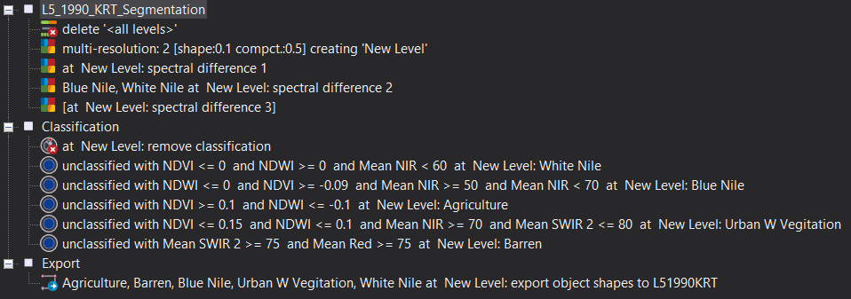
Figure 12. Landsat 5 Khartoum eCognition Ruleset

White Nile Summary: Based on the averages, we can set the classification ruleset to be where unclassified objects with an NDVI less than or equal to 0, an NDWI greater than or equal to 0, and an NIR value less than 60 is classified as White Nile
Object # | Blue | Green | Red | NIR | SWIR1 | SWIR2 | NDVI | Brightness | NDWI | Thermal
1 | 128.2 | 67.7 | 74.9 | 41.7 | 31.6 | 18.7 | -0.3 | 70.9 | 0.2 | 133.6
2 | 128.1 | 67.7 | 74.1 | 38.6 | 28.1 | 16.6 | -0.3 | 69.6 | 0.3 | 134.1
3 | 126.8 | 66.7 | 73.2 | 40 | 29.4 | 17.4 | -0.3 | 69.7 | 0.3 | 134.3
4 | 129.9 | 68.8 | 75.3 | 39.5 | 30.8 | 18.7 | -0.3 | 70.9 | 0.3 | 133.1
5 | 128.4 | 67.5 | 74.6 | 42.5 | 34.2 | 20.3 | -0.3 | 71.6 | 0.2 | 134
6 | 128.7 | 67.8 | 75 | 44.5 | 39.6 | 23.5 | -0.3 | 73.8 | 0.2 | 137.7
7 | 130.6 | 69.3 | 75.8 | 40.7 | 34.2 | 20.4 | -0.3 | 72.1 | 0.3 | 133.6
8 | 129.6 | 68.2 | 75.8 | 45 | 40.2 | 24 | -0.3 | 74.3 | 0.2 | 137.1
9 | 125 | 65.2 | 72 | 42.1 | 31.5 | 18.5 | -0.3 | 69.9 | 0.2 | 134.9
10 | 124.5 | 64.9 | 72.8 | 45.3 | 34 | 20.2 | -0.2 | 70.9 | 0.2 | 134.7
11 | 124.2 | 64.7 | 71.3 | 46.1 | 35.7 | 20.5 | -0.2 | 71.4 | 0.2 | 137
12 | 129.6 | 67.9 | 75.3 | 45.7 | 41.3 | 24.1 | -0.2 | 74.4 | 0.2 | 136.5
13 | 128.3 | 67 | 74.9 | 51.9 | 49.4 | 28.9 | -0.2 | 77.1 | 0.1 | 139.2
14 | 122.9 | 63.6 | 69.6 | 46 | 32.1 | 18.1 | -0.2 | 69.7 | 0.2 | 135.6
15 | 122.5 | 63.3 | 68.9 | 47.6 | 34.9 | 19.1 | -0.2 | 70.1 | 0.1 | 134.4
Avg | 127.2 | 66.7 | 73.6 | 43.8 | 35.1 | 20.6 | -0.3 | 71.8 | 0.2 | 135.3
Min | 122.5 | 63.3 | 68.9 | 38.6 | 28.1 | 16.6 | -0.3 | 69.6 | 0.1 | 133.1
Max | 130.6 | 69.3 | 75.8 | 51.9 | 49.4 | 28.9 | -0.2 | 77.1 | 0.3 | 139.2

Blue Nile Summary: Based on the averages, we can set the classification ruleset to be where unclassified objects with an NDVI greater than or equal to -0.09, an NDWI less than or equal to 0, and a NIR value greater than or equal to 50 and less than 70 to be classified as Blue Nile
Object # | Blue | Green | Red | NIR | SWIR1 | SWIR2 | NDVI | Brightness | NDWI | Thermal
1 | 112.9 | 56.1 | 66.3 | 61.9 | 38.4 | 21.9 | -0.03 | 70.2 | -0.05 | 134.1
2 | 113.4 | 56.5 | 66.9 | 62.8 | 41.1 | 23.4 | -0.03 | 71.7 | -0.05 | 137.8
3 | 111.7 | 55.6 | 66.2 | 62.4 | 40.1 | 22.9 | -0.03 | 70.9 | -0.06 | 137.3
4 | 112.3 | 55.6 | 66.5 | 63 | 42.4 | 23.9 | -0.03 | 71.6 | -0.06 | 137.6
5 | 111.6 | 55.2 | 65.5 | 61.8 | 39.9 | 22.8 | -0.03 | 70.5 | -0.06 | 136.9
6 | 110.5 | 54.8 | 65 | 60.8 | 36.7 | 20.9 | -0.03 | 69.1 | -0.05 | 135.1
7 | 112.4 | 56 | 66.8 | 62.2 | 39.6 | 22.6 | -0.04 | 70.8 | -0.05 | 136.2
8 | 110.7 | 54.9 | 65.2 | 60.6 | 36.3 | 20.7 | -0.04 | 69 | -0.05 | 134.4
9 | 113.5 | 57.1 | 67.6 | 63.1 | 42.8 | 24.3 | -0.03 | 72.4 | -0.05 | 138.5
10 | 113.3 | 56.4 | 67 | 62.9 | 43.2 | 24.4 | -0.03 | 72.1 | -0.05 | 137.7
11 | 114 | 56.6 | 67.3 | 63.5 | 46.2 | 26 | -0.03 | 73.2 | -0.06 | 139
12 | 114.6 | 56.9 | 67.5 | 63 | 44 | 25.2 | -0.03 | 72.4 | -0.05 | 136
13 | 113.7 | 56.5 | 67.1 | 62.3 | 41.4 | 25.7 | -0.04 | 71.4 | -0.05 | 134.9
14 | 111.5 | 55.3 | 65.7 | 61.5 | 38.5 | 22 | -0.03 | 69.8 | -0.05 | 133.8
15 | 112.1 | 55.7 | 66.1 | 63.4 | 42.9 | 23.8 | -0.02 | 71.8 | -0.06 | 138.4
Avg | 112.5 | 55.9 | 66.4 | 62.3 | 40.9 | 23.4 | -0.03 | 71.1 | -0.05 | 136.5
Min | 110.5 | 54.8 | 65 | 60.6 | 36.3 | 20.7 | -0.04 | 69 | -0.06 | 133.8
Max | 114.6 | 57.1 | 67.6 | 63.5 | 46.2 | 26 | -0.02 | 73.2 | -0.05 | 139

Agriculture Summary: Based on the averages, we can set the classification ruleset to be where unclassified objects with an NDVI greater than or equal to 0.1, and an NDWI less than or equal to -0.1 is classified as Agriculture
Object # | Blue | Green | Red | NIR | SWIR1 | SWIR2 | NDVI | Brightness | NDWI | Thermal
1 | 108.6 | 53.5 | 53.6 | 103.1 | 90.2 | 39.2 | 0.3 | 84.8 | -0.3 | 145.4
2 | 105.6 | 50.6 | 51.3 | 91.5 | 77.6 | 34.6 | 0.3 | 79.6 | -0.3 | 146
3 | 109.6 | 53.5 | 53.6 | 109.7 | 91 | 39 | 0.3 | 85.7 | -0.3 | 143.6
4 | 108.5 | 53.2 | 57 | 91.7 | 85.6 | 41.6 | -0.3 | 83.9 | -0.3 | 150.1
5 | 108.4 | 52.7 | 56 | 90.6 | 83.2 | 39.9 | -0.3 | 83 | -0.3 | 150.1
6 | 108.4 | 52.7 | 56 | 90.6 | 83.2 | 39.9 | 0.2 | 83 | -0.3 | 150.1
7 | 112.9 | 55.8 | 60.2 | 94.5 | 97.6 | 48.3 | 0.2 | 90.1 | -0.3 | 161.5
8 | 111.3 | 54.8 | 58.1 | 89.7 | 92 | 45.8 | 0.2 | 85.7 | -0.2 | 148.3
9 | 106.4 | 50.9 | 51.4 | 96.8 | 81.2 | 36.5 | 0.3 | 81.1 | -0.3 | 144.8
10 | 106.9 | 51.3 | 52.2 | 91.5 | 80.3 | 36.8 | 0.3 | 80.7 | -0.3 | 145.7
11 | 105.4 | 51.1 | 50.9 | 93.7 | 78.3 | 35.1 | 0.3 | 80.5 | -0.3 | 149.1
12 | 105.9 | 51 | 53 | 89.4 | 79.1 | 36.3 | 0.3 | 79.7 | -0.3 | 143
13 | 106.2 | 51.9 | 53.7 | 93.3 | 82.1 | 37.6 | 0.3 | 82.1 | -0.3 | 149.6
14 | 109.3 | 53.2 | 56.6 | 88.7 | 88.7 | 42.6 | 0.2 | 83.9 | -0.3 | 148.2
15 | 109.6 | 53.5 | 57.3 | 87.9 | 93.6 | 46.5 | 0.2 | 85.5 | -0.2 | 150.1
Avg | 108.2 | 52.6 | 54.7 | 93.5 | 85.6 | 40.0 | 0.2 | 83.3 | -0.3 | 148.4
Min | 105.4 | 50.6 | 50.9 | 87.9 | 77.6 | 34.6 | -0.3 | 79.6 | -0.3 | 143
Max | 112.9 | 55.8 | 60.2 | 109.7 | 97.6 | 48.3 | 0.3 | 90.1 | -0.2 | 161.5

Urban W Vegetation Summary: Based on the averages, we can set the classification ruleset to be where unclassified objects with an NDVI less than or equal to 0.15, an NDWI less than or equal to 0.1, NIR greater than or equal to 70, and a SWIR 2 value less than or equal to 80 to be classified as Urban with Vegetation
Object # | Blue | Green | Red | NIR | SWIR1 | SWIR2 | NDVI | Brightness | NDWI | Thermal
1 | 119.3 | 60.8 | 69.3 | 84 | 108.3 | 61.8 | 0.1 | 94.5 | -0.2 | 158.3
2 | 125.5 | 65.4 | 79.4 | 81.1 | 119.6 | 73.4 | 0.01 | 100.5 | -0.1 | 159.1
3 | 120.2 | 62.3 | 71.7 | 82.5 | 108.9 | 63.8 | 0.07 | 95.3 | -0.1 | 158
4 | 123.6 | 64.3 | 78.4 | 88.2 | 124.4 | 69.9 | 0.06 | 101.5 | -0.2 | 161.6
5 | 126.2 | 67.2 | 81.8 | 86.2 | 126.5 | 77.3 | 0.03 | 103.6 | -0.1 | 160.3
6 | 123.9 | 65.4 | 79.4 | 82.1 | 118.3 | 71.5 | 0.02 | 100.3 | -0.1 | 161.6
7 | 125.6 | 64.9 | 78.7 | 85.4 | 119.4 | 71 | 0.04 | 101.2 | -0.1 | 163.3
8 | 123.8 | 65.2 | 77.1 | 84.7 | 119.6 | 71.6 | 0.05 | 100.7 | -0.1 | 162.9
9 | 125 | 64.9 | 76.9 | 81.8 | 113.2 | 68 | 0.03 | 98.3 | -0.1 | 158.7
10 | 121.4 | 62.3 | 75 | 79.4 | 112.1 | 67.4 | 0.03 | 97.6 | -0.1 | 165.9
11 | 120 | 61 | 70.8 | 79.5 | 104.7 | 61.2 | 0.06 | 93.5 | -0.1 | 157.2
12 | 122.2 | 63.4 | 74.6 | 78.4 | 112.1 | 67.8 | 0.02 | 97 | -0.1 | 160.2
13 | 126.2 | 65.2 | 75.7 | 81 | 108.5 | 64.3 | 0.03 | 97.1 | -0.1 | 159
14 | 123 | 63.5 | 75.5 | 85.5 | 116.5 | 66 | 0.06 | 98.7 | -0.1 | 161
15 | 124.7 | 65.7 | 77.5 | 89.5 | 122.7 | 71.3 | 0.07 | 101.8 | -0.2 | 161
Avg | 123.4 | 64.1 | 76.1 | 83.3 | 115.7 | 68.4 | 0.0 | 98.8 | -0.1 | 160.5
Min | 119.3 | 60.8 | 69.3 | 78.4 | 104.7 | 61.2 | 0.01 | 93.5 | -0.2 | 157.2
Max | 126.2 | 67.2 | 81.8 | 89.5 | 126.5 | 77.3 | 0.1 | 103.6 | -0.1 | 165.9

Barren Summary: Based on the averages, we can set the classification ruleset to be where unclassified objects with a SWIR 2 value greater than or equal to 75, and a Red band value greater than or equal to 75 are to be classified as Barren
Object # | Blue | Green | Red | NIR | SWIR1 | SWIR2 | NDVI | Brightness | NDWI | Thermal
1 | 132.4 | 72.4 | 92.3 | 86.6 | 142.1 | 91.8 | -0.03 | 112.2 | -0.09 | 168
2 | 126.1 | 68.2 | 89 | 84.7 | 146.2 | 95.2 | -0.02 | 110.8 | -0.1 | 166.4
3 | 125.7 | 66.3 | 84.2 | 81.1 | 138 | 91.3 | -0.01 | 108.1 | -0.1 | 170.2
4 | 122.7 | 64 | 79.2 | 75.9 | 125.6 | 81.6 | -0.02 | 102.4 | -0.08 | 167.6
5 | 124.4 | 65.9 | 82.3 | 78.4 | 126.8 | 81.5 | -0.02 | 103.8 | -0.09 | 167.4
6 | 131.2 | 70.4 | 89.9 | 84.4 | 143.7 | 96.7 | -0.03 | 111.9 | -0.09 | 167
7 | 129.8 | 68.8 | 86.9 | 81.6 | 142.2 | 95.1 | -0.03 | 110.1 | -0.09 | 166.2
8 | 134.3 | 71.5 | 90.3 | 85.2 | 145.6 | 97.2 | -0.03 | 113.1 | -0.09 | 167.4
9 | 136.8 | 74.3 | 94.7 | 87.9 | 139.3 | 90.3 | -0.04 | 112.8 | -0.08 | 166.3
10 | 133.9 | 70.7 | 87.9 | 80 | 129.6 | 85.5 | -0.05 | 107.8 | -0.06 | 166.8
11 | 132.5 | 69.4 | 86.5 | 78.7 | 126.4 | 83.3 | -0.05 | 106.5 | -0.06 | 169
12 | 137.4 | 74 | 93.8 | 87 | 140.8 | 91.6 | -0.04 | 113.1 | -0.08 | 167.1
13 | 135 | 72.6 | 91 | 83.6 | 141.7 | 92 | -0.04 | 111.4 | -0.07 | 164.1
14 | 130 | 70.5 | 89.3 | 83.7 | 135.4 | 87.5 | -0.03 | 109.2 | -0.09 | 168.1
15 | 123.7 | 63.2 | 75.8 | 70.2 | 110.2 | 70.8 | -0.04 | 97.7 | -0.05 | 169.9
Avg | 130.4 | 69.5 | 87.5 | 81.9 | 135.6 | 88.8 | 0.0 | 108.7 | -0.1 | 167.4
Min | 122.7 | 63.2 | 75.8 | 70.2 | 110.2 | 70.8 | -0.05 | 97.7 | -0.1 | 164.1
Max | 137.4 | 74.3 | 94.7 | 87.9 | 146.2 | 97.2 | -0.01 | 113.1 | -0.05 | 170.2

Results
The supervised object-based image analysis for the district of Khartoum in 1990 using ArcGIS Pro classified agriculture as accounting for 10.9% of the land cover. Barren land and urban with vegetation made up the majority of the remaining land cover area, accounting for 37% and 37.4% of the regional land cover respectively. The remaining land cover was comprised of the Blue and White Niles, accounting for 8.2% and 5.2% of the region, and lastly, developed land comprised just 1.3% of Khartoum.
Comparatively, the supervised OBIA for Khartoum in 2020 using ArcGIS Pro classified 3.8% of land cover to be agriculture, indicating a 7.1% decrease. Barren land saw a 37% decrease from 1990 with the majority of barren land appearing to go to urban with vegetation, which showed a 28.9% increase, as well as developed land, which grew by 11.5%. Additionally, the Blue Nile saw a 1.6% decrease in land cover while the White Nile increased by 3.9%. Fallow land also grew by 1.4% from 1990.
Furthermore, the supervised object-based image classification analysis for the district of Khartoum in 1990 using eCognition appeared to show agriculture encompassing 6.9% of the land. Barren land and urban appeared to be the two largest land cover classes encompassing Khartoum district coming in at 47.9% and 34.1% respectively. The remaining land cover was comprised of the White and Blue Nile rivers making up 4.7% and 6.2% of the land cover respectively.
When comparing this to the 2020 land cover change, agriculture comprised only 2.7% in 2020, suggesting a decrease of 4.2%. Additionally, the change in fallow land cover present in 2020 indicated a 7.9% increase. Moreover, barren land now fell either under the urban or urban with vegetation classes and comprised 21.4% and 55.8% of the Khartoum land cover respectively. Lastly, for the Khartoum district, the White Nile went from 4.7% in 1990 to 5.1% in 2020 while the Blue Nile increased slightly more, going from 6.2% in 1990 to 6.9% in 2020.
Subsequently, when looking at the land cover change for the Jebel Awlia district using ArcGIS Pro, barren land saw a significant change in land cover, decreasing by 78.7%. Additionally, urban with vegetation saw a 69.7% increase in land cover change with a 5% increase in fallow land, a 3.3% increase in the White Nile, a 0.5% increase in the Blue Nile and lastly a 0.3% increase in agriculture.
When looking at the eCognition land cover classification analysis for Jebel Awlia, barren land cover appeared to decrease by 76.2% with the largest increases in land cover change shown in the urban with vegetation, fallow land, and agricultural classes. Urban with vegetation increased by 38.7% from 1990 whereas fallow land and agriculture increase by 18.6% and 17.3% respectively. The White Nile showed an increase of 1.4%, whereas the Blue Nile showed a mere increase of 0.1% between 1990 and 2020. A summary of the results can be seen in tables 5 through 8 below.
ArcGIS Pro Khartoum Land Cover Change 1990 vs 2020
Land Cover Class | 1990 (Acres) | 2020 (Acres) | Change in Area ( Acres) | 1990 (%) | 2020 (%) | Change in Area (%)
Agriculture | 4,325.6 | 1,495.9 | -2,829.70 | 10.9% | 3.8% | -7.1%
Barren | 14,617.6 | N/A | -14,617.60 | 37% | N/A | -37%
Blue Nile | 3,222.2 | 2,604.8 | -617.40 | 8.2% | 6.6% | -1.6%
Developed | 526.4 | 5,067.7 | 4,541.30 | 1.3% | 12.8% | 11.5%
Fallow | N/A | 545.7 | 545.70 | N/A | 1.4% | 1.4%
Urban W Vegetation | 14,768.9 | 26,202.1 | 11,433.20 | 37.4% | 66.3% | 28.9%
White Nile | 2,041.4 | 3,586.2 | 1,544.80 | 5.2% | 9.1% | 3.9%
Total Area | 39,502.1 | 39,502.4
Table 5. ArcGIS Pro Supervised OBIA Land Cover Change for Khartoum 1990 vs 2020

ArcGIS Pro Jebel Awlia Land Cover Change 1990 vs 2020

Land Cover Class | 1990 (Acres) | 2020 (Acres) | Change in Area (Acres) | 1990 (%) | 2020 (%) | Change in Area (%)
Agriculture | 6,506.9 | 7,071.6 | 564.7 | 3.5% | 3.8% | 0.3%
Barren | 145,928.5 | N/A | -145,928.5 | 78.7% | N/A | -78.7%
Blue Nile | 764.1 | 1,584.5 | 820.4 | 0.4% | 0.9% | 0.5%
Fallow | 22,905.2 | 32,261.1 | 9,355.9 | 12.4% | 17.4% | 5%
Urban W Vegetation | N/A | 129,278.4 | 129,278.4 | N/A | 69.7% | 69.7%
White Nile | 9,332 | 15,381.9 | 6,049.9 | 5% | 8.3% | 3.3%
Total Area | 185,435 | 185,577.5
Table 6. ArcGIS Pro Supervised OBIA Land Cover Change for Jebel Awlia 1990 vs 2020

eCognition Khartoum Land Cover Change 1990 vs 2020
Land Cover Class | 1990 (Acres) | 2020 (Acres) | Change in Area (Acres) | 1990 (%) | 2020 (%) | Change in Area (%)
Agriculture | 2,756.1 | 1,070.1 | -1,686 | 6.9% | 2.7% | -4.2%
Barren | 18,960.5 | N/A | -18,960.5 | 47.9% | N/A | -47.9%
Blue Nile | 2,449.5 | 2,734.9 | 285.4 | 6.2% | 6.9% | 0.7%
Fallow | N/A | 3,153.8 | 3,153.8 | N/A | 7.9% | 7.9%
Urban | N/A | 8,481.6 | 8,481.6 | N/A | 21.4% | 21.4%
Urban W Vegetation | 13,470.5 | 22,081.9 | 8,611.4 | 34.1% | 55.8% | 21.7%
White Nile | 1,871.9 | 2,027.5 | 155.6 | 4.7% | 5.1% | 0.4%
Total Area | 39,508.5 | 39,509.8
Table 7. eCognition Supervised OBIA Land Cover Change for Khartoum 1990 vs 2020
eCognition Jebel Awlia Land Cover Change 1990 vs 2020
Land Cover Class | 1990 (Acres) | 2020 (Acres) | Change in Area  (Acres) | 1990 (%) | 2020 (%) | Change in Area (%)
Agriculture | 1,127.9 | 33,185.3 | 32,057.4 | 0.6% | 17.9% | 17.3%
Barren | 150,897.8 | 9,638.1 | -141,259.7 | 81.4% | 5.2% | -76.2%
Blue Nile | 749.9 | 924 | 174.1 | 0.4% | 0.5% | 0.1%
Fallow | 22,417.4 | 56,984 | 34,566.6 | 12.1% | 30.7% | 18.6%
Urban W Vegetation | N/A | 71,879.5 | 71,879.5 | N/A | 38.7% | 38.7%
White Nile | 10,255.5 | 12,969.2 | 2,713.7 | 5.5% | 6.9% | 1.4%
Total Area | 185,449 | 185,580
Table 8. eCognition Supervised OBIA Land Cover Change for Jebel Awlia 1990 vs 2020
- Planet Labs
Planet Labs imagery was acquired for a comparative analysis with Sentinel-2 10-meter spatial resolution imagery to see the effectiveness of Sentinel-2 based classifications when compared with the 3-meter Planet Lab imagery. Figure 13 shows the 3-meter Planet Labs imagery in a color-infrared composite view, covering a small section of the capital region of Khartoum taken on Sept. 28th, 2020. Furthermore, figure 14 highlights the supervised object-based classification for the Planet Labs imagery using eCognition. Following that, figure 15 shows the 10-meter Sentinel-2 spatial resolution imagery for the same region of interest. Table 9 quantifies the classified areas in acres for both satellite images.
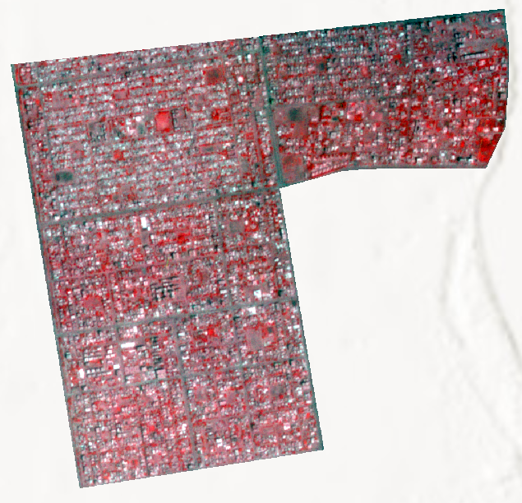
Figure 13. Planet Labs

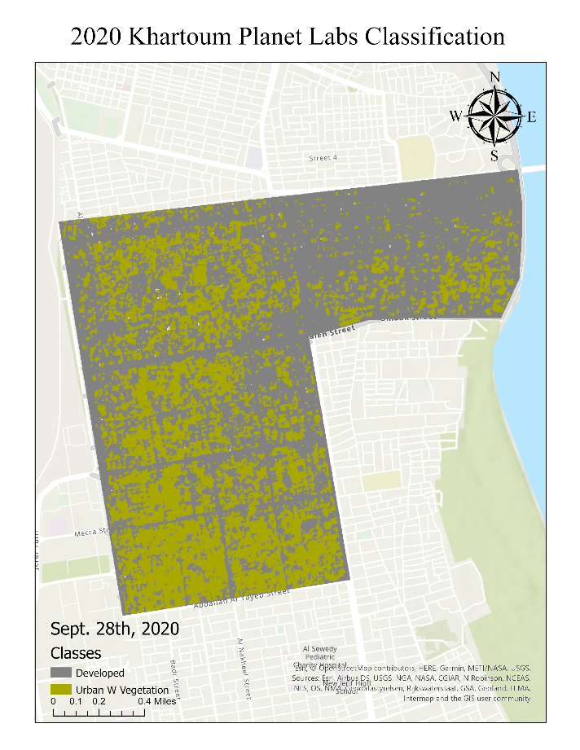
Figure 14. Planet Labs Classification Using eCognition

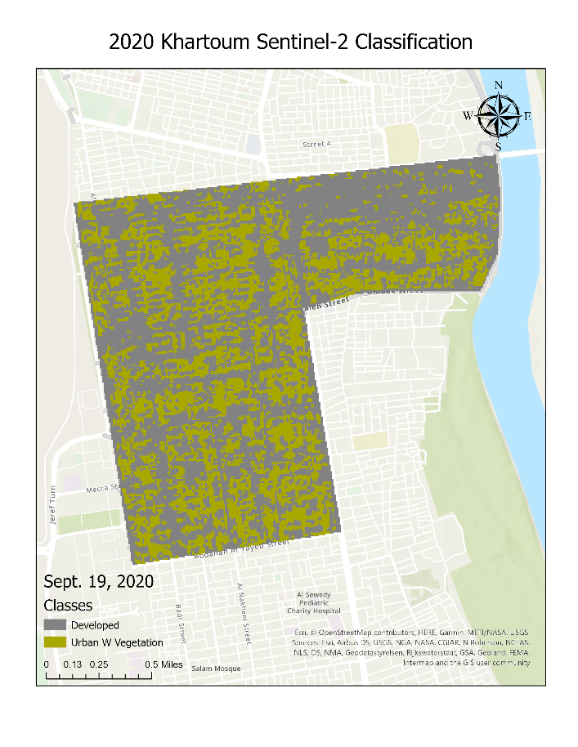
Figure 15. Sentinel-2 Classification Using eCognition

Land Cover Class | Planet Labs  (acres) | Sentinel-2  (acres)
Developed | 905.3 acres | 877.1 acres
Urban W Vegetation | 582.8 acres | 597 acres
Table 9. eCognition Supervised OBIA Land Cover Classification Planet Labs vs Sentinel-2

Analysis
eCognition Developer was designed to be a powerful development program geared towards object-based image analysis. For that reason, it is often used to develop rulesets to automate the analysis of remote sensing data. One of its distinguishing qualities is its ability to allow the user to incorporate and utilize all the individual bands for any given set of imagery. In addition to that, the user can also set layer weights for each individual band to create specific rulesets that can be developed within the process tree environment for raster analysis, pattern recognition, image segmentation, and object-based image classification as can be seen in figures 20 through 23.
ArcGIS Pro on the other hand, allows for a much broader demographic of industries to utilize its resources. As a result, it has an extensive toolbox for a variety of different workflows. Despite allowing its users to create composite images for multi-band raster datasets, ArcGIS Pro has certain limitations when it comes to the visualization of those layers. Although the option to switch between the different bands within a composite image to create different combinations exists, it only allows for the visualization of 3-bands at a time to create an RGB multi-band composite image. This restriction creates certain limitations when attempting to classify multi-band imagery.
To compare the classification abilities of each software program, classification comparison bar graphs were created highlighting the percent difference in classification between the two programs for each class. Fig. 24 highlights the classification percent differences for the Landsat 5 Khartoum 1990 image. Here you can see a significant 11% difference between what ArcGIS Pro and eCognition classified as barren, with eCognition identifying more barren land. Additionally, there also appeared to be a 4% difference between what the two software programs classified as agriculture, and a 3.3% classification difference for urban with vegetation.
Furthermore, for the Sentinel-2 Khartoum 2020 classification, as shown in fig. 25, there appeared to be a much more noticeable discrepancy between the two software programs. A 20% classification difference was evident between ArcGIS Pro and eCognition for fallow land, with eCognition classifying more of the land cover as fallow. There also appeared to be a 10.4% classification difference for urban with vegetation as ArcGIS Pro classified more of the land cover to fall within that class.
Moreover, when looking at figure 27, we can see that both software programs produced similar results when classifying the 1990 Landsat 5 Jebel Awlia imagery with no percent difference in classification exceeding 3%. The 2020 Sentinel-2 classification comparison, however, as can be seen in figure 28, shows a 30% difference in urban with vegetation as well as a 14% difference in agriculture and a 13% difference in fallow land. A visual inspection of figures 16 through 23 can allow us to infer that eCognition was more reliable in classifying the imagery.
Therefore, as shown in figure 26, eCognition was used as the basis to produce a percent difference in land cover change bar chart for Khartoum. Developed land increased by a factor of 862% from 1990, along with fallow land, urban with vegetation, and the White Nile; that all increased by factors of 100%, 77.4%, and 75.7% respectively. Meanwhile agriculture decreased by 65.4%, barren decreased by 100% and the Blue Nile decreased by 19.2% during the same time frame.
Similarly, as can be seen in figure 29, agriculture in the district of Jebel Awlia increased by a factor of 2,842%. Land cover for fallow, urban with vegetation, as well as both the Blue and White Niles have also increased. Barren significantly decreased by nearly 94%, allowing for agriculture, fallow land and urban with vegetation to grow in the region of Jebel Awlia.
Lastly, when comparing the Sentinel-2 and Planet Labs imagery, Sentinel-2 does a very satisfactory job at classifying the region of interest, as can be seen in table 9, when compared to the 3-meter spatial resolution of the Planet Labs imagery. This indicates that Sentinel-2 imagery is highly suitable for detailed land cover change classification with the added benefit of being able to cover a much larger area of interest by having a swath width of 290 km at 10-meter spatial resolution. In addition to that, it is also freely accessible to the public.

- ArcGIS Pro Classification Maps

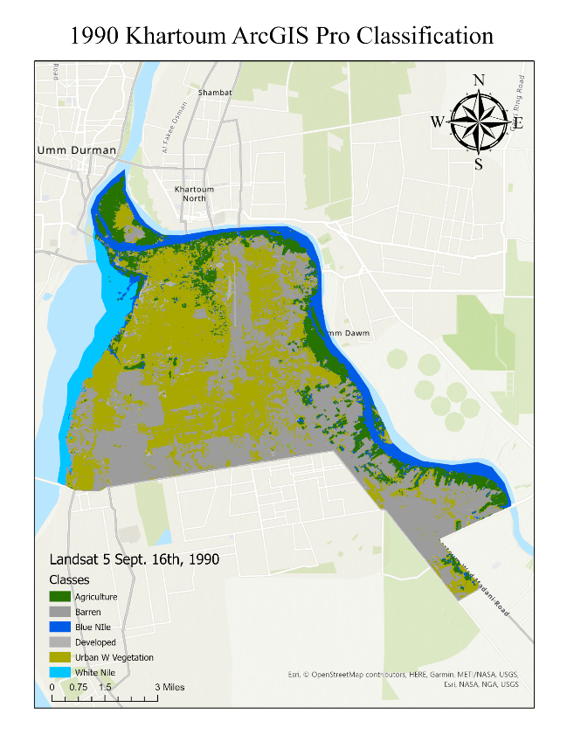
Figure 16. Object Based Supervised LULC Classification for Khartoum in 1990
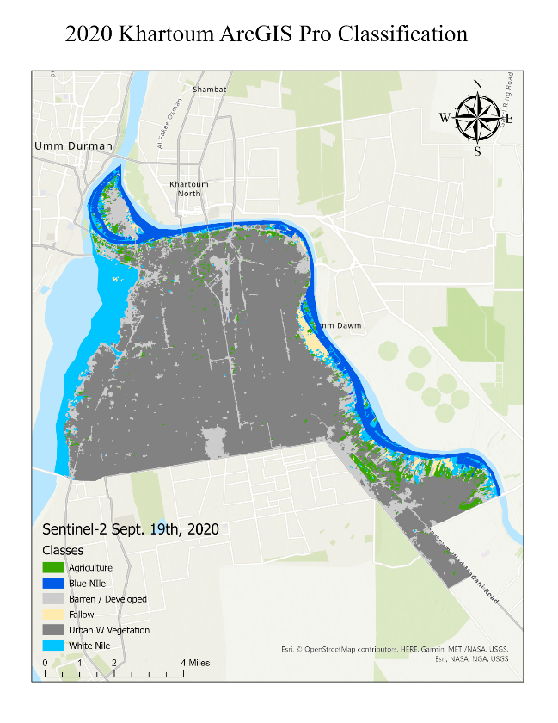
Figure 17. Object Based Supervised LULC Classification for Khartoum in 2020

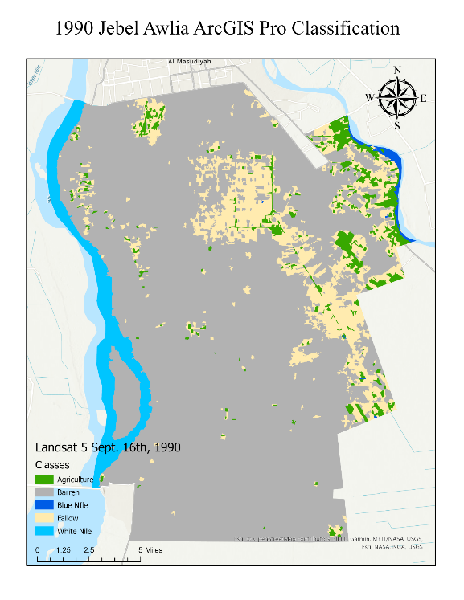
Figure 18. Object based Supervised LULC Classification for Jebel Awlia in 1990
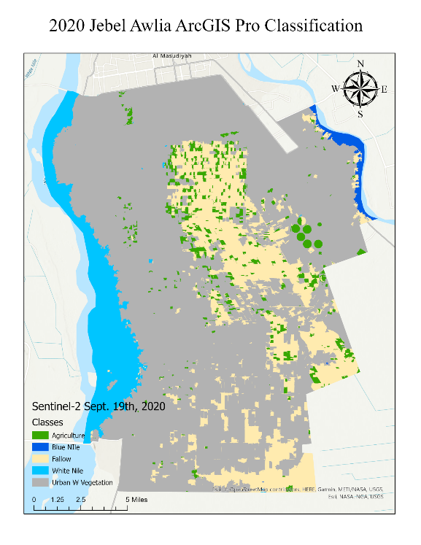
Figure 19. Object Based Supervised LULC Classification for Jebel Awlia in 2020

- eCognition Classification Maps

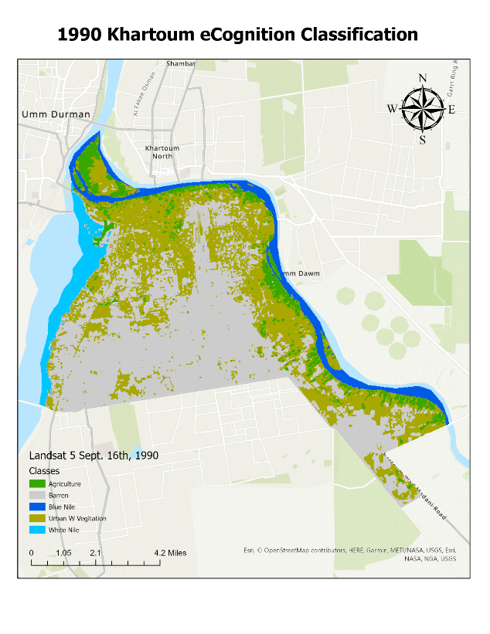
Figure 20. eCognition Classification of Khartoum in 1990
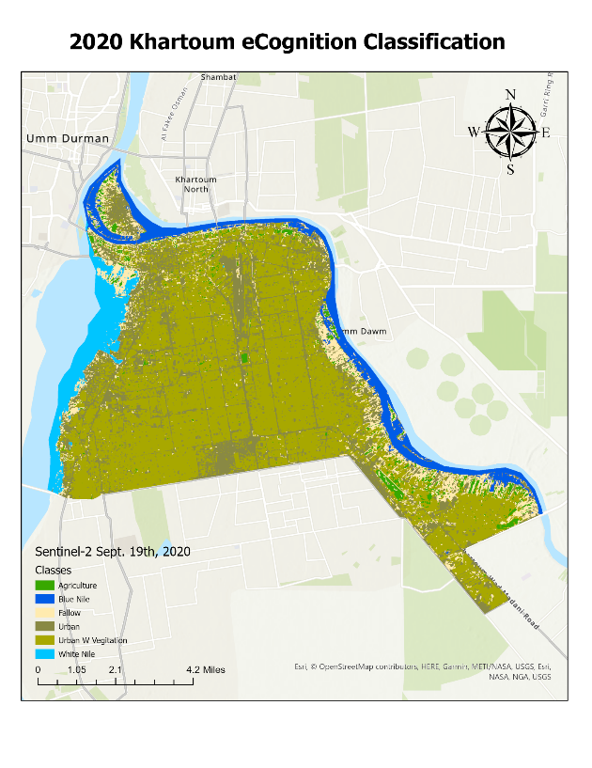
Figure 21: eCognition Classification of Khartoum in 2020

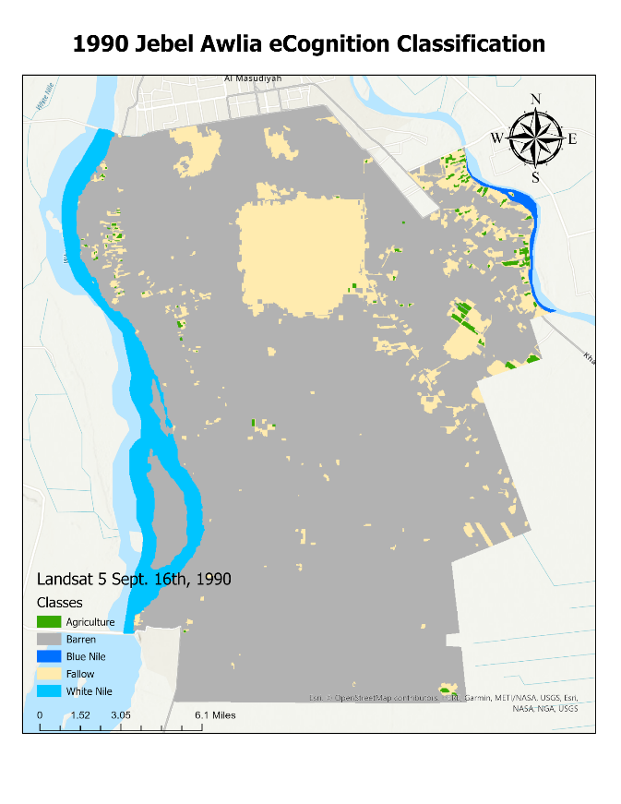
Figure 22: eCognition Classification of Jebel Awlia in 1990
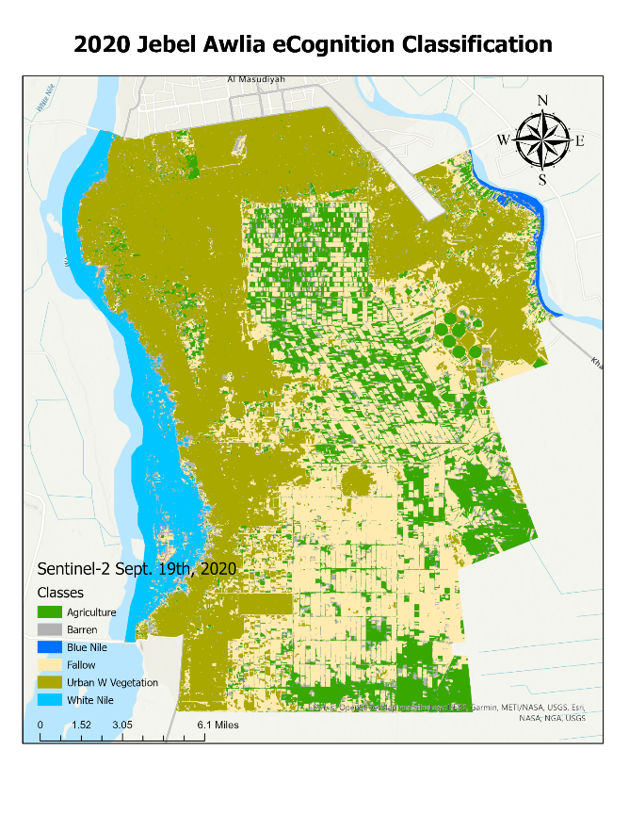
Figure 23: eCognition Classification of Jebel Awlia in 2020

Figure 24. Landsat 5 Khartoum 1990 Software Classification Comparison

Figure 25. Sentinel-2 Khartoum 2020 Software Classification Comparison

Figure 26. Bar Graph Showing Percent Difference in Land Cover Classes for Khartoum
Using eCognition

Land Cover Class | 1990 (Acres) | 2020 (Acres) | Difference (acres) | eCognition Percent Difference
Agriculture | 4,325.60 | 1,495.90 | -2,829.70 | -65.4%
Barren | 14,617.60 | 0 | -14,617.60 | -100%
Blue Nile | 3,222.20 | 2,604.80 | -617.40 | -19.2%
Developed | 526.4 | 5,067.70 | 4,541.30 | 862.7%
Fallow | 0 | 545.7 | 545.7 | 100%
Urban W Vegetation | 14,768.90 | 26,202.10 | 11,433.20 | 77.4%
White Nile | 2,041.40 | 3,586.20 | 1,544.80 | 75.7%
Table 10. Table Showing Percent Difference in Land Cover Classes for Khartoum
Using eCognition

Figure 27. Landsat 5 Jebel Awlia 1990 Classification Comparison

Figure 28. Sentinel-2 Jebel Awlia 2020 Software Classification Comparison

Figure 29. Bar Graph Showing Percent Difference in Land Cover Classes for Jebel Awlia
Using eCognition

Land Cover Class | 1990 (Acres) | 2020 (Acres) | Difference (acres) | eCognition Percent Difference
Agriculture | 1,127.90 | 33,185.30 | 32,057.40 | 2842.2%
Barren | 150,897.80 | 9,638.10 | -141,259.70 | -93.6%
Blue Nile | 749.9 | 924 | 174.10 | 23.2%
Fallow | 22,417.40 | 56,984 | 34,566.60 | 154.2%
Urban W Vegetation | N/A | 71,879.50 | 71,879.50 | 100%
White Nile | 10,255.50 | 12,969.20 | 2,713.70 | 26.5%
Table 11. Table Showing Percent Difference in Land Cover Classes for Khartoum
Using eCognition

Summary
Urban activity significantly increased within the capital district of Khartoum, as the population grew from 2.4 million people in 1990 to 5.8 million in 2020. This growth in population is reflected in the land cover change for Khartoum as developed land increased by more than 800% within that time frame. Barren land decreased by a factor of 100% as urban with vegetation and fallow land along the Blue and White Nile channels grew by factors of 77.4% and 100% respectively. It is also imperative to note that land cover change for the White Nile grew by a factor of 75.7% from 1990. This is important to note as floods along the White Nile are becoming increasingly frequent and more devastating with unprecedented flooding events occurring in September of 2020 resulting in a nationwide state of emergency.
Moreover, due to the agricultural sector playing a significant role in the country’s economy, with 80% of Sudan’s labor force being in the agricultural sector, and agricultural products accounting for 80 to 90% of the country’s exports, indicating an overwhelming dependence of its economies on natural resources, it is imperative to see some form of agricultural growth within the region over the past 30 years. This is also reflective in the land cover change analysis as agricultural land grew more than 2800% in Jebel Awlia. Fallow land also significantly increased by 154%, along with a 100% in urban with vegetation, a 94% decrease in barren land, and a 23% and 26.5% increase in land cover for the Blue and White Niles respectively.

Conclusion
Access to data and information for evidence-based planning is crucial to helping the Sudanese people adapt to the challenges they face. The objective of this analysis was to quantify the land cover change for the districts of Khartoum and Jebel Awlia in conjunction with the increased population growth within the region to see how human activity has shaped the land cover change of the region over the previous three decades. With the population increase and the high dependency of the Sudanese people on natural resources, the land cover change data showed a significant increase in agricultural and fallow land, in addition to an increase in urban with vegetation land within the Jebel Awlia and Khartoum regions. Furthermore, with the increased flooding events that have recently hit Sudan, the Blue and White Nile classes have also increased with officials recording the highest water levels on the Blue Nile in 2020 since records began more than a century ago. This work aims to lay the groundwork for future land cover mapping and remote sensing applications for this capital region of Sudan given its projected increase in population size over the next 30 years. Given the global effects of climate change and human activity, accurate land cover maps form the basis for GIS analysis and for better governance and this project lays a baseline for further remote sensing-based mapping applications for the Khartoum region.

Works Cited
Albalawi, E. K., & Kumar, L. (2013). Using remote sensing technology to detect, model and map desertification: A review. https://rune.une.edu.au/web/handle/1959.11/13125
Ambalam, K. (2014, April 30). United Nations Convention to Combat Desertification: Issues and Challenges. E-International Relations. https://www.e-ir.info/2014/04/30/united-nations- convention-to-combat-desertification-issues-and-challenges/
El-Hamid, H. T. A., Kaloop, M. R., Abdalla, E. M., Hu, J. W., & Zarzoura, F. (2021). Assessment and prediction of land-use/land-cover change around Blue Nile and White Nile due to flood hazards in Khartoum, Sudan, based on geospatial analysis. Geomatics, Natural Hazards and Risk, 12(1), 1258–1286. https://doi.org/10.1080/19475705.2021.1923577
Environment, U. N. (2017, September 21). State of the environment in Sudan. UNEP - UN Environment Programme. http://www.unep.org/explore-topics/disasters-conflicts/where- we-work/sudan/state- environment-sudan
Hilmi, H., & Sedahmad, S. (2014). Land use land cover change detection: A case study: Khartoum state, Sudan, 1972 -2006. Global Journal of Environmental Science and Technology, 2, 75.
Lahlaoi, H., Rhinane, H., Hilali, A., Lahssini, S., & Moukrim, S. (2017). Desertification Assessment Using MEDALUS Model in Watershed Oued El Maleh, Morocco. Geosciences, 7(3), 50. https://doi.org/10.3390/geosciences7030050
Lamqadem, A. A., Pradhan, B., Saber, H., & Rahimi, A. (2018). Desertification Sensitivity Analysis Using MEDALUS Model and GIS: A Case Study of the Oases of Middle Draa Valley, Morocco. Sensors (Basel, Switzerland), 18(7). https://doi.org/10.3390/s18072230
Lee, E. J., Piao, D., Song, C., Kim, J., Lim, C.-H., Kim, E., Moon, J., Kafatos, M., Lamchin, M., Jeon, S. W., & Lee, W.-K. (2019). Assessing environmentally sensitive land to desertification using MEDALUS method in Mongolia. Forest Science and Technology, 15(4), 210–220. https://doi.org/10.1080/21580103.2019.1667880
Mohamed, T. A. (2016). MONITORING AND ANALYZING OF DESERTIFICATION TREND IN NORTH SUDAN USING MODIS IMAGES FROM 2000 to 2014. https://cola.siu.edu/geography/_common/documents/papers/mohamed.pdf
Zakieldeen, S. A. (2009). Adaptation to Climate Change: A Vulnerability Assessment for Sudan. Adaptation to Climate Change, 24.
https://pubs.iied.org/sites/default/files/pdfs/migrate/14586IIED.pdf

