STATEWIDE GROUNDWATER VULNERABILITY STUDY FOR MARYLAND

By Olufunso S. Ogidan
GEOG 596B
June 2010

Adviser: Dr. Barry Evans

INTRODUCTION AND BACKGROUND

Groundwater is a major source of public and private drinking water as well as agricultural water supplies in the state of Maryland (Wolman, 2008). However, there has been concerns and outcry over the potential contamination of this vital resource in the state. Sources of potential pollution to groundwater in Maryland include leakages from Underground Storage Tanks (UST), dumping sites, spillage from activities that generate, utilize or transport potential contaminants as well as pesticide leachates from farming practices. Developing a detailed statewide vulnerability map can help decision makers to determine areas where critical groundwater protection or monitoring is necessary.
The DRASTIC model is one of the most widely used groundwater vulnerability methods available. The DRASTIC model utilizes seven hydrogeologic factors to determine the vulnerability of groundwater to contamination from anthropogenic sources. The seven hydrogeologic factors are Depth to groundwater, net Recharge, Aquifer media, Soil media, Topography (slope), Impact of the vadose zone and hydraulic Conductivity (Aller, Truman, Lehr, & Petty, 1985).
The goal of this project is to develop a statewide groundwater vulnerability map that will show the areas with the greatest potential to groundwater pollution. The resulting map will rank vulnerability based on the DRASTIC index calculated from the integration of established weighting and assigned rating to each of the hydrogeologic factors. Thereby providing decision makers with areas where targeted critical groundwater quality and vulnerability assessments might be required.

LITERATURE REVIEW

The U.S. Environmental Protection Agency (EPA) first introduced the DRASTIC methodology for groundwater vulnerability assessment in 1985 (Aller, Truman, Lehr, & Petty, 1985). The DRASTIC method utilizes seven hydrogeologic factors to assess the vulnerability of groundwater in an area. The seven hydrogeologic factors include Depth to groundwater, net Recharge, Aquifer media, Soil media, Topography, Impact of the vadose zone and hydraulic Conductivity (Aller, Truman, Lehr, & Petty, 1985). The DRASTIC mapping method is perhaps the most widely used groundwater vulnerability method in the United States (Rupert M. G., 1999). However, the widespread usage of the DRASTIC model has met some criticism; some authors have questioned the efficiency of the method particularly due to lack of calibration (Barbash & Resek, 1996; Rupert M. , 1997; Rupert M. , 2001) and others have proposed some form of improvement to the DRASTIC methodology. For example, Rupert, M. 1997 proposed the use of point rating calibration of nitrate and nitrite as nitrogen concentration in groundwater in combination with the land use, soil media and depth to water as an alternative to the DRASTIC model. The DRASTIC however, remains the method of choice for groundwater vulnerability assessment. This might be because the data needed for DRASTIC studies are usually readily available in the public domain and the availability of Geographic Information Technology has made the analysis relatively easy to perform.
Most DRASTIC studies focused on either a single hydrogeologic setting or county. Perhaps this is because most groundwater studies are conducted at the county government level. Few studies however, have applied the DRASTIC methodology to a statewide groundwater vulnerability assessment in the United States. Examples of such studies include the development of statewide groundwater DRASTIC vulnerability assessment model for Nebraska (Rundquist, Peters, Di, Rodekohr, Ehrman, & Murray, 1991) and Oklahoma (Osborn & Hardy, 1999). Conversely, such large-scale regional groundwater vulnerability studies are common in other countries around the world (Lobo-Ferreira & Oliviera, 1997; British Geological Survey, 2005). There is currently no statewide groundwater vulnerability study for the state of Maryland. Most existing vulnerability studies focused on the pesticide pollution or groundwater quality studies in specific regions of the state (Bolton, Personal Communication; Andreasen & Fewster, 2005; Ator & Reyes, 2008).
Groundwater pollution remains a major public concern in the state of Maryland. For example, Methyl Tertiary Butyl Ether (MTBE) leakages have resulted in groundwater pollution in many parts of the state, resulting in several class action lawsuits (Barnhardt, 2007; Park, 2008). As of April 30, 2009, there are 8,580 underground storage tanks (UST) and 11,109 confirmed releases in the state (U.S. Environmental Protection Agency, 2009). Another source of groundwater pollution in the state includes non-point source pollutions such as pesticide leachates due to the wide use of pesticide in many part of the state (Ator & Reyes, 2008). A United States Geological Survey (USGS) report identified 27 different pesticides and pesticide byproducts in Maryland’s western and central regions groundwater system (Gilliom, et al., 2006). Other potential sources of groundwater pollution include spillage at the ground surface, and waste disposal sites.
One of the assumptions of the DRASTIC methodology is that contaminations occur at the ground surface (Aller, Truman, Lehr, & Petty, 1985). However, most of the potential groundwater pollution sources in the state of Maryland do not occur at the ground surface. This suggests that the DRASTIC map generated in this study cannot be singularly used to determine the suitability of a site for waste disposal or USTs. In these cases, other factors such as design criteria will play a major role in the decision-makings. We believe a statewide groundwater vulnerability map can serve as a screening tool to determine areas where critical groundwater monitoring might be required. The DRASTIC methodology has been found to be particularly suitable for such large-scale regional groundwater vulnerability study (Robins, 1998).

METHODOLOGY

The DRASTIC model is one of the most widely used groundwater vulnerability assessment model available. The method was developed by the U.S. Environmental Protection Agency (Aller, Truman, Lehr, & Petty, 1985). As previously mentioned, the word DRASTIC corresponds to the initials of the seven hydrogeologic parameters that affect and control the movement of groundwater into, through and out of an area.
Each of the DRASTIC parameter has an established relative weight ranging from 1-5. The weights were developed using the Delphi technique and assigned based on relative importance of the hydrogeologic factor in question (Aller, Truman, Lehr, & Petty, 1985). Appropriate ratings were methodologically assigned to each area in the attribute table for that parameter (the ratings range from 1-10) based on the characteristics of the parameters in specific area. We then compute the DRASTIC index by applying a linear combination of the seven parameters based on the equation below
DRASTIC Index = D_{R}D_{W} + R_{R}R_{W} + A_{R}A_{W} + S_{R}S_{W} + T_{R}T_{W} + I_{R}I_{W} + C_{R}C_{W}
Where
D, R, A, S, T, I, C = Initials of the seven hydrogeologic factors,
R= Ratings
W= Weight
All analysis to include interpolation, clipping, reclassification and raster calculation were performed ArcGIS 9.3.1. The resulting index from the raster calculation is the DRASTIC Index for the state of Maryland

DATA AND ANALYSIS

The data used for this project either were obtained from publicly available data sources or published literatures. Where the data is not readily available, we estimated the data based on scientific procedures outlined in published literatures.

Depth to Water:
The depth to water is essential because it determines the depth that contaminant will have to travel before reaching the groundwater. Depth to water (measured in feet) is the distance from the ground surface to the water table. The water table in an unconfined aquifer is defined as the top of the saturated region where water rise and fall freely under atmospheric pressure. This region is synonymous to the level of water is a well in an unconfined aquifer (Aller, Truman, Lehr, & Petty, 1985; Al-Zabet, 2002). In a confined aquifer on the other hand, the water table is defined as the distance from the ground surface to the top of the aquifer. This region is synonymous to the bottom of the confining unit (Aller, Truman, Lehr, & Petty, 1985).
For the purpose of this study, Depth to Water was estimated from interpolation of data obtained from USGS for 490 groundwater wells in and around Maryland (U.S. Geological Survey, 2009). An average of depth from the surface to water over four years was used to determine Depth to water at that point. We decided to use a four years average because only few active well data are available for the state. In addition, an average water depth over time will likely reduce the seasonal variability in groundwater level. Continuous Interpolated Depth to Water surface for the state was generated by interpolation of the point data. Ratings were applied to the interpolated data to generate the DRASTIC depth to water surface for the state. Figure 1 is a map showing the reclassified depth to water surface for the state of Maryland
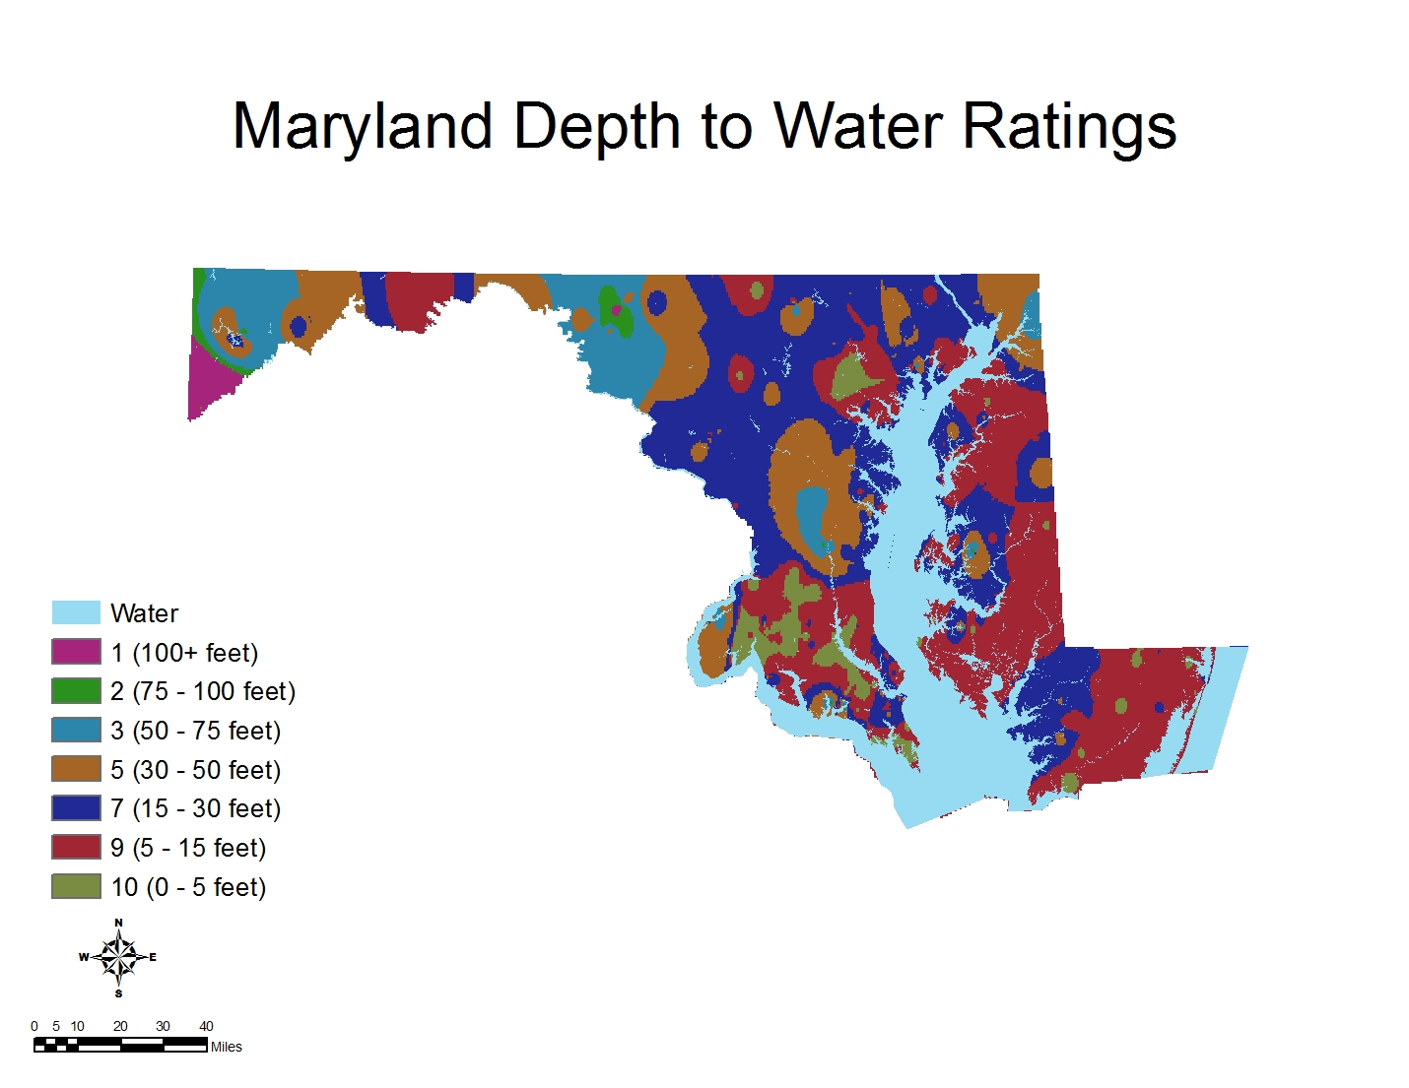
Figure 1 Map showing the DRASTIC Depth to Water Surface for the state of Maryland

Net Recharge:
Net recharge is the quantity of water from precipitation that infiltrates into the ground to reach the water table. Net recharge (measured in inches per year) is the average annual amount of infiltration that reaches the aquifer. The net recharge does not take into consideration the distribution, intensity or duration of recharge events (Aller, Truman, Lehr, & Petty, 1985).
We could not find any existing data that presents the net recharge for the state of Maryland. However, a good estimate of net recharge can be made by using the hydrologic soil group characteristics. Hydrologic soil groups are defined based on the runoff potential estimates; the soils are characterized based on the rate of infiltrations when thoroughly wets soils with no vegetation cover are exposed to precipitation from long duration storms (Cowherd, 2008). Previous studies have estimated net recharge for each hydrologic soil groups for the state of Maryland (Rawls, Brakensiek, & Saxton, 1982; Comstock & Wallis, 2000). We obtain the hydrologic soil groups data for Maryland from the U.S. Department of Agriculture soil data mart (U.S. Department of Agriculture, 2009). Table 1 is a list of the hydrologic soil group and the associated estimated net recharge for the state of Maryland (Rawls, Brakensiek, & Saxton, 1982).
Table 1 Table showing the Estimated USDA Annual Recharge Volume based on an average annual precipitation of 46 inches/year for Maryland
Hydrologic Soil Group | USDA Average Annual Recharge Volume (inches/year)*
A | 18
B | 12
C | 6
D | 3

The estimates were based on an average precipitation of 46 inches/year. Ratings were applied to hydrologic soil group polygons based on the estimated recharge and the data was reclassified to generate the DRASTIC net recharge surface for the state of Maryland. Figure 2 is a map showing the estimated net recharge surface for the state.
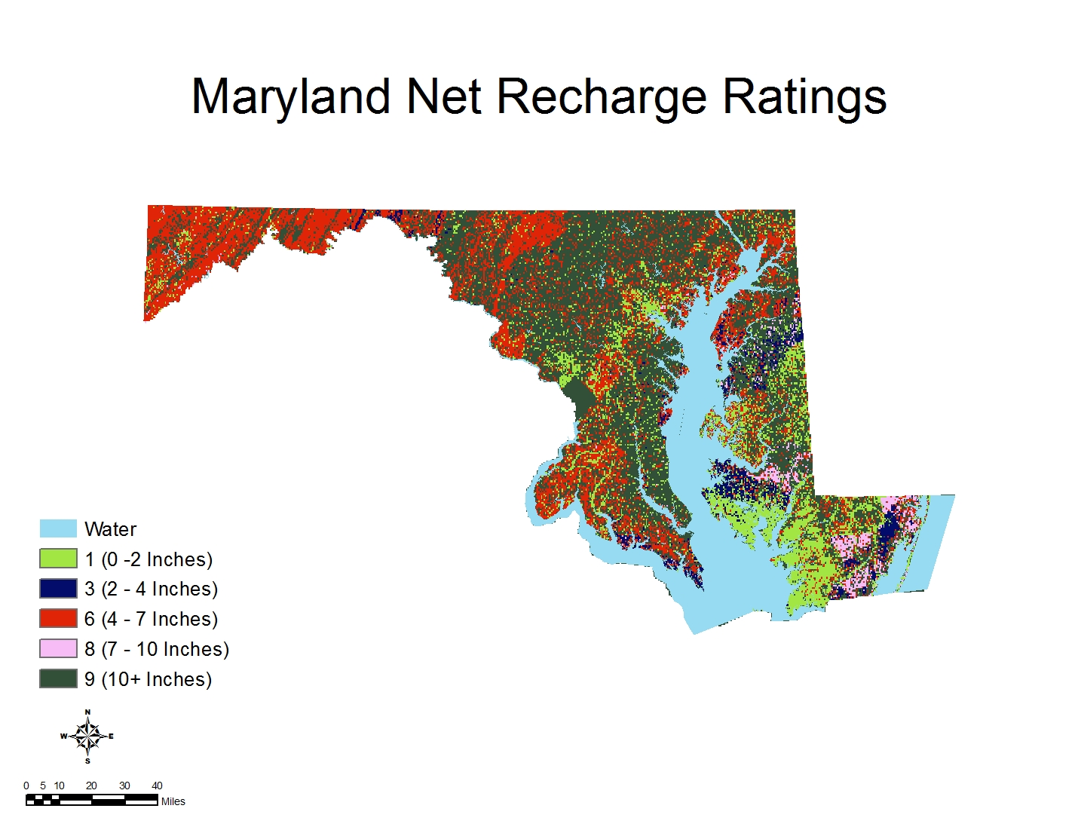
Figure 2 Map showing the Reclassified Net Recharge Surface for the state of Maryland

Aquifer Media:
Aquifer media refers to the consolidated or unconsolidated subsurface rock that serves as the aquifer. An aquifer is a water bearing formation that can economically yield water to well (Aller, Truman, Lehr, & Petty, 1985). We obtained the national aquifer data from the U.S. Geological Survey (U.S. Geological Survey, 2003). Maryland is underlain by four major national aquifers. These aquifer systems include the North Atlantic Coastal Plain aquifers, the Piedmont and Blue Ridge aquifers, the Valley and Ridge aquifers and the Appalachian Plateaus aquifers. Locally, the aquifers are further characterized based on the geology of the aquifers rock units. We utilized the rock characteristics of the aquifer medium to estimate the DRASTIC ratings for this study. The rated was reclassified to generate the DRASTIC aquifer media surface. Figure 3 is a map showing the reclassified aquifer media surface based on the significant media type for the state of Maryland
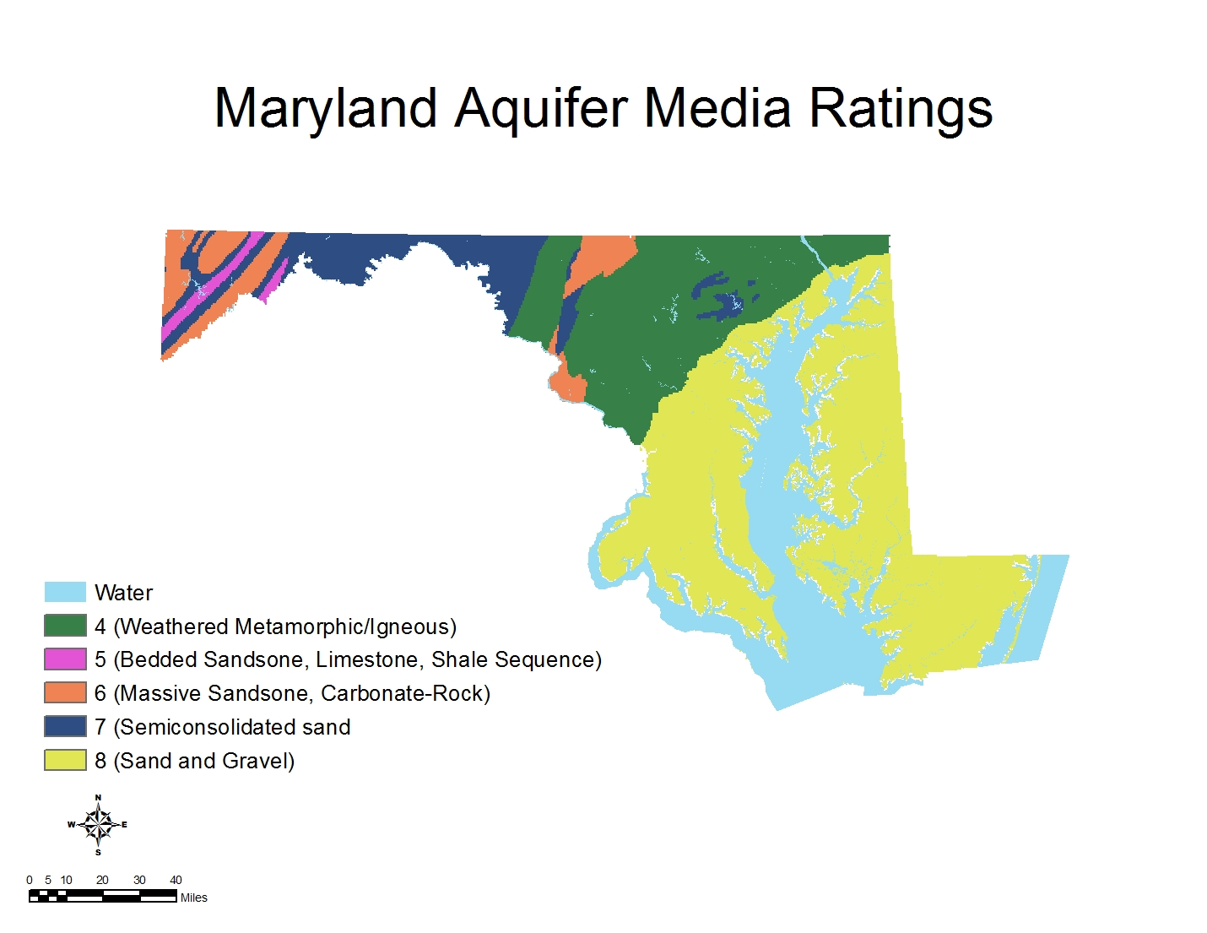
Figure 3 Map showing the reclassified Aquifer Media Surface for the state of Maryland

Soil Media:
Soil media is the upper weathered zone of the earth up to about six feet or less from the surface (Aller, Truman, Lehr, & Petty, 1985). The soil media play a vital role on the amount of infiltration and biogeochemical attenuation of contaminants before seepage into the groundwater system. The soil media data was obtained from the U.S. Department of Agriculture soil data mart (U.S. Department of Agriculture, 2009). An estimate of the DRASTIC ratings was determined from the data by using a combination of significant soil type, drainage and percent loam attributes. The rated data was reclassified to generate the soil media DRASTIC surface for the state. Figure 4 is a map showing the reclassified soil media surface for the state of Maryland.
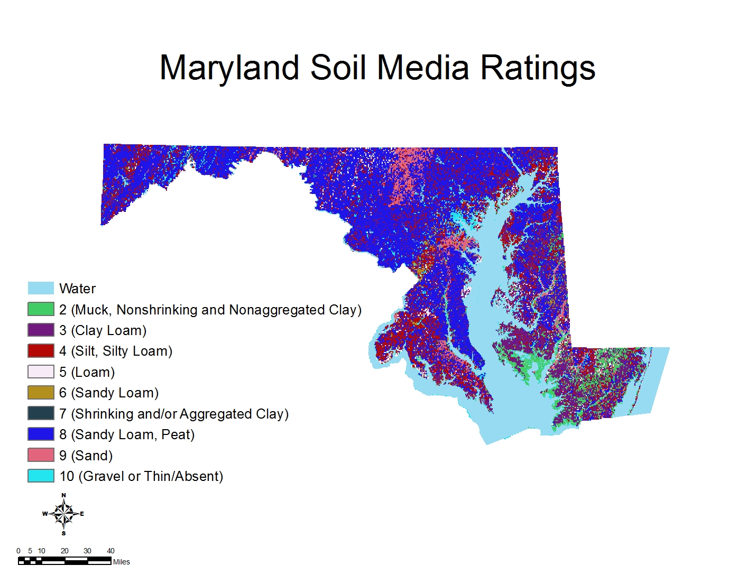
Figure 4 Map showing the reclassified soil media surface for the state of Maryland

Topography (Slope):
Topography describes the slope variability of the land surface (Al-Zabet, 2002). The topography of an area will influence the proportion of precipitation and anthropogenic contaminants that will be washed away as runoff or infiltrate into the ground. In general, the steeper the slope, the less likely the introduced pollutant will seep into the ground. In addition, the topography plays a major role in soil formation, which is another factor that influences vulnerability. Maryland 30m resolution Digital Elevation Model (DEM) obtained from USGS (U.S. Geological Survey, 2009) was used to calculate the slope for the state. The DEM quad was mosaic using the spatial analyst operation in ArcGIS. We then converted the elevation data to percent slope. Ratings were assigned based on ranges to the percent slope and reclassified to generate the DRASTIC Slope Surface for the state. Figure 5 is a map showing the reclassified percent slope for the state. As previously mentioned, the steeper the slope, the less likely the introduced pollutant will seep into the ground therefore a lower Rating
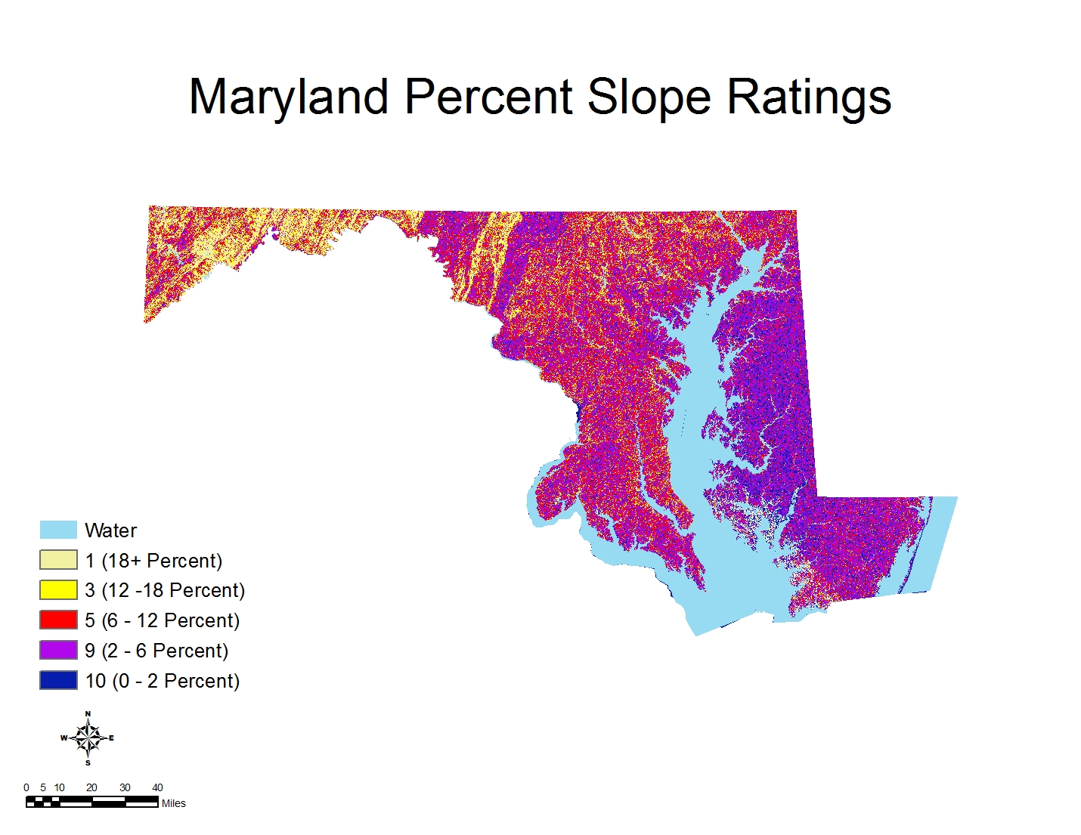
Figure 5 Map showing the reclassified percent slope for the state of Maryland

Impact of the Vadose Zone
The vadose zone is the zone between the land surface and the regional water table. It includes the capillary fringe as well as localized perched ground water if present (U.S. Geological Survey, 2006). The DRASTIC ratings for the impact of the vadose zone are based on the characteristic of the unsaturated zone rock types (Aller, Truman, Lehr, & Petty, 1985). The impact of the vadose zone was estimated from published geologic map of Maryland (Reger & Cleaves, 2008). Ratings were assigned based on the significant media type and reclassified to generate the Impact of the Vadose Zone surface for the state of Maryland. Figure 6 is a map showing the reclassified ratings of the impact of the vadose zone based on the significant media.
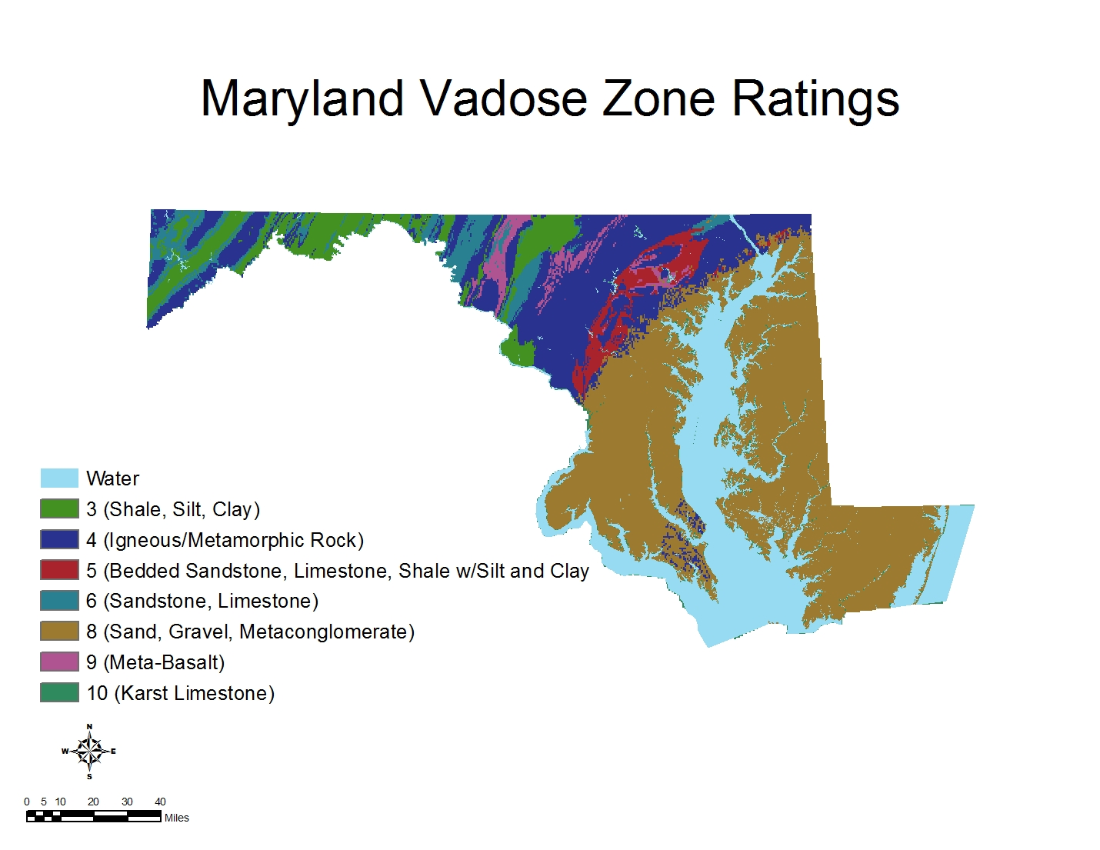
Figure 6 Map showing the reclassified ratings of the impact of the vadose zone based on the significant media type

Hydraulic Conductivity
Hydraulic conductivity describes the ability of an aquifer to transmit water. The hydraulic conductivity (measured in gpd/ft²) determine the rate at which groundwater will flow under a specific hydraulic gradient (Aller, Truman, Lehr, & Petty, 1985; Al-Zabet, 2002). Hydraulic conductivity data are usually calculated from aquifer pumping tests (Aller, Truman, Lehr, & Petty, 1985). We did not find any published hydraulic conductivity data for the state of Maryland. However, we estimated the hydraulic conductivity for the state based on the physical characteristics such as rock types and aggregation of the aquifer (Aller, Truman, Lehr, & Petty, 1985). The estimates for the hydraulic conductivities were based on the procedure outlined by Aller et al. (1985). Ratings were assigned to the estimated hydraulic conductivities data. The rated data was then reclassified to generate the DRASTIC Hydraulic Conductivity surface for the state. Figure 7 is a map showing the reclassified estimated hydraulic conductivity of Maryland based on the aquifer characteristics
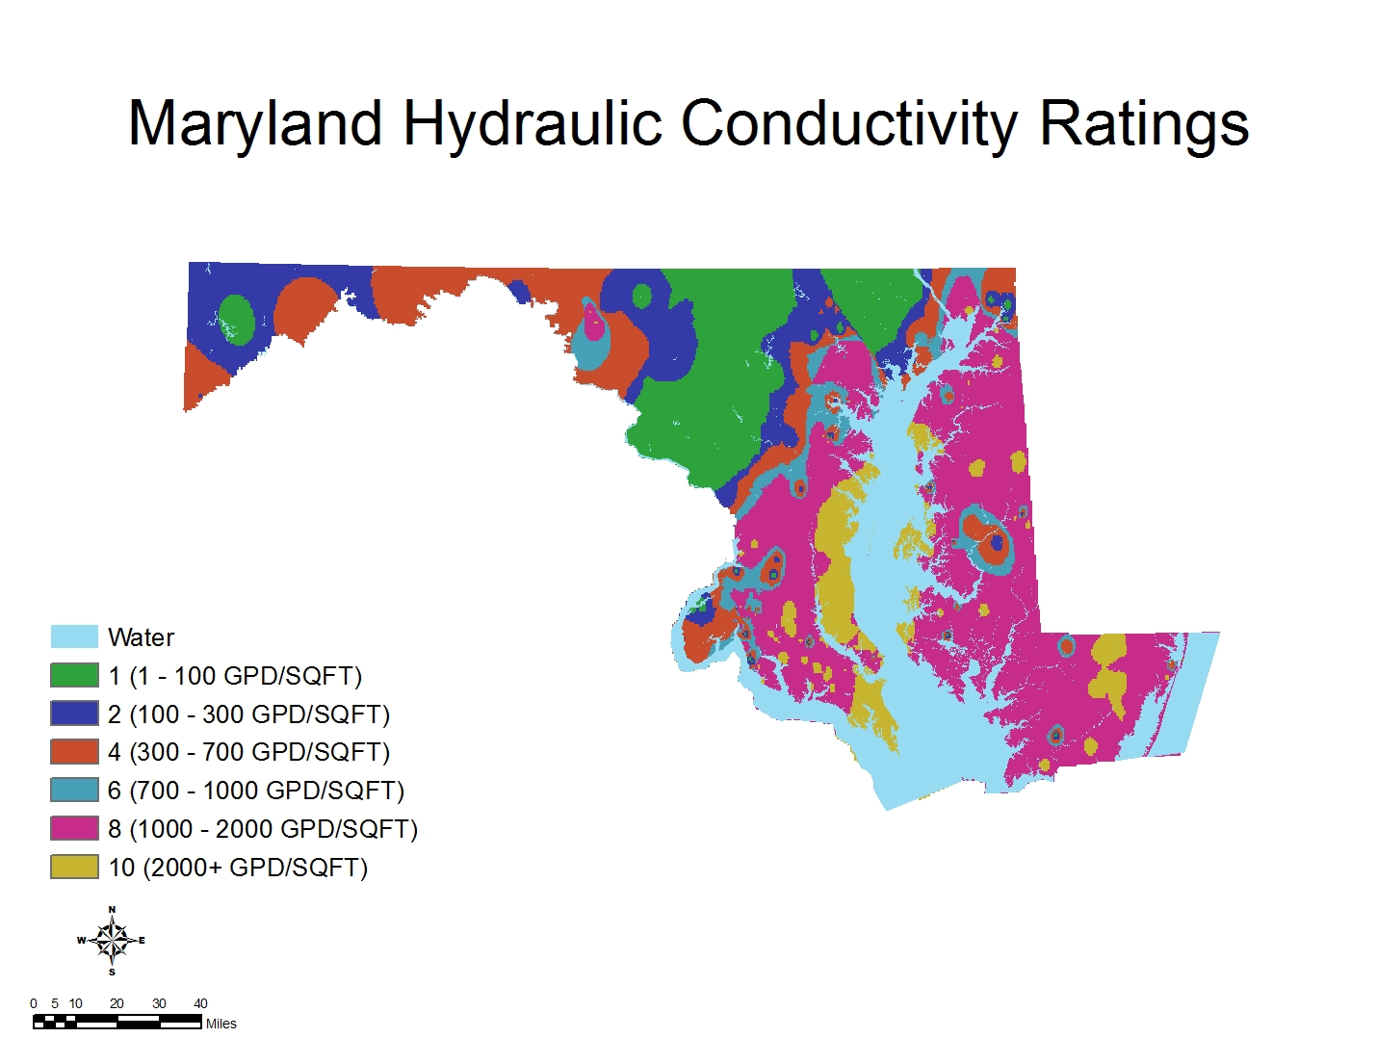
Figure 7 Map showing the reclassified estimated hydraulic conductivity of Maryland based on the aquifer characteristics

RESULT AND LIMITATION:

The resulting thematic map provides a relative ranking of the DRASTIC Index (D_{i}) based on susceptibility to groundwater pollution. Figure 8 is a map showing the overall DRASTIC Index for Maryland. The color theme for the DRASTIC index map is based on the EPA established DRASTIC color scheme (Aller, Truman, Lehr, & Petty, 1985). Higher DRASTIC index indicate higher vulnerability. The DRASTIC map for Maryland shows a general west-east trend. The calculated DRASTIC Index is higher in the Eastern part of the state and around the edges of the Chesapeake Bay. Vulnerability generally reduces westward from the Chesapeake Bay with the lowest vulnerability in westernmost Garrett and Allegany counties.
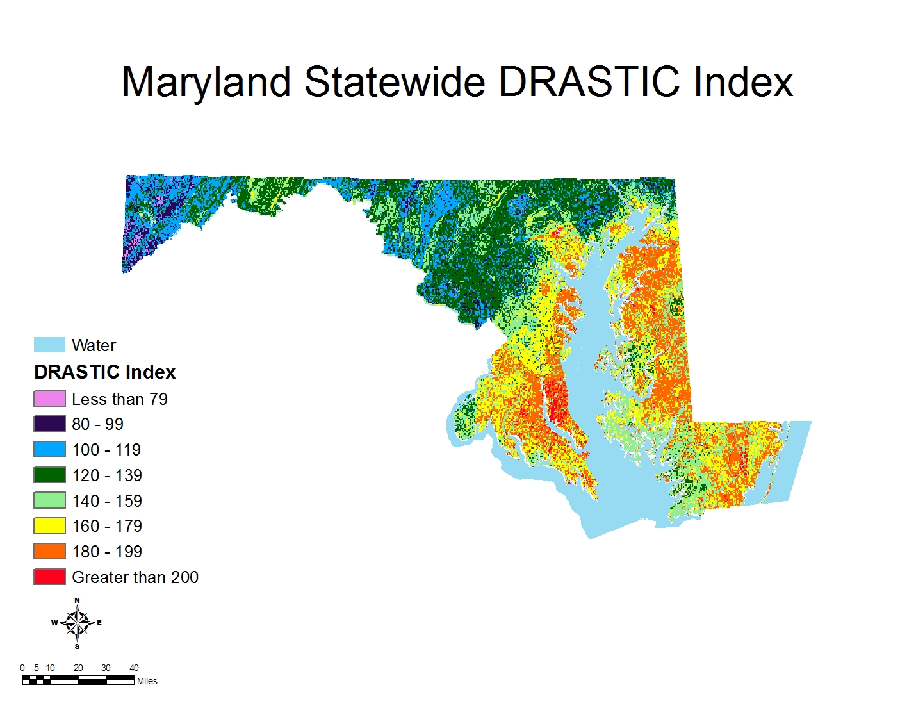
Figure 8 Map showing the DRASTIC Index for Maryland

Some hydrogeologic parameters were estimated due to unavailability of published data. In addition, there was no available data on the spatial locations of previous groundwater contaminations in the state of Maryland that can be used to analyze the correlation between DRASTIC generated vulnerable areas to known contamination incidences.
One of the assumptions of the DRASTIC methodology is that contaminations occur at the ground surface (Aller, Truman, Lehr, & Petty, 1985). However, most of the potential groundwater pollution sources in the state of Maryland do not occur at the ground surface. This suggests that the DRASTIC map generated in this study cannot be singularly used to determine the suitability of a site for waste disposal or USTs. In these cases, other factors such as design criteria will play a major role in the decision-makings.

CONCLUSION

The DRASTIC methodology was utilized to generate a statewide groundwater vulnerability map for Maryland. The resulting Maryland DRASTIC map indicates that the potential for groundwater pollution is higher in the eastern part of the state. This suggests that more concern needs to be given to activities that could result in groundwater pollution in the eastern part of Maryland. Although most of the western two-third of the state lies in areas with lower vulnerability index; there are patches of areas with high DRASTIC index. Therefore, it is important to consider the local DRASTIC index at a specific location rather than the general index trend during decision-making process of project that could result in groundwater pollution.

Bibliography
Aller, L., Truman, B., Lehr, J. H., & Petty, R. J. (1985). DRASTIC-A Standardized System for Evaluating Groundwater Pollution Potential Using Hydrogeologic Settings. U.S. Envirionmental Protection Agency, Rober S. Kerr Environmental Research Laboratory, Office of Reseach and Development, EPA/600/2-85/018.
Al-Zabet, T. (2002). Evaluation of Aquifer Vulnerability to Contamination Potential Using the DRASTIC Method. Environmental Geology , 203-208.
Andreasen, D., & Fewster, T. B. (2005). Estimation of areas contributing recharge to selected public-supply wells in designated metro core areas of Upper Wicomico River and Rockawalking Creek basins, Maryland. Maryland Geological Society, Hydrogeology and Hydrology Program.
Ator, S. W., & Reyes, B. (2008). Pesticide in Ground Water of Central and Western Maryland. U.S. Geological Survey.
Barbash, J., & Resek, E. (1996). Pesticide in Groundwater: Distribution, Trends and Governing Factors. 588.
Barnhardt, L. (2007, February 22). Fallston residents' class action suit OK'd: Judge says they may seek damages against Exxon Mobil in alleged well contamination. Retrieved November 13, 2009, from Baltimore Sun: http://articles.baltimoresun.com/2007-02-22/news/0702220027_1_exxon-station-fallston-contamination
Bolton, D. (Personal Communication, October 20). Maryland Department of Natural Resources. (O. Ogidan, Interviewer)
British Geological Survey. (2005). Britain Beneath Our Feet. Retrieved November 13, 2009, from Land Quality & Groundwater- Groundwater Vulnerability: http://www.bgs.ac.uk/britainbeneath/land_groundwater_vulnerability.html
Comstock, S. R., & Wallis, C. (2000). The Maryland Stormwater Management Program: A New Approach to Stormwater Design. Baltimore, Maryland: Maryland Department of the Environment.
Cowherd, D. (2008). Hydrologic Soil Group: Harford County, Aberdeen Proving Ground, Maryland. USDA Natural Resources Conservation Service.
Gilliom, R., Barbash, J., Crawford, C., Hamilton, P., Martin, J., Nakagaki, N., et al. (2006). Pesticides in the Nation's Streams and Groundwater, 1992-2001. U.S. Geological Survey.
Lobo-Ferreira, J., & Oliviera, M. M. (1997). DRASTIC GROUNDWATER VULNERABILITY MAPPING OF PORTUGAL. 27th Congress of the International Association for Hydraulic Research, (pp. 132-137). San Francisco.
Osborn, N. I., & Hardy, R. H. (1999). Statewide Groundwater Vulnerability Map of Oklahoma. Oklahoma Water Resources Board Technical Report 99-1.
Park, M. (2008, May 9). MTBE leak puts lives of families on pause: Long wait for resolution to gas additive case. Retrieved November 13, 2009, from Baltimore Sun : http://articles.baltimoresun.com/2008-05-09/news/0805080342_1_mtbe-patricia-morgan-fallston
Rawls, W., Brakensiek, D., & Saxton, K. (1982). Estimation of Soil Properties. Transactions of the American Society of Agricultural Engineers , 25 (5), 1316-1320.
Reger, J. P., & Cleaves, E. T. (2008). Physiographic Map of Maryland. Baltimore: Maryland Department of Natural Resources: Maryland Geological Survey.
Robins, N. (1998). Recharge: The Key Groundwater Pollution and Aquifer Vulnerabilty. In N. Robins, Groundwater Pollution, Aquifer Recharge and Vulnerability (pp. 1-5). London: Geological Society Special Publication, 130.
Rundquist, D. C., Peters, A. J., Di, L., Rodekohr, D. A., Ehrman, R. L., & Murray, G. (1991). Statewide groundwater-vulnerability assessment in nebraska using the drastic/GIS model. Geocarto International , 6 (2), 51-58.
Rupert, M. (2001). Calibration of the DRASTIC ground water vulnerability mapping method. Ground Water , 39 (4), 625-30.
Rupert, M. G. (1999). Improvement to the DRASTIC Ground-Water Vulnerability Mapping Method. U.S. Geological Survey National Water-Quality Assessment Program.
Rupert, M. (1997). Nitrate (NO2+NO3-N) in Groundwater of the Upper Snake River Basin, Idaho and Western Wyoming, 1991-95. U.S. Geological Survey Water Resources Investigation Report.
U.S. Department of Agriculture. (2009, March 12). Soil Data Mart. Retrieved October 31, 2009, from Natural Resources Conservation Service: http://soildatamart.nrcs.usda.gov/County.aspx?State=MD
U.S. Environmental Protection Agency. (2009, September 30). UST/LUST Program Status In Maryland. Retrieved November 11, 2009, from U.S. EPA : http://www.epa.gov/oust/states/md.htm
U.S. Geological Survey. (2003). Principal Aquifers of the 48 Conterminous United States, Hawaii, Puerto . Madison, WI: U.S. Geological Survey.
U.S. Geological Survey. (2009, September 14). The National Map Seamless Server. Retrieved October 2, 2009, from USGS: http://seamless.usgs.gov/index.php
U.S. Geological Survey. (2006, December 14). Toxic Substance Hydrology Program. Retrieved November 20, 2009, from USGS: http://toxics.usgs.gov/definitions/unsaturated_zone.html
U.S. Geological Survey. (2009, October 29). USGS Ground Water for Maryland. Retrieved November 2, 2009, from National Water Information System: Web Interface: http://water.usgs.gov/
Wolman, M. G. (2008). Water for Maryland's Future: What We Must Do Today. Maryland Department of the Environment.

