Examination of the Nigerian Extractive Industry’s
Impact on Agriculture in Kaduna State, Nigeria,
Using a Spatial-Temporal Analysis of MODIS NDVI Data

Christopher M. Parrett
Pennsylvania State University
Masters of Geographic Information Systems
Advisor: Dr. Brian King, PSU
29APR2014

Table of Contents
Executive Summary 3
Introduction 3
Background 3
Hypothesis 5
Study Area - Kaduna State 6
Scope/Task, Purpose, Goals 7
Phenology 8
MODIS NDVI 9
Analytical Method 10
Results 15
Conclusion 16

Executive Summary
Africa is beginning to enter the world-stage, with Nigeria poised to be the economic power on continent; however, recent events threaten to destabilize not only Nigeria, but the region. Nigeria's economy relies on oil and does not leverage its vast and diverse resources, principally agriculture. This study employed a resource-constrained approach using ArcGIS, Python, and open source data to locate changes in land-cover that could negatively impact agricultural productivity in Kaduna State, Nigeria. The Famine Early Warning System (FEWS) eMODIS NDVI data provided a highly-temporal, moderate resolution data series that enabled detection and characterization over large areas of land. Changes were compared to higher resolution data to assess their relation, if any, to extractive industry. The process identified approximately 21 changes, most all associated with urban expansion or water management. No evidence of extractive industry encroachment on the agriculture industry was uncovered.

Introduction
There is a large amount of research focusing on changes in land-cover, land-use and their resulting impact on the socio-economics of the local population. Many of these studies focus on relatively limited areas and rely on high-resolution imagery to measure changes between two distinct periods in time. This traditional method measures spatial distributions of potential change in land-cover classification and land-use with a higher degree of precision that oftentimes supports field measurements. This focused technique allows geographers to develop detailed data on the effects of the change in land-cover on a regional population; however, the method does not reveal when that change actually occurred in time and often requires detailed a priori knowledge of the area. The principle of spatial autocorrelation implies that the changes observed in such a limited area may be only applicable to those populations close to the change, both spatially and temporally. Furthermore, the use of significant amounts of high-resolution data requires high-end processors, toolsets, and increased storage, while field work is often expensive and time consuming. This paper examines a process that provides a geospatial analyst with a relatively inexpensive process that uses moderate resolution, high-temporal remote sensing data to identify and assess land cover changes over wide-areas. This process would also cue the analyst not only to the areas of change, but would indicate when during the time the change occurred in order to better determine the cause of the change and its impact on a larger population.

Background
The continent of Africa has long been regarded as the third world – a geopolitical manifestation of the Cold War that offered little to the world stage other than provide a proxy battleground for the Soviet Bloc and NATO. Most of sub-Saharan Africa remained governed by the remnants of European colonialism until the 1960s when many of the colonies received independence, leaving Africa a mere afterthought of the United States (US). Up to the turn of the century in the post-Cold War era, US interest in Africa seemed limited to intervention and humanitarian assistance. As recent as 1995, the US Department of Defense indicated that the United States had “very little traditional strategic interests in Africa.” This changed in October 2008, when the US Department of Defense (DoD) created a full-spectrum combatant command responsible for all DoD operations on the African continent - AFRICOM. This change signaled a greater geo-political shift toward Africa that would move well beyond the historical humanitarian and peacekeeping operations.
Africa’s population is expected to double by the year 2050. This growth is putting pressure on the governments to provide health, education, and services in a resource constrained environment. Centuries of neglect and manipulation, rooted in European colonialism, left a very fragmented continent with poor governance and endemic corruption. The ethnic and religious diversity of the continent further complicates matters as tribes are separated by arbitrary national borders, as population growth forces other tribes into direct competition, and as the religious cultures – mainly Christian and Islamic –begin to impede upon each other across the North and sub-Saharan continent. Africa has become a tumultuous continent with a diverse set of issues to address, and Nigeria seems to be a microcosm of the continent’s woes.
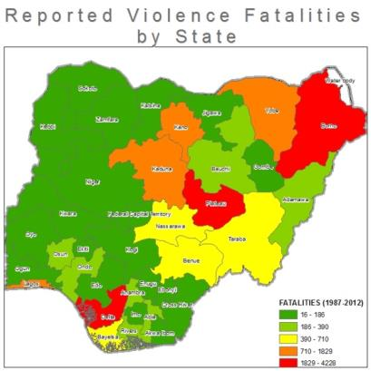
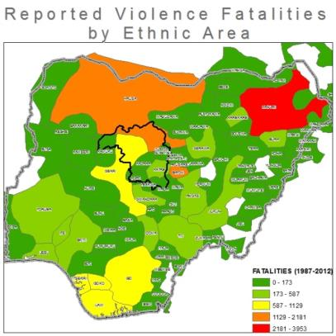
Nigeria is the most populous African nation with approximately 168.8 million people (2012), and its second largest economy with a gross domestic product (GDP) $262.6 billion. By 2030, it is estimated that Nigeria will become the fourth most populous country in the world. Nigeria is one of the most dense and culturally diverse countries, having over 521 languages and over 250 dialects and ethnic groups within its borders. Nigeria’s population is approximately 50% Muslim, predominantly in the sub-Saharan north, and 40% Christian largely in the south. Communal violence seems to be a persisting characteristic of rural Nigeria, with clashes between ethnic (Figure 1.a) or occupational groups being indicative of a deeper conflict between Christians and Muslims. These conflicts have earned Nigeria the fourth most violent country and the seventh most fatal. In light of the amount of foreign investments that have been aimed improving Nigeria’s stability, it is odd to see that violence has not abated.
Figure 1.a - Violence by Ethnic Area (ACLED)
Figure 1.b - Violence by State Area (ACLED)
Nigeria continues to be the economic power in sub-Saharan Africa and its petroleum industry is the largest in Africa (12th world-wide) with potential to grow. In 1977, Nigeria nationalized the extractive industry and owns all mineral and petroleum rights. Nigeria illustrates why an oil-based economy can be a curse – coined the resource curse by Sachs – with 54 percent (2004) of the population living below the national poverty line. As oil income flowed in, agricultural-based growth was deemphasized or ignored; however, agriculture employs over 70% of Nigeria’s rural population. Compounding this issue is the fact that a small percentage of native population is actually employed by petroleum and mining operations, with most of the labor traditionally being foreign. The world’s growing dependency on oil and the continuing unrest in the Middle East – especially after the 9/11 Terrorist attacks on the US – has put the vast resources of Nigeria back in the spotlight. While this may seem like good news for Nigeria, the oil and extractive industry is arguably one of the primary sources of mistrust between the people of Nigeria and their government. It may also lead to global conflict.
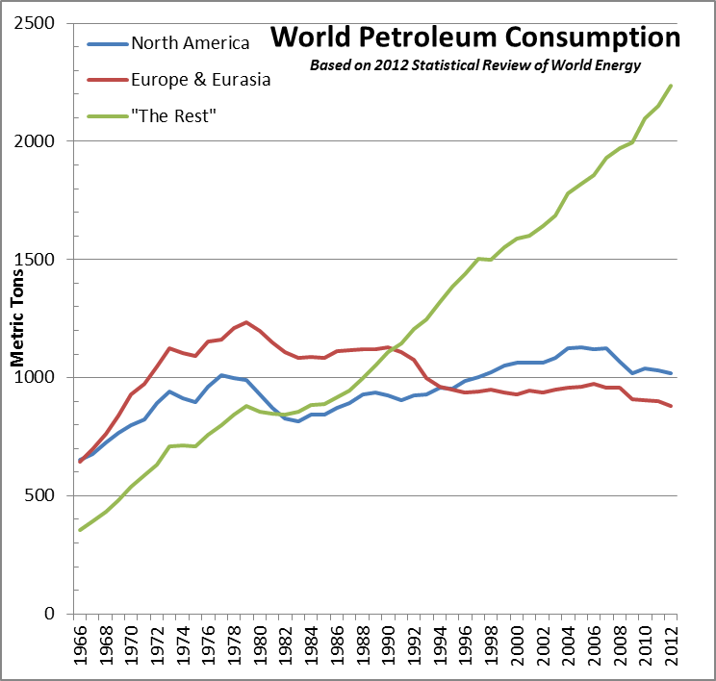According to British Petroleum’s (BP) 2012 Statistical Review of World Energy, in 2004 Europe, Eurasia, and North America’s consumption of petroleum was eclipsed by non-western powers – Zakaria’s “rise of the rest”. In 2006, Chinese President Jintao held a large African summit promising billions of dollars in investments, economic support, and construction of schools and hospitals. In 2007, Foreign Policy reported that the Chinese government offered Nigeria $9 billion to rebuild its entire rail network at a time that Nigeria was asking the World Bank for a $5 million loan for a smaller portion of the same railway. While there is nothing wrong with foreign investment in Africa, the increasing Chinese presence is taking up – and in some instances displacing – political, economic, and military space once dominated by the European colonials and the US.
Figure 2 - World Petroleum Consumption (BP.com)

Hypothesis
To counter act the effects of corruption and an oil-centric economy, strong governance with a diversified economy is key to stabilizing Nigeria’s future. USAID’s Strategic Assessment 2010-2013 asserts that developing the Agricultural sector is essential to Nigeria’s long term socio-economic stability; however, given current levels of violence, and the large amounts of foreign investment and growth of the extractive industries, one must wonder if extractive industries have been encroaching on the agricultural sector.
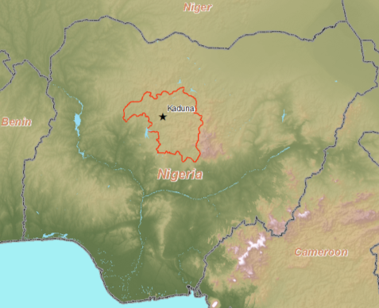
The hypothesis is formed that a significant expansion of extractive industries result in land-cover transformations from a vegetated land-cover to an impervious surfaces/ non-vegetated land-cover class, which has a negative impact on agricultural productivity. Since there is obvious levels of corruption throughout the Nigerian government, reported statistics are not reliable. The use of remote sensing would supply an objective way to assess if significant levels of extractive industry encroachment on agricultural land. While direct causation between industrial encroachment and decreased agricultural output would be difficult to establish and prove, deriving a method to estimate changes in vegetative land-cover over a larger area would undoubtedly be valuable to geographers across a wide range of applications.

Study Area - Kaduna State
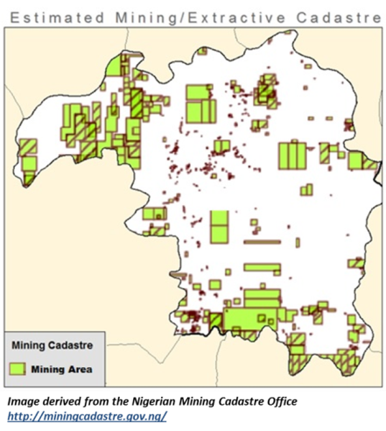
The study area for this paper was limited to Kaduna State, Nigeria, located at 10°20′N 7°45′E. In the 2006 national census, Kaduna State had a population of 6,113,503, with a projected 7,474,000 in 2013 (3.18% growth). This makes Kaduna State third nationwide in population and population density, behind Lagos and Abuja. Kaduna State is approximately 46,053 sq. km, which is only about 5% total land area of Nigeria (923,768 sq km). It has several major rivers flowing through its generally mild terrain with scattered areas of plateaus and ridges. Kaduna State’s central location and good transportation network of roads and rail-lines make it an important hub connecting the northern and southern portions of Nigeria.
Figure 3 – Kaduna State, Nigeria: Shaded Relief
Kaduna State’s economy is highly-dependent on agriculture sector, which contributes over 56% of Kaduna State’s Gross Domestic Product (GDP) and employs over 4 million people. Kaduna State’s central location south of the Saharan desert and just north of the inter-tropical conversion zone also makes it ideal for a variety of crops, with distinct growth during the rainy season (May-October). Kaduna State contributes a significant portion of Nigeria’s national agricultural production, supplying 22% percent of maize, 69% percent of soy beans, 36% percent of cotton, and is currently the largest producer of rice in Nigeria. Furthermore, a majority of agriculture is farmed under the bush fallow system, meaning that land is left idle for a period of time to allow natural regeneration of soil fertility. This primitive method not only drastically decreases potential productivity, it complicates land-cover monitoring and classification of agricultural areas.
Figure 4 – Depiction of Mining Cadastre Areas
Based on visual inspection of the Nigerian Mining Cadastre Office, Kaduna State has a significant amount of potential land that is being offered for mineral exploration. Kaduna State reports large deposits of Uranium, Gold, Tantalum-Niobium, Lead, Zinc, Coal are known to be throughout the region. The exploration, development, and processing of these minerals could directly impact agriculture productivity through land encroachment and environmental hazards. In 2010 a gold mining operation released lead into the water stream, killing approximately 400 children and contaminating over 1000 more. The villagers stated they would “rather die of lead poisoning than poverty”; they can make 10 times as much money mining as they do from farming.
Finally, Kaduna State has experienced a high-degree of violence over the past 10 years. (Figure 1.b) It has a diverse tribal composition, with a large Muslim population in the North that cedes increasingly to Christian as one progresses south, evidenced by the implementation of partial Sharia law in the state. Most notably in recent past, the Al Qaeda extremist group Boko Haram (“Western education is a sin”) has terrorized the region in an attempt to establish complete Sharia law. In reaction, there are several Christian extremist groups that respond with their own violent tactics, throwing the region into almost constant turmoil.

Scope/Task, Purpose, Goals
To date, researchers have relied on high-end, oftentimes expensive software toolsets to perform intensive image processing routines on raw data. While this type of pure remote sensing science will always be required in research and development, the growing availability of remote sensing data and the pervasiveness of geographic information systems (GIS) have helped to grow academia, small business start-ups, and non-profit organizations across the world. An excellent example of utilization of these technologies to tackle global issues is the Famine Early Warning Systems Network (FEWS NET).
The hypothesis to be tested is that an expansion of extractive industries will result in transformations in land-use. This transformation would likely occur from a vegetated land-cover class to an impervious surfaces and/or a non-vegetated land-cover class. A significant transformation could have a serious and negative impact on agricultural productivity.
In order to test this hypothesis, the first goal was to develop a method of monitoring large areas for changes in land-cover and identify areas of probable de-vegetation over a time-span. Since the monitoring would take place over relatively large areas, high-resolution data would not be feasible. Furthermore, the benefit of a priori knowledge of an area is not guaranteed, so a method that provides a tipping and cueing mechanism to alert an analyst to potentially impacted areas, both spatially and temporally, would be beneficial. It would also provide scalability and flexibility, allowing this process to be run on larger areas and in different regions.
Another goal of this study was to conduct it on a budget and with limited resources. The process needed to quickly and inexpensively process a spatial-temporal dataset over a relatively large area relying on the ESRI ArcGIS framework and Python open source packages. The main reason behind this constraint is to examine and assess the applicability of utilizing ArcGIS, along with other open source packages, to provide the home and educational user with a low-cost image processing capability. The primary toolsets used in this study were ArcGIS 10.2, Spatial Analyst and Geostatistical Analyst extensions, and Python’s SciPy, NumPy, Pandas, and MatPlotLib packages. ESRI provides an excellent deal for students and home GIS users’ offering licenses for a relatively small amount of money. The ArcGIS licenses were acquired through Pennsylvania State University’s educational license program. This, coupled with the integration of Python, opens up their mature platform to an array of applications, empowering students to explore open source GIS and statistical packages while still being able to utilize ESRI’s GIS toolset.
In recent years, ESRI has started to incorporate more robust imagery processing toolsets that provide even more capability to users. Unfortunately, the system used for this research was limited in both storage and communications bandwidth as well. Therefore, the use of large amounts of high-resolution imagery would place significant stress on the system. The tipping and cueing mechanism in the first goal also helps the analyst stay within budget when they must order high-resolution imagery from a commercial vendor. By having a better understanding of where and when a change occurred, it greatly reduces the volume of imagery required to perform a more detailed search.
The final objective was to derive an objective assessment on the extractive industry’s impact, if any, on agriculture. While the implications are nationwide, the study focuses on Kaduna State – which has abundant agriculture, extractive activities, and violence. The intent would be to confirm/deny direct effect of extractive industry’s expansion on agricultural industry and identify any secondary issues arising during the course of the study.

Phenology
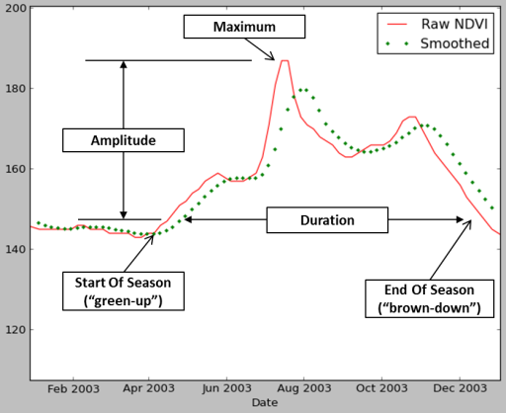
The use of remote sensing to observe and measure changes in plants on the earth’s surface has become a key pillar in environmental monitoring. In the case of land monitoring, much of that land surface is covered by plants. Phenology is the study of the relationship between vegetative growth and its environment. Phenology affects “nearly all aspects of the environment, including the abundance, distribution, and diversity of organisms, ecosystem services, food webs, and the global cycles of water and carbon.” Phenology is oftentimes focused at specific plant species and their distinct life-cycle – for example, Ever-greens would have much different phenology than a deciduous tree that loses its leave in the fall. By using remote sensing to assess larger areas and biomes, one can start to infer the types of plants, land-use, and even begin to judge the health of vegetation in that area. This expanded focus also allows researchers the ability to define seasonal parameters and make inferences on potential impacts to the environment and climate. Through the use of remote sensing processes such as the normalized difference vegetative index (NDVI), scientists can start to infer types of vegetation or make assessments on the health of know plant types. The NDVI is difference between the red and near-infrared (NIR) reflectance of a surface divided by their sum:
Figure 5 – Seasonal Parameters from Phenology. Adapted from USGS.gov
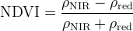

Healthy vegetation exhibits an inverse relationship between vegetation brightness in the red and infrared regions. This is due to chlorophyll’s absorption of the red wavelength and strong scattering or reflecting of the infrared energy of the plant’s mesophyll layer. There are a few drawbacks to the NDVI: the technique is highly dependent on atmospheric effects and brightness values. Also, background soil colors and moisture content will contribute to the scene, as will water. Regardless, scientists have been able to successfully derive seasonal parameters (Figure 5) of areas to derive the Start of Season (“green up”) and End of Season (“brown down”), providing the duration of the growing season. By analyzing the amplitude, the scientists can infer plant types – such as evergreens having a consistent high-ratio, deciduous having a distinct winter without leaves – or can infer land-use, such as areas with two or more “humps”, indicating crops with alternating planting techniques.

MODIS NDVI
Platform | Terra | Aqua
Orbit | Circular, Sun-Synchronous
Altitude | 705 km
Swath Width | 2330 km x 10 km
Pass-times | 10:30 AM (Descending) | 1:30 PM  (Ascending)
Spatial  Resolution: | 250 m (bands 1-2)  500 m (bands 3-7)  1000 m (bands 8-36)  For complete band-listing visit:  http://modis.gsfc.nasa.gov/about/specifications.php
Table 1 – MODIS Specifications
MODIS (or Moderate Resolution Imaging Spectroradiometer) is one of the primary instruments aboard the two Earth Observation System (EOS) platforms, Terra and Aqua. Compared to its predecessor – Advanced Very High Resolution Radiometer (AVHRR) – MODIS offers a significant increase in spatial and spectral resolution, allowing greater insight into atmospheric and land phenomenology. The EOS satellites are in a near-polar, sun-synchronous, circular orbit with a 2330 km (cross track) by 10 km (along track at nadir). Both satellites provide 36-spectral bands at varying resolutions at two standard times a day (see Table 1). Consequently, the EOS constellation covers the entire Earth's surface every 1 to 2 days providing a highly-temporal, multispectral dataset at moderate resolution. The United States (US) Geological Survey (USGS) freely provides access to the various MODIS data products via its websites GloVIS and EarthExplorer.
The MODIS 13Q1 dataset is a pre-processed NDVI which provides a key capability to monitor biomass on a 250 meter scale at a high temporal frequency. The data is available in 1110 km x 1110 km (approximately) tiles in a Hierarchical Data Format (HDF4), along with corresponding quality index and acquisition datasets. The MODIS 13Q1 data are computed from atmospherically corrected bi-directional surface reflectance that have been masked for water, clouds, heavy aerosols, and cloud shadows. There have been several issues, however, raised with the raw format of MODIS 13Q1 from the remote sensing community; issues with the map projection (Sinusoidal), HDF 4 format, 16-day composite interval, the high-latitude "bow-tie" effect, mosaicking complications, and the time latency from collection to dissemination.
In response to a community-specific requirement for an alternatively packaged dataset, the USGS Earth Resources Observation and Science (EROS) Center developed a suite of products called eMODIS. USGS provides the eMODIS NDVI dataset that provides atmospherically corrected data, already masked. Unfortunately, the data is provided on a continental scale resulting in an extremely large file – a single dataset covering Africa is approximately 1.6 GB. Furthermore, at least in this instance, the data would require a significant amount of image processing to fill in the voids left by the cloud masking.
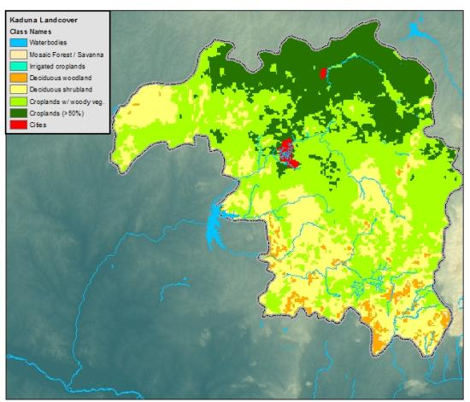
The Famine Early Warning System - a non-profit organization founded by USAID to “provide objective, evidence-based analysis to help government decision-makers and relief agencies plan for and respond to humanitarian crises” – provide scientists with high-quality data that could be used directly out of the box to monitor changes in biomass over keys areas of the world. The eMODIS data is one of FEWS Net’s primary sources. In order to USGS used a 10-year running average to provide void-fill values, performed temporal smoothing, reduced the area to smaller and more manageable subsets, and provide the data within days. The FEWS eMODIS NDVI started in 2001 and has been providing data in near real-time starting in 2010. This provides an opportunity to download 12 years of historical data at a uniform interval and test this concept. Having a data source that is ready to be ingested into a GIS without any preprocessing necessary empowers “disadvantaged users” to be able to perform studies using at-home/educational licenses and open source toolsets.

Analytical Method
This process uses an annual collection FEWS eMODIS data to provide a spatial-temporal signature similar to hyper-spectral data cubes. Taking advantage of the FEWS database, 12 years of NDVI data at a 10-day temporal resolution were downloaded and clipped to the Kaduna State administrative boundary, resulting in a collection of 72 datasets per year. Each annual collection was stacked to create a 72-band annual composite that could then analyzed using the Sample tool from the Spatial Analyst extension. The Sample output of a single or group of point features would be processed by a Python script to provide a visualization of the NDVI intensity versus time phenology curve.
Figure 6 – GLC2000 Land-cover classification. Note that most of Kaduna State is considered Croplands or Croplands w/ Vegetation.
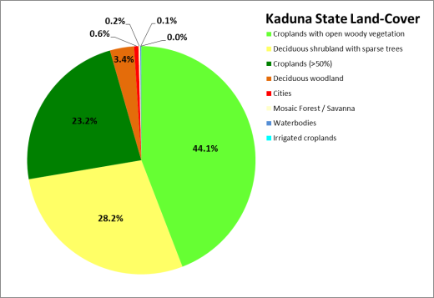
A brief analysis of the vegetative composition of Kaduna State was necessary to understand and interpret results of any analysis of the NDVI data. The Global Land Cover 2000 (GLC2000) database, from the European Commission, Joint Research Centre (JRC). The GLC2000 dataset was published in 2003 would provide a baseline to compare the outputs of the NDVI time-series classifications. The GLC2000 breakout shows 8 major classes in Kaduna, with the bulk of the land-cover in the North and North-east being categorized as croplands (>50%). Most all the vegetation is classified as deciduous indicating that the phenology of the region will mostly follow rainy-season and complicating any attempt to discriminate between deciduous trees and agriculture. Impervious surfaces were a small fraction of land-cover in 2000, indicating that most of Kaduna State would show some response to precipitation, to include wet/dry bare earth. Based on this fact, it is assumed then that any increase in impervious surfaces would be easier to locate and identify. It was therefore determined that the focus of the change detection efforts would be directed at the appearance of impervious surfaces or bare-earth versus any attempt at discriminating between agricultural and non-agricultural vegetation.
Figure 7 – GLC2000 Classifications of Kaduna State
Since the intent was also to provide a tip and cue mechanism, both in space and time, to a change in land-cover, it was desirable to have the algorithm work without any a priori knowledge of the area, relying only on the data available. Since the precondition of no a priori had to be met, an unsupervised classification was required. I chose the Iterative Self-Organizing Data Analysis Technique Algorithm (ISODATA). The ISODATA algorithm was ideal for this application because an initial number of clusters could be specified, but the algorithm would adjust the number of clusters dynamically based on statistical analysis of the clusters. During this iterative process, initial clusters with large standard deviations were merged or split and the clustering re-run until the standard deviations of the clusters stabilized.
Utilizing ArcGIS’s ISODATA Cluster toolset, the raw FEWS eMODIS NDVI datasets were run through the clustering algorithm to derive clusters that could then be used to perform land-cover classifications. In this case, the clusters were fed into the ArcGIS Maximum Likelihood Classification toolset. The Maximum Likelihood Classification tool is based on the assumption that cells in each of the clusters in the multidimensional space normally distributed. Since we can infer from the ISODATA algorithm that the standard deviations of the populations are stable – meaning after several iterations the standard deviations have not change significantly - then this assumption seems safe. The Maximum Likelihood Classification also relies on Bayes' theorem of decision making. Baye’s theorem is based on
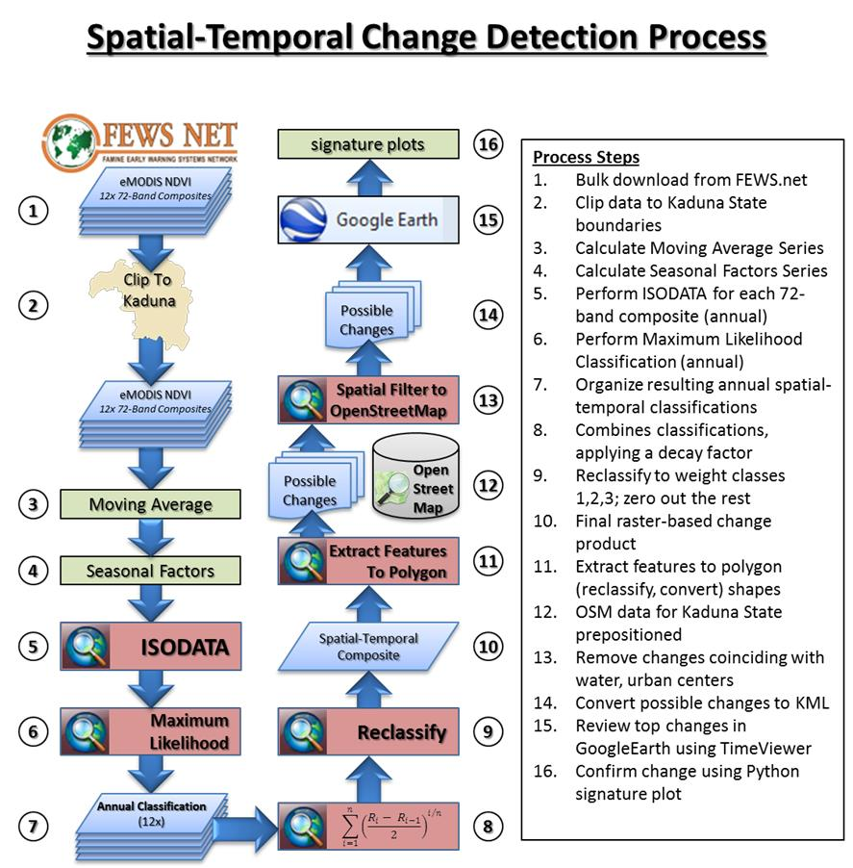
Figure 8 – Process Workflow Visualized
the rule that relates the odds of two events, one before (a priori) and one after (a posteriori), based on new information contained by another event. The probability is expressed in terms of the likelihood ratio. It then follows, given these two characteristics for each pixel, a statistical probability is computed or each class to determine the membership. This results in each cell being assigned to the class to which it has the highest probability of being a member. The resulting raster in this case was a classification of NDVI values over time on an annual scale, with a 10-day overlapping time step that grouped cells based on their statistical classification of intensity over time. (ESRI supplied a toolset that actually linked their ISODATA tool with the Maximum Likelihood Classification tool. The results were the same, and in the interest of efficiencies, all future calculations utilized their combined ISO Cluster Maximum Likelihood Classification tool).This process was repeated over the remaining data, resulting in a temporal NDVI classification for every year. These classifications could then be compared in series on an annual scale (versus by each raw band) in order to identify changes in land cover class and identify times of change.
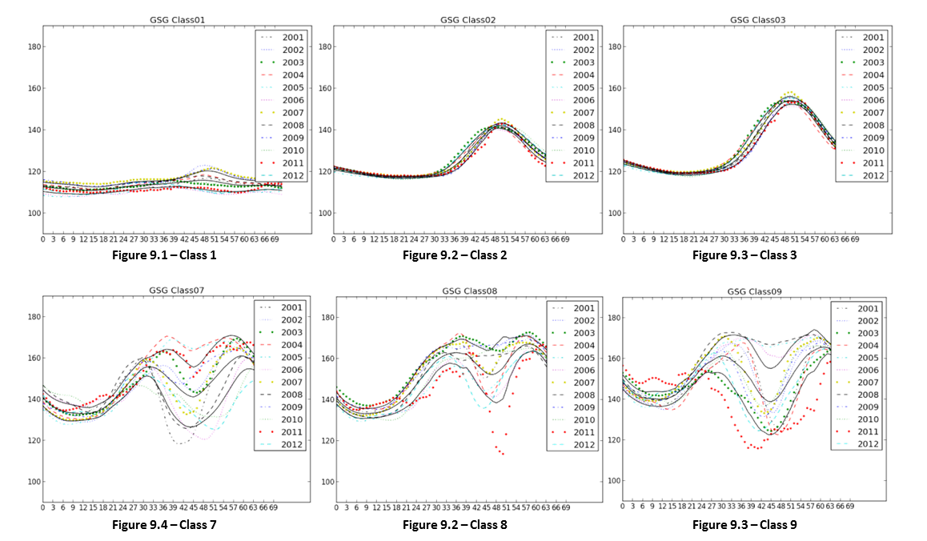
An examination of years 2001 and 2012 provided encouraging results. A Python script was developed to ingest and plot the temporal signatures of each class in the signature file (GSG). Once a visual inspection of the class signatures was possible, qualitative analysis of the classes revealed that several exhibited a stable pattern – meaning the intensity versus time curve were very similar and the standard deviation between year 2001 and 2012 was small. Other classes that were labeled similarly by the toolset exhibited erratic behavior, especially during the rainy season periods of May through October. Further analysis of the remaining years supported the above assessment; classes “1” (Figure 9.1), “2” (Figure 9.2), and ”3” (Figure 9.3) were consistent from year to year, with little variance in the sample set, whereas the rest of the middle classes (Figures 9.4-9.6) exhibited a strong tendency to de-correlate during the rainy season. It should be noted at this point that ESRI has documented that the MLC toolset arbitrarily assigns class numbers. This initially seemed like an insurmountable issue; however, when one considers the intent of the study was to locate and identify the appearance of impervious or bare earth where vegetation once existed, it greatly simplified the process. Excluding agriculture due to its persistent and oftentimes unpredictable rotations (man-made choices in crop type, for instance) and focused on deciduous areas, enables this study to ignore any land-cover class assessed to be vegetative in nature and focuses on locating and identifying changes in land cover from a vegetative class to a non-vegetated class.
One issue that did complicate the analysis was the homogeneity of Kaduna State. As stated previously, Kaduna was largely classified by the GLC2000 data as deciduous and cropland, with little diversity. Early in the study, the initial classification process was run with the entire country of Nigeria before being clipped down to Kaduna State. The problem with this process was that the resulting classifications were too wide; some of the vegetated NDVI classes contained areas that were tropical and or coastal (in the south), which did not exist in Kaduna. Running the NDVI data clipped to Kaduna State through the Maximum Likelihood Classification toolset resulted in an unstable classification with divergence in the stable non-vegetated classes, possibly due to the reduced range of pixel values.
In an attempt to improve classification, a seasonal decomposition process was applied to remove the random component – which in this case could likely be attributed to rain and/or surface temperature fluctuations. The first step involved calculating a trend series (moving average over a defined period - in this instance, a period of 6 time steps – 60 days – was used.) The original time series is then either subtracted from or divided by the trend values to derive a de-trended series. The multiplicative method of seasonal decomposition was employed since the seasonal variation fluctuated and the additive model expects a relatively constant season over time. The next step is to calculate the seasonal factors – the simplest method is to average the de-trended values for a specific season (in this case 3 periods, or 30 days). For example, the seasonal effect for January is the average of the de-trended values for all Januarys in the series (2001 through 2012). Now that both a trend and seasonal component is calculated, a random series can be calculated as the original series / (trend series * seasonal factors). In this study, it was expected that the seasonal series would help stabilize the results, yet retain some of the temporal fluctuations (whereas a moving average could overly smooth). The data was stacked to 73-band cubes and ran it back through the ISO Cluster Maximum Likelihood Classification toolset with a 12-class scheme. This had much better results in smaller areas, but was a significant increase in image processing and disk serialization.
Once the annual composite rasters were built, they were then compared in sequence from year 2001 to year 2012. Since a simple addition at this point would be fruitless – the unstable middle bands would negate any meaning in the summation – each composite was reclassified to refocus the analysis on the impervious and non-vegetative surfaces, removing the unstable vegetated surfaces from consideration. In order to maintain a temporal aspect, while still guarding against volatile land surface classifications, a simple slope algorithm (below) with a temporal decay factor was applied that would compensate for potential misclassifications (for example, areas that were classified as “5” in 2001,”1” in 2002, and then back to “5” in 2003).
$$\sum_{i=1}^{n}{{\left(\frac{R_{i}- R_{i-1}}{2}\right)}^{i/n}}$$
The resulting sequence was a single raster that supplies areas of change in a spatial-temporal aspect, keying an analyst into areas that have exhibited persistent land-cover change, favoring more recent changes over older changes. The areas of change were extracted from the raster by running a slope analysis and applying a qualitative threshold to the raster, then converting the raster to vector polygons. These features were then filtered against open street map (OSM) data to remove areas such as urban centers, water features, and rivers. The filtered results were then translated to KML files for use in GoogleEarth to explore each change using their TimeViewer tool. GoogleEarth was used to examine each of the potential areas of change to determine if the change was real, if the extent of change was significant, and if the timeframe of the change was reflected in the temporal classifications.

Results
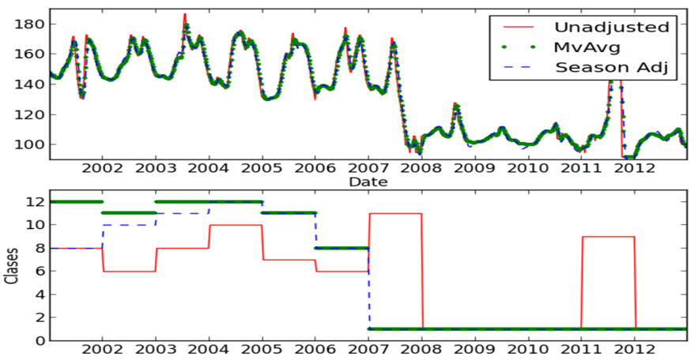
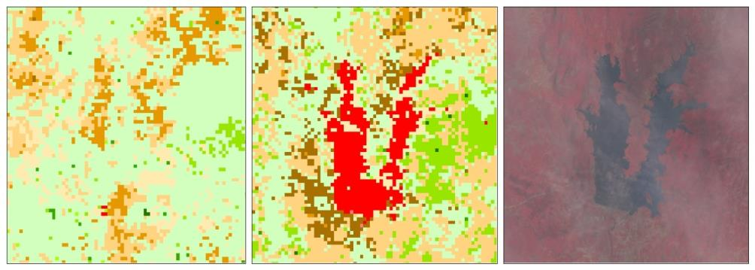
There were 21 probable transitions from vegetative to non-vegetative land-cover detected. The majority of these probably changes were considered urban encroachment or deforestation, which could possibly be related to expanded agriculture. There was no evidence of any extractive industry activity in the vicinity of the changes. Interestingly, the Kaduna Petroleum Refinery was identified as a change (false alarm), but probably due to some fortuitous phenomenon associated with the plant – it was established in 1986, well before the first NDVI dataset in Jan-2001. Of the 21 changes, perhaps one of the most impressive was the detection of the Gurara Hydro-electric Power Plant (HEPP).
Figure 10 –Confirmed Change Gurara HEPP
2001 2012 2012
The upper left frame in Figure 10 shows the area south of the town of Gurara, Nigeria in 2001 with only vegetated land-cover indicated. The middle frame shows a large impervious surface in the same area. The frame in the upper right reveals that a large body of water appeared sometime after 2001. Using the temporal signature of a center pixel, there clearly is only vegetated classes through the year 2005. It appears that after 2005, the land-cover classification started to creep toward the lower order classes. Clearly in year 2007, the reservoir began to fill and remained full until 2012. It is interesting to note that the red line was the original Nigeria-wide NDVI classification, and the moving average and seasonal factor the adjusted data for just Kaduna State. One can clearly see the improvement in classification consistency.
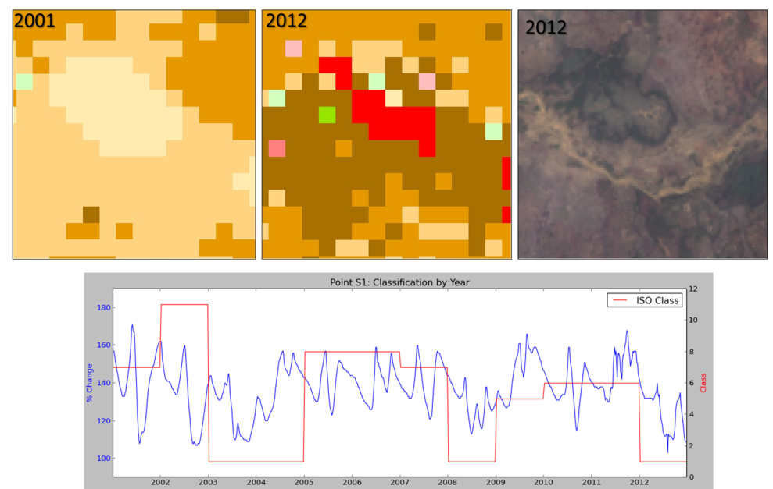
While the process demonstrated potential in this study, the false alarm rate would prove to be unacceptable. Six possible changes could not be confirmed due to the lack of higher-resolution imagery and the signatures were inconclusive. But the remaining 58 of the possible changes were directly related to water. Several studies indicate similar issues with water due to the turbidity and changes in water levels at the shoreline. While eMODIS applies a general water mask, the edges and smaller streams still present challenges. Using OSM hydrologic data – some of the better hydro data available for Nigeria – the false alarm rate was still unacceptable. Further examination of the OSM data was less than complete and likely derived from Russian 1:500K maps, with source dates circa 1980’s.
Figure 11 – False Alarm. Possible dry lake bed.
An example of a false alarm (Figure 11) shows that in 2001, a circular feature exhibiting a vegetative-type land-cover classification for the year (Class “7”). In 2012, that feature was replaced with an impervious surface class (Class “1”). In high-resolution imagery that same year, standing water is not visible in-scene; however, soil color is obviously darker and could be indicative of saturated soil. Looking at the signature plot for the region, it has a history of fluctuating between classes. The periods where the feature is classified to in the class “1” – impervious surface – correlate to years of significant rainy seasons. It is possible that the feature is simply a shallow depression that fills up with water during the rainy seasons, but is dry in years of medium to light rain.
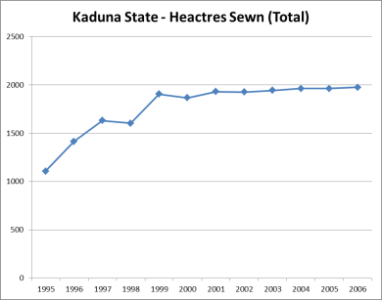
Even though the results were disappointing, with better situational awareness of hydrologic features, it is reasonable to assume that many of these false alarms could be mitigated with a larger exclusion (buffer) area, though at risk to excluding real change. On a positive note, there is a potential application of the change detection toolset in finding water bodies. Regardless, there was little to no evidence of extractive industry encroachment upon Kaduna State’s agricultural sector. The fact that the process revealed minimal evidence of land-cover changes related to the extractive industry was detected does not necessarily mean that the extractive and agricultural industries are mutually exclusive; there could be several explanations to consider:
- First, it is highly likely that little to no significant change between 2001 and 2012 occurred in the Kaduna State extractive sector or agricultural sector. Kaduna State itself remains under-developed in terms of agriculture and has exhibited minimal increases in production capacity (only 2.2% growth between 2001-2006).
- Second, petroleum is king and the bulk of the petroleum extractives occur in the south. Literature consistently characterizes mining industry as stagnate; consequently, even if mining had expanded, there is likelihood that the surface signature was minimal. Changes could be too small or unobservable (subsurface mines) since many of the minerals are subsurface and are extracted through tunneling type operations (as opposed to strip mines).
- It is a possibility that real changes could have been excluded during the filtering process or through mis-classification.
Consequently, it was noted that urban expansion and/or increased agriculture was noted in several instances. The FAO statistics indicate that agricultural output across Nigeria actually increased between 2001-2011. This by itself could support the observations, however, FAO reported that per capita production index is still much lower than other countries and that it is decreasing. What is more likely is that the reported population growth could be fueling the increase, which is supported by the many examples of urban expansion. Furthermore, there was noticeable increase in water management, which could have helped to increase agricultural yields, though any direct effect would be difficult to ascertain.

Conclusion
In conclusion, there was little to no evidence of extractive industry encroachment upon the agricultural industry. Several instances of urban expansion and/or increased agriculture were noted, which given the rapid growth of Kaduna State’s population, is to be expected. The process developed in this study has potential for future applications, but many challenges. It proved able to identify sustained areas of decreased vegetation both spatially and temporally. The FEWS Net program provided eMODIS NDVI data that was easy to work with and reliable, enabling this study to be completed. The process may not scale to larger, more diverse areas as consistent classification becomes challenging. Future model improvements could incorporate surface temperature and precipitation, though the resolution of such data may complicate its inclusion. The process was practical, computationally inexpensive, and well within the capabilities of a home user. ArcGIS’s image processing is making progress, but it is not the best tool for spatial-temporal analysis; significant scripting in Python and several other packages (such as NumPy, SciPy, and Pandas) were absolutely critical.

References

Literary References
Ammani, A. A., Ja’afaru, A. K., Aliyu, J. A. and A. I. Arab. 2012. Climate Change and Maize Production: Empirical Evidence from Kaduna State, Nigeria Journal of Agricultural Extension, Vol. 16 (1):
Bebbington, A., Bebbington, D. H., Bury, J., Lingan, J., Muñoz, J. P., and Martin Scurrah. 2008. Mining and Social Movements: Struggles Over Livelihood and Rural Territorial Development in the Andes. World Development Vol. 36, No. 12: 2888–2905
Biazin, B., and G. Sterk. 2013. Drought Vulnerability Drives Land-Use And Land Cover Changes In The Rift Valley Dry Lands Of Ethiopia. Agriculture, Ecosystems and Environment 164: 100– 113
Brown, David E. 2013. AFRICOM at 5 Years: The Maturation of a New Combatant Command. Strategic Studies Institute, US Army War College.
Campbell, J. B., & Wynne, R. H. 2011. Introduction to remote sensing (5th ed.). New York: Guilford Press.
Catoire, Richard G. 2000. A CINC for Sub-Saharan Africa? Rethinking the Unified Command Plan, Parameters, Winter 2000-01: 102-17.
Chindo, Murtala. 2011. An Extensive Analysis of Mining in Nigeria Using a GIS. Journal of Geography and Geology Vol. 3, No. 1: 3-12
Folberth, C., Gaiserb, T., Abbaspour, K., and R. Schulin. 2012. Regionalization of a Large-Scale Crop Growth Model for Sub-Saharan Africa: Model Setup, Evaluation, and Estimation of Maize Yields. Agriculture, Ecosystems and Environment 151 (1): 21– 33
Food and Agriculture Organization of the United Nations. Foreign Agricultural Investment - Country Profile: Nigeria. Rome, Italy, 2012
Friedman, T. L. 2008. Hot, flat, and crowded: why we need a green revolution-- and how it can renew America. New York: Farrar, Straus and Giroux.
Gallo, K. P., Ji, L., Reed, B. Dwyer, J., and J. Eidenshink. 2004. Comparison of MODIS and AVHRR 16-Day Normalized Difference Vegetation Index Composite Data. University of Nebraska, School of Natural Resources, Lincoln, NE
Gobin, A., Campling, P., and J. Feyen. 2002. Logistic modelling to derive agricultural land use determinants: a case study from southeastern Nigeria. Agriculture, Ecosystems and Environment 89 (1): 213–228
Hamilton, J. D. 1994. Time Series Analysis. Princeton, N.J.: Princeton University Press.
Jalloh, A., Roy-Macauley, H., and P. Sereme. 2012. Major agro-ecosystems of West and Central Africa: Brief description, species richness, management, environmental limitations and concerns. Agriculture, Ecosystems and Environment 157: 5-16
Jansen, L. J.M., and A. Di Gregorio. 2002. Parametric Land Cover And Land-Use Classifications As Tools For Environmental Change Detection Agriculture, Ecosystems and Environment 91: 89–100
Jenkerson, C., Maiersperger, T., and G. Schmidt; 2010. eMODIS: A User-Friendly Data Source. United States Geological Survey, 2010–1055
Lambin, E. F., Geist, H.J., and E. Lepers. 2003. Dynamics Of Land-Use and Land-Cover Change In Tropical Regions. Environmental Resources Vol. 28:205-241
Lunetta, R. S., Knight, J. F., Ediriwickrema, J., Lyon, J. G., and L. D.Worthy. 2006. Land-Cover Change Detection Using Multi-Temporal MODIS NDVI Data. Remote Sensing of Environment 105: 142–154
Lyncha, K., Binns, T. and E. Olofin. 2001. Urban agriculture under threat: The Land Security Question in Kano, Nigeria. Cities, Vol. 18, No. 3: 159–171
McCarthy, J. M. 2008. Nigeria and The United States: An Analysis Of National Goals. U.S. Army War College, Carlisle, PA
McCusker, B., and P. O’Keefe. 2013. Introduction: Peasants, Pastoralists And Proletarians: Joining The Debates On Trajectories Of Agrarian Change, Livelihoods And Land Use. Human Geography Volume 6, Number 3: 3-11
McLoughlin, G., and C. Bouchat. 2013. Nigerian Unity in the Balance. Strategic Studies Institute, US Army War College, Carlisle, PA
Michalopoulos, S., and E. Papaioannou. 2011. The Long-Run Effects Of The Scramble For Africa. National Bureau of Economic Research, Working Paper No. 17620,JEL No. N17,N47
Pare, S., Söderberg, U., Sandewall, M., and J.M. Ouadba. 2008. Land Use Analysis From Spatial And Field Data Capture In Southern Burkina Faso, West Africa. Agriculture, Ecosystems and Environment 127 (1): 277–285
Sachs, J., and A. Warner. 1995. Natural Resource Abundance and Economic Growth. National Bureau of Economic Research, Cambridge, MA
Spruce, J., Sader, S., Ryan, R., Smoot, J., and et. al. 2011. Assessment of MODIS NDVI Time Series Data Products for Detecting Forest Defoliation by Gypsy Moth Outbreaks. Remote Sensing of Environment 115 (1): 427–437
Stefanova , W. L., and M. Netzband. 2005. Assessment of ASTER Land Cover And MODIS NDVI Data at Multiple Scales for Ecological Characterization of an Arid Urban Center. Remote Sensing of Environment 99 (1): 31 – 43
Stéphenne, N., and E.F. Lambin. 2001. A Dynamic Simulation Model Of Land-Use Changes In Sudano-Sahelian Countries Of Africa (SALU) Agriculture, Ecosystems and Environment 85 (1): 145–161
Tucker, C. J., Townshend, J., and T. E. Goff. 1985. African Land-Cover Classification Using Satellite Data. Science Volume 227, Number 4685: 369-375.
U.S. Agency for International Development. NIGERIA STRATEGY 2010 – 2013, Washington D.C., 2009.
US Department of Defense, Office of International Security Affairs. United States Security Strategy for Sub-Saharan Africa. Washington, D.C. 1995 : pg. 3.
Zakaria, F. 2008. The Post-American World. New York: W.W. Norton.

Web References
Africa Command (AFRICOM) Official Website http://www.africom.mil/about-the-command (Last accessed 24APR2014)
Pflanz, M. 2013. Africa’s Population Will Double In 40 Years, Study Says; Most Of The Growth Will In Continent’s Poorest Countries. National Post. http://news.nationalpost.com/2013/09/13/africas-population-will-double-in-40-years-study-says-most-of-the-growth-will-in-continents-poorest-countries/ (Last accessed 29APR2014)
CIA World Factbook. Nigeria. https://www.cia.gov/library/publications/the-world-factbook/geos/ni.html (Last accessed 20APR2014)
World Bank Indicators http://data.worldbank.org/indicator (Last accessed 20APR2014)
Armed Conflict Location and Event Database. January 1997 – March 2013. http://www.acleddata.com/data (Last accessed 20APR2014)
US Energy Information Administration (EIA) http://www.eia.gov/countries/country-data.cfm?fips=NI (Last accessed 20APR2014)
FAO Country Page – Nigeria: http://www.fao.org/ag/agp/AGPC/doc/Counprof/nigeria/nigeria.htm (Last accessed 29APR2014)
British Petroleum (BP) Statistical Review of World Energy. 2013. http://www.bp.com/en/global/corporate/about-bp/energy-economics/statistical-review-of-world-energy-2013.html (Last accessed 29APR2014)
Naím, M. Foreign Policy 2007. Rogue Aid. http://www.foreignpolicy.com/articles/2007/02/14/rogue_aid (Last accessed 29APR2014)
Commercial Agriculture Development Project (CADP) Nigeria http://www.cadpnigeria.org/kaduna/
Faul, M. 2013. Doctors treat lead-poisoned children. Associated Press http://news.yahoo.com/nigeria-doctors-treat-lead-poisoned-children-100739575.html (Last accessed 29APR2014)
The National Phenology Network , https://www.usanpn.org/about/why-phenology (Last accessed 29APR2014)
Global Land Cover 2000 database, European Commission, Joint Research Centre (JRC), 2003 http://bioval.jrc.ec.europa.eu/products/glc2000/glc2000.php (Last accessed 29APR2014)
ESRI, ArcGIS 10.2 Help Documentation http://resources.arcgis.com/en/help/main/10.1/index.html#/How_Maximum_Likelihood_Classification_works (Last accessed 29APR2014)

Catoire, Parameters, pp. 102-17
US DOD, Office of International, United States Security Strategy for Sub-Saharan Africa, p. 3.
Africa Command (AFRICOM) Official Website http://www.africom.mil/about-the-command (Last accessed 24APR2014)
National Post Africa’s population will double in 40 years, study says; most of the growth will in continent’s poorest countries http://news.nationalpost.com/2013/09/13/africas-population-will-double-in-40-years-study-says-most-of-the-growth-will-in-continents-poorest-countries/ (Last accessed 29APR2014)
CIA World Factbook, Nigeria https://www.cia.gov/library/publications/the-world-factbook/geos/ni.html (Last accessed 20APR2014)
World Bank Indicators http://data.worldbank.org/indicator (Last accessed 20APR2014)
McCarthy, pg. 2
Ibid.
Armed Conflict Location and Event Database http://www.acleddata.com/data (January 1997 – March 2013) (Last accessed 20APR2014)
FAO Country Profile FDI – Nigeria, pg 3-7
US Energy Information Administration (EIA) http://www.eia.gov/countries/country-data.cfm?fips=NI (Last accessed 20APR2014)
FAO, pg. 2
USAID Strategic Study 2010-2013, pg. 8
FAO Country Page – Nigeria: http://www.fao.org/ag/agp/AGPC/doc/Counprof/nigeria/nigeria.htm (Last accessed 29APR2014)
British Petroleum (BP) Statistical Review of World Energy. 2013. http://www.bp.com/en/global/corporate/about-bp/energy-economics/statistical-review-of-world-energy-2013.html (Last accessed 29APR2014)
Zakaria, pg. 2
Naím, M. 2007. Rogue Aid. Foreign Policy http://www.foreignpolicy.com/articles/2007/02/14/rogue_aid (Last accessed 29APR2014)
Igwe
Kaduna State National Website http://www.kadunastate.info (Last accessed on 29Apr2014)
Ibid.
Commercial Agriculture Development Project (CADP) Nigeria http://www.cadpnigeria.org/kaduna/ (Last accessed on 29Apr2014)
Kaduna State Website
Faul http://news.yahoo.com/nigeria-doctors-treat-lead-poisoned-children-100739575.html (Last Accessed 29APR2014)
Campbell, pg. 485-486
The National Phenology Network , https://www.usanpn.org/about/why-phenology
Campbell, pg. 483-484
For a complete listing of MODIS products, visit: https://lpdaac.usgs.gov/products/modis_products_table
GLOVIS: http://glovis.usgs.gov/‎
EarthExplorer: http://earthexplorer.usgs.gov
USGS LPDAAC https://lpdaac.usgs.gov/products/modis_products_table/mod13q1 (Last accessed 31MAR14)
Jenkerson, et. al.
FEWS NET, the Famine Early Warning Systems Network http://www.fews.net/about-us (Last accessed 24APR14)
USGS FEWS NET Poratal http://earlywarning.usgs.gov/fews/africa/web/readme.php?symbol=zd (Last accessed 24APR14)
Global Land Cover 2000 database http://bioval.jrc.ec.europa.eu/products/glc2000/glc2000.php (Last accessed 20NOV14)
ESRI, ArcGIS 10.2 Help http://resources.arcgis.com/en/help/main/10.1/index.html#/How_Maximum_Likelihood_Classification_works
Ibid.
Lunetta, pg 12
Lunetta, p 147
FAO, http://www.fao.org/countryprofiles/index/en/?iso3=NGA&subject=4
Ibid.

