Colorado Front Range Protected Lands: Land Valuation Spatial Patterns

Maevlyn Stevens
Advisor: Professor Travis Flohr
Support: Professor Fritz Kessler
April 23, 2023

Abstract

This study examines the visible patterns between protected lands and property values within the Colorado Front Range. Conservation easements are legally binding mechanisms to preserve natural and public resources perpetually. Other forms of protected public lands also exist and conserve natural resources. Natural and public resources include those vital to all life, such as air, soil, and water. These same resources enhance residents' quality of living through scenic viewsheds and outdoor recreation opportunities. Motivations for land conservation vary by the landowner, but a demonstrated financial benefit likely incentivizes conservation. This study examines the spatial distribution of land values to determine whether proximity to protected lands or different types of land exert a positive influence.
This study confirms that protected land and land value relationships are complex. Generally, this study demonstrates the primary research hypothesis that land values adjacent and nearby to protected land tend to be higher. However, not all land values were higher, and not all types of protected lands appeared to influence increased property values. Local government protected lands seemed to affect property values positively. Proximity to protected land appeared to heavily influence urban land values, while rarely influencing rural land values.
Since conservation easements and other forms of land protection benefit all forms of life by conserving resources necessary for existence, it is crucial to understand how they influence property values in rural and urban contexts, as it can be a conservation incentive for property owners.

Introduction

Problem Statement

Intense development pressure has come to many parts of the Rocky Mountain region. The Denver region, within the Colorado Front, was touted as one of the US's fastest-growing metropolitan areas decades ago (Scorsone et al. 2001). The Metropolitan Policy Program at Brookings (2016) notes that the Colorado Front range represents eighty percent of the total population in Colorado and that from 1990 to 2007, growth was more than double the rest of the United States. Authors further predict that by 2040 the Front Range population will increase to 6.3 million from 3.9 million (in 2007), a growth of almost seventy percent in thirty-three years (Metropolitan Policy Program, 2016). Job opportunities and lifestyle factors drive this explosive growth (Holmquist, 2022; Metropolitan Policy Program, 2016). Lifestyle factors often include outdoor recreation resources. There is an inherent tension - the more attracted people are to an area rich in natural and outdoor recreation resources, the more threatened those resources can become by increasing development.

Natural and rural landscapes attract people due to their scenic beauty, wildlife, and significant recreational opportunities, such as hunting, fishing, hiking, biking, horseback riding, skiing, and climbing (Holmquist, 2022). Additionally, a subset of the population also seeks out rural landscapes for lower population densities and less governmental land use controls (Brown & Simpson, 2017). Large tracts of federal, state, and county lands bolster these community values through parks, forests, and open spaces. Many upscale communities, towns, and cities maintain extensive wild open spaces in addition to groomed dirt and paved trails and parks. The combination of highly sought-after amenities and population migration into Colorado has increased development pressures, causing real estate prices to increase dramatically, especially during the COVID-19 pandemic. Throughout Colorado, the average home price rose by almost one-third from 2019 to 2021, while areas in the Colorado Front Range often saw a doubling in already high home prices, reportedly due to people seeking more outdoor access (Svaldi, 2022). Residents become concerned about the changes in the character of these areas brought about by intensive, rapid development. As a result, residents seek ways to conserve the lifestyle attributes of the landscapes they inhabit.

The passage of bonds to purchase conservation easements and open space indicates that the communities value protected land. Significant donations of conservation easements to land trusts, with or without tax benefits to the landowner, are also a clear signal that residents value land protection. However, the land is a finite resource and ever more finite after both development and conservation. Conservation easements and protected lands generally increase surrounding land values when conserving landscape amenities and open space (Reeves et al., 2018). However, the relationships between land value and different protected land types can vary by location and are unclear. This study examines different types of protected lands (whether or not they have actual conservation easements in place) without assessing individual outdoor recreation amenities because amenities data was not readily available and free of duplicative information.
Research Questions
The purpose of this study is to document and examine the relationships between assessed property values and various protected lands and asks the following questions:
- To what degree do conservation easements impact adjacent and nearby property values?
- What impact do different conservation easement programs have on property values?

Literature Review

The primary literature review themes include development and the American West, conservation easements, land value, and spatial conservation and land value patterns.
Development and the American West
According to Gosnell and Abrams (2009), migration to rural areas worldwide in this era is driven primarily by natural and cultural amenities, citing health migration spa-oriented Bath, U.K. as an early example. Scorsone et al. (2001) observe that "non-employment-based amenities" have driven significant population increases in the Colorado Front Range. In other words, people will move to improve their quality of life. Americans are moving from urban centers to non-metropolitan areas at rates not seen since 2012, including locations such as ski areas within the Colorado Front Range (Frey, 2022; Svaldi, 2022).
Conservation Easements
Conservation Easements are a vital tool in protecting land from development. Land is a limited resource, and many areas face intense development pressure. A primary component of a conservation easement is that landowner rights to subdivide and develop the property are eliminated. Forgoing these rights results in a decreased taxable value and often qualifies as a tax deductable charitable contribution. It is likely that the land itself retains specific critical values not adequately captured in land valuation, leading to surrounding land value increases. This literature review confirms this opinion, with researchers finding solid connections between open space protection (and conservation easements) and proximal home price increases and even tax revenue increases. Some authors go so far as to postulate that within specific parameters, conservation easements held by public entities can increase tax revenue to the point that the easements are self-funded. (Reeves et al., 2018)
Conservation easements protect resources necessary to live, such as water, but they also protect the quality of life regarding access to scenic vistas and recreational opportunities. Quality of life, in turn, protects property values. Further, they appear to be a better return on investment than developed land. Fausold & Lilieholm (1999) compared the cost to municipal budgets per acre of open space versus developed land and found overwhelmingly that open space returned a value on cost outlays, while residential development often cost more than it returned. In one example in Connecticut, Massachusetts, and New York, on average open space costs $0.29 versus $1.13 per dollar for developed land in respective services required for each dollar spent (Freedgood & Wagner, 1992, as cited in Fausold & Lilieholm, 1999). The basic concept is that cows or trees do not require infrastructure or other social services such as police, fire, and schooling.
While some conservation easements represent the pristine preservation of natural landscapes, conservation easements often preserve land in conjunction with limited human uses. A public benefit must be present to gain a federal tax break to establish a conservation easement under the Internal Revenue Code (IRC) 170 (h). Public benefit can be in the form of recreation opportunities, scenic viewshed, historic structure(s), or land supporting a government delineated conservation policy, such as the US Department of Agriculture's Natural Resources Conservation Service (NRCS) Agricultural Conservation Easement Program (ACEP). Additional supporting conservation values include preserving natural space, habitat (including water resources), and space adjacent to other conserved land or protected open space. The US Forest Service Forest Legacy Program which purchases conservation easements, adds development pressure and threats, and timber resources to the above conservation values (USFS, n.d.). The NRCS ACEP also purchases easements and specifically protects agricultural land and wetlands. Protected agricultural land includes productive soil, grazing lands, historical or archaeological resources, and land supporting a relevant policy (NRCS, n.d.). Wetland easements support both the restoration and preservation of wetland areas (NRCS, n.d.).
Land Value
Traditional market valuation techniques seek to capture neighborhood-level values and consumer willingness to pay. Location and the spatial context come into play but in a very general way. Structures are much easier to compare than land. There are wide disparities in conservation easement appraisals as accurate comparables for land can be challenging to identify. Take the example of an over 10,000 acre ranch that boasts pristine alpine meadows and riparian habitat and supports Rocky Mountain Elk calving and endangered trout. How many of those are likely to coexist in the same county and have recently been on the market?
German et al. (2000) take a fresh look at fundamental concepts of land valuation, arguing that traditional appraisal methods cannot possibly capture value adequately for land only without buildings present. The approach argues for a redefinition of the neighborhood for comparables to a larger geographic extent and for more sophisticated spatial analysis of characteristics such as regional context and lot size.
Similarly, Seidl et al. (2020) examine three ways to value land (including traditional appraisals) in Colorado. Their principal finding is that different approaches benefit different land scenarios. They found that Geographic Area Rate Caps (GARC) and Average Assessed Land Value (AALV) approaches favor low development pressure landowners. In contrast, traditional appraisals favor those in areas of high development potential. This study's main benefit is considering how to value environmental services absent development pressure. A table related to the "IRS conservation purposes test" listing 17 environmental services is beneficial for consideration of hedonic model regression coefficients. The authors introduced a matrix for considering public benefit, which is helpful as it lends more objectivity to a somewhat subjective process. Since they did not include GIS modeling, this article would only help consider land valuation techniques. Further, there was a complete lack of ground-truthed data for the AALV approach, so of the three, that approach is the least convincing.
Spatial Statistics
Hiebert & Allen (2019), confirm the view of this study that traditional market valuation often does not explicitly capture valued amenities such as forested areas. A limitation of this study is that it focuses simply on forest views, and proximity to forested and agricultural areas and the impact on home sale price in just Greenville County in North Carolina.
Conservation and Open Space Effects on Land Value
Many authors have established that open space increases surrounding property values, whether in the US or abroad. According to Reeves et al. (2018), the main influences on increased property value include the ability to be developed, proximity, and type of forest (coniferous, deciduous). This study did not consider the impact of scenic viewshed for non-proximal properties. These authors posited a scheme whereby public conservation easement entities could reap the benefits of increased property values and property tax increases to finance future conservation easements. Mittal (2014) expands on the influences on value by examining various types of open space in addition to conservation easements in a small city and county seat in Massachusetts, about an hour from Boston. Mittal also considered proximity but added views (of the property) and environmental amenities/ecosystem services more explicitly. Mittal also defined and explored varying concepts of proximity. Another unique approach from this author includes examining the adverse effects of conservation easements and open space, such as farmyard odors and crime in urban parks.
Votsis (2017) studied the impact on apartment prices in Helsinki of parks, forests, and fields. The urban focus is also of interest. This study considers the broadest range of ecosystem services, such as pollution mitigation (including noise), health, and stormwater management.
Conclusion
Previous research shows that housing prices are positively affected by proximity to forests, parks, fields, open spaces, and natural habitats. Additionally, agricultural conservation easements positively impact housing prices in suburban and urban areas. However, there still is a gap in the literature in synthesizing the impact of conservation easements on land valuation, as this relationship was not always clear and seemed variable in previous studies.

Methodology

This study identifies and explores various types of protected lands and how they impact property value per acre in the Colorado Front Range. Advances in GIS allow for more sophisticated land valuation, placing properties in a broader context (German et al., 2000). This study contrasts protected lands in urban and developed areas with those in more rural areas by sampling Adams, Denver, and Jefferson Counties. Protected land categories range from local to federal, and public to private. Patterns and relationships between variables will be evaluated using visual analysis, bivariate maps and by calculating land value in proximity and adjacent to protected land categories.

Data & Materials

This study utilizes existing publicly available spatial data. Analysis of various types of protected land via the Colorado Ownership, Management and Protection (COMaP) dataset helps to determine relative influence on property values. The land value per acre is based on value figures from appraised value not tax assessment value. Parcel size is very likely to influence value. The value sum of each individual parcel may be less than the value of the whole. Many easements span multiple parcels. This aspect of value was addressed by calculating a value per acre, but this is a simplification.
Easement processes and protections afforded vary between programs and entities. One land trust's portfolio may look very different than another depending on organizational goals. Some land trusts take a watershed protection approach while others are more driven by federal program funding, or regional protection goals based on donor intent. Further, not all public lands are administered in the same way. The Bureau of Land Management (BLM) for example may dramatically change land use, leasing out mineral extraction on grazing lands challenging the land’s definition as permanently protected open space. It was outside of the scope of this study to address this level of detail, but it was considered in the final analysis as context. Even with eleven COMaP categories, quite a few various land uses were captured under broad categories. For example, within the “local” category both parks and cemeteries were included. It is easy to see that a cemetery might have a different impact on property value than a park. Types of protected land include USFWS, USFS, Tribal lands, NPS, NGO and land trust, federal, state, private conservation, BLM, and local. Though some categories sound as if they overlap; given ownership, management, and easement holder roles, no lands are duplicated, every polygon is discreet. COMaP categories are as follow:
- USFWS lands are those owned or managed by USFWS and include mostly National Wildlife Refuges, but also private land conservation easements held by USFWS, and fish hatcheries.
- USFS lands are those owned or managed by USFS and include primarily National Forests, but also lands such as National Grasslands, Monuments, and Recreation Areas; Experimental Forests; Wild and Scenic Rivers; and Archaeological, Geological, and Mineral Reserve Areas.
- NPS lands are those owned or managed by USFS and include primarily National Parks, but also National Historic Sites, Monuments, Preserves, and Recreation Areas.
- BLM lands are those owned or managed by BLM and include primarily general BLM land, but also include BLM Wilderness, Areas of Critical Environmental Concern, National Conservation Areas, and National Monuments.
- Tribal lands are those belonging to the Southern Ute and Ute Mountain Ute.
- NGO and land trust lands are owned or managed by an NGO or land trust. These lands include conservation easements and land held in fee title.
- Federal lands are not all federal lands as USFWS, USFS, NPS, and BLM are separate. In this context, Federal lands include Federal Aviation Administration, Federal Bureau of Prisons, general USA (agency unknown), US Army Corps of Engineers, US Bureau of Reclamation, and US Department of Agriculture, Commerce, Defense, and Energy. This is a fairly small dataset and only represents one conserved park protected in perpetuity in Jefferson County and managed by the Department of Energy. All other acreage is not protected land.
- State lands are those that are owned or managed by state entities such as the Colorado State Land Board and Colorado Parks & Wildlife and include primarily land board lands, and additionally wildlife areas, universities, parks, habitat areas, fish hatcheries, administrative areas, fishing and hunting accesses, and even a few department of transportation wetlands.
- Private conservation are privately owned or managed lands and include greenbelt, land with protections such as a deed restriction, natural areas, parks, open space, trails or trail access, cemetery, golf course, sport facility, and state habitat areas. About half of these private lands represent perpetual protection via a conservation easement. Though they have various types of easement holders to include land trusts and government, they are all managed privately.
- Local lands are those owned or managed by city, county, metro district, school district or joint government. These lands are made up of cemeteries, dog parks, fairgrounds, parks, agriculture, golf courses, greenbelt, museums, natural areas, swimming pools, stormwater areas, wetlands, trails, reservoirs, etc. Only 516 of 8168 entities have perpetual protection via conservation easements, fee title, or deed restrictions.
There is a category for private lands, which are those held by private landowners with no conservation easement or deed restriction protection. These were excluded from the analysis, but were useful in verifying that all Colorado land was accounted for in the dataset. Table 1 provides detailed data layers, attributes, and sources.
Table 1: Detailed data layers, attributes, and sources.

Layer Name | GIS Layer  Name | Attributes | Data Type | Source
Colorado County Boundaries | Colorado_County_Boundaries | County name, FIPS, coords | Vector shapefile | https://data-cdphe.opendata.arcgis.com/datasets/colorado-county-boundaries/explore?location=38.982450%2C-105.550600%2C8.23
COMaP | COMaP_v20211005 | Owner, public access, protection type, name, easement holder, holder type, acres | Vector shapefile | https://comap.cnhp.colostate.edu/comap-downloads/#
Southwest Regional Gap Analysis Project | Co_landcover | Landcover category, count | Raster | https://swregap.org
Adams County parcel data | Parcels | parcel Id, address, owner, appraised value (blank), assessed value (blank), Sale Price, Land Use Code, Area | Vector shapefile | Adams County Colorado Government  https://data-adcogov.opendata.arcgis.com/
Adams County property values | Property_values | Type, actual value, assessed value, acres | Standalone table | Adams County Colorado Government  https://data-adcogov.opendata.arcgis.com/
Jefferson County parcel data | Jefferson | parcel Id, address, owner, appraised value, assessed value, Sale Price, Land Use Code, Area | Vector shapefile | Colorado Information Marketplace  https://data.colorado.gov/Local-Aggregation/Statewide-Aggregate-Parcels-in-Colorado-2021-Publi/izys-vycy
Denver County parcel data | Denver | parcel Id, address, owner, appraised value, assessed value, Sale Price, Land Use Code, Area | Vector shapefile | Colorado Information Marketplace  https://data.colorado.gov/Local-Aggregation/Statewide-Aggregate-Parcels-in-Colorado-2021-Publi/izys-vycy

Analysis & methods

ArcGIS Pro v.3.1.0 was utilized to perform mapping and descriptive spatial analyses. An overview of the mapping and analysis process is outlined in Figure 1.
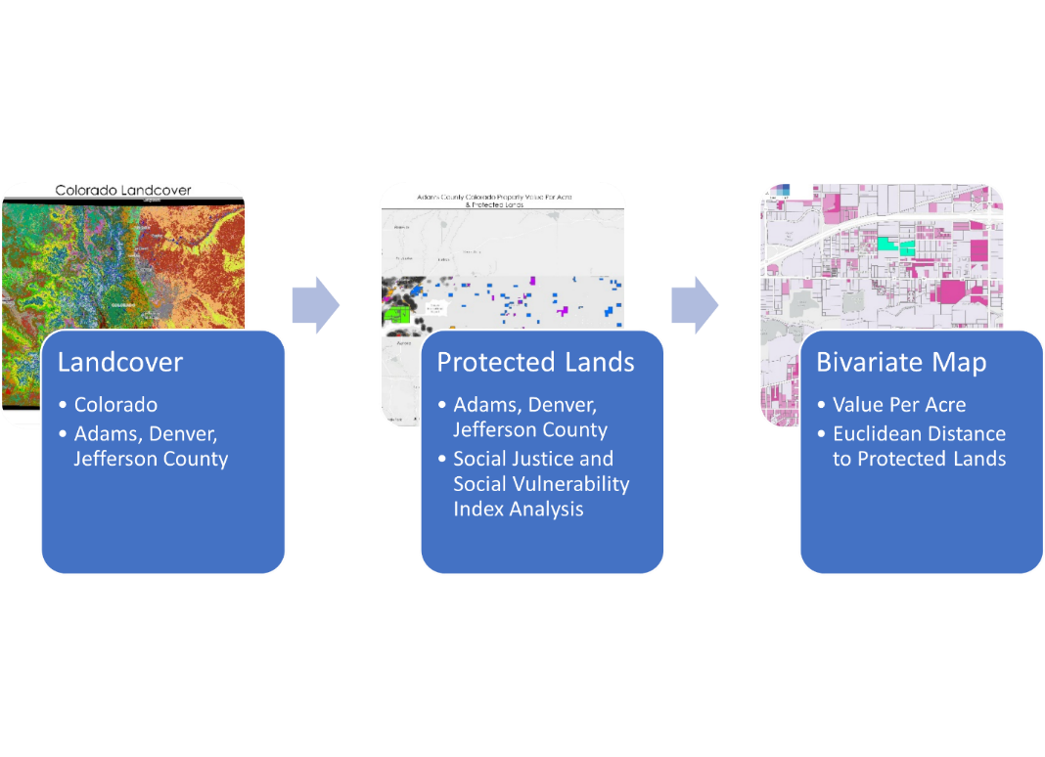
Figure 1: Analysis and methods overview.
Sampling
Three representative counties symbolize lower socioeconomic conditions; rural lands, with low population density and a high plains mountain environment; and higher socioeconomic status, higher population density, and more access to formal mountain amenities. Adams, Douglas, and Jefferson counties were selected as they are in the Colorado Front and represent a range of rural to urban demographics (Lowry et al., 2005).
Further, census data was explored via the US Centers for Disease Control and Prevention (CDC)/ Agency for Toxic Substances and Disease Registry (ATSDR) Social Vulnerability Index (SVI) and the US Environmental Protection Agency (EPA) 's Environmental Justice Screening and Mapping (EJScreen) tools. The SVI examines factors such as overall social vulnerability, socioeconomic status, household characteristics, racial and ethnic minority status, and housing type and transport. For overall social vulnerability (see Table 2 for more details) Adams ranked high, Denver ranked medium to high, and Jefferson ranked low (CDC/ATSDR, 2022). The EJScreen tool looks at environmental hazards in relation to demographic factors. For example, according to CDC/ATSDR (2022), one of twelve environmental indicators is "the lifetime cancer risk from inhalation of air toxics" and one of seven demographic indicators is "the percent of a block group's population in households where the household income is less than or equal to twice the federal poverty level." For all environmental factors the eastern part of Adams County was in the less than 50 percentile compared to the rest of the state, meaning that it is relatively unpolluted. The western side of the county closest to Denver radically differed with census block groups ranking in the 95-100 percentile for all categories, meaning that there are significant environmental pollutants present. For all environmental factors the majority of Denver County was in the at least 80-90 percentile compared to the rest of the state, and often much higher, meaning most of the county is significantly polluted. Jefferson County meanwhile was relatively unpolluted, being in the less than 50 percentile for all environmental factors compared to the rest of the state. (EPA, n.d.)

The CDC does not provide a state-level enumeration unit for its SVI tool (CDC/ATSDR, 2022). However, the EPA's EJ screen tool shows that most of the state was in the less than 50th percentile for all environmental factors compared to the rest of the nation (EPA, n.d.).
Table 2. Comparison of county Social Vulnerability categories (CDC/ATSDR, 2022).
 | Overall Social Vulnerability | Socioeconomic Status | Household Characteristics | Racial & Ethnic Minority Status | Housing Type & Transport
Adams | High | Medium-High | High | High | Medium-High
Denver | Medium-High | Medium-High | Low-Medium | High | High
Jefferson | Low | Low | Low-Medium | Low-Medium | Low

Descriptive Analyses
This study begins with a comprehensive analysis, examining land cover in Colorado and along the Front Range. Next, protected lands throughout the Colorado Front Range were mapped and overlain with county boundaries. A visual inspection confirmed the number of easements per county and is confirmed via a Structured Query Language (SQL) query. Table 3 details and compares state and county acreage totals and acreage per conservation easement type.
Table 3. Comparison of state and county acreage per land category (Colorado Natural Heritage Program, 2021).
 | USFWS | USFS | Tribal | NPS | NGO & LT | Federal
Adams | 15,965 | 0 | 0 | 0 | 1,135 | 1,055
Denver | 0 | 0 | 0 | 0 | 894 | 728
Jefferson | 4,543 | 832,992 | 0 | 0 | 12,005 | 2,688
Colorado | 171,592 | 14,478,127 | 770,208 | 709,418 | 187,971 | 453,571
 | State | Private Conservation | BLM | Local | Private | Total COMaP Acres
Adams | 25,269 | 13,091 | 0 | 12,479 | 5,815,180 | 5,890,085
Denver | 124 | 1 | 0 | 4,888 | 73,993 | 80,628
Jefferson | 22,388 | 15,468 | 78 | 75,601 | 1,047,922 | 2,013,685
Colorado | 11,589,705 | 2,376,504 | 8,289,876 | 443,411 | 34,890,067 | 66,620,880

Relevant parcel shapefiles include at a minimum: parcel number, parcel size, and property value. Property value per acre was calculated for ease of comparison. It is important to note that large numbers of parcels have zero property value because for tax purposes government entities do not pay property taxes. Further, agricultural land value is assessed as just 29 percent of actual value (Colorado Division of Property Taxation, 2015). Finally, conservation easements themselves influence property value for those encumbered parcels as they are generally appraised below fair market value due to the elimination of development rights.
Almost entirely full sample sizes are used, only non-numerical parcel identifiers and zero property value parcels were removed. These parcels were generally public utilities with no accompanying property value. The Pairwise intersect tool allows the data to retain all original attributes.
Data cleaning involved removing duplicates, transforming text fields to integer fields, indexing values, and checking and repairing polygons. Polygons with self-intersections and duplications were corrected within parcel data. The calculate geometry tool ensured accurate area measurements.
To avoid potential edge effects of county-level analysis, Euclidean distances were calculated for all variables at a state level. This does not account for state-level edge effects, but it did help to lessen the influence on the county study area, especially as study counties were not on the border of Colorado. Euclidean Distance utilized a mask and processing extent of the state of Colorado with a cell size of 15 meters for statewide data such as USFWS, USFS, Tribal lands, NPS, NGO and land trust, federal, state, private conservation, BLM, and local protected land types. Zonal Statistics as Table with statistics type as Median was run to pair distance calculations back to a parcel data index for each Euclidean Distance layer.
Finally, tables and variables were joined to the unit of analysis, the parcel dataset. Parcel polygons were converted to centroid points utilizing Feature to Point (Data Management Tools). A kernel density layer of the value per acre per parcel was created using the Kernel Density planar method (Spatial Analyst Tools).

The COMaP data layer was then overlain on the kernel density layer to compare property values with the locations of protected land. Finally, several dozen detailed bivariate maps were produced to illustrate the relationship between property value per acre and Euclidean distance from protected lands for each county and for each land category. Only one of the maps is included herein (Figure 4), but all maps were analyzed to produce the results. Bar charts display mean value per acre from varying median distances for each county and each land category (Figures 5, 10, A1 and A2). Again, parcels with zero property value per acre were excluded from these charts.

Results

Descriptive Analyses

The State of Colorado has 67 million acres (Stacker, 2022) and 64 counties (CDPHE, 2018). The US government owns less of the land in Colorado than other Western states, but the figure is still over one-third (Esri et al., 2022). Over 14 million acres (over 20 percent of Colorado) are administered by the US Forest Service, with the Bureau of Land Management as the other large holder at over 8 million acres (over 11 percent of Colorado) (Colorado Natural Heritage Program, 2021).
Colorado has 6,740 conservation easements totaling 2,896,711 acres (over 4 percent of Colorado) of various types held by multiple entities such as land trusts, Non-Governmental Organizations (NGOs), and local, state, and federal governments. The smallest easement, Niwot Hills, is 0.009 acres, is held privately, and is in Boulder County. The largest, Sangre de Cristo Conservation Area, is 89,324 acres of private land with an easement held by the US Fish and Wildlife Service (USFWS). Colorado Open Lands land trust has the most easements by number, with a count of 801 easements, Colorado Cattleman's Agricultural Land Trust is a close second with 794, and Boulder County has the third most holding 765. Most are perpetual, but a small portion is protected for 30 and 40 years, and many are listed as unknown protection. These easements are distributed throughout Colorado. A few vast tracts cluster in the south-central portion of the state along the New Mexico-Colorado border in the Sangre De Cristo Mountains. (Colorado Natural Heritage Program, 2021)

Adams County
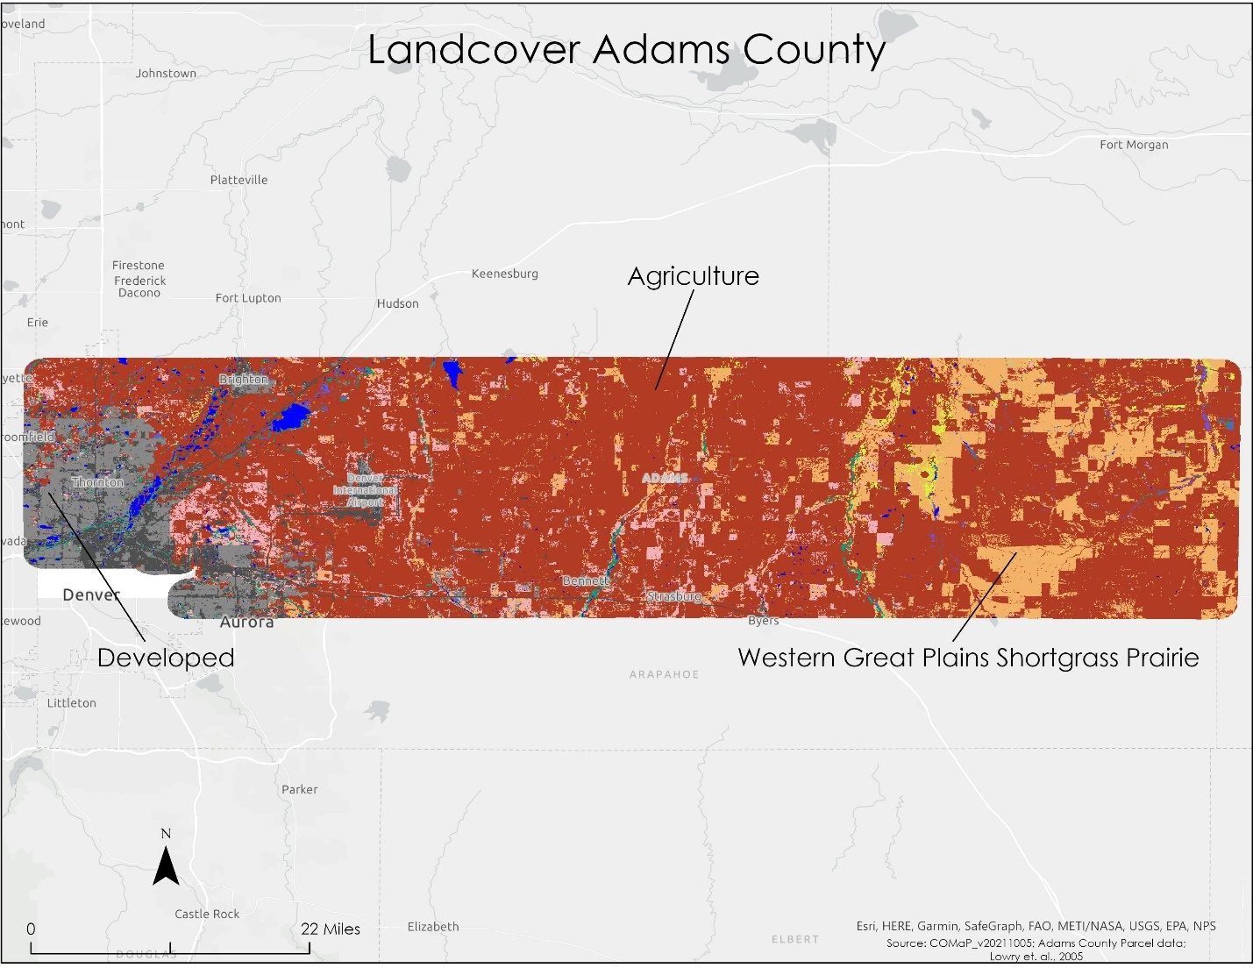
Adams County has no USFS, Tribal, NPS, or BLM land. Private land comprises 98.7 percent of the land. State land is a distant second at 0.4 percent. USFWS land is third, with almost 0.2 percent. Private conservation is fourth, with over 0.2 per cent, and total NGO and land trust land is sixth, with over 0.01 percent. The largest land use category for the county is agriculture (Figure 2). (Lowry et al., 2005; Colorado Natural Heritage Program, 2021).

Figure 2. A Landcover Map of Adams County, Colorado, indicates primarily agricultural land use (Lowry et al., 2005).
The far west side of the county has significantly more urban development than the rest (with smaller parcels), and generally, property values are substantially higher (Figure 3) (Lowry et al., 2005; Colorado Natural Heritage Program, 2021).
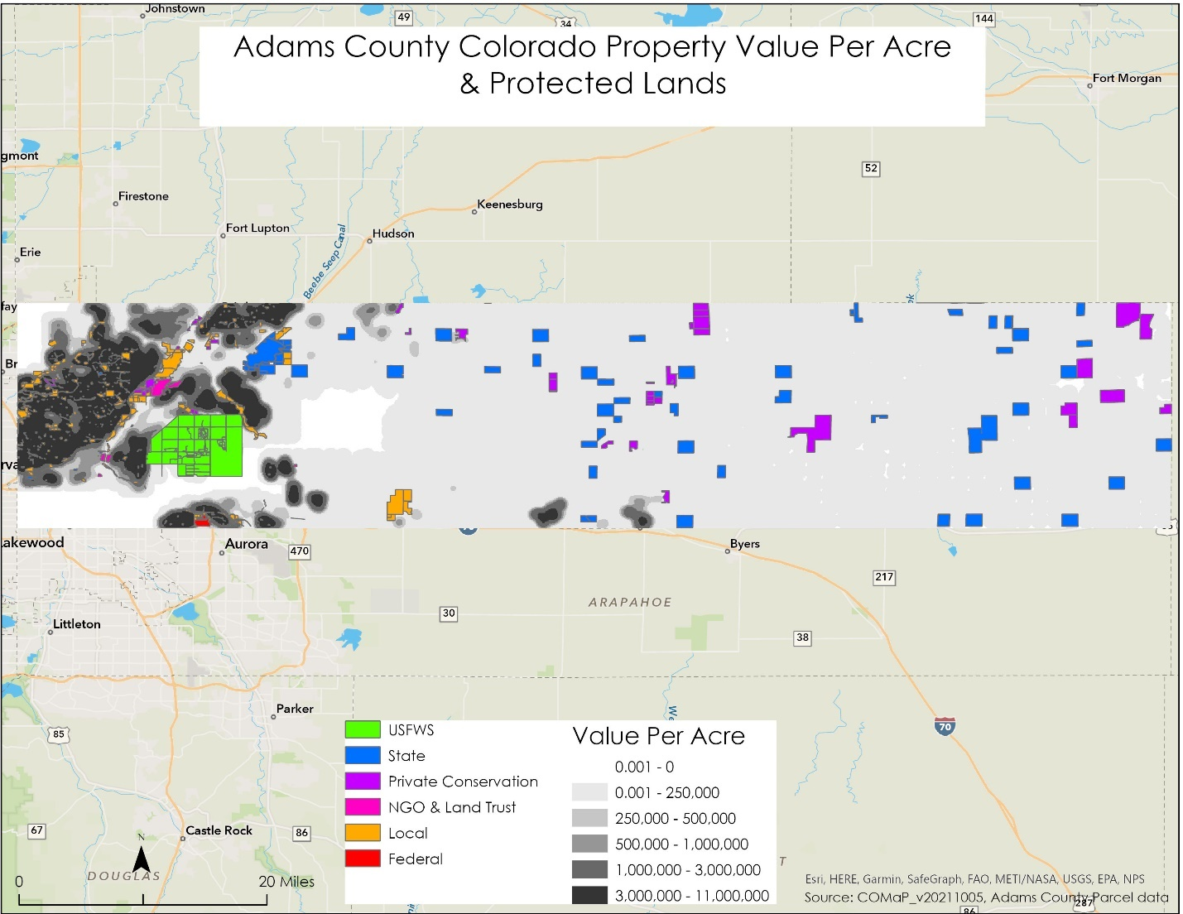
Figure 3. Assessed land value per acre and protected land categories in Adams County, Colorado (Colorado Natural Heritage Program, 2021).
The Local protected land category is adjacent to numerous high-value properties in Adams County (Figure 4). Adams County contains one Federal protected property. A few assessed property values are relatively high nearby on the west side of the property. The parcels are not adjacent but are only separated from the property by a road. Adams County also contains state protected lands. Overall, most assessed adjacent property values are low. Only one state protected property may have an impact on adjoining property values. Proximal parcel land values increased adjacent to one private conservation-protected property in Adams County, Colorado. The property was part of a country club and golf community. (Colorado Natural Heritage Program, 2021)

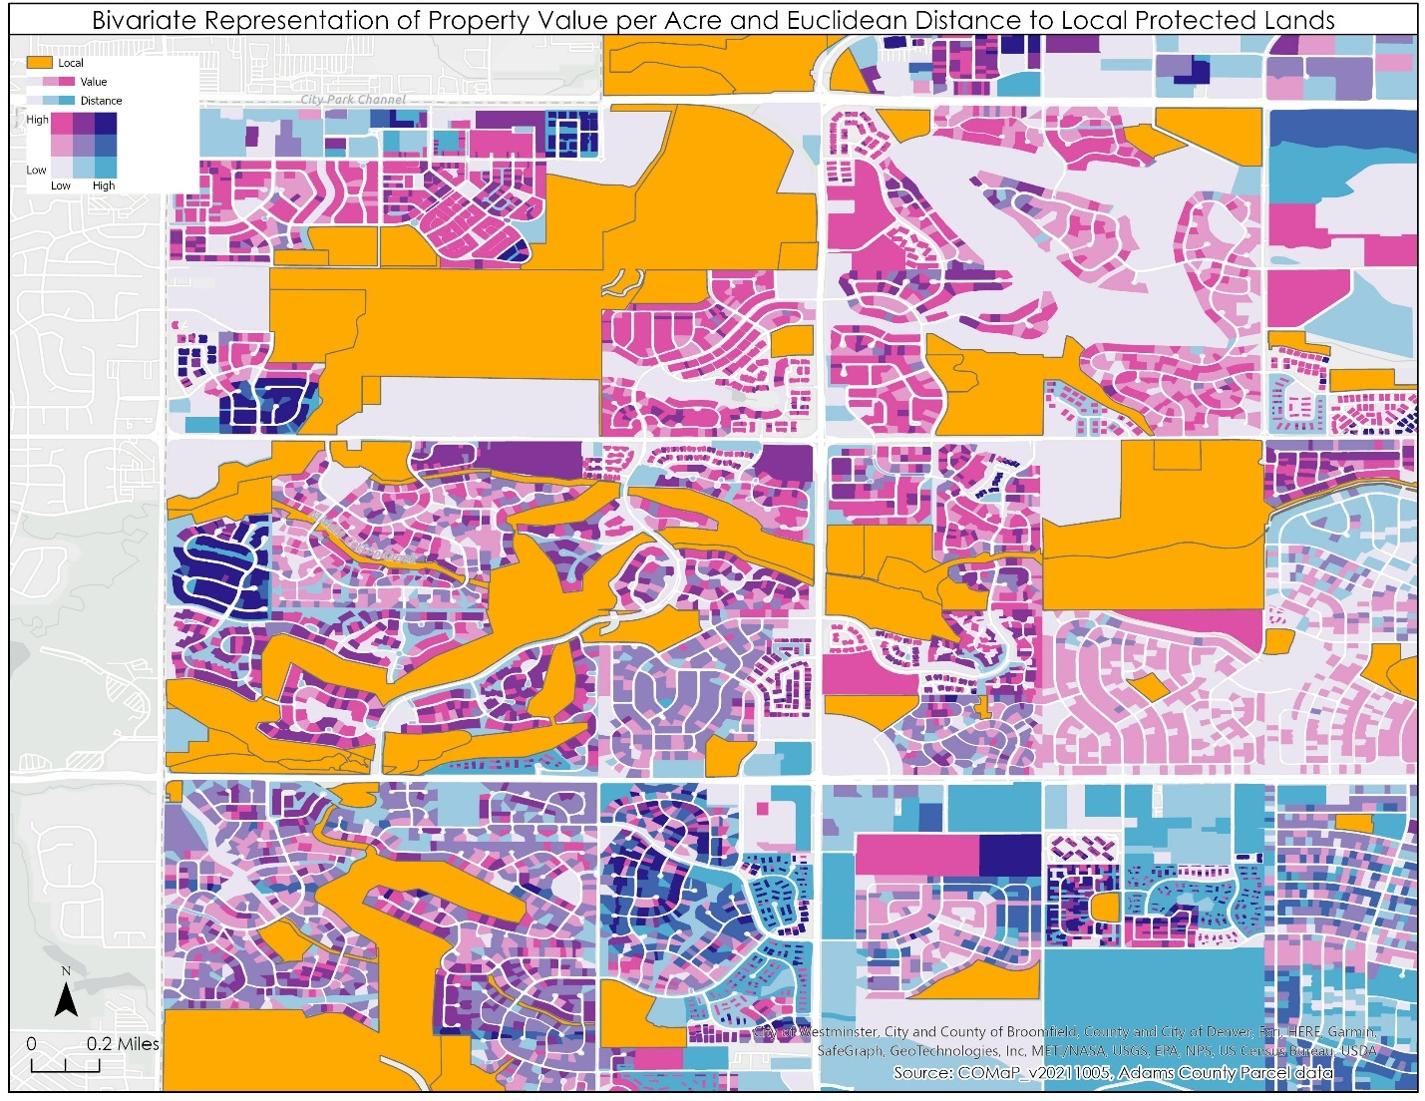
Figure 4. Close-up of many proximal parcel land values, which saw an increase adjacent to the local government protected property in Adams County, Colorado (Colorado Natural Heritage Program, 2021).
In Adams County, no parcels adjacent to USFWS or NGO and land trust protected lands displayed increased property values. NGO and land trust lands showed a slight potential increase in nearby mean property values when looking at more generalized median distances of less than or equal to 1/8 of a mile compared to greater than 5 miles. Federal, state, and private conservation protected lands represented a minimal potential influence on increased property values for adjacent lands and no potential positive impact for nearby property values. Of all protected land categories in Adams County, local government protected lands represented by far the most potential positive influence on increased property values for adjacent and nearby lands. (Figure 5) (Colorado Natural Heritage Program, 2021)

Figure 5. Property values in relation to median distance from protected lands in Adams County (Colorado Natural Heritage Program, 2021). Parcels with zero property value per acre were excluded.

Denver County
Denver County has no USFWS, USFS, Tribal, NPS, or BLM land. Private land makes up the vast majority of the land, at almost 93 percent. Local land is a distant second at 6 percent. Total NGO and Land Trust land is third with 1 percent. The largest land use category for the county by far is developed (Figure 6). (Lowry et al., 2005; Colorado Natural Heritage Program, 2021)

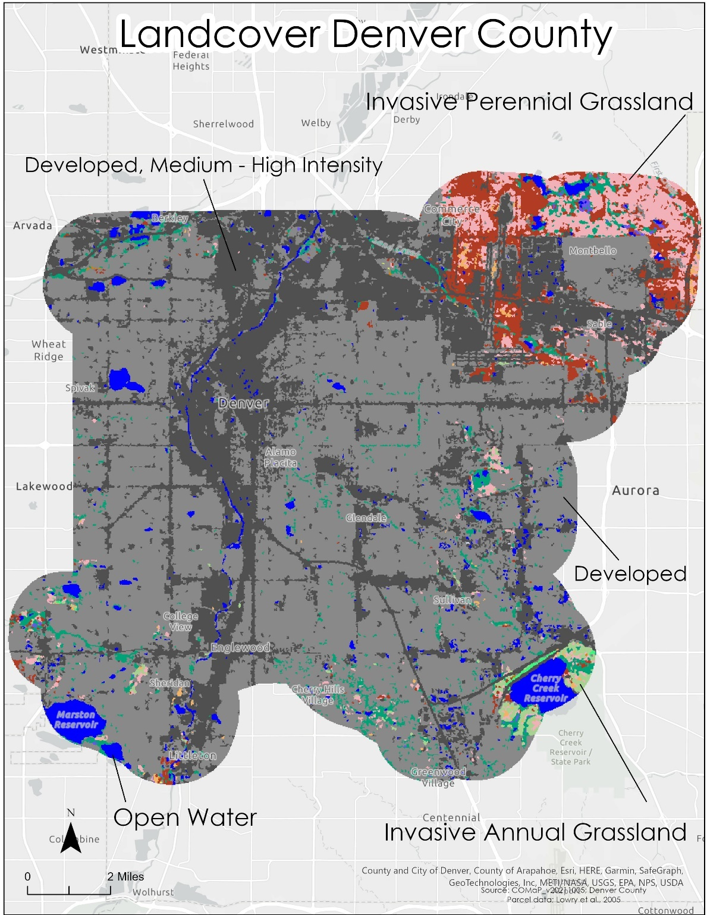

Figure 6. A Landcover Map of Denver County, Colorado, indicates primarily developed land use (Lowry et al., 2005).
Most of Denver County is developed with small parcels and property values are generally high (Figure 7) (Lowry et al., 2005; Colorado Natural Heritage Program, 2021).
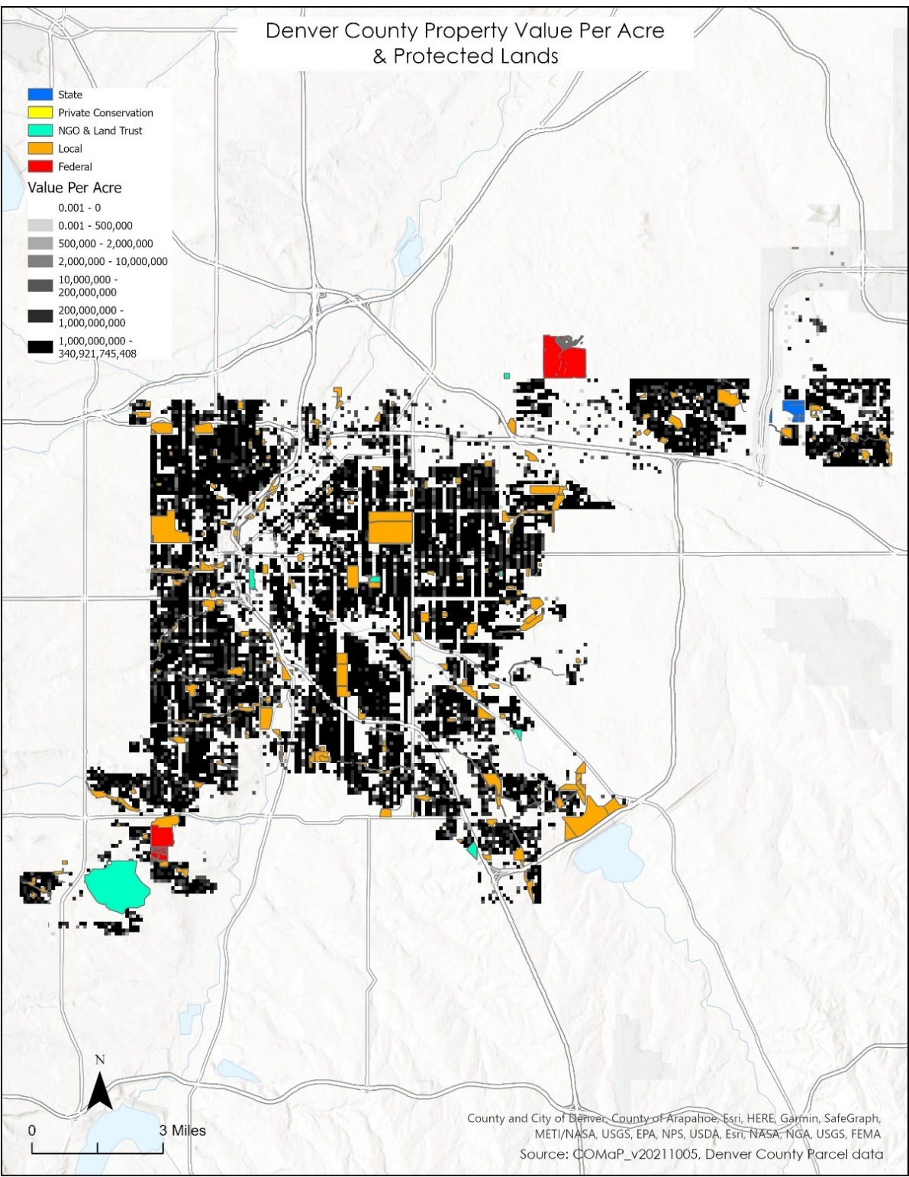

Figure 7. Assessed land value per acre and protected land categories in Denver County, Colorado (Colorado Natural Heritage Program, 2021).
In Denver County, no parcels adjacent to or generally nearby (a median distance of less than or equal to 1/8 mile) the one Private Conservation property indicated an increased property value. Parcels separated from federally protected lands by a road showed a potential increase in some property values, but generally nearby properties did not increase in value. Some state-protected lands displayed increased adjacent property values, but generally nearby properties did not increase in value. Local and NGO and land trust protected lands illustrated the most potential influence on increased property values for adjacent and nearby lands. (Figure A1). (Colorado Natural Heritage Program, 2021)
Jefferson County
Jefferson County has no Tribal or NPS land. Private land makes up over 50 percent of the land. The USFS is the second largest entity at 41 percent. Local land is third at over 3 percent. Private conservation is fifth with 0.7 percent and Total NGO and land trust land is sixth with 0.6 percent. The western portion of the county is mainly natural land cover, while the northeast represents concentrations of developed lands. (Figure 8). (Lowry et al., 2005; Colorado Natural Heritage Program, 2021)
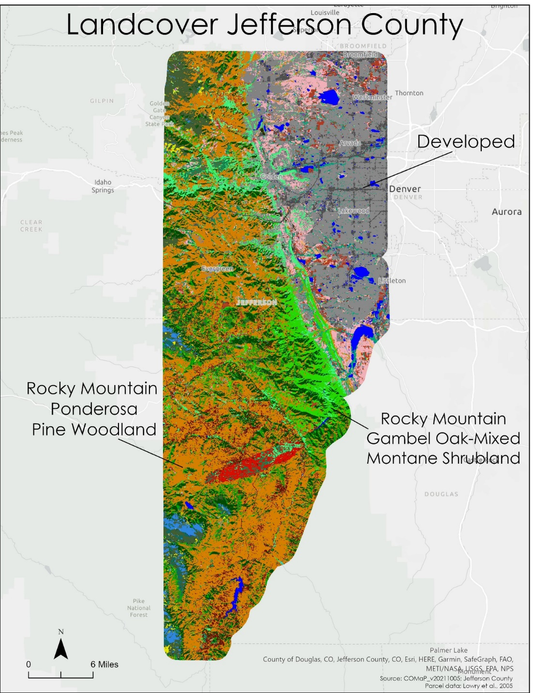

Figure 8. A Landcover Map of Jefferson County, Colorado, indicates primarily natural and developed land use (Lowry et al., 2005).
Primarily natural and developed landcovers divide Jefferson County, and property values are mainly concentrated in the developed northeast (Figure 9). (Lowry et al., 2005; Colorado Natural Heritage Program, 2021)
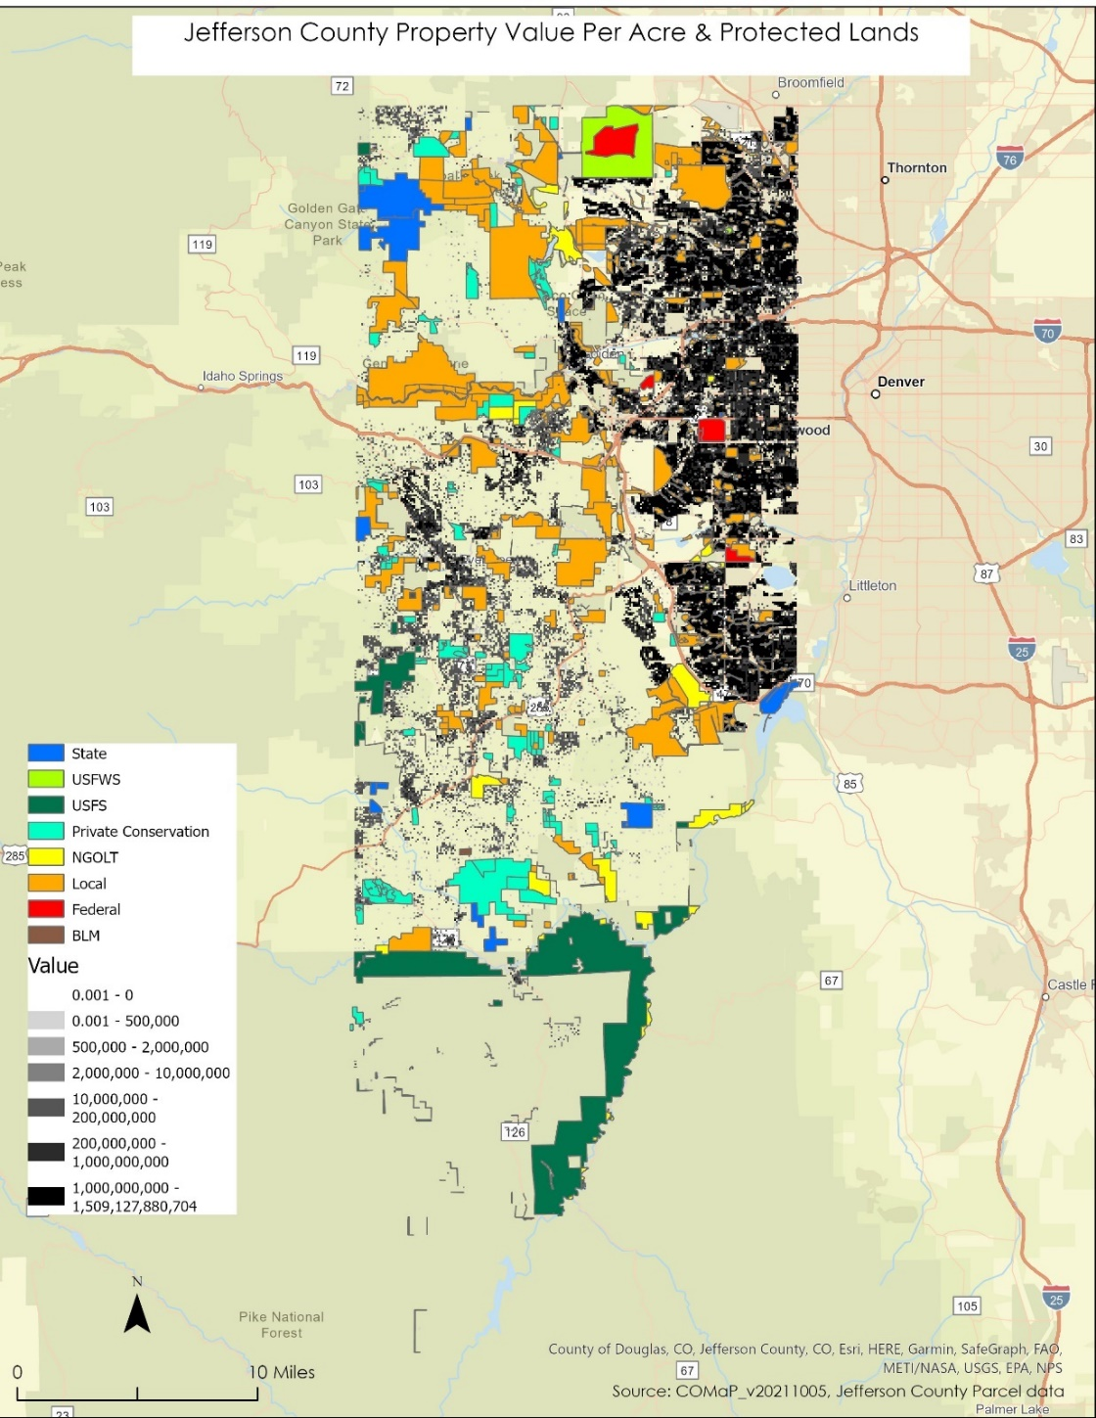

Figure 9. Assessed land value per acre and protected land categories in Jefferson County, Colorado (Colorado Natural Heritage Program, 2021).
In Jefferson County, no parcels adjacent or nearby (less than or equal to a median distance of 1/8 mile) to USFS or BLM-protected lands displayed increased property values. USFWS-protected lands represented a fairly minimal potential influence on increased property values for adjacent and nearby lands. Of all protected land categories in Jefferson County, numerous state, federal, NGO land trust, local, and private conservation lands demonstrated potential solid influence on increased property values for adjacent lands. NGO and land trust, local, and federal all showed a potential solid influence on increased property values for nearby lands. (Figure A2). (Colorado Natural Heritage Program, 2021)
Adams, Denver, and Jefferson Counties
For all three counties, local government protected lands appeared to potentially increase property values significantly in parcels within a median distance of less than or equal to 1/8 of a mile (Figure 10).

Figure 10. Property values in three Colorado counties in relation to median distance from local protected lands (Colorado Natural Heritage Program, 2021). Parcels with zero property value per acre were excluded.

Discussion

None of the three counties had Tribal or NPS lands, so this study could not assess the impact of those protected lands on adjacent property values. All except Jefferson did not have BLM lands, and Jefferson only had one BLM property. Only Jefferson had USFS land, while Denver was the only county with no USFWS land. Land protection categories are not equally represented in size or distribution across the three counties making comparison challenging. (Colorado Natural Heritage Program, 2021)
Only local protected lands demonstrate a potentially strong influence on adjacent property values in all three counties (Colorado Natural Heritage Program, 2021). This result is exciting and contradicts information from the previous hedonic valuation of land protection methods applied in Larimer County in Northern Colorado (Kling et al., 2015). Kling et al. found that "only proximity to national and state parklands had a significant positive impact on property values, while city/county [local] land, national forest, and privately conserved land exhibit marginally significant or no significant effects." This result is also concerning because only 6 percent of the local protected lands in Colorado are protected via more strict conservation easements, fee title, or deed restrictions (Colorado Natural Heritage Program, 2021).
No shared category of land showed no impact on property values for each county, though each had at least one type that appeared to have no influence. Similarly, all had varying categories that seemed to exert a potentially weak influence on property values where just one of many properties influenced another, or the dataset was limited to just one property and that property showed an influence. (Colorado Natural Heritage Program, 2021)
While state land is the highest percentage category of protected land in Adams county, it represented a minimal potential influence on increased property values for adjacent and nearby property values. It is worth noting that local and NGO and land trust lands comprise Denver County's most significant percentages of non-private land, respectively, and also display strong potential influences on increases in adjacent and nearby property values. Interestingly, USFS lands represent Jefferson County's largest non-private land category by acreage but do not appear to influence adjacent or nearby property values. (Colorado Natural Heritage Program, 2021)
An important observation is that developed land cover areas in all three counties correlated with higher property values. Many of the protected lands within these developed areas appeared to be the ones impacting increased property values. This seems to be a preliminary potential confirmation that protected lands have a larger impact on increased property values in urban settings than rural areas. (Lowry et al., 2005; Colorado Natural Heritage Program, 2021).
Overall Study Impact
These results demonstrate that there is potentially a relationship between protected lands (local protected lands in particular) and increased property values for adjacent and nearby land in Adams, Denver, and Jefferson Counties. Further, this study indicates that there may be a proportionally higher impact on increased property values in urban areas than in rural areas from nearby and adjacent protected lands. This research supports the previous scholarship of Reeves et al., 2018; Mittal, 2014; and Votsis, 2017 which demonstrated the positive impact of various types of open space and/or protected land on housing prices.
Public and Private Policy Implications
This study has policy implications for local public entities that hold or own conservation easements or protected land categories adjacent or nearby to other public local lands, as it means that protected lands potentially increase those holdings' value. The fact that protected lands potentially increase adjacent and/or nearby property values is of interest to private investors as well.
It is interesting to note that Adams County, relative to the rest of Colorado, has a high ranking of social vulnerability. Social vulnerability suggests that more practical agricultural easements will likely have more impact than luxury mountain amenities. Those that are in lower socioeconomic situations are less likely to need a tax deduction from a charitable contribution but more likely to be incentivized by conservation easement purchase options that allow for a continued living from the land. Given that many rural areas are not currently zoned for small lot development, the foregone development rights are simply not worth as much either. A low charitable donation value makes an outright purchase more attractive. Agricultural land has many conservation values, from scenic viewshed to wildlife habitat. Many federal programs encourage and financially incentivize benefits to wildlife, such as setting aside acreage to leave seeds on the crops for wildlife food and cover. Purchasing easements or protected lands is a way to reach a segment of the population that may have vital environmental resources but cannot afford charitable donations. On the opposite side of the spectrum, Jefferson County has a low ranking of social vulnerability in comparison to the rest of the state. Unsurprisingly, many categories of protected land- local, state, federal, NGO and land trust, private conservation lands- had significant impacts on property values. (Colorado Natural Heritage Program, 2021)
Scientific Impact
The study results show that not all protected lands and conservation easements are the same, whether the land or the incentives infrastructure. Optimizing land conservation in a specific context will benefit the most people and land. This study also forms a basis for examining rural and urban conservation contexts and can serve as a foundation for sophisticated models considering a large set of dependent variables.
Future Research Plans
An expanded study area to include the entire state of Colorado and a deeper examination into protected lands subcategories would likely result in more tailored conservation approaches and could have applicability to other state conservation approaches. Utah is particularly interesting as a future study area due to the presence of large tracts of existing protected land, the availability of state conservation easement purchase funds, and several successful county and municipal open space bond programs. It would also be interesting to compare the property value influence of conservation easement protected lands to other protected land categories. Comparing by proportionate acreage and the number of acres impacted would be of value because it would level the variations between counties and protected land categories. This comparison would provide a more accurate accounting of the significance of the impact.
Challenges/Limitations
Though Colorado is an open-data state, there were still significant limitations to the available data. For example, parcel data was available only for 32 of 64 counties. There were wide disparities in the detail provided within the existing parcel data. Some counties did not publish property value information by parcel. Data on public access and recreational opportunities, historical or agricultural structures, the threat of development, and landowner circumstances was also incomplete.
Further, edge effects almost certainly influence the data. For example, whether a state or county boundary is utilized, there are nearby easements or protected open space outside of those lines in each instance. In one example, Dinosaur National Monument spans the Utah-Colorado border.
Colorado has remarkable quantities and types of national, state, and county conserved land. Most of the western portion of the state represents federal land. Not all protected land categories were present in the study area, and present lands' distribution, size, and count were extremely variable. Finally, more research should be performed to rule out coincidence. Just because protected lands are adjacent and nearby to relatively high property values does not confirm independently that the proximity to protected lands causes the high property values.

Conclusion

Land protection via conservation easements and other development restrictions are a means to combat climate change, biodiversity loss, shrinking open space and agricultural lands, increasingly overburdened public lands, and decreasing quality of life for present and future generations. Conservation easements protect natural and public resources in perpetuity and are likely the most legally protected.
This research demonstrates that land values can increase with proximity to protected land in primarily urban areas within three counties along the Colorado Front Range. Local protected land had the most consistent impact on increased property values. This information allows us to optimize conservation approaches and financial incentives resulting in the protection of vital resources.

References

Brown, J., & Simpson, K. (2017, December 31). Colorado Divide: Why some Coloradans are cashing out of the Front Range and seeking their rural happily-ever-after. The Denver Post. Retrieved April 17, 2022, from https://www.denverpost.com/2017/12/31/colorado-migration-urban-rural/
Clay County Assessor's Office. (n.d.). Market Value Definition- USPAP Standard. Retrieved on April 5, 2023, from https://www.claycountymo.gov/application/files/3115/3565/9258/Market_Value_Definition.pdf#:~:text=%E2%80%9CMarket%20Value%20means%20the%20most,not%20affected%20by%20undue%20stimulus.
Colorado Department of Public Health and Environment (CDPHE). (2018, February 19). Colorado County Boundaries. 2010 US Census Bureau's Master Address File / Topologically Integrated Geographic Encoding and Referencing (MAF/TIGER) Database (MTDB). Retrieved on June 3, 2022, from https://www.cohealthmaps.dphe.state.co.us/arcgis/rest/services/OPEN_DATA/cdphe_geographic_analysis_boundaries/MapServer/5
Colorado Division of Property Taxation. (2015, January). Classification and Valuation of Agricultural Property in Colorado. Retrieved on April 2, 2023, from https://dolocnty.colorado.gov/sites/dolocnty/files/documents/Agricultural-Property-in-Colorado.pdf
Colorado Natural Heritage Program. (2021, October 05). The Colorado Ownership, Management and Protection Map (COMaP), v20211005. Colorado State University, Ft. Collins, CO. Retrieved on June 1, 2022, from https://comap.cnhp.colostate.edu
Esri, BLM, BoR, DoD, NPS, USFWS, USFS, USGS. (2022, May 23). USA Federal Lands. ArcGIS Living Atlas of the World. Retrieved June 17, 2022, from https://services.arcgis.com/P3ePLMYs2RVChkJx/arcgis/rest/services/USA_Federal_Lands/FeatureServer

Fausold, C.J. & Lilieholm, R.J. (1999). The Economic Value of Open Space: A Review and Synthesis. Environmental Management, 23 (3), 307-320. https://forestbioproducts.umaine.edu/wp-content/uploads/sites/202/2010/10/The-Economic-Value-of-Open-Spacepdf.pdf Copyright 1999 by Springer-Verlag New York Inc. For educational use only.

Frey, W.H. (2022, April 14). New census data shows a huge spike in movement out of big metro areas during the pandemic [blog]. The Avenue, Brookings. Retrieved April 19, 2022, from https://www.brookings.edu/blog/the-avenue/2022/04/14/new-census-data-shows-a-huge-spike-in-movement-out-of-big-metro-areas-during-the-pandemic/

German, J.C., Robinson, D., & Youngman, J. (2000). Traditional Methods and New Approaches to Land Valuation. Lincoln Institute of Land Policy. https://www.lincolninst.edu/publications/articles/traditional-methods-new-approaches-land-valuation

Gosnell, H. & Abrams, J. (2011). Amenity migration: diverse conceptualizations of drivers, socioeconomic dimensions, and emerging challenges. Geojournal, 76, 303-322. https://link-springer-com.ezaccess.libraries.psu.edu/article/10.1007/s10708-009-9295-4

Hiebert, J. & Allen, K. (2019). Valuing Environmental Amenities across Space: A Geographically Weighted Regression of Housing Preferences in Greenville County, SC. Land, 8, 147. doi:10.3390/land8100147

Holmquist, T. (2022, February 11). 20 Reasons People Are Moving to Colorado. Uncover Colorado. Retrieved April 17, 2022, from https://www.uncovercolorado.com/moving-to-colorado/
Kling, R.W., Findley, T.S., Gahramanov, E., Theobald, D. (2015, October). Hedonic Valuation of Land Protection Methods in the Rural-Urban Fringe: Implications for Cluster Development. Journal of Economics and Finance. https://www.researchgate.net/profile/Robert-Kling-2/publication/271916596_Hedonic_Valuation_of_Land_Protection_Methods_Implications_for_Cluster_Development/links/0a85e53be908319c83000000/Hedonic-Valuation-of-Land-Protection-Methods-Implications-for-Cluster-Development.pdf

Lowry, J. H.Jr., Ramsey, R.D., Boykin, K., Bradford, D., Comer, P., Falzarano, S., Kepner, W., Kirby, J., Langs, L., Prior-Magee, J., Manis, G., O'Brien, L., Sajwaj, T., Thomas, K.A., Rieth, W., Schrader, S., Schrupp, D., Schulz, K., Thompson, B., … Wolk, B. (2005) Southwest Regional Gap Analysis Project: Final Report on Land Cover Mapping Methods, RS/GIS Laboratory, Utah State University, Logan, Utah.

Mittal, J. (2014). Value capitalization effect of protected properties: A comparison of conservation easement with mixed-bag open spaces. Journal of Sustainable Real Estate, 6(2), 23-45. DOI:10.1080/10835547.2014.12091864 https://www.researchgate.net/publication/277816811_Value_Capitalization_Effect_of_Protected_Properties_A_Comparison_of_Conservation_Easement_with_Mixed-Bag_Open_Spaces

Metropolitan Policy Program. (2016). A Profile of Colorado's Front Range. Retrieved on April 17, 2022 from https://www.brookings.edu/wp-content/uploads/2016/07/front_range.pdf
Natural Resources Conservation Service (NRCS). (n.d.). Agricultural Conservation Easement Program. USDA. Retrieved April 19, 2022, from https://www.nrcs.usda.gov/wps/portal/nrcs/main/national/programs/easements/acep/
Reeves, T., Mei, B., Bettinger, P., & Siry, J. (2018). Review of the effects of conservation easements on surrounding property values. Journal of Forestry, 116 (6), 555-562. DOI:10.1093/jofore/fvy046 https://academic.oup.com/jof/article/116/6/555/5095608
Scorsone, E., Thilmany, D., & Davies, S.P., (2001, August). Determinants of Population Change in Regional Economies: A Study of the Colorado Front Range. American Agricultural Economics Association Annual Meeting, Chicago, IL., August, 2001. Retrieved April 17, 2022, from https://ageconsearch.umn.edu/record/20767/ Copyright 2001 by Eric Scorsone. For educational use only.
Seidl, A., Hill, R., & Mangus, L. (2020, October). Alternative methods for substantiating payments for conservation easements in Colorado. Regional Economic Development Institute Colorado State University. https://redi.colostate.edu/wp-content/uploads/sites/50/2020/10/REDI-Report-Alt-Val-Easments-Oct-2020.pdf
Stacker. (2022, August 12). Colorado is the #9 state with the most land owned by the federal government. stacker. Retrieved January 29, 2023, from https://stacker.com/colorado/colorado-9-state-most-land-owned-federal-government
Svaldi, A. (2022, January 30). Pandemic pushed Colorado home prices to record highs, listings to record lows- especially in high country. The Denver Post. Retrieved April 17, 2022, from https://www.denverpost.com/2022/01/30/olorado-home-prices-inventory-pandemic/#:~:text=Front%20Range%20counties&text=Douglas%20County%20leads%20metro%20Denver,at%20the%20end%20of%202021.
US Centers for Disease Control and Prevention (CDC)/ Agency for Toxic Substances and Disease Registry (ATSDR). (2022, December 1). CDC/ATSDR Social Vulnerability Index (SVI). CDC. Retrieved January 29, 2023, from https://www.atsdr.cdc.gov/placeandhealth/svi/interactive_map.html
US Department of Agriculture (USDA). (2022, November). NRCS Conservation Easement Areas by State (Colorado). GeoSpatialDataGateway. Retrieved November 3, 2022, from https://datagateway.nrcs.usda.gov/GDGHome.aspx
US Environmental Protection Agency (EPA). (n.d.). EJScreen, EPA's Environmental Justice Screening and Mapping Tool (Version 2.1). EPA. Retrieved January 29, 2023, from https://ejscreen.epa.gov/mapper/
US Forest Service (USFS). (n.d.). Forest Legacy. USDA. Retrieved April 19, 2022, from https://www.fs.usda.gov/managing-land/private-land/forest-legacy
US Forest Service (USFS). (2022, September 12). Forest Legacy Completed Projects. USDA Forest Service. Retrieved November 14, 2022, from https://apps.fs.usda.gov/fsgisx02/rest/services/wo_spf_nic/wo_spf_nic_ForestLegacyCompletedProject_01/FeatureServer

Votsis, A. (2017, February). Planning for green infrastructure: The spatial effects of parks, forests, and fields on Helsinki's apartment prices. Ecological Economics, 132, 279-289. https://www.sciencedirect.com/science/article/pii/S0921800916311430

"Maps throughout this paper were created using ArcGIS® software by Esri. ArcGIS® and ArcMap™ are the intellectual property of Esri and are used herein under license. Copyright © Esri. All rights reserved. For more information about Esri® software, please visit www.esri.com."

Appendix

Figure A1. Property values in relation to median distance from protected lands in Denver County (Colorado Natural Heritage Program, 2021). Parcels with zero property value per acre were excluded.

Figure A2. Property values in relation to median distance from protected lands in Jefferson County (Colorado Natural Heritage Program, 2021). Parcels with zero property value per acre were excluded.

