Daniel Uhrhan
GEOG 596b
4/29/2014
Geospatial Assessment
I. Summary of Findings – The Risk Terrain Model (RTM) shown in Appendix A, Figure 7 was created from three natural disaster types (earthquake, flood, and tornado) and shows that the active and decommissioned nuclear generation sites in Illinois are situated in areas of moderate risk for the listed risk factor types. A second RTM shown in Appendix A, Figure 8 used additional risk layers of karst topography and landslide hazards and places the nuclear sites in the moderate to low-moderate risk zones.
II. Question -- With so much time between original planning and construction, are the nuclear power plants in Illinois sited in areas where the risks of operation are mitigated?
III. Grounding
A. Background
Illinois is steeped in the history of our nation’s nuclear research programs from the beginnings of the Manhattan Project and Enrico Fermi’s first man-made nuclear chain reaction to research and design of reactors carried out at Argonne National Laboratory up through the 1990s. Generally, coal is considered king as far as energy sources for power generation is concerned; however, nuclear power took hold in the northern half of the state. The state joined Pennsylvania as a state capable of generating power for the power grid in 1960 when the Dresden 1 reactor was commissioned and began producing energy at Dresden Generating Station near Chicago (Exelon Corporation, 2011). Over the next thirteen years, six more reactors were commissioned in the state with two reactors apiece at Dresden, Quad Cities Nuclear Generating Station, and Zion Nuclear Power Station. With two newer reactors producing energy at the station, Dresden 1 was decommissioned in 1978 (Exelon Corporation, 2011). The next expansion in the state’s nuclear power capabilities came from 1984 to 1988 when two units came online at Braidwood Nuclear Generating Station, Byron Nuclear Generating Station, and LaSalle County Nuclear Generating Station and an additional reactor at Clinton Nuclear Generating Station. In 1998, Zion Nuclear Power Station closed both reactors down and began decommissioning procedures for both reactors in an effort to make the entire station inert by 2020 (United States Nuclear Regulatory Commission, 2012). This leaves eleven reactors active at six nuclear power sites across the northern half of Illinois, the most nuclear generating stations and reactors in any state (Landis, 2011).
Illinois is also a state with many different risks to building a facility like a nuclear power plant. Foremost among these disasters for Illinois are earthquakes, floods, and tornadoes although they certainly are not the only natural disasters to occur in the state. Each of these are considered the most likely to occur as Illinois is within the area of effect for the New Madrid seismic zone, parts of the state are within Tornado Alley, and the considerable history of flooding. To a lesser extent, parts of the state are at risk for landslides and sinkhole activity.
B. Geospatial aspects (see https://www.e-education.psu.edu/sgam/node/172)
The main question of the project deals with the locations of the nuclear power plants and their intersection in space with various risk layers both individually and combined into a RTM. The idea is to see which areas of the state have a high or low degree of risk associated with them.
C. Key assumptions
- Risk factors do not stop at state borders, but only the state of Illinois is the area of interest (AOI).
- The risk factors being examined are not zero at any one place; rather the probabilities for risk are lower at one place than at any other.
- Risk factors are generally considered to be natural phenomenon or random environmental influences whose causes are understood, but may not be accurately predicted.
- The data and maps I have found are accurate representations of risk factors for the AOI.
- While nuclear facilities are considered to be high priority targets for acts of terror, the risk of terrorism will not be a factor included in the Risk Terrain Model. The fact that it is a nuclear facility automatically makes that facility and adjacent areas a high risk factor.
IV. Evidence
A. Preexisting evidence (Both spatial and aspatial)
- Locations of the nuclear power plants
- Types of natural hazards present in AOI
- Risk maps for natural hazards occurring in AOI
B. Derived evidence (Describe in Appendix A your methodology for deriving the evidence)
The risk data for each hazard type came in both raster and vector formats. Some of this data was easily converted to a workable format, while others necessitated manual digitization of the source maps. Once in a workable raster format, the source data was resampled into consistent cell sizes and clipped to the AOI in order to keep the risk layers as similar to one another as possible. They were then reclassified into values from 1 to 5 to reflect a low to high risk factor assigned to the risk categories contained in the source maps. The karst data in Appendix A, Figure 4 is the only deviation from this system as it was based on presence of karst and sinkhole topography rather than a risk of encountering that landform. It would be possible to use some of the spatial analyst tools to interpolate risk factors on a 1 to 5 scale as was done with the other risk layers. Once the risk layers were prepared and finalized, the RTM was created using map algebra functions to add the layers together into the results shown in Figures 7 and 8.

V. Analysis
A. What are the possible alternatives?
- Create more risk layers to add into the RTM
- Change the risk factor values by increasing/decreasing the scales
- Normalize the RTM values
B. Compare the alternatives.
Create more risk layers to add into the RTM
Adding more risk layers would have an unknown effect on the current results. Depending on the risk layers that are added and how they are prepared, results may vary. By adding the landslide and karst data, the risk in the resulting RTM was slightly lowered from a moderate risk factor to a moderate-low risk factor. However, it could have just as easily worked the other way.
Change the risk factor values
The current scale of 1 to 5 could be changed to allow for more or less risk factor values which could dramatically alter the look of the RTM and risk layer maps.
Normalize the RTM values
The categories for the RTM could be normalized to match the 1 to 5 scale of the rest of the risk layer maps. This may be a good idea in order to reduce the number of color variations that are currently being used and to match the other maps somewhat.
VI. Conclusions
Depending on the data used to create the RTM, the nuclear power plants are situated in areas of moderate and moderate-low risk. When the earthquake, flood, and tornado data were added together (Appendix A, Figure 7) all seven of the nuclear sites fell into the moderate risk zones with a value of 9 or 10. When the landslide and karst data were included (Appendix A, Figure 8) two sites broke into the moderate risk zone and five were categorized as moderate-low with the risk values ranging from 10 to 13. The karst data not matching the other risk layers scaling probably skews this second RTM a bit more than initially thought.
Given the data used and the knowledge that other factors are taken into account in determining where to site nuclear power plants, it is probably safe to say that the power plants were placed in locations where the risks of operation are mitigated.

Appendix A: Maps, Graphics, and Methodology for Derived Evidence
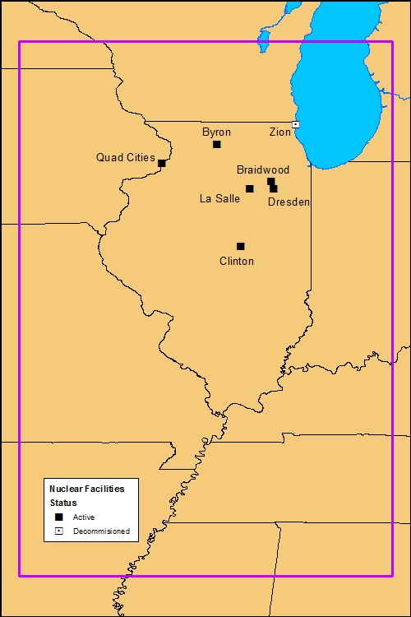
Figure 1. A map showing the area of interest with the location of the nuclear facilities plotted.
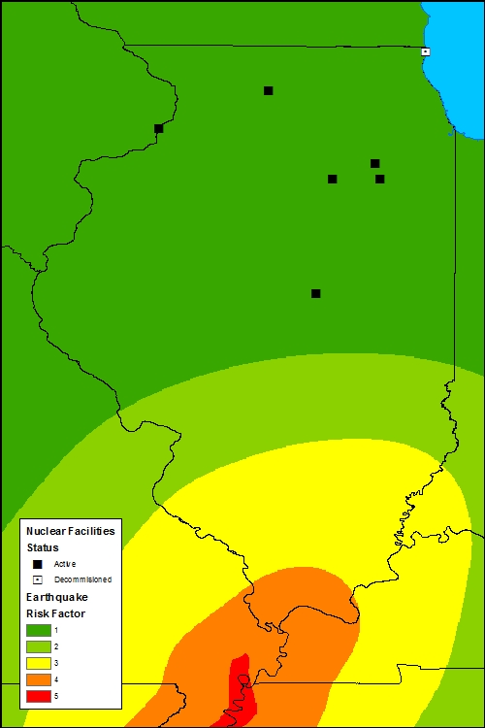
Figure 2. The Earthquake risk layer applied to the AOI.
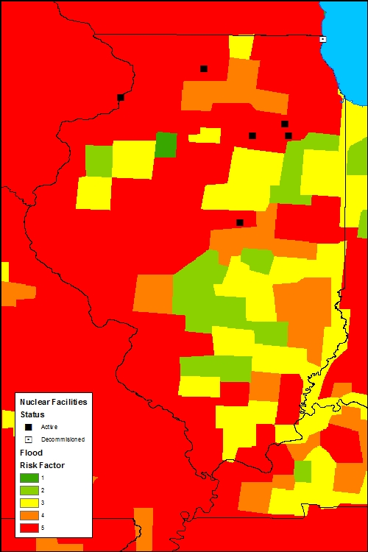
Figure 3. The Flood risk layer applied to the AOI.
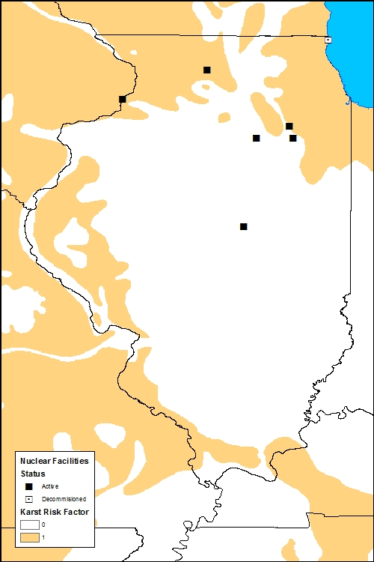
Figure 4. A map showing the areas containing Karst land formations.
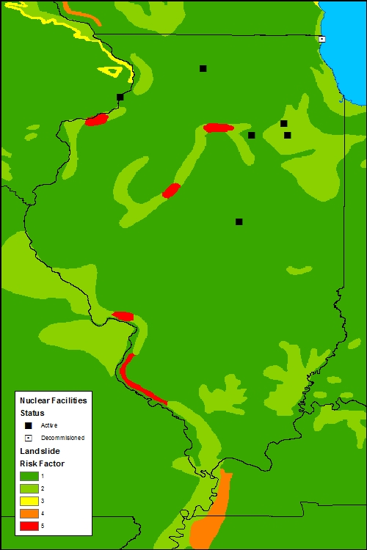
Figure 5. The Landslide risk layer applied to the AOI.
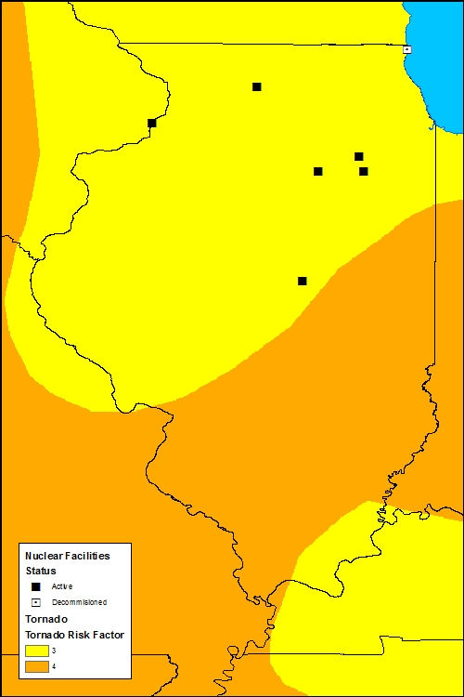
Figure 6. The Tornado risk layer applied to the AOI.
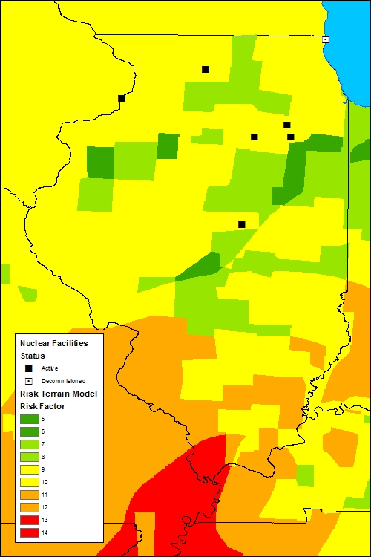
Figure 7. Risk Terrain Model with Earthquake, Flood, and Tornado risk layers.
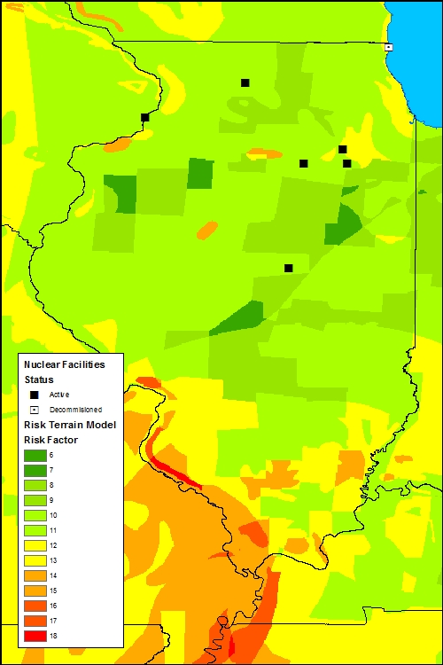
Figure 8. Risk Terrain Model with Earthquake, Flood, Karst, Landslide, and Tornado risk layers.

Appendix B: Annotated Bibliography
Catastrophe.org. (2011, April 18). US Tornado Map | Catastrophe.org. Retrieved July 29, 2012, from Catastrophe.org Web Site: http://catastrophe.org/2011/04/18/us-tornado-risk-map/
Website with maps and data on various types of natural hazards occurring in the United States.
Dedman, B. (2011, March 17). What are the odds? US nuke plants ranked by quake risk. Retrieved July 29, 2012, from MSNBC News Web Site: http://www.msnbc.msn.com/id/42103936/#.UDYBBKO05_a
News article ranking the nuclear plants of the United States by risk of earthquake.
Exelon Corporation. (2011). Dresden Generating Station Fact Sheet. Retrieved April 28, 2012, from Exelon Corporation Web Site: http://www.exeloncorp.com/assets/energy/powerplants/docs/Dresden/fact_dresdenplant.pdf
An info sheet from the Exelon Corporation that contains specific facts on the Dresden Generating Station.
Exelon Corporation. (2012). Exelon Corporation: Illinois. Retrieved April 28, 2012, from Exelon Corporation Web Site: http://www.exeloncorp.com/community/locations/illinois.aspx
Exelon Corporation operates all of the nuclear power generation stations in Illinois and offers information and locations on those plants.
Great Places to Retire. (2012, June 30). Flood Hazard Risk Map for US. Retrieved September 1, 2012, from Great Places to Retire Web Site: http://www.greatplacestoretire.com/flood-map.php
Website containing maps and information on the best places to retire, which includes various natural disaster risk maps for the entire US.
Harder, A. (2012, February 13). Is America Poised For A Nuclear Renaissance? Retrieved April 28, 2012, from National Journal Web Site: http://energy.nationaljournal.com/2012/02/is-america-poised-for-nuclear.php
An article that asks whether nuclear power is ready to take off again in the shadow of the Fukushima incidents or if the most recent permits granted in the United States are seen as more of an aberration.
Illinois Emergency Management Agency. (2009, May). Nuclear Generating Facilities in Illinois. Retrieved April 27, 2012, from Ready Illinois: http://www.iema.illinois.gov/iema/radiation/pdf/BNFS_PowerPlantBrochure.pdf
A digital pamphlet with information on the nuclear power generation stations in Illinois, the different types of reactors present in the state, as well as spent nuclear fuel.
Illinois State Geological Survey. (2005). Illinois Natural Resources Geospatial Data Clearinghouse. Retrieved April 27, 2012, from Illinois Natural Resources Geospatial Data Clearinghouse Web Site: http://www.isgs.uiuc.edu/nsdihome/
The clearinghouse contains various datasets that could be useful for primary and ancillary layers on the model.
Landis, T. (2011, March 15). Illinois' nuclear ban not going anywhere. Retrieved April 30, 2012, from The State Journal-Register Web Site: http://www.sj-r.com/top-stories/x13275048/Illinois-nuclear-power-industry-needs-to-learn-from-Japan-state-representative-says
News article where the Google maps app originally appears. The article also discusses the Fukushima incident and its effect on the nuclear power industry in Illinois.
NatHazMap.com. (2012). Hazard Maps, News, & Resources - Natural Hazard Maps, News, and Resources. Retrieved July 29, 2012, from NatHazMap.com Web Site: http://nathazmap.com/home
Website hosting maps and data of their own as well as links to other sites containing hazard maps and data.
National Atlas of the United States. (2012, July 22). NationalAtlas.gov. Retrieved July 29, 2012, from National Atlas Data Download: http://nationalatlas.gov/atlasftp.html?openChapters=chpclim,chpenvi,chpgeol#chpgeol
A government website with data and finished map products in various categories available for download.
Ready For Anything Now. (2010). Tornado Risk in Tornado Alley. Retrieved July 29, 2012, from Ready For Anything Now Web Site: http://www.readyforanythingnow.com/disaster%20survival%20guide%20articles/Tornado%20Risk%20in%20Tornado%20Alley.html
Website containing maps and information on the risks of living in Tornado Alley and how to mitigate that risk.
Rutgers Center on Public Security. (2011). Retrieved June 26, 2012, from Rutgers Center on Public Security Official Website: http://www.rutgerscps.org/
A website containing information and documents regarding spatial risk analysis and Risk Terrain Modeling for crime and global threats.
SJ-R.com. (2011, March 14). Nuclear power stations in Illinois - Google Maps. Retrieved April 30, 2012, from Google Maps: https://maps.google.com/maps/ms?hl=en&gl=us&ptab=2&ie=UTF8&oe=UTF8&msa=0&msid=208109426211512772807.00049e772338fc1290bbb
A Google Map app that shows the locations and information to the nuclear power generation stations in Illinois. It looks like the information contained comes from the Exelon Corporation website.
U.S. Geological Survey. (2012, August 16). Earthquake Hazards. Retrieved July 29, 2012, from USGS Earthquake Hazards Program Web Site: http://earthquake.usgs.gov/hazards/?source=sitenav
A government website that contains links to spatial data and maps regarding earthquakes and other seismic anomalies.
United States Census Bureau. (1996). Population of States and Counties of the United States: 1790 to 1990. Retrieved April 27, 2012, from United States Census Bureau Web Site: http://www.census.gov/population/www/censusdata/pop1790-1990.html
A government website has a report that displays various population statistics from the earliest period of the United States to 1990.
United States Department of Energy. (2010, November 22). CP-1 Goes Critical, December 2, 1942. Retrieved April 27, 2012, from The Manhattan Project: An Interactive History: http://web.archive.org/web/20101122183641/http://www.cfo.doe.gov/me70/manhattan/cp-1_critical.htm
An article covering the first man-made nuclear chain reaction created during an experiment for the Manhattan Project.
United States Nuclear Regulatory Commission. (2012, March 29). NRC: History. Retrieved April 27, 2012, from United States Nuclear Regulatory Commission Web Site: http://www.nrc.gov/about-nrc/emerg-preparedness/history.html
The site has a brief history of nuclear power generation within the United States with a slant toward safety regulations and emergency preparedness of the nuclear power industry.
United States Nuclear Regulatory Commission. (2012, March 29). NRC: Zion Units 1 & 2. Retrieved April 30, 2012, from United States Nuclear Regulatory Commission Web Site: http://www.nrc.gov/info-finder/decommissioning/power-reactor/zion-nuclear-power-station-units-1-2.html
The source contains information specifically about the Zion Nuclear Power Station including shut-down and decommissioning dates for the station.

