Legislative Redistricting Models for Wisconsin

Legislative redistricting is the most political process that happens in the State of Wisconsin (for that matter the nation). Districts that were drawn 10 years prior to the most current census, due to shifts in population may not represent an equal number of constituents are required to be redrawn. This process starts in the year ending in 1 (2001, 2011, 2021) and typically ends in the year ending in 2 (2002, 2012, 2022). The responsibility of redistricting in Wisconsin is given to the current elected legislators.
“Although a legislative responsibility, the courts have been involved in legislative redistricting to some degree in each of the past 5 decades. In all cases, judicial intervention was the result of the legislature and the governor failing to agree on a plan to redraw legislative district boundaries. In contrast, the legislature has had comparatively little difficulty in enacting congressional redistricting plans, even in cases where the number of seats have been reduced due to relative population growth”. (Keane, Wisconsin Legislative Reference Bureau, 2010)

As noted above, passing a legislative redistricting plan in Wisconsin has been difficult. The goal of this project is to provide a non-partisan analysis of the current redistricting process in our state and to look at other state’s processes for legislative redistricting. In particular, I would like to look at states that redistrict in a non-partisan manner, like Iowa and California. Through my research on the current redistricting model in Wisconsin and the non-partisan models of redistricting that are currently implemented in other states, I would like to determine if implementation of a new redistricting model would allow the legislature to pass a redistricting plan without judicial intervention (quicker) and how these models may affect the overall cost of this process.

Current Redistricting Process in Wisconsin
In order to look at new redistricting models for Wisconsin, it is important to understand the current process. Currently the process of redistricting is mandated by the Wisconsin Constitution, “The redistricting process in Wisconsin is mandated by article 4, section 3, of the Wisconsin Constitution, which requires that the state senate and assembly be redistricted following each federal census according to the number of inhabitants”. (Keane, Wisconsin Legislative Reference Bureau, 2005) Wisconsin traditionally goes through a series of steps before the actual redrawing of maps begins.
- Redistricting Data Program
- Local Redistricting
- Legislative and Congressional Redistricting

Redistricting Data Program
The Redistricting Data Program (RDP) is a U.S. Census Bureau program that provides “state legislatures with the small area census population tabulations necessary for legislative” and congressional redistricting. This voluntary program allows states to help define the geography that will be tabulated during the next census. This program also serves as the mechanism to which census geography and tabulations are delivered to states. “The Census Bureau must transmit total population to the states within one year of census day, customarily April 1 of the year following the census”. The following link lists the five phases of this program: (http://www.census.gov/rdo/, n.d.)
Phase 1 - State Legislative District Project – This part of the project allows states to insert state legislative districts into the Census Bureau’s Geographic database (TIGER). Once this data has been inserted into the TIGER database it can be enumerated in the next census. This is an important step in the redistricting process, the loss or gain of population in legislative districts determines if the districts need to be re-drawn.
Phase 2 - Voting District/Block Boundary Suggestion Project – This phase of the program allows states to insert Voting Districts (wards in Wisconsin) into the TIGER database to be tabulated. Also during this phase, collection blocks can be altered to become more useful for local municipalities.
Phase 3 - Delivery of the P.L. 94-171 Redistricting Data Files and Geographic Products – This by far is the most important phase of the program. This phase of the program is the actual delivery of redistricting geography (early in the year ending in xxx1) and the P.L. 94-171 population totals that when merged together, constitute the final delivery of data to states.
Phase 4 - Collection of Post-2010 Census Redistricting Plans – This phase collects congressional and state legislative redistricting plans that have been passed by each state. It is important to note that if a redistricting plan splits census geography, the geography would be split to accommodate the plan in the TIGER database but, the population totals in the corresponding census blocks would not be changed.
Phase 5 - Evaluation of the 2010 Census Redistricting Data Program and Recommendations for the next census. This phase of the program serves as an after action review for the previous census. This phase gives states the ability to tell the Census Bureau what went right and what could be improved.
This RDP is an important part of the redistricting process. It allows states to give input into the creation of redistricting geography. It also allows states to suggest potential changes to data structures and actual fields in the final datasets. As an example, the real estate market crash occurred during the time the RDP was in full force for Census 2010, states asked for detailed housing information to be supplied with the PL 94-171 data (redistricting population totals) to aid in the redistricting process, and the Census Bureau was able to accommodate this request. The Wisconsin Legislature fully participates in the RDP. I currently serve as the state’s liaison for the RDP.

Local Redistricting
The local redistricting process in Wisconsin starts after the 3rd phase of the RDP. The process of local redistricting is unique to our state. Once the data is delivered to the legislature, it is prepared and distributed to all 72 Wisconsin counties. At the point where the counties receive the data, the 180 day statutorily mandated process of local redistricting begins.
First 60 days – Counties use this first 60 days to draw a tentative county supervisory district plan. “County boards are to work cooperatively with municipalities in establishing supervisory districts. Supervisory districts are to be comprised of whole contiguous municipalities, parts of the same municipality, or contiguous parts of adjoining municipalities consisting of whole wards.” (Keane, Wisconsin State Legislature, 2011)

Second 60 Days – After the tentative supervisory plan has been created, municipalities must then create municipal wards based on the tentative supervisory plan. These wards must be created based on a specific set of population ranges based on the municipalities’ population. As an example, cities with a population over 150,000 must create wards that range between 1,000 and 4,000 people, while cities, villages and towns with populations between 10,000 and 38,999 must create wards that are between 600 and 2,100. (Keane, Wisconsin State Legislature, 2011) Once wards are established they need to be reported to each county within 5 days of adoption. Municipalities over 10,000 must also report their newly established wards to the Wisconsin Legislature.

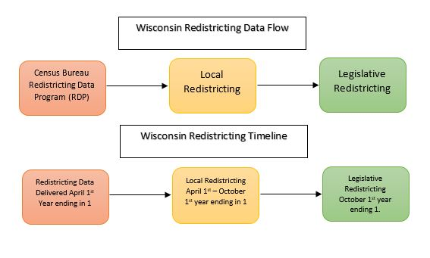
Final 60 Days – During this period the county must finalize and adopt a supervisory plan, while municipalities that are required to do so, must create aldermanic districts.
Figure 1: Data flow and timeline diagram.

Legislative Redistricting
Once Census data has been delivered to the state and the process of local redistricting has finished, the process of legislative redistricting may begin. The municipal ward data that is created in local redistricting and is reported to the Wisconsin Legislature and is typically used as the base layer for legislative redistricting.
Once the data is collected, it is placed into a Geographic Information System (GIS) and is given to legislative leadership. Legislative leadership then constructs redistricting plans and creates legislation built from their redistricting plans. The resulting legislation follows the path of a normal bill, working its way through the legislative process.
The process of legislative redistricting in Wisconsin is seen as very partisan, divisive and costly. Just the partisan nature of redistricting has been enough for people to call for a different model to be put in place. Due to various factors, the courts have had to draw the redistricting plans in four of the last five decades in Wisconsin. Even in the last round of redirecting, a plan was passed by the legislature and signed in to law by the governor, but a lawsuit was filed with the Eastern District Federal court. The federal court redrew districts 8 and 9 of that plan. This litigation took several months to settle and resulted in large litigation fees.

Principals of Redistricting
The basic principal behind the redistricting process is equal population of districts. “Redistricting is the process by which legislative bodies maintain the principle of equal representation by adjusting their district boundaries to reflect changes in population”. (Keane, Wisconsin Legislative Reference Bureau, 2005)
Geographic Measures
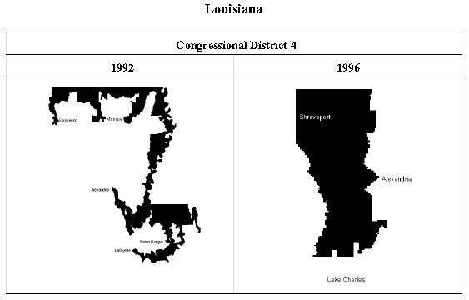
Compactness and Complexity – Compactness is the measure of how long a district is compared to its width. Compactness can be measured in several different ways. One way of measuring compactness is to compare a district’s shape to a circle. The closer a district measures to a comparably sized circle, the more compact it is said to be. The complexity of a district is a measure of the perimeter of the district compared to area of the district. In figure 2, it is apparent that the 4th congressional district drawn in Louisiana in 1992 is very complex and is not compact, whereas the new district drawn in 1996 is much more compact and less complex.
Figure 2: Louisiana Congressional District 4
Figure 2: Examples of Compactness and Complexity (Watson, 2011)
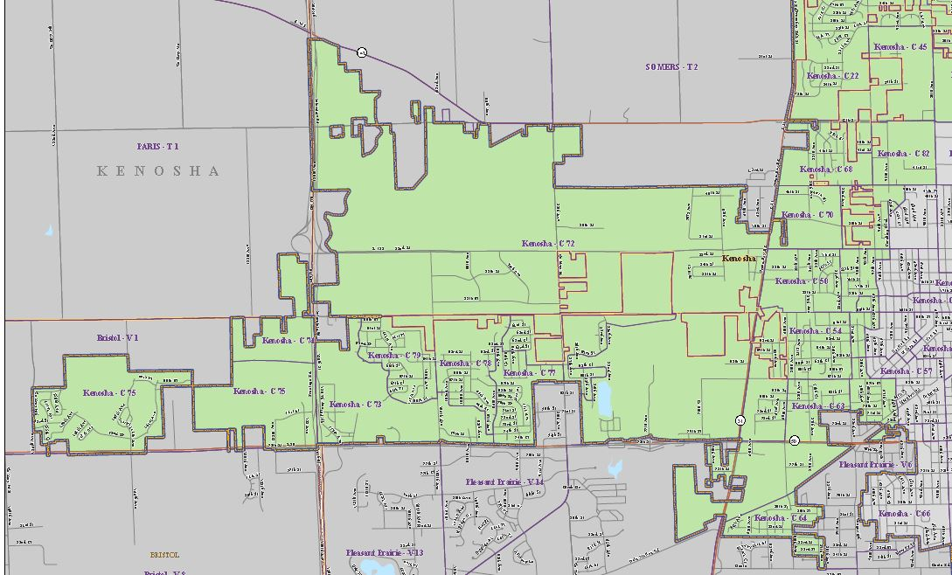
Contiguity – Districts should be contiguous or all portions of a district should be connected. This is a complicated matter in Wisconsin, as districts in Wisconsin are still considered contiguous if they are composed of whole municipalities, even if the municipality is made up of non-contiguous pieces. Figure 3 below shows assembly district 64 is Wisconsin which is considered to be contiguous because the non-contiguous part of the same municipality (City of Kenosha) is included in the district.
Figure 3: Wisconsin Assembly District 64 (Wisconisn Assembly Districts , 2011)
Other Measures
Protection of Minority Rights – “Court interpretations of the Voting Rights Act have made it unlawful for states to draw district lines in a manner that dilutes the voting strength of racial minorities, either by concentrating them in a district or dividing them among two or more districts”. (Keane, Wisconsin Legislative Reference Bureau, 2005)
Community of Interest – Preserving a community of interest during redistricting means trying to keep people with the same interests together in the same district. This may mean keeping whole municipalities or counties together or keeping persons with common economic or political interests that may also wish to be grouped together. (Keane, Wisconsin Legislative Reference Bureau, 2005)

Redistricting Commissions

“Twenty-one states have a redistricting commission that draws up the plan, advises the legislature on drawing up the plan or acts as a backup if the legislature fails to draw up the plan for legislative districts”. (NCSL - Redistricting, 2013) The Iowa model seems to be the commission model that has sparked the most interest in Wisconsin, for this reason I will concentrate my research on this model, and how it could be implemented in Wisconsin.
The Iowa model is based on a state statute and not on a constitutional amendment. This means that a new law could be passed at any time with a simple majority and signed into law by the governor. In Iowa, a non-partisan bureau of the legislature (Legislative Service Bureau) has been given the responsibility for drawing new legislative and congressional maps after new census data is released. The Legislative Service Bureau (LSB) has three chances to draw new maps and submit them to the legislature, if after three tries a LSB plan is not approved, the Iowa Supreme Court then takes up the matter. In the four decades that this law has been in place, the matter has not gone to the court.
Commission Selection – The redistricting commission is made up of four legislators that are selected by the majority and the minority leadership in each house (Senate and Assembly). The last member of the commission is a non-partisan who is not a member of the legislature. This person is elected by the commission with a minimum of three of the four votes. This fifth member of the commission serves as the commission chair.
The purpose of the commission is to act in an advisory role for the LSB when they are drafting plans. If LSB has any questions or needs direction, they would contact the commission. The commission also holds public hearing on redistricting plans and provides feedback from the public and the legislature on the submitted plans. (Legislative Guide to Redistricting , 2001)
Cartographic Measures
The following measures need to be followed by the LSB when drawing plans.
- Equal population
  - The mean deviation of a house (assembly district plan) shall not exceed 1 percent (5 percent for a Senate district plan). Any district that has a mean deviation over or under these numbers must be justified by LSB in order to be considered by the legislature.

- Compactness
  - Compactness of proposed districts should be “square, rectangular, or hexagonal in shape to the extent permitted by natural or political boundaries”. Most counties in Iowa are square so it is quite easy to draw compact districts.

Other Considerations
  - “The Iowa Code provides that districts shall not be drawn to favor any political party, an incumbent legislator or member of Congress, or any other person or group, or for the purpose of augmenting or diluting the voting strength of a language or racial minority group.⁷² To ensure compliance with these requirements, the Iowa Code provides that data concerning the addresses of incumbents, the political affiliation of registered voters, previous election results, and demographic data other than population head counts not otherwise required by federal law are not to be considered or used in establishing districts.⁷³ Prior to the adoption of Iowa Code chapter 42, the Iowa Supreme Court found that protecting incumbents, preserving present districts, avoiding joining part of a rural county with an urban county, and ensuring the passage of the redistricting plan to be improper grounds for the Legislature to rely on to justify the extent of the population variances among districts in a particular legislative redistricting plan.⁷⁴”
Observations on the Iowa model
These “other considerations” are really what makes this kind of redistricting unique. By taking out election data and incumbent addresses it really puts the focus on one person one vote.
Another very interesting thing to note is that Senators that are paired together in a new district may have their terms reduced. (Legislative Guide to Redistricting , 2001)

A Committee Based Model for Wisconsin
In order to implement the Iowa model of redistricting in Wisconsin, some changes would need to be made to fit with Wisconsin’s statutes relating to local redistricting, data collection and data dissemination.
Assembly Bill 185 (AB185), which was introduced in the Legislature’s current session, is very similar to the Iowa model. In fact, it looks like most of the language is taken right from the Iowa statutes relating to redistricting. The major differences I found between the Iowa statutes and Assembly Bill 185 deal with our use of municipal wards to draw districts and our nested Assembly and Senate District scheme, but more or less the bill is modeled directly after the current Iowa statute. (Wisconsin Legislative Documents, 2013)
What I do find interesting about the Iowa model is that it is just a change in statute and not a constitutional amendment. I was unaware when I started this project that the current process of redistricting in Iowa could be changed by a party that controls the house, senate and governorship. If it was a constitutional amendment, it would require passage of the same bill in two consecutive sessions of the legislature (at least in Wisconsin). The advantage of passing a bill to change the process is that it is easier; it only takes a simple majority and a governor’s signature. A constitutional amendment is very difficult to pass, but, it is very difficult to change.
The model that is outlined in AB185 would need to have some changes made to it before it could be implemented in Wisconsin.
Data Preparation – Data preparation in Wisconsin needs to occur every year and should be handled by a joint effort between the Legislative Technology Services Bureau (LTSB) and the Legislative Reference Bureau (LRB). Collections of ward level data every year in Wisconsin will allow us to transmit accurate municipal boundaries to the U.S. Census Bureau. If these boundaries are transmitted to the Census Bureau on a yearly basis, this will insure accurate municipal boundaries are included with the 2020 Census TIGER Geography. Along with the transmission of municipal boundaries, voting districts (municipal wards in Wisconsin) should be submitted to the Census Bureau as part of Phase II of the Redistricting Data Program (RPD). Phase II or Block Boundary suggestion will allow LTSB to alter the interior of the municipalities in the 2020 TIGER database. This transmission of data to the Census Bureau should be made mandatory. These programs are currently voluntary and Wisconsin has a very low participation rate (around 14% for the last decade). Making the Census data better will ensure a smooth local and legislative redistricting.
Technological Aspects of Redistricting – Delivery of Census 2020 geography typically takes place between January and March of the year ending in 1 (i.e. 2011, 2021). The redistricting population counts or the PL 94-171 data are required to be delivered to all the states on or before April 1st, of all years ending in (( i.e. 2011, 2021). A GIS database of TIGER geography and Census tabulation areas needs to be created and disseminated to all counties and local governments. The delivery of this data to locals starts the 180 days local redistricting process.
Once the process of the local redistricting is complete, a new GIS database will need to be created for the legislative and congressional redistricting process to begin. This database will include the new municipal ward information created during local redistricting. Also during this time a GIS interface to the Wisconsin Legislature’s bill drafting system will need to be implemented. Included in this GIS interface would be tools to check for technical errors in the plan.
Once bills are produced, cartographic representation of plans will need to be produced in an electronic format and be made available for public consumption. Some timelines in the bill would need to be altered to fit this dissemination of census data and for the collection of municipal ward information (local redistricting).
Statute Related Aspects of Redistricting – The actual drafting of the districts would be done by the LRB. They have the expertise to look at the constitutional and statutory based requirements necessary to make a legislative redistricting plan. In this model of redistricting, the LRB would have access to the commission to ask questions relating to the drawing of the plans. Once a plan is completed, they would have the ability to put the plan into bill format and submit it to the commission. The LRB would also be able to handle legislative research related to the commission’s feedback from the legislators or the public. This is mostly the same in AB185, but again, timeframes would need to be adjusted to fit with the delivery of census data and the local redistricting process that occurs in our state.
Creation of a Post-Census Redistricting Database – After the 180 day local redistricting cycle, municipal ward information that is submitted to the LRB would need to be combined in a redistricting database used to create the new legislative and congressional districts. This data would be ready for use in November of the year ending in 1 (2001, 2011, and 2021).
Passage of a Redistricting Plan – The passage of any plan using this model would need to take place on or before March 1st of the year ending in 2 (2002, 2012, and 2022). This would give potential candidates for these new districts enough time to circulate nomination papers to be placed on the fall election ballot.
Most of the changes to AB185 that would need to take place for this type of model of redistricting to be implemented in Wisconsin would be relatively small, including mostly timelines that would need to be adjusted based on census data delivery and current local redistricting statutes.

Cartographic Measures
Deviation from Ideal Population – Deviation from the ideal population for this model of redistricting would probably be a little higher than the 2011 Act 43 plan that was signed into law. This is due to the fact that the Act 43 plan was drawn of census blocks; thus making it easier to get closer to ideal population for districts. I would suspect that deviations would not exceed +/- 2% for either the current or this Iowa based model.
Compactness – Compactness comparisons between the two models would probably be similar but the Iowa based model that doesn’t use political data to draw districts would probably be more compact. There would be less of a need to stretch districts to pick up areas that vote a certain way.
Communities of Interest – Plans that have been drawn on an Iowa based model may be more inclined to keep communities of interest together in terms of keeping political subdivisions together (whole counties and municipalities). The splits of these political subdivisions would primarily be based on population (because that is all this model uses to draw districts).
Competitiveness – The Iowa based model may or may not be more competitive in Wisconsin. Autocorrelation is definitely in play in regards to political affiliation in our state. Even though the map would be drawn by a non-partisan agency that would not be using election data, districts may become less competitive. If communities are kept together, than voting patterns would be kept together, so red districts may become dark red and blue districts may become darker blue. The current model of redistricting may target some areas to become more competitive based on the election data used in the process.
Time – Because of the time frames set forth for data delivery and local redistricting, I do not see an Iowa like model being any faster that the current model. In fact, legislative districts were passed into law just 4 ½ months after the census data arrived at the state Capitol in Madison. This was mostly due to the fact the districts were passed into law before the local redistricting process was complete and the plans were drawn on data directly from the census bureau.
Cost – From a technical standpoint the cost would only be slightly lower with the Iowa model in Wisconsin. Workstations and software would still need to be purchased for the LTSB and the LRB, and the data would still need to be disseminated and collected from local officials so there may not be a huge savings to the state. Also, there is no guarantee that a non-partisan drawn plan would not be challenged in court, which seems to be where a majority of the costs come from.

Final Thoughts
A non-partisan model of redistricting could be implemented in Wisconsin with some changes to the current statutes. These changes would not need to be a constitutional amendment, however, if it is not, a simple majority could change any statute written right before the process of redistricting starts. Unlike the Iowa model, Wisconsin performs a local redistricting process before legislative and congressional districts are drawn. This process, if followed, would need to be accounted for in any bill to change the redistricting process. The cartographic measures of redistricting could be impacted by a change to drawing districts based only on population. The changes to these measures would need to be compared against plans that resulted from the current model in Wisconsin. Currently a test in Wisconsin to compare the output of a non-partisan redistricting model to the current model has not been done. In the end it is not conclusive to me that a new non-partisan model of redistricting in Wisconsin would result in better measures of deviation from ideal, compactness, or competitiveness. Also, unless the statutes were further altered, time and money associated with redistricting in Wisconsin would not be greatly affected.

Test of Assembly Bill 185
Since my initial research there has been a big push by one political party to change the redistricting model used in Wisconsin. Assembly Bill 185 was not brought out of committee to be debated on the floor of the legislature, however the authors of the bill have held informal “public hearings” across our state, hoping to generate enough interest to force the bill onto the Assembly floor.
The authors of Assembly Bill 185 have also conducted an experiment in regards to the actual content of the bill by simulating the redistricting model that was specified. The bill is very similar to the Iowa model of redistricting, so they instructed the Legislative Reference Bureau (LRB), a non-partisan bureau of the legislature, to draw both a legislative and congressional redistricting plan based on the criteria specified in the bill. If the LRB had any questions in regards to drawing the plan, they would have to contact the legislative authors, whom for this test, served as the redistricting commission. The LRB was able to create the legislative and congressional plans over the course of several weeks. The results of this experiment were then published on the legislative office’s website (http://legis.wisconsin.gov/senate/cullen/reform-redistricting/Pages/side-by-side.aspx). The release of this information also generated several articles in the local newspapers. The following is a link to an article published in the Milwaukee Journal Sentinel: (http://www.jsonline.com/news/opinion/end-partisan-redistricting-in-wisconsin-b99199581z1-244106841.html).
Although this was a test of the Iowa model in Wisconsin, it still does not account for some of the other problems associated with the redistricting process I had identified in my initial research. Racial community of interest concerns may still come up in Milwaukee County, although the numbers that came out of the test seem satisfactory, some questions still need to be asked: Will the racial communities of interest accept the outcome of this new model of redistricting? If there are factions within a community of interest that don’t agree with the outcome of legislative redistricting (regardless of the model), will they sue that State of Wisconsin? Again, if a lawsuit is filed against the state, the cost saving associated with implementing a new model of redistricting may be reduced.
A second factor that is not addressed by this test is the collection of the municipal ward data to be used in this process. The current local redistricting laws in Wisconsin require counties and local municipalities to perform redistricting as soon as new census data is delivered. This process can only begin after April 1 of any year ending in 1; this is the federally mandated deadline for US Census data to be delivered to each state. Once this data is delivered, the current Wisconsin statutes allow up to 180 days for local redistricting to be completed. If this local redistricting is not allowed to occur, the only data that could be used by the legislature to draw maps is the census block. The earliest the state could start drawing redistricting plans with ward data generated from local redistricting is October of the year ending in 1. These two issues are not exclusive to any specific redistricting model. If the current model is maintained or a new model is implemented, these issues will still need to be addressed.

A New Model for Data Collection
The impact of racial communities of interest have in our most populous county (Milwaukee County) on the redistricting process is not easily solved; in my opinion the federal court is the only place that could truly resolve any Federal Voting Rights questions. There are some things that could and should be changed before the next round of redistricting. First, an updated model for the collection of municipal ward data should be implemented. A new data collection model will ensure an accurate and complete dataset for legislative redistricting. And second, a process needs to be created to provide the U.S. Census Bureau with accurate data for their data improvement programs, including the Boundary and Annexation Survey and Phase 2 of the Redistricting Data Program called the Block Boundary Suggestion Program.

The Municipal Ward
Municipal wards in Wisconsin, are typically “referred to as a “precinct” in other states, or a “voting district” (VTD) by the Census Bureau, Wards do not constitute election districts from which municipal officials are elected, and thus are not subject to the “one person, one vote” requirement which governs the formation of election districts. Instead, wards are intended to serve as administrative sub-units that are aggregated into election districts of equal population. Cities, villages, and towns form municipal wards by combining whole census blocks. Municipalities are required to adjust ward boundaries following the decennial federal census to conform to statutorily prescribed population ranges, and as well as meet other requirements, including compactness, contiguity, and community of interest. Once established, wards serve as the building blocks used by the legislature, counties, and cities in redistricting their respective election districts. (Keane, Wisconsin Legislative Reference Bureau, 2011)
Since 1980, municipalities in Wisconsin that have a population over 1,000 are required to divide themselves into municipal wards. These wards are created in the second of the three sixty day periods of local redistricting, defined earlier in this document. Once wards are established, municipalities must submit these geographic boundaries to the county in which they are located. If a community has a population over 10,000, they must also submit their data to the Legislative Reference Bureau (LRB). Historically, the ward data submitted by municipalities over 10,000 is used to draw legislative districts.
Over the course of the last 34 years, the process of data collection specified by the existing statute has become outdated and somewhat obsolete. The current process only allows for the collection of some of the state’s municipal ward boundaries. The statute also specifies that municipalities who are required to submit ward data must submit a paper map and the block list to the LRB. These submissions have become problematic and burdensome for the counties, municipalities and the LRB. The development of personal computers, file exchange systems (FTP, e-mail, websites and internet file sharing) and Geographic Information Systems (GIS) means we can now collect more (and more accurate) data in a shorter time period.

Problems with the Current Data Collection Model
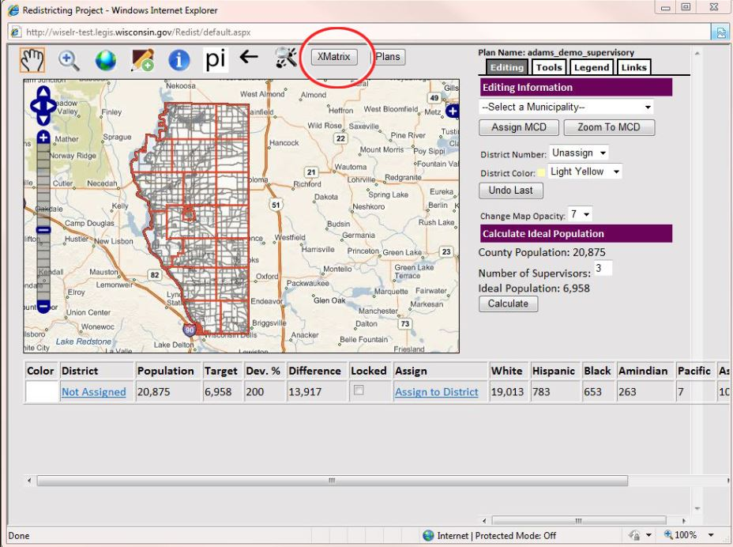
The current process of ward data collection requires each municipality in Wisconsin to submit (within 5 days of adoption) a paper map, census block list, and a copy of the ordinance or resolution to the county they are located, as well as to the LRB if there population is over 10,000. For the 1980 and 1990 census cycles, this required the state to copy hundreds of poster sized census block maps with corresponding population totals and to mail them to every county and every community with a population over 10,000. In the 1990 census a DOS based computer program was included to help with creating the required block lists and for adding population totals. For the 2000 census, a standalone GIS application was given to all 72 counties as well as to all cities over 10,000 in population. We mailed a single map delineating the census block boundaries, and a CD-ROM that included the Wisconsin Shape Editor for Local Redistricting (WISE-LR) application, census PDF maps, and database files with census block population totals. The WISE-LR application was a very basic GIS application that was pre-loaded with Census 2000 block geography and population totals for each county. The application pictured below is a screen shot from the web based WISE-LR application used in the 2010 redistricting cycle.
Figure 4: This is a screen shot of the 2010 WISE-LR application.
When this application was released in March of 2001, we had no idea what type of response we would receive from local governments. In fact, we became very skeptical after a series of technical training sessions held across the state, where we found that the first hour of a half day training was sometimes dedicated to showing some users how to use a mouse! Much to our surprise, during the summer and fall of 2001 we were able to collect a statewide digital ward layer built from the local government’s use of the WISE-LR software. We still did receive paper submission of ward data from communities over 10,000, but the paper submissions were only used to verify the electronic ward data submitted with the GIS software. In 2010, the same WISE-LR software was released to county and local governments, however, this version of the software was developed as an open source web application.

Problems with WISE-LR Data
In 2010, the WISE-LR application was once again able to collect a complete statewide ward dataset, however, one problem persisted throughout the local redistricting process, the quality of the Census 2010 municipal boundaries. Census 2010 blocks were not aligned properly with municipal boundaries that had been maintained by county and local government’s GIS professionals. My GIS staff and I logged almost 800 calls in the six month local redistricting period; nearly half were due to the misalignment of Census municipal boundaries.
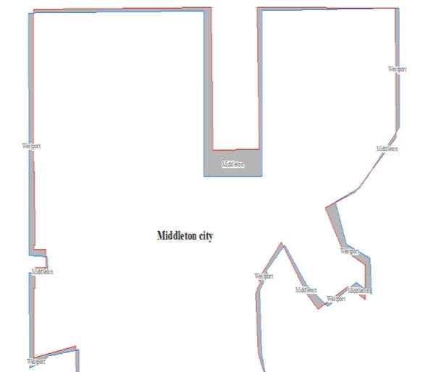
The misalignment of Census 2010 municipal boundaries resulted in many challenges for local officials trying to redistrict. Our statutes indicate that census geography must be used for local and legislative redistricting, and that block boundaries may only be altered to add a municipal annexation (adding a piece of geography to an existing city or village). The image below depicts some of the differences (in gray) that were found between local government GIS datasets and the Census 2010 TIGER data.
There were many factors that lead to the boundaries of municipalities not being accurate in the Census 2010 TIGER data, but the primary reason was the lack of participation from local governments with the Census Bureau’s data improvement programs.
Figure 5: The difference between Census 2010 and local GIS datasets.

Boundary and Annexation Survey (BAS)
The Boundary and Annexation Survey (BAS) is a voluntary Census Bureau program that allows communities to update municipal boundaries in the Census Bureau’s TIGER database. Here are some specific about the program.
- This is an annual program. Data is made available to all municipalities in December, and the program runs from January 1st – March 31st.
- Municipalities are the only entities that can legally update the municipal boundaries in the Census Bureau’s TIGER database (There are 1,850 cities, towns and villages in Wisconsin at this time).
- The survey is sent to the highest elected official. This communication is a paper form that simply asks if the community had any boundary changes over the last year.
- MAF/TIGER Partnership Software (MTPS) is given to users to electronically update TIGER data.
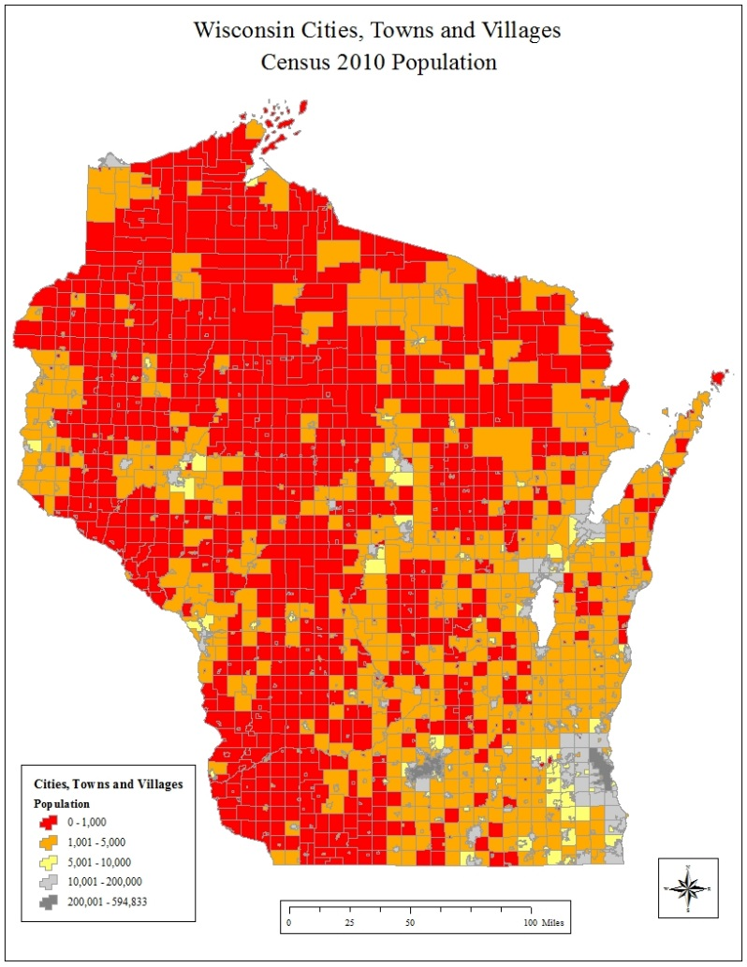
Over the last ten years the participation in this voluntary program was extremely low. The overall participation rate for communities in Wisconsin has averaged only 14% per year. One reason this survey has been ineffective is the fact that the Census Bureau contacts the highest elected official in each community by letter. If there are boundary changes to report, the municipality has three options to respond to the survey. Their first option is to mark the boundary changes on a Census paper map. Responding to BAS in this manner is the worst case scenario for the Census Bureau and the municipality. Marking up a paper map by an elected official can lead to spatial inaccuracies and scale problems that make boundaries inaccurate in the TIGER data.
Figure 6: 2010 Wisconsin Cities, Towns and Villages population
Also, Wisconsin is made up over 1,200 town governments; most of which are very small (736 have populations under 1,000). In fact, 1,760 out of the 1,852 municipalities in Wisconsin have a population under 10,000. The highest elected official in these communities may only work for the municipality on a very limited basis. The map above shows the population of municipalities in Wisconsin based on Census 2010. The municipalities in red are under 1,000 in population, the communities in orange are under 10,000. These municipalities have limited resources, including limited access to a GIS or a GIS professional. There is a good possibility the BAS survey is not answered or is updated by a paper map in these communities.
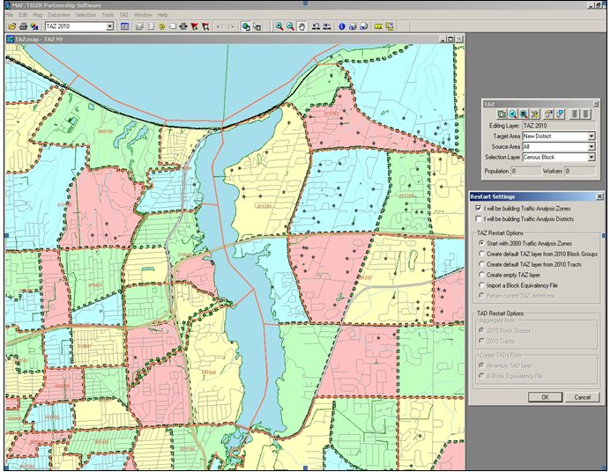
The second option for municipalities to respond to the BAS is to use the Master Address TIGER Partnership Software (MTPS). This software allows municipalities to use a free application that allows them to mark the map electronically, and then submit the data back to the Census Bureau. If used correctly, this software will submit data back to the Census Bureau in the correct format. There are some problems associated with this software that make communities unlikely to use it for a BAS submission. First, the software is quite difficult to use, and thus requires a good amount of training. The software is not based on the industry standard GIS software, so even the most seasoned GIS professional will need to be trained before using it. Second, the correct municipal boundaries need to be on screen digitized, which means that after loading local data into the system, lines would have to be electronically traced to be updated in the Census Data. Finally, this separate, independent, GIS will need to be maintained with software and data updates. The image above shows a screen shot of the MTPS software.
Figure 7: This is a screen shot of the Census Bureau's MTPS software.
The third and final option would be to use in an in house GIS to electronically respond to the BAS. This option requires municipalities to follow very detailed instructions for data comparison and submission. Many communities choose not to submit data this way because they don’t have the resources to dedicate a GIS professional to read and understand the 72 page instruction and requirement document (BAS Digital Respondent Guide). Additionally, if not done correctly, the Census Bureau may reject a file submitted this way.

Consolidated Boundary and Annexation Survey (CBAS)
Due to the low response rate of the BAS program, the Census Bureau started to consolidate the program to become more efficient. “To reduce the burden on local governments and avoid duplication of efforts, the Census Bureau offers consolidation agreements to counties that are interested in submitting boundary changes for the legal governments (incorporated places and minor civil divisions) within their jurisdiction. The consolidated BAS (CBAS) program allows counties to report boundary and feature changes for some or all of the legal governments within their county. Once a local government agrees to the consolidation, the local government will no longer receive BAS materials. Instead, the county BAS respondent will be responsible for providing the Census Bureau with all boundary updates”. (United States Census Bureau, 2014)
The CBAS seems to be an ideal way for Wisconsin to submit data to the Census Bureau. Although GIS resources are fairly scarce at the municipal level in Wisconsin, most of the 72 counties in Wisconsin have a robust GIS system that maintains all of its own municipal boundaries. The only problem getting counties signed up for the CBAS program is the perception that the Census Bureau is difficult to work with.

LTSB BAS Data Integration Tool
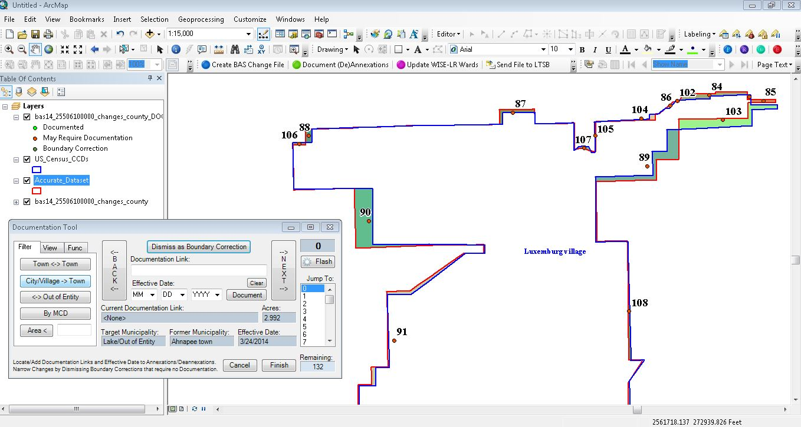
In order to facilitate the process of getting accurate municipal datasets to the Census Bureau, the LTSB created an add-in for ArcGIS Desktop called the BAS Data Integrator. This tool allows counties and municipalities to quickly and easily participate in the BAS or CBAS programs. With this tool they can submit data to the Census Bureau without dedicating a large amount of time and/or expense. This tool also allows them to submit data from within their current GIS system.
Figure 8: This is a screen shot of LTSB BAS Data Integration Tool
This tool takes in a shapefile (or feature class) of local municipal boundaries (or wards), compares it to the boundaries that are currently in the TIGER database, and filters for Census’ geographic tolerances. The differences that are found between the TIGER data and the local datasets are either spatial corrections or annexations. Most spatial corrections are areas in the Census data that are off due to scale or translation issues from paper submissions. Annexations are the new areas of a city or village that are usually taken away from a surrounding township. This tool is made to be used by both municipalities and counties, but, it is ideally suited for a county to use the tool as part of a submission for the CBAS program.
In order to insure that the output would be accepted by the Census Bureau, we worked with BAS program lead, and their technical staff, to ensure the output from the tool was approved. The BAS tool was released in time for the 2013 BAS cycle. Leading up to the release of the software LTSB staff met with county and municipal GIS staff to demonstrate the BAS tool, talk about the consolidated BAS program, and to inform local governments on why it is important to have accurate municipal boundaries in the Census database. Specifically, Census municipal boundaries are used to perform local redistricting, legislative redistricting and to administer elections in Wisconsin. The TIGER municipal boundaries are also used by federal and state agencies to administer programs and to distribute funds. These boundaries are used in place of more accurate local dataset because a statewide layer of local datasets has yet to be collected in our state.
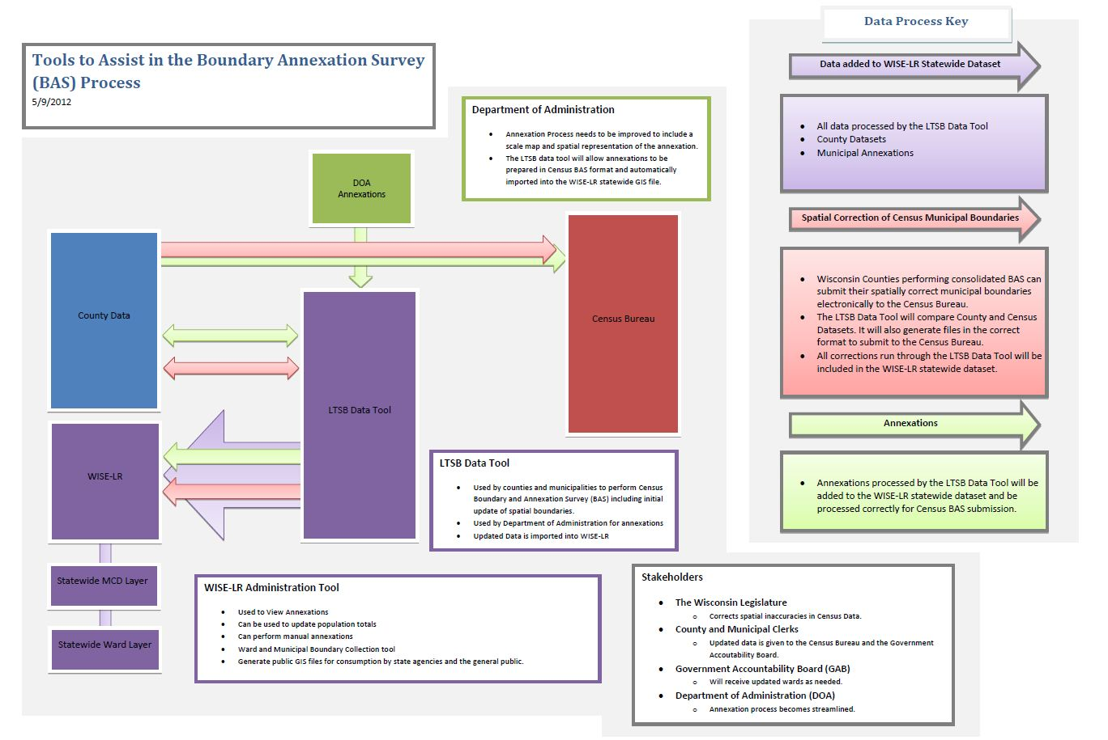
In 2011, 2 of 72 counties signed up for the 2012 consolidated BAS program. In 2012, after a grass roots effort between the LTSB and the Census Bureau, we were able to sign up 26 of 72 counties for CBAS program and an additional 8 counties submitted data before the March 31st deadline. In total 34 of the 72 counties submitted data using the BAS Data Integrator. In addition to creating the BAS submission package, local datasets used in the BAS Data Integration tool are zipped and sent via FTP to LTSB. These datasets are then merged together to create a statewide version of local municipal boundaries.
Figure 9: This is the data flow model for updating Census Bureau data and statewide boundary collection.

Suspension of 2014 BAS
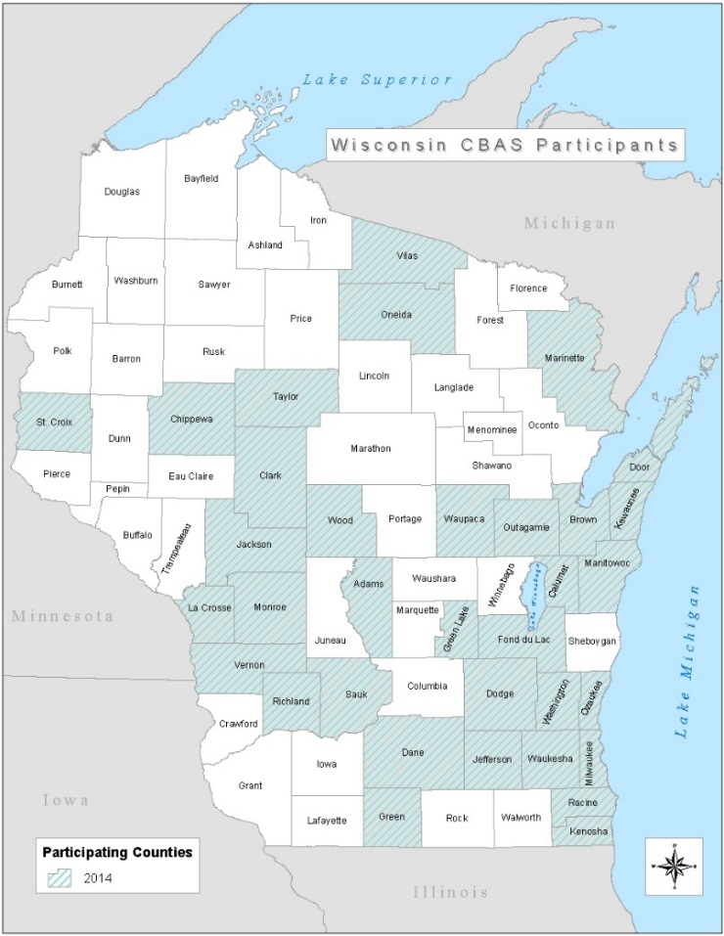
In October of 2013, my office was notified that the 2014 BAS program was suspended due to funding. This was a blow to the work of LTSB, the Census Bureau and municipalities who had contributed to the effort to correct the municipal boundaries through BAS and CBAS. Even though the 2014 BAS was canceled, LTSB and the Census Bureau have continued the effort to sign up counties for the CBAS. To date 34 of 72 counties have received sign-off from each municipality in their county to submit data on their behalf. LTSB has also compiled the local data sets used with the LTSB BAS Integration tool. The first “statewide” dataset can be found at this location.

The Need for Legislation
Although there has been success signing up approximately half of our counties for the CBAS program, it has been very difficult to get all of the counties signed up. In addition to the redistricting process and the needs of federal and state agencies, a new need has arisen for updated municipal boundaries from our Government Accountability Board (GAB). The process of redistricting begins with local redistricting, the legislature then draws legislative and congressional districts, if these districts are passed by the legislature, they are then sent to the governor to be signed into law. The task of administering elections in Wisconsin has been given to the GAB.
Figure 10: Wisconsin CBAS Participants 2014
The GAB is required to interpret the law passed by the legislature, and help municipal and county clerks administer elections. The GAB also maintains the Statewide Voter Registration System (SVRS). The SVRS system allows municipal clerks in Wisconsin to assign registered voters into election units. Each election unit in the SVRS system requires the municipal clerk to create a separate election ballot. In the past, this system was a tabular system that would record district information by street delineation. The table (figure 11) shows a very basic example on how the structure of the old SVRS system may have looked. When new annexations occurred in a community a new street segment was added to the table and the corresponding districts would need to be identified (row in red).

Street | Address Range | Assembly District | Senate District
Main | 100-200 | 1 | 1
Main | 300-400 | 2 | 1
Main | 450-475 | 3 | 1
Scenic Dr. | 100-300 | 4 | 2
Figure 11: Tabular structure of SVRS prior to 2011.
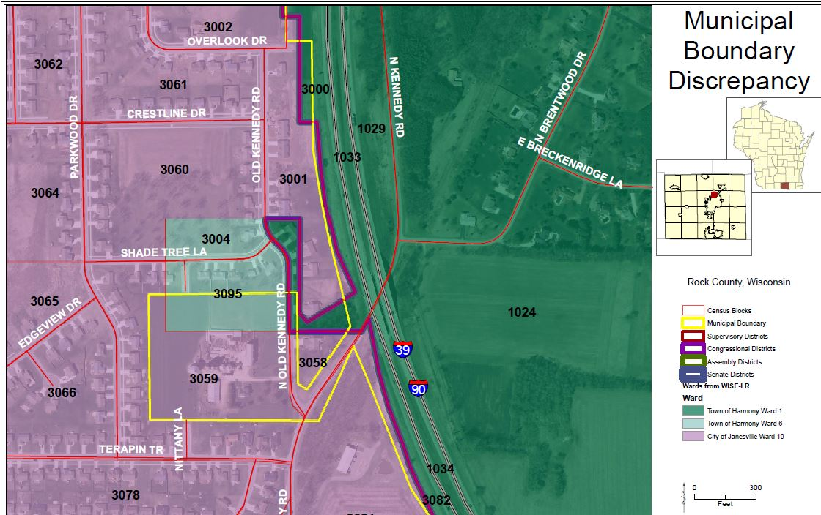
This tabular system was replaced after local redistricting occurred in 2011. The GAB used the statewide ward layer that was collected from the LTSB’s WISE-LR application to replace street segments with ward geography. In principal this was a good idea, however, the WISE-LR ward data was based on the Census geography with spatially inaccurate boundaries. Due to these spatial inaccuracies, municipal clerks found that geocoded voters were turning up in the wrong ward or even municipality.

“Based on initial analysis, Rock County (which at the time relied exclusively on GIS shape files of the district and ward maps from WISE-LR) reported identifying approximately 200 addresses that were placed in the wrong municipality based on the TIGER 2010 data. Rock County provided a specific example of some corrections to municipal boundaries that directly conflict with census blocks and the specific statutory language of Acts 43 and 44, affecting State Assembly, State Senate, and Congressional districts. In this case, the municipal boundary between the Town of Harmony and the City of Janesville was approximately 0.1 miles off (528 feet) in the census data. This caused census blocks containing 9 houses that are in the City of Janesville to be incorrectly placed in the Town of Harmony. In addition, the same error caused census blocks containing one house or farm in the Town of Harmony to be incorrectly placed in the City of Janesville. Obviously, this situation also creates the likelihood of a shift in the population for the City of Janesville and Town of Harmony under Acts 43 and 44, which specifically attributed certain census blocks to incorrect municipalities. This situation is repeated in many other counties, if not all counties.” (Kennedy, 2012)
Figure 12: Municipal Boundary Discrepancy in Rock County

In order to correct the placement of voters into the wrong ward or municipality, the GAB inserted more spatially accurate county datasets (where it was available). Currently the SVRS uses a hybrid layer comprised of the Census based WISE-LR data and more spatially accurate county datasets.

Draft Legislation
Over the last year, the LTSB and the LRB have looked at the local redistricting, legislative redistricting, Census Bureau data programs and election administration processes.
We have concluded the best way to try and improve the overall quality of the Census Bureau’s data is to make changes to the current statute. The changes we suggest making have been discussed with several stakeholder groups, including, the County Clerks, County Land Information Officers, State Agencies and the GAB.
If passed, the bill draft would require the following:
- During years ending in 1, ward boundaries created by municipalities must be reported to the county clerk by October 15th. The county clerk must compile these ward boundaries and transmit them to LTSB by November 1st. This must be transmitted in an electronic form approved by LTSB.
- Within 5 days of any municipal boundary change the municipality must inform the county clerk of the change.
- Each year the county clerk shall transmit ward boundaries to the LTSB by January 1st and July 1st.
- LTSB will provide a statewide ward and municipal database
- LTSB will participate on behalf of the state in geographic boundary information programs when offered by the Census Bureau.
The following is an analysis of the bill written by the LRB.
“Currently, the municipal clerk or board of election commissioners of each municipality, within five days after adoption or enactment of an ordinance or resolution dividing the municipality into wards, or any amendment thereto, must transmit one copy of the ordinance or resolution to the county clerk or board of election commissioners of each county in which the municipality is located together with a ward map and a list of the block numbers of the census blocks comprising the wards. If the population of the municipality exceeds 10,000, the clerk or board must submit the same documents to the Legislative Reference Bureau (LRB) at the same time.

This bill deletes the requirement to transmit this report to the LRB but, in addition, directs each municipal clerk or board of election commissioners to transmit a report to the county clerk or board of election commissioners of each county in which the municipality is contained, no later than October 15 of each year following the year of a federal decennial census, confirming the boundaries of the municipality and each ward within the municipality. Under the bill, the report must be accompanied by a map showing the municipal and ward boundaries and a list of the census block numbers of which the municipality and each ward within the municipality are comprised. The bill also directs each county clerk or board of election commissioners, no later than January 15 and July 15 of each year, to transmit to the Legislative Technology Services Bureau (LTSB), in an electronic format approved by LTSB, a report confirming the boundaries of each municipality and each ward and supervisory district within the county as of the preceding January 1 or July 1 except that in the year following the year of the federal decennial census, the second report must be transmitted no later than November 1 and must be current to the date of the report. The report that is due on November 1 must also include a list of the census block numbers of which the county and each municipality and ward within the county are comprised.

The bill then provides that, upon receipt of the information from each county clerk or board of election commissioners at each reporting interval, LTSB must reconcile and compile the information received into a statewide database consisting of municipal boundary information for the entire state. The bill also directs LTSB to participate, on behalf of this state, in geographic boundary information programs when offered by the U.S. Bureau of the Census.

The reporting system established by the bill first applies in 2016. Currently, with certain exceptions, the wards created by a municipality in response to each federal decennial census must remain in place until the wards are revised in response to the next federal decennial census. This bill creates an exception that permits a municipality to create a ward after a decennial ward revision if the ward consists of territory that lies between an actual municipal boundary that existed on April 1 of the year of a federal decennial census and an intersecting municipal boundary that deviates from the actual boundary on that date if the deviating boundary was used by the U.S. Bureau of the Census to enumerate the population of the municipality in that census.”

In essence, this draft will change the way ward and municipal data is collected in our state. The current process has ward data being created by any municipality over 1,000 in population, but only ones with population over 10,000 in population have to send their data directly to the Legislature. This bill would instruct all communities who are required to create wards to send their data (and any updates) to the county (or counties) in which they are located. The ward data would then be compiled at the county and sent to LTSB (in a GIS format) twice a year. Once LTSB has the data it will be assembled into a statewide layer of information that will be made publicly available. This data must also be used by LTSB to participate in any data improvement programs offered by the U.S. Census Bureau.
The passage of the bill does not change the legislative redistricting model used in Wisconsin but, it does improve the availability of accurate data to be used in local redistricting, legislative redistricting and election administration.
Below is a data flow diagram that shows how data flows in local redistricting under the current statute and how it flows after the proposed legislation is passed.

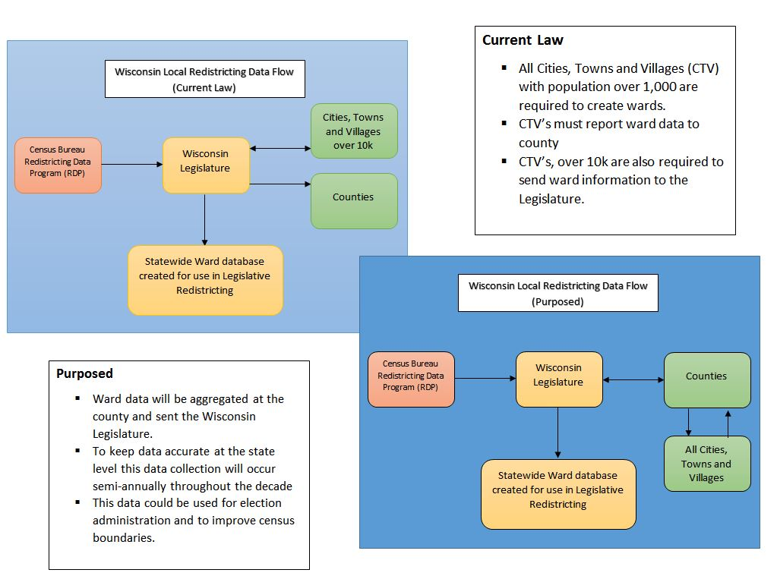
Figure 13: Wisconsin Local Redistricting Data Flow before and after proposed legislation.

Works Cited
http://www.census.gov/rdo/. (n.d.). Retrieved November 2013, from http://www.census.gov: http://www.census.gov/rdo
Keane, M. (2005, September). Wisconsin Legislative Reference Bureau. Retrieved October 29th, 2013, from Redistricting: Why Legislative Districts: http://legis.wisconsin.gov/lrb/gw/gw_3.pdf
Keane, M. (2010, July). Wisconsin Legislative Reference Bureau. Retrieved from Wisconsin Redistricting Chronology, 1950-2002: http://legis.wisconsin.gov/lrb/pubs/im/10im4.pdf
Keane, M. (2011, March). Wisconsin Legislative Reference Bureau. Retrieved from Guidelines for Adjusting Municipal Wards Following the 2010 Federal Census: http://legis.wisconsin.gov/lrb/pubs/ib/11ib1.pdf
Keane, M. (2011, March). Wisconsin State Legislature. Retrieved November 2013, from Legislative Reference Bureau: http://legis.wisconsin.gov/lrb/pubs/ib/11ib1.pdf
Kennedy, K. J. (2012, January 13). Redistricting Anomalies. Retrieved from Government Accountability Board: http://gab.wi.gov/node/2145
Legislative Guide to Redistricting . (2001, January 2). Retrieved October 2013, from Iowa General Assembly: http://www.legis.state.ia.us/Central/LSB/Guides/redist.htm
NCSL - Redistricting. (2013). Retrieved October 2013, from NCSL: http://www.ncsl.org/research/redistricting.aspx
United States Census Bureau. (2014, March 23). Retrieved from Boundary and Annexation Survey (BAS) County Consolidation Agreements: http://www.census.gov/geo/partnerships/bas/bas_cca.html
Watson, P. (2011, January 22). How to Draw Redistricting Plans that Will Stand up in Court. Minnesota.
Wisconisn Assembly Districts . (2011, 7). Retrieved October 2013, from Wisconsin Legislature: http://legis.wisconsin.gov/ltsb/redistricting/PDFs/ad64.pdf
Wisconsin Legislative Documents. (2013). Retrieved October 2013, from Wisconsin State Legislature: http://docs.legis.wisconsin.gov/2013/related/proposals/ab185

