GEOG 596B: Individual Studies - Capstone Project
GIS for Reservoir Management: Estimating Original Gas In Place
Jeffrey Vu (jcv136)
Penn State University
Abstract
Reservoir management plays an important role in the oil and gas industry. The purpose of reservoir management is to find out how much of the oil or gas in a prospect or field can be extracted to obtain the greatest economic recovery from a reservoir. Volumetric estimation is the common technique that the geoscientists use to calculate hydrocarbons in place based on geologic mapping data. The preferred methodology of calculating Original Gas in Place (OGIP) is typically evaluated from data covering a prospect or field in a spreadsheet or in the Petra application. Any changes that effect volume, such as a more detailed delineation of the reservoir, demands that data in the spreadsheet be updated and the results be recalculated.
This project focuses on creating a workflow using out-of-the-box tools in Esri’s ArcToolbox to help the reservoir engineers monitor and study the reservoirs, based on the geologic mapping data and reservoir engineering parameters. The workflow will eliminate the steps in data exchanges between a spreadsheet and Esri’s ArcGIS mapping software, and allow users to make assumptions related to input data and to run different scenarios. The workflow is considered a screening procedure to quickly assess a field without spending considerable time running complicated simulation models.
Background
Reservoir management basically is the dynamic process by which geoscientists and reservoir engineers use geology and petroleum engineering to forecast and manage the recovery of oil and gas in place from a prospect or field. It is very important in the petroleum industry because it provides the operators the confidence to move forward with development and investment. The objectives of reservoir management are to increase oil and gas production, decrease the risk, maximize recovery and minimize costs.
The American Association of Petroleum Geologists considers forecasting hydrocarbon an advanced process that needs the combination of geological and engineering data. It depends on the available data, and one or more of these methods (AAPG, 2014) may be used to estimate reserves:
- Analogy
- Material balance
- Production history
- Volumetric
Volumetric methods are primarily used to evaluate the in-place hydrocarbons in new, non-producing wells and pools and new petroleum basins. However, even after pressure and production data exists, volumetric estimation provides a valuable check on the estimates derived from material balance and decline analysis methods.
Normally, the reservoir engineers get the OGIP results from the geologists. In some cases, for quickly screening an area of interest, the engineers use the geologic parameters from the geologists to calculate the OGIP in Microsoft Excel.
Introduction
The volumetric analysis is based on geological maps, core logs and analysis of wireline logs. Isopach maps are used for reservoir thickness to calculate the bulk volume of the reservoir. The volume of hydrocarbons in a reservoir can be calculated directly by volumetric methods. The trapezoidal formula (Dean, 2007) in Figure 1 is one of the methods to calculate reservoir volume.
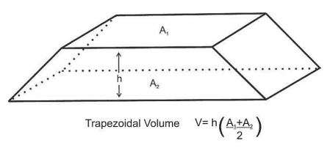
Figure 1. Volumetric rule: Trapezoidal (Dean, 2007).

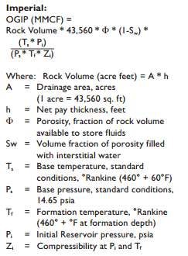
Figure 2 shows the volumetric calculation of hydrocarbon in place requires knowing the areal extent of the reservoir. The accuracy of volumetrics depends on data for net pay, porosity, and water saturation. Net pay is the part of a reservoir from which hydrocarbons can be produced at economic rates (Dean 2007). Porosity is the volume of the non-solid portion of the rock filled with fluids, divided by the total volume of the rock. Water saturation is the fraction of water volume to pore volume. Compressibility factor is also known as Z factor, which is the function of pressure and temperature (Lord, 2014).

Figure 2. The OGIP volumetric calculation (Dean, 2007).
There are several ways to automate the calculation the OGIP. Back to the old days, the user had to enter variables in the command line as in Figure 3 to determine reservoir gas in place using BASIC programming language (Cranmer, 1982).
Cranmer, John L.: “BASIC Reservoir Engineering Manual”, PennWell (1982) 24-25.
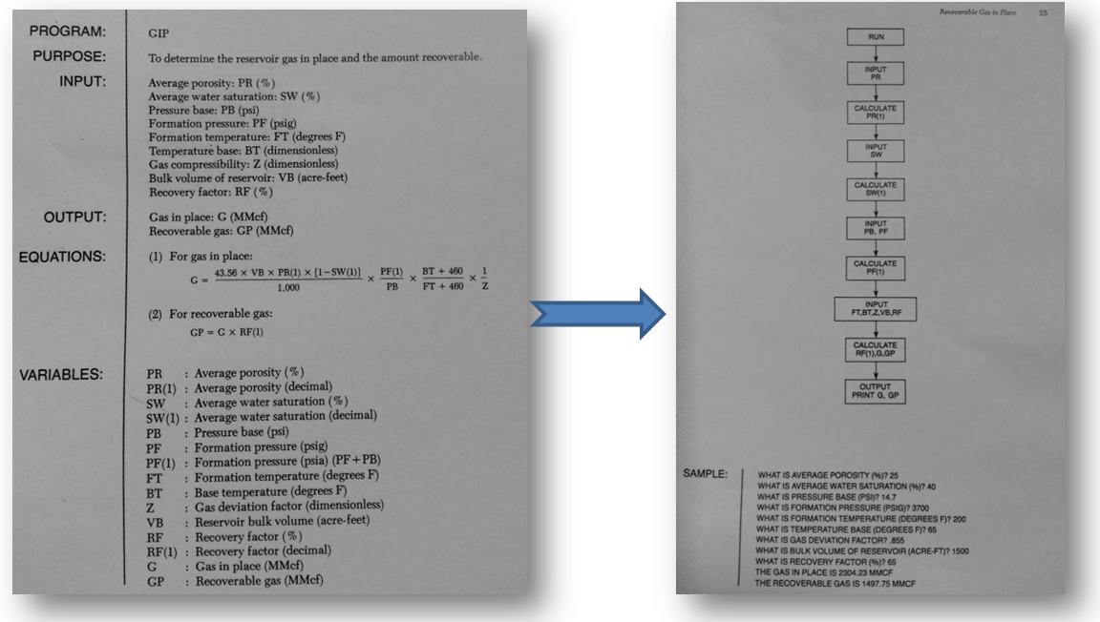
Figure 3. Determine gas in place using BASIC programming language (Cranmer, 1982).
As technology changed and improved, additional ways to calculate the OGIP became available to users. Excel, Mathcad, Petra continue to be used to perform the calculations. Examples using Microsoft Excel (Petroleum Support) and Petra are shown in Figure 4 and 5.
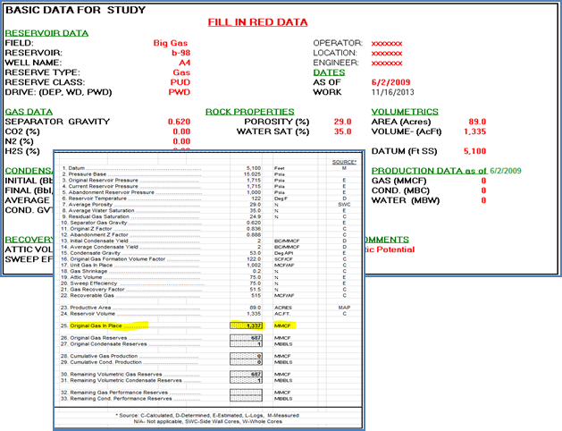
Figure 4. Calculate OGIP in Microsoft Excel.
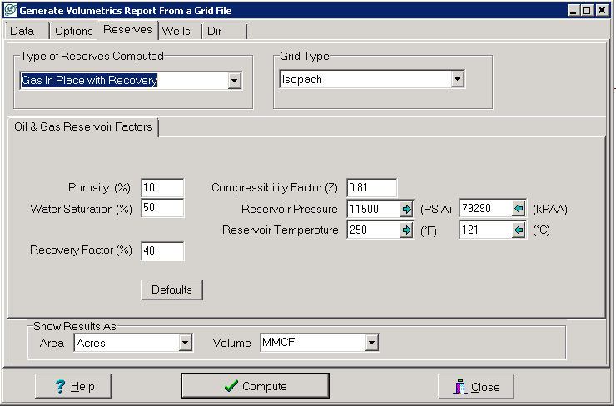
Figure 5. Calculate OGIP using Petra.
Typically, the OGIP is calculated in Petra by the geologists with the inputs of reservoir engineering parameters such as temperature, pressure, Z factor, and geologic mapping data like net pay, porosity, and water saturation. All data, however, are not always available. This is the main reason some reservoir engineers who want to estimate the OGIP without waiting for a completed data set have created a workflow using a combination of ArcGIS and Excel to calculate the values in each Public Land Survey System (PLSS) section. Figure 6 shows the workflow where the reservoir engineers use the extracted values from Petra grids to calculate the OGIP, row by row, in Excel.
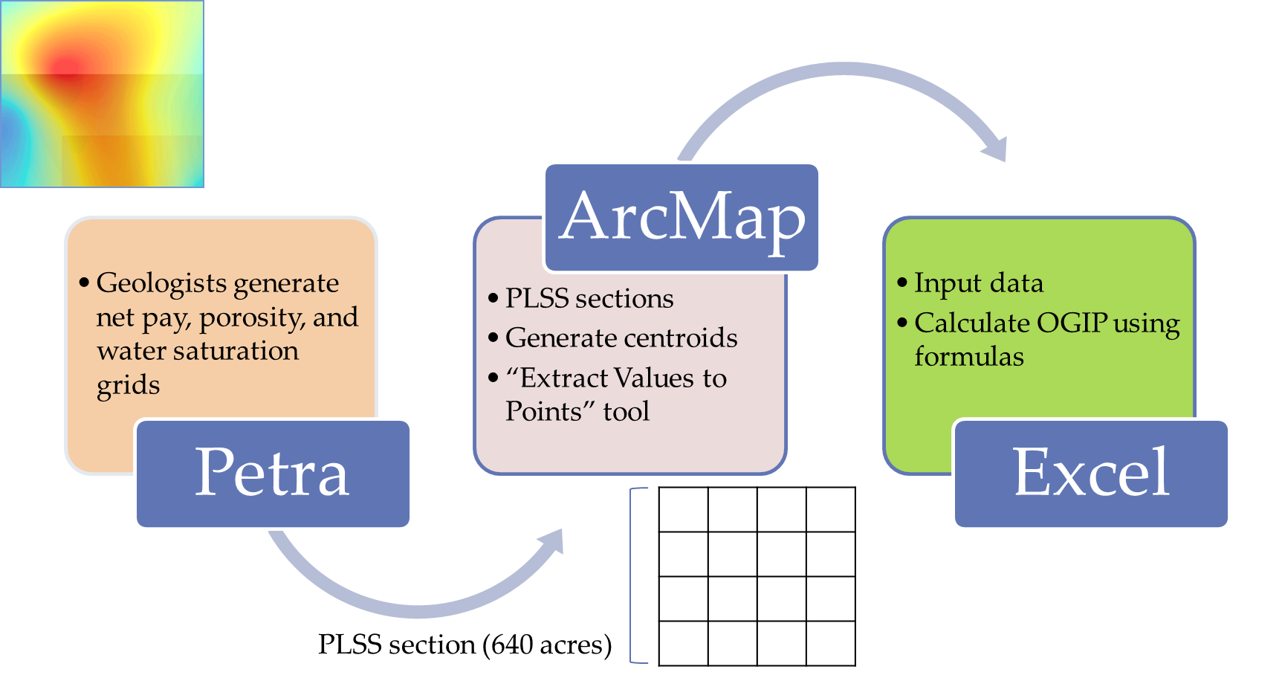
Figure 6. Current workflow.
This workflow works fine, but it is only for a specific area and requires manual steps to complete the calculations. The reservoir engineers have to map the calculated values in each section.

Objectives
Leveraging geoprocessing in ArcGIS, we built a screening workflow to estimate the OGIP, using the tools in ArcToolbox. The idea is to streamline the work processes and reduce the steps in data exchanges between the Excel spreadsheets and ArcMap. The workflow allows a user to estimate the OGIP under different uncertainties by making distinct assumptions to run in different scenarios.

ArcGIS Geoprocessing Workflow
The devised workflow identifies the common areas with available data by intersecting all the input grids. An intersected polygon layer is created to generate the 40-acre fishnet polygons, with its table storing all the parameters to calculate the OGIP for each 40-acre polygon. The reason the 40-acre unit is used is because traditional vertical wells typically use 40-acre spacing. In some states under Public Land Survey System, we can use existing quarter-quarter sections instead of generating new ones to help the users locate high-graded areas more easily. In Figure 7, we can easily locate the OGIP value in the SE of SE quarter colored in blue within the red section.
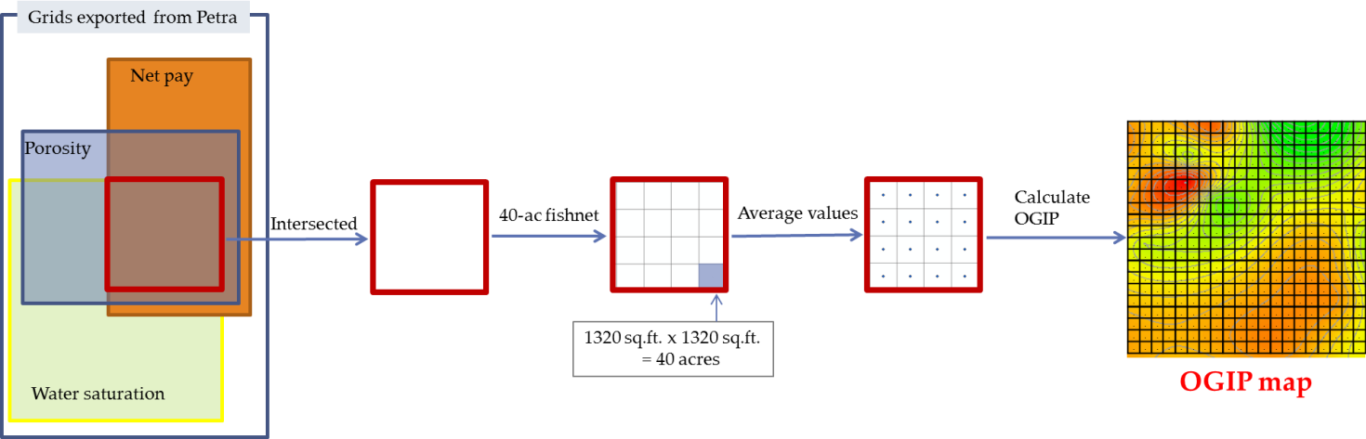
Figure 7. New workflow.
Input grids are mainly exported from a geological software program by the geologists. The workflow allows users to enter the assumed parameter values, but net pay and porosity grids are required. In addition to the geological values, we also need the reservoir engineering parameters to calculate the OGIP. All input grids must have the same coordinate systems and cell sizes.
Figure 8 shows the inputs in ArcMap. These are the grids containing values of net pay, porosity, and water saturation.
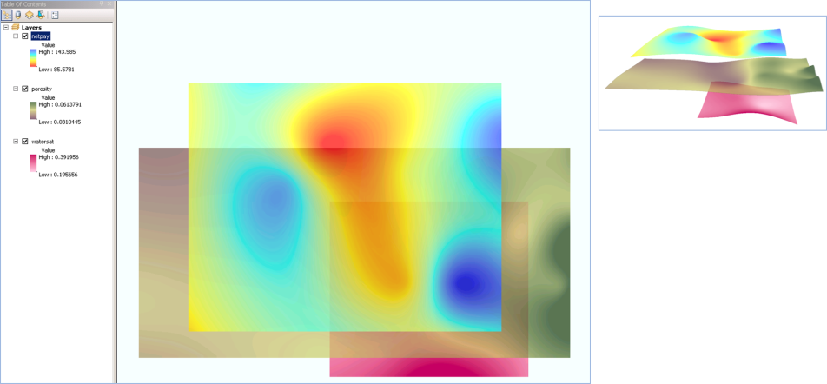
Figure 8. Inputs in ArcMap.
Methods
Data management is very important. The workflow will create a project’s folder structure to store data inputs and outputs as in Figure 9.
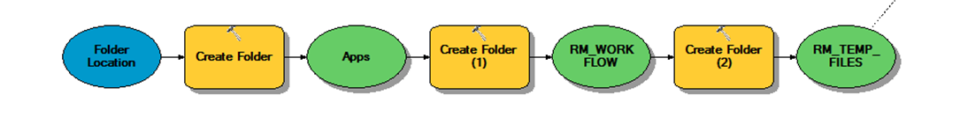Figure 9. Create new folders in model builder.
With the limitations of the tools in ArcToolbox, Pythons codes are needed on several occasions. We need the codes to check whether the inputs are in a grid or in numeric format. Figures 10 shows the conditions in Python codes. If the input is in a grid format, it will be copied into the project’s workspace. Otherwise, a new grid is generated based on the user’s inputs with the spatial reference from the intersected polygon.
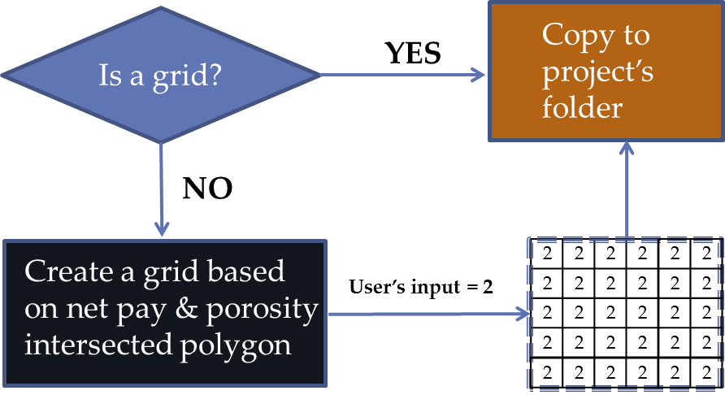
Figure 10. Determine input formats.
When all required grids are available, the next analysis is to eliminate all negative values because the calculations only accept positive values. Figure 11 illustrates the Con tool performing a conditional if/else evaluation on each of the input cells of an input raster. It will set the raster cell to 0 when the value is negative.
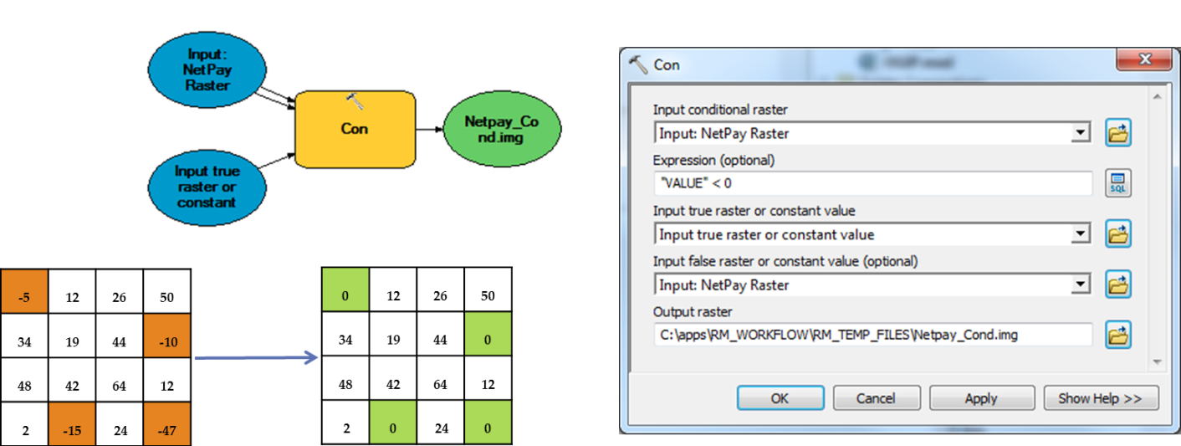
Figure 11. Con (Spatial Analyst) to eliminate negative values.
Cell values in a raster can be either positive or negative. Cells can also contain the NoData values to represent the absence of data. Sometimes, there are areas in a raster data set that we don’t want to display such as borders or other data considered to not have valid values. Another required analysis to identify the NoData cells is Reclassify. We want to reclassify or change the values in all input rasters before converting to polygons to make certain that intersected polygons will be covered areas with data. Figure 12 shows the Reclassify tool setting raster cells to NoData or 1.
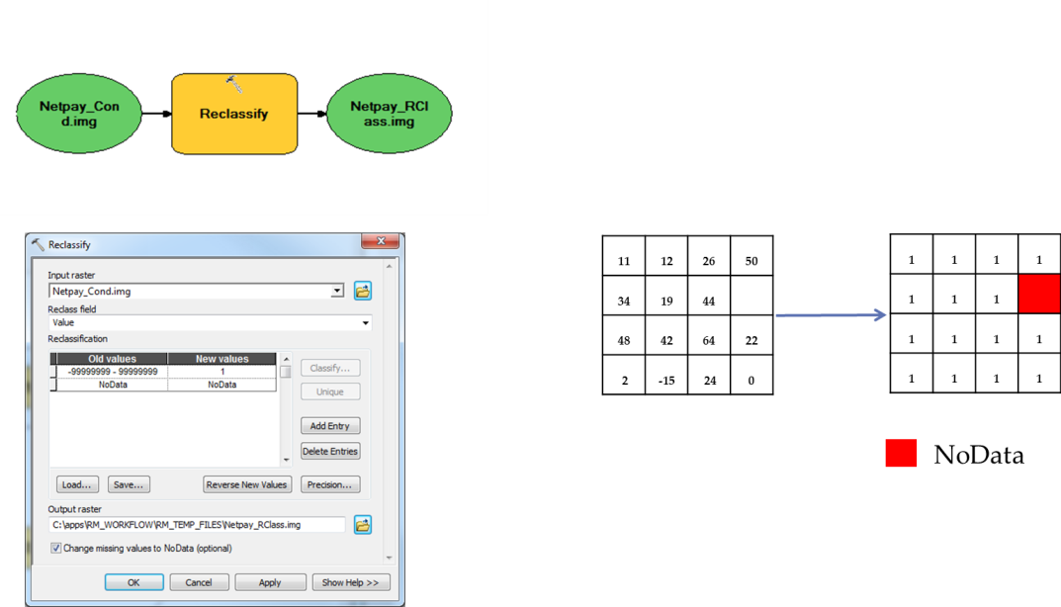
Figure 12. Reclassify tool to exclude NoData.
Once all raster data sets have been converted to polygons, the workflow intersects them with each other to create a common polygon that covers an area with valid data. The intersected polygon will be used as the template extent in the Create Fishnet tool. Unfortunately, there is a bug (NIM03777) in the ArcGIS software that does not take an input extent parameter from a linked previous tool when used in a model. To overcome this issue, the Python codes are used to create the fishnet polygons as shown in Figure 13. Function Arcpy.Geometry can be used to capture the input coordinates.
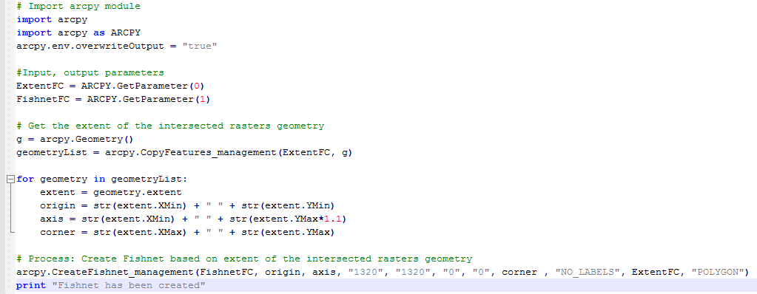
Figure 13. Python code to create the fishnet polygon.
To simplify the workflow, as in Figure 14, the Con and Reclassify tools have been ported from the model into the Python codes, where the inputs are validated.
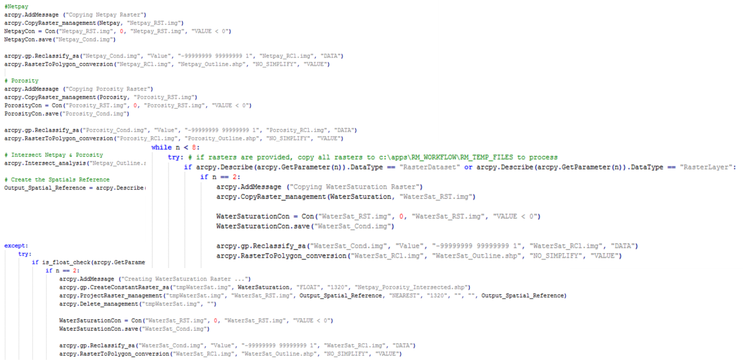
Figure 14. Python code to detect input formats with Con and Reclassify tools embed.
Figure 15 shows the next step to run the Zonal Statistics as Table tools to compute the average values in each fishnet polygon for all input grids.
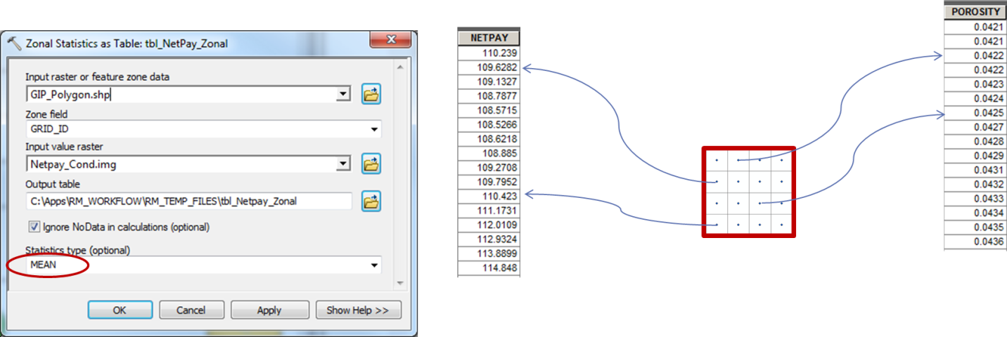Figure 15. Zonal Statistic as Table tool.
Since all results are from the Zonal Statistics as Table tool are saved in different tables, Figure 16 shows additional fields are added in the table to store values in the fishnet polygons.
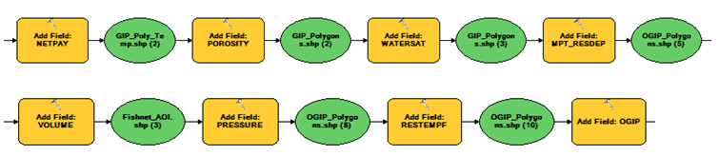Figure 16. Add fields in the table.
Next, the tools join all the Zonal Statistics tables with average values to the fishnet polygons. To improve the performance, we need to remove a join before joining another table to the fishnet polygon table as in Figure 17.
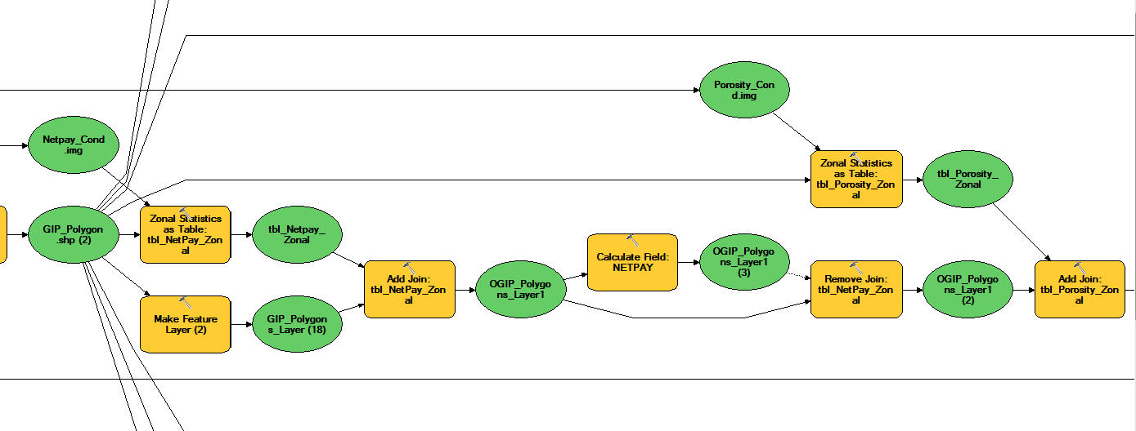 Figure 17. Join tables in the model.
Eventually, the attempts to test different techniques to calculate the OGIP paid off since some methods took over a day to calculate, while the final strategy only took just over an hour to do the calculation for a whole state of Wyoming. Some calculations are computed in the Python expression with functions in the Calculate Field tool, whereas others are just using the simple VB expressions as seen in Figure 18.
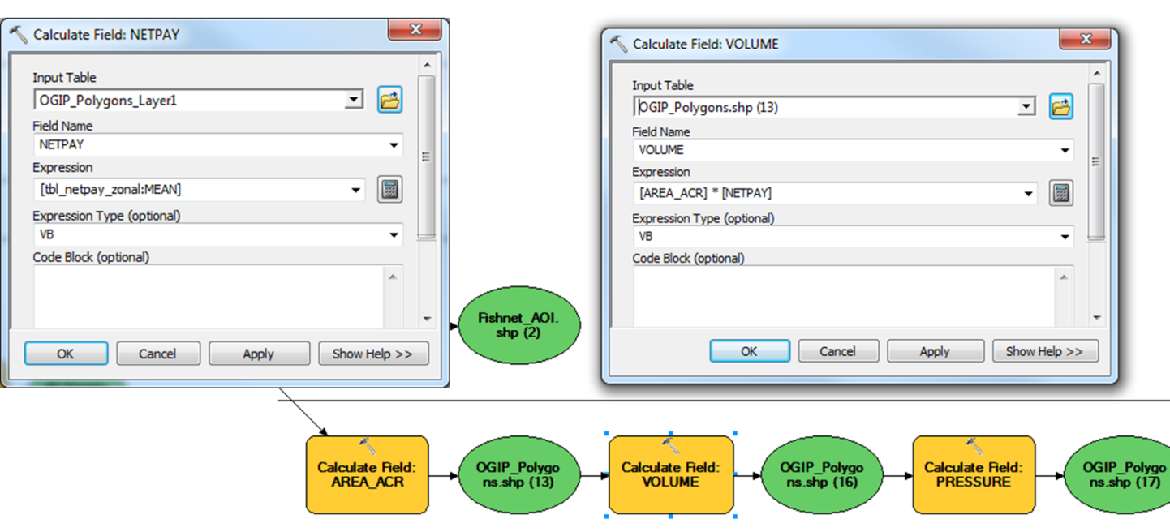Figure 18. Calculating fields using VB expressions.
Figure 19 shows how parameters are passed into the functions in Python expression to calculate average height, pressure, temperature, etc. before calculating the OGIP.
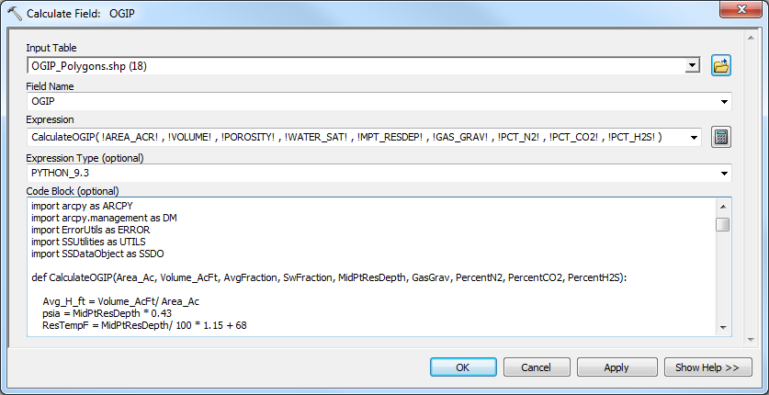
Figure 19. Calculating OGIP using Python expressions.
After the fishnet polygons are populated with the OGIP values, the OGIP centroids are generated in the model. These center points will be used to create the OGIP raster using Inverse Distance Weighted (IDW) interpolation, which determines cell values using a linear weighted combination of the center points. Once the OGIP raster is created, we can create the OGIP contour map with the users’ optional inputs like contour intervals, base contour, and contour smoothing tolerance.
When model outputs are added to the ArcMap table of contents, their symbology can be predefined by referencing a layer file. Figure 20 shows the Layer Symbology property in the model.
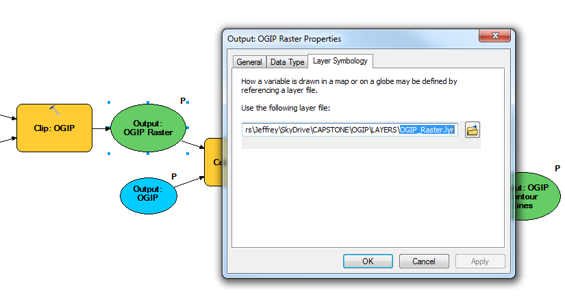Figure 20. Using a layer file to display results with predefined symbologies.
To run the workflow, the user needs to navigate to the model from ArcMap. The workflow can be run from ArcCatalog as in Figure 21, but the user will not be able to see the map result.
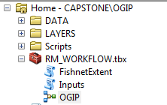
Figure 21. OGIP model in ArcCatalog

Figures 22 shows the graphic user interface where the user can select raster inputs, enter parameters to calculate the OGIP, and set raster cell size, as well as contour lines’ properties for map display.
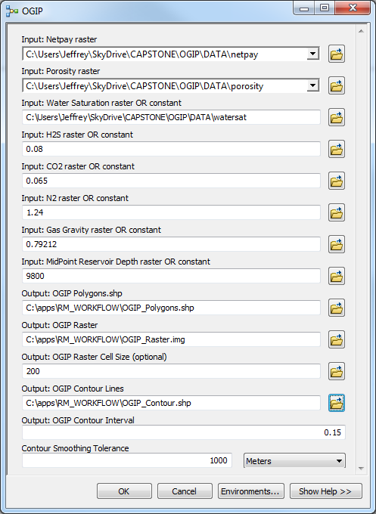
Figure 22. Graphic user interface to calculate the OGIP.
Figure 23 shows the attribute table with calculated OGIP in billion cubic feet along with all inputs and calculated fields. The result map will be added automatically, and referenced to the predefined layer files as in Figure 24.
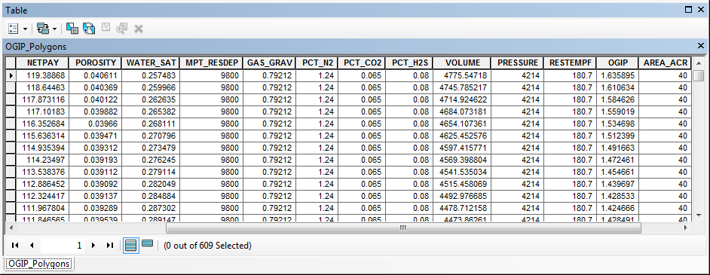Figure 23. OGIP attribute table.

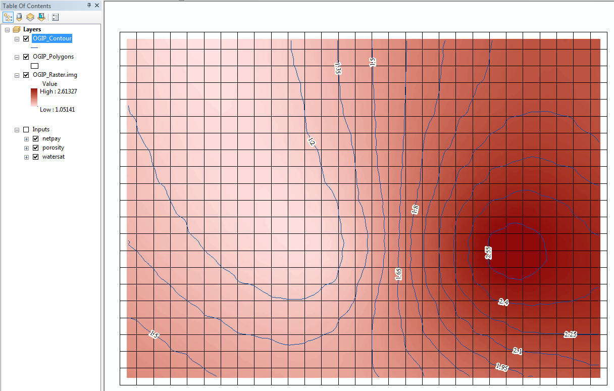Figure 24. OGIP raster and contour map.

Conclusions
The new OGIP workflow is a good start to bring potential opportunities to leverage GIS technology in the petroleum industry. This work demonstrates that ArcGIS is not simply a mapping tool. It is a fully functional analysis tool within which the geoscientists and engineers can perform different analyses on their existing data.
The reservoir engineer can easily monitor and study the reservoir with the calculated OGIP values, the raster grid, and the contour map. The workflow provides flexibility in making different input assumptions to run numerous scenarios. In addition, this workflow streamlines the data manipulation steps to avoid human error when working with data.
For future development, the OGIP workflow can be improved by adding more functionalities to calculate remaining recoverable reserves, gas reserves, or future net revenue.
References
- AAGP, Reserves estimation. American Association of Petroleum Geologists. Web. 16 June 2014.
- ArcGIS Help 10.1. http://resources.arcgis.com/en/help/main/10.1. Esri. Web. 24 May 2014.
- Cranmer, John L.: “BASIC Reservoir Engineering Manual”, PennWell (1982) 24-25.
- Dean, Lisa. Reservoir Engineering for Geologists. Fekete Associates Inc. Web. 22 May 2014.
- Lord, David. Basic Geology and Volumetric Analyses. Petrocenter. Web. 22 May 2014.
- Petroleum Support. Volume Reservoir and Gas Reserve Calculator Spreadsheet. Web. 22 May 2014.

