**Urban Sprawl and Its Effects on Urban Heat Island in Dallas-Fort Worth-Arlington, TX and Minneapolis-Saint Paul, MN**

**Matthew Welshans  
Masters Candidate, The Pennsylvania State University  
Faculty Advisor: Dr. Jay Parrish**

**Abstract**

The urban heat island (UHI) is a temperature phenomenon generally observed in urban areas where urban areas tend to be warmer relative to their surrounding suburban and rural areas. This is because paved and metallic surfaces tend to heat up quicker than green surfaces such as trees and grass, and those paved and metallic surfaces tend to hold heat longer at night, causing air temperatures just above the surface to remain warmer because the heat has not had a chance to escape. In prior research in various areas, this phenomenon has been tied to urban sprawl through various methods.

The goal of this project is to identify a relationship between urban sprawl and urban heat island. Thermal imagery from the Advanced Spaceborne Thermal Emission and Reflection Radiometer (ASTER) sensor from the Terra EOS Satellite were manipulated to find surface temperature covering areas of the Minneapolis-Saint Paul, MN/WI and Dallas-Fort Worth, TX metropolitan areas. These were compared to land cover data provided by the National Land Cover Database (NLCD) from 2001, 2006, and 2011.

The percent of impervious surface was also compared to the surface temperature to determine how urban buildup impacts temperature. The data confirms that temperatures in urban areas in general are higher than rural classifications. There were some anomalies that are discussed and some hypotheses on why these anomalies exist. The magnitude of the UHI was measured using percent impervious surface where rural land has less than 15% impervious surface per pixel and urban land has greater than 15% impervious surface. Non-urban land cover was also compared to urban land cover to view trends in UHI magnitude.

**Introduction**

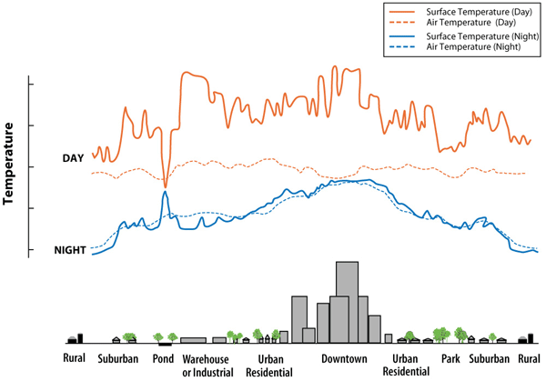An urban heat island (UHI) is a local temperature phenomenon that typically occurs in urban areas where surface temperatures are higher than surrounding rural areas due to population buildup and lack of green spaces. This effect is usually felt most in the evenings (EPA, 2012), mainly because pavement tends to keep its heat while green spaces tend to lose heat at night. Figure 1shows how air temperature tends to mirror the surface temperature at night over various land covers while in daytime heating, the surface heats up and the air temperature tends to lag until the afternoon hours.

**Figure 1 –** Comparison of air temperature vs. surface temperature for various land use types (EPA 2012).

The EPA (2012) states that UHI effects can increase electricity demand in cities in cities, increase air pollution and contribute to health issues due to poor air quality. A study done by Sailor (2002) shows that electricity demand in New Orleans increased by about 10 megawatt-hours (MWh) for every 1°C increase past 20°C. Thus temperature increases tend to increase the power consumption in cities, which can hamper the load on the power grid. In extreme circumstances, this can lead to brownouts across a region. Air pollution also increases as the power plants are taxed and have to generate more energy. Additionally, temperature increases tend to increase low-level air pollution such as increased concentrations of ozone near the surface. Finally, health issues such as heat stroke and breathing issues are further amplified as temperatures increase in larger cities. Mortality rates also increase as heat waves are further amplified by UHI effects (EPA, 2012). As the UHI strengthens in larger cities, these issues may increase in frequency over time.

Urban sprawl as a concept can be defined as a conversion of rural areas to built-up areas around a city’s core. The development of areas results in a loss of green spaces such as open fields and a buildup of infrastructure including streets and sidewalks along with buildings. Given that the infrastructure and buildings absorb heat during the day and hold onto the heat longer at night, it should come as no surprise that the further development of surrounding rural areas would contribute to an increase in the size and magnitude of the UHI around a city. Additionally, the increase in greenhouse gas emissions from vehicles driving from the outer limits of an urban area to the central core can contribute to UHI effects.

The main question is how to quantitatively measure the change in urban sprawl and the change in the UHI across a metropolitan area. This project seeks to measure how the UHI changes in response to urban sprawl using satellite-derived imagery. The main goal of this project is to accurately define a relationship between the increase in urban sprawl across a metropolitan area and the change in size and strength of the UHI in that metropolitan area.

This project will seek to find a correlation between urban buildup and the magnitude and pattern of the UHI around two metropolitan areas: Dallas-Fort Worth, TX and Minneapolis-Saint Paul, MN/WI. The Dallas metropolitan area sits within a humid-subtropical climate, which means that summers tend to be hot and humid and winters remain mild. The Minneapolis-Saint Paul metropolitan area sits within a humid continental climate zone, which means summers are warm and humid with cooler winters, although temperature can vary wildly throughout the year. The Dallas-Fort Worth-Arlington, TX metropolitan area had a 2010 population of 6,426,214 and encompasses an area of 9286 square miles, while the Minneapolis-Saint Paul metropolitan area had a 2010 population of 3,317,308 and encompasses an area of 6364 square miles (US Census Bureau, 2011).

These two metropolitan areas were chosen because they do not have a strong influence from two natural factors: topography and large water sources. Both of these factors can produce temperature anomalies across the area. For instance, temperatures tend to be milder at night closer to a large water source such as an ocean or large lake than further away from these sources. Temperatures in deep valleys can be much lower than surrounding higher elevations in certain weather patterns. By reducing the effects of these natural factors, the effects on temperature due to urban sprawl can be better isolated.

**Data Used**

Satellite imagery has been used to determine the skin or surface temperature as a measure of the strength of the UHI in a city versus the surrounding rural areas dating back to the 1970s. Although satellite technology has changed, the general premise remains the same: temperature can be derived from the measured radiative reflection using satellite sensors. Generally the satellite can measure the reflected radiation from the first object it sees, so generally data can only be accurately measured on clear-sky days (Jin 2012). Limitations in the time frames when satellites are overhead may mean that the peak levels of sunshine may not have reached the ground and thus temperatures may be a little lower than expected (Rinner and Hussain, 2011). However, since the satellite paths generally move over the sites at the same time, this is not as problematic over a time period.

In this project, imagery data from the Advanced Spaceborne Thermal Emission and Reflection Radiometer (ASTER) sensor from the Terra satellite were used to derive surface temperature. ASTER launched in late 1999 aboard the NASA Terra satellite as a cooperative project between NASA and Japan’s Ministry of Economy Trade and Industry (Abrams et al, 2002). The satellite runs on a sun-synchronous and near polar orbit, with complete Earth coverage in a 16 day period (Abrams et al, 2002). The ASTER sensor has been preferred to the Landsat 7 ETM+ sensor for temperature studies because it has five bands dedicated to thermal IR wavelengths (Figure 2) and has higher resolution in the spectrum, both of which may provide a more precise calculation of surface temperature from radiance values (Mallick et al, 2013; Nichol et al 2009).

**Figure 2**– Comparison of Landsat 7 bands and ASTER bands (Abrams et al, 2002).

Land Cover data were provided from the National Land Cover Database (NLCD), which is a service of the Multi-Resolution Land Characteristics Consortium, a group of several federal agencies led by the US Geological Society. The land cover data are based on Landsat images at a 30m resolution and feature 16 classifications of land cover and percent impervious surface (Homer et al, 2012). Data sets from 2001, 2006, and 2011 were used in this project to compare land cover and percent impervious surface to a pixel’s temperature. It should be noted for the purposes of this project that preliminary data from 2011 were used to process data but this did not vary much from the data released shortly after the research was completed. This was made available by the USGS EROS Center staff responsible for the NLCD.

**Methodology**

Study areas were established using the defined metropolitan statistical areas (MSAs) as defined by the US Office of Management and Budget. The Dallas-Fort Worth-Arlington MSA (Figure 3) covers 12 counties in Texas, while the Minneapolis-Saint Paul MSA (Figure 4) covers 11 counties in Minnesota and 2 counties in Wisconsin (Office of Management and Budget, 2010).

**Figure 3 –** Map of Dallas-Fort Worth, TX Metropolitan Area.

**Figure 4 –** Map of Minneapolis-Saint Paul, MN/WI Metropolitan Area.

Daytime ASTER data were obtained on nearly cloudless days in time periods corresponding as close to the NLCD data sets (2001, 2006, and 2011 as possible and in the same season of the year to aid in comparing the data sets. Metropolitan study areas were split into eastern and western sections because ASTER data swaths are approximately 60km wide (Abrams et al, 2002).

The general equation for measuring the UHI is $UHI= \overline{T_{urbanLC}}-\overline{\sum{\overline{T_{ruralLC}}}}$ where UHI is the difference between the mean temperature of urban land cover pixels and the mean temperature of the surrounding rural land cover categories (Jin, 2012). ASTER does not automatically sense temperature, but it can be derived using the Temperature Emissivity Separation (TES) method (Gillepsie et al, 1998). This method uses the radiance measurements from the TIR bands to calculate both emissivity (the amount of energy emitted by the surface) and temperature across multiple TIR bands. The reason this method is required is because emissivity is not known in advance for multiple land features in an image (Gillespie et al 1998).

A simplified illustration of the TES Method is seen in Figure 5. The general theory is that because emissivity is inversely related to the amount of radiation reflected back to the sensor from the surface, the brightness of the pixel is inversely related and therefore can be used to produce a first guess of the maximum emissivity (εmax) per pixel. A ratio is then created between that individual pixel’s εmax and the mean εmax across the entire image. This creates a histogram or spectrum of normalized emissivity ratios across the image, but the amplitude of these ratios needs to be calculated. To find the amplitude, the difference between the minimum ratio and maximum ratio is calculated. A second calculation can determine then the pixel’s minimum emissivity level. This allows the surface emissivity per band to be calculated. The pixel’s temperature can then be calculated using Planck’s Law since emissivity and radiance are now known. The fourth step is simply a quality assurance flag because this is a statistical process. A calculation of precision and accuracy is done across the image and areas of potentially bad data are flagged.

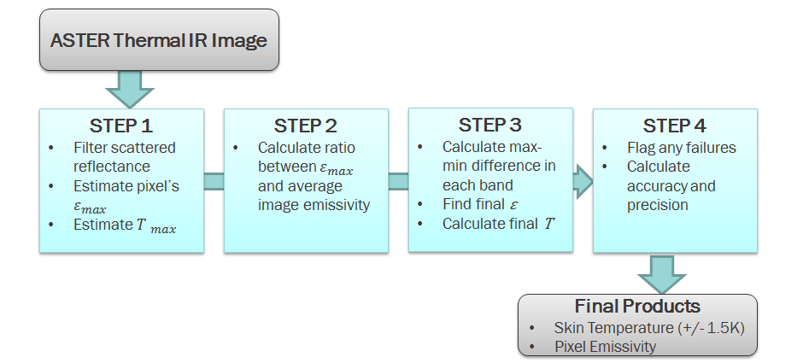

**Figure 5** – A simplified flow chart of the TES Method adapted from Gillepsie et al (1998).

Because this process is well documented and used in processing ASTER data, many software programs have this algorithm built in. In the software used for this project (ENVI 5.0), the two step process is to correct for atmospheric effects (such as filtering the irradiance out of the image) by running a thermal atmospheric correction algorithm and then calculate emissivity and temperature using the TES method (Yale Center of Earth Observation, 2012). This exports images for surface temperature and emissivity.

Processed temperature data from ASTER and land cover data were imported into ESRI ArcGIS 10.2. ASTER images from the same date were combined into a single mosaicked image. Any clouds within the individual ASTER images were filtered using various methods including manually tracing clouds as polygons and erasing those from the raster image or using the *Set Null* tool to erase pixels with temperature values below a certain threshold. A layer containing 10000 random points within the raster mosaic was then created for each time frame. Surface temperature, percent impervious surface, and land cover values were derived at each point and exported into a database table for further processing within Microsoft Excel.

Averaged temperatures were calculated for each land cover type to determine how land cover affects temperature. The amount of impervious surface in each pixel was classified into 10-percent ranges to show how the amount of paved and metallic surface affects temperature. These average temperature values were then compared to the image’s average temperature to see how patterns change with time.

Temperature patterns were mapped using ArcMap. The departure from average image temperature layer was smoothed using the focal statistics tool to calculate the average value per pixel of its neighbors within a 10 pixel (900m) radius. This smoothed layer shown in a layer on top of a layer of percent impervious surface from the corresponding NLCD vintage. This allowed for a visual comparison of areas with extreme temperature differences to urban sprawl patterns. Contours were calculated from the smoothed layer and show where the temperature was the same as the image average temperature.

**Results**

*Minneapolis-Saint Paul Metropolitan Area (East)*

Figure 6 shows a map comparing the departure from average image temperature to percent impervious surface in the western half of the Minneapolis-Saint Paul metropolitan area. The map showed that downtown core areas saw a significant increase in temperatures as shown by the increase in red colors in key areas near the center of the urban core. Urban sprawl was shown to spread a bit toward the northeast into Washington County but was not significant as buildup was modest in those areas. The largest urban buildup occurred to the south of the Minnesota River and that was reflected by increased temperatures in the northern and western areas of Dakota County.

Figure 7 shows temperature trends in the 15 land cover categories contained within the ASTER swath. The results were not surprising. Water and wetlands tended to be cold sinks with vegetation such as forests and grassland contributing to below average temperatures. Agricultural areas had temperatures near the image average and cleared land and urban areas were well above the average image temperature.

Figure 8 shows the temperature trends compared to the percent impervious surface. One trend that was noted was a sharp increase between the first 10 percentile and the second 10 percentile. A nearly linear increase is noted at a gentler slope in the three time periods. In Jin (2012)’s writings, he stated that rural areas typically contain less than 15% impervious surface per pixel and urban areas typically contain more than 15% impervious surface for his computation of UHI.

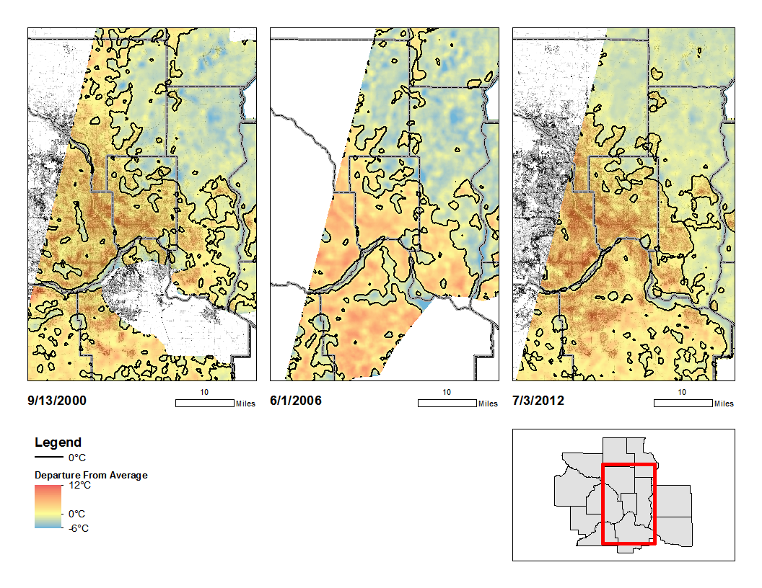

**Figure 6–** Map showing departures from average temperature and percent impervious surface in the eastern half of the Minneapolis-Saint Paul, MN/WI metropolitan area in 2000, 2006, and 2012. Data from NCLD (2014) and ASTER mapped in ESRI ArcGIS 10.2.

Using Jin (2012)’s findings, UHI was calculated by finding the average temperature for rural pixels and finding average temperature for urban pixels within the image. The results are shown in Table 1. A noted increase in UHI occurred between 2000 and 2006, corresponding to an increased buildup in urban area. The growth in urban sprawl was much lower between 2006 and 2012, corresponding to a nearly flat change in the UHI in the eastern portion of Minneapolis.

**Figure 7** – Temperature Departures versus Land Cover (2000, 2006, and 2012) for the eastern half of the Minneapolis-Saint Paul, MN/WI metropolitan area.

**Figure 8** – Temperature Departures versus Percent Impervious Surface (2000, 2006, and 2012) for the eastern half of the Minneapolis-Saint Paul, MN/WI metropolitan area.

|  |  |  |  |
| --- | --- | --- | --- |
| Date | *TUrban(IS>0.15)* | *TRural(IS<0.15)* | UHI Magnitude |
| 9/13/2000 | 29.866°C | 26.357°C | 3.509°C |
| 6/1/2006 | 34.137°C | 29.680°C | 4.457°C |
| 7/3/2012 | 35.463°C | 31.009°C | 4.453°C |

**Table 1** – Computation of UHI in the eastern half of the Minneapolis-Saint Paul, MN/WI metropolitan area by subtracting the average temperature of rural pixels from the average temperature of urban pixels as defined by Jin (2012).

*Minneapolis-Saint Paul Metropolitan Area (West)*

Figure 9 shows a map comparing the departure from average image temperature to percent impervious surface in the western half of the Minneapolis-Saint Paul metropolitan area. The spatial extent of areas above the image average remained similar with only modest buildup occurring along the northwest corridor from the downtown core and on the south side of the Minnesota River. However, the intensity of temperatures in the downtown core compared to the outlying regions increased over time, indicating that the magnitude of the UHI had increased over time.

Figure 10 shows the departure from average image temperature classified by land cover type. Results were very similar to those in the east (Figure 7) with urban areas and barren land above image average and water, wetlands and vegetation below the image average. Agricultural land was around the image average. The one that stood out in these results is the sharp increase in temperatures in barren land from 2004 to 2011. However, barren land only made up 0.14% of the image in 2011, so this likely is skewed data and can be ignored.

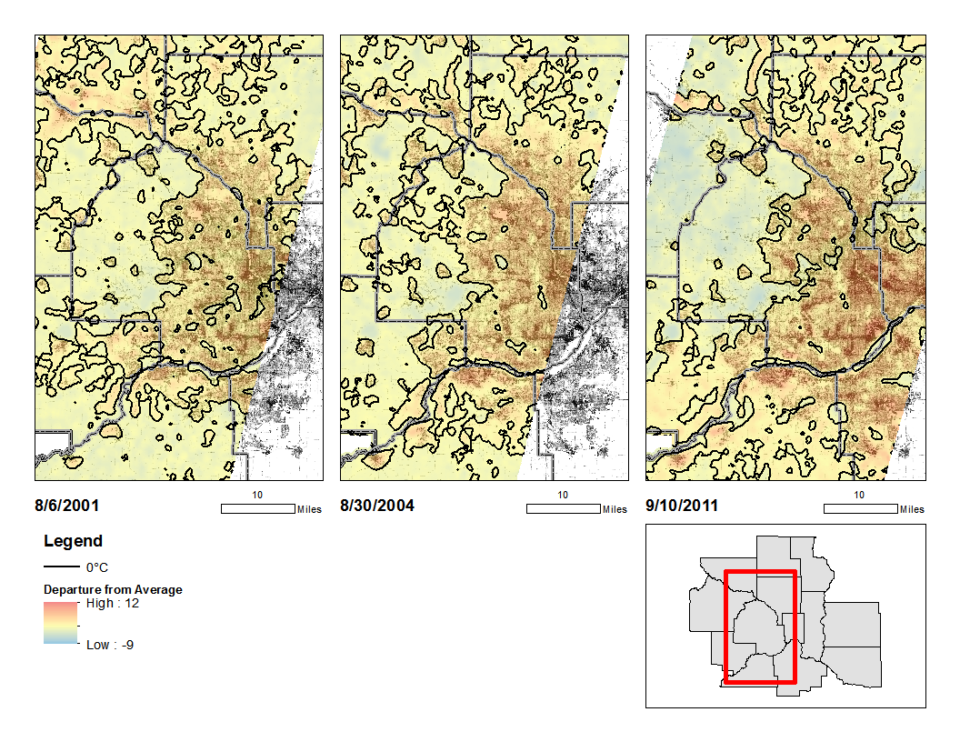

**Figure 9 –** Map showing departures from average temperature and percent impervious surface in the western half of the Minneapolis-Saint Paul, MN/WI metropolitan area in 2001, 2004, and 2011. Data from NCLD (2014) and ASTER mapped in ESRI ArcGIS 10.2.

Figure 11 shows a plot of average temperature departure compared to the percent impervious surface by 10 percent intervals in the western half of the metropolitan area. Again, a strong increase in temperature change occurred between the first 10 percent range and the second and a gentler linear growth in temperature as the percent impervious surface increases. This suggests that there is a large temperature difference between very low impervious surface (where water and vegetation are prevalent) compared to higher impervious surface (urban buildup).

**Figure 10** – Temperature Departures versus Land Cover (2001, 2004, and 2011) for the western half of the Minneapolis-Saint Paul, MN/WI metropolitan area.

**Figure 11** – Temperature Departures versus Percent Impervious Surface (2001, 2004, and 2011) for the western half of the Minneapolis-Saint Paul, MN/WI metropolitan area.

UHI calculations in the western half of Minneapolis showed a similar trend to those in the eastern half. A strong increase of just over 1°C occurred between 2001 and 2004 with a modest increase of less than 0.2°C occurred between 2004 and 2011. Again, a weak growth in urban area was noted in this time period.

|  |  |  |  |
| --- | --- | --- | --- |
| Date | *TUrban(IS>0.15)* | *TRural(IS<0.15)* | UHI Magnitude |
| 8/6/2001 | 35.391°C | 32.711°C | 2.680°C |
| 8/30/2004 | 28.195°C | 24.401°C | 3.794°C |
| 9/10/2011 | 30.900°C | 26.947°C | 3.953°C |

**Table 2** – Computation of UHI in the western half of the Minneapolis-Saint Paul, MN metropolitan area by subtracting the average temperature of rural pixels from the average temperature of urban pixels as defined by Jin (2012).

*Dallas-Fort Worth, TX (East)*

Figure 12 shows maps comparing the departure from average image temperature to percent impervious surface in the eastern half of the Dallas-Fort Worth metropolitan area from 2001 to 2013. Substantial growth has occurred in this region, especially in the outer northeast suburbs.

Collin County, TX (in the northeast corner of each map) has seen population nearly double from the 2000 to 2010 Census (US Census Bureau 2010) and this is shown in the spread of both impervious surface from the southwest corner of the county in the 2001 map to covering most of the county by 2013. Temperature patterns also responded with above average temperatures also spreading from the southwest corner in 2001 to the northeastern corner. Indeed, both spatial increases in UHI and magnitude changes (indicated by brighter red colors) have occurred in the last 13 years across this eastern part of the region.

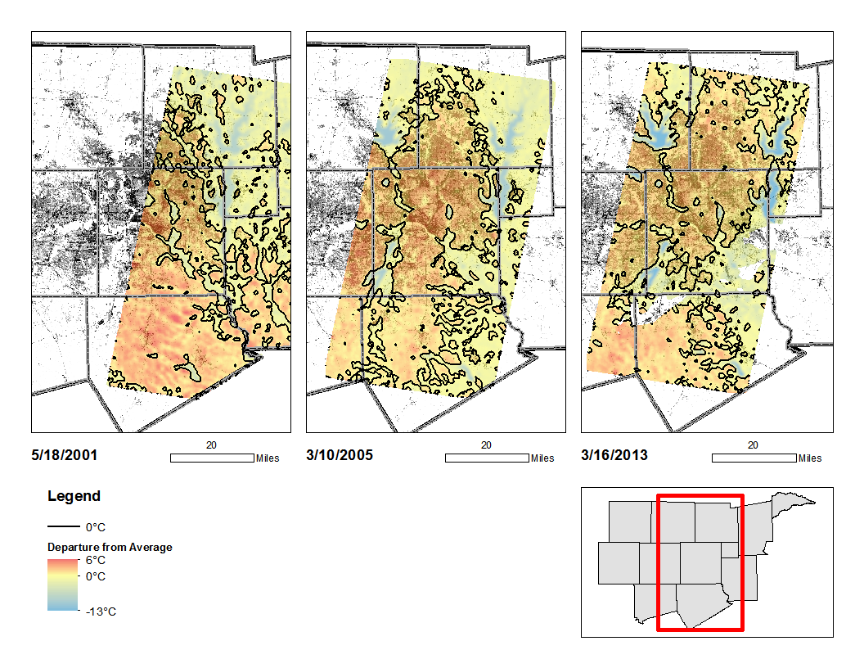**Figure 12 –** Map showing departures from average temperature and percent impervious surface in the eastern half of Dallas/Fort Worth, TX metropolitan area in 2001, 2005, and 2013. Data from NCLD (2014) and ASTER mapped in ESRI ArcGIS 10.2.

Figure 13 shows the departure from average image temperature classified by land cover type. Overall, there were not many notable differences from the graphs shown for Minneapolis-Saint Paul. Urban areas remained above the image average, as did cultivated cropland. Water, wetlands, and forests remained below image average as expected. There were some differences in barren land and shrub/scrub land; however, it should be noted that these types of land cover made up less than a tenth of a percent of the image and thus are negligible.

**Figure 13** – Temperature Departures versus Land Cover (2001, 2005, and 2013) for the eastern half of the Dallas-Fort Worth, TX metropolitan area.

**Figure 14** – Temperature Departures versus Percent Impervious Surface (2001, 2005, and 2013) for the eastern half of the Dallas-Fort Worth, TX metropolitan area.

Figure 14 shows the temperature departures from the image average compared to the percent impervious surface per pixel. The graph shows a similar signature with a strong increase in temperature from the 0 to 10 percent impervious to 10 to 20 percent impervious surface. However, there is a notable difference in the slope from the 2001 data to the other two data sets. Both the 2005 and 2013 data sets showed a slight dip in average temperature when the amount of impervious surface in the pixel was between 50 and 90 percent. This dip was only approximately a 0.2 to 0.3°C change so it could be negligible, but caused some questions since it was shown in two of the three data sets.

Calculations for UHI are shown in Table 3. One pattern that seemed to emerge was that the higher UHI values tended to occur when mixed pixels (those pixels containing 20-60% impervious surface) had higher average temperatures. This was because there were generally fewer pixels that have high percentages of impervious surface (greater than 60 percent) than mixed pixels. Looking at the graph in Figure 14, this means that 2005 should have the highest UHI value, and this is confirmed in Table 3. Indeed, the 2005 UHI was measured to be about 0.5°C higher than the 2001 and 2013 measurements.

|  |  |  |  |
| --- | --- | --- | --- |
| Date | *TUrban(IS>0.15)* | *TRural(IS<0.15)* | UHI Magnitude |
| 5/18/2001 | 32.701°C | 30.811°C | 1.890°C |
| 3/10/2005 | 25.831°C | 23.491°C | 2.340°C |
| 3/16/2013 | 30.147°C | 28.362°C | 1.785°C |

**Table 3** – Computation of UHI in the eastern half of the Dallas-Fort Worth, TX metropolitan area by subtracting the average temperature of rural pixels from the average temperature of urban pixels as defined by Jin (2012).

*Dallas-Fort Worth, TX (West)*

Figure 15 shows temperature departure from the image average compared to the percent impervious surface in the western half of the Dallas-Fort Worth, TX metropolitan area. There are some major differences in the map compared to the others. While a general heat island is shown over the central portion of each view (where Fort Worth is located), the outer bounds of the heat island was hidden by the relatively warm rural areas, shown by the brighter reds.

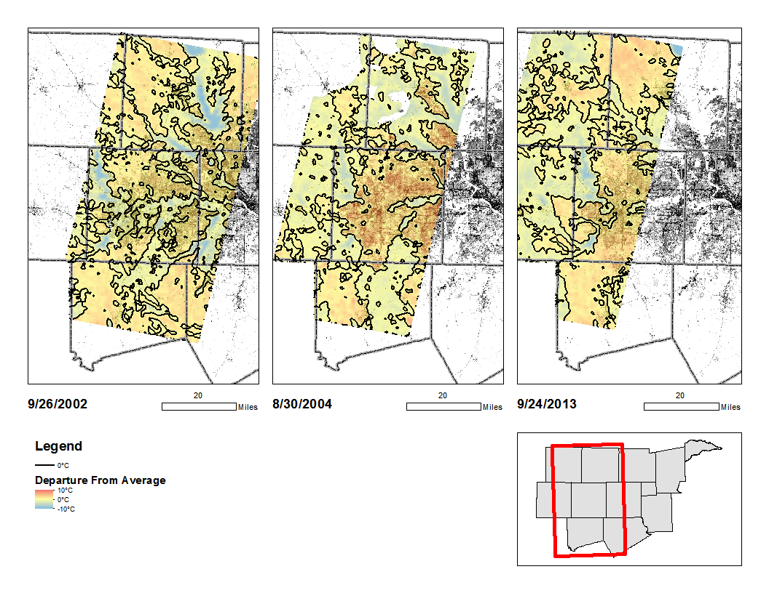**Figure 15 –** Map showing departures from average temperature and percent impervious surface in the eastern half of Dallas/Fort Worth, TX metropolitan area in 2002, 2004, and 2013. Data from NCLD (2014) and ASTER mapped in ESRI ArcGIS 10.2.

Figure 16 shows the departure from average image temperature classified by land cover type. There were no major surprises as patterns remained consistent with the other study areas. Water, forests, and wetlands remained cold sinks, while urban areas were warmer than the image average. Land classified as cultivated crops had slightly above average temperatures, which is consistent with the eastern half of Dallas-Fort Worth. Grassland and pastures were relatively near the image average.

**Figure 16** – Temperature Departures versus Land Cover (2002, 2004, and 2013) for the western half of the Dallas-Fort Worth, TX metropolitan area.

**Figure 17** – Temperature Departures versus Percent Impervious Surface (2002, 2004, and 2013) for the western half of the Dallas-Fort Worth, TX metropolitan area.

Figure 18 shows the departure from average image temperature compared to the percent impervious surface. This is where things get interesting. Temperatures in general increased as the amount of impervious surface per pixel increased. The problem is only the 2004 data behaved as expected with a sharper increase from rural to mixed (0-20% IS) and a more gradual slope in the mixed to urban areas (20+% IS). The other two time periods had a general low slope. This result is not surprising given that on Figure 13, the rural areas in 2002 and 2013 had been nearly as warm as the urban areas. Thus, it should not be a surprise that UHI was much higher in 2004 than in 2002 and 2013. This was confirmed in Table 4. The UHI measured in 2004 was double that of 2013 and over triple that of 2002.

|  |  |  |  |
| --- | --- | --- | --- |
| Date | *TUrban(IS>0.15)* | *TRural(IS<0.15)* | UHI Magnitude |
| 9/26/2002 | 35.317°C | 34.431°C | 0.885°C |
| 8/30/2004 | 36.995°C | 33.572°C | 3.423°C |
| 9/24/2013 | 37.543°C | 36.087°C | 1.456°C |

**Table 4** – Computation of UHI in the eastern half of the Dallas-Fort Worth, TX metropolitan area by subtracting the average temperature of rural pixels from the average temperature of urban pixels as defined by Jin (2012).

**Discussion**

As shown in the results section, there were some differences in the UHI patterns compared to percent impervious surface. Most of this can be explained by the land cover makeup of the metropolitan area’s non-urban areas. Each type of land has a different surface albedo or reflectivity, and usually it is higher in cleared land areas such as pastures and grassland than in areas of water or forest. The albedo is proportional to surface temperature, so urban areas and cleared areas tend to have higher surface temperatures. The reflectivity also differs depending on the time of year.

In Figures 18 and 19, most of the non-urban land cover in the Minneapolis-Saint Paul study areas was made up of Agricultural areas (Pastures and Cropland) with forested land making up between 15 to 20% of the land cover contained within the ASTER image. Surface temperatures tended to be about 2 to 4°C higher in agricultural areas than in the forested areas, but since agriculture made up about half of the image pixels, the average image temperature tended to skew toward the average temperature of land classified as agriculture.

**Figure 18 –** Land Cover Composition within the ASTER image areas in the eastern half of Minneapolis-Saint Paul, MN/WI. Agriculture and Forest make up the largest portions of the non-urban areas.

**Figure 19 –** Land Cover Composition within the ASTER image areas in the western half of Minneapolis-Saint Paul, MN/WI. Agriculture and Forest make up the largest portions of the non-urban areas.

**Figure 20 –** Land Cover Composition within the ASTER image areas in the eastern half of Dallas-Fort Worth, TX. Grassland and Agriculture make up the largest portions of the non-urban area.

**Figure 21 –** Land Cover Composition within the ASTER image areas in the western half of Dallas-Fort Worth, TX. Grassland and Agriculture make up the largest portions of the non-urban area.

In Figures 20 and 21, most of the non-urban land cover composition in the Dallas-Fort Worth study areas was made up of Grassland followed by Agriculture. Because a large portion of the area is made up of these two types of land cover, it is highly susceptible to drought conditions. Texas has had its fair share of droughts, with the most recent occurring in the time period from 2000 to early 2004, 2005 to early 2007, 2008 to late 2009, and from 2011 to today (Amico et al, 2011). Indeed, droughts affected much of the Dallas/Fort Worth area in the early 2000s and a much stronger drought from 2010 until present day (Henry, 2011). Because soil dryness affects surface temperature and drought conditions typically lead to weaker vegetation, surface temperatures can increase significantly in droughts. It is believed that this phenomenon was observed in the Dallas-Fort Worth area and resulted in rural areas being nearly as warm as urban areas in the early 2000s and early 2010s.

**Conclusions/Next Steps**

This project showed how GIS can be used to determine how Urban Heat Island can be correlated to urban sprawl. It was confirmed that there is a good link between the amount of impervious surface per pixel and increased temperatures in urban areas. Surface temperature depends on a variety of other factors, including the land cover type and time of the year. For example, water typically has a lower surface temperature during the daytime hours than most other land cover, while forested areas, which absorb more sunlight, typically has lower surface temperature than grassland or barren land, which has a higher reflectivity and tend to warm faster.

One important factor that was briefly touched upon in discussing the project results is the effects of large climatic events such as droughts. Since surface dryness affects surface temperature, soil moisture content may also need to be considered and accounted for in trying to determine magnitude of UHI.

The Multi-Resolution Land Cover Consortium, which is headed by the USGS, is planning to produce land cover classification data sets at a 30m resolution every 5 years. The next data set should be the 2016 set, which should include enhancements to older data in addition to the newest Landsat-based imagery. Additional data processing could determine whether current trends continue in future data sets. Landsat 8 data and enhancements to ASTER should also continue into the near future. Landsat 8 imagery is backwards compatible with older data with a longer history and can be used to supplement the ASTER imagery as a second source of temperature data.

There are two trends that are occurring in urban areas that may affect the magnitude of UHI in urban areas. For the first time since the 1920s, cities are growing faster than suburban areas in more than half of the largest metropolitan areas in the United States according to the US Census Bureau (Dougherty and Whelan, 2012), and this trend is expected to continue through the next decade. What will be interesting is to see if buildup in these major cities affects UHI magnitude. The theory is that UHI should increase as flats as population density in cities increases. The other factor that may affect UHI is the implementation of green initiatives within urban areas. Parks and green areas tended to have lower temperatures than areas that had a larger percentage of concrete such as city business districts and industrial areas (Rinner and Hussain, 2011). This type of planning combined with green initiatives such as green roofs and replacing concrete and asphalt with less impervious surfaces may help to reduce the UHI in cities, so it will be interesting to see how such efforts affect the magnitude.

**Works Cited**

Abrams, M., Hook, S. & Ramachandran, B. (2002). ASTER User Handbook (Version 2). Pasadena, CA: NASA Jet Propulsion Laboratory. Obtained from <http://asterweb.jpl.nasa.gov/content/03_data/04_Documents/aster_user_guide_v2.pdf>

Amico, C., DeBelius, D., Henry, T., & Stiles, M. (2011). “Dried Out: Confronting the Texas Drought.” *NPR/StateImpact: Texas*. Obtained from <https://stateimpact.npr.org/texas/drought/>

Gallo, K.P., Tarpley, J.D., McNab, A.L., & Karl, T.R. (1995). Assessment of urban heat islands: a satellite perspective. *Atmospheric Research, 37*, 37–43.

Gillespie, A.R., Rokugawa, S., Matsunaga, S., Hook, T., Kahle, A.B. (1998). A temperature and emissivity separation algorithm for advanced spaceborne thermal emission and reflection radiometer (ASTER) images. *IEEE Transactions on Geoscience and Remote Sensing, 36*, 1113–1126.

Henry, T. (2011). “A History of Drought and Extreme Weather in Texas.” N*PR/StateImpact: Texas*. Obtained from <http://stateimpact.npr.org/texas/2011/11/29/a-history-of-drought-and-extreme-weather-in-texas/>

Jin, M. (2012). Developing an Index to Measure Urban Heat Island Effect Using Satellite Land Skin Temperature and Land Cover Observations. *Journal of Climate, 25*, 6193-6201. doi: http://doi.org/10.1175/JCLI-D-11-00509.1

Jin, S., Yang, L., Danielson, P., Homer, C., Fry, J., and Xian, G. (2013). A comprehensive change detection method for updating the National Land Cover Database to circa 2011. *Remote Sensing of Environment*, 132: 159 – 175.

Land Processes Distributed Active Archive Center (2013). ATSER SWIR User Advisory. Retrieved from <https://lpdaac.usgs.gov/sites/default/files/public/aster/docs/ASTER_SWIR_User_Advisory_July%2018_08.pdf>

Land Processes Distributed Active Archives Center (2014). ASTER Level-1B Registered Radiance [satellite imagery] Retrieved from <http://earthexplorer.usgs.gov/>

Mallick, J., Rahman, A., & Singh, C.K. (2013). Modeling urban heat islands in heterogeneous land surface and its correlation with impervious surface area by using night-time ASTER satellite data in highly urbanizing city, Delhi-India. *Advances in Space Research, 52,* 639-655. doi: <http://dx.doi.org/10.1016/j.asr.2013.04.025>

Multi-Resolution Land Characteristics Consortium (2014). NLCD 2001 Land Cover and Percent Developed Impervious (2011 edition) [Land Cover/Impervious Surface Data for 2001] Retrieved from <http://www.mrlc.gov/nlcd01_data.php>

Multi-Resolution Land Characteristics Consortium (2014). NLCD 2006 Land Cover and Percent Developed Impervious (2011 edition) [Land Cover/Impervious Surface Data for 2006] Retrieved from <http://www.mrlc.gov/nlcd06_data.php>

Multi-Resolution Land Characteristics Consortium (2014). NLCD 2011 Land Cover and Percent Developed Impervious. [Land Cover/Impervious Surface Data for 2011] Retrieved from <http://www.mrlc.gov/nlcd11_data.php>

Nichol, J., Fung, W.Y., Wong, M.S. (2009). Urban heat island diagnosis using ASTER satellite images and ‘in situ’ air temperature. *Atmospheric Research, 94,* 276-284. doi: http://dx.doi.org/10.1016/j.atmosres.2009.06.011

Office of Management and Budget (2009). OMB Bulletin Number 10-02: “Update of Statistical Area Definitions and Guidance on Their Uses.” Retrieved from <http://www.whitehouse.gov/sites/default/files/omb/assets/bulletins/b10-02.pdf>

Rajasekar, U. & Weng, Q. (2009). Spatio-temporal modelling and analysis of urban heat islands by using Landsat TM and ETM+ imagery. *International Journal of Remote Sensing,* 30(13), 3531-3548. doi: http://dx.doi.org/10.1080/01431160802562289

Rinner, C. & Hussain, M. (2011). Toronto’s Urban Heat Island—Exploring the Relationship between Land Use and Surface Temperature. *Remote Sensing, 3,* 1251-1265. doi: <http://dx.doi.org/10.3390/rs3061251>

Sailor, D. J. (2002). *Urban Heat Islands: Opportunities and Challenges for Mitigation and Adaption*. Paper Presented at the North American Urban Heat Island Summit, Toronto, ON. Retrieved from http://www.cleanairpartnership.org/pdf/finalpaper_sailor.pdf‎

Streutker, D. (2003). Satellite-measured growth of the urban heat island of Houston, Texas. *Remote Sensing of Environment, 85,* 282-289. doi: <http://dx.doi.org/10.1016/S0034-4257(03)00007-5>

US Census Bureau. (2010). Census 2010, Summary File 1, Matrix P1 [data set]. Retrieved from <http://factfinder2.census.gov>.

US Geological Survey (2013). “Frequently Asked Questions about the Landsat Missions.” *Landsat Missions.* Retrieved from <http://landsat.usgs.gov/L8_band_combos.php>.

Urban Area Criteria for the 2010 Census (2011). 76 Federal Register 53030 (24 Aug 2011).

Yale Center for Earth Observation (2012). *ASTER Images* [pdf] Retrieved from <http://www.yale.edu/ceo/Documentation/ASTER.pdf>

**Acknowledgements**

I would like to acknowledge Beth King and Dr. Doug Miller at the Penn State MGIS Program for guidance through the capstone project workshop process and throughout the Masters’ program. I would also like to acknowledge the staff at the USGS EROS Center, including Jon Dewitz, Joyce Fry, and Dr. Jim Vogelmann, for their assistance in obtaining draft versions of the 2011 land cover and impervious surface data prior to official release for use in this project.