Investigating the Validity of Mapping Pioneer Cemeteries: A Precursor to using Mapped Data as a Tool for Historical Research

By

Gail Brown

Submitted in Partial Fulfillment
Of the requirements for a degree of

Master of Arts
Geographic Information Systems

Pennsylvania State University

Under Supervision of Deryck Holdsworth

December 2010

Table of Contents
Introduction: Visualizing and Analyzing the Past with Historical GIS 5
Learning What Cemeteries Have to Say 7
Cemetery Research 12
Site Delineation 15
Historical Background 15
Early Indian History 16
European Influence 20
American Settlement 21
Early Forts 23
Settlements 24
Mormon Trail 25
Transportation 26
Data Development 29
Early Settlements and Post Offices 29
Cemeteries 32
Railroads 36
Known Burial Data 36
Stone Location 41
Data Analysis 43
Cemetery Overview 43
Settlements 44
Cemeteries 49
Half-breed Tract Lee County, Iowa 52
Density 53
Average date of death 54
Overall 59
Seasonality of death 60
Pioneer Burial Data 62
Summary 65

Investigating the Validity of Mapping Pioneer Cemeteries: A Precursor to using Mapped Data as a Tool for Historical Research

Abstract

Early pioneer settlements in Iowa developed rapidly in the mid-1830s, when the Iowa Territory was officially opened for settlement. In many ways these early settlements were living organisms. Settlements started and grew, and in some cases, died. The question that is being raised here is, if historical data from early known burials is tabulated in a database and entered into a geographic information system (GIS), will it shed new light on early pioneer settlements. Current digital technologies are used to store and correlate historical evidence in order to map spatio-temporal data and visualize early settlements.
The life of a historical settlement is recorded, in part, within the pioneer cemeteries that share the early life of the settlements. This research looks at what role known burials in pioneer cemeteries may play in enabling researchers to analyze events during Iowa’s founding. Data from known burials should shed light on early pioneer life, and make it possible to confirm the location of early Iowa settlements, reveal early pathways into the prairies, or determine whether women died at a higher rate than males during the child-bearing years. This initial research will focus on gathering available data, creating a database for GIS analysis, and conducting initial analyses to determine if further work is warranted.

Introduction: Visualizing and Analyzing the Past with Historical GIS

Like many software products, the software for a Geographical Information System (hereafter GIS) was developed in response to specific needs, and its development cut through many uses. In general, the GIS tools were initially developed as a means of handling large volumes of data in a spatial manner, whether for transportation, decennial census, or analyzing forest maps of East Africa (Coppock and Rhind, 1991, 26). None of this, though, precludes using a GIS to analyze historical data. Historical GIS incorporates two important elements of a Geographical Information System. One element is digital cartographic or the ability to create an accurate visual map of a location seen at any number of spatial scales ranging from the local through to regional and national frames. The second is the ability to give spatiality to an infinite variety of attributes about a location due of the databases upon which GIS rests. When attributes are joined to a spatial feature, the researcher is able to connect site location with information about the site, and portray those associations at multiple scales. GIS technology makes it possible to manipulate large volumes of historical data as well as to create images of historical data across time. Historical atlases such as the National Geographic Historical Atlas of the United States, and broad synthesizing narratives such as that offered by Donald Meinig in his four-volume Shaping of America series (Meinig 1986, 1995, 2000, 2006) link detailed local case studies with broader regional patterns to represent change over time. As such, Fyfe and Holdsworth (2009) position HGIS within a longer trajectory: “Historical geographies have a long tradition of using graphical and cartographic methods as ‘ways of seeing’ and representing spatial change over time” (348). HGIS makes such representations that much easier, if the data are there.
Gregory and Healey (2007) explain that this connection of spatial and attribute data presents historians three advantages. One, given a geographical location, incompatible data can be brought together based on location. Two, data can be visualized, revealing patterns in new ways. Three, it is possible to analyze data that shares a spatial location based on that location (Gregory and Healey, 2007, 639). This union of the spatial and temporal enables space to become a part of the historical question, and allows the researcher to ask both quantitative and qualitative questions. It is feasible to look at layers as disparate as settlements, burials, and waterways in an attempt to understand the historical significance of each. Looking at historic data in relation to a geographical location has the potential of creating new data.
In order to do this in the realm of historical GIS, the first step is often to develop a database that allows comparisons to be made. GIS databases are “substantial works of historical geographical scholarship in their own right “(Healey and Stamp, 2000, 639). The effort required to develop a historic database is substantial, but it enables the integration of data from numerous sources that perhaps have not been joined to-date.
The assumption is that space (geography) affects history (Knowles, 2000, 457). In this study, one of the central geographic questions was whether the location of Iowa rivers and early railroad corridors played a part in Iowa settlements in the nineteenth century. By joining the spatial location of cemeteries and nineteenth-century burials with other historical data from the same time period, new information about the interaction between places and people during the pioneer era might be revealed, or old information may be affirmed.

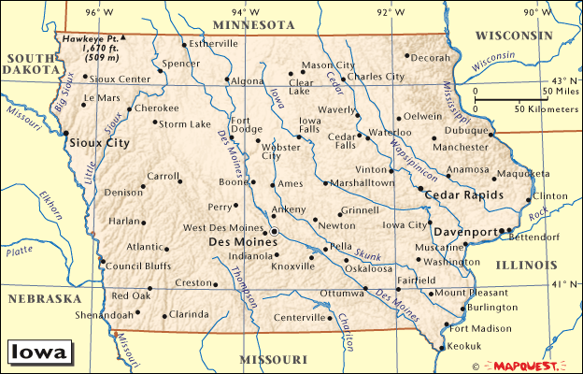
Figure 1: Map of Iowa.

Learning What Cemeteries Have to Say

Obituaries in newspapers or death records in county courthouses are two of the main sources of information about a person’s passing, but burials in the pioneer cemeteries in Lee and Van Buren County present a wealth of information from an era when neither of those other sources were as established. The most obvious data, of course, is that a known burial gives names, date of death, and often date of birth. Mapping this information makes it possible to look at the average date-of-death by year as well as gender, and to visualize where the earliest known burials took place. By mapping the known burials and looking at the location of these burials in relation to the early settlements, it may be possible to analyze how geography, specifically the location of Iowa rivers, influenced the locations where early pioneers settled in the Iowa Territory.
The idea to study historical geography using GIS and cemeteries is not new. Jimenez and Cossman (2006, 164) used known burial data to study the seasonality of death of historic African-American populations in Augusta, Georgia. They found the rate of death for youth 1-17 was 36% higher in the summer, and those aged 39 and over was 28% higher in the winter. Their research also disclosed that seasonality of death was most prevalent prior to central heating, when individuals lacked the ability to protect themselves from temperature extremes, and prior to modernization when infectious diseases were more prevalent.
Settlers in early Iowa faced both of these elements. In Iowa, summers reach temperatures above 90 degrees Fahrenheit, and in the winter, temperatures fall below zero-degrees Fahrenheit. Malaria, cholera, typhoid and smallpox were serious health risks during the 1800s in Iowa (Iowa Pathways, 2005) and periodic epidemics threatened the lives of early Iowa settlers. The location of Iowa along the Mississippi River, where travelers entered the territory by traveling north from New Orleans, brought in disease from deck passengers on the steamboats (See page 25).
This research also considered changes in the number of deaths per year to see if other dependent variables, such as increase in available transportation and modernization of health-care systems, could be found. “Mortality doesn’t discriminate except in how or when one dies, which is best determined by one’s access to resources” (Cossman and Jimenez, 2006,151). As early settlements took root, more amenities would be available and the quality of life improved.
Johan Liebens studied cemetery data in St. Michael’s Cemetery in Pensacola, Florida, where his study showed that in the first half of the nineteenth century infant mortality was high, as was mortality for those between 30 and 55. In the second half of the nineteenth century, infant mortality was lower and age of death was higher (Liebens, 2003, 63). If this is true, age of death within a pioneer cemetery should increase as the settlement matures and as access to modern resources increases with the advent of trains and reliable transportation in the area. Modern advancements allowed people to develop better and cleaner living conditions. Modernization also attracts more people to the populated areas and advances such as medical care, allowing people to live longer.
Jimenez and Cossman (2006, 178) conclude that three main factors influence the seasonality of death. One, the availability of healthcare; two, the ability to control temperature; and three, an educational level that allows for employment beyond general labor. All of these suggest that as a community develops, and more resources are available to the population, the rate of death will decrease and the age of death will increase. If this is true, the number of deaths within a pioneer cemetery should decrease as the settlement matures and access to modern resources increase.
Attempting to expand early Iowa history by mapping known burials is an effort to look at how geography helped shape early pioneer settlements. Dobbs states that it is “important to view the unfolding of this settlement landscapes as a process, a continuum of human choices made and spatial patterns established in response to conditions on the ground” ( Dobbs, 2009, 339). Entering temporal data on date and age of death, and giving it spatiality by linking the data to point layer related to the burial sites, may reveal that cemeteries developed as pioneers moved into the state.
It is know that the early settlers tended to cling to the rivers and streams, and initially stayed away from the prairies. The woods found along the river banks gave them building materials and fuel, and offered shelter from the sun in the summer and blizzards in the winter (Cole, 1920, 131). Within southeast Iowa, which has the Mississippi River as its eastern border, “(t)he river routes provided by the Mississippi River . . . and tributaries shaped the early patterns of settlement in the state” (Bogue, 1973, 85) (see Figure 2).
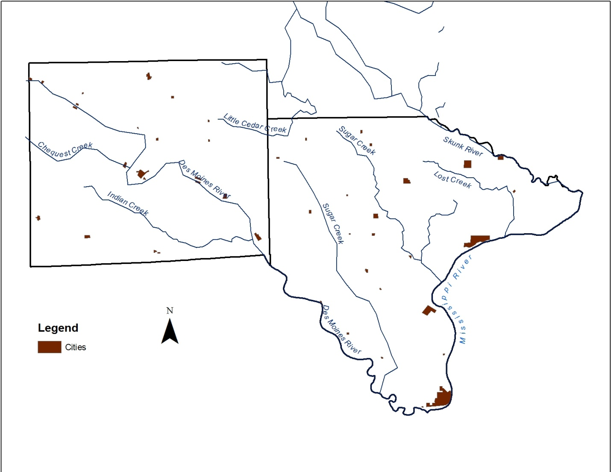Figure 2: Major waterways in southeast Iowa.

Mapping known burials using the date of death should show a correlation between the known burial data and the settlements. The data may also reveal time and age of death to help determine if modernization brought better health care, living situations and longer life.

Cemetery Research

In 1830 Iowa, the land between the Mississippi and Missouri Rivers, was legally opened for settlement (see Figure 3).
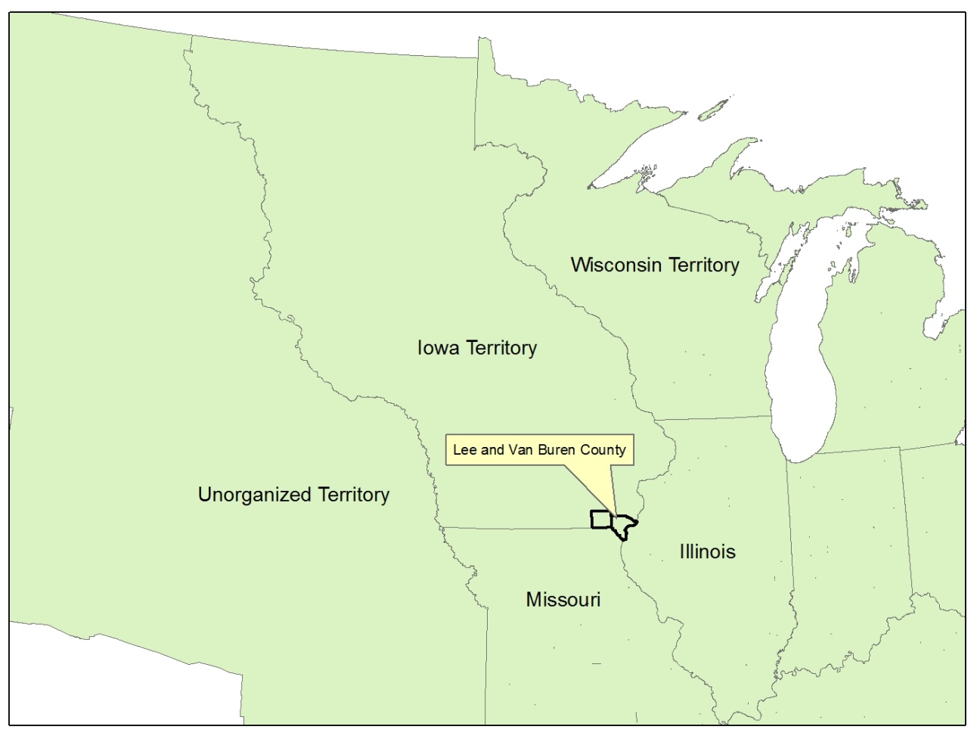
Figure 3: Map of Iowa Territory in 1840, highlighting the counties under study.

Between then and 1900, early pioneers changed the face of Iowa forever. The movement of these pioneers – their routes and early settlements – was mapped by applying GIS to gravestone data. The main source of data for this first phase of research was from known burials in pioneer cemeteries within two of the earliest established counties of southeast Iowa. Knowles states it well when she says that GIS not only has the boredom of data entry, there are additional problems of “Extracting data from historical sources is analogous to data mining, but it is data mining with a pickax and shovel at the rock face, it can rarely be automated”(Knowles2005, 5). The majority of time in this portion of the research was spent locating and entering data of pioneer cemeteries into a spreadsheet before importing it to a GIS. It was a surprisingly slow process to locate the many databases assembled by genealogists, who digitally transcribed cemetery records for their needs. Although both counties have genealogy websites, each county handled the data in a different manner.
A broad definition of cemeteries was used when collecting data in order to be inclusive of all cemetery types. Churchyard cemeteries were burial sites situated next to early churches and were established to bury church members. Military cemeteries were specifically for the burial of military personnel only. In the early 1800s, many families buried members on their own property in sites known as family burial grounds. Public cemeteries were established to be close to, but not within, a settlement. These cemeteries were established within one-half mile of a settlement. For historical purposes, because public cemeteries were large and well ordered, and often recorded on an historical plat book, there is a better chance that the graves weren’t disturbed (Ruggs, 2000, 282). From a research perspective, public cemeteries and church yards were often located on an historical plat book, such as the A. T. Andreas Illustrated Historical Atlas of the State of Iowa (1875), making it easier to determine the cemeteries physical location. For this research, cemeteries are merely defined as places where people were buried.
Although no distinction is made between the types of cemeteries, the research is limited to pioneer cemeteries. In Iowa, the definition for pioneer cemeteries is cemeteries that have fewer than 12 burials in the past 50 years (SAPIC, accessed June 2010). This definition was changed from 6 burials to 12 and was signed into law May 26, 2009, which was after this research had started. Each of the counties in this study area had approximately 40 listed pioneer cemeteries. Known burial data was limited to the nineteenth century, leaving approximately 500 stones per county. Although this is a limited amount of data, it is hoped that research will show the data reveals useful information and verifies that further research is warranted.

Site Delineation

Historical Background

Present-day Iowa is in western north-central United States, between the Missouri River and the Mississippi River. It shares its northern boundary of latitude 43°30’ with Minnesota and it shares its southern boundary of 40°30’ with Missouri. The smallest Midwestern state, ranking 25th in size among all 50 states, it nonetheless has 99 counties, a reflection perhaps of the slow scale of travel in early decades that necessitated many nearby county seats (see Figure 4). The 99 counties have an average size of 565 square miles, and the county lines tend to follow the Township lines that were established under Thomas Jefferson’s administration. The focus for this initial research is Lee County and Van Buren County in the southeast corner of Iowa. Both of these counties are within the earliest settled part of Iowa. Before embarking on the analytical segment of this work, it is important that the broad contours of settlement history are outlined as the case study sites did not develop in a vacuum. There was a long history of Indian occupancy, some of which influenced the location of early American forts and fur trapper activities. In addition, significant movements of early settlers involved wagon routes for Mormons heading west as well as routes made possible by river and rail transportation networks.

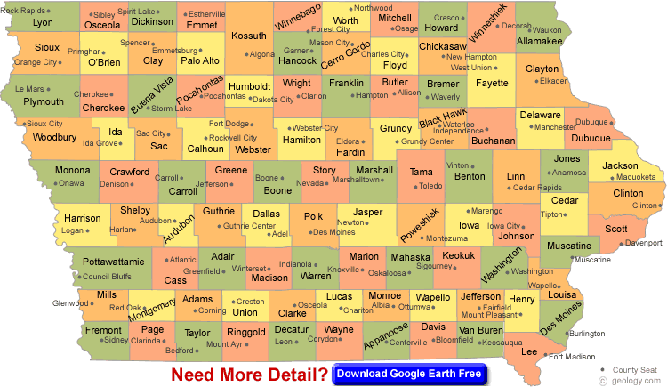
Figure 4: Map of Iowa counties and county seats.

Early Indian History

Indian occupation and use of this area dates back to the Paleo-Indian period, which began about 10,000 years ago. Mound builders were some of the first known Iowan inhabitants. Their name is derived from the mounds they created to bury their dead. The mounds are normally found on hilltops overlooking river valleys and are found throughout Iowa. Effigy National Monument in northeast Iowa is the most well known site of Indian Mounds, but nineteen mounds overlooking the Des Moines River valley are located in the Lacey Keosauqua Park near Keosauqua, in northwest Van Buren County.
Oneota peoples were present in Iowa from around 1250 A.D. to the 1700s. Oneota settlements are found along streams, and in southeast Iowa they are located along the Mississippi River and its tributaries. Sites found in southeast Iowa extend 70km from north of Fort Madison to just south of Muscatine in Lee County. Two Oneota sites in southeast Iowa, referred to as the Bailey Farm and McKinney sites, show no evidence of European trade (Alex, 2000, 187).
The Ioway Indians, where the state of Iowa gets its name, are one of the best known tribes in the area. According to Lance Foster, “The Ote, the Missouria, the Ioway, and the Winnebago show up the prehistoric record as the Oneota culture” (1996, 41). The Oneota began breaking up in the 1600s.
There is archeological evidence that the Ioway Indians were in northwest Van Buren County, within the Des Moines River valley, from the 1770s to the 1820s. The site hasn’t been excavated, but evidence found on the ground includes trade beads, European gunflint, pottery, glass and pipestone (Alex, 2000, 222). The items match the historic descriptions of goods the Ioway received in trade from the British and French during the time of their colonial power. The Ioway lost power and land due to wars with the Sioux, Sauk and Fox. The last known presence of Ioway in Iowa, according to Foster (1996) was when their big village along the Des Moines River was destroyed, the present location of Iowaville, Iowa. By 1838, the Ioway relinquished all of their land and were moved to a reservation in northeast Kansas.
The Sauk and Mesquaki were the largest and most powerful of Iowa's Indian tribes. They moved into the Illinois area from Michigan in the 1730s, and used eastern Iowa as a hunting ground. Historical evidence places the Sauk in eastern Iowa in the 1760s, while the Mesquaki were located along the Mississippi River on the Illinois side. Documented settlements in southeast Iowa suggest that the Sauk and Mesquaki had summer homes along the Mississippi, Des Moines, Cedar and Skunk Rivers. The locations of the winter quarters or hunting camps are not stated. Archaeologists have documented 25 villages, and 14 of these have been confirmed. All are along the prairies flanking streams (Alex, 2000, 227).
As the United States developed westward, pressure was put on the Indians to move west of the Mississippi River. The Sioux lived along the Upper Iowa River. The Sauk and Mesquaki were south of the Upper Iowa River. The Sauk, although part of Iowa’s history, lived in Illinois, east of the Mississippi River.
In April 1803, Thomas Jefferson signed a treaty with France and purchased the Louisiana Territory (see Figure 5). This increased the size of the United States by 800,000 square miles. The land purchased stretched from the Mississippi River to the Rocky Mountains (see Figure 5). With the purchase of the Louisiana Purchase, the closest segment, Iowa, was opened for settlement and the Indians again needed to be displaced.

1790 Map of the Louisiana Territory
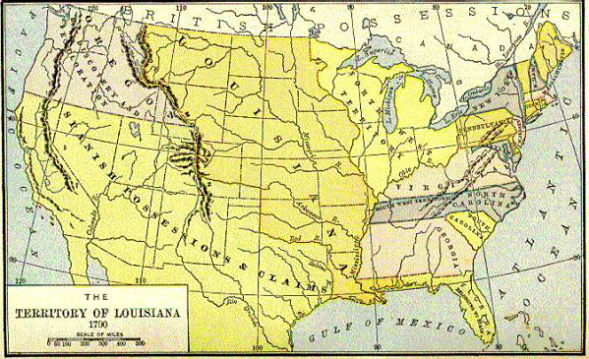
Figure 5: 1790 Map of the Louisiana Territory. http://www.earlyamerica.com/earlyamerica/milestones/louisiana/louismap.html

The Treaty of 1804 was signed one year after the Louisiana Purchase, when Governor William Harrison, governor of the Indiana Territory, persuaded five Indians to sign a treaty that ceded 51 million acres of Indian lands to the United States. The five Indians, however, did not have the authority to sign the treaty and Chief Black Hawk, a Sauk, refused to acknowledge the legitimacy of the treaty.
The government forced the Indians to move from their homes on the Illinois side of the Mississippi River into Iowa in 1829. Black Hawk refused to obey, and returned with his tribe to their summer grounds in Illinois in 1830 and in 1831. The Sauk made a third attempt to return to their lands east of Mississippi River in 1832, which resulted in what is known as the Black Hawk War. The war lasted for three months, and resulted in the Indians being forced back west of the Mississippi River. Most the Indians who were fleeing from Illinois were killed, and several, including Black Hawk, were sent to prison (Schwieder, 1996, 15).
This defiance led to the Black Hawk Purchase in 1832. The United States forced the Sauk Indians to cede a strip of land 50 miles wide and 195 miles in length along the Mississippi River. The Black Hawk Purchase started in the southern tip of Iowa along the Missouri border, and proceeded north along the Mississippi River to present-day Clayton County.
1833 was the start of the legal, non-Indian settlement in the Iowa Territory. Although the Indians were forced to leave, town names such as Keosauqua and Keokuk are ongoing reminders of those earliest settlers. Even the name Iowa is taken from the Ioway Indians.

European Influence

The French were the first European colonial power to interact with these Indian groups, and fur trading and mining posts were established at what is Dubuque in the 1600s.
Lead mining in northeast Iowa began in prehistoric Iowa and continued through the nineteenth century. The first Europeans in the area were Louis Joliet and Father Jacques Marquette in 1673. They travelled down the Mississippi river to the mouth of the Des Moines River.
Julien Dubuque, after whom the city of Dubuque is named, was the first white man to create a house in Iowa. In 1788, Dubuque received permission from Mesquaki chiefs to work the lead mines that are found in northeast Iowa in. The land allotted to him was 21 miles along the Mississippi River. In 1796 the Spanish Governor of the Louisiana Territory gave Dubuque a land grant to the mines. Dubuque called the area the Mines of Spain. Today the area is referred to as the Mines of Spain Recreation Area. Julien Dubuque’s grave is located in the area (Sage, 1974, 34; Schwieder, 1996, 23-24),

American Settlement

The American phase of this settlement history came when the area was included as part of the Louisiana Purchase. Iowa was placed under the territorial jurisdiction of Michigan in 1834, and then two years later under the newly created Territory of Wisconsin. Iowa became a separate territory in 1833 and a state in 1846 when the population reached 60,000, the minimum set by the Northwest Ordinance necessary for statehood. By 1851, all Indian lands in Iowa had been ceded to the U.S. government.
During the 1830s, Southeast Iowa was a gateway for American pioneers entering the new territory. The Mississippi Rivers and its tributaries helped to shape the pattern of early settlement in Iowa (Bogue, 1996, 82). The two counties in this study are intersected by the Des Moines River, the Skunk River, and the Cedar River, all of which flow from the interior of Iowa and feed into the Mississippi River (see Figure 6).
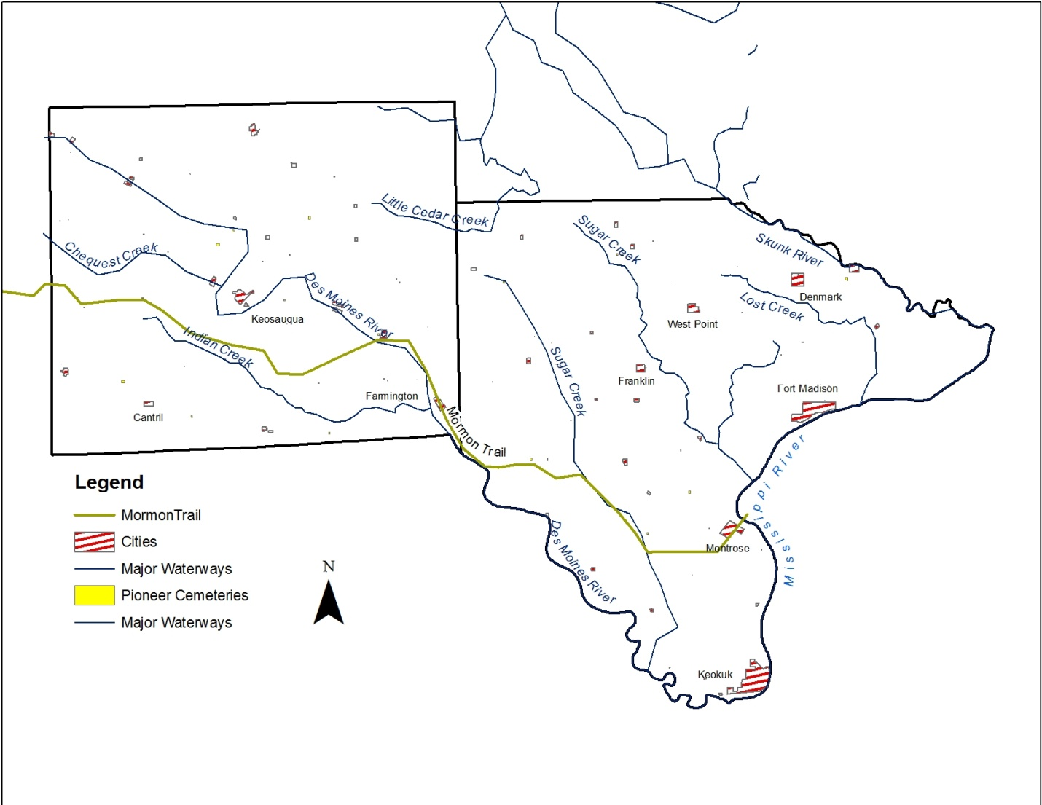
Figure 6: The two-county area under study showing main rivers and settlements pertinent to the research.

The Des Moines River cuts through the state, northwest to southeast, and giving access to much of the interior of Iowa. According to Bogue (1963), more people settled in counties along the Des Moines River than in counties that didn’t border the river. In the study area, the Des Moines River borders Lee County on the southwest and cuts through Van Buren County from the northwest to southeast. The Mississippi River serves as Lee County’s eastern border. The river navigation and location of these rivers suggest that the counties in the study area will offer data from early pioneer routes.
George Parker estimated that by 1850 approximately 200,000 people were living in Iowa, but fewer than 10 percent lived on the prairie. “The remainder had started at the mouths of the rivers flowing into the Mississippi, and were creeping upward along their banks where the timber and the bottom lands joined” (1940, 100). These rivers had to be approached from the south, since “It was impossible for the population to pierce the interior in any considerable number from points above parallel forty-two north latitude, which divides the state into two almost exactly equal parts” (Parker, 116). Streams and rivers above this parallel are considerably smaller and more shallow, making navigation difficult. This suggests that the earliest development in Iowa will be in the southeast corner of the state.

Early Forts

The first two forts built in Iowa, Fort Madison and the first Fort Des Moines (the second Fort Des Moines was built in central Iowa by the Des Moines and Raccoon Rivers) were in this two-county area. The site for Fort Madison, located at the site of present-day city called Fort Madison, was selected in 1808. This was the first American outpost built in the Upper Mississippi Valley, and was garrisoned by 50-60 troops. The location, however, was poorly selected. A ridge gave Indians protection, and a ravine on the west gave them easy access. Black Hawk led several charges against the fort, and in 1813 the soldiers were forced to abandon the fort under darkness of night, setting it on fire as they left. Archeologists have recovered bronze buttons with First Infantry insignia, as well as trade beads and melted lead from the ruins of the fort. Digs have revealed the location of the stockyards, barracks and officers quarters (Alex, 2000, 228).
Fort Des Moines was built in 1834, in the area of present-day Montrose, Iowa, adjacent to the Des Moines River. It was intended as a central location to investigate the Des Moines River and as a permanent fort in the interior of the territory. It was abandoned in October 1836. Archeologists tests in 1966 failed to locate any of the fort’s structures.

Settlements

The first white settlers in the study area were trappers and traders, scattered along the Mississippi River. Some these settlers were employed by the American Fur Company, and intermarried with the Sac and Fox Indians. A treaty between the United States and the Sacs and Foxes in 1824, known as the Half-Breed Track, set aside 100 hectares in Lee County between the triangular area between the Mississippi and Des Moines Rivers. The north boundary was by a line extending eastward from the northern Missouri border (see Figure 7).
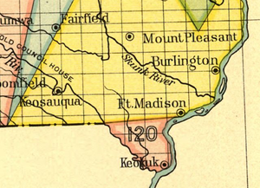
Figure 7: The Half-Breed Tract was located in Lee County, Iowa. An 1824 treaty between the Sacs, Foxes and the United States set aside a reservation for mixed-blood people related to the tribes. (http://commons.wikimedia.org/wiki/File:Lee_County_Half-Breed.png)

“Dozens of archeological sites in eastern Iowa illustrate the early historic period succession from trading and military posts, and squatters camps to homesteads and the first town sites with associate industries such as ceramic and brick works; grain, lumber, and fabric mills; and rock and mineral quarries” (Alex, 2000, 234). However, no burial site within the Half-Breed Track was ever found.

Mormon Trail

One of the most dramatic phases of pioneer movement into and across Iowa is associated with the Mormon Trail. Mormons had created a significant settlement in Nauvoo, Illinois, from 1839 and 1846. Nauvoo was a Mississippi River settlement, across from Montrose, Iowa. Nauvoo quickly grew into the largest settlement in Illinois. Due to harassment that escalated to armed conflict, the Mormons agreed to leave Illinois and move west. They began moving into Iowa and created a staging area near Montrose, along Sugar Creek. “From February through September of 1846, thousands of Latter-day Saints abandoned Nauvoo, fleeing to the West in barges and ferries across the Mississippi River” (lsd.org). The majority, some 7,000 or more, left Nauvoo between March and May.
On February 25 and 28, 1846, the first detachments left Iowa. “As fast as these vacated the Sugar Creek base, others crossed over from Nauvoo, Illinois, made their final preparations, and followed at intervals until late in the year” (Sage, 1987, 75). The trail they took them from Sugar Creek, in Henry County, to Farmington and Bonaparte, both in Van Buren County. In spring of 1853, 2,500 Mormons camped at Keokuk, Iowa, in Henry County, to earn money before heading to their final destination in Deseret, what became Utah. The campground was just north of Keokuk along the Mississippi River (see Figure 8). Although there may be Mormon burials in the pioneer cemeteries located close to the Mormon Trail, discerning this will require additional research in terms of matching names to historical documents.
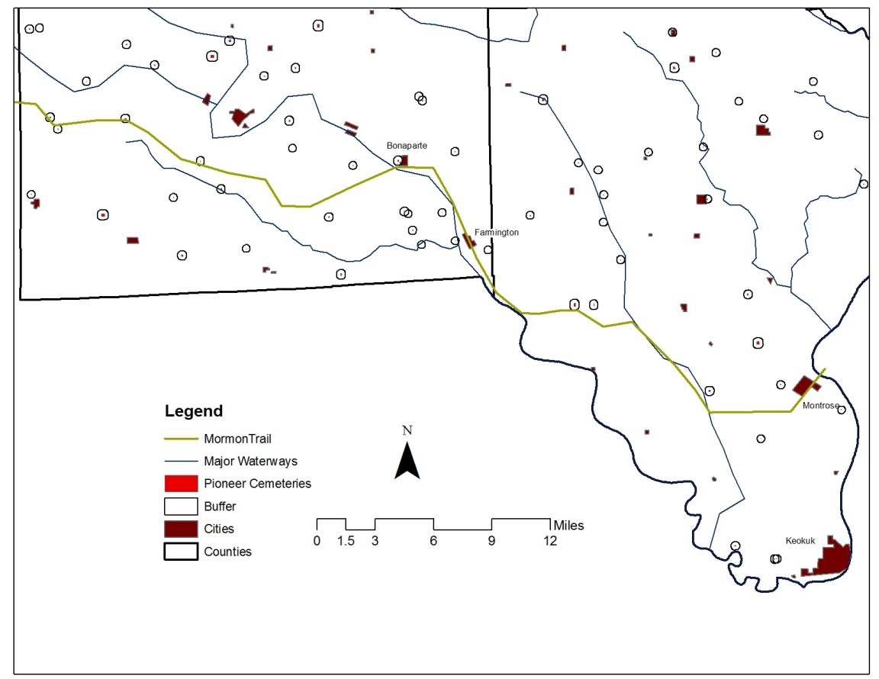
Figure 8: The Mormon Trail through southern Iowa. A buffer has been added around the cemeteries to make them visible.

Transportation

Transportation along the Mississippi River strongly affected the southeast corner of Iowa. Steamboats started coming up the Mississippi River in the 1820s after stern-wheel or side-wheel steamboats made upstream transportation viable after 1811. Many people took advantage of deck passage. For a small fee, people lived and slept on the deck for the three-weeks it took to travel north to Iowa. Deck passage was a very crowded, dirty way to travel and, according to Schwieder (1996, 55), this crowded living brought the worst of the cholera cases to Iowa. Three main cholera outbreaks were in 1832, 1848, and 1860. It may be possible in later research to see if cause of death can be determined on burial records to see how the disease affected death rates, or if the deaths due to cholera were located near the main waterways, or the port settlements of Keokuk and Burlington.
Railroad expansion west of the Mississippi River opened new areas to settlements. Early settlers relied on waterways to move into the interior of the territory, and to import and export goods. These water routes saw a decline, however, when the new railroads were opened. Railroad companies plotted sites along the lines, around which they planned future development. Major divisional settlements were set at distances of 200- to 300-miles to ensure repairs, supplies, and crew changes (Stromquist, 161).
By the 1860s, Iowa had an excellent system of railroad transportation. The first railroad, built in 1856, ran from Keokuk to Montrose, Iowa. By 1861 it was possible to go from Keokuk into Bentonsport in Van Buren County, as well as up to Fort Madison along the Mississippi River. By the end of the nineteenth century, 235 miles of railroads were interwoven through the two counties in this study (see Figure 9).
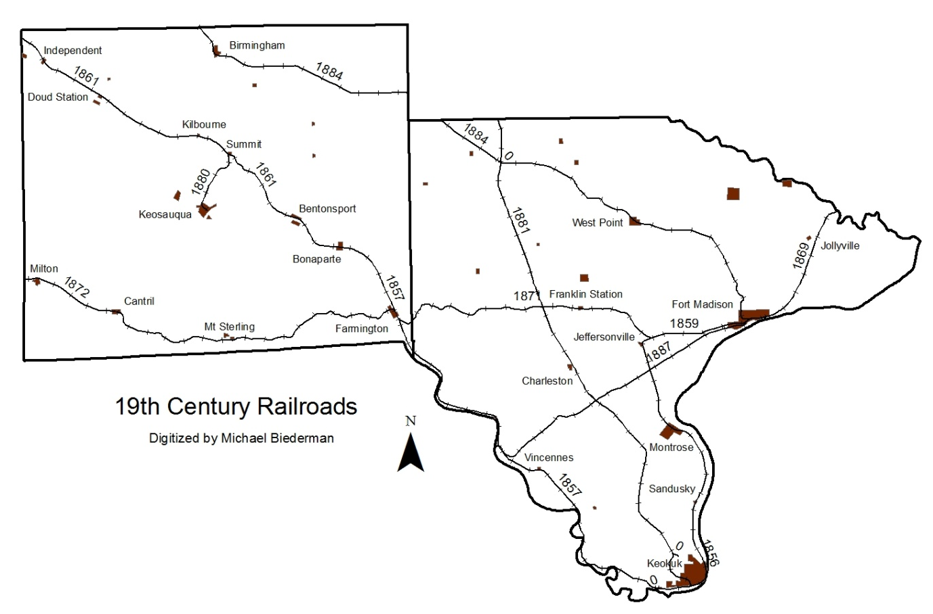
Figure 9: Railroad corridors.

Officials liked to brag that everyone in the state was within eight miles of a railroad (Schwieder, 1996, 54). This enabled farmers to transport grains at all times of the year, not just when the river was passable. People could also travel without being dependent on the weather.
By the early 1870s “. . . the pioneer era had come to an end in the Hawkeye state; all parts of Iowa then had some settlement” (Schwieder, 1996, 51). Farms and small settlements blanketed the state in a pattern similar to present day Iowa. This is evident by comparing today’s populated places with maps of the early settlements and the county maps in the A.T. Andreas' Illustrated Historical Atlas of the State of Iowa.

Data Development

The most challenging and laborious part of this phase of the research was locating data and transforming it into a format that could be used in a GIS. The primary source for base maps was the Natural Resources Geographic Information Systems (NRGIS ) Library (http://www.igsb.uiowa.edu/nrgislibx/), sponsored by the Iowa Geological and Water Survey division of the Iowa Department of Natural Resources. The NRGIS site has data available by county, such as roads, rivers, cities and county boundaries. The data does go back to the 1930 aerial photography. They are also the ones who georeferenced the pages of the A.T. Andreas' Illustrated Historical Atlas of the State of Iowa, which made it possible to use the maps for digitizing.

Early Settlements and Post Offices

The A.T. Andreas' Illustrated Historical Atlas of the State of Iowa from 1875 includes township maps of the two counties in the study (see Figure 10). The maps, which were hand drawn, show the location of settlements, post offices, railroads and roads and cemeteries.

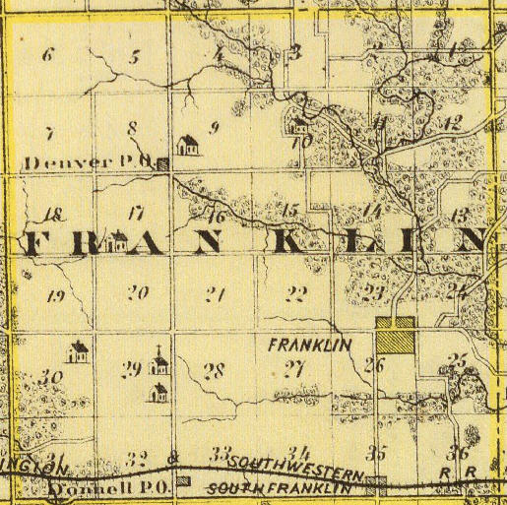
Figure 10: A sample of a plat from A.T. Andreas' Illustrated Historical Atlas of the State of Iowa, georeferenced by the NRGIS. This reflects a township in Lee County. Post offices, railroads, and settlements are evident.

With GIS it is possible to create new data, using a method called digitizing. Using the township pages from the A.T. Andreas' Illustrated Historical Atlas of the State of Iowa as a guide, settlement boundaries were drawn and attributes about the settlements entered into an attribute table (see Figure 11). The historical data pertaining to the settlements were from books by David Mott and Tom Savage.
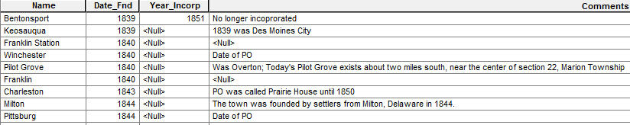
Figure 11: Attribute table for settlements entered. Shows Date_Find and comments, which supplements the information.

Mott’s book, Abandoned Towns, Villages and Post Offices of Iowa, published in 1930, gives town name, founding date, abandonment date and date of incorporation, when relevant. He also includes dates that post offices were established and abandoned. Savage’s book, A Dictionary of Iowa Place-Names, published in 2007, has similar information. Once the settlements data from A.T. Andreas' Illustrated Historical Atlas of the State of Iowa were digitized, the information from these two sources was added to the attribute table. This made it possible to compare settlement information with the data from the cemeteries.
Post Offices in the A.T. Andreas' Illustrated Historical Atlas of the State of Iowa were drawn as a small square. The square was giving location, not the actual shape of the building. These were entered in GIS as point data, that is, a point that has latitude and longitude for the post office location, and an attribute table. Since the A.T. Andreas' Illustrated Historical Atlas of the State of Iowa included the name of the post office, it was possible to cross reference the post office name with the names in David Mott’s book and enter a data founded and date closed into the attribute table.

Cemeteries

The cemeteries on the A.T. Andreas' Illustrated Historical Atlas of the State of Iowa of 1875 were marked with the standard cross symbol, rather than with the actual cemetery boundaries. To enter this into GIS, a new layer was created and a point was placed on the map using the center of the cross symbol on the atlas. The cemeteries were not given a name when they were entered, since the atlas did not have any names. In that the maps were hand-drawn, it was assumed that the cemetery locations were not exact, but that they were in the correct section-township-range.
In order to place the known burials in the correct cemetery, GIS required the cemetery be created as a polygon, that is, that it have area. During the initial digitizing process, a point was placed on each cross symbol, but a polygon was created around these points to fulfill the above requirement.
The State Historical Society of Iowa (SHSI) (http://www.iowahistory.org/index.html) donated the state-wide cemetery layer created by that office. This was a polygon layer of cemeteries within the state of Iowa. According to the SHSI, cemetery boundaries are entered into the layer only when the real-world boundaries are known. This meant there were cemeteries from the A.T. Andreas' Illustrated Historical Atlas of the State of Iowa, or listed on the county websites, that were not present in the cemetery shapefile donated by the state. This type of uncertainty is prevalent in historic GIS. “GIS databases are notoriously poor at handling uncertainty in completeness, inaccuracy and ambiguity, in the data that they are representing” (Gregory, 2007, 641). The uncertainty of cemetery locations between the sources had to be dealt with in a consistent manner in order to include the data in a GIS for analysis. For those cemeteries not within the state layer, the boundaries were created using several data sources.
Lee and Van Buren County both maintain websites with data on pioneer and/or abandoned cemeteries. If the cemetery location was described on the site, this was used to locate the cemetery on the GIS map. If the location was near a cemetery marker that referenced the A.T. Andreas' Illustrated Historical Atlas of the State of Iowa it was assumed the two cemeteries were the same. When a SHSI layer showed a cemetery in the same section-township-range as a cemetery digitized from the A.T. Andreas' Illustrated Historical Atlas of the State of Iowa, it was assumed that the reference was to the same cemetery, and that the SHSI was the most accurate.
Aerial photographs for the area from 1930 and 2009 from the NRGIS Library were used whenever possible to verify locations. In some circumstances gravestones were visible on the aerials, or patterns of a cemetery were visible, i.e., patterns of the head stones were visible on the aerial, making it possible to locate the cemetery. When this happened, the aerial, which has a 1-meter resolution, was used as the correct location (see Figure 12).

Pioneer Cemetery

State provided boundary
Figure 12: A comparison of the boundaries proved by the state and those drawn based on the aerial photo available from Iowa DNR GIS website. | The 2009 NAIP aerial showing the headstones at a sample cemetery. The NAIP aerials are 1 meter resolution.

At times, the only data that was given online regarding cemetery location was its location within a specific Section-township-range. If there was a cemetery marked on the A.T. Andreas' Illustrated Historical Atlas of the State of Iowa that corresponded with Section-township-range, and no other cemetery was nearby, that site was where the cemetery boundaries were drawn. If, however, a different cemetery was already in that Section-township-range, the cemetery that was to be drawn was added arbitrarily along an existing road, but within the correct Section-township-range. In that a section within the PLSS system covers one square-mile, this ensured one mile accuracy (See Figures 13 and 14).

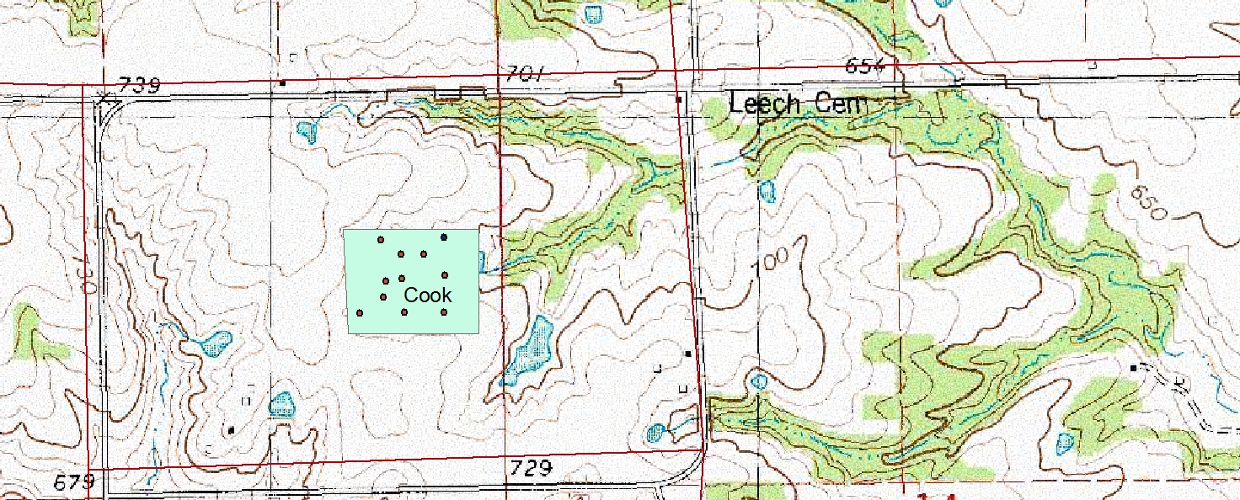
Figure 13: Example of difference between cemetery locations based on Iowa Gravestone Project website, and county topographic map. According to the Van Buren County cemetery list, Cook Cemetery is alternately called Leach Cemetery.
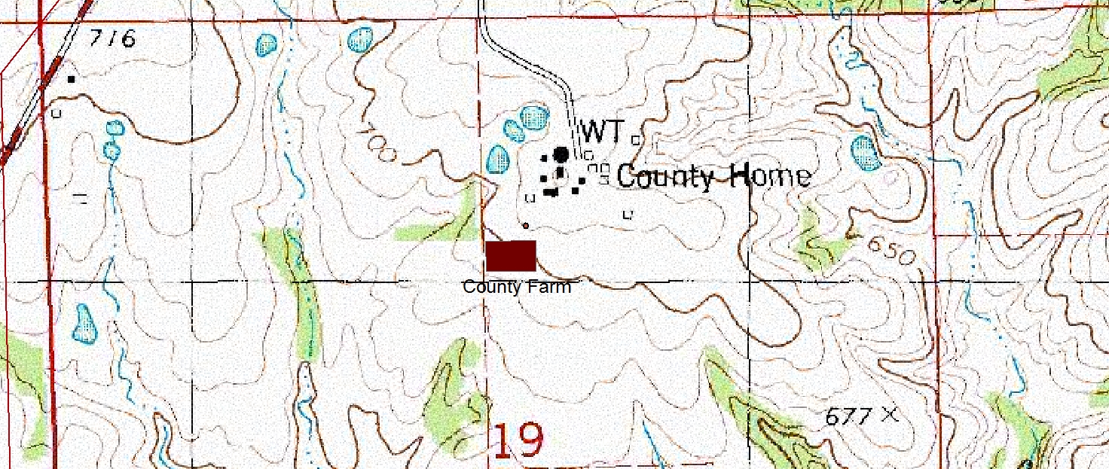
Figure 14: Example of accurate cemetery location based on Iowa Gravestone Project website, and county topographic map.

Finally, at times the cemeteries were located only with a latitude/longitude taken from a topographic map. In this case, the latitude and longitude were used as the centriod of the cemetery. For cemeteries not in the Iowa state shapefile or in the A.T. Andreas' Illustrated Historical Atlas of the State of Iowa, it was necessary to either research online, or contact a county representative to determine cemetery location.

Railroads

The dates that the railroads were built and the date they were abandoned are available on the Iowa Department of Transportation web site (http://www.iowadot.gov/iowarail/railroads/maps/maphome.htm, accessed September 20, 2010). The date the railroads were started and abandoned was recorded as attributes in the database.

Known Burial Data

The biggest challenge in Phase I of this research was locating the known burial data and developing a database that would allow future analysis on a variety of attributes. “Spatially highly accurate maps and closely linked databases of historic cemeteries, or even methodologies for the development of these maps and databases, do not seem to exist. . . “(Liebens, 2003, 57). Neither of the counties in this research had known burial data in a format easily imported into a GIS. This made it necessary to create a design a database for GIS analysis.
Known burial data came from several sites. Lee and Van Buren County both participate in the Iowa Grave Stone Project (http://iowagravestones.org/ ). Volunteers throughout the state take digital photos of grave stones and submit them to an online website. The site enables the user to search by county and cemetery name. When the data on the photographs was legible, the information from the stones was entered into a spreadsheet and coded. In some circumstances, the stones were worn and not legible (see Figure 15).
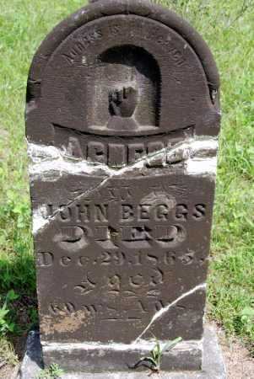 | 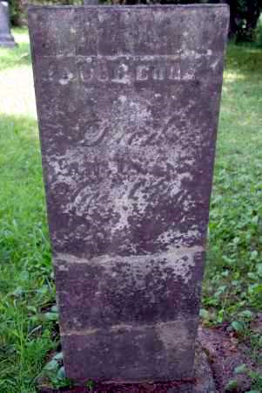
Figure 15: Images from the Iowa Gravestone Project website (http://iowagravestones.org/). Note that old stones are not always legible.

Both counties also participate in the Iowa Genealogy Web. A plethora of information was available on these sites. Both counties maintain a list of pioneer or abandoned cemeteries. In several cases, a list of burials within the cemetery was also available. (See Figures 16 and 17).
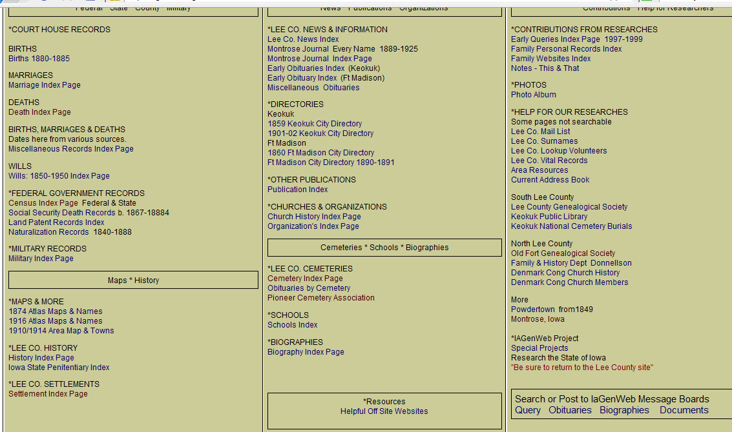  Figure 16: Lee County IA http://iagenweb.org/lee/ | 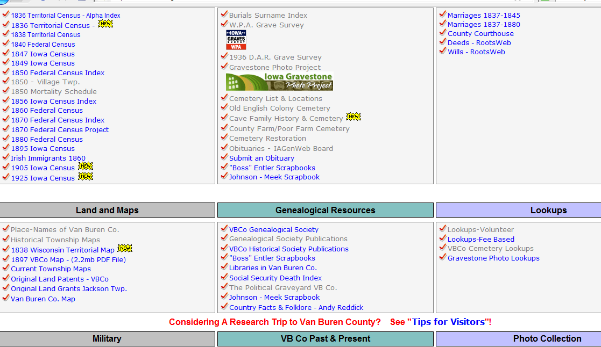  Figure 17: Van Buren County, IA http://iavanburen.org/

These lists were copied and saved as a text file, and then imported into the spreadsheet. Using a spreadsheet made it possible to assign all cemeteries the same headings and ensured consistency in formatting so a join could be performed later in GIS.
All known burial data were entered into a spreadsheet containing 20 fields. Data from the stones included first name (Fname), last name (Lname) and middle initial (MInitial). Date of birth and date of death were divided into three temporal fields – the numerical date of the month (1-31), the numerical month of the year (1-12), and the calendar year (1800-1900). Gender was entered when implied or obvious (i.e. script states “son of” or the name clearly implied gender, such as Martha or Patrick). A comment field was used to enter notes on familial relationships, military or fraternal allegiance. Inferred data in the spreadsheet was date of birth, when date of death and age are given; age, when date of birth and date of death are given (see Figure 18).
Lname | Fname | Gender | Age | Mos | Days | Comment
Figure 18 Portion of spreadsheet showing column headings
Several code fields were designed for the cemeteries, in order to keep the data separated by county and cemetery name. One field, marked Cem_Name was for the name of the cemetery. A second field, marked county, contained the name of the county where the cemetery was located. Field three was marked CEMCODE and contained a unique code given to each cemetery. The CEMCODE consists of the first initial of the county, and the first three or four letters of the cemetery name laid out as follows: X_XXX. So a cemetery in Lee County was coded L_CEM. This code made it possible to sort cemeteries by county as well as name.
The SGCODE stands for single grave code. Each known burial was given a unique code. The code consists of the CEMCODE followed by “SG” and then sequential numbering starting at 1. That is, CEMCODESG#. So a stone in Lee County was coded L_CEMSG1, L_CEMSG2, etc. The final SG number reveals the total recorded burials in a single cemetery (see Figure 19). Because the SGCODE is unique, it was the code used to join known burial points to the cemetery polygon layer once the data was in the GIS.
Cem_Name | County_Name | CEMCODE | SGCODE | MGCODE
Acklam | Lee | L_ACK | L_ACKSG1 | L_ACKMG1
Acklam | Lee | L_ACK | L_ACKSG2 | L_ACKMG1
Figure 19 Portion of spreadsheet showing data entered

The MGCODE stands for multigrave stones, which refers to stones that list more than one person on the stone. Each person listed on the stone received the same MGCODE. If there were five people on one stone, each person had the same MGCODE, such as L_ACKMG1. This made it possible to sort data by families, and made it possible to find entries that were double entered; once because they were listed on a family stone, and once because they had an individual stone. When data was extracted from online tables, it was not possible to determine if stones were single grave or multi grave, so only the single grave code was used.
After all of the data was entered into a spreadsheet, date-of-birth, date-of-death, and age were calculated when possible. Simple formulas were entered (Date of Death – Age; Date of Birth + Age; Date of Death – Date of Birth) into columns. The results were randomly checked for accuracy by manually calculating the date-of-birth, date-of-death, and age and comparing it to the calculated data.
The ability to query all of the data linked to the feature that shows on the map, such as all of the known burials within one cemetery, is the feature that makes GIS so powerful. That is, it is possible to enter a script that says, for example, ‘show me all of the houses that are red in Cedar Rapids, Iowa.’ If ‘red’ is one of the attributes that was entered, all red houses are selected, enabling the user to gather both count and location.
To apply this query feature to age of death, it was necessary to have a value assigned. For children who died prior to their first birthday, the age in months was divided by 12 to give a fractional age. There were several instances where a child’s age was not given. For example, the stone may say infant son/daughter of AW and S. In order to keep the data, an age of 0 was given to each of these stones. Zero was used to maintain accuracy within the database. Since the actual age wasn’t known, a true age could not be assigned. It may have been that infant was still born, died shortly after birth, or that an age simply was not given. By putting those known burials in their own category of age zero, they can be separated at a later date if necessary, without influencing the more accurate ages.

Stone Location

To join the burial data with the correct cemetery in the GIS, two things had to happen. First, the cemetery had to have physical boundaries. How these cemetery boundaries were determined was discussed above. Second, once the boundaries (polygons) were created, a point layer was created and one point was added for each known burial in the cemetery. That is to say, if the Old Cemetery had 52 known burials, 52 points were digitized onto the Old Cemetery polygon. The point data were given attributes for the CEMCODE and the SGCODE. The SG code was calculated by running a script for sequential numbering, and then joining the data from the CEMCODE with the column for the numbering code. It was essential that the cemetery have the same SGCODE as the database in order for a many-to-one join to work in the GIS environment. This join is ultimately what makes it possible to associate the information about the location with the physical location.
It is important to note here that the burial points were located in the correct cemetery, but the actual location within that cemetery was arbitrary. It was impossible to know where each burial was located without doing a site visit and individually marking all head stones.
Also, some of the cemetery data was from lists that volunteers hand entered from old records. This table contains all known burials, but it is not known if there is a visible/legible stone in the corresponding cemetery.

Data Analysis

Cemetery Overview

Data from the known burials feature layer for Lee and Van Buren Counties were combined using GIS. The known burials data were stored as point values and assigned a unique identifier based on the single grave code in the layer.
Spatial variables came from two sources. One, the early settlement layer, digitized off the A.T. Andreas' Illustrated Historical Atlas of the State of Iowa. This polygon feature class contained an attribute that held the data of settlements. Since this layer is spatial in nature it allowed an analysis based on geographic location. The second layer is the cemetery boundaries layer. No attribute data beyond name is associated with this layer.
Van Buren County has 42 abandoned or pioneer cemeteries, and information for 481 burials was entered. Of these, 74 entries do not have an age, or age could not be calculated, and 43 have no date-of-death. Lee County shows 34 abandoned or pioneer cemeteries and information for 609 burials was entered. Of these, 97 entries do not have an age, or age could not be calculated, and 60 have no date-of-death. Therefore, within the two counties in the study, there were a total of 62 cemeteries and information for 1,090 known burials.
All of the reported pioneer cemeteries in Lee County had more than five burials. Van Buren County, however, had 11 pioneer cemeteries with five or fewer entries. Three of these only had one burial, and two of these had two burials. This may mean they were family cemeteries, or cemeteries used by pioneers while traveling along a trail (see Tables 1 and 2).
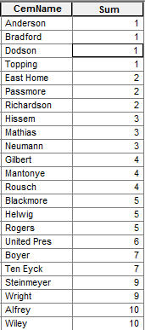 | 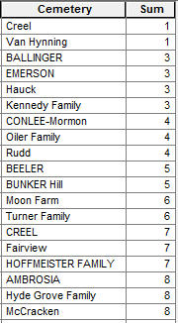
Table 1: Van Buren County cemeteries with 10 or fewer recorded burials. | Table 2: Lee County cemeteries with 10 or fewer recorded burials.

Settlements

One hypothesis that this research examined was whether the earliest Iowa settlements were located along the main waterways leading into the Iowa interior. Dobbs states that “. . . initial conditions must be taken into account to understand the development of either individual towns or systems of towns” (Dobbs, 2009, 332). When pioneers first came into Iowa, the landscape was 79.5% tall grass prairie and 11.9% forest (Smith 94). The green color in Figure 20 shows how extensive the original Iowa prairie was. Pioneers favored homestead sites that were dry, close to a water source, and had available wood, which means they selected sites that were at the edge of the forest, near a waterway and the prairie (Jordon, 1964, 209).
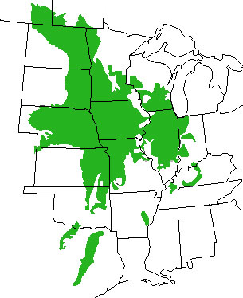
Figure 20: Map of the estimated extent of prairie before 1800s. http://www.iowaprairienetwork.org/FAQ/faq.shtml

If these speculations are true, then the earliest settlements in southeast Iowa should be seen along the Des Moines River, the Skunk River, and the Cedar River. If so, it will verify Parks statement that pioneers entered Iowa through the southeast corner of Iowa where rivers made it possible to enter into the new territory. In order to test this, the settlement boundaries that were digitized from the A.T. Andreas' Illustrated Historical Atlas of the State of Iowa were added to the GIS. This resulted in the identification of forty-six settlements in Lee and Van Buren County. A one-mile buffer was added to the major waterways, and all of the settlements falling within the one-mile buffer were selected. A total of 27 settlements in the two counties were within one-mile of the major navigation routes. No date of establishment was found for two of the settlements, Melrose, and Buena Vista. Of the 25 settlements for which a date of establishment was found, fourteen, or 56%, were settled before Iowa became a state in 1846, and twelve, or 48%, were established before 1840 (see Figures 21 and 22).
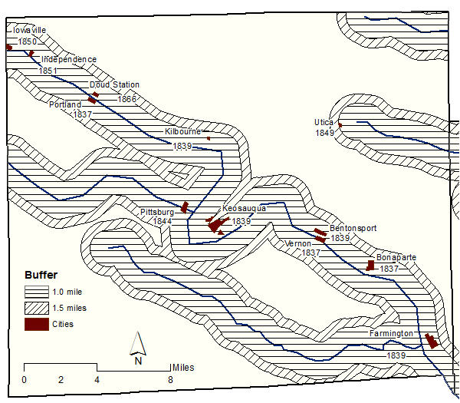
Figure 21: Settlements with founding date in Van Buren County, Iowa, that are within one-mile of a major waterway.
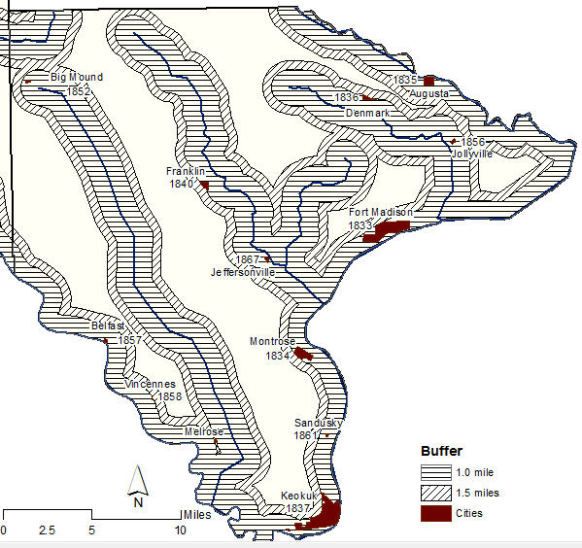
Figure 22: Settlements with founding date in Lee County, Iowa that are within one-mile of a major waterway.

In Van Buren County, the oldest settlements are in the southeast corner of the county and move northwest along the rivers. The oldest settlements in Lee County are along the Mississippi River. The number of settlements and the shifting of the settlement dates move inland along the rivers, which does support the statement that early settlements were established along the major waterways.
Of the 46 cities, 30 are within one-mile of the railroads, and 39 are within two-miles (see figure 23). In that Van Buren and Lee County are among the earliest counties established in Iowa – both established in 1836 – there seems to be less correlation between the dates the railroads were built and settlements established. The exception appears to be along the Des Moines River in southwest Lee County between Keokuk and Farmington. Two settlements, Belfast and Vincennes, were established along the track within a year of the railroad construction date. Of the two, today only Vincennes is considered a populated place, which is defined by the United States Geological Survey (USGS) as “places or areas with clustered or scattered buildings and a permanent human population” [http://geonames.usgs.gov/domestic/feature_class.htm accessed November 5, 2010).

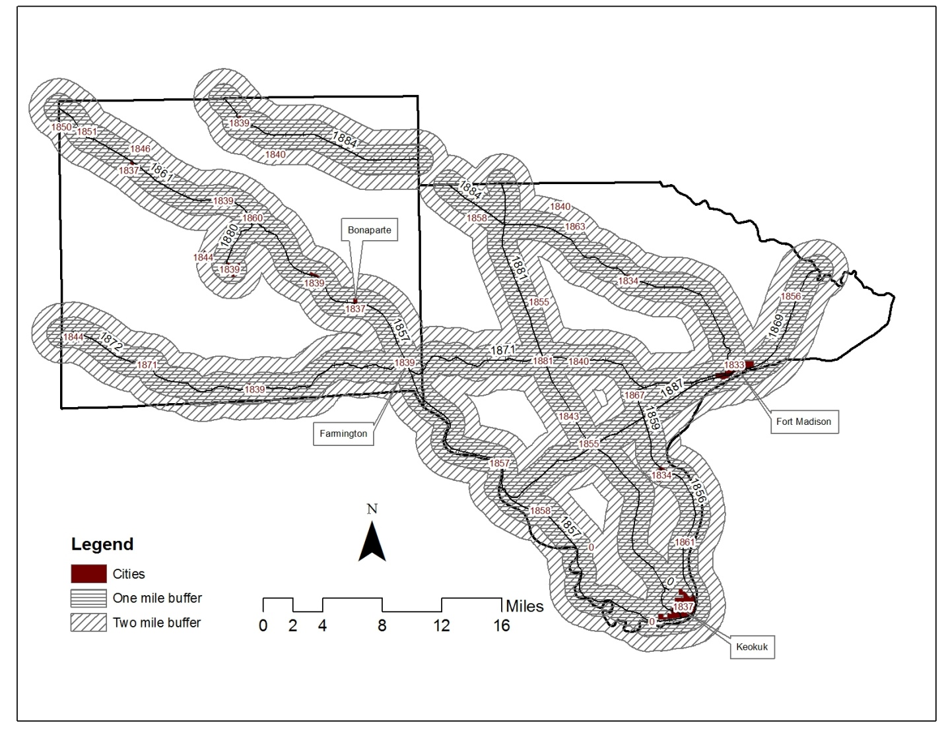
Figure 23: Cities within two miles of a railroad.

Cemeteries

In that 56% of the early settlements in Lee and Van Buren County were within one mile of a major waterway, it is logical to hypothesize that early burials will be within one-half mile of the settlements. Ruggs states that in the nineteenth century it was common to have a cemetery located outside of the settlement. To determine this, a one-half mile buffer was added to the settlements and cemeteries within that buffer were selected.
Lee County had 34 pioneer recorded cemeteries. Six of these, or 17.6%, are within one-half mile of the settlements located along the waterways. Only 78 out of 748 known burials are in that one-half mile buffer, and only six are dated before 1846. These known burials were within one-half mile of Augusta, settled in 1835; Fort Madison, settled in 1833; and Denmark, settled in 1836 (see Figure 23).
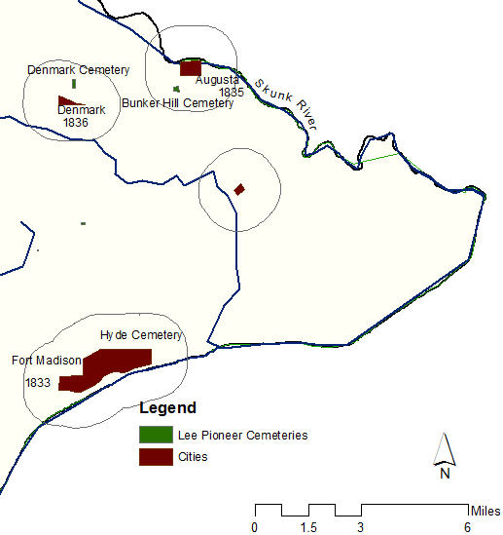
Figure 24: Cemeteries in Lee County that have stones dated prior to 1846 and are within one mile of a river. The cemeteries are difficult to see, due to the small size.

Van Buren County has 42 pioneer cemeteries. Five of these, or 11.9%, are within one-half mile of the settlements located along the waterways. Only two known burials are in that one-half mile buffer and dated before 1846. These known burials were within one-half mile of Milton, settled in 1844; Birmingham, settled in 1839; Winchester, settled in 1840; Bonaparte, settled in 1837; and Farmington, settled in 1839 (see Figure 25.)
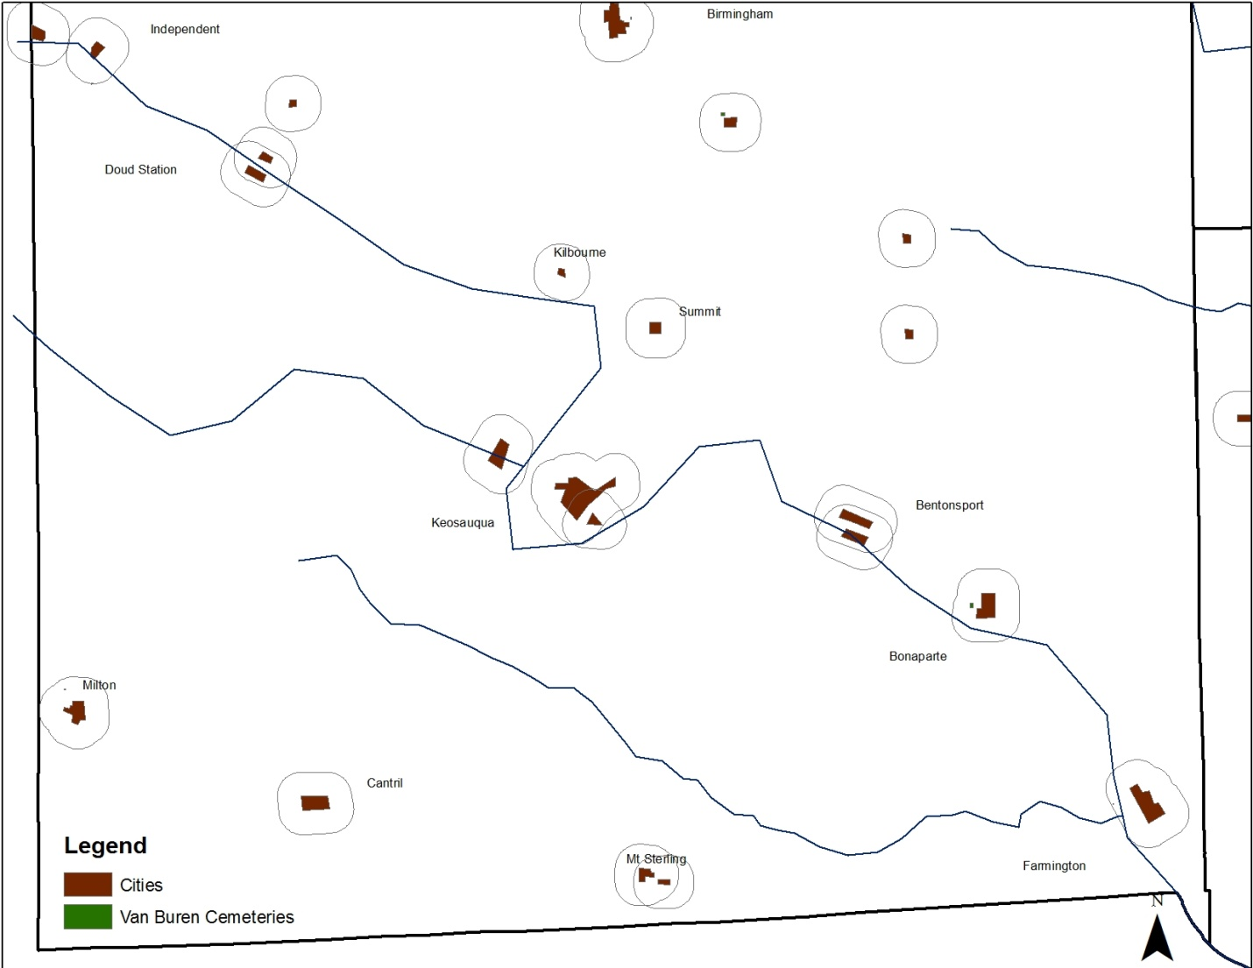
Figure 25 Cemeteries in Van Buren County that have stones dated prior to 1846 and are within one mile of a river. The cemeteries are difficult to see, due to the small size.

As noted earlier, the Mormon Trail went through this part of Iowa in the mid-1840s. A list of some known Mormon burials is available online, but does not include the name of the cemetery where individual was buried. One online sources states: “The WPA Writers Program attributes some of the burials in the Snyder Cem. in Bon. Twp., to the Mormon pioneers at this camp” http://iavanburen.org/history/bonaparte1967book/HistoryOfBonaparte-part3.html accessed November 5, 2010), but more data needs to be collected in the second phase of the research. The trail clearly followed the major waterways, and passed through the older settlements (see Figure 26). The Mormon Trail through this part of Iowa was initiated in 1846, so is not reflective of the routes earlier settlers took into Iowa.
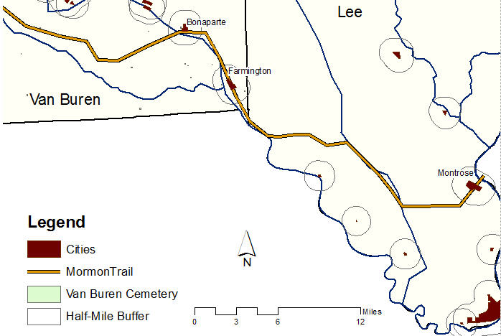
Figure 26: Mormon Trail with cities founded before Iowa became a state.

Half-breed Tract Lee County, Iowa

Burials are missing from the Half-Breed Tract. The Lee County Genealogical site (www.iagenweb.org/lee/cems/atohau.htm ) merely states that there is a lost cemetery in Section 7 Jefferson Township. The only pioneer cemetery located in this portion of Lee County, Yellow Banks, has a recorded earliest marking of 1856. There are also no known burials from the original Fort Madison that was built in Lee County in 1808. It is possible that gravestones related to the fort are in a still-active cemetery, and therefore not part of this study, or that due to the fort’s short history no one is buried there.

Density
Once the known burials data were entered into the database, it was joined to the cemetery layer in GIS.
A density map using the kernel setting in spatial analyst was created at two different search distances. Kernel density calculates the density of features, in this case known burials, and maps the area of highest density. Using different search radius resulted in two distinct maps. The density of known burials, the darker blue, is higher near the water routes. The first calculation was run with the search distance set to 5,000 meters, which left several cemeteries out of the calculations. By expanding the search radius to 10,000 meters, the majority of the known burials were included. Figure 26 below shows that the points of highest density are closest to the water routes. These areas of high density are also near the earliest settlements in the two counties. This suggests that earliest settlers to Iowa did indeed use the waterways as major points of entry.
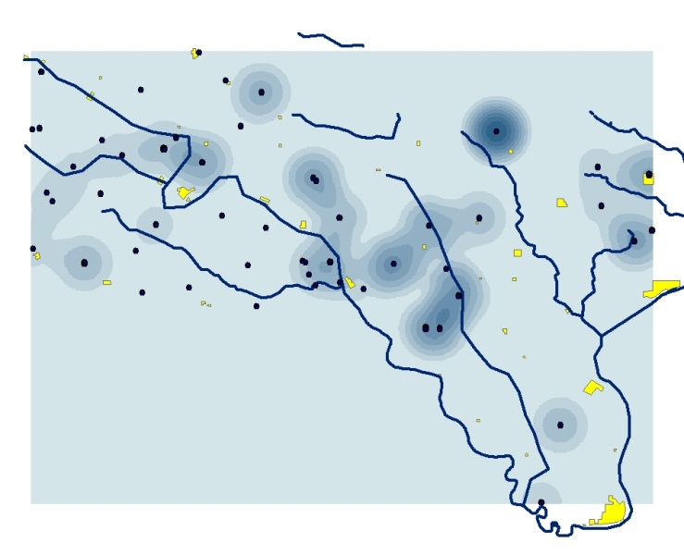  Figure 27: Kernel density classification, search radius set to 5000 meter, field set to date of death. | 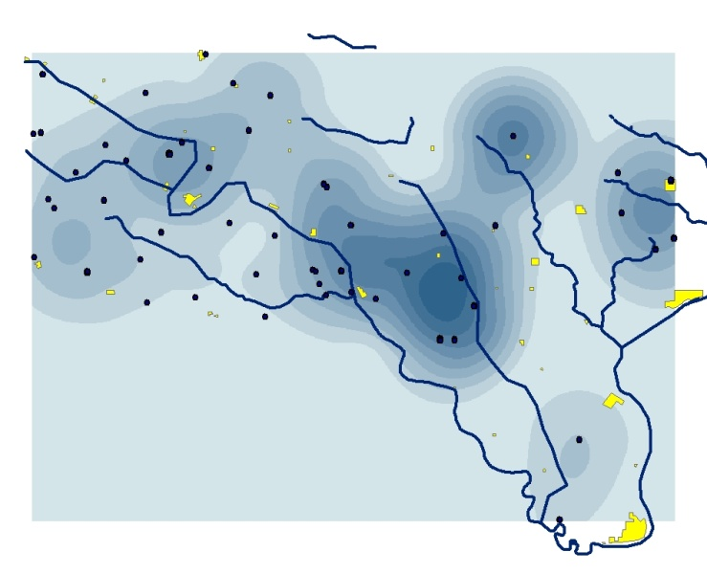  Figure 28: Kernel density classification, search radius set to 10000 meter, field set to date of death.

Average date of death

Data was entered for 1,240 known burials in the two counties. Of these, only 1,057 have a recorded age, or the data necessary to calculate an age, i.e. date of birth and date of death. General statistics were run on three layers: data that had age; data that had age and gender, and data that had age and gender separated by male and female. The minimum age of zero reflects infants who died at an age of less than one month, or where the age of death was not given, but the comments stated “infant son/daughter of.” The average age of death overall, as seen in Table 2 below, is 35.5.

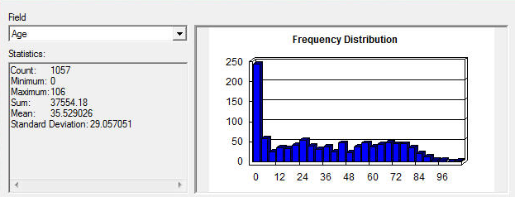
Table 2: Average age of death for all burials that had an age, or where it was possible to calculate age.
It was thought that the average date-of-death for women should be lower than for men. Due to risks associated with child bearing, women tended to die earlier than men. To test this, data was separated on the gender field.
The average age-of-death is remarkably consistent for all categories. The average age-of-death overall was 35.5 years. When the date was separated by gender, there were 505 female known burials, and 469 male known burials. The average age-at-death, however, varied by 0.797 years, or approximately 9 months (see Tables 3 and 4).
Female Deaths
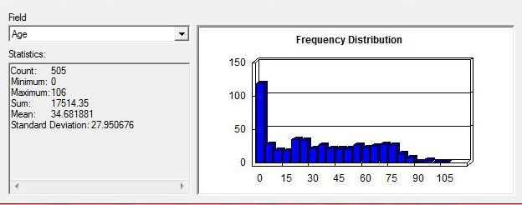
Table 3: Average age of death for all females that had an age, or where it was possible to calculate age and gender was assigned.
Male Deaths
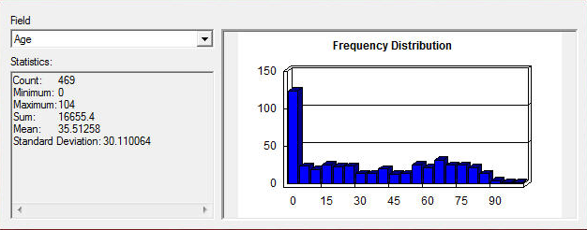
Table 4: Average age of death for all males that had an age, or where it was possible to calculate age and gender was assigned.

During pioneer days, it was not uncommon for women to die during childbirth: “ . . . between 1 and 1.5 percent of all births end in a mother’s death. . . . Since the typical mother gave birth to between five and eight children, her lifetime chances of dying in childbirth were as high as 1 in 8” (Childbirth in Early American). Since men didn’t experience child birth, logic seems to suggest that women during childbearing years died at a higher rate than men of the same age.
The averages above, which are simply the average age of death for all males and for all females, seem to suggest that males and females were dying at the same approximate age. It also appears that most women were dying at the end of the child bearing years, an average age of 34, rather than during the early and mid-child bearing years. In order to check this hypothesis, males and females were placed into separate categories, and an analysis was done based on age-of-death by category (see Figure 29).

Figure 29 Chart showing age of death for males and females.

The above chart shows that the rate of death for males and females is similar up until the late teens. In fact, from birth to approximately age 20, there were only four more female deaths than males. From 20 to 30 that number increases to 18. The difference remains at 18 until the 41 to 50 year-old category, where the gap begins to close. The age span from 21 to 40, where the number of deaths is most divided, includes the primary marriage/child-bearing ages. In that the total number of samples for this is 974, it is not possible to draw conclusions, but the trend is supporting the risk that women faced due to childbirth.
To determine if the age of death for woman changed with the modernization of the settlements, the number of deaths was separated by decade. In the graph below, there is evidence of a dramatic change in the difference between counts for males and females as the Iowa settlements grew. The number of women dying by decade was consistently higher than the number of males until 1870. As can be seen in Figure 30 below, from 1870 onward the number of women dying per decade was similar to or less than the number of males.

Figure 30: Graph showing age of death by decade for men and women.

The shortcoming with this data is that the population of the settlements is not known. This data may be available from the 1840 census, but was not part of this phase of research.

Overall
For overall statistics, the highest rate of death, as seen in the chart below, was for infants aged newborn to five. This is followed by the 21 to 30 year-old group (see Figure 31).

Figure 31: Death by age.

Infants aged zero to five in less healthy environments were reported to die at a rate of 3 in 10. In healthy environments, the rate was 1 in 10 (Childbirth in America). Statistics in the two cemeteries in this research strongly support this statement. Given the nature of pioneer settlements, with limited resources, lack of modern amenities, is expected that the environment might be considered unhealthy. This implies that rate of death for infants should also decrease as the settlements modernize. In order to test this, infant deaths zero to five were charted by decades (see Figure 32).

Figure 32: Death by decade of children aged zero to five.

Note on the graph that the peak for the number of deaths is in the 1860. As stated previously, there was a cholera outbreak in the 1860s. Also, the drop in the number of deaths follows a pattern similar to the drop in the number of women dying. The similarity in pattern reinforces the theory that as settlements modernized, death rates dropped.

Seasonality of death

Seasonality of death looks at whether there is a pattern in the death rate that suggests that death is influenced by weather. This is important in the study of pioneer cemeteries since early pioneers had little, if any, control over indoor temperatures.
A study by Cossman and Jimenez shows that the majority of deaths were in the summer and winter months due to the extremes in temperatures in Georgia. Their study shows an overall pattern of death with the highest rate of death in summer and the lowest rate of death in autumn. The data from the two southeast counties in Iowa appear to be the direct opposite. The season with the lowest over-all number of deaths is summer, while spring and autumn have the highest (see Figure 33).

Figure 33: Death by season.

Of the 883 entries, 280 deaths were infants aged zero to five. Only 222 had a known month of death, which is needed in order to look at seasonality of death. The seasons were defined as winter; December through February: spring; March through May: summer; June through August: and autumn; September through November (see Figure 34).

Figure 34: Season of death for infants.

Infant death in the 1800s was highest during the fall months of September, October, and November. Cossman and Jimenez state “. . . many of the studies that find summer months to be high in regards to morality are studying infants and children” (2006, 154). This raises the question of whether different weather patterns between the south, where Cossman and Jimenez did their study, and Iowa, where this research is conducted, is a factor.
The size of database, which is not valid for statistical comparison, may also be skewing the results. Further study is warranted to determine if the size of the data is the cause of this discrepancy, or if other factors may be involved.

Pioneer Burial Data

Phase 1 of this research consisted of joining data from two of Iowa’s earliest counties; Van Buren County and Lee County in the southeast portion of the state. By joining data from both counties into a single GIS database, it became possible to compare data that crossed county boundaries. Prior to this, each county maintained its own cemetery data from the 1800s, and comparisons and analysis was not easily completed.
Compiling data from known burials within pioneer cemeteries in two counties enabled the researcher to map spatio-temporal patterns that reflected the founding of a sample of Iowa settlements in the nineteenth century, the date of death of males and females, as well as death by age and season. Mapping these attributes made it possible to “ . . . view the unfolding of this settlement landscape as a process, a continuum of human choices made and spatial patterns established in response to conditions on the ground” (Dobbs 339). Specifically, by analyzing date-of-death by cemetery and county, it was possible to establish the progression of founding settlements along the waterways in Iowa.
The data also showed that women were dying at an earlier age than their male counterparts during the child bearing years and during the earlier years of the settlements. As the settlements matured and became modernized, the dates-of-death tended to even out. This change in death rate was evident for women during the child-bearing years, and infants aged zero to five; both of these were high risk groups.
The percentage of each settlement within the one-mile buffer of a major waterway suggests that the early settlers did move in to Iowa by navigating the waterways in southeast Iowa. The majority of settlements along the railroads were founded prior to the construction of the railroads, because they were settled when pioneers entered the state along the waterways. This may be because railroads were intended to service the active communities, and secondarily to settle new locations. It will be necessary to look at railroads and settlements outside this area in order to fully appreciate the affect of the early railroads on the settlements. Buffering exercises for a sequence of early railroad lines in more than two counties might also be profitable. Did trunk lines become corridors of innovation, or better medical knowledge, compared to branch lines, and did settlements along river ways, removed from rail lines, atrophy?
GIS appears to be a valid method for analyzing historic data by integrating spatial and aspatial data, as well as attributes needed for spatio-temporal analysis. Phase I of this research joined data from two of Iowa’s earliest counties, Van Buren and Lee. At the time of the research, each county maintained its own cemetery data, making it difficult to see patterns across a broader area. By joining data that previously sat in individual county repositories, and creating one GIS database to handle the data, historical data were more conveniently accessed and it became possible to compare data that crossed county boundaries. GIS enabled the landscape to be integrated with temporal data and analyzed, giving snapshots of the communities.
Phase II will require attempting to physically locate the known burials in the correct location within the cemetery boundaries. This will enable ground truthing to verify that the data from the written records is correct and complete. When the cemeteries and known burials are GPSed, the cemetery layer will be turned over to the ISHA to include in their cemetery layer.
Even more ambitious would be a laborious exercise to link manuscript census information about individuals to this cemetery data set, to ascertain whether occupations were a surrogate for wealth and whether that played a role in longevity. Even further down the line, obituary notices or death records in county courthouses might shed light on causes of death. Here too, the foundational GIS work outlines here provides a spatial platform on which a range of research questions might be raised.

Summary
It does appear that further research is warranted that can harness the data management and data visualization capacities of GIS. I plan to continue with the research in several inter-related ways. First I will visit the pioneer cemeteries in Lee and Van Buren County to verify the data that has been entered, a ground-truthing of other people’s entries. Second, and related to those cemeteries examined in this pilot, I will explore whether a gravestone by gravestone plotting of data will suggest a different set of insights than those derived from the clustering of all the data into one single point. As such, it offers yet another spatial scale at which GIS visualization can be utilized. There may be generational or ethnic patterns within parts of the cemeteries. Thirdly, I will also enter data from several more of Iowa’s earliest counties in order to have a more statistically valid pool of data from which to draw conclusions. Three options come to mind: counties along the Mississippi river, counties along one of the main Iowa rivers that drew settlers into the central and western part of the state, or counties associated with either the Mormon Trail or the first railroad corridor. I anticipate that insights from this snowballing of the data will help me and others take on the more ambitious state-wide analysis that was my initial intent. But in the end, the interest in markers and settlement has been served by careful attention to detail, and the frame of GIS has given me confidence that incremental insights will accrue, and repay the time and effort needed to code and check data. At every turn, the fragmentary nature of the evidence means that GIS analysis will not be able to produce certainties, but it definitely has the capacity to suggest work of use for historians, demographers and genealogists alike. .
Works Cited

“Aboard the Underground Railroad, Henderson Lewelling House.” National Park Service, U.S. Department of the Interior. http://www.nps.gov/history/nr/travel/underground/ia3.htm Accessed January 18, 2010.
Alex, Lynn. Iowa's Archaeological Past. Iowa City: University of Iowa Press, 2000.
Andreas, A.T. Illustrated Historical Atlas of the State of Iowa. Chicago: Andreas Atlas Company, 1875.

Bailey, Timothy J. and James B. M. Schick. “Historical GIS Enabling the Collision of History and Geography.” Social Science Computer Review. 27, 3 (2009): 291-296.

Baugh, Alexander L. “Remember the Mormons in Lee Coutyn, Iowa: Marking the Past in Montrose and Keokuk.” Mormon Historical Studies. 4, 2 (2003): 175-184.
Bogue, Allan. From Prairie to Corn Belt, Farming on the Illinois and Iowa Prairies in the Nineteenth Century. Chicago: University of Chicago Press. 1963.
Bogue, Allan. “The People Come.” Patterns and Perspectives in Iowa History. Ed. Dorothy Schwieder. Ames: Iowa State University Press, 1973. Pages 81-103.
Bromberg, Francine W. and Steven J Shephard. “The Quaker Burying Ground in Alexandria Virginia: A Study of Burial Practices of the Religious Society of Friends.” Society of Historical Archaeology. 40, 1 (2006): 57-88.
Carpenter, Allan and Randy Lyon. Between Two Rivers: Iowa Year by Year, 1846-1996. Ames: Iowa State University, 1997.
Cole, Cyrenus. A History of the People of Iowa. Cedar Rapids: The Torch Press, 1921.
Coppock J.T. and D. W. Rhind. "The History of GIS." Geographical Information Systems. Ed. by Maguire D.J., M. F. Goodchild, and D.W. Rhind. Hoboken: John Wiley and Son, 2001.
Dobbs, G. Rebecca. “Backcountry Settlement development and Indian Trails, a GIS Land-Grant Analysis.” Social Science Computer Review. 27, 3 (2009): 331-347.
Fiser, Ronald, and National Geographic. “National Geographic Historical Atlas of the United States.” 2004. Washington DC: National Geographic Society.
Foster, Lance M. “The Ioway and the Landscape of Southeast Iowa.” Journal of the Iowa Archeological Society, 43 (1996) 1-5.
Francis, Doris. “Cemeteries as Cultural Landscapes.” Mortality. 8, 2 (2003) 222-227.
Fyfe, David A and Deryck W Holdsworth. "Historical GIS and Visualization." Social Science Computer Review 27, 3 (2009) 348-362.
Gregory, Ian N. A Place in History, A Guide to Using GIS in Historical Research 2nd Edition. Belfast: Center for Data Digitization and Analysis. Queens University, 2005.
Gregory, Ian N. and Richard G Healey. “Historical GIS: Structuring, Mapping and Analyzing Geographies of the Past.” Progress in Human Geography. 31(5) 2007: 638-653.
Gregory, Ian N. and Paul S. Ell. Historical GIS. Cambridge: Cambridge University Press, 2007.
Healey, Richard B. Trem Stamp. “Historical GIS as a Foundation for the Analysis of Regional Economic Growth.” Social Science History. 24, (2000): 575-612.
Iowa DNR State Parks. Lacey Keosauqua State Park. www.iowadnr.gov/parks/state_park_list/lacey_keo.html. Accessed July 15, 2010.
Iowa Gravestone Project. http://iowagravestones.org/. Accessed January 23, 2009 to June 8, 2010.
“Iowa Pathways: The battle against contagious diseases.” Iowa Pathways: 2005 – 2010 Iowa Public Television. http://www.iptv.org/iowapathways/mypath.cfm?ounid=ob_000331 Accessed June 12, 2010.
"What is Left of the Prairie?" Iowa Prairie Network. http://www.iowaprairienetwork.org/prairies/remaining.shtml. Accessed October 8, 2010.
Jimenz, Albert M and Jerallynn S Cossman. "When People Died: An Examination of Seasonality of Mortality Using an Historic African American Population." Sociological Spectrum (2006): 149-181.
Jordon, T G. "Between the forest and the prairie." Agricultural History 38, 4, (1964): 205-216.
Knowles, Anna Kelly. “Introduction.” Social Science History. Fall 2000. 24:3
Knowles, Anne Kelly. “Historical Uses of GIS.” Paper delivered at PACSCL Symposium. Future Foundations: Mapping the Past: Building the Philadelphia Geohistory Network. December 2, 2005.
Liebens, Johan. “Map and Database Construction for an Historic Cemetery.” Society for Historical Archaeology. 37, 4 (2003): 56-68.
Meinig, Donald. Shaping of America Vols 1 through 4. New Haven: Yale University Press. 1986, 1995, 2000, 2006.
Merry, Carl A. The Historic Period. University of Iowa Press. 1996. http://www.uiowa.edu/~osa/learn/historic/hisper.htm Accessed January 17, 2010.
“Nauvoo, Illinois: 1839-1846, The Pioneer Story, The Mormon Pioneer Trail, Church of Jesus Christ of the Later Day Saints.” http://lds.org/gospellibrary/pioneer/pioneerstory.htm Accessed January 20, 2010.
Padilla, Cynthia. “Historical GIS; Mapping the Past to Understand the Future.” Mar/Apr 2008 www.onlinemag.net Accessed January 28, 2010.
Parker, F. George. Iowa Pioneer Foundation. Iowa City: Athens Press, 1940.
“The Pioneer Story.” Church of Jesus Christ of Latter-Day Saints. Intellectual Reserve, Inc. 2000. http://www.lds.gospellibrary/pioneer/pioneerstory.htm. January 20, 2010.
Rosseth, Catherine Anne. “Reinterpreting the Laurel Hill Cemetery Using Geographic Information Systems (GIS).” Graduate Program in Historic Preservation. University of Pennsylvania.
Rugg, Julie. “Define the Place of Burial; What makes a cemetery a cemetery?” Mortality, 5, 3 (2000): 259-275.
Russ, Teri Alana. “Grave Intensions; a Comprehensive Guide”. Historical Archaeology. 40, 2 (2006): 103-104.
Sage, Leland. A History of Iowa. Ames: Iowa State Press, 1987.
Savage, Tom. A Dictionary Of Iowa Place-Names. Iowa City: University of Iowa Press, 2007.
Schlichting, Kurt. Peter Tuckel. Richard Maisel. “Residential Segregation and the Beginning of the Great Migration of African Americans to Hartford Connecticut.” Historical Methods. 39, 5 (Summer 2006): 132-143.
Schwieder, Dorothy. Iowa:The Middle Land. Ames: Iowa State University Press, 1996.
Smith, Daryl D. "Iowa Prairie: Original Extent and Loss, Preservation and Recovery Attempts." Journal of Iowa Academy of Science (1998): 94-108.
State Association for the Preservation of Iowa Cemeteries. http://www.rootsweb.ancestry.com/~iasapc/, accessed June 12, 2010.
Stromquist, Shelton. A Generation of Boomers: The Pattern of Railroad Labor Conflict in Nineteenth-Century America (Working Class in American History). Urbana: University of Illinois Press, 1987.

Townships are part of what is known as the Public Land Survey System (PLSS). As the United States began purchasing land west of the thirteen colonies, it was necessary to survey it in order to sell it. The new land was surveyed and divided Townships, each of which was broken into on-square mile sections. This accounts for the orderly tiers of Iowa’s 99 counties.
The NRGIS are credited for georeferencing the plats taken from the A.T. Andreas' Illustrated Historical Atlas of the State of Iowa.
The early rail lines that show on the 1930 imagery were digitized and attributes researched by Michael Biederman, a student at Kirkwood Community College.
See books such as Tor Bernhardsen, Geographic Information Systems: An introduction, New York: John Wiley and Sons, 2002, for more information.
Buffer: A zone is created around a feature at a specified distance. The results in creating a polygon are that specific buffer zone that is form polygonal coverages. http://gislounge.com/buffer/
Kernel density is defined in the ArcGIS Help file, as well as textbooks, such as Introduction to Geographic Information Systems, Kang-tsung Chang, McGraw Hill, New York. 2008. 424 pages.

